
STRATEGIC MANAGEMENT (LCMB7003)

Strategic Analysis of DELL TECHNOLOGIES

Student name: Dhruv Kalpeshkumar Shukla
Student Number: 2210110
Lecturer: Hossein Shokri
Submission Date:08/05/2023

Table of Contents
1. Introduction 3
2. Dell Background 3
2.1 Mission and Objectives 4
3. Macro environmental analysis 4
3.1 PESTLE Analysis 5
4. Micro-environmental analysis 8
4.1 Industry life cycle 8
4.2 Porter Five Forces Analysis 10
5. Internal analysis 12
5.1 Strategic Resources and Capabilities of Dell 12
5.2 Value chain analysis 14
5.2.1 Primary Activities 15
5.2.1 Secondary Activities 15
5.3 VRIO Analysis of distinct resources and Capabilities 16
5.4 SWOT Analysis 17
6. Strategies to sustain competitive Advantage 18
7. Growth strategies 20
8. Green Strategy and CSR 22
9. Conclusion 25
10. Recommendation 25
References 27

1. Introduction
This report aims to investigate the strategic management of Dell technologies by identifying central challenges faced by organisations. According to Farid (2022), the definition of strategic management is the procedure of setting objectives, goals, and processes to create an organisation or company more competitive. This report selected Dell Technologies, an American-based software manufacturing company that focuses on HDTVs, electronics, PCs, network switches, data storage devices, and computer peripherals that operates with 133000 that help to generate 101.6 billion USD in 2022 along with net income and operating profit 2442000,000 USD and 5771000000 USD, respectively. It helped Dell Technologies become the 3rd largest organisation under the S&P 500 and NASDAQ-100, with a 50 billion USD net worth in 2021 (Dell.com, 2023).
This report contains six segments; the first section deals with the introduction of strategic management, along with a brief description of the mission, objectives, and background. The second portion will include a "Macro-environment analysis" as a PESTLE analysis and a "Micro-environment analysis" as Porter's five forces and industry life cycle. The fifth section will involve internal analysis with identified strategic resources and capabilities, value chain analysis, VRIO framework, and SWOT analysis. Also, this report includes strategies to reach sustainable competitive advantage along with green strategy, CSR, and growth strategies, and outlined recommendations for future development.

2. Dell Background
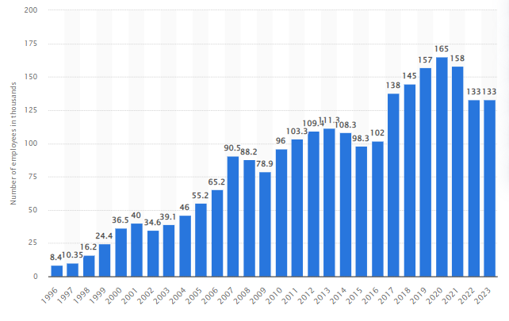
Figure 1: Employees of Dell Technologies
(Source: Alsop, 2023a)
Dell Technologies is a multinational technology company headquartered in Round Rock, Texas, United States. It was founded in 1984 by Michael Dell as well as is currently one of the largest technology firms in the world (Fortune, 2023). As of 2023, the organisation has 165,000 employees in the global markets, making it one of the largest employers in the technology sector (Alsop, 2023a). In terms of financials, Dell Technologies is consistently recognised as one of the top technology firms in the world. According to Gara (2021b), Dell Technologies has a market capitalisation of over $70 billion and generates annual revenue of $90 Billion, making it one of the largest technology companies in terms of revenue. On the other hand, Dell Technologies operates in multiple markets, including PCs, servers, storage, networking as well as services. The company also serves customers in different sectors in the form of consumers, small and medium-sized businesses, large enterprises, education, and government. Moreover, Alsop (2022) reported that Dell Technologies has a significant global presence in 180 countries. In addition, the firm has a strong focus on research and development with substantial investment in technology and innovation advancements.

2.1 Mission and Objectives
Dell Technologies' mission is to be a trusted partner for various customers, helping them transform their businesses along with unlocking the full potential of technology. The organisation aims to provide cutting-edge technology solutions that have been reliable, scalable, secure as well as sustainable enabling its customers to thrive in the digital era (Moorhead, 2021). On the other hand, the objectives of Dell Technologies include the firm focusing on understanding along with meeting the needs of customers by delivering superior technology solutions that solve their issues and enable success (Forbes, 2021). Dell Technologies aims to drive innovation across its entire portfolio through products and services that have constant evolution and adapted to changing technology trends and customer requirements. Dell Technologies has been committed to environmental sustainability and social responsibility in striving to create products and solutions that are environmentally responsible, energy-efficient, and socially inclusive.

3. Macro environmental analysis
Oluka Nagitta and Mkansi (2022) mentioned that the macro-environmental analysis, also known as PESTLE, is a framework used in strategic management as well as marketing to assess and evaluate the external factors that impact a firm's operations, performance, and strategies.

3.1 PESTLE Analysis
Factors | Analysis | Opportunity/Threat
Political | - 27th list of corrupt countries (Cillizza, 2022).  - Hourly increase pay of wages rises by 0.2% (Iacurci, 2023).  - The US has been the most stable country. | - Opportunity for Dell Technologies as a low corruption rate ensures smooth operations with flexibility and transparency.  - The threat for Dell Technologies as high wages leads to increased labour costs impacting profitability.  - Opportunity for the firm to drive its innovation along with competitiveness.
Economic | - The GDP rate of the US is 2.6% in 2022 (Trading Economics, 2022).  - Rise in inflation by 8.3% (Statista, 2023).  - The US has a 21% rate of corporate tax (PWC, 2022). | - Opportunity for Dell Technologies leading to high demand for technology products such as computers, servers and others with capturing large market share.  - The threat for Dell Technologies disrupting the supply chain in the form of availability and cost of components production delays leading.  - Opportunity for Dell Technologies to encourage it more to invest in Research and Development activities leading to innovation and development of new products.
Social | - Rise in population to 333 Million in 2022 (Worldometers, 2022).  - Low social mobility (Eppard, 2021). | - Opportunity for Dell Technologies as a large population provides a large pool of potential firm employees.  - The threat for the organisation is low social mobility indicates low economic opportunities with the reduced purchasing power of the firm's products.
Technology | - There is a 92% internet usage rate in the US (Petrosyan, 2023).  - Use of data analytics, customer-facing web applications and others. | - Opportunity for Dell Technologies in growing need of undergoing digital transformation in staying competitive.  - Opportunity for the firm in enabling it to make data-driven decisions and improve products and services.
Legal | - “Civil Rights Act of 1991” has been followed.  - “Equal Pay Act of 1963” determined (U.S. Department of Labor, 2021). | - Opportunity for Dell Technologies to ensure non-discrimination in the workplace by removing controversy.  - The threat for Dell Technologies in strictly following the law, such as non-compliance, can result in legal penalties and fines.
Environmental | - The US has a commitment to reduce carbon emissions by shifting to a low-carbon economy.  - “Resource Conservation and Recovery Act” | - Opportunity for Dell Technologies to ensure that the firm has a capitalisation through market trends by developing as well as offering innovative and sustainable products.  - Opportunity for the organisation to ensure compliance with environmental regulations avoid disposal of wastes, and avoid fines.
Table 1: PESTLE Analysis
(Source: Self-developed)

4. Micro-environmental analysis
According to Singh, Sarangal, and Singh (2021), micro-environmental analysis is micro-environmental scanning or assessment that refers to evaluation as well as an examination of immediate external factors that directly impact a specific organisation or industry.

4.1 Industry life cycle
Dell Technologies is a multinational technology organisation headquartered in the United States. The company has undergone different stages through the industry life cycle, with the chosen case study indicates that the firm has set to become a leader in cloud and edge computing. However, Aguilar and Sánchez (2020) suggested that the industry life cycle analysis can be divided into four stages in the form of introduction, growth, maturity, and decline. Dell Technologies has an evolution over the years, adapting towards changing market dynamics as well as technological advancements positioning itself to succeed in emerging cloud and edge computing space.
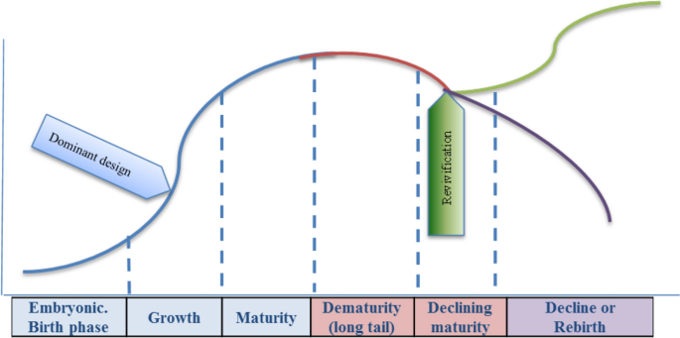
Figure 2: Industry life cycle
(Source: Aguilar and Sánchez, 2020)
In the introduction stage, the firm Dell Technologies was founded in 1884 as a PC manufacturer focusing on D2C (Direct-to-consumer) sales which was a disruptive approach at that specific period (Gara, 2021a). However, the company gained popularity by offering customisable PCs as well as superior customer service, disrupting the traditional retail model. This ensured a helping hand for Dell Technologies in establishing itself as a key player in the PC market and laid the foundation for its future success. On the other hand, Pohani (2023) suggests that through the growth stage, Dell Technologies have an expansion of its product portfolio beyond PCs to have an inclusion of servers, storage, networking as well as software solutions. The organisation leveraged its direct sales model along with supply chain efficiencies in gaining a competitive advantage, becoming one of the largest technology companies in the world. Dell Technologies also made strategic acquisitions in the form of EMC corporation along weigh VMware in enhancing its capabilities and ensure expansion towards new markets.
As the industry matured, Dell Technologies have a continuation to innovate as well as adapt changing needs of customers. The company has shifted its focus to solutions along with services rather than just the hardware in providing end-to-end technology solutions to its consumers. However, Dell Technologies also recognised the growing importance of cloud computing and edge computing in the digital transformation era and started investing heavily in these areas (Dell Technologies, 2022b). Dell Technologies face the terror of a decline in traditional hardware products as the industry has shifted to cloud computing along with edge computing solutions. As there has been an evolution through the cloud and edge computing industry, customers' preferences, as well as behaviours, have changed. Customers can have a preference for more cloud-based solutions than on-premise hardware.

4.2 Porter Five Forces Analysis
Porter's five forces analysis can provide positive insights into how Dell Technologies, as described in the case study, set to become a leader in cloud and edge computing (Isabelle et al., 2020).
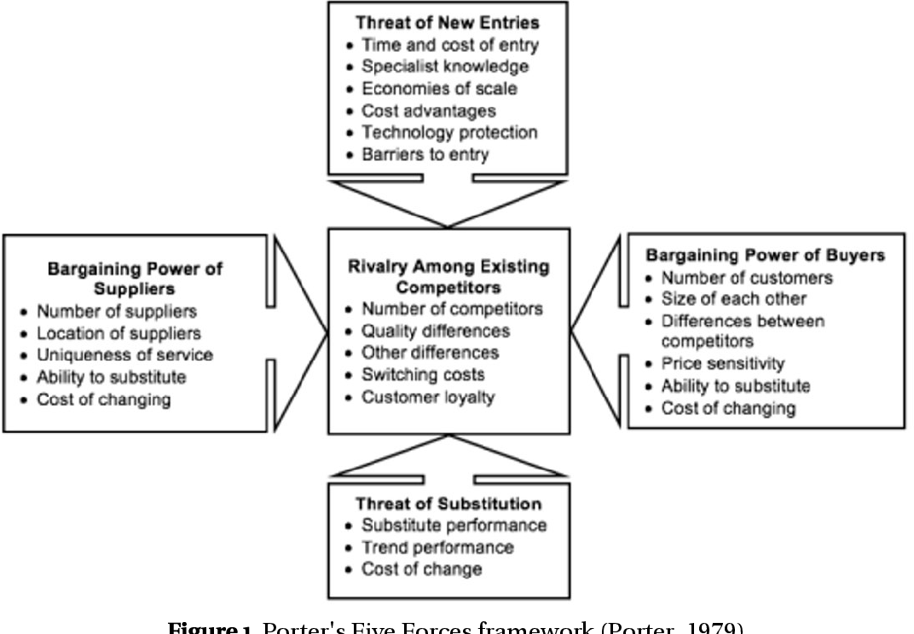
Figure 3: Porter's five forces
(Source: Isabelle et al., 2020)
Competitive rivalry
The firm Dell Technologies face high competition from the other major players in the cloud along with the edge computing market in the form of Google Cloud, Lenono Thnk Agile, IBM Red Hat, and others (Mehta, 2022). The competition has been characterised by high product similarity along with price sensitivity. The firm has deployed strategies to differentiate itself from competitors by offering unique value proportions such as innovative edge computing solutions and others. This has an allowance to Dell technologies in carving out its niche in the market and gaining a competitive advantage.
Bargaining power of suppliers
Dell Technologies has low bargaining power over the suppliers in the industry, such as the firm relying on the global supply chain for its components of hardware. However, the bargaining power of the suppliers could impact the availability and cost of these components (Bruijl, 2018). To mitigate these risks, Dell Technologies has engaged in strategies in the form of dual sourcing as well as strategic partnerships with important suppliers to ensure a stable supply of components with reducing dependency on a single supplier. This helps the firm in dealing with its risks along with maintaining cost competitiveness.
Bargaining power of buyers
The bargaining power of buyers is high, and customers in the cloud and edge computing industry have uplifted expectations for customised solutions and competitive pricing. However, Dell technologies have addressed this by focusing on customer-centric strategies such as providing tailored solutions, excellent customer service, and flexible pricing models. Understanding along with meeting the customer needs, the firm has enhanced customer satisfaction and loyalty, reducing the bargaining power of buyers.
The threat of substitute goods
The cloud and edge computing industry has been subject to rapid technological advancement and disruptive business models that would replace traditional computing solutions (Verhoef et al., 2021). Tacking the specific threat, Dell Technologies have pursued a strategy of diversification by expanding its product as well as service offerings beyond the traditional hardware towards including software and services along with solutions for cloud and edge computing. This has allowed Dell technologies to adapt to changes in market dynamics and mitigate the threat of substitution.
The threat of new entrants
The threat of new entrants in the cloud and edge computing industry has been relatively low due to the high entry barriers, including significant investments through expertise infrastructure as well as ecosystem partnerships (Perifanis and Kitsios, 2022). However, Dell Technologies proactively monitors the market for potential disruptors and innovation trends to stay ahead of the potential new entrants and maintain its position in the market.

5. Internal analysis

5.1 Strategic Resources and Capabilities of Dell
According to Cheng (2022), Dell Technologies has its KSFs factors, such as product customisation cost structure, customer services, connection with suppliers, and competitive prices, with a customer-centric approach to manage its cash flow process and supply chain to meet target competitive advantage. Core competencies: As per this article Dell Technologies maintain five competencies that identify its strategic capabilities and resources, namely low and speed cost, organisational structure, market segmentation skills and capabilities, "direct-scale distribution channels', and "value-added customer services".
Organisational Structure
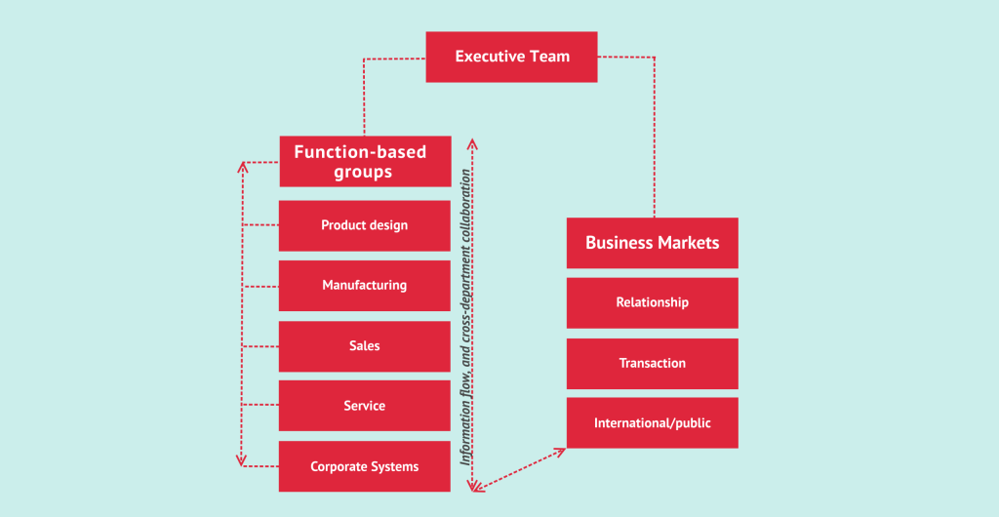
Figure 4: Organisational structure of Dell
(Source: Cuofano, 2022)
As per Cosh et al. (2010), an effective organisational structure allows innovative business performance. The organisational structure of Dell Technologies includes a hierarchical structure involving business development, global, and functional that help in allocating resources and tasks to team leaders with controls that provide a clear image of economies of scale. Dell's centralised organisational structure contains upper levels, supportive technical staff, functional teams, organisational sales and support divisions, HR department, IT and finance business operations.
Resource-based business model
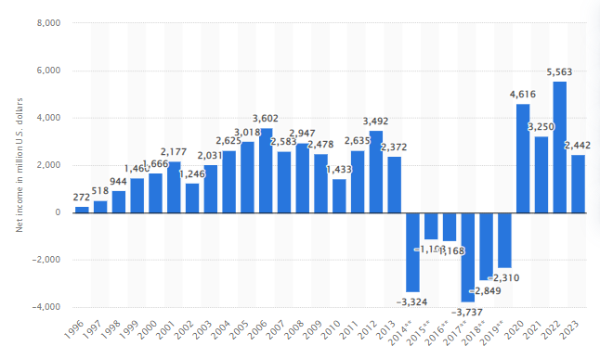
Figure 5: Dell Technologies net income/loss worldwide
(Source: Alsop, 2023)
Teece (2018) stated that the competitive advantage could be built on its internal capabilities instead of the industry environment. In the given scenario, applying a "resource-based approach" that identifies a "direct-sale distribution channel" that includes internet-based distribution operation with retailers and dealers while involving consumers to place particular orders on products of Dell technologies to get door-step deliveries. Moreover, it will help to eliminate excessive costs because it reduces the participation of third parties, along with managing the cost of inventory. Dell technologies always focused on pursuing minimum costs and speed by squeezing inefficiencies and time lag in its assembly and manufacturing process. For example, Dell accepts parts in minutes instead of days, working in the Topfer manufacturing centre where electronic components and microchips skitter are collected on the conveyor belt and assembly employees having experience in an integrated computerised system that saves times due to reducing the number of employees touched per machine (Lin et al., 2020). With "value-added customer service" and market segmentation capabilities and skills, Dell technologies focus on meeting challenges of the supply chain through multilayer transformation, including different stages, such as evaluating customer value, acknowledging the external environment, charting clear benefits and course, refining the portfolio and govern, ad Dell's strengths bring in the product to market efficiently. That helps in Dell technologies economic value; it measures net loss to net profit between 2014 to 2022, from -3324 million USD to 5563 million USD (Alsop, 2023).

5.2 Value chain analysis
Inbound Logistics | Operations | Outbound Logistics | Sales and marketing | Services
- Dell contains an international supply chain network that offers its retail operations in Ireland, the United States, India, China, Brazil, Poland, and Malaysia.  - It uses multiple inbound logistics via air and sea sources. | - Dell optimise its operation to achieve high efficiency  - It has a global distribution channel  - Using Six Sigma to improve quality | - Logistics and third-party vendors help in external logistics to deliver IT solutions to clients  - It includes a balanced mix transportation strategy to cut emissions and wastages | - Dell increased its number of partners through a multi-channel strategy  - Apart from, the official website Dell Technologies promote their products in traditional and social media by investing 1045 million USD in advertising | - Better reputation  - High profitability  - Higher customer satisfaction
Firm infrastructure | Human resource management | Technology development | Procurement
- Efficient firm infrastructure with interconnected manufacturing and IT  - It have total assets of 122.3 billion dollars from 118.2 billion USD in 2018 | - 145000 permanent employees in 2018  - Strategic HRM policies  - VMware's employee number increased by 39% | - Cloud computing, big data, and agile implementation in production  - Making Kean sales network and supply chain management to provide innovative technological solutions | - Close coordination to manage sourcing and supply-demand criteria  - Sustainable operation ensure better performance and relationship with suppliers
Table 2: Value chain analysis
(Self-created)

5.2.1 Primary activities
According to Dudovskiy (2015), inbound logistics actions of inventory and warehousing include a collaborative, transparent, and leadership that is associated with an efficient audit cycle for organised training for SER suppliers. Outbound logistics serve different customers through quick shipment with a wide range of partnerships and RBA. The services of Dell allow post and pre-sales support for customers, which is reflected in its 50,000 phone calls attempted by employees from clients per day. The marketing and sales of Dell focus on shifting the public's attention through social media and traditional marketing associated with brand image. Operations include "lean Six Sigma" to help organisational growth by reaching 200,000 orders per day.

5.2.1 Secondary activities
Dell focuses on expanding its storage portfolio by serving world-class products and solutions. Technology development serves an entire management layer, including networking, connectivity, and compute storage, for customers. HRM elements reflect Dell becoming the 50th most attractive business hub for new associates, with 57% of frontline workers and advanced hiring placement to achieve goals (Prasetyanti and Simatupang, 2015). Procurement of Dell technologies focus on a pivotal value chain approach with cost reduction and e-waste management to increase its profit margin with VCA procurement to make diverse business connections.

5.3 VRIO analysis of distinct resources and capabilities
Resources | Value | Rare | Imitation | Organisation | Competitive advantage
Supply chain | Yes | Yes | High, because competitors also have flexible SCM | Authorised by Dell structure and capabilities | Moderate
Financial resources | Yes | No | Financial metrics and market liquidity are also available for competitors | Dell have a stable and reasonable financial position | Sustainable competitive advantage
Pricing strategy and channel management | Yes | No | It regularly imitated by the industry | Dell have an analytics engine for pricing analysis | Temporary
Product portfolio and talent engagement | Yes | No | Maybe imitated by competitors | Yes, Dell Gas utilise details | Short-term competitive advantage
Table 3: VRIO analysis
(Self-created)
Analysis
According to Knott (2019), the valuable resource includes direct sales models in Dell that support reducing retailing costs while maintaining contact and reputation among product buyers. Rarity of Dell is using product diversity and marketing channel management online to help to increase brand image. However, it is not rare and easily merchandise by its competitors, like HP, Lenovo, Apple, and Acer. Regarding Imitability, the SCM model of Dell is expensive and would be tough to imitate by its current risks because it increases their initial costs and needs to re-organise structure. JIT adoption and lean production use in Dell help to eliminate excessive expenses (Davis and DeWitt, 2021). Well-managed and organised hierarchy structure of Dell helps in operating dedicated HRM efficiently while maintaining proper management throughout the business model, operation, workforce culture, and structure.

5.4 SWOT analysis
Strengths | Weakness
- Product customisation  - Direct selling business operation  - Brand value 31.20 billion USD in 2023 | - Low differentiation  - Commodity products  - Poor customer service because minimum retail locations
Opportunity | Threats
- Tablet growth of the market  - Expand enterprise solutions business  - Follow a strategy of diversity to strengthen market presence | - Increasing competition and demands for tablets and smartphones  - Lowering profit margin  - Slow growth in the laptop market
Table 4: SWOT analysis
(Self-created)
Analysis
Strengths of Dell technologies involving 31.20 billion USD from 7.5 billion USD brand value of Dell recognised as its reputation and goods quality. Dells allows its clients to customise its laptops along with different green initiatives, such as recovering approximately 2 billion pounds through reuse and recycling by offering "global mail-back services" and responsible data protection. Using "direct selling business operation " by big-box retail locations resulted in a minimum profit margin (Dell.com, 2022). The weaknesses belong to commodity hardware products sales that involve low-profit margin and an increased number of declined calls from Dell's service centres leading to customer dissatisfaction. Minimum unterscheidung associated with lower chances to afford competitive pricing because of R&D investment than its rivals missed opportunities to produce a strong product line. For example, between 2019 and 2020, R&D investment in Dell technologies is recorded from 4604 million USD to 2454 million USD (Panchal, 2020). The opportunity measures in Dell technologies its expanded divisions for business solutions, like infrastructure, cloud, and security. 1.74% growth market forecasting for tablets by 2023/28 make an opportunity for Dell technologies (Macrotrends, 2022). Moreover, it may help strengthen the market presence of Dell by implementing product differentiation policies. The threats determined for Dell technologies are increased demands for tablets and smartphones than notebooks at a minimum price, and reducing computer industry growth by 27.8% between 2021 and 2022 associated with high risks for Dell (Kaur, 2023). Heavy competition from Apple, Lenovo, Acer, IBM, and HP regarding distribution, product selection, brand technology, reputation, and price being outmoded for Dell technologies.

6. Strategies to sustain competitive advantage
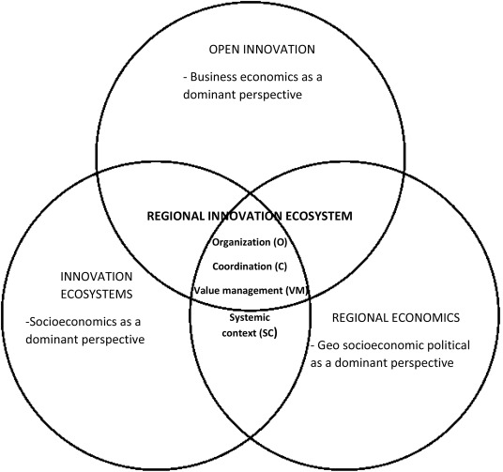
Figure 6: Complementary framework for open innovations in regional
Innovation ecosystem
(Source: Robaczewsk et al. 2019)
Sustainable theory
As reported by Camilleri et al. (2023), Open innovation approaches are more applicable for sustainable competitive advantages for computer manufacturing institutions with secretive trading trends and traditional reliance on internal resources. This proposal is enrooted in the extreme belief about disseminating understandings and producing a collaborative engagement with stakeholders that leads to win-win opportunities for both company and customers. As mentioned by Pihlajamaa (2021), open inbound innovation is acknowledged as attempting successfully leverage outer resources for generating innovations including dynamic capabilities for firms' performance within comparable costs. As per resources, Dell Technologies developed a typological framework of six different inbound pen innovations depending on the dimensional diversity of managerial attention, such as proactive or reactive, and the location of trending innovations categorised as internal, external and shared and also these dynamic capabilities are classified as impression management capabilities, collaboration capabilities, sensing capabilities, and absorptive capabilities.
The strategy used by Dell technologies to meet sustainable business operation
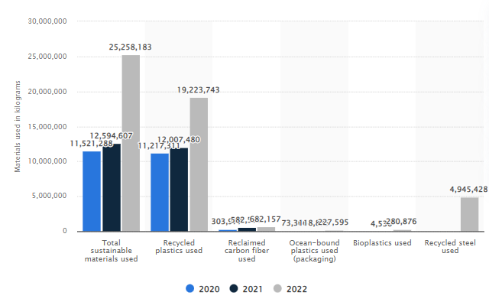
Figure 7: Dell Technologies' sustainable materials used in products and packaging
(Source: Alsop, 2022)
According to Lepore et al. (2023), Dell Technologies initiates plans for better achievements in 2020, which includes reducing the energy severity of the manufactured products portfolio by 64%, decreasing the energy intensity of the server portfolio is more than 78%, while, drove laptops efficiencies regarding only $3 in total electricity costs, and reducing 74% energy efficiency in functional capacity by approximately 74%. This company started utilising pounds of recyclable materials from older computer parts such as creating shiny new motherboards by eliminating golds from old and used e-wastes, introducing closed recycling loops, turning out plastics from used parts into 125 new Dell products, and reusing carbon fibres obtained from aerospace institutions in their mobility items. According to company reports, they are claiming that 28 pounds of used electronics were revived in 2019-2022 through generating sustainable recycling solutions for consumers globally, promoting easy recycling options such as group-off, on-sit pickups, participating in asset reselling programs, and funding for fostered trusts helping strict disposal and data sanitisation quality. As mentioned by McMillan (2023), the organisation extremely dependent on consumer visibility by empowered supply chain resilience including investing for potential consumer annual tours and facilitating supply facilities, launching a "supply chain sustainability report" to supplement suppliers and providing strategic support to the suppliers to mitigate water risk associated with computer productions.
Theories of competitive advantage
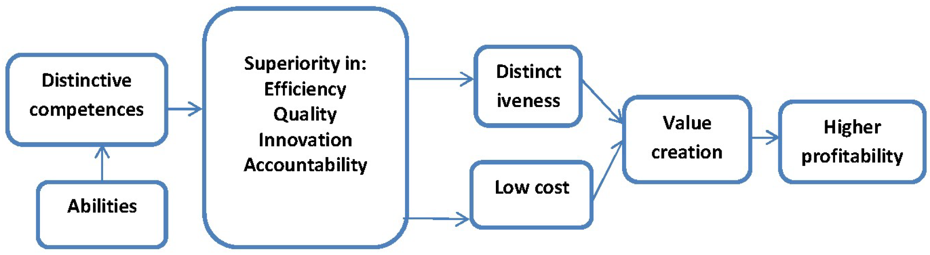
Figure 8: Theories of competitive advantage
(Source: Hosseini et al., 2018)
Conforming with Eltivia et al. (2023), strategic management is a constant but gradually developing discipline assuming both academic and business management practices, while this theory contributes to the evolution of ethical and fundamental disciplines in the context of advances in competitive strategies. More elaborated understanding of the optimal usage of resources and generating globalisation of production and services worldwide. The fundamental assumptions regarding employee satisfaction, employment opportunities, increasing employee potentiality, considering capability more than capacity, and representing socio-cultural stability. At micro and macro levels business practices deploy adjustment plans for the development of individual financial situations involving man-made obstacles and barriers. Competitive advantages are regulated by different factors such as branding, the quality of offered products, cost structure, consumer services, intellectual poverty, and distributional networking.

7. Growth strategies
According to Loukopoulos and Papadimitriou (2022), growth strategy has the involvement of various components in the form of expanding products and services offerings, focusing on customer-centric solutions, adopting of omnichannel marketing model, and others. Dell Technologies has been expanding its product along with service offerings in meeting the evolving needs of cloud and edge computing markets. This includes launching and developing new products and services that cater to increasing demand for data centre infrastructure, storage solutions, and software-defined networking. As per the report of Dell Technologies (2023), Dell Technologies' Infrastructure Solutions Group, which includes storage, services, and networking products, generated revenue of $9.9 billion in 2021, representing 4% yearly growth.
On the other hand, Dell Technologies has been focusing on delivering customer-centric solutions that address its unique requirements of cloud and edge computing environments. This has the inclusion of offering tailored solutions for industries such as healthcare, telecommunications, and financial services. According to the annual report of Dell Technologies, its Client Solutions Group, that has the inclusion of notebooks, desktops, as well as workstations, reported revenue of $13.8 billion in 2021, determining 7% yearly growth (Dell Technologies, 2022a). Moreover, Dell Technologies has been actively pursuing strategic partnerships and acquisitions to strengthen its position through cloud and edge computing markets. These have allowed the firm to expand its capabilities, reach, and customer base.
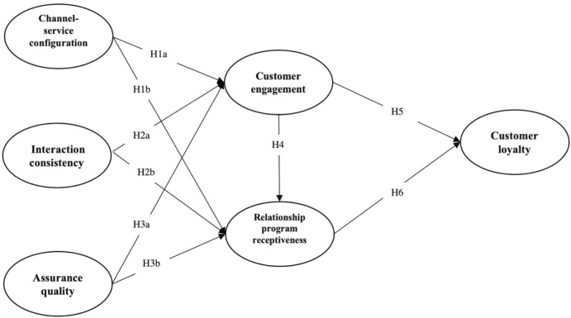
Figure 9: Omni-channel business model
(Source: Gao and Huang, 2021)
As illustrated by Duffy (2021), Dell Technologies has a formation of strategic partnerships with leading cloud providers such as Amazon Web Services, Microsoft Azure, and Google Cloud in offering integrated solutions and services. Dell Technologies VMware business which has a focus on cloud computing as well as virtualisation, reported revenue of $4.4 Billion in 2021, suggesting 4% growth every year. Furthermore, the firm has the adoption of an omnichannel business model with a robust partner ecosystem as a formal element of its corporate growth strategy. The approach allows the company to engage with customers through various channels such as retail, online as well as partner-led sales ensuring the creation of a seamless experience across various touchpoints. Gao and Huang (2021) reported that Dell Technologies is actively pursuing an omnichannel strategy in driving growth over its cloud computing solutions.
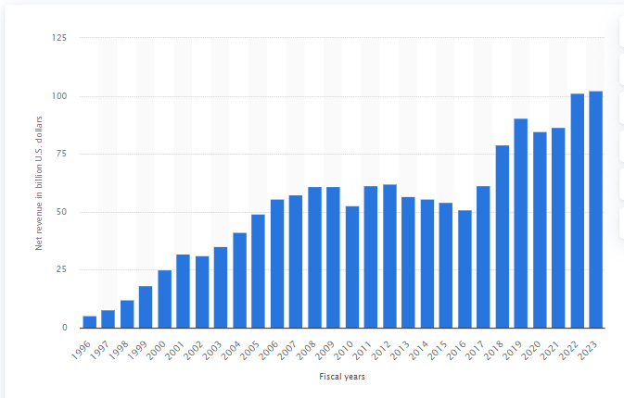
Figure 10: Revenue of Dell Technologies
(Source: Alsop, 2023)
In 2021, the firm had a record $101 Billion revenue with a double growth across various segments (Alsop, 2023b). The company's omnichannel business model played a leading role in ensuring the achievement of these results by allowing consumers to closely interacting with Dell Technologies through multiple channels and enabling the firm to reach a wider customer base.

8. Green Strategy and CSR
As mentioned by Carrera (2022), during globalisation and financial development procedure, which progressively facilitate a condensessive and problematic occurrence addressing the disconnection between organisations and their territorial surroundings, where CSR or Corporate Social Responsibility implementation can generate effective problem-solving policies. The current super-territorial dimensions of these organisations have the ability to reduce the geographical and socio-political cultural differences and ensure increased productivity in significant consequence management in terms of inter-relationship, including national laws and territorial boundaries affected by their choice differences.
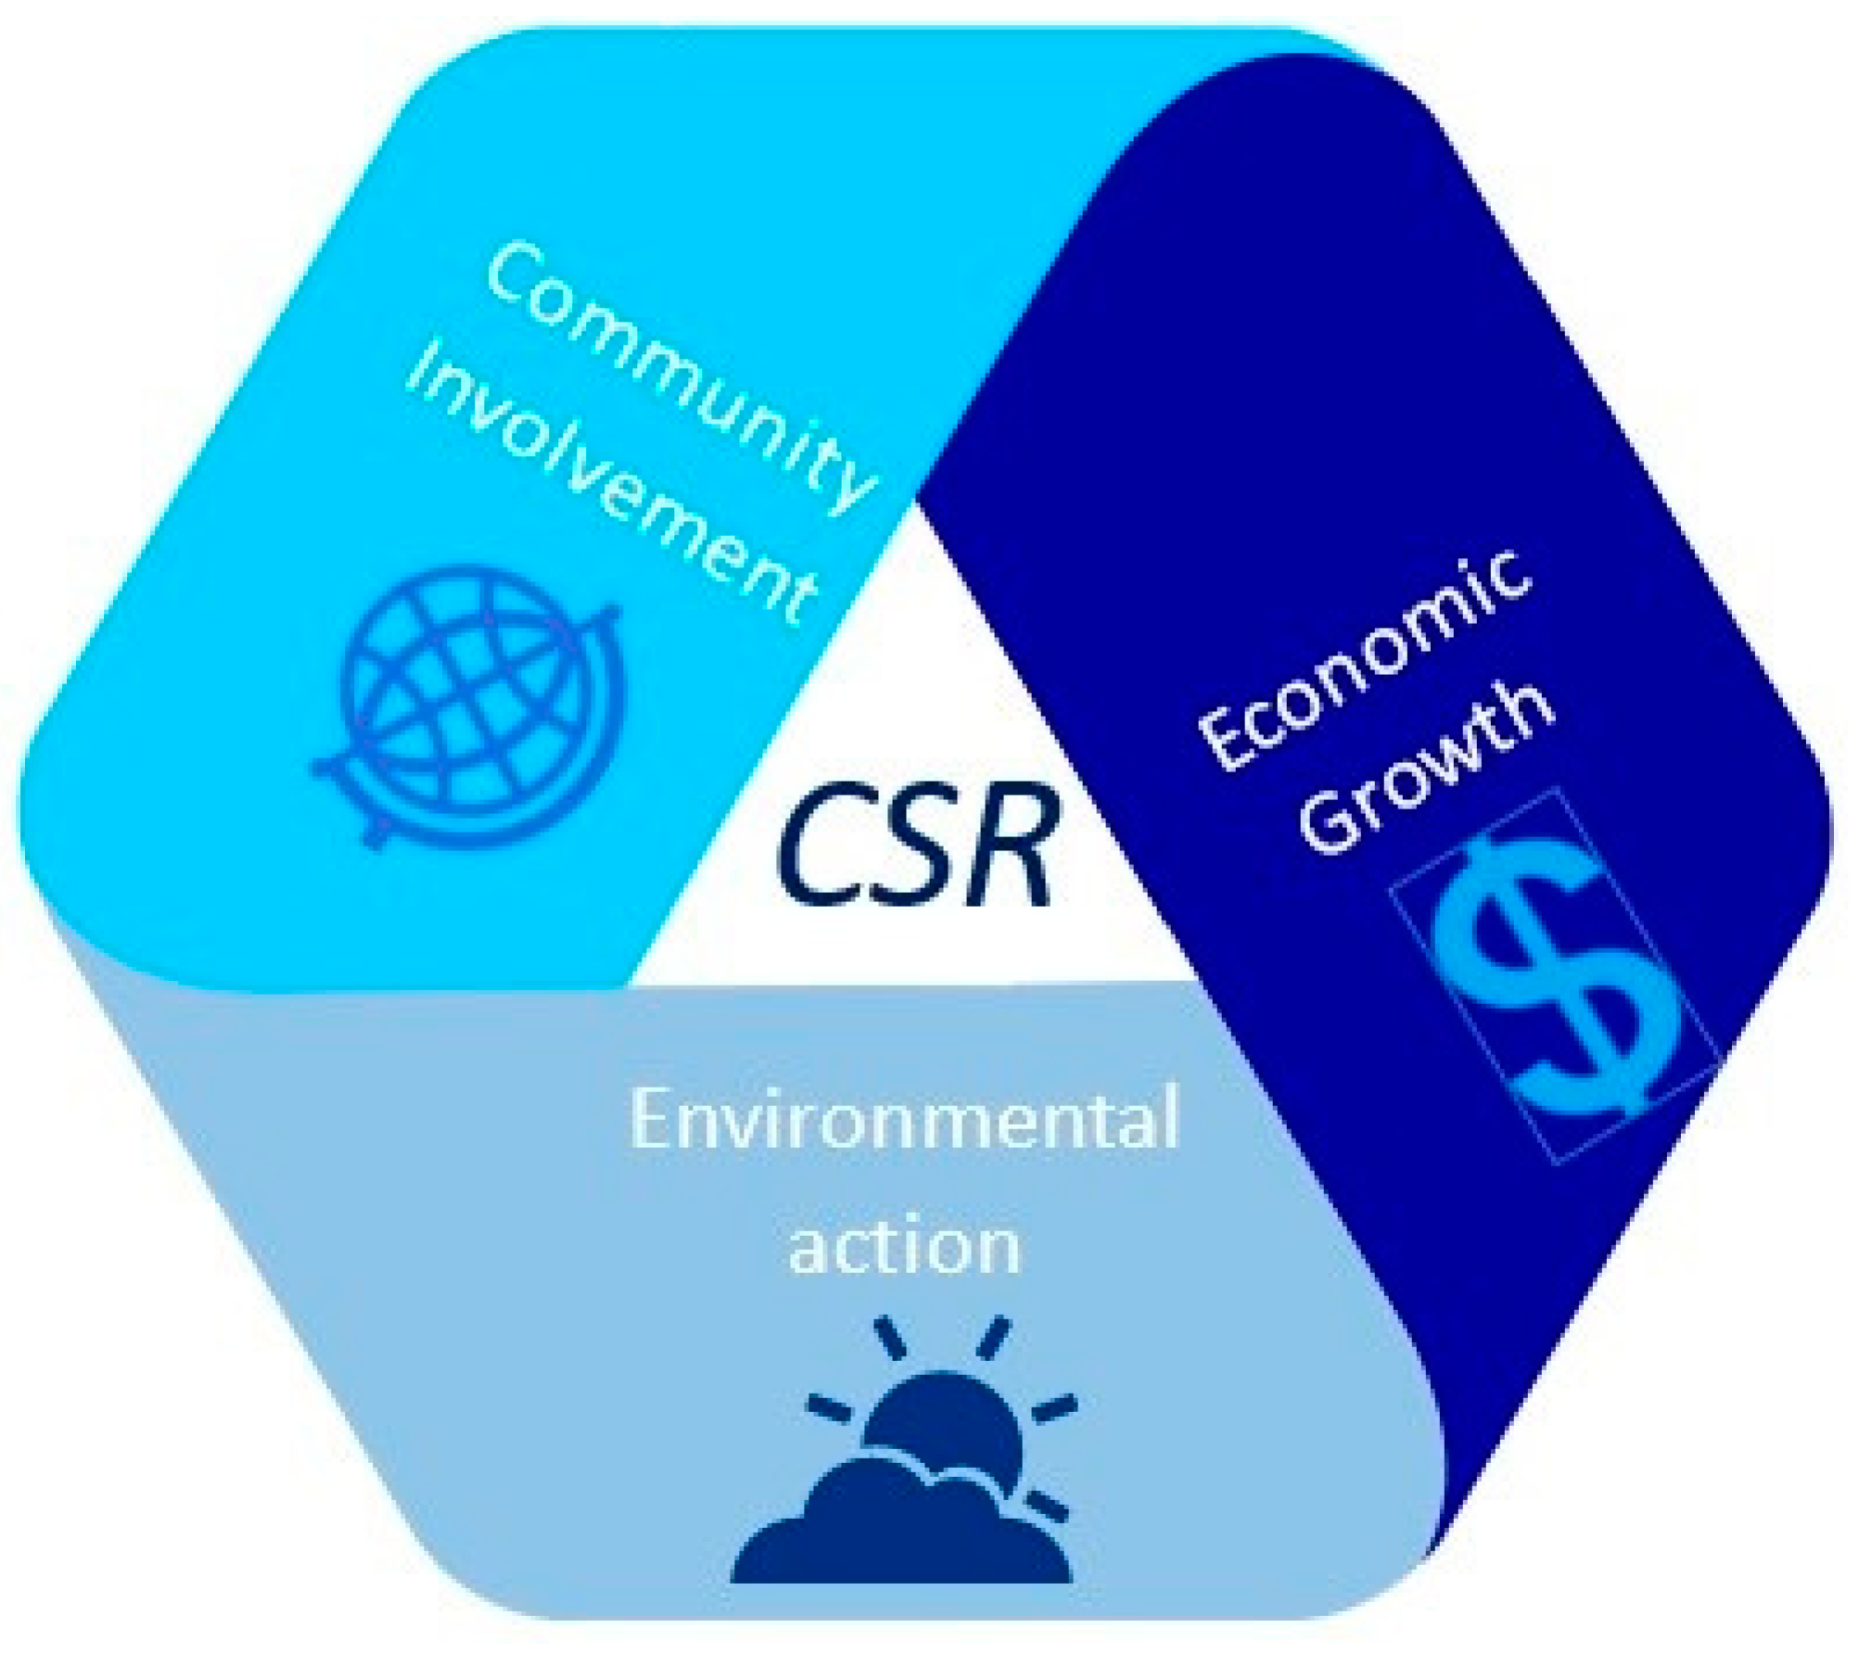
Figure 11: Activities of Corporate Social Responsibility
(Source: Rivo-López et al., 2021)
According to Rivo-López et al. (2021), the progress towards attaining innovations and purposely-driving culture includes initiating Business Roundtable and Information Technology Industry Council to promote their members for sustainable business management. Conforming to Koch et al. (2021), the largest computer manufacturer committed to efficiency services with the environment and social sustainability regarding e-waste disposal programmes through business activities.
The main challenges in the improvement of e-waste disposal from an environmental and economic perspective such as lower recycling rates, increasing value rapturing, and facilitating programmes to support e-wast controlling. According to Chou et al. (2022), reports show that 418 million tonnes of e-waste can gradually denote n a regular basis. Nearly 53.06 billion USD in gold as e-waste are scaled through computer productions around the world. As per Dell, old and used equipment from warehouses has similar issues and a lot of plastic waste is also generated from these electronic parts and remains as disposal challenge for the companies. However, manufacturing plastic-made computer parts causes high-level CO2 emissions and becomes unsustainable for the environment. ICT and IT firms are examined the impact of Green policies to resolve sustainable issues including governing concerns and focused on economic performance, which oriented to trends investing in environmental, social and authorised initiatives satisfying employees, supplementing congenial working environments and diversity for adaptive programs in better corporate practices, financial performance and higher market values (Bhaskaran, 2023).
In response, the company initiated economically circular business trends for the supply chain and increased volatility in materials; as an example, Dell committed to achieving a total of 50 million pounds of disposed of items within 2020 for business necessity and rethinking energy usage in their facilities. 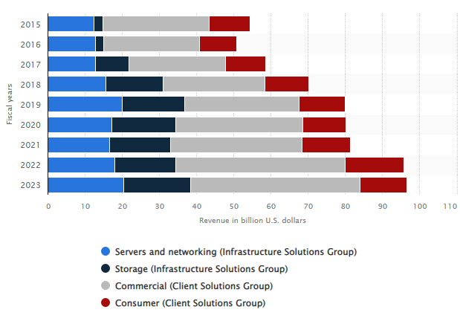
Figure 12: Dell Technologies revenue worldwide from 2015 to 2023, through Segments
(Source: Alsop, 2023)
In the financial year 2023, Dell Technologies announced 20.4 billion USD in revenue from networking and servers subsegments which is a part of their Infrastructure Solutions Group. The Dell EMC includes several company practices such as hardware, notebooks, servers, converged systems, storage, and cloud solutions (Alsop, 2023). As stated by Cheng (2022), potential alarming growth in Dell initiates immediate action. It provides analysis of the competitive computer industry as well as its internal expertise to adopt sustainable competitive advancements. As per views by Roper (2020), this world's largest computer production company must implement different strategies to resolve sustainability competitiveness across the world and such as; firstly, Dell should improve their services and become more concerned about potential competitors. Secondly, the company must pay attention to establishing a good connection between functions and regions and also resolve supplier resiliencies in order to improve supplier bragging capacity; thirdly, this organisation should improve their diversified result portfolio to meet increased market differentiation. Meanwhile, fourthly, Dell must include their balance sheet and revenue statement in EVA measurement, which enforced managers to elaborate their strategic thinking.

9. Conclusion
It has been concluded from the above study that Dell Technologies is a multinational technology company headquartered in Round Rock, Texas, United States. Dell Technologies' mission is to be a trusted partner for various customers, helping them transform their businesses along with unlocking the full potential of technology. However, the company is impacted by the external environment of the US in the form of the inflation rate, GDP rate and others. Dell Technologies has deployed strategies to differentiate itself from competitors by offering unique value proportions such as innovative edge computing solutions and others. Application of an omnichannel business model, delivering customer-centric solutions and other are the growth opportunities for the company.

10. Recommendation
Innovation and R&D
Dell Technologies should have a continuation through investing in research and development to drive innovation through cloud and edge computing. This has an inclusion of development in cutting-edge technologies such as edge computing solutions as well as cloud infrastructure to stay ahead of the competition. The firm should also collaborate with the partners along with consumers to co-create solutions that address their evolving needs and pain points through cloud and edge computing space.
Portfolio optimisation
Dell Technologies should have a continuation in optimising its portfolio by having an alignment through its products and services with the evolving needs of the cloud and edge computing market. This inclusion denies non-current assets and invests in strategic areas such as edge computing infrastructure, hybrid cloud solutions as well as software-defined networking. Dell Technologies should also leverage its vast brand portfolio, including Dell, Pivotal, VMware, and SecureWorks. This provides end-to-end solutions that cater to diverse customers' requirements.
Market expansion
Dell Technologies should focus on expanding its market presence through cloud and edge computing space. It has the inclusion of target key vertices such as retail, healthcare, and manufacturing, where there has been an uplifted demand for cloud and edge computing solutions. However, Dell Technologies should also have an expansion through its geographical footprint through emerging markets where there has been a growing need for digital transformation as well as the adoption of cloud and edge computing technologies.
Customer success and services
Dell Technologies should provide prioritisation through customer success and services in ensuring customer satisfaction along with loyalty. This inclusion of providing comprehensive consulting, support services, and implementation in helping customers successfully adopt and integrate cloud and edge computing technologies. However, the firm should also leverage data analytics as well as artificial intelligence in gaining insights into customers' preferences and needs and proactively addressing their issues and requirements.

References
Aguilar, C.M. and Sánchez, Á.M. (2020). The Industry Life Cycle in an Economic Downturn: Lessons from Firm’s Behavior in Spain, 2007–2012. Journal of Business Cycle Research, 17. doi:https://doi.org/10.1007/s41549-020-00048-w.
Alsop , T. (2022). Dell Technologies sustainable materials usage FY 2022. [online] Statista. Available at: https://www.statista.com/statistics/1240982/dell-technologies-sustainable-materials-usage/ [Accessed 25 Apr. 2023].
Alsop, T. (2022). Topic: Dell Technologies. [online] Statista. Available at: https://www.statista.com/topics/2285/dell/#editorsPicks [Accessed 24 Apr. 2023].
Alsop, T. (2023). Dell net income 1996-2019. [online] Statista. Available at: https://www.statista.com/statistics/264914/dell-net-income-since-1996/ [Accessed 25 Apr. 2023].
Alsop, T. (2023). Dell Technologies revenue by subsegment 2021. [online] Statista. Available at: https://www.statista.com/statistics/1122924/dell-revenue-by-subsegment/.
Alsop, T. (2023a). Dell employees 1996-2019 | Statista. [online] Statista. Available at: https://www.statista.com/statistics/264917/number-of-employees-at-dell-since-1996/ [Accessed 25 Apr. 2023].
Alsop, T. (2023b). Dell Revenue 1996-2019. [online] Statista. Available at: https://www.statista.com/statistics/264911/dells-net-revenue-since-1996/ [Accessed 24 Apr. 2023].
Bhaskaran, R.K. (2023). Sustainability Initiatives, Knowledge-Intensive Innovators, and Firms’ Performance: An Empirical Examination. International Journal of Financial Studies, [online] 11(1), p.14. doi:https://doi.org/10.3390/ijfs11010014.
Bruijl, G. (2018). The Relevance of Porter's Five Forces in today's Innovative and Changing Business Environment. SSRN Electronic Journal, 1(1), pp.1–23. doi:https://doi.org/10.2139/ssrn.3192207.
Camilleri, M.A., Troise, C., Strazzullo, S. and Bresciani, S. (2023). Creating shared value through open innovation approaches: Opportunities and challenges for corporate sustainability. Business Strategy and the Environment. doi:https://doi.org/10.1002/bse.3377.
Carrera, L. (2022). Corporate social responsibility. A strategy for social and territorial sustainability. International Journal of Corporate Social Responsibility, 7(1). doi:https://doi.org/10.1186/s40991-022-00074-0.
Cheng, J. (2022). Sustainable Competitive Advantage Analysis and Recommendations for Dell Company to Achieve Success. Open Journal of Social Sciences, [online] 10(12), pp.486–497. doi:https://doi.org/10.4236/jss.2022.1012033.
Cheng, J. (2022). Sustainable Competitive Advantage Analysis and Recommendations for Dell Company to Achieve Success. Open Journal of Social Sciences, 10(12), pp.486–497. doi:https://doi.org/10.4236/jss.2022.1012033.
Chou, D.C., Chen, H.-G. and Lin, B. (2022). Green IT and corporate social responsibility for sustainability. Journal of Computer Information Systems, 63(2), pp.1–12. doi:https://doi.org/10.1080/08874417.2022.2058643.
Cillizza, C. (2022). Analysis: the US Is Only the 27th Least Corrupt Country in the World. [online] CNN. Available at: https://edition.cnn.com/2022/01/25/politics/us-corruption-perception-index-trump/index.html [Accessed 25 Apr. 2023].
Cosh, A., Fu, X. and Hughes, A. (2010). Organisation structure and innovation performance in different environments. Small Business Economics, [online] 39(2), pp.301–317. doi:https://doi.org/10.1007/s11187-010-9304-5.
Cuofano, G. (2022). Dell Organizational Structure. [online] FourWeekMBA. Available at: https://fourweekmba.com/dell-organizational-structure/ [Accessed 25 Apr. 2023].
Davis, G.F. and DeWitt, T. (2021). Organisation Theory and the Resource-Based View of the Firm: The Great Divide. Journal of Management, [online] 47(7), p.014920632098265. doi:https://doi.org/10.1177/0149206320982650.
Dell Technologies (2022a). Dell Technologies Delivers Fourth Quarter and Full-Year Fiscal 2022 Financial Results | Dell Technologies. [online] investors.delltechnologies.com. Available at: https://investors.delltechnologies.com/news-releases/news-release-details/dell-technologies-delivers-fourth-quarter-and-full-year-fiscal [Accessed 24 Apr. 2023].
Dell Technologies (2022b). The Future Belongs to the Innovators Contents. [online] Available at: https://www.delltechnologies.com/asset/en-us/solutions/business-solutions/briefs-summaries/dell-tech-future-belongs-to-innovators.pdf [Accessed 24 Apr. 2023].
Dell Technologies (2023). 2023.03.02 | Dell Technologies Delivers Fourth Quarter and Full Year Fiscal 2023 Financial Results. [online] www.dell.com. Available at: https://www.dell.com/en-us/dt/corporate/newsroom/announcements/detailpage.press-releases~usa~2023~03~20230302-dell-technologies-delivers-fourth-quarter-and-full-year-fiscal-2023-financial-results.htm#/filter-on/Country:en-us [Accessed 24 Apr. 2023].
Dell.com (2022). FY22 ESG Report | Dell India. [online] www.dell.com. Available at: https://www.dell.com/en-in/dt/corporate/social-impact/esg-resources/reports/fy22-esg-report.htm [Accessed 25 Apr. 2023].
Dell.com (2023). Computers, Monitors & Technology Solutions | Dell India. [online] Dell. Available at: https://www.dell.com/en-in [Accessed 24 Apr. 2023].
Dudovskiy, J. (2015). Dell Value-Chain Analysis - Research Methodology. [online] Research-Methodology. Available at: https://research-methodology.net/dell-value-chain-analysis/ [Accessed 25 Apr. 2023].
Duffy, C. (2021). Dell Technologies to Spin off Its Ownership Stake in VMWare | CNN Business. [online] CNN. Available at: https://edition.cnn.com/2021/04/14/tech/dell-technologies-vmware-spinoff/index.html [Accessed 24 Apr. 2023].
Eltivia, N., Riwajanti, N.I. and Susilowati, K.D.S. (2023). Proceedings of the 3rd Annual Management, Business and Economics Conference (AMBEC 2021). [online] Google Books. Springer Nature. Available at: https://books.google.co.in/books?hl=en&lr=&id=52WkEAAAQBAJ&oi=fnd&pg=PA191&dq=Theories+of+competitive+advantage&ots=L9XLMZ_4KZ&sig=5TNDonQJn_XUDQZYwm5N3KyfNJU&redir_esc=y#v=onepage&q&f=false [Accessed 24 Apr. 2023].
Eppard, M.R.R. and L.M. (2021). The ‘American Dream’ of Upward Mobility Is broken. Look at the Numbers | Mark R Rank and Lawrence M Eppard. [online] the Guardian. Available at: https://www.theguardian.com/commentisfree/2021/mar/13/american-dream-broken-upward-mobility-us [Accessed 25 Apr. 2023].
Farid, O. (2022). Strategic Management Identity. American Journal of Industrial and Business Management, [online] 12(05), pp.995–1005. doi:https://doi.org/10.4236/ajibm.2022.125051.
Forbes (2021). Dell | Company Overview & News. [online] Forbes. Available at: https://www.forbes.com/companies/dell/?sh=3bdfa8f76dea [Accessed 24 Apr. 2023].
Fortune (2023). Dell Technologies Company Profile. [online] Fortune. Available at: https://fortune.com/company/dell-technologies/ [Accessed 25 Apr. 2023].
Gao, M. and Huang, L. (2021). Quality of Channel Integration and Customer Loyalty in Omnichannel retailing: the Mediating Role of Customer Engagement and Relationship Program Receptiveness. Journal of Retailing and Consumer Services, 63, p.102688. doi:https://doi.org/10.1016/j.jretconser.2021.102688.
Gara, A. (2021a). Deal of the Century: How Michael Dell Turned His Declining PC Business into a $40 Billion Windfall. [online] Forbes. Available at: https://www.forbes.com/sites/antoinegara/2021/08/03/deal-of-the-century-how-michael-dell-turned-his-declining-pc-business-into-40-billion-windfall/?sh=3635c2e5c2ae [Accessed 24 Apr. 2023].
Gara, A. (2021b). How Wall Street’s Greatest Piece of Financial Engineering Propelled Michael Dell to a $50 Billion Fortune. [online] Forbes. Available at: https://www.forbes.com/sites/antoinegara/2021/04/18/how-wall-streets-greatest-piece-of-financial-engineering-propelled-michael-dell-to-a-50-billion-fortune/?sh=156a957a482e [Accessed 24 Apr. 2023].
Hosseini, A., Soltani, S. and Mehdizadeh, M. (2018). Competitive Advantage and Its Impact on New Product Development Strategy (Case Study: Toos Nirro Technical Firm). Journal of Open Innovation: Technology, Market, and Complexity, [online] 4(2), p.17. doi:https://doi.org/10.3390/joitmc4020017.
Iacurci, G. (2023). Wage Growth Is Cooling — but Workers Still Have Bargaining power, Economists Say. [online] CNBC. Available at: https://www.cnbc.com/2023/03/10/wage-growth-is-cooling-but-workers-still-have-bargaining-power.html [Accessed 24 Apr. 2023].
Isabelle, D., Horak, K., McKinnon, S. and Palumbo, C. (2020). Is Porter’s Five Forces Framework Still Relevant? a Study of the capital/labour Intensity Continuum via Mining and IT Industries. Technology Innovation Management Review, 10(6), pp.28–41. doi:https://doi.org/10.22215/timreview/1366.
Kaur, D. (2023). The PC market collapsed in 2022 with worst ever fourth quarter decline. [online] Tech Wire Asia. Available at: https://techwireasia.com/2023/01/the-pc-market-collapsed-in-2022-with-worst-ever-fourth-quarter-decline/#:~:text=The%20PC%20market%20collapsed%20in%202022%20with%20worst%20ever%20fourth%20quarter%20decline [Accessed 25 Apr. 2023].
Knott, P.J. (2019). Does VRIO help managers evaluate a firm’s resources? Management Decision, [online] 53(8), pp.1806–1822. doi:https://doi.org/10.1108/md-08-2014-0525.
Koch, L., Roberts, S. and Ellis, J.E. (2021). Dell. Putting Purpose Into Practice, pp.292–302. doi:https://doi.org/10.1093/oso/9780198870708.003.0024.
Lepore, D., Vecciolini, C., Micozzi, A. and Spigarelli, F. (2023). Developing technological capabilities for Industry 4.0 adoption: An analysis of the role of inbound open innovation in small and medium‐sized enterprises. Creativity and Innovation Management. doi:https://doi.org/10.1111/caim.12551.
Lin, P., Zhang, X., Yan, S. and Jiang, Q. (2020). Dynamic Capabilities and Business Model Innovation of Platform Enterprise: A Case Study of DiDi Taxi. Scientific Programming, [online] 2020, pp.1–12. doi:https://doi.org/10.1155/2020/8841368.
Loukopoulos, A. and Papadimitriou, D. (2022). Organisational Growth Strategies for Greek Social Enterprises' Social Impact during the COVID-19 Pandemic. Social Enterprise Journal, 18(4), pp.541–562. doi:https://doi.org/10.1108/sej-10-2021-0084.
Macrotrends (2022). Dell Research and Development Expenses 2015-2022 | DELL. [online] www.macrotrends.net. Available at: https://www.macrotrends.net/stocks/charts/DELL/dell/research-development-expenses [Accessed 25 Apr. 2023].
McMillan, K. (2023). Carbon Accounting for Sustainable Computing in Cloud Provisioned Data Centers. [online] dspace.mit.edu. Available at: https://dspace.mit.edu/handle/1721.1/150244 [Accessed 24 Apr. 2023].
Mehta, S. (2022). Council Post: Edge, Rising across Industries, Seeks to Challenge the Cloud for the All-Star Role in Digital Transformation. [online] Forbes. Available at: https://www.forbes.com/sites/forbestechcouncil/2022/08/30/edge-rising-across-industries-seeks-to-challenge-the-cloud-for-the-all-star-role-in-digital-transformation/?sh=9294794348be [Accessed 24 Apr. 2023].
Moorhead, P. (2021). Dell Technologies Impacting Lives with ‘One Million Connected Devices Now’ Participation. [online] Forbes. Available at: https://www.forbes.com/sites/patrickmoorhead/2021/03/29/dell-technologies-impacting-lives-with-one-million-connected-devices-now-participation/?sh=3f2e7110dea2 [Accessed 24 Apr. 2023].
Oluka Nagitta, P. and Mkansi, M. (2022). Macro Environment Determinants Affecting the Availability of Artemisinin-based Combination Therapies in Uganda. International Journal of Pharmaceutical and Healthcare Marketing, 17(1), pp.97–114. doi:https://doi.org/10.1108/ijphm-09-2020-0074.
Panchal, R. (2020). Dell – History, Brand Value and Brand Strategies - BeNextBrand. [online] benextbrand.com. Available at: https://benextbrand.com/dell-history-brand-value-strategies/ [Accessed 25 Apr. 2023].
Perifanis, N.-A. and Kitsios, F. (2022). Edge and Fog Computing Business Value Streams through IoT Solutions: a Literature Review for Strategic Implementation. Information, 13(9), p.427. doi:https://doi.org/10.3390/info13090427.
Petrosyan, A. (2023). Internet Penetration United States 2023. [online] Statista. Available at: https://www.statista.com/statistics/209117/us-internet-penetration/#:~:text=As%20of%202023%2C%20approximately%2092 [Accessed 25 Apr. 2023].
Pihlajamaa, M. (2021). What does it mean to be open? A typology of inbound open innovation strategies and their dynamic capability requirements. Innovation, 25(1), pp.1–24. doi:https://doi.org/10.1080/14479338.2021.1907192.
Pohani , R. (2023). Accelerating Transformation Anywhere with next Generation Dell PowerEdge Servers. [online] Dell. Available at: https://www.dell.com/en-in/blog/accelerating-transformation-anywhere-with-next-generation-dell-poweredge-servers/ [Accessed 24 Apr. 2023].
Prasetyanti, L.A. and Simatupang, T.M. (2015). A Framework for Service-based Supply Chain. Procedia Manufacturing, [online] 4, pp.146–154. doi:https://doi.org/10.1016/j.promfg.2015.11.025.
PWC (2022). United States - Corporate - Taxes on corporate income. [online] taxsummaries.pwc.com. Available at: https://taxsummaries.pwc.com/united-states/corporate/taxes-on-corporate-income [Accessed 25 Apr. 2023].
Rivo-López, E., Villanueva-Villar, M., Michinel-Álvarez, M. and Reyes-Santías, F. (2021). Corporate Social Responsibility and Family Business in the Time of COVID-19: Changing Strategy? Sustainability, 13(4), p.2041. doi:https://doi.org/10.3390/su13042041.
Robaczewska, J., Vanhaverbeke, W. and Lorenz, A. (2019). Applying open innovation strategies in the context of a regional innovation ecosystem: The case of Janssen Pharmaceuticals. Global Transitions, 1, pp.120–131. doi:https://doi.org/10.1016/j.glt.2019.05.001.
Roper, W. (2020). Infographic: Social, Environmental Company Policies Grow. [online] Statista Infographics. Available at: https://www.statista.com/chart/22550/support-for-enivronmental-social-company-proposals/ [Accessed 24 Apr. 2023].
Singh, R., Sarangal, R.K. and Singh, G. (2021). The Impact of Micro and Macro Environment on Entrepreneurial Success: Case of J&K MSMEs. FIIB Business Review, [online] 11(1), p.231971452110618. doi:https://doi.org/10.1177/23197145211061809.
Statista (2023). United States - Monthly Inflation Rate February 2021/22. [online] Statista. Available at: https://www.statista.com/statistics/273418/unadjusted-monthly-inflation-rate-in-the-us/#:~:text=The%20annual%20inflation%20rate%20in [Accessed 25 Apr. 2023].
Teece, D.J. (2018). Dynamic capabilities as (workable) management systems theory. Journal of Management & Organization, [online] 24(3), pp.359–368. doi:https://doi.org/10.1017/jmo.2017.75.
Trading Economics (2022). US GDP Growth Revised down to 3.4% in Q3. [online] Tradingeconomics.com. Available at: https://tradingeconomics.com/united-states/gdp-growth [Accessed 25 Apr. 2023].
U.S. Department of Labor (2021). Summary of the Major Laws of the Department of Labor | U.S. Department of Labor. [online] Dol.gov. Available at: https://www.dol.gov/general/aboutdol/majorlaws [Accessed 25 Apr. 2023].
Uniquewritersbay.com (2017). Organisational Structure And Organisational Functions at Dell Company. [online] uniquewritersbay.com. Available at: https://uniquewritersbay.com/organizational-structure-organizational-functions-dell-company/ [Accessed 25 Apr. 2023].
Verhoef, P.C., Broekhuizen, T., Bart, Y., Bhattacharya, A., Qi Dong, J., Fabian, N. and Haenlein, M. (2021). Digital transformation: A multidisciplinary reflection and research agenda. Journal of Business Research, [online] 122, pp.889–901. doi:https://doi.org/10.1016/j.jbusres.2019.09.022.
Worldometers (2022). U.S. Population (2019) - Worldometers. [online] Worldometers.info. Available at: https://www.worldometers.info/world-population/us-population/ [Accessed 25 Apr. 2023].

