PID Controller Simulations for a Closed Loop CIWS Turret System

Sam Parker

ACDA5011 – Instrumentation and Control

Wales Institute for Science and Art
University of Wales Trinity Saint David



Abstract
A turret with a transfer function was simulated in MATLAB and Simulink. A closed loop feedback system was designed around the system and the performance of a 2 second settle time and less than 5% overshoot had to be met. The stability was analysed using Nyquist, Bode and pole zero plots. The results showed that the system was stable for the performance criteria and other input variables.

Introduction
Control systems are used in many different scenarios and can be defined in different ways. For example, figure 1 below shows an ‘open loop’ system whereby the input passes through the controller (system 1) to the plant (system 2), which then generates the output. Notice in this system there is no feedback, and so it cannot measure the condition of the output signal. A real-world example of an open loop system would be a washing machine. The clothes are put in, set the timer and the washing machine runs for the set amount of time regardless of the state of the clothes it is cleaning. In this case the controller would be the timer we set, and the output would be the washing function.

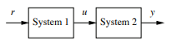
Figure 1 - Open Loop System [1]
Proportional, Integral, Derivative (PID) controllers are a main stay in various industry control applications and are the most common control application to this day due to their simplicity, easily replicable design, low implementation costs and high degree of tunability [2]. An example of a closed loop PID control system is shown in figure 2 below. They also offer good closed-loop performance for factors such as fast settling and minimum overshoot, making them ideal in nature for something such as a rotating tank turret. The fast settling will allow the turret to quickly perform operations to acquire the target, and the minimum overshoot will mean that when aiming at the target, the turret is more likely to be accurate.

Figure 2 below shows a representation of a closed loop control system. e refers to the error and is the difference between r (the desired output) and y the actual output. The error signal e is given to the PID controller (C(s) in the figure) where the derivative and integrals are computed with respect to time. The control signal, u that goes to the plant is given by the magnitude of the error, multiplied by the proportional gain (K_{p}) plus the integral gain (K_{i}), times the integral of error added to the derivative gain (K_{d}) multiplied by the derivative error. This is shown in Equation 1 below [3]. This equation is for the time domain, and so discussions later in this paper will discuss equations in terms of s, the complex frequency domain.

The proportional part, K_{p} will lead to a proportionally large correction of the system if the error is large. The integral K_{i} integrates the historical error values of the time that the system is running, and so means that if all error for the system is eliminated, the value will not grow. Finally, K_{d} tries to take into account the error that will arrive in the future, and so is also known as a damping method [4].
$$u\left(t\right)=K_{p}e\left(t\right)+ K_{i} \int{e\left(t\right)dt+ K_{p}\frac{de(t)}{dt}}$$
Equation 1 - PID Output [3]

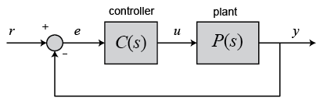
Figure 2 - Closed Loop Feedback [3]

Reznik refers to PID controllers as being used in 90 – 99% of control systems, and so making them a staple in modern industry [5]. The birth of modern PID controllers came about when Taylor Instrument Companies introduced in 1939 a new model of the ‘Fulscope’ pneumatic controller. The controller offered a function known as ‘pre-act’ which utilised a control function that was based on the derivative of the error signal, and thus was the first instance of a PID controller [6]. Research around the 1940s began to flourish as industry realised the potential of automated control, but it wasn’t until 1942 where Zeigler and Nichols set out in their paper how to effectively find the control parameters for a control system [7].

There are two different methods for Zeigler Nichols (ZN) controller tuning which are applied to the frequency and time domains. For time, a step response of a system is obtained by using a unit step input on the system, which will produce a response which can be recorded. For frequency the presence of a controller means that the integral and derivative gains are set at zero. The proportional gain is then altered until oscillations occur in the system. This ZN methodology was hugely popular when it first arrived, but it was soon found that closed loop systems using the ZN tuning method encountered robustness issues [1]. The Zeigler Nichols (ZN) tuning method is still widely used today.

A Laplace transform is a technique that can be used to solve equations that vary with time, such as oscillating vibrations where the initial state if the system can be described as time (t) = 0. The Laplace transform takes the original differential equation and converts it into an algebraic form. This algebraic expression is then transformed again into the solution of the original problem, and hence you have a Laplace transform [9]. In the case of PID controllers, the Laplace transform takes the function of time t and converts into a function of complex frequency, known as s. The process to convert a unit, used in this lab exercise is shown in equation 2 below. The Laplace transform makes the process of analysing the time domain response more computationally friendly, and so can be done in MATLAB and Simulink.
$$u\left(t\right)= \frac{1}{s}$$
Equation 2 - Unit Step Laplace Transform
For this lab assignment it was given that a CIWS turret has the transfer function G(s) shown in equation 3 below, where a, b and c were in this case 5, 0 and 7 respectively. Clearly, the 0 term will cancel and so the transfer function applied is shown in equation 4. As this is an equation that is in terms of s, it is the Laplace transform of the time domain equation so it is easier to compute and analyse. MATLAB and Simulink were used to simulate the control system, and a closed system was designed that had to meet the following criteria with a step input:
- Bring the process under control within two seconds,
- Have an overshoot of less than 5%.
The rest of the report will outline the simulation steps, a results section and a discussion of what the results show. Included in this discussion will be a brief introduction to the different stability measures that have been used.
$$G\left(s\right)= \frac{1}{{as}^{2}+bs+c}$$
Equation 3 - CIWS Turret Transfer Function
$$G\left(s\right)= \frac{1}{{5s}^{2}+7}$$
Equation 4 - Used Transfer Function

Simulation Steps
Initially, the system diagram shown in figure 3 was created. This simulated the closed loop control system that was specified. The PID(s) represents the controller in the system, and the box with the equation represents the plant. The scope on the far right has taken readings at different parts, which will be discussed in the results section.
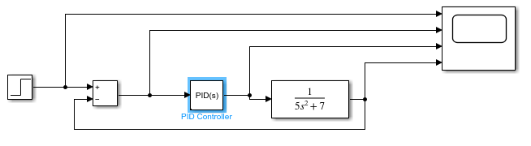
Figure 3- Closed Loop Control System

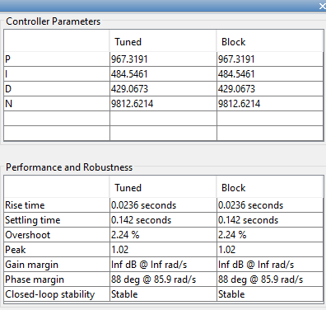
Figure 4 - Parameters

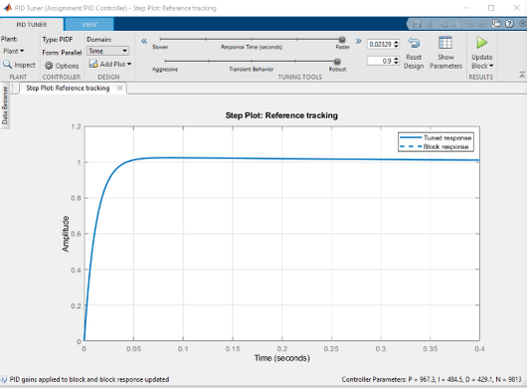
Figures 4 and 5 show the different tuning parameters for the control system. In figure 4, P refers to K_{p}, I refers to K_{I} and D refers to K_{D}. N refers to the filter coefficient and can be defined as parameter that is needed to implement the derivative action [10]. Figure 5 shows a graphical representation in the time domain for the step response. As is clear, the response time (s) is set to the fastest tuning, and the transient behaviour is tuned to be as robust as possible. Prior to tuning the step plot would overshoot and then undershoot, forming what looks like an oscillation. The tuning removes this as to meet the criteria an ideal system has been created, that in practical terms will not be able to be achieved.
Figure 5 - Tuning and Step Plot
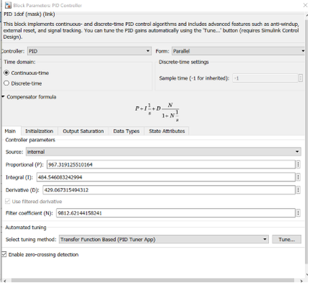
Figure 6 - Tuning Parameters
Figure 6 shows the tuning parameters mentioned above to more significant figures. Note that for all processing in the MATLAB workspace, it was these values that have been carried across to ensure maximum accuracy. Figure 6 also shows the compensator formula for a PID controller, which can also be expressed as equation 5 below.
$$K_{p}+ \frac{K_{I}}{s}+ K_{D}\frac{s}{\frac{s}{N}+1}$$
Equation 5 - PID Controller Equation

Equation 5 multiplied by equation 3 will lead the forward transfer function for the system and is represented in equation 6 below.
$$\frac{\left(K_{P}+K_{D}N\right)s^{2}+\left(NK_{p}+K_{I}\right)s+ K_{i}N}{as^{4}+\left(b+Na\right)s^{3}+\left(C+Nb\right)s^{2}+CNs}$$
Equation 6 - Forward Transfer Function
An equation for the feedback loop of the system can be derived from equation 6. Taking equation 6 as X, equation 7 represents the transfer function with the error part of the system (the feedback) included.
$$\frac{X}{1+XH}$$
Equation 7 - Total Transfer Function, X = Equation 6, H = 1

Equation 7 when worked through is equal to equation 8 below.
$$\frac{\left(K_{P}+K_{D}N\right)s^{2}+\left(NK_{p}+K_{I}\right)s+ K_{i}N}{as^{4}+\left(b+Na\right)s^{3}+\left(C+Nb+K_{P}+K_{D}N\right)s^{2}+\left(CN+NK_{P}+K_{I}\right)s+K_{I}N}$$
Equation 8 - Total System Transfer Function
In order to prove the mathematics an additional system was built, shown in figure 7 below. The bottom part of the system diagram represents equation 8. In theory, if these equations are correct, then the two systems should cancel each other out, and provide a ‘0’ reading on the scope. This is because equation 8 represents the total transfer function of the whole system, and so is essentially the whole loop rolled into one controller. Note that the values used in these equations are shown in figure 6 for the K values and N and equation 4 for values of a, b and c
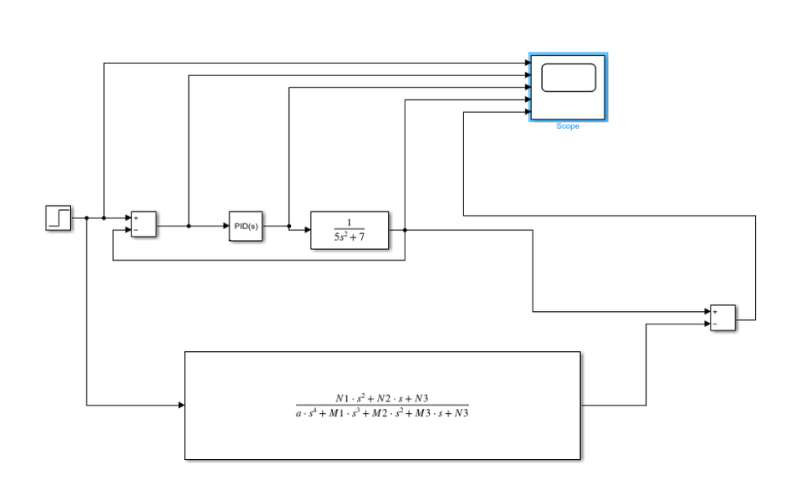
Figure 7 - System Error Proof, N1 = $\left(K_{P}+K_{D}N\right)$, N2 = $\left(NK_{p}+K_{I}\right)$, N3 = $K_{i}N$, M1 = $\left(b+Na\right)$,
M2 = $\left(C+Nb+K_{P}+K_{D}N\right)$, M3 = $\left(CN+NK_{P}+K_{I}\right)$

Discussion
Scope graphs
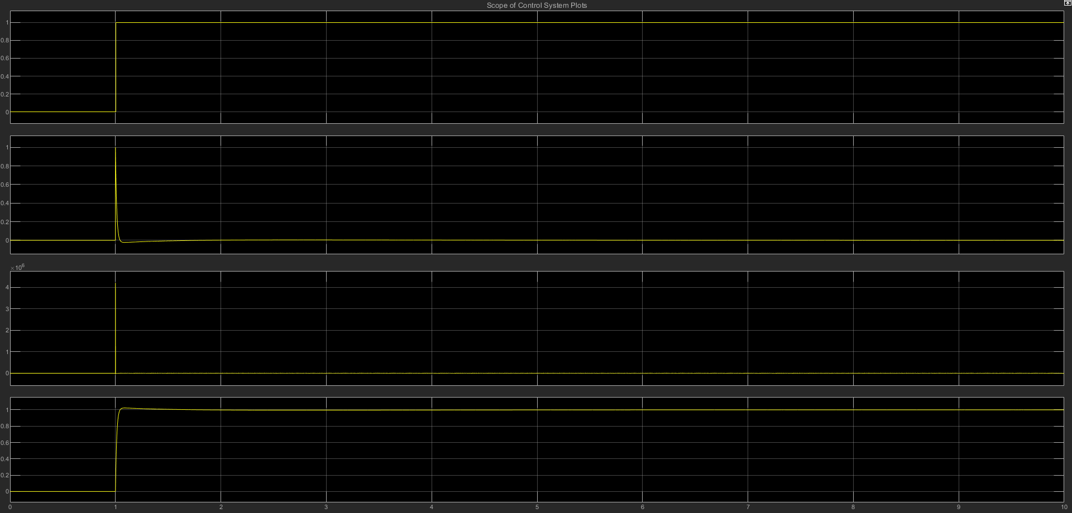
Figure 8 shows the output from the figure 3, the closed loop control system. The top graph shows out input into the system (also known as the step input from 0 – 1). The second graph represents the error of the system, and is the difference between the input and output. The third graph shows the PID output. It is responsible for correcting the error that is fed in from the previous step, which will generate a value that brings the value back down to zero. Notice that the magnitude of this graph is extremely large. This is because of the tuning that we have put on the system, as the error is very quickly reduced to zero. The final graph is the system output, and represents the transfer function. This output is then fed back into the system in the feedback loop, and hence forms the closed loop system. The y-axis represents the position that the turret has turned to, and the x axis represents time.
Figure 8 - Scope Outpit

Figures 9 and 10 show the result from figure 7, the system error proof. As figure 9 shows the blue line (the combination of the original system and equation 8) being insignificant in comparison to the original plot it means that equation 8 is correct for the total transfer function of the system. Figure 10 shows the blue line from figure 9 on its own plot. Notice that the graph is not a perfectly flat line, but is orders of magnitude lower than figure 9. The reason that the value is not 0 at all points is due to rounding errors. In Simulink the top part of the system in figure 7 is calculating to many significant figures, but as the bottom part was manually derived using the MATLAB workspace, and the values copy and pasted from figure 6, the difference in the number of significant figures is causing this rounding error. Note that both these figures have the same x and y axis labels as figure 8.

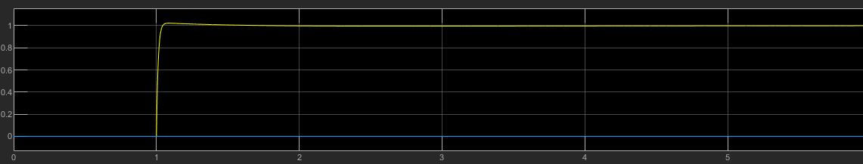
Figure 9 - Scope Output Combination
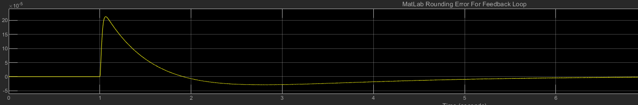
Figure 10 - Rounding Error

Nyquist
A Nyquist plot determines the closed loop stability of a system with the frequency response of an open loop, or in this case just the forward transfer function for all real frequencies. The parameters that it measures are the gain margin and the phase margin. Phase margin is the degree to which an open-loop can be changed, before a closed-loop becomes unstable [11], and measures how close the second pole is to causing instability. Gain margin is the amount of gain a system can handle before making it unstable. It is said that a phase margin of greater than 45° is stable [12]. Clearly, the gain margin is very large, and the system is very stable as the point at which it crosses the negative real axis is far from the 180° point on the unit circle. The Nyquist plot also shows system stability following the phase margin criteria, as there is a very large angle between where the blue line (the plot itself) crosses the unit circle in the double negative quadrant.

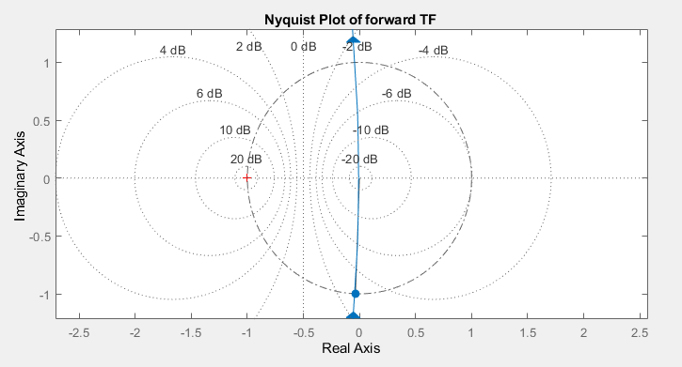
Figure 11 - Nyquist Plot

Bode
A Bode plot is very similar to the Nyquist plot and shows the stability of the system by plotting the phase and gain margins. Figure 12 shows the Bode plot where the top plot represents the gain, and the bottom plot represents the phase of the system. The phase margin is 88° for this system (which demonstrates good stability), and the gain margin is infinite as the phase never reaches -180° on the bottom plot. This means that the system will always remain stable, regardless of the gain that is applied. This plot supports the Nyquist plot, and shows that the system is stable as it never has a 0 dB gain at a phase shift of -180°. The Nyquist and bode plots differ, as although the Bode states an infinite gain margin, there is a point at which the Nyquist plot crosses the unit circle.

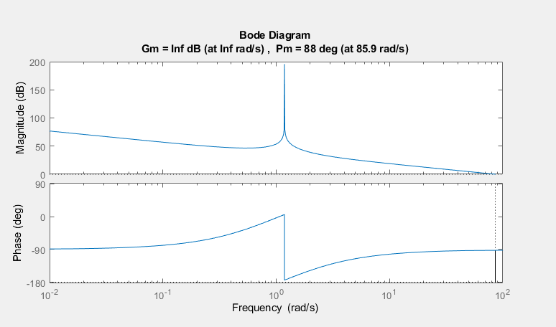
Figure 12 - Bode Diagram
Pole Zero Plots
These plots help to show the response of a system, and again are another measure of stability, providing the transfer function is known. The location of the poles on the plot tells us information about the time domain response of our system, and specifically tells us when the transfer function of a system tends towards infinity. Conversely, the zeros on a pole zero plot tell us where the transfer function of the system tends towards zero. Figure 13 shows a pole at approximately 9900 on the real axis, and 0 on the imaginary axis, indicating that it has no imaginary part. This is the dominant pole in the stable region and represents the exponential decay of the entire system. As this value lies far from the origin, the decay will be rapid, which is good for a tank turret that needs to be able to acquire targets rapidly. The other pole that lies close to the origin will provide a negligible stability change, relative to the previously mentioned one, and so does not need to be considered. Additionally, figure 14 shows a conjugate pole pair on the imaginary axis, yielding a purely sinusoidal wave, or the undamped response. As this pole lies on 0 for the real axis, the wave does not grow or decay meaning it does not affect the system stability.
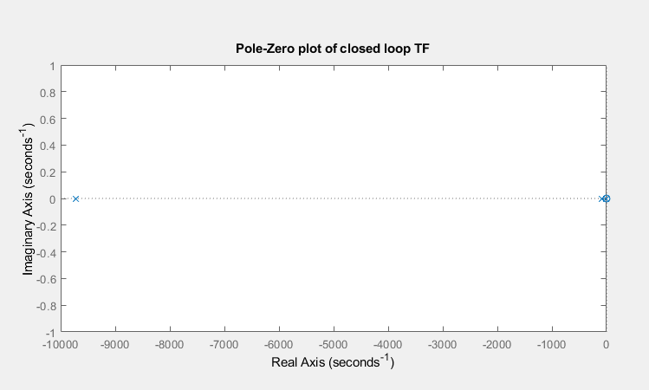
Figure 13 - Pole Zero Plot of Transfer Function
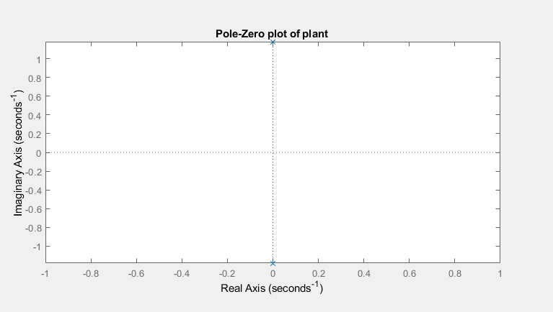
Figure 14 - Pole Zero Plot of The Turret Transfer Function
Conclusion
As all the stability measures have met the criteria that defines a stable system, it is safe to say that in this simulation, application of the turret controlled by this system will be stable. However, the likelihood of such as response occurring in real life is questionable, especially for a heavy turret. The unreasonably fast rise and settling times shown in figure 4 are assuming completely perfect conditions and does not take into account the heavy mass of a moving part, which will also effect how much the turret overshoots its intended position.

References

[1] | K. Astrom and R. Murray, Feedback Systems, Princeton University Press, 2008.
[2] | V. Kumar, B. Nakra and A. Mittal, "A Review on Classical and Fuzzy PID Controllers," International Journal of Intelligent Control and Systems, pp. 170-181, 2011.
[3] | University of Michigan, "Control Tutorials: for MatLab and Simulink," Michigan University, [Online]. Available: https://ctms.engin.umich.edu/CTMS/index.php?example=Introduction&section=ControlPID. [Accessed 25 April 2023].
[4] | W. Budiharto and e. al, "DESIGN OF OBJECT TRACKING FOR MILITARY ROBOT USING PID CONTROLLER AND COMPUTER VISION," ICIC International, vol. 14, no. 3, pp. 289-294, 2020.
[5] | L. Reznik, O. Ghanayem and Bourmistrov, "PID plus fuzzy controller structures as a design base for industrial applications," Engineering Applications of Artificial Intelligence, vol. 13, pp. 419-430, 2000.
[6] | S. Bennett, "The Past of PID Controllers," Annueal Reviews in Control, vol. 25, pp. 43-53, 2001.
[7] | J. Zeigler and N. Nichols, "Optimum Settings for Automatic Controllers," Journal of Dynamic Systems, Measurement and Control, vol. 115, no. 2B, 1993.
[8] | A. Molland, The Maritime Engineering Reference Book, Butterworth-Heinmann, 2008.
[9] | J. Schiff, The Laplace Transform: Theory and Applications, Springer Science & Business Media, 1999.
[10] | MATLANB, "PID Controller," MathWorks, [Online]. Available: https://uk.mathworks.com/help/simulink/slref/pidcontroller.html. [Accessed 25 April 2023].
[11] | S.-H. Kim, Electric Motor Control, Elsevier, 2017.
[12] | Zumbahlen, Linear Circuit Design Handbook, Newnes, 2008.
[13] | WatElectronics, "What is an Open Loop Control System & Its Working," WatElectronics, 30 September 2020. [Online]. Available: https://www.watelectronics.com/what-is-an-open-loop-control-system-its-working/. [Accessed 24 April 2023].
[14] | K. Astrom and R. Murray, Feedback Sytems, Princeton: Princeton University Press, 2008.

