Cycles to Share Database

SQL Assignment

by Bryn Sutton

Contents
Introduction 1
Queries & Index 1
CRUD Matrix 1
Transaction 1 1
Transaction 2 2
Transaction 3 3
Transaction 4 4
Performance Tuning 5
Indexes 5
Rollback 6
Distributed Database Solution 6
Appendix One 8
SQL code used to generate each table structure 9
SQL code used to create the referential integrity constraints 10
SQL code used to create the check constraint(s) 11
SQL code to build the database performance tuning enhancements 11
SQL code to populate each table with sample data (minimum of four records per table) 12
SQL code to demonstrate evidence of testing carried out to validate the constraints 13
SQL code to demonstrate evidence of transaction rollback and commit operations 17

Introduction
This assignment covers the construction of a database for a bicycle renting company. The project included creating the tables and contents, with the addition of streamlining the database by adding indexes to certain tables. In addition there is a proposed fragmentation of the database across the network.

Queries & Index

CRUD Matrix

Index | C R U D | C R U D | C R U D | C R U D
Account

Account Subscription

Tariff Rate

Station

Transaction 1

Transaction: (R) For pre-rental conformation emails the customers. Listing the account Number, first and Last Name and e-mail address.

Transaction Volume:
Average: 30 per Day
Peak: 50 per Day (Weekends)

SELECT accountNo, firstname, lastName, email
FROM Account
WHERE accountNo = ‘AC6589’

Predicate: accountNo = ‘(Account Number)’
Join Attributes: None
Ordering Attributes: None
Grouping Attributes: None
Built-in Functions: None
Transaction Map

Average = 30
Max = 50
Attributes updated: None
Account No
(50)

Bike Rentals
(300)

Access | Entity | Type of Access | Per Transaction | Avg per Hour | Peak per Hour
1 | Account | R | 1 | 30 | 50

Transaction 2

Transaction: (R) To check a subscription date, selects from subscriptionID, accountNo, startDate, endDate and subscriptionType.

Transaction Volume:
Average: 100 per Week
Peak: 100 per Week

SELECT subscriptionID, accountNo, starDate, endDate, subscriptionType
FROM AccountSubscription
WHERE accountNo = ‘AC6589’

Predicate: accountNo = ‘(Account Number)’
Join Attributes: None
Ordering Attributes: None
Grouping Attributes: None
Built-in Functions: None
Attributes updated: None

Transaction Map

Average = 30
Max = 50

Account No
(50)

Access | Entity | Type of Access | Per Transaction | Avg per Week | Peak per Week
1 | AccountSubscription | R | 1 | 100 | 100

Transaction 3

Transaction: (R) Updates the Tariff Rates according to company deals and seasonal offers.

Transaction Volume:
Average: 4 per Week
Peak: 7 per Week

UPDATE TariffRate
SET firstHourRate = ‘Value’ hourlyRate = ‘Value’
WHERE tariffID = ‘TariffID’

Predicate: TariffRate = ‘(Tariff Rate)’
Join Attributes: None
Ordering Attributes: None
Grouping Attributes: None
Built-in Functions: None
Attributes updated: None

Transaction Map

Average = 4
Max = 7

tariffID
(9)

Access | Entity | Type of Access | Per Transaction | Avg per Week | Peak per Week
1 | TariffRate | R/U | 1 | 4 | 7

Transaction 4

Transaction: (R) Locates other stations contact details to order or move bike stock according to promotions or seasonal requirements.

Transaction Volume:
Average: 36 per Week
Peak: 54 per Day (Weekends)

SELECT stationCode, phoneNumber, regionalStation
FROM Station
WHERE stationCode = ‘Station Code’

Predicate: stationCode = ‘(Station Code)’
Join Attributes: None
Ordering Attributes: None
Grouping Attributes: None
Built-in Functions: None
Transaction Map

Average = 36
Max = 54
Attributes updated: None
statioinCode
(44)

Bike Rentals
(300)

Access | Entity | Type of Access | Per Transaction | Avg per Week | Peak per Week
1 | Station | R | 1 | 36 | 54

Performance Tuning

Indexes
Indexes help to speed up the database search time. For example in transaction 1 the information required is contained within four of the fourteen fields. When searching for a name and email of a customer it is more efficient to pull up only the four fields requires instead of all the fields in the table.
When repeating a task a multiple times, the indexing of specific information can save time.

Transaction 1: To help streamline the business by trying to prevent bikes being booked out and not being picked up, the company sends out an e-mail reminder the day before the bike is due to be picked up.
As this is a frequent operation of the business the criteria are searched more often and thus require an index to speed up the acquisition of relevant table columns.

Transaction 2: Checking subscription dates, either due to the need to send a renewal notice or for customer queries, the subscriptionID, accountNo, starDate, endDate, subscriptionType fields are all required.

Transaction 3: The Company is constantly changing hourly tariff rates due to promotions or seasonal offers. However each station may have a variety of different offers on. Therefore an index in the tariff rate table is required as it can be updated daily.

Transaction 4: Due to some stations being situated in different terrain, i.e. Aberystwyth station will have a higher proportion of mountain and off-road bikes, while Swansea will have more street bikes. Therefore if one station has a higher number of off-road bookings than they have off-road bikes in stock they will need to phone another station to transfer the bikes.
Particularly busy stations may require bike transfers from multiple other stations and must phone to enquire and arrange transportation. Therefore a quick index on station phone numbers is important.

Rollback
The roll back function prevents a transaction from updating the database if programmed specifications are not met. For example if a new customer’s details were being put into the system and there was a power cut or server malfunction the information entered would not be stored, preventing the user from having to scroll through hundreds of names to find and complete the form.
In the Cycles Database the client is allowed a maximum of six bicycles per day, if they try and rent out more the system will roll back the seventh transaction and not update the database, while also giving a warning notice.
(See Appendix one for code)

Distributed Database Solution

The database will be logically distributed, with each regional station having their own database, however only the company HQ in Swansea will have unlimited access to the data.
This format will help keep the data intact in the event of the loss of any individual server failure as the company HQ has a complete copy and the regional stations have their own individual data fragment that can be used to rebuild the whole if required.

The database will consist of horizontal and vertical fragmentations depending upon the information provided in the tables.

The ‘Account’ Table will have a mixed fragmentation, with each regional station having access to their own data excluding paymentCardCVC and password fields, which will only be viewable by Swansea HQ.

Regional Access Fields
AC1: accountNo, registrationDate, firstName, lastName, D.O.B., phoneNumber, cityCode, postCode, address, paymentCard

AC11: stationCode = ‘S1000’

accountNo | registrationDate | firstName | lastName | D.O.B. | phoneNumber | cityCode | postCode
AC1256 | 2018-01-15 | Dave | Stenn | 12/08/1991 | 07589625362 | S1000 | SA731FG
AC5698 | 2017-07-21 | Lucy | Stuart | 18/06/1994 | 01658955236 | S1000 | SA65 9LP
AC1568 | 2017-06-17 | Steve | Mini | 21/10/1998 | 07555896512 | S1000 | SA726HJ

paymentCard | address
4589652635225489 | 24 Miltonway, Haverfordwest
1256998522563265 | 36 John St, Neyland
5698523655854578 | 22 Jason Terrace, Milford Haven

AC14: stationCode = ‘S4000’

accountNo | registrationDate | firstName | lastName | D.O.B. | phoneNumber | cityCode | postCode
AC5632 | 2018-02-16 | Matt | Newton | 14/11/1983 | 07589526981 | S2000 | SE731GG
AC1598 | 2017-03-22 | Julie | Jarvis | 08/04/1998 | 01854156895 | S2000 | SE65 9LJ
AC8369 | 2017-05-19 | Steve | Tucker | 20/12/1998 | 70256956895 | S2000 | SE726HK

paymentCard | address
4589652635225489 | 42 Honeybridge, Aberystwyth
1256998522563265 | 58 Johnside Lane, Aberystwyth
5698523655854578 | 22 Kings Terrace, Aberystwyth

The ‘AccountSubscription’ Table will be visible to each regional station respectively i.e. Haverfordwest station One and station two will be the only stations that can see the Haverfordwest Customer Subscriptions, in addition to HQ in Swansea.

Regional Access Fields
AS1: subscriptionID, accountNo, startDate, endDate, subscriptionType, tariffID, subscriptionStatus

AS11 Haverfordwest Station One
subscriptionID | accountNo | startDate | endDate | subscriptionType | tariffID | subscriptionStatus
AS1568 | AC1584 | 11/12/2018 | 11/01/2019 | Monthly | TMO17 | Active
AS5268 | AC9632 | 15/04/2019 | 15/04/2020 | Annual | TYR18 | Active
AS1369 | AC1578 | 22/052019 | 22/05/2019 | PAYR | PAYR8 | Active

AS12 Haverfordwest Station Two
subscriptionID | accountNo | startDate | endDate | subscriptionType | tariffID | subscriptionStatus
AS1568 | AC1594 | 13/12/2018 | 13/01/2019 | Monthly | TMO17 | Active
AS5268 | AC9662 | 15/05/2019 | 15/05/2020 | Annual | TYR18 | Active
AS1369 | AC1588 | 21/052019 | 21/05/2019 | PAYR | PAYR8 | Active

AS13 Cardigan Station One
subscriptionID | accountNo | startDate | endDate | subscriptionType | tariffID | subscriptionStatus
AS1568 | AC1585 | 10/12/2018 | 10/01/2019 | Monthly | TMO17 | Active
AS5268 | AC9632 | 12/04/2019 | 12/04/2020 | Annual | TYR18 | Active
AS1369 | AC1570 | 20/052019 | 20/05/2019 | PAYR | PAYR8 | Active

AS14 Aberystwyth Station One
subscriptionID | accountNo | startDate | endDate | subscriptionType | tariffID | subscriptionStatus
AS1568 | AC4584 | 08/12/2018 | 08/01/2019 | Monthly | TMO17 | Active
AS5268 | AC9032 | 10/04/2019 | 10/04/2020 | Annual | TYR18 | Active
AS1369 | AC0578 | 18/052019 | 18/05/2019 | PAYR | PAYR8 | Active

The ‘Bike’ Table will be visible to all stations in a Read Only format, as they will need to see what bikes are available in the various stations, as bikes can be requested and transferred from station to station.
Only the Swansea HQ branch will be able to make changes to this table.

The ‘City’ Table will not be viewable by any station other than the HQ, as it is not required for the regional stations to have this information.

The ‘Rental’ and ‘Rental Bike’ Table will be horizontally fragmented, allowing each regional station to view their own data.

The ‘Station’ Table will not be fragmented, it can be viewed by all stations.

The ‘Tariff’ Table will be horizontally fragmented, allowing each regional station to view their own data.

Appendix One
FILE ONE

SQL code used to generate each table structure

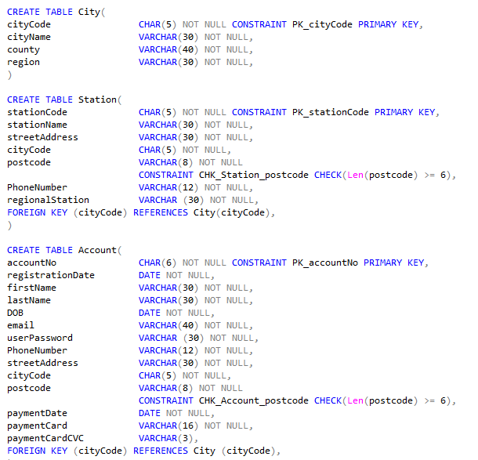
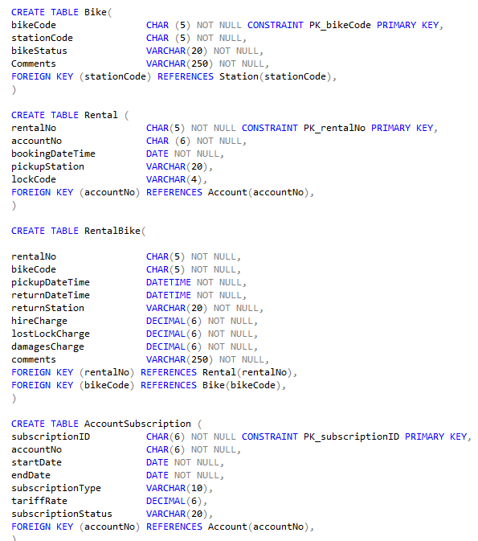
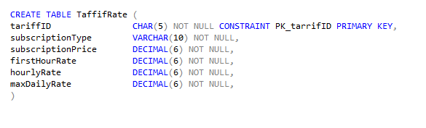

TABLE UPDATES
(Insert Updates)

SQL code used to create the referential integrity constraints

See above

SQL code used to create the check constraint(s)

ALTER TABLE Account
ADD CONSTRAINT CHK_Account_paymentCard CHECK(Len(paymentCard ) >= 16)

ALTER TABLE Account
ADD CONSTRAINT CHK_Account_paymentCardCVC CHECK(Len(paymentCardCVC ) >= 3)

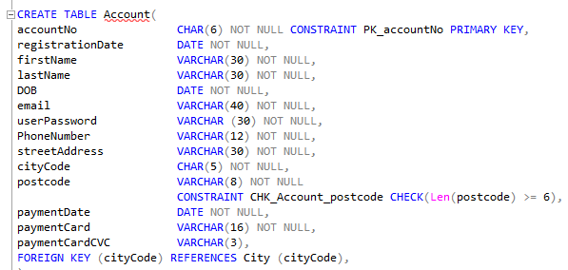

SQL code to build the database performance tuning enhancements

QUERY 1:
SELECT accountNo, firstName, lastName, email FROM Account
WHERE accountNo = 'AC6589'

INDEX 1:
CREATE UNIQUE INDEX AccountIndex ON Account (accountNo, firstname, lastName, email)

QUERY 2:
SELECT subscriptionID, accountNo, startDate, endDate, subscriptionType
FROM AccountSubscription
WHERE accountNo = 'AC6589';

INDEX 2:
CREATE UNIQUE INDEX SubscriptionIndex ON AccountSubscription (subscriptionID, accountNo, startDate, endDate, subscriptionType)

QUERY 3:
SELECT stationCode, phoneNumber, regionalStation FROM Station
WHERE stationCode = 'S1000';

INDEX 3:
CREATE UNIQUE INDEX StationIndex ON Station (stationCode, phoneNumber, regionalStation)

QUERY 4:
UPDATE TariffRate
SET firstHourRate = '9.00', hourlyRate = '7.00'
WHERE tariffID = 'TDY18';

INDEX 4:
CREATE UNIQUE INDEX TariffIndex ON TariffRate (tariffID, firstHourRate, hourlyRate)

FILE TWO

SQL code to populate each table with sample data (minimum of four records per table)
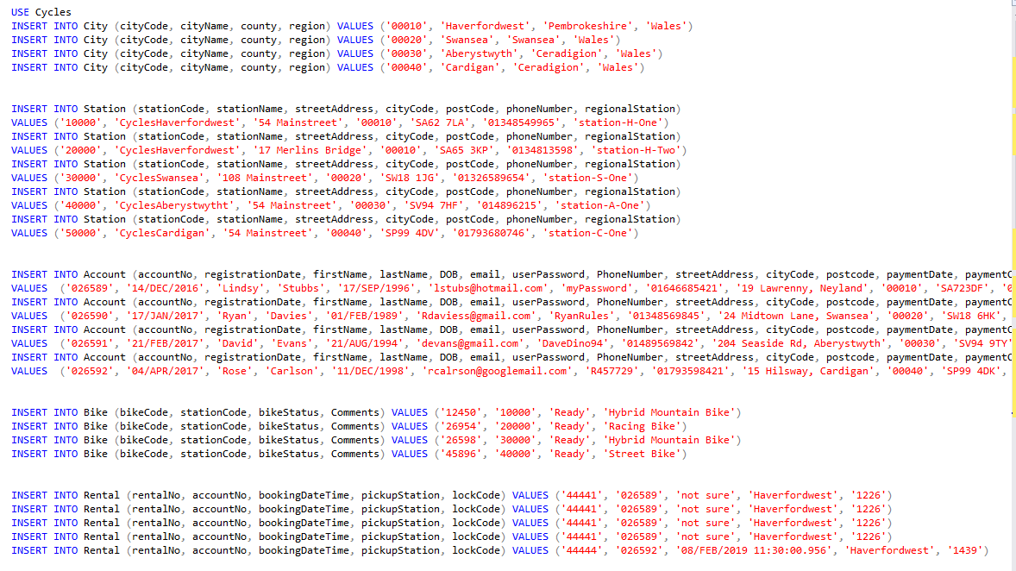
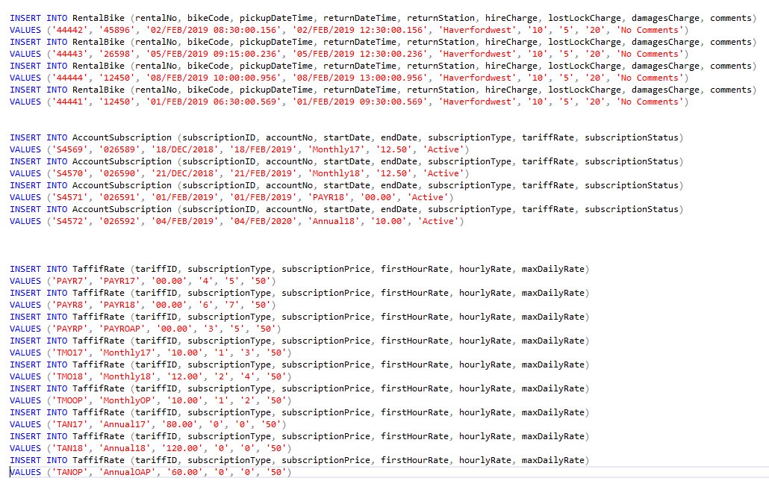

UPDATES

SQL code to demonstrate evidence of testing carried out to validate the constraints
PRIMARY KEY CONSTRAINT VERIFICATION
TABLE Account
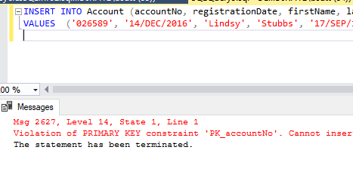
TABLE AccountSubscription
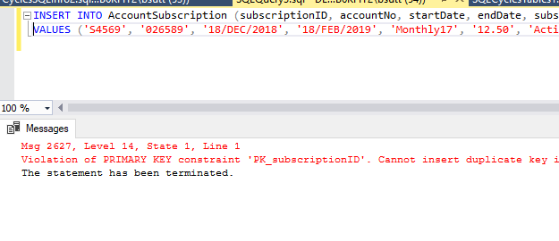
TABLE Bike
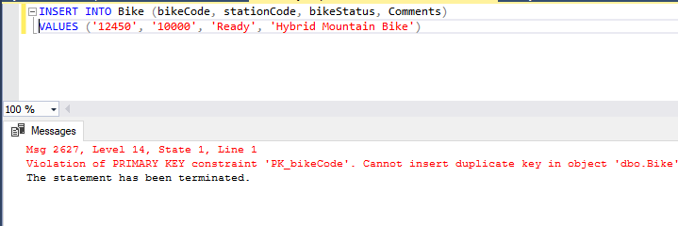

TABLE City
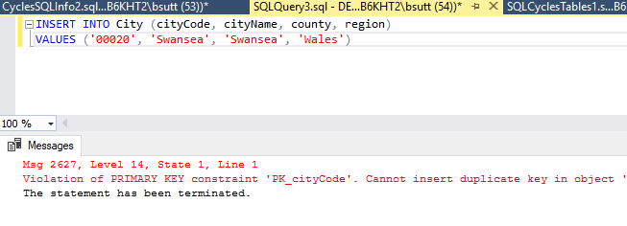
TABLE Rental
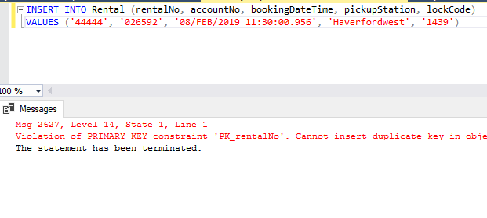
TABLE Station
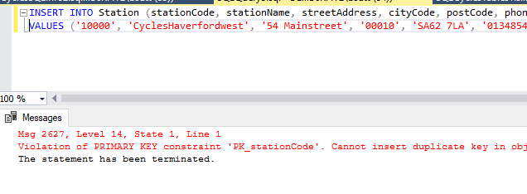
TABLE TariffRate
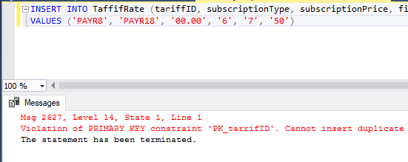

CHECK LEN CONSTRAINT VERIFICATION

TABLE Station
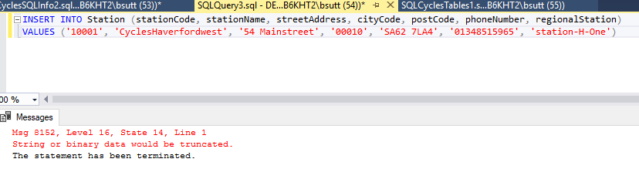

TABLE Account
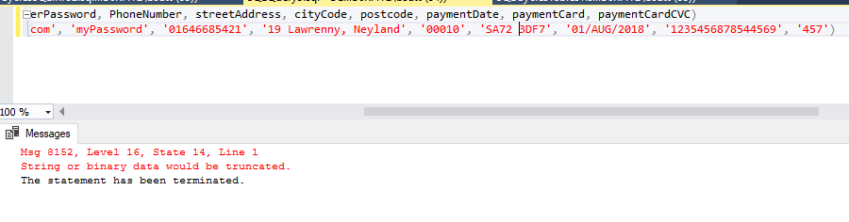
Payment Card
INSERT INTO Account (accountNo, registrationDate, firstName, lastName, DOB, email, userPassword, PhoneNumber, streetAddress, cityCode, postcode, paymentDate, paymentCard, paymentCardCVC)
VALUES ('AC6595', '14-DEC-2016', 'Lindsy', 'Stubbs', '17-SEP-1996', 'lstubs@hotmail.com', 'myPassword', '01646685421', '19 Lawrenny, Neyland', 'C0010', 'SA723DF', '01-JUL-2018', '123545687854456', '557')

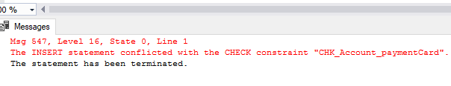

Payment Card CVC

INSERT INTO Account (accountNo, registrationDate, firstName, lastName, DOB, email, userPassword, PhoneNumber, streetAddress, cityCode, postcode, paymentDate, paymentCard, paymentCardCVC)
VALUES ('AC6595', '14-DEC-2016', 'Lindsy', 'Stubbs', '17-SEP-1996', 'lstubs@hotmail.com', 'myPassword', '01646685421', '19 Lawrenny, Neyland', 'C0010', 'SA723DF', '01-JUL-2018', '1235456878544565', '57')

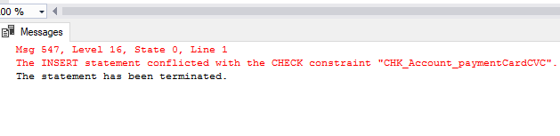

SQL code to demonstrate evidence of transaction rollback and commit operations


