

Student No: 2239451
Student Name: Dumitru Butcaru
Module No: LCLM 6002
Module Name: Design thinking and innovation
Lecturer’s Name: Dian Mayasari

Executive Summary
This report has examined the innovation within Apple PLC. It applied the Innovation Ambition Matrix and created the Apple AI+ plan. Apple's online shopping system was safe and worked well, whereas it didn't have many ways to pay or many discounts. Samsung and OnePlus allow people to pay in more ways and have more deals often. Apple fixed prices, which made it harder for those with less money to afford, so its rivals appealed to those who were price sensitive. To address those challenges, the plan applied two change management theories and the 8-step change model created by Kotter to enable people to embrace Apple AI+ and to ease the transition process. This plan introduces privacy-oriented generative AI to enhance user experience, support the planet, and maximise profits, which demonstrating that Apple can be ahead of the pack, staying ethical, welcoming digital change, and taking care of the environment.

Table of Contents
Introduction to the chosen organisation 4
Part 1- Analysis of the organisation’s approach to innovation 6
Discuss Innovation Ambition Matrix 6
Application of the framework on Apple 6
Current design thinking and innovations the organisation is engaged in 7
New Innovation opportunities 8
Discuss the Customer journey map. 8
Draw and application of the customer journey. 9
Analysis 9
Places for digital innovation opportunities 11
Part 2- Proposed digital transformation initiative 11
Based on previous analysis, propose a new digital transformation initiative. 11
Strategies to overcome key challenges identified 13
Updated customer journey map that illustrates the new customer journey experiences 14
Analysis 14
Ways the proposed initiative will positively impact the company 300 16
Strategies to measure the impact and the success of the proposed initiative 250 17
Conclusion 18
References 19

Introduction to the chosen organisation
Apple PLC shall be recognised as one of the world's leading technology brands operating in the UK and internationally. The company will become recognised as a manufacturer and marketer of new electronic products, software and Internet services. Its primary products include products such as the iPhone, iPad, Mac, Apple Watch, and AirPods. Its platforms like Apple Music, iCloud and the App Store will continue to expand its online ecosystem. The company's headquarters is in Cupertino, California and also founded in 1976 (Yahoo Finance, 2025). Through opening shop outlets, website domains and partnerships with other businesses, it will attempt to increase its presence in the UK market. Apple's commitment to creativity, good user experience and sustainability through investment in renewable energy and eco-friendly designs will continue to shape the way they work. Through continued innovation, commitment to privacy, and quality, Apple will continue to be the global leader that transforms technology and connects people through elegant, intelligent, and sustainable solutions (Apple Inc., 2024).

Figure 1: Apple logo
(Source: Logo histories, 2023)

Key consumer and industry trends and data that affect the organisation
The changes in consumer and industry trends related to technological innovation, digital innovation, and sustainability have a high impact on Apple's performance. The smartphone market around the world is still young and expected to expand due to the implementation of 5G technologies, improved capabilities of AI, as well as the rising popularity of devices produced in an eco-friendly manner. It also states that Apple has an estimated market share of about 20.1 per cent in the smartphone market around the world, and a robust growth in the high-end markets (Milmo, 2024). Customers in the UK are becoming more inclined towards appliances that contain continuous connectivity, great security and extended software services-areas where Apple has competitive flair.
One major trend which has impacted Apple is the transformation to digital ecosystems and services that are subscription-based. Apple Music, iCloud+, and Apple TV+ are some of the services that drive recurring revenue and enhance customer retention. The wearable and health technology products and divisions of the company are soaring high, and this side of the company shows the interest of consumers in the health monitoring and management of their lifestyles.
The issue of sustainability is a new driver in the industry, along with ethical production. Apple has also invested in ensuring that it becomes carbon-neutral in all its supply chains by the year 2030, which is attractive to environmentally conscious consumers (Deepak, 2025). Moreover, data privacy and security are also one of the key differentiations in the time of rising digital surveillance and cybersecurity risk. The launch of AI-powered personalisation and the next category of product, mixed reality (vision pro) originates demonstrates that Apple can pay attention to the trends toward innovations. All in all, being continually focused on innovation, ecosystem growth and ethical technology, Apple is well positioned among the changing market and consumer demands.

Part 1- Analysis of the organisation’s approach to innovation

Discuss Innovation Ambition Matrix
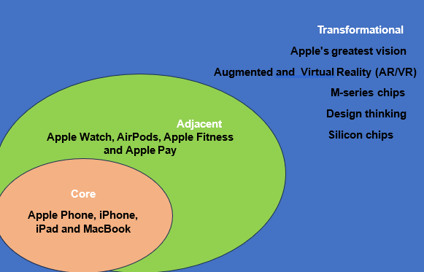
Figure 2: Innovation Ambition Matrix
(Source: Created by the learner)
The Innovation Ambition Matrix classifies innovation into three types: core, adjacent and transformational. Core work is what makes the current ongoing work better; Adjacent work is the expansion into new markets, and Transformational is when either the company is making new products or following a new business model (Kraus et al., 2023). This framework helps organisations to show their innovative efforts and invest wisely, so that they continue to grow for a long time. For Apple, the matrix demonstrates how it can stay on top through making small changes and through launching big, game-changing ideas that change the way people use technology.

Application of the framework on Apple
Apple is a careful company in its innovation plan, covering all three parts of the plan. This will assist the firm to remain competitive in the present and also seek to be a market leader in the future. Core innovation involves improving its primary products: iPhone, iPad and MacBook through making minor yet significant tweaks. They also introduced improved power management, increased speed with the processor, improved camera sensor resolution, and communication between the device (Liu et al., 2025). The new iPhones make use of superior A-series and smarter power controls to ensure longer durability and faster performance. Such updates ensure that users are happier and remain loyal. The unity between iOS and macOS, as well as iCloud, provides users with a free flow of integrated digital space across all Apple-powered devices.
Side innovation allows Apple to expand its business beyond its typical area. Wearables and services such as the Apple Watch, AirPods, Apple Fitness, and Apple Pay are also now sold by the company. The new domain also aligns with the primary ecosystems that are based on the rapidly expanding industries like health and wellness, as well as financial technology.
For example, the Apple Watch Series 9 uses Artificial Intelligence (AI) to track activity and health, putting Apple at the top of the pack with its preventive health technology. Apple's expansion into digital services such as iCloud, Apple Music, and Apple TV demonstrates the way related innovations can provide steady revenue, as well as more engagement than just the purchase of hardware (Yang, 2023). By connecting devices, Apple maintains its competitive advantage in a balanced system that adapts to evolving lifestyles.
Transformational innovation is Apple's greatest vision for the future. The Apple Vision Pro brings Augmented and Virtual Reality (AR/VR), or the concept of augmented reality and virtual reality, to change the way people interact with devices (Apple Vision Pro, 2025). Apple's new M-series chips demonstrate a strategy to make its own silicon, with the benefit of relieving the company of reliance on suppliers such as Intel and enabling greater optimisation of its products (Apple, 2020). These initiatives are keeping in mind Apple's long-term vision of being a leader in novel fields such as mixed reality, artificial intelligence, and sustainable technology.
Despite that innovation, Apple does not have it all set. Frequent small updates can lower the excitement of the user, as they are now used to breakthrough features. Apple's closed ecosystem, while guaranteeing quality, can be limiting prospective use with other systems and deter appeal for cross-platform users. Apple's way around those is the focus on design thinking, sustainability in terms of carbon-neutral manufacturing, recycled materials and easier accessibility (Apple, 2025). Together, these efforts keep Apple known as a design-driven innovator, in which combining technology, lifestyle and environmental responsibility flows in one brand experience.

Current design thinking and innovations the organisation is engaged in
Apple begins its design thinking with the idea of caring about its customers/users, innovating new ideas and testing these ideas as many times as possible. Their focus is on making hardware and software compatible so as to make it natural and emotional. An example of this could be the Dynamic Island on the iPhone, which converts the camera cutout to an interactive design trick. Features such as Handoff and Continuity also show how Apple is thinking in systems, allowing people to shift easily from one device to another.
Apple's design thinking is a strength, yet it can also be a weakness if it gives a great product. However, the compromises are made in terms of how easy it is to get repairs or how expensive that repair might be. The closed Apple system has the potential to prevent people from modifying and adding things for themselves. Nevertheless, Apple keeps on inventing, testing and paying attention to how a product makes people feel, setting high standards of simple, elegant and user-pleasing design.

New Innovation opportunities
The Technology Acceptance Model (TAM) by Davis states that people accept and use the technology only when the technology is easy to use and helpful. Whereas the Diffusion of Innovation (DOI) theory shows how new technology or things spread through different types of adopters, such as innovators, early adopters, early majority, late majority, and late adopters. Apple can use TAM and DOI to explore and expand into new fields.
An opportunity for Apple is AI personalisation, extending its products, integrating generative AI into Siri, Health and Apple Music. By using TAM, Apple can better understand natural language processing and improve Siri's predictive analysis; Apple can improve both usefulness and ease of use. With ideas of DOI, Apple can sell first to early adopters such as tech professionals, and then to the majority through updates for all devices.
Apple’s brand identity and customer trust help the quick spread of its new technologies or products; however, the privacy concerns may slow it down. Apple can use privacy-safe AI technology to make its users comfortable and allow them to try new things. It also keeps Apple apart from companies such as Google and Amazon that are questioned in terms of the way they use data.

Using TAM and DOI together allows Apple to make a guess of how fast people will use new AI and AR/VR technologies. It also helps Apple to plan marketing strategies to get the best response from the people. These models show that Apple has the potential to develop not just gadgets. Instead, they can develop an intelligent ecosystem that gives a personalised and adaptive experience, is an adaptive and privacy-first experience, keeping it ahead of the competition.

Discuss the Customer journey map.
The customer journey map demonstrates each step a customer takes with a brand from noticing it for the first time to remaining loyal after purchasing its products. It highlights the needs of customers along with their problems and their mode of engagement. For Apple, the map has five typical steps: awareness, consideration, purchase, use and advocacy. By looking at these steps, Apple can improve their online as well as store experience to ensure that its customers are getting the same value whether they shop online or in stores. This is well suited to Apple's customer priorities and placing emotion, high-quality service and easy-to-use digital tools at the front, which makes the brand feel like it inspires and is easy to get.

Draw and application of the customer journey.
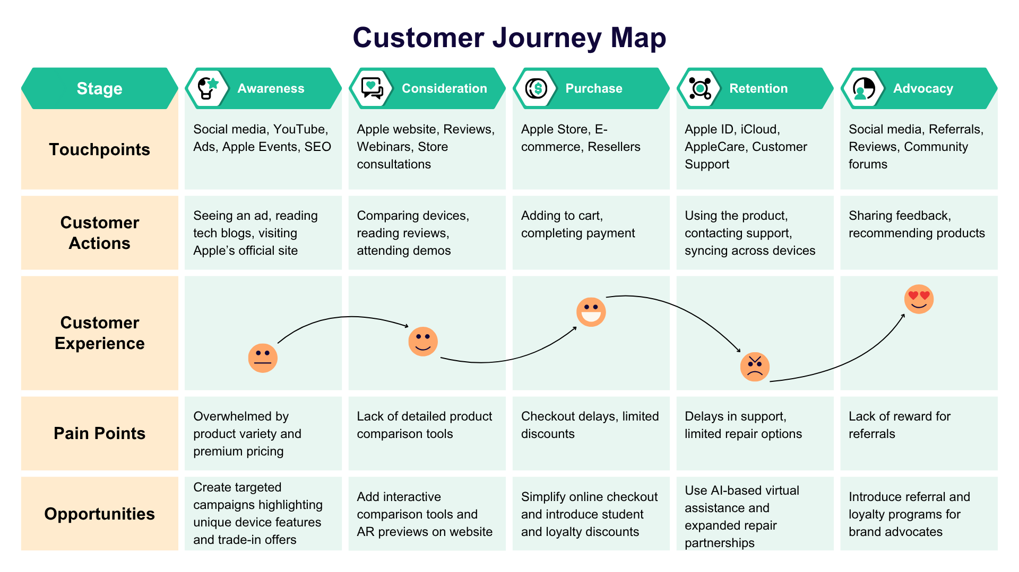
Figure 3: Customer Journey Map
(Source: Created by the Learner)

Analysis
Apple's customer journey is driven by the need to offer a different experience; every interaction fulfils Apple's promise of simplicity and innovation. The first is awareness, which is what Apple does through emotional stories and high-quality imagery in global ad campaigns. The marketing is not to inform, it is to inspire, to make products lifestyle goals. This phase targets both innovators and early adopters, according to Rogers' Diffusion of Innovation theory, where early customers affect later customers.
In the consideration stage, Apple depends on openness and continuous design to keep users interested. In-store assistance, AR previews of products and detailed evaluations on the web allow customers to make decisions. Yet, Apple's style allows individual product comparisons to be minimal, so price-sensitive consumers might be confused.
More interaction online might transform more opportunities into price-sensitive customers. The purchase stage is showing Apple's cross-channel play. Whether shopping online or in a store, customers can rely on the convenience and reliability of the services. In stores, hands-on learning and interest are increased with Apple's "Today at Apple" classes (Apple, 2025b). However, the online purchase option is not very flexible in terms of selecting the payment method and discounts, which can be leveraged by its competitors, such as Samsung and OnePlus. Increasing loyalty rewards and reducing a complicated checkout process could help boost sales.
Retention is an important component of Apple's journey, its network, which includes iPhone, Mac, Watch, and iCloud, binds users to Apple. The relationship that data sync and device compatibility make users trust and be faithful to the brand. However, delays in service and strict rules related to repair affect the brand image negatively. Apple's initiative on AI-powered support and green repair programs could strengthen its image. Finally, the happy users or customers spread the word about Apple to their communities. With the help of brand ambassadors, they assist organisation to share their feelings in the form of stories as well as experiences on social media.
Pain points
- New apps on new platforms: with the help of new technologies with the innovative products comes with the VisionOS. With the help of this, it comes with the feasibility of working smoothen services.
- Privacy vs AI: Apple values the privacy of its users. These commitments may affect its market positioning in the AI sector due to cloud-based applications, and Apple cannot adapt this technology to maintain user privacy and security.
Gain points
- Seamless cross-device continuity: Apple’s services like iCloud sync and built-in functionality provide users convenience, while switching between multiple devices and easy to access all important data without inconvenience (Apple Support, 2025).
- Strong retail and support experience: Apple’s physical stores (Apple Stores) and its customer support (Genius Bar) make users feel safe, comfortable and supported. The customers can try, test the products, get help and assistance and also learn how to use them. This reduces the concern of the customers to buy Apple’s products and also improves customer experience.
- Hardware and software co-design performance: Apple designs its own silicon chips and software so that they work together perfectly and seamlessly (Pereira, 2021). As a result, its device has longer battery life, better performance and special functions that work seamlessly.
- Brand trust and privacy positioning: Apple is all about user privacy, which makes it trustworthy. Users feel safe on Apple products, and they are willing to pay more for this promise of privacy and security.

Places for digital innovation opportunities
- AR and Spatial try-before-buy tools: Apple can allow one to try any device, such as Vision Pro, virtually on the web or apps with AR, so that one can check what the device looks and feels like without having to own one. This helps to reduce uncertainty or doubts and makes them more likely to buy.
- Smart setup help: Apple can do its part by creating a system to make the setup of a device easy for its customers. If any issue is detected when setting up the device, it can provide step-by-step support or schedule a Genius Bar appointment. This smoothens the setup and reduces the required support.
- Incentives for VisionOS developers: Apple can provide financial help to the developers to develop high-quality apps for systems like VisionOS. Provide templates for more efficient coding and feature the apps on the App Store for increased visibility.
- Clear trade-in and finance calculator: Apple can provide instant trade-in value for old devices, financing programs to reduce costs and make purchase affordable, and transparency into pricing even at the time of checkout. This would make purchasing easier and less stressful, which would increase the chances of customers completing their purchase.

Part 2- Proposed digital transformation initiative

Based on previous analysis, propose a new digital transformation initiative.
Apple intends to introduce Apple AI+ based on its previous experience. It is a machine learning algorithm that is both personal and Generative Artificial Intelligence and will enhance user experience across all Apple devices and services. It will be based on the design mentality, innovation culture and sustainability objectives of Apple and align itself with the global trend of a personalised AI. Apple AI+ will move into iOS, macOS, watchOS and visionOS, providing users with an intelligent, adaptable, high-security assistant. It is powered primarily by the device using federated learning; hence data remains confidential and consumes less energy. Also gets to know what the user likes on the device, makes Siri smarter, enhances performance on their device, and provides product recommendations on health, music, and productivity. The plan addresses the primary challenges that have been previously observed. It provides robust AI and privacy of user data. Also simplifies the process for new users, voice commands, and Artificial Intelligence. It also assists developers to create more spectacular visionOS applications, which increase the range of digital and augmented reality or Virtual Reality applications of Apple (Apple Machine Learning Research, 2024)
On the side of the environment, Apple AI+ will monitor the energy consumption, suggest green practices, and assist Apple in its ambition of zero carbon in 2030 (Deepak, 2025). It will also make new appearances, such as AI as a service plans, partnerships with healthcare, and education. More device usage, the happier customers and the number of people utilising the new AI feature will be measures of success. This is the way to gain trust, become more accessible, and make Apple a leader in ethical and people-first technology by introducing personalised, private AI into its products, thereby making Apple AI+.

Strategies to overcome key challenges identified
The new AI+ product made by Apple had several issues, including how to approach users to utilise it, maintain data privacy, and ensure environmental safety. Apple had to employ the concepts of the Lewin Change Management Theory and Kotter 8-Step Change Model to address these.
According to the Lewin Change Management theory, change occurs in three stages, which include unfreeze, change, and refreeze (Halim and Kovara, 2024). In the case of AI+, the initial way in which Apple unfreezed it is by informing employees, developers, and customers that the AI would be personal, private, and green. They threatened that they would be left behind unless they changed. They launched awareness campaigns, workshops and briefings in order to generate urgency. Also updated the products by incorporating AI+ to iOS, macOS, watchOS and to visionOS. This encompassed on-device learning, enhanced Siri and AR/VR applications. The development, support, and product teams incorporated these features and green practices. Apple solidified the change by turning AI+ into a normal work. New processes, metrics and feedback loops ensured the change was permanent and continuous monitoring ensured that privacy, energy consumption, and user happiness continually rose. This maintained the entire system of Apple, including making and selling, to be geared towards innovation, privacy and sustainability.
The 8-Step Model by Kotter states that by improving their ability to change, organisations can increase their chances of success today and also in the future. It is presented to Apple with an action plan (Laig and Abocejo, 2021). Apple created urgency by showing the advantages of AI+ and the dangers of not using it. Next, they created an AI engineer, sustainability, and product manager leadership team. They created a dream that AI+ is a consumer, private assistant. Also, globalise this vision among the stores, online, and through developers to mobilise people. Action was also made possible by Apple providing tutorials, tools, and APIs to allow people to build new visionOS applications. It used the momentum of early victory, such as improved Siri and energy-saving suggestions. Finally, Apple was able to retain the gains and institutionalise the changes as part and parcel of the culture and the products. The integration of the comprehensive perspective of change with the practical steps of Kotter helped Apple achieve its consumption, privacy, and environmental targets, and AI+ is among the major key points of its ethics-first, innovative, and people-centric technology approach.

Updated customer journey map that illustrates the new customer journey experiences
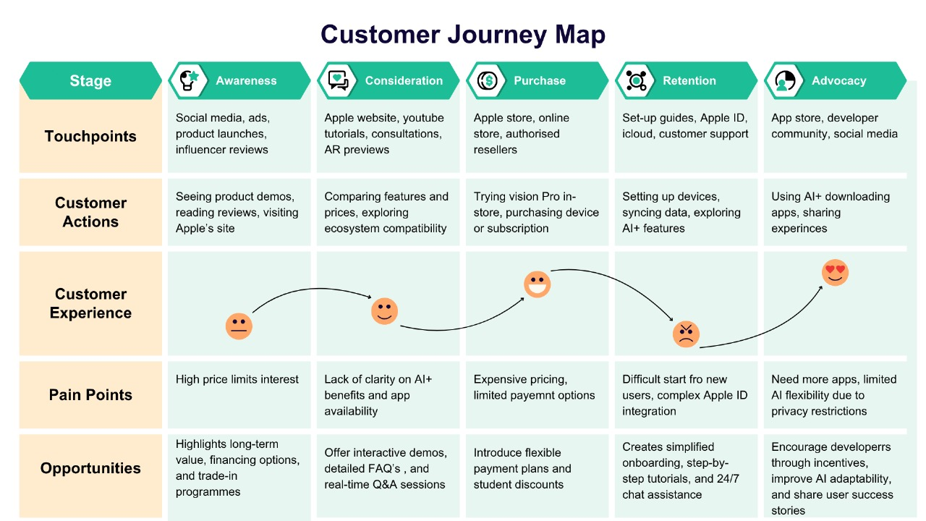
Figure 4: Customer journey map
(Source: Created by the learner)

Analysis
The new customer journey map demonstrates how individuals apply Apple AI+ AND vision Pro on the awareness, consideration, purchase, onboarding, and use levels. High price, challenging onboarding, limited applications to new platforms such as visionOS, and the privacy AI trade-off are the primary issues.
Awareness stage
The image of the high-end brand is thrilling when individuals first hear about Apple; however, the price prevents a certain group of people from purchasing the brand at the very beginning. It would be a good opportunity to speak more about sustainability, new ideas, and payment options, which would make the product seem more valuable.
Consideration
Individuals are not indifferent when making a decision, and on the other hand, they do not know what AI+ is capable of and how it would be integrated into the large context of Apple. Presentation of live demonstrations, AR examples, and transparent AI descriptions will assist them in becoming more engaged.
Purchase stage
People purchase when they are fond of the new ideas of Apple, whereas the cost becomes an obstacle. Buyers would find it easier to purchase with flexible payment options and student discounts.
Onboarding stage
It remains difficult to set up due to the complexity of Apple ID setup and transferring between other brands. People would be happier with easier steps to set up, help in the stores, and step-by-step tutorials.
Usage and advocacy stages
Privacy and device connection create trust in the course of the usage, and sharing the number of visionOS apps and limited AI functions reduces interest. To enhance the experience, it will be to enlist developers to create more apps and strike a balance of privacy that is on-device against the use of clouds. The solution to these particular issues will allow Apple to provide a comfortable, personal, and inclusive experience, and ensure that people remain loyal and advertise the brand.

Ways the proposed initiative will positively impact the company 300
The privacy-oriented generative AI system is called Apple AI+. It provides Apple with a lot of strategic advantages that can enhance its performance, competition, and sustainability.
-The Apple AI+ helps customers to feel better as it provides them with highly personalised and customizable services. It learns across the device and data is kept confidential, and therefore users will have custom suggestions, better Siri and seamless usage across all Apple devices. This makes the customers happy and demonstrates that Apple cares about individuals and confidentiality.
-AI+ assists Apple in driving innovations and becoming a leader. Although numerous rivals apply cloud AI, the personal AI of Apple has a special offer that reflects the desire of the world to use the technology fairly and clearly. This puts Apple at an advantage both in the rich and poor markets.
-AI+ assists in addressing Apple's green objectives. It consumes less power in gadgets and monitors carbon consumption; hence it helps achieve Apple's mission to be carbon-zero by 2030. The AI can propose green habits, contributing to making Apple sound environmentally friendly and green buyers and investors.
-The plan is also more profitable for Apple and increases its ecosystem. Paid subscriptions, AI services, and deals can contribute to earnings for Apple, particularly within health and learning. The developers of the visionOS applications create value, attract more money to the app, and retain customers.
-Apple AI+ is responsible for demonstrating ethical leadership. Apple has managed to enhance their responsibility image by ensuring the safety of the data and showing concern about the planet. It is a long-term trust which will increase the confidence of partners, attract proficient individuals, and leave Apple at the top of technology. The Apple AI+ is a huge transformation, blending new concepts, privacy, and being green. It will drive long-term expansion, gain customer confidence, and enable Apple to be unique in the global market.

Strategies to measure the impact and the success of the proposed initiative 250
Measuring the success of the Apple AI+, both numbers and opinions will be used in four major fields: the way customers use it, the money they make, the ideas, and the environment.
Customer Metrics
Measuring the satisfaction level will allow Apple to observe the number of individuals who start utilising AI+, the number of individuals who use it daily, and the level of customer satisfaction. It can also examine the speed at which people learn to utilise it, the frequency at which the AI+ features are used, and the number of individuals who continue using it in the future. Such figures demonstrate the ease of the system and the way it is appreciated.
Financial Metrics
The AI+ generated money is through subscriptions, device upgrades or deals with developers. Also consider the average amount of money that each user brings on board and how it increases the sales of devices with AI+. These figures indicate whether the product is profitable.
The metrics under innovation and ecosystem include
Apple has an opportunity to measure the number of new outside apps created to work with visionOS, the number of developers joining, and the number of development integrations with AI+ that take place within its ecosystem. Measures of success can also be made by the number of patents being filed and the rate of implementation of new AI functionality.
Sustainability Metrics
The amount of energy used by each device, the amount of carbon pollution reduced, and the number of users who use AI+ green tips will be measured. It also measures the proximity to the 2030 objective of Apple of zero carbon emissions.
Qualitative Insights
To get to know what is good and what requires improvement, it will hear user remarks, read their feelings and seek the opinion of developers.
These approaches provide a complete picture of how the Apple AI+ operates, its money, the planet, and the trust that people have in it. Profits, sustainability and trust are taken as the measures of success.

Conclusion
The report has examined the topic of innovation and the use of design thinking at Apple PLC, based on such concepts as the Innovation Ambition Matrix, Technology Acceptance Model, and Diffusion of Innovation theory. It was discovered that Apple emphasises three categories of innovation: core, adjacent and transformational, particularly through the addition of AI, sustainability and ecosystem development. The strategy named Apple AI+ demonstrates the way privacy-oriented generative AI can advance customer experience, enhance everyday company operations, and assist Apple in achieving carbon-neutral targets. Using the Change Management Theory by Lewin and the 8-step Change Model by Kotter, Apple will be able to change successfully and address the issues of pricing, teaching the new users, and privacy. In general, the plan reveals how Apple maintains a competitive advantage through ethical innovation, prioritising customers through design, and pioneering sustainability to remain a world leader in responsible digital transformation.

References
Apple (2020) Apple announces Mac transition to Apple silicon Available at: https://www.apple.com/in/newsroom/2020/06/apple-announces-mac-transition-to-apple-silicon/ (Accessed 16 October 2025)
Apple (2025) We’ve reduced our emissions by over 60% Available at: https://www.apple.com/in/environment/ (Accessed 16 October 2025)
Apple (2025b) watchOS 26 delivers more personalised ways to stay active, healthy, and connected Available at: https://www.apple.com/in/newsroom/2025/06/watchos-26-delivers-more-personalized-ways-to-stay-active-and-connected/ (Accessed 16 October 2025)
Apple Inc. (2024) Apple Intelligence is available today on iPhone, iPad and Mac. Available at: https://www.apple.com/newsroom/2024/10/apple-intelligence-is-available-today-on-iphone-ipad-and-mac/ (Accessed: 16 October 2025).
Apple Machine Learning Research (2024) Learning with privacy at scale. Available at: https://machinelearning.apple.com/research/learning-with-privacy-at-scale (Accessed: 16 October 2025).
Apple Support (2025) Use Handoff to continue tasks on your other devices Available at: https://support.apple.com/en-in/102426 (Accessed 16 October 2025)
Apple Vision Pro (2025) New powerful M5 chip and comfortable band. Available at: https://www.apple.com/apple-vision-pro/ (Accessed 16 October 2025)
Deepak (2025) Apple’s 2030 Carbon Neutrality Roadmap. Available at: https://thesustainableinnovation.com/apple-carbon-neutrality/ (Accessed: 16 October 2025).
Halim, L.V. and Kovara, S. (2024) ‘Quality Of Work Life And Change Management.’ Available at: https://repository.ubaya.ac.id/46534/1/Paper%20Vietnam%202024.pdf
Kraus, N., Kraus, K., Manzhura, O.L.E.K.S.A.N.D.R., Ishchenko, I.N.N.A. and Radzikhovska, Y.U.L.I.I.A. (2023) ‘Digital transformation of business processes of enterprises on the way to becoming industry 5.0 in the gig economy.’ WSEAS Transactions on Business and Economics, 93(20), pp. 1008-1029. Available at: https://elibrary.kubg.edu.ua/id/eprint/45850/1/Kraus_Digital_Transformation_Business_Processes_2023.pdf
Laig, R.B.D. and Abocejo, F.T. (2021) ‘Change management process in a mining company: Kotter’s 8-step change model.’ Journal of Management, Economics, and Industrial Organisation, 5(3), pp. 31-50. Available at: https://www.researchgate.net/profile/Ferdinand-Abocejo/publication/354614425_Change_Management_Process_in_a_Mining_Company_Kotter's_8-Step_Change_Model/links/615093f2f8c9c51a8af65225/Change-Management-Process-in-a-Mining-Company-Kotters-8-Step-Change-Model.pdf
Liu, F., Christou, A., Dahiya, A.S. and Dahiya, R. (2025) ‘From printed devices to vertically stacked, 3D flexible hybrid systems.’ Advanced Materials, 37(10), p. 2411151. Available at: https://doi.org/10.1002/adma.202411151
Milmo, D. (2024) Apple overtakes Samsung as world’s top smartphone seller. Available at: https://www.theguardian.com/technology/2024/jan/17/apple-samsung-worlds-top-smartphone-seller-iphone-honor-google-divide-android (Accessed: 16 October 2025).
Pereira, G. (2021) ‘Apple Memories and automated memory-making: The networked image inside the iPhone chip.’ Available at: https://mediarep.org/bitstreams/c21cf6f2-65b1-4355-99bc-797a59900258/download
Yahoo Finance (2025) Apple Inc. Company Profile. Available at: https://uk.finance.yahoo.com/quote/AAPL/profile/ (Accessed: 16 October 2025).
Yang, W. (2023) ‘APPLE'S STRATEGIC DECISION-MAKING Apple's Strategic Decision-Making: Navigating Innovation and Market Dynamics.’ Available at SSRN 5060488. Available at: https://papers.ssrn.com/sol3/Delivery.cfm?abstractid=5060488

