Executive Summary
The purpose of this paper is to develop a sustainable business strategy for Verdant Leisure Company, which is an SME in the United Kingdom’s hospitality and tourism industry. The paper aims at conducting a strategic analysis of the company followed by the provision of strategic growth choices/options/action points. Various theories and models will be used in this analysis. They include Porter’s value chain model, PESTEL analysis, Porter’s five forces model, Ansoff matrix, SFA framework, and Mendelow’s stakeholder matrix. Based on the strategic analysis and strategic growth choices, the paper will then provide recommendations on strategic implementation, monitoring and evaluation.

Student ID: 1908330
Student name : Clara Maria Barna
Programme: BA (Hons) Leadership and Management skills for the workplace
Module : Module: Strategic Management for SMEs
Module Code: BMSW6104
Lecture: Faizu Edu
Assessment brief Author: Md Kalam
Internal Verifier: Husam Alharahsheh

Table of Contents
Executive Summary 1
Introduction 3
Strategic Development Process 3
Strategic Analysis (SWOT) 3
Internal Analysis (Porter’s Value Chain Model) 3
External Analysis (PESTEL) 6
Industry Analysis (Porter’s Five Forces Model) 8
Summary of Findings into SWOT 9
Strategic Growth Choices/Options/Action Points 11
Strategic Option Analysis (Ansoff Matrix Model) 11
Market Penetration 12
Product Development 12
Market Development 12
Diversification 12
SFA Framework 13
Stakeholder Analysis (Mendelow’s Stakeholder Matrix) 13
High Power and High Interest 14
High Power and Low Interest 14
Low Power and High Interest 15
Low Power and Low Interest 15
Conclusions and Recommendations: Strategic Implementation, Monitoring and Evaluation 15
Conclusions 15
Recommended Strategic Direction 15
Timeline of the Strategic Implementation Process 15
Benefits and Drawbacks 16
References 17

Introduction
The purpose of this report is to develop a sustainable business strategy for a selected SME or organization. The company whose sustainable business strategy will be developed is Verdant Leisure. Verdant Leisure is a private company that was started in 1990, with its headquarters in Lancaster, United Kingdom. It is an award winning tourism company that engages in the provision of excellent holiday accommodation, as well as, holiday homes for sale (Verdant Leisure 2023). Some of the services that are offered by the company include holiday home ownership, self-catering holidays and the purchase or renting of holiday homes and caravans for clients and their families to create memories and spend time together. The current chief executive officer of the company is Graham Hodgson. Various reasons can explain why this company was selected to be used in this report. First, the company is headquartered in the United Kingdom. Secondly, the company has about 97 permanent employees, with other employees hired on a temporary basis during the peak season (Verdant Leisure 2023). Coupled with this, the company has an annual revenue of about $32 million. These two characteristics qualify the company to be an SME, and as such, justified to be used in this report.
Various theoretical models will be underpinned in this report. They include SWOT analysis tool, Porter’s Value chain model, PESTEL analysis tool, Porter’s Five Forces model, Ansoff Matrix Model, SFA framework and Mandelow’s stakeholder matrix. The report will be divided into three main sections. The first section will be the strategic development process, which will involve strategic analysis, internal analysis, external analysis and industry analysis. The second section will be the strategic growth choices, options or action points. It will entail the strategic option analysis, the strategic direction and stakeholder analysis. The final section will provide the conclusion and recommendations for strategic implementation, monitoring and evaluation. The expected outcome for the selected company is to consider implementing the recommendations provided to develop a suitable sustainable strategy for ensuring continuous growth.

Strategic Development Process

Strategic Analysis (SWOT)

Internal Analysis (Porter’s Value Chain Model)
Porter’s value chain model, as developed by Michael porter, refers to an internal analysis tool that is used in developing an analytical structure, which involves interdependent activities, from the moment raw materials are acquired to when the final products or services are delivered to the consumers. The value chain model provides a set of activities that an organization can use to create value for its consumers (University of Cambridge 2023). Apart from this, companies can use the value chain to examine their activities and determine how they are connected. This model has an impact on the profits of a company as it helps it to understand its sources of value. Porter recognized that organizations engage in a wide variety of activities, while converting inputs to outputs. As a result of this, he classified them into primary and secondary activities. Primary activities include inbound logistics, operations, outbound logistics, marketing and sales and service (University of Cambridge 2023). On the other hand, secondary activities include procurement, human resource management, technological development and infrastructure.

Primary Activities
Inbound logistics is a primary activity that is concerned with relationships with suppliers and activities involved in handling inputs. Over the past years, Verdant Leisure has built strong relationships with its suppliers (Verdant Leisure 2023). The company has engaged with a large number of suppliers, both locally and internationally. The company works with about 20 suppliers, who provide the necessary goods and services required to offer holiday home ownership and short breaks in self-catering accommodation. These suppliers are responsible for providing various facilities, including parks, bars, shops, pools and restaurants.
The second primary activity is operations and involves the activities needed to transform inputs into outputs. Verdant Leisure conducts its operations in Scotland, Northern England and North Devon (Verdant Leisure 2023). Its operations are divided across parks, ownership and holidays. The company offers parks for leisure activities in Northern England, South East Scotland, Central Scotland, South West Scotland and Southern England. Within these parks, the company offers self-catering holidays. In ownership, the company offers caravans and lodges for sale (Verdant Leisure 2023). The company offers a wide range of caravans and lodges to suit the budgets of its customers. The company also provides holiday offers across the various locations mentioned above. These holidays include Easter, summer and half term holidays.
The third primary activity is outbound logistics and involves activities needed in the collection, storage and distribution of output. Verdant Leisure delivers its products and services in a variety of ways. In the selection of its parks, the company considers the most picturesque locations in the United Kingdom (Verdant Leisure 2023). Its parks are family friendly and provide a wide range of fantastic facilities. The company works with the best manufacturers in the United Kingdom to provide high quality holiday homes that meet the needs of its consumers. Through its website, the company ensures that customers can access the wide variety of parks and holiday homes and destinations.
The fourth primary activity is marketing and sales and involves activities aimed at informing buyers about the products and services that are on offer. They are also aimed at inducing buyers to make purchases. One way in which Verdant Leisure has enhanced marketing and sales is by investing in branding. This strategy has led to the company’s products and services being easily identified by consumers (Verdant Leisure 2023). The internet has played an essential role in promoting the branding strategy of the company. The company has engaged in the advertisement of its parks and holiday homes worldwide. For example, the company’s parks and holidays are advertised on its website (Verdant Leisure 2023). The company has adopted product packaging, in which all its parks and holiday homes are similar in terms of quality, appearance and facilities among others.
The fifth primary activity is service and involves activities that are aimed at keeping products and services working effectively for the customers. Verdant Leisure has direct contact numbers for its customers for all kinds of enquiries. The company provides support across its various offices, as well as, through its various social media sites, including Facebook, Twitter and Instagram (Verdant Leisure 2023). Coupled with this, the company also has experts to provide customers with any information they may need.

Secondary Activities
The first secondary activity is procurement and involves acquiring inputs or resources that are needed by a company. To acquire its inputs, Verdant Leisure collaborates with the best manufacturers of holiday homes in the United Kingdom (Verdant Leisure 2023). Apart from this, it works with other suppliers to provide restaurants, bars, swimming pools and shops among others.
The second secondary activity is human resource management and involves activities such as hiring, training, compensating and dismissing among others. Verdant Leisure employs about 250 permanent staff and 200 temporary staff during the peak season (Verdant Leisure 2023). The company abides by employment laws in its various areas of operations. Its recruitment and people management processes ensures that prospective employees are legally entitled to be working in the United Kingdom. The company has put in place various policies to ensure positive relationships and cooperation with employees. Apart from this, it provides training in different areas to promote growth and development among employees.
The third secondary activity is technological development and involves hardware, software, equipment and procedures required to transform inputs into outputs. For the case of Verdant Leisure, its manufacturers are responsible for ensuring that holiday homes meet the needs of its consumers (Verdant Leisure 2023).
The other secondary activity is infrastructure and involves functions such as finance, accounting, legal, government relations and public affairs among others. Verdant Leisure has invested in building a reliable and scalable business model to ensure effective operation of holiday caravans and parks. The company has an effective supply chain that enables it to operate several facilities (Verdant Leisure 2023).Further, it provides online support through its website. It also provides backend management, effective employee management infrastructure and a seamless customer service.

External Analysis (PESTEL)
PESTEL analysis tool refers to a strategic framework that is used in evaluating the business environment of a firm. This tool is used in strategic planning process, risk management planning and innovation of products and market initiatives (Dincer & Yuksel 2019). It examines political, economic, social, technological, environmental and legal factors in the external environment.

Political
Political factors are those that result from government actions and policies. Evidence indicates that about 27 million Europeans travel to the United Kingdom annually for tourism purposes (Department for Digital, Culture, Media & Sport 2021). They make up almost two thirds of foreign tourists in the country, which implies that they are significant for the development of businesses such as Verdant Leisure. However, since the United Kingdom left the European Union, there have political and economic consequences, which will play an important role in the development of Verdant Leisure. This is mainly due to the fact that the number of tourists began to decrease after the exit (Department for Digital, Culture, Media & Sport 2021).

Economic
Economic factors are those that relate to the broader economy and are expressed in terms of financial nature. Since leaving the European Union, the United Kingdom’s economy has been significantly affected (Department for Digital, Culture, Media & Sport 2021). Some of the economic damages that have been experienced are related to productivity, trade, foreign direct investments and depreciation of the pound sterling. As a result of this, Verdant Leisure can maintains its economy by selling houses and renting them. Coupled with this, the economy of the United Kingdom supports SMEs operating in the country, which is an advantage to Verdant Leisure.

Social
Social factors are revolutions or shifts resulting from changes to life and leisure, and which can impact commercial activities. The fact that the society of the United Kingdom invests on holidays gives an advantage to Verdant Leisure. The existing market trends in the country can help Verdant Leisure to generate higher profits.

Technological
Technological factors are those that are related to technology and its associated changes. While Verdant Leisure is not a technology-based company, it invests in green technology innovations, including efficient charging points (Verdant Leisure 2023). The company offers options in theme parks and vacations, which drives tourism and more business. The company has also incorporated virtual reality, which has brought attractiveness and more life in its various entertainment resorts.

Environmental
Environmental factors results from recognition of changes in the physical environment, and which can pose risks and opportunities for organizations. Verdant Leisure invests in green technologies and holiday parks. As a result of this, the services that the company provides have positive impact on the environment. Its holiday parks and logistics abide by environmental standards (Verdant Leisure 2023). The company provides a plastic free environment supported by its green revolution in the tourism industry. The company follows environmental policies on reusing, reducing and recycling. One of its main policies has been ensuring a 100% carbon-neutral footprint.

Legal
Legal factors result from changes in the regulatory environment. The overall tourism industry in the United Kingdom faces legislation barriers, and especially due to the fact its products have an impact on the environment. As a result of this, Verdant Leisure requires innovative technology and other resources necessary for reducing the environmental impacts. While the company has faced legal hazards regarding its environmental clearance, there has been no evidence to prove this (Verdant Leisure 2023).

Industry Analysis (Porter’s Five Forces Model)
Porter’s five forces model refers to a framework that is used in the identification and analysis of five competitive forces that shape industries, by determining their strengths and weaknesses. It identifies the structure of an industry to aid in the determination of corporate strategy (Perera 2020). This tool aims at understanding the level of competition in an industry, and as such, enabling the enhancement of a firm’s long-term profitability. The five competitive forces are as analysed below.

Supplier Power
The supplier power assesses the ease with which suppliers can drive up prices. Suppliers can create challenges to a firm through strategies such as increasing materials cost and reducing product flow. In the tourism industry, the supplier power is moderate due to the availability of a large number of suppliers (Office for National Statistics 2023). This is an advantage to Verdant Leisure.

Buyer Power
Buyer power assesses the ease with which buyers can drive prices down. Buyers can create pressure by demanding high quality products at affordable prices. This can reduce profitability for businesses. Verdant Leisure has a loyal customer base that is willing to pay higher prices for its high quality products and services (Verdant Leisure 2023). However, the buyer power in the industry is high as there are many other companies offering similar products and services. This is thus a disadvantage to Verdant Leisure.

Competitive Rivalry
Competitive rivalry is a major force that involves the number and capabilities of competitors that are available in the market. For example, many competitors can reduce the attractiveness of the market. While there are many companies in the tourism industry in the United Kingdom, there are only a few at the level of Verdant Leisure (Office for National Statistics 2023). This includes Heaven Holiday Park and Park Heaven among others. Despite this, the level of competition in the industry is still high, and as such, a disadvantage to Verdant Leisure.

Threat of Substitution
The availability of close substitute products and services in the market leads to customers switching to alternatives when the prices are high. This reduces the power of suppliers and affects the attractiveness of the market. While there are similar products and services in the market, the threat of substitution is moderate, and as such, an advantage to Verdant Leisure.

Threat of New Entry
This threat is based on the fact that profitable markets is attractive to new entrants. This reduces the overall profitability of the industry. Various SMEs are entering the tourism sector in the United Kingdom (Office for National Statistics 2023). However, Verdant Leisure has a positive brand image and reputation that gives it a competitive edge. Apart from this, its investment in green technology has given it a competitive edge.

Summary of Findings into SWOT
The findings from internal and external analysis above can be summarized into SWOT. SWOT analysis tool or matrix refers to a strategic planning and management process that is aimed at identifying an organization’s strengths, weaknesses, opportunities and threats (SWOT). This tool is applied in evaluating the strategic position of an organization by identifying internal and external factors that are either favourable or unfavourable in achieving the intended goals and objectives (Calicchio 2010). It plays an essential role in supporting decision-making processes in organizations. The SWOT analysis matrix can be used in assessing the strategic planning and management process for Verdant Leisure.

Strengths
As a leading organization in the holiday service industry, Verdant Leisure Company has several strengths that have enabled it to maintain a competitive edge in the marketplace. The company has a successful track record, when it comes to holiday park integration through mergers and acquisitions. Over the past years, the company has been successful in incorporating several holiday parks (Verdant Leisure 2023). This has been aimed at streamlining its operations and creating a sustainable supply chain. Coupled with this, the company has focused on selecting holiday parks with ideal locations, as well as, beautiful architecture. Verdant Leisure’s good reputation in the industry is a strength that has enabled it to attract increased investments. As a long established company, Verdant Leisure has been able to attract investments from several potential investors, majorly financial institutions (Verdant Leisure 2023). Verdant Leisure provides a high level of customer satisfaction as evidenced by its positive reputation and a highly experienced management team. As a result of its high level of customer satisfaction, the company a strong brand value and brand image that customers are attracted to. This provides it with an opportunity to create new business segments and product categories. Apart from this, the company has a strong customer relationship management department and a skilled and competent workforce. This has enhanced innovation in the company. It has enabled the company to solve complaints and meet customer demands.

Weaknesses
Weaknesses refers to areas in which Verdant Leisure can develop. One of the main weaknesses of the company is the fact that it has failed to invest in the delivery of new competitive services. While the company has an effective scope of growth across various geographies, it has failed to put more resources into research and marketing, as well as, the development of unique services. This has mainly resulted from the fact that it is a growing SME, and as such, has a low level of investment strength. In the recent past, the company has indicated that its products and services are yet to meet its expectations (Verdant Leisure 2023). Another weakness of the company is its failure to counter new entrants in the market. As a result of this, the company has lost market share in some niches. Another major weakness of the company is that it has a limited number of holiday stays across its various operating geographies (Verdant Leisure 2023). This makes it difficult to meet the needs of all its consumers. Further, the company’s acquisition strategy has led to capital being stuck as opposed to generating profits.

Opportunities
Verdant Leisure has various opportunities that it can take advantage of. The first opportunity results from the new tax policy that has been implemented by the government. This new tax plan provides relief to SMEs and does not reduce personal income tax rates (Entin 2022). Through this new tax policy, Verdant Leisure can enhance its business activities, which can lead to an improvement in profits. Coupled with this, the company can take advantage of favourable exchange rates and foreign travel safety concerns, which are beneficial to the tourism sector. For example, it can boost its holiday parks. The company has the opportunity of expanding its online presence, by taking advantage of the technology changes that occur from time to time. While the company has made a large investment in the online platform, it can increase its investment to attract more customers from around the world. It can also use the online platform to collect and analyse customer and market data. Through this, the company can enhance the delivery of products and services. The company has also been committed to investing and developing holiday parks and the community (Verdant Leisure 2023). This gives it the potential to grow its business. It rewards and commitment to the environment provides it with an opportunity to build loyalty with customers and the government.

Threats
Just like other companies in the industry, Verdant Leisure is faced with various threats. The first threat concerns intense rivalry from the expanding number of competitors in the industry over the past years. The high level of competition in the industry has affected the company’s total sales (Verdant Leisure 2023). The company has especially faced competition from companies offering similar products and services. The effects of the COVID-19 pandemic are still a threat to the company. Since the beginning of the pandemic, the tourism demand has significantly fallen. While normalcy is resuming, the rate of demand is not the same as it was before the beginning of the pandemic. As a result of this, the revenues of the company have been affected (Verdant Leisure 2023). Another major threat facing the company results from its rapid expansion strategy, in which challenges of managing capital arises. While the company continues to engage in mergers and acquisitions, it faces the threat of lacking a balance between revenue and costs. As a result of this, the business can experience losses. The environmental norms of the government pose a threat to the company. Coupled with this are the impacts of Brexit as had been discussed above.

Strategic Growth Choices/Options/Action Points

Strategic Option Analysis (Ansoff Matrix Model)
The Ansoff matrix is a framework applied by management teams of companies to plan and conduct an evaluation of growth initiatives. It helps in conceptualizing the level of risk in various growth strategies (Fortin 2017). It is also used in the assessment of the drivers of business growth. The matrix is based on four main areas, which are market penetration, product development, market development and diversification. The Ansoff matrix is as indicated in the image below.
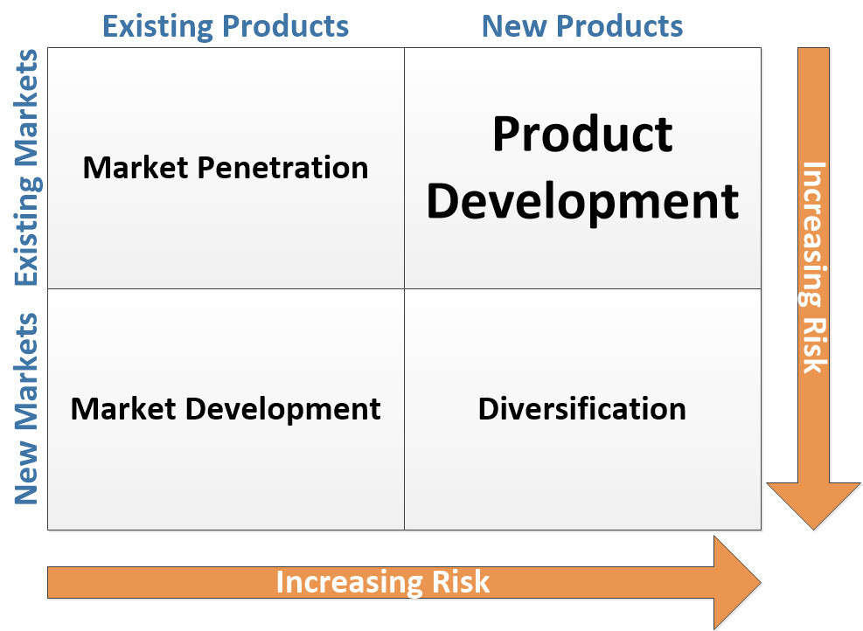
Figure 1 Ansoff Matrix, Source: (Fortin 2017).

Market Penetration
Market penetration focuses on increasing the sales of existing products and services into existing markets. Verdant Leisure can focus on increasing its market share by reducing the cost of attracting new customers. It can use various promotion and distribution channels to achieve this strategy. It should increase the number of parks and hotels for potential customers, who may be looking forward to having comfortable stays in its various entertainment locations. It should also target young people, who are interested in adventure while on holiday stays. This can be achieved by promoting its various parks and providing attractive prices and discounts.

Product Development
Product development is concerned with expanding products and services along various demographics and to target new customer segments. Extensive research and development is conducted with a focus on the areas of competition with other firms in the same market (Fortin 2017). Verdant Leisure has achieved this with the introduction of new services, including attractive hotel stays for customers in different parts of the country. For example, customers have enjoyed locations that provide British heritage (Verdant Leisure 2023). The company has also focused on gaining competitive advantage over the new and emerging hotels that provide new services. Customers have had a wide variety of locations to choose from.

Market Development
This strategy involves entering new markets and expanding into various market geographies. This is achieved by catering to various customer segments and expanding regionally and internationally (Fortin 2017). Due to the competitive nature of the hospitality industry, the company has focused on expanding to attract a large number of customers. It has expanded into new customer segments and increased the market share of parks and hotels. Another way in which the company can develop competitive advantage is by creating unique products and services.

Diversification
This strategy involves entering new markets by introducing new products and services. Its purpose is to enable firms to evaluate future business opportunities and growth opportunities in new market areas (Fortin 2017). This is achieved by introducing a diversified range of new products and services. Verdant Leisure utilizes a dynamic business approach, in which it diversifies into various services and hotels. This has been aimed at achieving customer satisfaction. The aim of the company has been to gain competitive advantage in the UK hospitality industry, which is considered highly diversified and with a significant number of new companies.

SFA Framework
The SFA framework, as developed by Gerry Johnson and Kevan Scholes, refers to a tool that is used in the analysis strategic possibilities. It stands for suitability, feasibility and acceptability (Oregon State University 2023). The suitability perspective analyses whether an option that is being considered is suitable for the goal that is to be achieved. The feasibility perspective considers whether an option aligns with the opportunities that are available to an organization (Oregon State University 2023). On the other hand, the acceptability perspective considers the external factors that may impact the strategic options.
There are four main available options for Verdant Leisure that can contribute to the achievement of its long-term sustainable strategy. Option 1 is to use various marketing and distribution channels to market products and services. This option also includes increasing the number of parks and hotels and targeting young people. Option 2 is to introduce new products and services in various parts of the country. Option 3 is to focus on expansion and increasing the customer base. This option also involves creating unique products and services. Option 4 is to introduce a diversified range of new products and services. Based on this, the SFA framework for Verdant Leisure is as below. The framework uses a scale of 1 to 5, with 1 being a better option and 5 being a worst option.
Angles of Approach | Option 1 | Option 2 | Option 3 | Option 4
Suitability | 1 | 1 | 1 | 2
Feasibility | 1 | 3 | 4 | 2
Acceptability | 1 | 1 | 1 | 1
Total | 3 | 4 | 6 | 5
Table 1 SFA Matrix for Verdant Leisure, Source: (Researcher 2023).
Based on the SFA matrix, the best option to consider would be option 1, which is to use various marketing and distribution channels to market products and services and to increase the number of parks and hotels and target young people.

Stakeholder Analysis (Mendelow’s Stakeholder Matrix)
Mendelow’s stakeholder matrix is a tool that is used in analysing stakeholder attitudes and expectations, as well as, their impact on business decisions. This matrix is based on two key variables, which are power and interest. Power is about the ability of stakeholders to induce, coerce and persuade other groups to take specific courses of action (Wesonga 2018). On the other hand, interest is about the likelihood of stakeholders to be motivated to use their power to ensure that their needs are met. Based on this, Mendelow developed four main categories as indicated below.
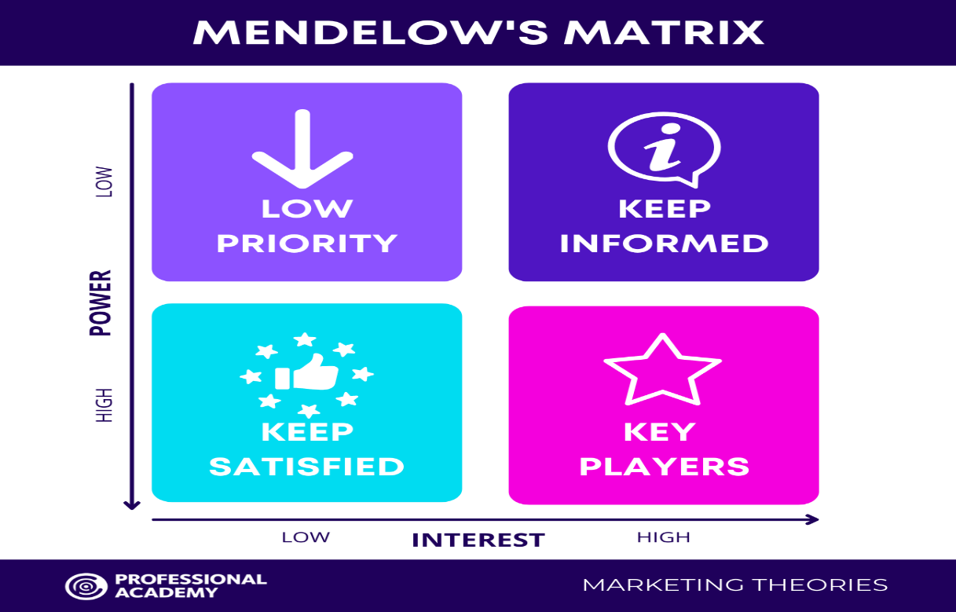
Figure 2 Mendelow’s Matrix, Source: (Professional Academy 2023).

High Power and High Interest
Stakeholders that have a high power and high interest are very crucial for a business. In the case of Verdant Leisure, these stakeholders include suppliers, technology providers and employees. They play an essential role in providing goods and services aimed at meeting the demands of customers.

High Power and Low Interest
Stakeholders with high power and low interest are important for a business, and as such, need to be satisfied. In the case of Verdant Leisure, these stakeholders include consumers and the government. The company must follow government legislation and policies and must also upgrade its products and services to meet the demands of consumers.

Low Power and High Interest
Stakeholders with low power and high interest must remain informed at all times. In the case of Verdant Leisure, trade unions are the main stakeholders with these features. The company must inform trade unions about employee engagement and benefits. This is mainly because failure can lead to legal and ethical issues, which might negatively impact the company.

Low Power and Low Interest
Stakeholders with low power and low interest should be monitored as they have an impact on the business. For Verdant Leisure, these stakeholders are mainly the public, who are not its customers but might show interest in their products and services. The company must ensure that it maintains a positive reputation to keep the public happy.

Conclusions and Recommendations: Strategic Implementation, Monitoring and Evaluation

Conclusions
This report has provided a detailed analysis of the plan for growth for Verdant Leisure, which is an SME in the United Kingdom. Various models and theories have been applied in conducting a strategic analysis of the company. They include the Porter’s value chain model, PESTEL analysis, Porter’s five forces model, and SWOT analysis. These theories and models have helped in the identification of the best growth opportunity for the firm. It can thus be concluded that the company should consider both the internal and external environment factors when selecting the best growth opportunity. It can also be concluded that the company should enhance its decisions on capital management. Considering these aspects will ensure that the firm is managed effectively to lead towards success.

Recommended Strategic Direction
The recommended strategic direction for Verdant Leisure is to use various marketing and distribution channels to advertise its products and services across various geographical locations. Coupled with this, the company should increase the number of parks and hotels and ensure that it targets the young population, who are highly interested in adventure.

Timeline of the Strategic Implementation Process
The strategic implementation process should begin with defining the goals of the strategy to be achieved. In this case, the goals are to develop marketing and distribution channels, to increase the number of parks and hotels and to target the young population. Research should then be conducted before the final strategy is effectively developed. The implementation of the strategy should involve work delegation and clear responsibilities and duties must be assigned. Marketing and distribution should begin immediately and be completed in the next six months. Parks and hotels should be increased bi-annually to ensure that there are many options. Within the next five years, the company should have sufficient customers, including the young population.

Benefits and Drawbacks
The proposed strategic direction will ensure that the company increases its customer base, and as such, increasing revenue and profits. It will ensure that the company’s brand is marketed all over the world, and as such, increasing opportunities for expansion. It will also ensure that has a wide variety of options for holiday homes, and as such, fully meeting the needs of its consumers.
If the proposed strategic direction is not followed, the company might face challenges in promoting its brand. It will be difficult for the company to have access to new consumer segments. The company will also have limited products and services, and as such, failing to meet the needs of its customers. This can negatively impact its revenue and profitability.

References
Calicchio, S 2020, ‘Swot Analysis in 4 Steps’, United Kingdom, UK: Stefano Calicchio.
Department for Digital, Culture, Media & Sport 2021, ‘The Tourism Recovery Plan’, Available from https://assets.publishing.service.gov.uk/government/uploads/system/uploads/attachment_data/file/992974/Tourism_Recovery_Plan__Web_Accessible_.pdf (30th Mar. 2023).
Dincer, H & Yuksel, S 2019, ‘Handbook of Research on Decision-Making Techniques in Financial Marketing’, Pennsylvania, PA: IGI Global.
Entin, SJ 2022, ‘A Tale of Two Tax Plans in the United Kingdom’, Tax Foundation. Available from https://taxfoundation.org/rishi-sunak-uk-tax-plan/ (30th Mar. 2023).
Fortin, F 2017, ‘Ansoff Matrix Essntials’, South Carolina, SC: CreateSpace Independent Publishing Platform.
Office for National Statistics 2023, ‘Tourism Industry’ Available from https://www.ons.gov.uk/businessindustryandtrade/tourismindustry (29th Mar. 2023).
Oregon State University 2023, ‘Strategy Analysis Framework (SAF)’, Available from https://open.oregonstate.education/strategicmanagement/chapter/8-strategy-analysis-framework-saf/ (29th Mar. 2023).
Perera, S 2020, ‘Understanding Porter’s Five Forces Analysis’, Avissawella, Sri Lanka: Nerdynaut.
Professional Academy 2023, ‘Mendelow's Matrix - Marketing Theories’, Available from https://www.professionalacademy.com/blogs/mendelows-matrix-marketing-theories/ (29th Mar. 2023).
University of Cambridge 2023, ‘Porter’s Value Chain’, Available from https://www.ifm.eng.cam.ac.uk/research/dstools/value-chain-/ (29th Mar. 2023).
Verdant Leisure 2023, ‘About us’, Available from https://www.verdantleisure.co.uk/about-us/ (29th Mar. 2023).
Verdant Leisure 2023, ‘Modern Slavery Statement’, Available from https://www.verdantleisure.co.uk/media/1gxks1to/modern-slavery-statement-fy23-website-copy-30.pdf (30th Mar. 2023).
Wesonga, A 2018, ‘Strategic-Purpose: Stakeholder-Mapping’, Munich, Germany: GRIN Verlag.

