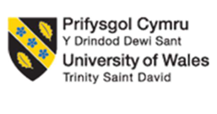
Student Name: Meet Dilipbhai Patel
Student ID: 2532591
Module Name: International Business Concepts (LCMB7034)
Lecturer Name: Charles Oham
Word Count: 5473
Submission Deadline: 14th August 2026

Table of Contents
Introduction 3
Section 1: 4
1. Organisational Classification and Global Strategy 4
1.1 Strategic Categorisation: Bartlett and Ghoshal Analysis 4
1.2 Critical Analysis: Strengths and Limitations 5
1.3 Global Configuration and Geographic Footprint 5
1.4 Competitive Advantage and Value Creation 7
2. Macro-Environmental Appraisal and Market Attractiveness 8
2.1 Host Country Analysis 8
2.2 Market Entry Analysis: The Eclectic (OLI) Paradigm Synthesis 14
3. Entry Mode Strategy and Strategic Synthesis 18
3.1 Historical Pattern Recognition 18
3.2 Strategic Fit & Justification for Nigeria 19
3.2.1 Assessing the Suitability of McDonald's Historical Entry Mode for Nigeria 19
3.2.2 Risk and Resource Commitment 19
3.2.3 Control versus Flexibility 20
3.2.4 Long-Term Strategic Fit 20
3.3 Conclusion & Recommendations 21
Section 2: Reflective Account 22
References 26

Introduction
Multinational corporations in the era of rising globalisation need to work at striking a delicate equilibrium of globalisation and local sensitivity as the competitive edge. The report focuses on McDonalds Corporation, which is among the most recognisable brands in the world of quick-service restaurants and determines its strategic potential in expanding to the Nigerian market. The analysis starts with a classification of the international strategy of McDonalds based on Bartlett and Ghoshal framework, and a macro-environmental analysis of Nigeria based on political, economic, legal and cultural environments, and the Eclectic (OLI) Paradigm. It also determines suitable modes of market entry which lead to strategies suggesting strategic recommendations. Gibbs has seven reflexive cycles of theory and practical application, so the report concludes with a reflective account that captures major learning outcomes.

Section 1:

1. Organisational Classification and Global Strategy

1.1 Strategic Categorisation: Bartlett and Ghoshal Analysis
Classification of McDonald's International Strategy using the Model
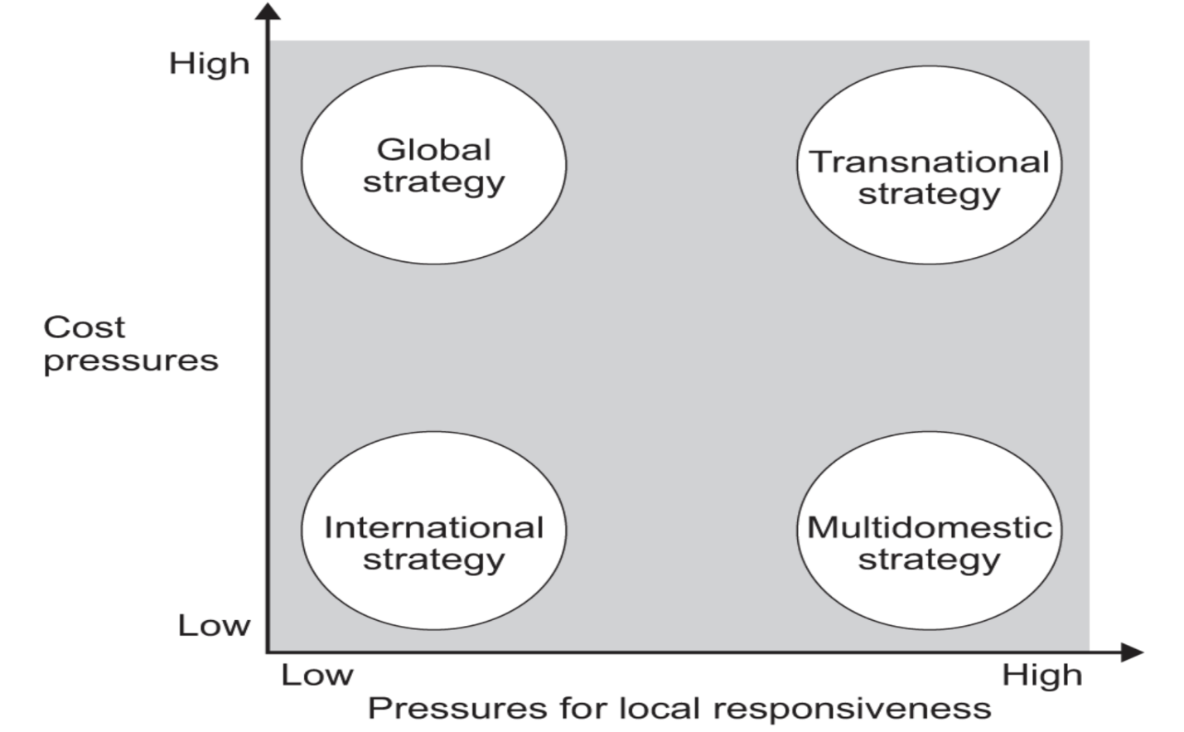
Figure 1: Bartlett and Ghoshal’s Model
(Source: AQA, 2020),
According to the model of Bartlett and Ghoshal (1989), an MNC might emerge as one of four types of international strategies depending on two variable: Global integration and Local responsiveness. There are four classifications: International, Global, Multidomestic and Transnational strategy. A Transnational Corporation (TNC) is high on world-wide efficiency as well as local responsiveness in terms of adapting to the needs of local markets. In the framework of Bartlett and Ghoshal (1989), McDonald's can be characterised as a Transnational Corporation (TNC) as it attempts to achieve a high level of "global integration" and "local responsiveness (AQA, 2020). By standardising its key strengths, such as the well-known brand, operating procedures, quality control and integrated supply chain, the Company has attained a high level of global integration, which facilitates the provision of a uniform quality of services and allows for achieving sizeable economies of scale across the international markets. With its business model of operating on a global scale, there were more than 43,000 restaurants in more than 100 countries and territories at the end of 2025 (McDonald's Corporation, 2026). At the same time, the company has shown its high local responsiveness with its approach of “glocalisation” which means to alter both the menu as well as the marketing accordingly with the local cultural, religious and dietary concerns, such as selling “McAloo Tikki Burger” in India and halal certified products in Muslim countries. This blend of global efficiency and localised adaptations helps McDonald's maintain a competitive edge and satisfy varying customer demands across the globe (Lu, 2024).

1.2 Critical Analysis: Strengths and Limitations
The reason behind this is that the transnational strategy of McDonald can only be sustained through Adaptive Leadership that helps leaders balance the need to standardise on a global level and on the other end to remain locally sensitive. Founded on the framework of Heifetz, adaptive leadership underlines identifying problems, forming cross-cultural teams, and promoting experimentation instead of using precise technical solutions (Nwanaga and Uzoka, 2022). Inside McDonalds, this leadership method will allow regional managers to decode cultural, religious and dietary expectations, tweaking menus and marketing without entirely altering the spirit of the core brand of the corporation. It also nurtures learning driven behaviours and enables the organisation to react promptly to the changing consumer trends, regulatory forces and supply chain improving various market places. Through a blend of authority and distributive decision making, adaptive leadership lowers the cost of coordination and removes the complexity of operations of the transnational strategies, which in the end strengthens the capacity of McDonalds to affect the competitive environment negligently at global and importantly local level.

1.3 Global Configuration and Geographic Footprint
McDonald's has its headquarters in Chicago and is a one of the biggest global quick-service restaurant chains. The company has more than 43,000 restaurants in more than 100 countries and territories with millions of customers visiting each location every day (McDonald's Corporation, 2026). It operates internationally across three business segments: United States, International Operated Markets (IOM) and International Developmental Licensed Markets & Corporate (IDLM&C). The IDLM&C segment includes over 75 countries or territories, and restaurants are mostly run by franchise and license (McDonald's Corporation, 2026).
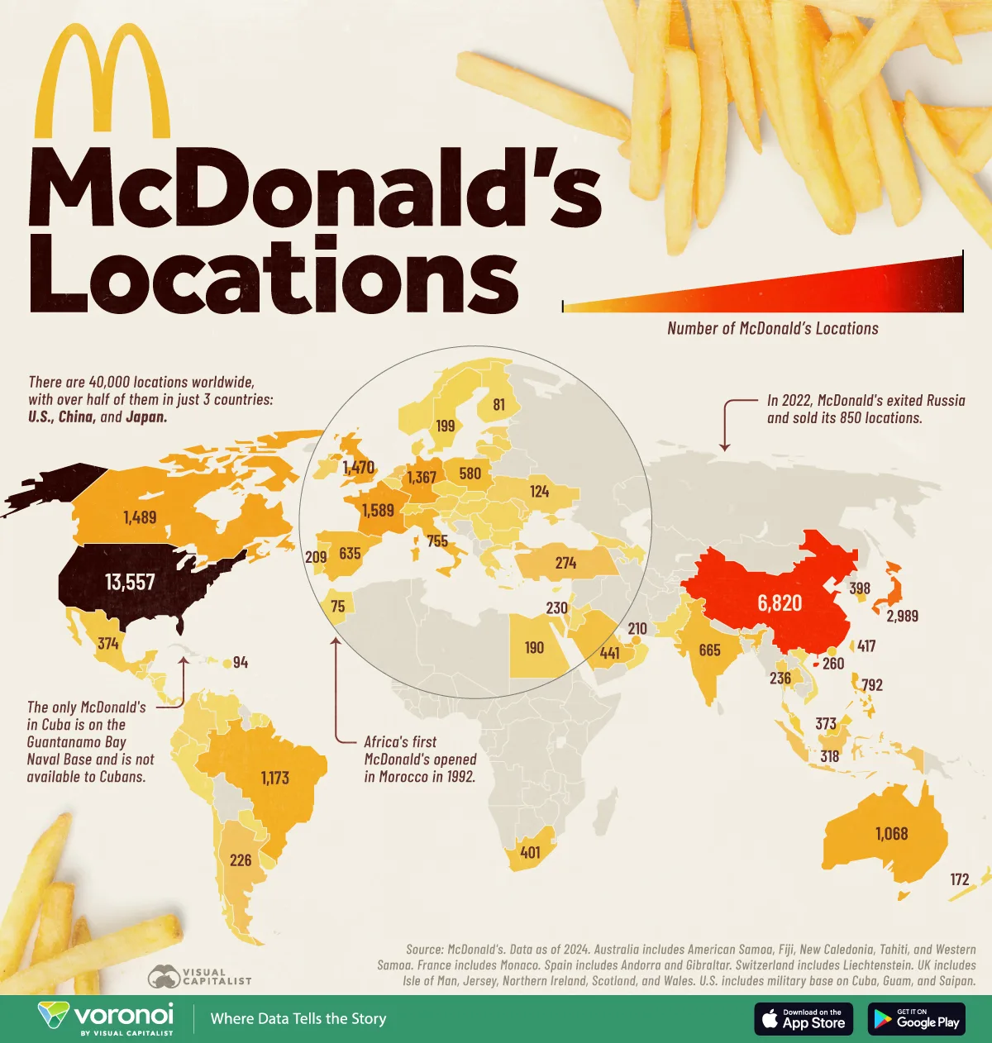
Figure 2: McDonald’s Location
(Source: Visual Capitalist, 2023)

1.4 Competitive Advantage and Value Creation
The three significant strategies that enable McDonald's to sustain its competitive advantage are the efficiency of the supply chain, the standardisation of its brand, and operational excellence. It has a globally integrated supply chain to ensure sourcing, quality control, timely delivery of products and create economies of scale to reduce operating costs. Standardisation of the brand helps McDonald's ensure that its customers have a similar experience at the company's restaurants in over 100 countries, enhancing their customer trust and loyalty to the brand. Furthermore, when it comes to operational excellence, the digital technologies, automated restaurant systems, and its loyalty programme complement its operations. In 2025, the world's second largest restaurant chain, McDonald's, recorded more than 200 million customers with 90-day active loyalty engagement in over 70 markets, highlighting the success of the company's digital journey in improving customer retention and sales (Yahoo Finance, 2024). All of these capabilities will enhance efficiency, boost competitiveness throughout the world, and help generate long-term value, which will buoy McDonald's ongoing growth in high-potential markets like Nigeria.

2. Macro-Environmental Appraisal and Market Attractiveness

2.1 Host Country Analysis
Political Factors:
The Nigerian political environment provides a major factor to determine the success of market entry for McDonald's as it is more complex in nature and it is a benefit – cost – risk trade off. Although the country has a tremendous demographic potential, some "political instability and risks" dissuade multinational enterprises (MNEs) from investing, set-up or stepping up business activities in this country as compared to its more stable democratic counterparts.
Governmental Intervention and Policy Framework
The political policies of host countries those that define where and how business takes place in the country are a key factor in international business operations. For a TNC such as McDonald's, it means coping with the ‘restrictions imposed by government intervention' within the system of international trade and investment. Those "large global MNEs" when coming into a host state's market can lead to what host governments see as a "loss of national sovereignty and autonomy", which can cause some host governments to intervene.
Current Statistical Indicators
- Demographic Scale:Nigeria ranks among the 7 countries in the world whose population surpasses 200 million, with a large population base, yet complex and diverse in order to be categorised as a politically complex consumer base (Ministry of Foreign Affairs of Denmark, 2026).
- Regional FDI Context: However, FDI inflows grew by 12% to about US$62 billion, signalling a rising investor confidence across the continent (UNCTAD, 2024).
- Institutional Integrity: Nigeria also generally struggles with institutional issues, with a score in the lowest third on international assessments like Transparency International's Corruption Perceptions Index (CPI) (e.g., about 142nd among 182 countries) in early 2026 (National Institute for Legislative and Democratic Studies, 2026).
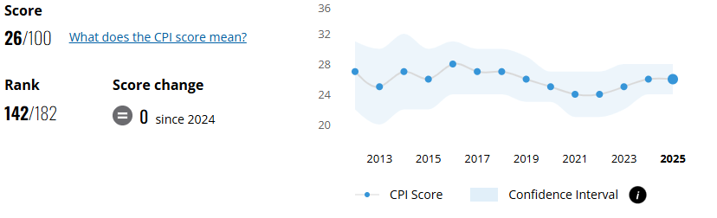
Figure 3: Nigeria Corruption Perceptions Index
(Source: Transparency International, 2025)
In a "politically unstable" country in particular, the disciplines of social science, such as politics and law, are necessary so that the managers can adjust the functional strategy of the company. For McDonald's, all these imply an alternative strategy that will reduce "economic exposure" and take advantage of "government-backed insurance programs" to deal with foreign investment risks. In the end, the rapid pace of change and the high political risk might make a high-control option such as a wholly-owned subsidiary less desirable than a partnership with shared risks.

Economic Factors:
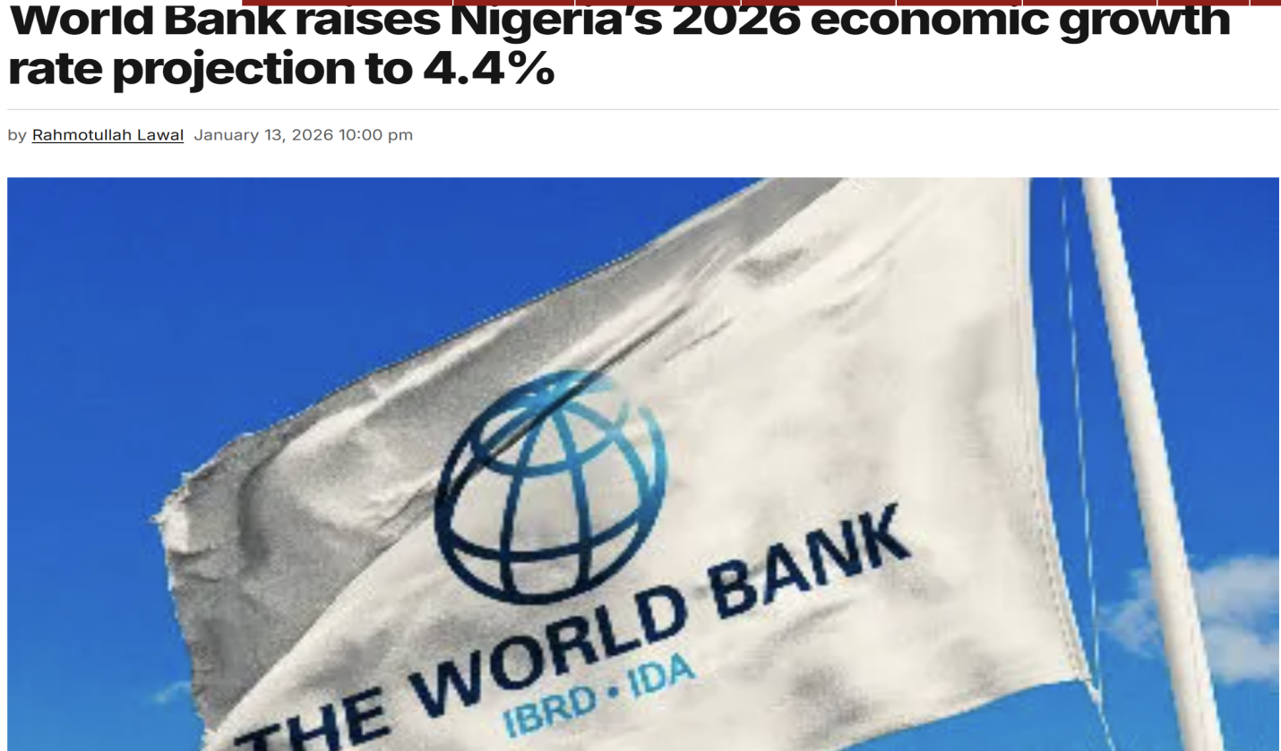
Figure 4: World Bank’s Prediction of Nigerian Economy
(Source: Lawal, 2026)
Nigeria stands out with potential markets as a large consumer in the fast-food world. Nigeria is estimated to have a population of 237.5 million in 2025, ranking it the sixth most populous nation in the world and its population is expected to continue growing at a rapid pace, thereby demanding an increasing number of quick-service restaurants and/or other consumer products (UNFPA, 2024).The World Bank expects Nigeria's economy to expand by 4.4% in 2026 on back of further macroeconomic reforms, reconstruction of industry, agricultural sector and improved non-oil industrial sector (Daily Telegraph Nigeria, 2026). The world bank also predicted growth to 2.6 % in the Nigerian Economy which gives a green light to MacDonald to expand into.
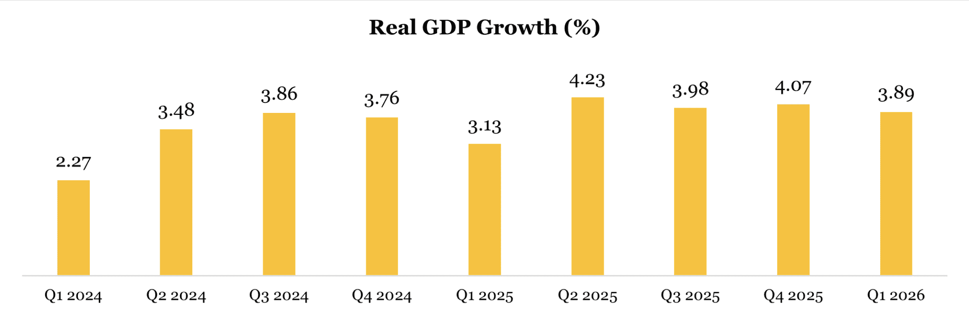
Figure 5: GDP of Nigeria
(Source: partners, 2026)
As per the data of NBS, Nigerian economy started to grow in real terms from Q2 2024 and is in consistent with growth which is why investors are looking to expand their business in such African countires.
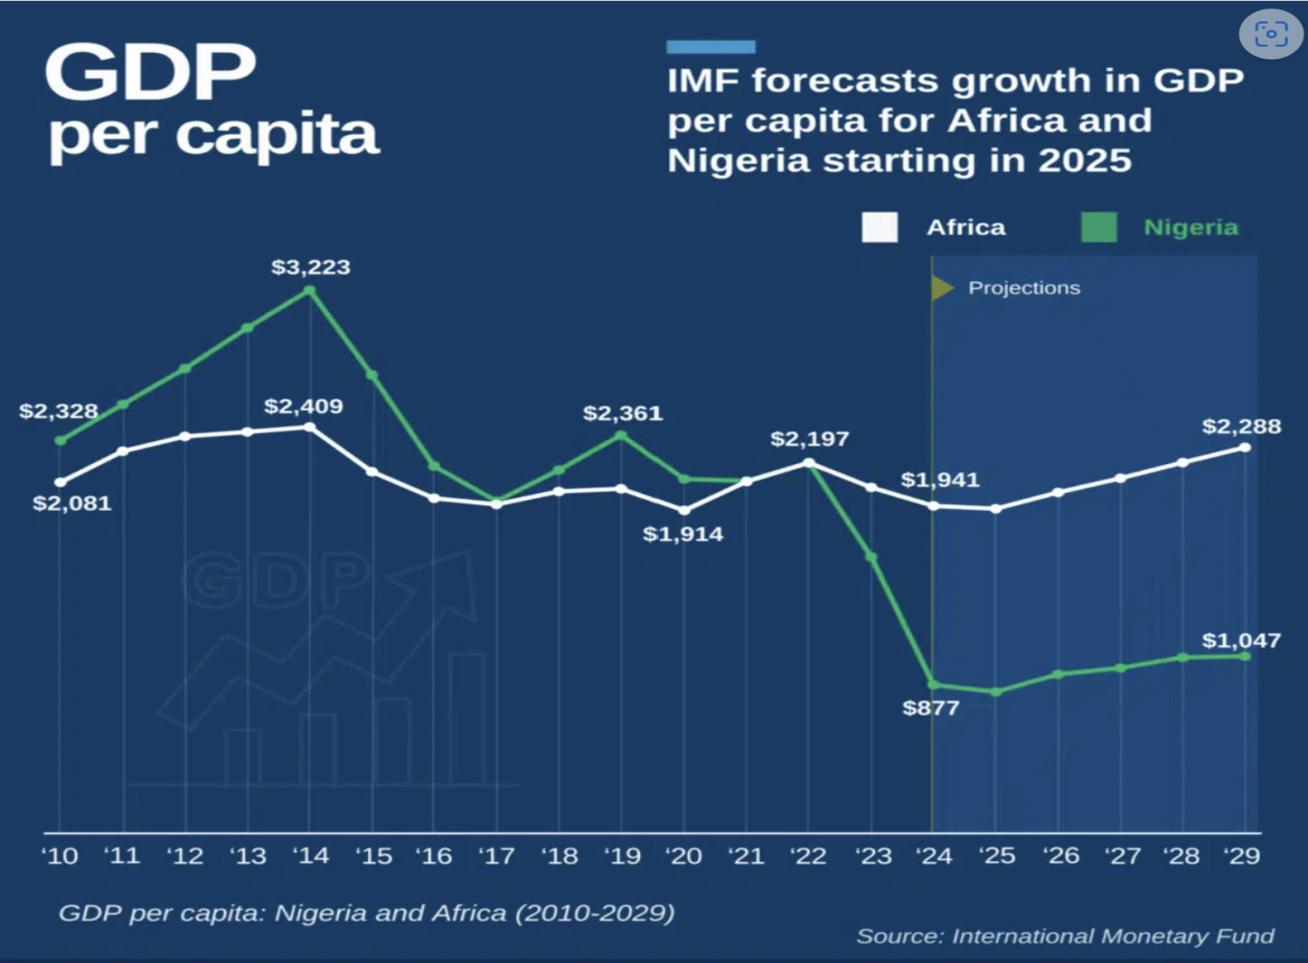
Figure 6: Nigeria’s GDP Forecast
(Source: Eghosa, 2025)
As evident in the above figure, the IMF also forecasted that there would be a considerable amount of spike in the GDP per capita of Nigeria and overall Africa from 2025. However, the Volatility of Foreign Exchange is another great difficulty for businessmen in foreign countries. Since the Nigerian naira's rate was liberalised in 2023, it has fallen by a lot, making imported raw materials, equipment and any franchise payments more expensive, and making profits less valuable if exchanged for foreign currencies. The IMF estimates that Nigeria's annual inflation rate will be around 15.4% in 2026 as a result of these factors, with shocks still being a potent source of inflation (International Monetary Fund, 2026). There could be a risk of hpurchasing power as income levels are still relatively low and income distribution is still very uneven. Foreign investors also face difficulties in financial planning, pricing and profit repatriation due to the continuous fluctuations in exchange rates. Beyond this, emerging markets, like Nigeria, remain vulnerable to shocks in the supply chains as well as fluctuations in commodity prices and from time to time supply of imported inputs. These risks can create some uncertainty for global restaurant chains, where providing consistent product quality and timely sourcing are critical to their operations. However, Nigeria's growing urban population, growing middle-class consumers, and continuing economic reforms offer long-term growth prospects.
Legal Factors:
The legal climate of Nigeria plays a significant role in the activities of the multinational food-service corporations such as McDonald's in the Nigerian legal system. Multinational food-service companies like the dependence of McDonald's on the Nigeria legal system are greatly influenced by the legal environment of the country. Labelling, consumer protection, quality, and food safety standards are regulated by the National Agency for Food and Drug Administration and Control (NAFDAC) and the Federal Competition and Consumer Protection Commission (FCCPC) which food businesses are required to adhere to (NAFDAC, 2025). Further, labour activities are regulated under the Labour Act and all employment laws and spread out a set of minimum employment standards and provisions for workplace security and wellbeing for the employees, are to be adhered to by the business.
If McDonald's were to enter Nigeria via franchising or joint ventures, then strong contractual protection is a must. Well-defined and crafted franchise contracts with regard to operation standards, quality control, royalty payment, resolution of disputes and monitoring of performance reduce the opportunity for opportunistic behaviour by local franchise holders. These legal instruments are built to ensure that the local level standards point to maintaining McDonald's universal standards for operation, while minimising other often found agency conflicts associated with emerging markets and developing regulatory frameworks.
Intellectual property (IP) protection is also key, as the competitive advantage of McDonald's hinges on the trademarks, recipes, operating systems and brand reputation it has built up around the world. Nigeria is also a member State of the World Intellectual Property Organisation (WIPO) and a party to over 11 WIPO treaties, thus creating a legal basis for trademark and patent protection (WIPO, 2026).Despite the advancements in the legal and institutional landscape, Nigeria is still ranked 105th out of 139 economies on the Global Innovation Index (GII) 2025, highlighting that while its innovation capabilities have improved over the last few years, its innovation ecosystem still has a struggle on hand and so is its lodging of institutions and IPE (World Intellectual Property Organization, 2025) . Thus, it is prudent for McDonald's to register its trademarks locally and enforce the same, carry out regular compliance audits and proactively monitor any potential trademark infringing activity or counterfeiting in order to protect its proprietary rights and uphold the integrity of its brand.
Cultural Factors:
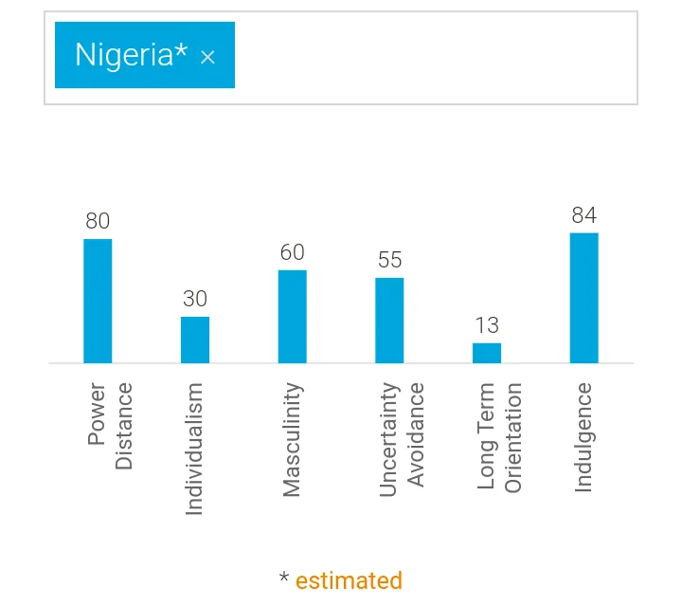
Figure 7: National Cultural Dimmensions
(Source: Charles, 2026)
Nigeria's cultural atmosphere is very important in shaping the preferences of consumers and the strategy of approaching the market for a product by any multinational company like McDonald's. Nigeria has a score of 80 on Power Distance, which suggests that Nigerians are not overly afraid of authority and 84 on indulgence, which implies that Nigerians have a high value for enjoyment, leisure, and freedom of consumption and choice (Adeyeye, 2025). From the cultural aspects, it could be inferred that internationally recognised fast food brands are often viewed as prestige, quality and modernity symbols, especially in the eyes of urban middle-class consumers. These preferences present the opportunity for McDonald's to be a high-quality, but still affordable, fast food restaurant. Consumer behaviour and labour management are also significant attributes that are influenced to a great extent by social stratification. There is a relatively high level of income inequality in Nigeria, as shown by the Gini Index of about 35.1 (Dataphyte, 2023). More frequent branded fast food buying was seen with those in higher income groups in the city, while price sensitivity is high with those in lower income groups.
The dietary preference and the diversity in religious groups further substantiate the need to embrace glocalisation. Nigeria is almost equally divided between Christians and Muslims, and catering to either culture is essential in the adaptation of menus. In Muslim-majority areas, McDonald's would have to offer halal-certified items, while at the same time adding local, popular tastes and components in its menu. It is also crucial to consider the language, festivals, and cultural values in the region when creating marketing communications, as it can help minimise cultural distance and enhance customer acceptance. McDonald's can offer a more satisfying experience to customers by integrating its global brand, while ensuring its products and services are locally adapted, thereby strengthening brand loyalty and sustainable competitive position in the Nigerian market (EduBirdie, 2026). Such a mix of worldwide consistency and local responsiveness is essential for successful expansion on an international scale in culturally different emerging markets.

2.2 Market Entry Analysis: The Eclectic (OLI) Paradigm Synthesis
Ownership (O) Advantages:
Dunning's 'Eclectic (OLI)' Paradigm states that McDonald's has strong ownership-specific advantages (O advantages) and can use them to help gain a sustainable competitive advantage when entering an emerging market like Nigeria. Most important is its brand, which has global recognition, advanced management know-how, sophisticated capability in the supply chain and highly standardised operating systems, all factors that the local competitors cannot easily duplicate. McDonald's has always been in the top list of the world's most valuable restaurant brands. The strong reputation and customer confidence of the McDonald's brand is manifested in its valuation of around US$40.5 billion, according to Brand Finance's Global 500 Report 2025 (Global Coffee Report, 2024). Not only does this powerful brand help the company capture consumers' attention in new markets, but it also lowers marketing expenses for brand awareness.
In addition, one of the big ownership benefits is the management and operational know-how that McDonald's brings to the table. The company has standardised procedures all around the world that encompass restaurant processes, food preparation, quality control, stock control, employee training and customer service. These systems guarantee the quality and efficiency of products and/or operations irrespective of the position in the market. The successful implementation of McDonald's integrated global business and capabilities is reflected in its estimated total revenue in 2025, which was around US$26.0 billion (Meihua International Medical Technologies Co., Ltd., 2024). In addition, McDonald's has developed a highly effective logistics and supplier management system, which will allow for efficient procurement and inventory management. International standards can be brought to Nigeria by way of training of its franchisees, supplier development programs, and digital management of the restaurants, which will allow local restaurants to reach international standards.
Location (L) Advantages:
Nigeria has some country-specific factors to make international expansion easier for McDonald's in view of the challenges encountered by the company, according to Dunning's Eclectic (OLI) Paradigm. The primary asset of this country is its size and growing consumer market. According to the United Nations World Population Prospects, Nigeria's population in 2025 is approximately 222.78 million, making it the largest market in African (Intelpoint, 2026). Also, Nigerians are urban dwellers, and quick service firms will find the trend of increasing income, lifestyle and demand for convenient dining attractive.
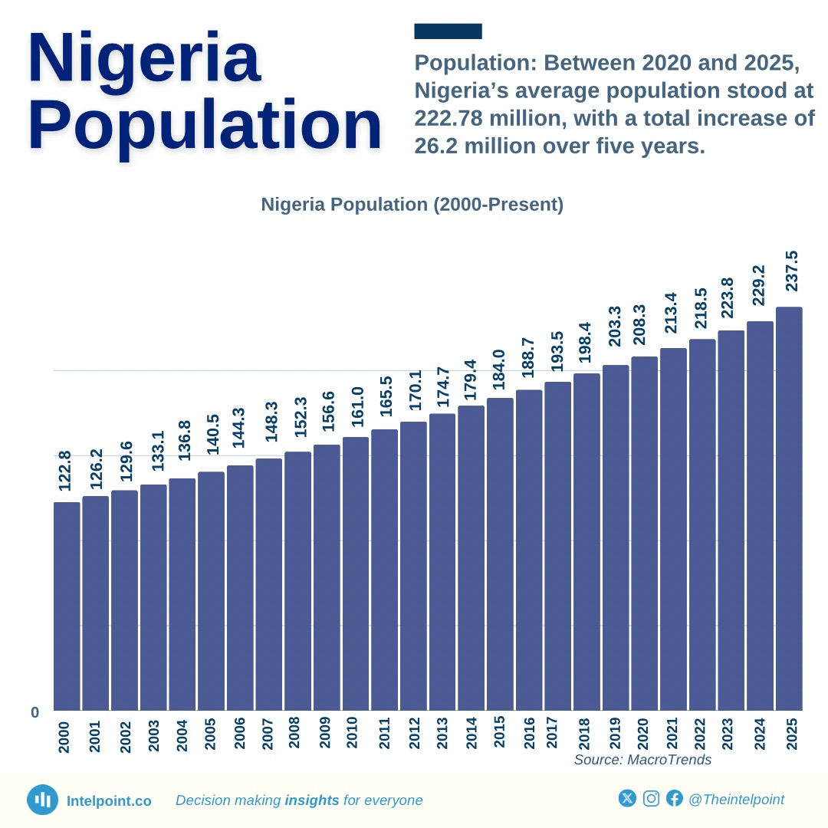
Figure 8: Nigeria Population
(Source: Intelpoint, 2026)
Locational Economies can also be realised in Nigeria by sourcing locally and developing regional supply chains. The country's enabling environment is large with a rich agricultural base for commodities like poultry, potatoes, cassava, tomato and vegetables for supporting the company's custom of sourcing from its countries, and reducing reliance on imported inputs. Moreover, Nigeria joined the African Continental Free Trade Area (AfCFTA), which offers a regional market with a US$3.4 trillion GDP—the latest official estimate by UNCTAD, the World Bank, and the AfCFTA Secretariat (Nigeria, United Nations, 2024). But there are considerable risks for the business to ponder as well. In 2025, Nigeria's inflation rate is expected to be at around 16.9%, which will drive up the operations costs, squeeze consumers' purchasing power and present price-challenge opportunities to multinationals like McDonald's (TechEconomy, 2026). These factors make the operation of a multinational company more expensive and risky.
Internalisation (I) Advantages:
Dunning's Eclectic (OLI) Paradigm builds on internalisation theory that says McDonald's has strong internalisation (I) advantages as it is better for this company to keep control over their proprietary assets rather than to simply put them out for license. Currently, in the Nigerian market, McDonald's brand name can be maintained, operating quality can be controlled, and management skills can be maintained in a master franchise or joint venture arrangement with a local partner who understands the market. The keys to McDonald's competitive advantage are its secret operating procedures, its quality assurance programs, employee training, its advanced tech system and supply chain management (Dudovskiy, 2024). The independence of the licensee with limited corporate control may also pose a greater risk of varying product quality, low-quality customer service and the failure to follow proper trademark or trade secret usage.
Identify Key Factors Influencing Entry Success
McDonald's organisational structure plays a major part in its successful international expansion. Around 95% of its restaurants are run by franchisees, and the company has a strong adherence to its brand, restaurant design, supplier selection, and operational procedures (MMCG Invest, 2024). This governance introduces various marketing flexibility, while still retaining the uniformity of product and customer experience throughout the international markets and drawing from local entrepreneurial skills. Moreover, the company spent about US$3.4B on capital expenditures in 2025 as the company is dedicated to the expansion of its restaurant network, the development of digital capabilities, and operational excellence (McDonald's Corporation, 2026). These firm-specific resources, such as brand equity, advanced management know-how and standardised operating systems, are important for a successful market entry and creating a sustainable competitive advantage.
Critically Evaluate the Attractiveness of the Chosen Market
Despite the potential of this large consumer market in Nigeria, rapid urbanisation and surging demand for international quick-service restaurants (QSR), there are also major hurdles, such as political unrest, volatile currency rates, high inflation, and weak infrastructure. Under these circumstances, wholly Owned Investment is relatively risky. Therefore, a Master Franchise Agreement/Joint Venture makes up for the most appropriate entry mode (Locnapps14, 2024). It allows McDonald's to benefit from the local market knowledge, reduce investment cost and risk, and retain effective control of its proprietary technology and management know-how and global operating standards.

3. Entry Mode Strategy and Strategic Synthesis

3.1 Historical Pattern Recognition
Review of Historical Entry Modes

Franchising
McDonald's has always relied on International franchising for market entry in foreign markets. In this model, independent operators, identified by McDonald's trademarks, have restaurants that leverage the brand's business model and standardised operating systems and meet the strict corporate standards for quality, service, and supply chain management. The company's growth in this way has helped it to reach countries and territories that do not require as much capital investment, and operations are still relatively simple, allowing it to ensure that it has a firm grip over its brand on a global level.

Joint Venture (JV)
Multinational companies have been resorting to joint ventures for entry into culturally or institutionally complicated markets. For instance, McDonald's opened first in China in 1990 in a joint venture, allowing for some adaptation to the local market while ensuring standards of operation and consistency of the brand across all global restaurants (Locnapps14, 2024). Just like that, McDonald's has engaged in joint ventures and master franchise agreements, allowing it to enter certain markets where having local knowledge and regulatory assistance is crucial to market entry success.

Acquisition
Another key international entry mode has been acquisition, especially for companies looking for a quick market footprint when they are retailers. For instance, In 1996, McDonald's expanded to India via joint ventures to guarantee that quality and food safety could be implemented in the market whilst also keeping the operation and control of the company intact and known. However, to enter Asia Tesco chose to explore the Asia environment through joint ventures, such as that it formed with Hymall in 2004, involving both in the venture 50-50 (CliffsNotes 2026).

Greenfield Investment
Greenfield investment means building up wholly owned operations and offers the highest degree of control over the operations. Tesco's first foray into China was through greenfield investment, establishing wholly owned stores, while greenfield investment at the end of the day, as well as through joint ventures, Tesco partnered with China Resources Enterprise (CRE) (CliffsNotes, 2026). Though this is a more controlled approach, it does involve a substantial capital investment and heightens political and financial risks for firms, which makes them less effective for volatile emerging markets.

Strategic Implications
Taking an internalisation theory point of view, McDonald's always chooses those entry methods that guard the know-how, operating systems, and world-renowned brands. Historically, this equating franchising and selective JVs offers the best fit when it comes to global control, local responsiveness and risk reduction – and this makes it a very suitable model for markets like Nigeria with complexities.

3.2 Strategic Fit & Justification for Nigeria

3.2.1 Assessing the Suitability of McDonald's Historical Entry Mode for Nigeria
McDonald's has a history of global expansion mainly using the concept of franchising supported by master franchise agreements, allowing for rapid international expansion while ensuring control of the brand, operating system and quality standards. A combination of a Joint Venture (JV) and a Master Franchise Agreement is a more strategic fit instead. Nigeria is a country that offers significant market opportunities, with a growing urban population. As per Nigeria's World Urbanisation Prospects (2024) of the United Nations, nearly 56 per cent of the country's population will reside in urban areas by 2025, driving the demand for modern retail outlets and quick-service restaurants (Daily Trust, 2024). In addition, Nigeria's economy is expected to grow by 3.6%, supported by macroeconomic reforms and diversification beyond the oil sector (APA News, 2024). Despite the current economic challenges, these trends are pointing to some good long-term opportunities for McDonald's.

3.2.2 Risk and Resource Commitment
Nigeria has great potential to grow, but it is also a market with some dangers for investments. Political risks, poor communication and transport facilities, high regulatory level costs, fluctuations in the exchange rate, and high inflation make the investment in a 100% subsidiary more challenging. The International Monetary Fund (IMF, 2025) has also projected the inflation rate for Nigeria to be in the region of 26.5%, while the continuing depreciation of the Nigerian naira has placed equipment, technology and food raw materials on the market at higher prices (BusinessDay, 2024). As such, the high-commitment entry modes into Japan, e.g. greenfield investments or wholly owned subsidiaries, are accompanied by significant financial and operational risk for McDonald's. The IMF also upgraded the country's growth prospects for 2025 and 2026, with India showing the highest growth among countries.
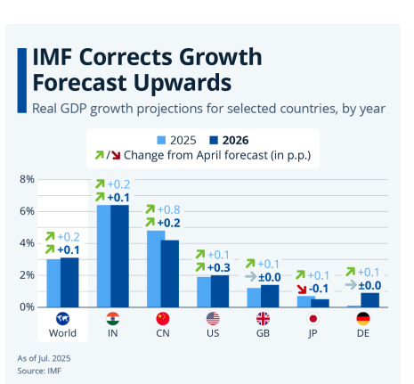
Figure 9: IMF corrects growth forecast upwards
(Source: bne IntelliNews, 2024)

3.2.3 Control versus Flexibility
A Joint Venture (under a Master Franchise agreement) gives McDonald's a good mix of corporate control and flexibility. The pros are that the business might be capable of maintaining control over its individual functioning systems, electronic platforms, restaurant design, top quality control and testing, and internationally recognised brand, even though allowing the neighbourhood spouse to modify marketing and match issues to Nigerian buyer tastes.
This flexibility becomes vital as Nigeria is a high Power Distance culture, which means that business relationships, local networks and institutional knowledge have a huge impact on commercial success (Otiwa et al., 2021). The local partners can thus help ensure that the McDonald's service standards apply worldwide while also facilitating regulatory compliance, supplier development and stakeholder engagement.

3.2.4 Long-Term Strategic Fit
From a long term strategic point of view, it is possible to analyze the Nigerian market using the Volatile, Uncertain, Complex, and Ambiguous (VUCA) framework, which involves analyzing factors such as Volatility (currency fluctuations and inflation), Uncertainty (changing government policy), Complexity (multiple regulatory requirements and infrastructure challenge) and Ambiguity (rapidly changing consumer behavior) (Project Management Institute 2026). A Joint Venture or Master Franchise Agreement helps to ensure McDonald's' proprietary know-how on managing as well as continuous information sharing, quicker decision-making locally and an increased adaptability of organisations (Balogun Harold, 2026).

3.3 Conclusion & Recommendations
The potential market entry of McDonald's in Nigeria is attached to the formidable Ownership (O) cost (e.g., world-class brand name and standardised management know-how), as against the daunting Location (L) cost (e.g potential political instability and extreme foreign exchange (FX) volatility). The magnitude of Nigeria's population estimates indicate the potential for large long-run profits, but the "benefit–cost–risk trade-off" is weighed down by economic exposure and infrastructural problems associated with volatile frontier markets.
Hence, a Master Franchise Agreement or a Joint Venture is recommended as the best option for entering the market. This enables risk mitigation in that financial risk is shared with a local partner who also has essential host-country expertise (Davis, 2026). So these modes allow McDonald's to achieve strategic coordination worldwide and safeguard its exclusive operating systems as well as give the responsiveness it needs to be successful in the complicated and unstable socio-economic climate of Nigeria.

Section 2: Reflective Account
Gibbs' Reflective Cycle (1988) is a systematic learning model that involves describing, feeling, evaluating, and summarizing an experience before providing and recording your learning and planning for the next practice (Creately, 2026). This reflective piece uses Gibbs’ Reflective Cycle to analyse the research and preparation for the report on the possible entry of McDonald's in the Nigerian market.

Figure 10: Gibbs’ Reflective Cycle
(Source: McLeod, 2025)
1. Description:
The task involved picking a Multinational Corporation (MNC) and selecting a target country where the chosen firm has no significant operational presence, and making a 5000-word strategic appraisal. For this reason, I decided on the McDonald's Corporation as my model because it can be said to be the top-most world brand, and I identified Nigeria as my target market because Nigeria is one of the most populous countries in the world and has never had a McDonald's restaurant. Three key requirements of the assessment steered my type of approach: Strategic taxonom, Bartlett and Ghoshal approach to classify different modes, Nigeria macro-environmental assessment, and Nigeria entry mode strategy evaluation. I used some case studies given out during the course of Starbucks, IKEA and Tesco to compare the historic trends that have occurred around McDonald's to those of other companies around the world. In addition, I also incorporated other authoritative sources from outside my own research efforts, such as the IMF, UN and the World Bank, to give the empirical content needed to fashion this "comprehensive critical evaluation".
2. Feelings:
At the start, I was very confident about the firm-specific analysis of McDonald's, Trade mark and Management know-how are well-defined Ownership (O) advantages. But although switching to the Host Country Analysis, I started to feel overwhelmed by the intricate nature of the Nigerian business environment, and my confidence was taken away. The sources pointed out the region's significant "political instability and risks," causing concern about how to substantiate a market entry recommendation. Reading through the assessment specification was a challenge, because there was a transition from a 'purely descriptive overview' to 'critical evaluation' that I had to make. Just saying that Nigeria has 200 million people wasn't enough; I wanted to model how inflation (26.5%) and FX volatility would more tangibly affect the McDonald's pricing and profitability.
3. Evaluation:
Emphasis on using a theoretical anchor, such as the Eclectic Paradigm (OLI Framework). It has helped me make step-by-step considerations of McDonald's internal strengths and Nigeria's location handicaps. The SEC filing (Form 10-K) gave a comprehensive evidence platform to examine McDonald's global setup and financial condition (U.S. Securities and Exchange Commission, 2026). In addition, benchmarking with the Starbucks case-study for Japan was very successful, as it clearly gives an example of how an MNC can approach a Joint Venture company to overcome a "clash of training cultures".
I had my first go at managing my time in the research phase, but again, it wasn't going well. I wasted too much time on the "geocentric vs. polycentric" in staffing under the EPRG Model, which, while relevant, started to take away from the 2,500-word limit of doing the macro environment appraisal. Another significant limitation I discovered was the lack of quality scholarly and organisational documents, in favour of wider-spread general websites, which were advised to be used "sparingly" in the assessment guidance.
4. Analysis: Supporting the Work with Theory and Lectures
In developing my insights, the theories introduced in the module played a pivotal role. The VUCA Framework (Volatility, Uncertainty, Complexity, Ambiguity) was especially useful in week 2 to analyse the Nigerian market. So the inflation rate of 26.5% was considered a "Volatility" challenge, and what I was saying is, McDonald's needs to "build in slack" or "stockpile inventory. The Framework has been used to identify Nigeria as a 'Complex' landscape, and the need for 'emergent practice', not 'best practice'.
Lectures explained to students how a wholly owned subsidiary might not be the best option for McDonald's and why they might choose franchising. Franchising is therefore a "strategic fit" approach in frontier markets because of its potential to reduce the "economic exposure" of the parent MNC and the low risk of losing a "management know-how" compared to a "technological know-how". Readings about "Intrinsic vs. Institutional Logic," which includes analysis of reasons why a TNC should not simply transplant its home country model to a host country, such as Nigeria, without first considering the value of cultural adaptation, informed the basis of my analysis of "Clash of Training Cultures.
5. Conclusion: Lessons Learned
The general conclusion that has emerged is that international business strategy is not simply sales expansion, but the "benefit–cost–risk trade-off. I am now aware that having a large population is of advantage to a factor of Location (L) only as long as "the abundance of consumers" and "the level of living" allow the factor to derive a long-run profit. I also learned that Entry Modes are evolutionary: that in the Starbucks and Tesco cases, a firm might enter through a Joint Venture to have access to the “local partner knowledge”, and then change to some other form of Entry Mode where it exercises greater control once the environment stabilises. It was an academic component which reinforced the importance of “research mastery” – synthesising primary sources of law with macro-economic information to present a “robust, evidence-based justification”.
6. Action Plan: Improving Future Research
To enhance my future research and analysis, I will employ the following strategies:
- Adaptive Leadership: I'll use the "Adaptive Leadership" model earlier in my planning, to better diagnose and identify "essential from the expendable in complex data sets.
- Refine Source Selection: I will spend the first part of my research going through both primary and scholarly sources (academic journals and reports from organisations), to ensure that my work will satisfy the Level 7 requirement for "excellent mastery" under Literature.
- Structured timeboxing: To prevent the “busyness epidemic” noted in the lectures, I will timebox my research for each portion (e.g. research 2 hours on PESTEL, 2 hours on OLI) to distribute the amount of words I have for each part more evenly throughout the report.
- Improve criticality: I will use the Higher 'Performance Questions' to help me write beyond a statement of fact and onto the more advanced and nuanced judgements needed for a Distinction.

References

Adeyeye, O. (2025) 'Macro-environmental appraisal and market entry: McDonald’s Corporation entry into the Nigerian fast-food industry', South African Journal of Business Management, 56(1), art. #41. Available at: https://www.scielo.org.za/scielo.php?pid=S2071-078X2025000100041&script=sci_arttext&utm
APA News (2024) World Bank projects 3.6% economic growth for Nigeria. Available at: https://apanews.net/world-bank-projects-3-6-economic-growth-for-nigeria/
AQA (2020). Teaching Guide: Bartlett and Ghoshal’s international, Multi-Domestic, Transnational and Global Strategies. [online] Aqa.org.uk. Available at: https://www.aqa.org.uk/resources/business/as-and-a-level/business-7131-7132/teach/teaching-guide-bartlett-and-ghoshals-international-multi-domestic-transnational-and-global-strategies.
Balogun Harold (2026) Doing business in Nigeria using joint venture structures. Available at: https://www.balogunharold.com/insights/doing-business-in-nigeria-using-joint-venture-structures
bne IntelliNews (2024) IMF corrects growth forecast upwards. Available at: https://www.intellinews.com/imf-corrects-growth-forecast-upwards-statista-393849/
BusinessDay (2024) IMF projects Nigeria’s inflation to average 26.5% in 2025. Available at: https://businessday.ng/breaking-news/article/imf-projects-nigerias-inflation-to-average-26-5-in-2025/
Charles, M. (2026) Describing the Nigerian Society Using the Hofstede’s Model of Cultural Dimensions – Part One. Available at: https://medium.com/@martinscharles561/describing-the-nigerian-society-using-the-hofstedes-model-of-cultural-dimensions-part-one-4ccaa0cf8b42
CliffsNotes (2026) Tesco’s International Growth Strategy. Available at: https://www.cliffsnotes.com/tutors-problems/Business-Other/58006091-Tescos-International-Growth-Strategy-Tesco-is-the-largest-grocery/
Creately (2026) Gibbs’ Reflective Cycle. Available at: https://creately.com/guides/gibbs-reflective-cycle/
Daily Telegraph Nigeria (2026) World Bank projects Nigeria’s economy to grow 4.4% in 2026-2027. Available at: https://telegraph.ng/news/2026/01/14/world-bank-projects-nigerias-economy-to-grow-4-4-in-2026-2027/
Daily Trust (2024) What happens when cities grow faster than infrastructure?. Available at: https://dailytrust.com/what-happens-when-cities-grow-faster-than-infrastructure/
Dataphyte (2023) Nigeria’s wealth inequality score is 35.1 and it’s 11th in West Africa. Available at: https://www.dataphyte.com/topic/geo-politics/nigerias-wealth-inequality-score-is-35-1-and-its-11th-in-west-africa
Davis, R. (2026) Franchising vs Joint Ventures: Which is Best for Global Growth?. Available at: https://robertdavisrdheritage.com/franchising-vs-joint-ventures-which-is-best-for-global-growth/
Dudovskiy, J. (2024) McDonald’s Business Strategy. Available at: https://research-methodology.net/mcdonalds-business-strategy/
EduBirdie (2026) Analysis of McDonald’s marketing management. Available at: https://hub.edubirdie.com/examples/analysis-of-mcdonalds-marketing-management/
Eghosa, F. (2025). Nigeria GDP per capita trend 1960-2025: Chart, analysis & forecast - Businessfront. [online] Businessfront. Available at: https://businessfront.com/guide/nigeria-gdp-per-capita-trend/
Eons Intelligence (2024) Nigeria’s population to hit 237.5 million by 2025, says UN data. Available at: https://eonsintelligence.com/details/news-108923456/nigeria-s-population-to-hit-237-5-million-by-2025-says-un-data-102784426
Global Coffee Report (2024) McDonald’s surpasses Starbucks as most valuable restaurant brand. Available at: https://www.gcrmag.com/mcdonalds-surpasses-starbucks-as-most-valuable-restaurant-brand/
Intelpoint (2026) Nigeria Population Growth. Available at: https://intelpoint.co/nigeria-population-growth/
International Monetary Fund (2026) IMF Executive Board Concludes 2026 Article IV Consultation with Nigeria. Available at: https://www.imf.org/en/news/articles/2026/06/09/pr26190-nigeria-imf-executive-board-concludes-2026-article-iv-consultation-with-nigeria
Lawal, R. (2026). World Bank raises Nigeria’s 2026 economic growth rate projection to 4.4%. The cable. [online] 13 Jan. Available at: https://www.thecable.ng/world-bank-raises-nigerias-2026-economic-growth-rate-projection-to-4-4/?__cf_chl_f_tk=wSdKFJULK3gyDNmz1ijXL1dmxRiD8MuxdnmQb3A4R.Y-1783011755-1.0.1.1-7Uf73V9GV4WNrKtNKOwEtXJG2t7uCdGsQhKRYj2DmKE
Locnapps14 (2024) Starbucks Japan localisation case study. Available at: https://locnapps14.medium.com/starbucks-japan-localisation-case-study-f58043160f28
Lu, M. (2024) Mapped: the number of McDonald's by country. Available at: https://www.visualcapitalist.com/mapped-the-number-of-mcdonalds-by-country/
McDonald’s Corporation (2025) McDonald’s reports fourth quarter and full year 2024 results. Available at: https://mcdonalds.mediaroom.com/2025-02-10-McDONALDS-REPORTS-FOURTH-QUARTER-AND-FULL-YEAR-2024-RESULTS
McDonald’s Corporation (2026) Form 10-K for the fiscal year ended December 31, 2025. Available at: https://www.sec.gov/Archives/edgar/data/63908/000006390826000035/mcd-20251231.htm
McLeod, S. (2025) Gibbs' Reflective Cycle. Simply Psychology. Available at:https://www.simplypsychology.org/gibbs-reflective-cycle.html
Meihua International Medical Technologies Co., Ltd. (2024) Form F-1: registration statement. Available at: https://www.sec.gov/ix?doc=/Archives/edgar/data/1835615/000121390024010298/ea192330-f1_meihuainter.htm
MMCG Invest (2024) McDonald’s Corporation: under the Golden Arches – a financial juggernaut. Available at: https://www.mmcginvest.com/post/mcdonald-s-corporation-under-the-golden-arches-a-financial-juggernaut
National Agency for Food and Drug Administration and Control (NAFDAC) (2025) NAFDAC guidelines for food hygienic practices. Available at: https://nafdac.gov.ng/wp-content/uploads/Files/Resources/Guidelines/FSAN/2025-2030/NAFDAC-Guidelines-for-Food-Hygienic-Practices
National Institute for Legislative and Democratic Studies (2026) Insecurity and Foreign Direct Investment in Nigeria. Available at: https://ir.nilds.gov.ng/handle/123456789/3465
Nwanaga, C.J. and Uzoka, N.E. (2022) ‘Relationship between Fast Food Consumption and Overweight and Obesity in Adolescents: A Systematic Review’, Journal of Nutrition and Metabolism, 2022. Available at: https://pmc.ncbi.nlm.nih.gov/articles/PMC8901100/
Otiwa, J., Edet, S. and Adomokhai, S.S. (2021) Hofstede’s cultural dimensions and implications for entrepreneurial development in Nigeria. Available at: https://www.researchgate.net/publication/365207467_HOFSTEDE'S_CULTURAL_DIMENSIONS_AND_IMPLICATIONS_FOR_ENTREPRENEURIAL_DEVELOPMENT_IN_NIGERIA
Partners, P. (2026). Nigeria’s Economic Growth Slows Slightly to 3.89% in Q1 2026. [online] Parthian Partners. Available at: https://parthianpartnersng.com/nigeria-gdp-growth-q1-2026/.
Project Management Institute (2026) VUCA (Volatility, Uncertainty, Complexity, and Ambiguity). Available at: https://www.pmi.org/disciplined-agile/vuca-volatility-uncertainty-complexity-and-ambiguity
TechEconomy (2023) S&P raises Nigeria’s inflation forecast to 16.9%, cites rising transport fares. Available at: https://techeconomy.ng/sp-raises-nigerias-inflation-forecast-to-16-9-cites-rising-transport-fares/
Transparency International (2025) Corruption Perceptions Index 2025: Nigeria. Available at: https://www.transparency.org/en/cpi/2025/index/nga
U.S. Securities and Exchange Commission (2026) Form 10-K. Available at: https://www.investor.gov/introduction-investing/investing-basics/glossary/form-10-k
UNCTAD (2024) Africa foreign investment hit record high in 2024. Available at: https://unctad.org/news/africa-foreign-investment-hit-record-high-2024
UNFPA (2024) World Population Dashboard - Nigeria. Available at: https://www.unfpa.org/data/world-population/NG
United Nations (2024) World Population Prospects. Available at: https://population.un.org/wpp/
Visual Capitalist (2023) Mapped: The Number of McDonald’s by Country. Available at: https://www.visualcapitalist.com/mapped-the-number-of-mcdonalds-by-country/
World Intellectual Property Organization (2025) Global Innovation Index: Nigeria. Available at: https://www.wipo.int/gii-ranking/en/nigeria
World Intellectual Property Organization (WIPO) (2026) Country profiles: Nigeria. Available at: https://www.wipo.int/en/web/country-profiles/NG
Yahoo Finance (2024) MCD's Digital Ecosystem to Turn Loyalty Into a Performance Engine. Available at: https://finance.yahoo.com/news/mcds-digital-ecosystem-turn-loyalty-125200458.html

