Daniel Cooksley – 2008898

Computer Architecture and Operating Systems - ACCA4022

Contents
Introduction 2
Report 2
1. Key functions of general Operating Systems 2
2. Use of Windows OS CLI Commands 3
3. Use of Linux OS CLI Commands 8
4. Use of Windows OS scripts. 13
5. Use of Linux OS scripts 18
Conclusion 21
Bibliography 21

Introduction

The following report will contain information based around Operating Systems. The report will always show research based around the functionality within different Operating Systems, this will contain Batch, Bash and PoweShell commands.

Report

Key functions of general Operating Systems
  - Introduce and analyse the key and common functions of modern general Operating Systems. No more than 400 words, images/visuals can be used, cite several reference sources.

Definition of an operating system [1] An Operating System is software that is loaded into the computer by a boot program, the operating system manages all of the applications and hardware within the computer by allowing the requests made by different software and hardware.

There are many functions within an Operating System these offer a wide range of functionality for the user whilst they’re using the device. These functions can include:

[2]
- Security – Operation System’s have off password protection, firewall protection. It can also prevent unauthorized access to programs and user data.

- Error Detection – The Operating System constantly monitors the system to detect errors and prevent any malfunctions within the computer system.

- System Performance – The Operating System constantly monitors the system health and uses its status to improve performance if needed. This can help improve performance by giving important information needed to troubleshoot problems.

- Memory Management – Main memory otherwise known as Primary Memory is made up of range of bytes or words where each byte is assigned a certain address. Memory is storage that can be directly accessed by the central processing unit (CPU)

- Processor Management – Operating System (OS) decides the order in which processes have access to the processor and how much processing time each process has. The processor management keeps track of the status of the process. The program which performs this task is known as the traffic controller.

[3] See below for an image showing Core functions of an Operating Systems.
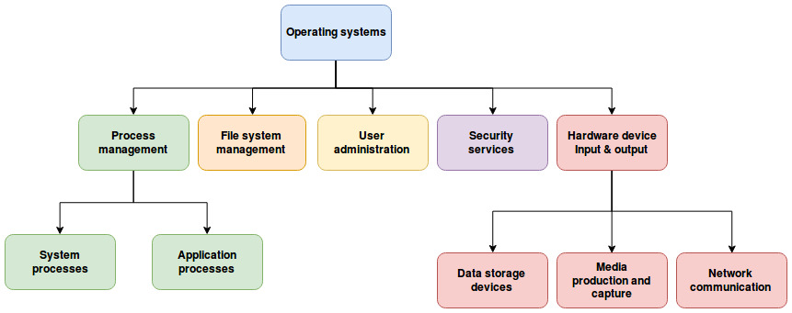

Use of Windows OS CLI Commands
  - Document the use of approx. 10 Batch or PowerShell commands, with screenshots and accompanying narration.

What is a CLI – (Command-Line interface)
[4]
A command-line interface (CLI) is a test-based user interface (UI) used to run programs, manage computer files, and interact with the computer. Command-line interfaces are also called command-line user interfaces, console user interfaces and character user interfaces.
PowerShell Commands
- “Get-PSDrive”

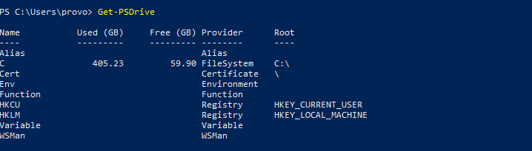
Above is an image of “Get-PSDrive” this command in PowerShell gets the drives in the current session. This command gets the following type of windows logical drives on the computer including the drives mapped to the network.
- “Get-PSDrive -PSProvider FileSystem”
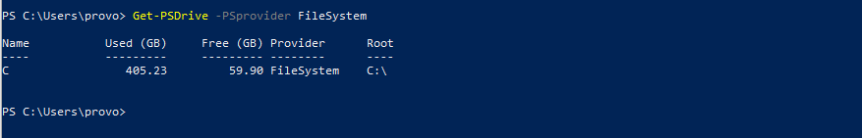
- “Get-History”

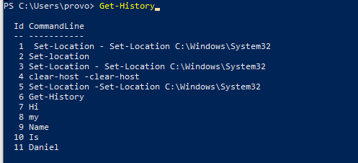
As you can see from the image above “Get-History” retrieves the command history. You can use this command to view the list of commands that you have executed in the current session it records each entered entry either successful or not.

- “Clear-Host”
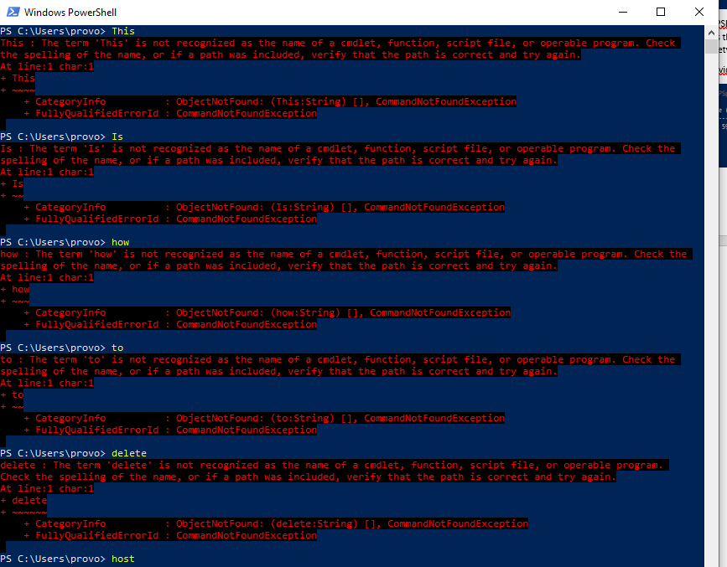
As you can see from the image above the information has been entered but not has been recognised as a command within PowerShell, to clear this error we would type in “Clear-Host”. This will then give the user a clear space to carry on working within PowerShell.
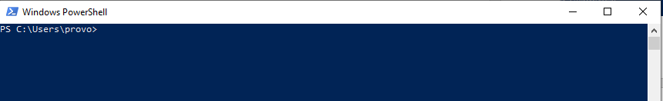
As you can now see above after typing “Clear-Host” all actions have been cleared from the window but not cleared from history on PowerShell as you can see below.
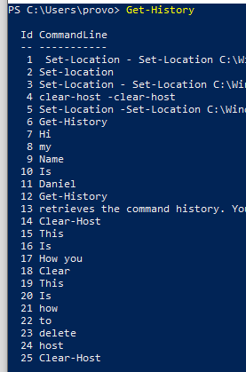

- “Get-Hotfix”
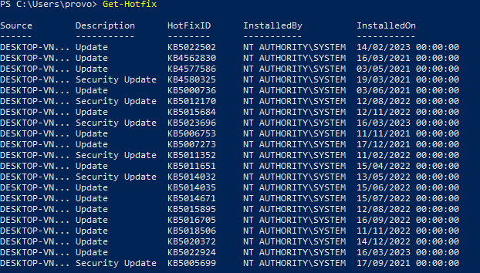
The picture above shows the number of hotfixes installed on the computer. You can use this command to view the description, installed by, and other details of the hotfixes.

- “Get-Process”
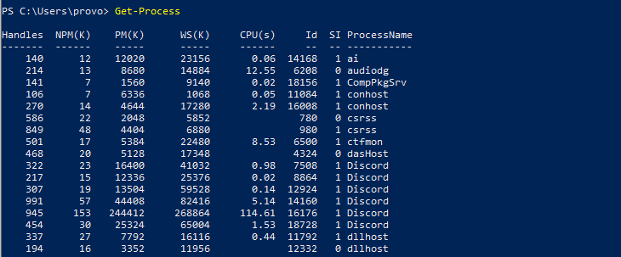
The above picture shows, the list of processes running on the computer. You can use this command to view the process ID, name, and other details of the running processes.

- “Get-ChildItem”
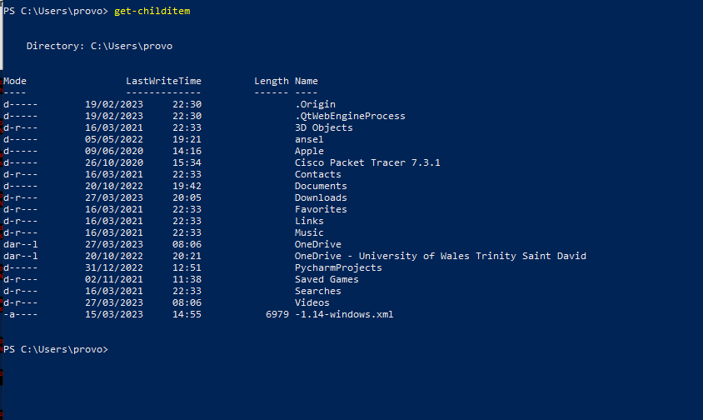
Image above show the list of files and folders in the directory, you can use this command to view the name, size details of the files and folders found in the directory.

- “Get-Command”
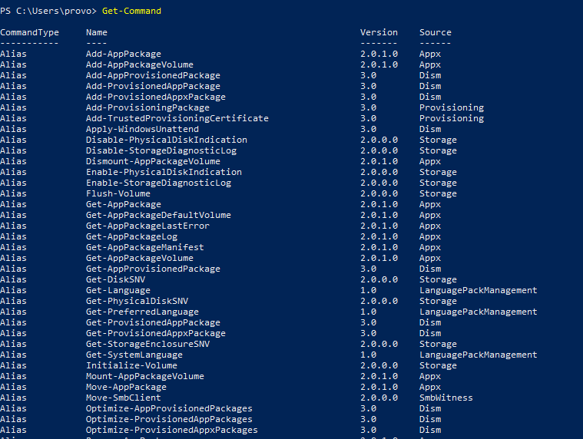

Image above shows Get-Command this can be used to get a list of commands available in PowerShell.

- “Get-help”
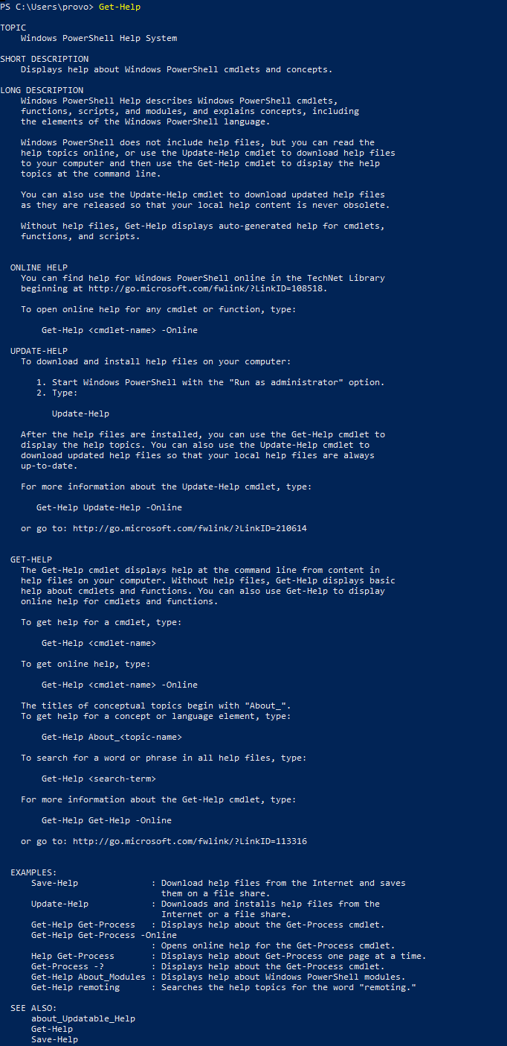
Image above shows the PowerShell Command Get-Help, this can be used when wanting to display helpful information about cmdlets and concepts.

- “Start-Service”
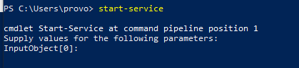
Above shows the command of start-service this can be used when after stopping a service as if the service is already running this command is ignored. Providing the service or display name of the service as an input object will start the service.
Example: Start-Service -Name Spooler

Use of Linux OS CLI Commands
  - Document the use of approx. 10 Bash commands, with screenshots and accompanying narration. No more than 350 words, cite 2 or more reference sources.

- ls – This Linux command lists all files and directories currently in the directory.
  - Open the terminal and type “ls”.
[5]

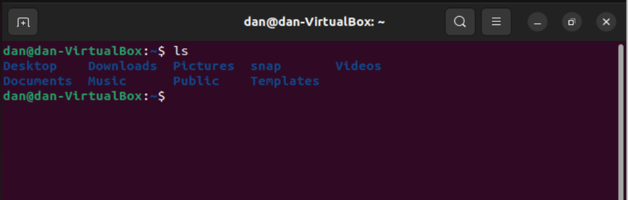

- cd – This Linux command changes the current directory to a specific directory.
  - Open the terminal and type – “cd/path/to/directory”.
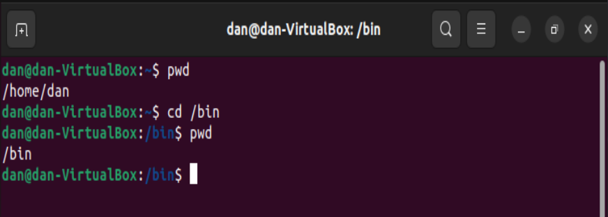
You can see from the image above “pwd” shows us out current working directory. We can change this using the “cd” command which is now show above.
- pwd – This Linux command shows the current working directory.
  - Open the terminal and type “pwd”.
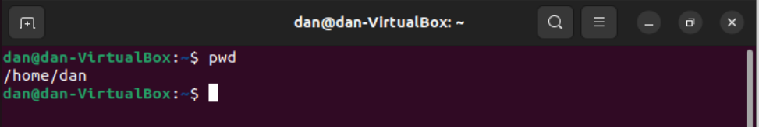
As you can see from the image above the commands that shows the current working directory is empty as we haven’t assigned a directory, we can do this by using the previous command, “cd”.
- mkdir – This Linux command creates a new directory with a specific name of your choosing.
  - Open the terminal and type – “mkdir directoryname”.

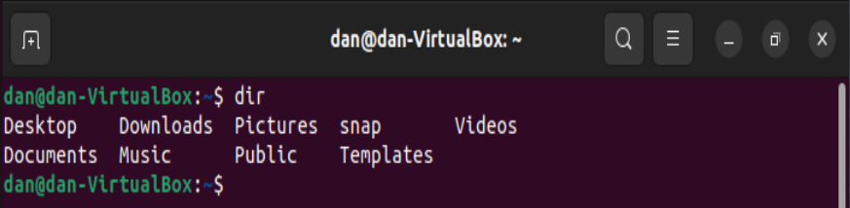
Image above shows the current directories we have placed on the available drive. We can add more directories by using the command “mkdir”. As you can see from the image below there is now an added directory called “Linux”
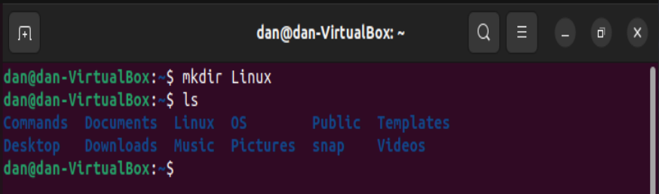

- rm - This Linux command removes a file or directory.
  - Open the terminal and type “filename”
OR
  - “rm -r directoryname”

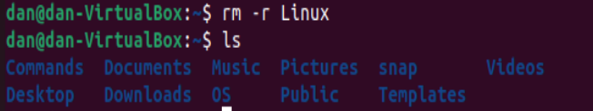
Image above shows the removal of the directory “Linux” this is done using the command “rm -r Linux”
- cp – This command copies a file or a directory from the location that has been specified with a certain location.
  - Open the terminal and type “cp filename /path/to/location”.
OR
  - cp -r directoryname /path/to/location

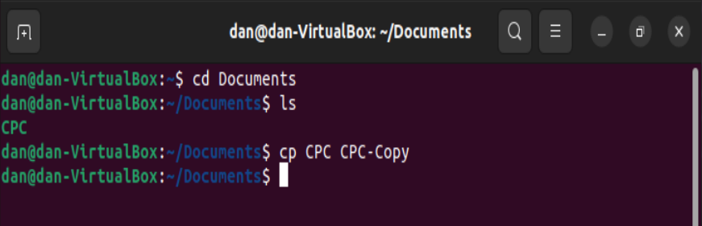
Image above show “cp” command taken place – we use a renaming convention to not overwrite the original text document, this will then show in the directory by using the command “ls”
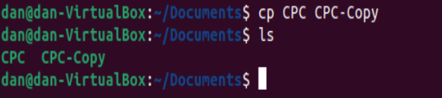
This now shows a copy within the directory.
- mv – This Linux command moves a file or directory to a specific location or it can be used for renaming purposes.
  - Open Terminal and type “mv filename /path/to/location
OR
  - mv filename newfilename – This is the command used to rename the chosen file.
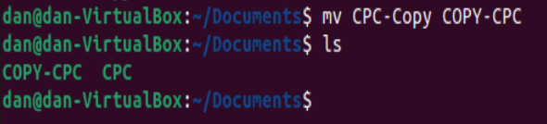
As you can see from the image above the file has now been renamed.
As per image above shows file COPY-CPC has now been moved from Documents directory and now been placed in the Pictures directory.
- clear – This command will clear the current work within the Linux terminal creating a clean working space.
[6]
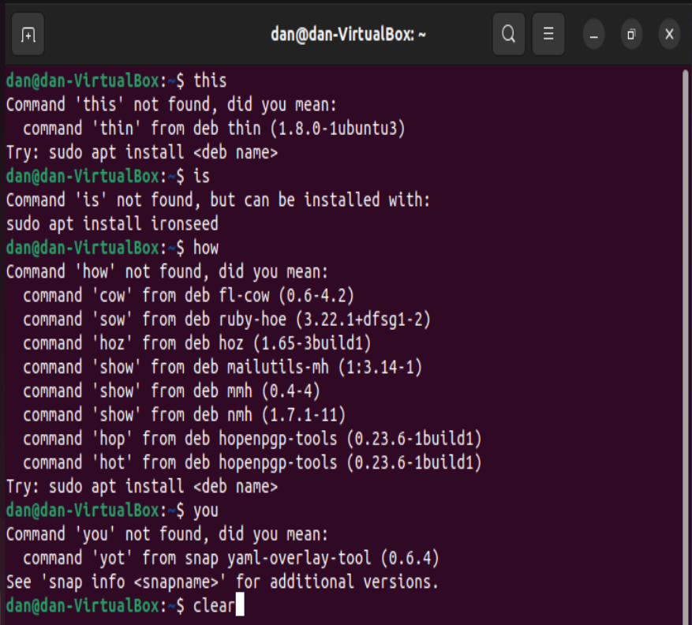
Image above shows purpose incorrect entries to create a overwhelmed working environment, once clear has been executed this will now clear the space above.
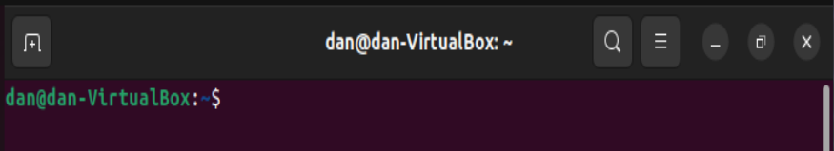
- cat – This Linux command shows the contents of a file in terminal window. Please note that it only shows it contents of a file if it has a file extension of .txt.
  - Open Linux Terminal and type “cat filename.txt”
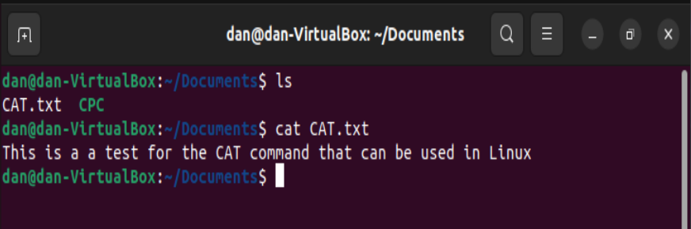
If an incorrect file type has been selecting, you can see the following error:

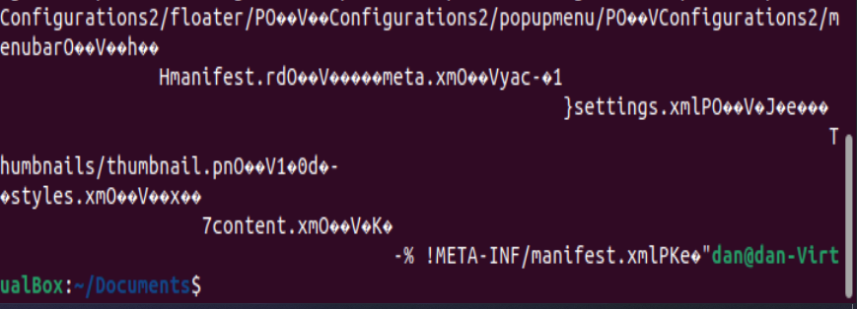
This is because Linux can only .txt files to show the contents.
- whoami – This command currently shows the user that is logged in.
  - Open up terminal server type “whoami”
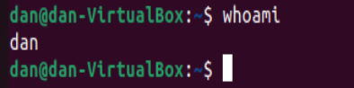
As you can see from the image above by typing “whoami” it currently shows correct user.

Use of Windows OS scripts.
  - Demonstrate key features of a Win. OS scripting language by documenting the use of Batch or PowerShell scripts, with screenshots and accompanying narration. No more than 350 words, cite 2 or more reference sources.

- Hello World – This is a simple script Hello World script written in Notepad ++ you can see the code below:
[7]
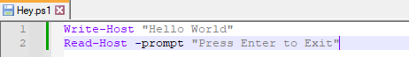
Line 1 – display what is written when the word is executed, there is an outcome with powershell that when the code is ran if it executed correctly the script will close automatically with such small code this leave a negative that you can read or see the script that has been actioned. I have counter acted this with line 2. This will prevent the PS window from closing until the Enter button has been pressed as you can see below.
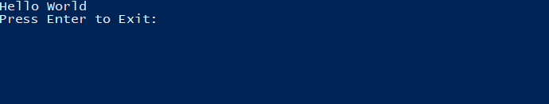
We can change this again by removing line 2 and setting the location within PS to C:\Users\provo\Desktop\PStests and running the ps1 file. This will allow the PS script to run and not close the PS window upon completion and continue within the workspace.
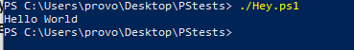
- Disc Check Script
Below is a code for checking disc space.

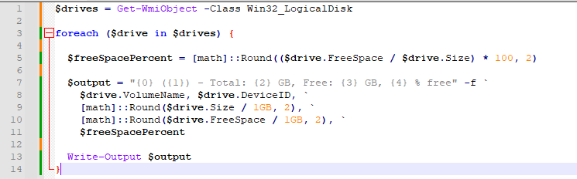

By executing this script within PowerShell, it will check all disc’s available and display in beneath the execution. See image below:
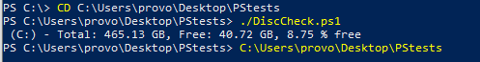
- Network Checker

Network checker code below, the code reads the Net adapter to get all status of the network adapters that are on the computer. The output is displayed with a true or false reading to allow the user easy readability.
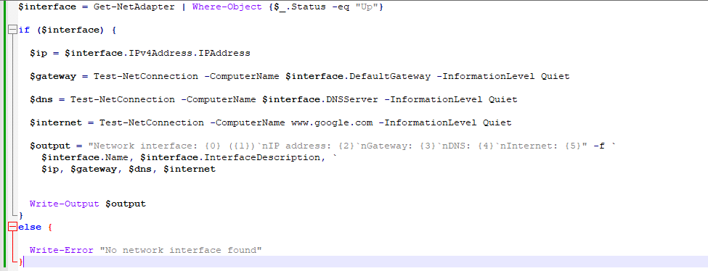
Please see outcome below:
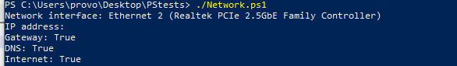
- Date Checker
Below is the code for checking the current Date within PowerShell.
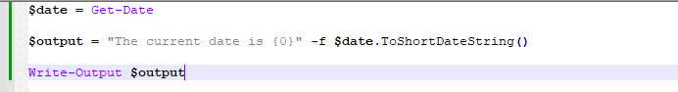
Below is the output:
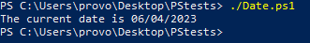
- Language Checker
Below is a basic code to check the current language that is set on the PC.
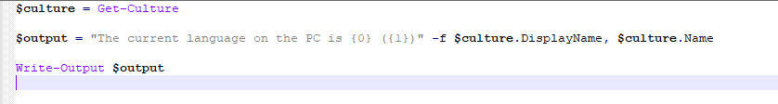
See output below:
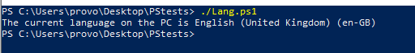
- Checking Ram Speed
Below is a code that checks the ram Mhz speed of the ram, this can useful when wanting to know to if you can enable XPM profile to make the clock speed of the ram faster for the system.
Please see code below:

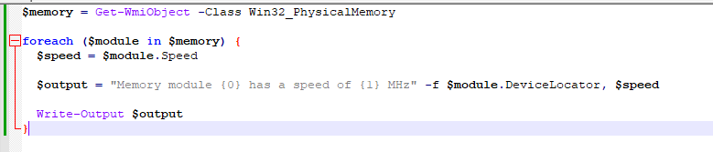
Please see output below:
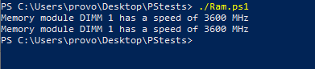
- Check FAN Speed
Fan Speed checker within PowerShell, Code read the fan speed and shows variable speed within the a formatted output and writes the output in the console. Will show “No Fan Found” if there is no fan found.
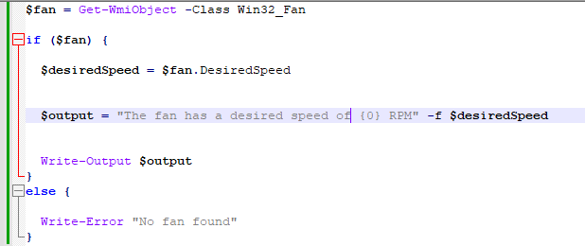
Output below:
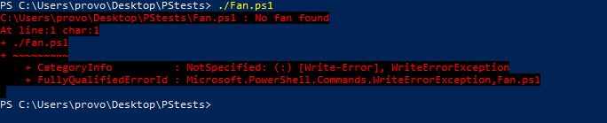
As you can see on my current machine, I get the error “No Fan Found” this is because I do not have a Fan installed onto the CPU, I have a an AIO water-cooled pump.
- Temperature of CPU
Below shows a code after installing “OpenHardwareMon” it then scans the CPU within the OHM and displays the current temp within the console. See code below:
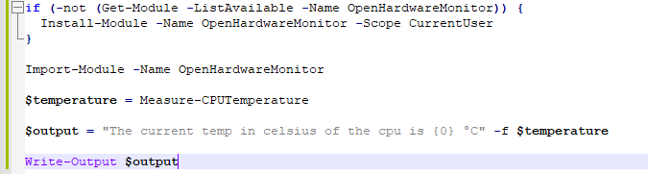
See output below:
- Bios Checker
[8]
Below is a written code to check the BIOS manufacture details within PowerShell, this is done by checking the BIOS VERSION, SERIAL NUMBER AND RELEASE DATE. This is then displayed in the output for the user to read.

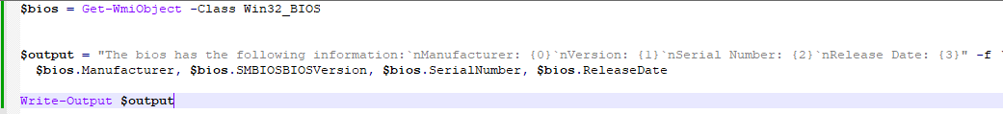
See output below:
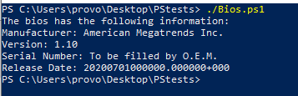
- Random Password Generator
Code below generates a random password; the first line makes a random word combining letters and numbers the second line writes and saves the file to a “password.txt” in the same place as where the script would be saved. The third line generates the password for the user to see as an output.

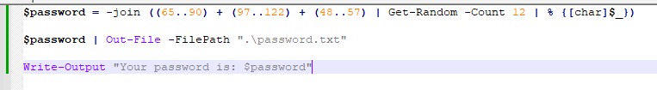

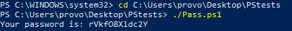

Use of Linux OS scripts
  - Demonstrate key features of a Linux OS scripting language by documenting the use of Bash scripts, with screenshots and accompanying narration. No more than 350 words, cite 2 or more reference sources.
- Hello World
[9]
Code below shows a simple Hello World with the Ubuntu/Linux VM. Please see code below:
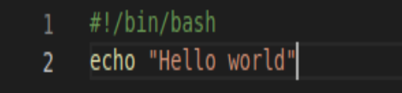
See output of code with the Linux terminal:
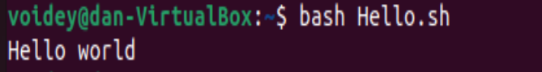
- Time Checker
This code checks the time within the Linux terminal, see code and output of code below:
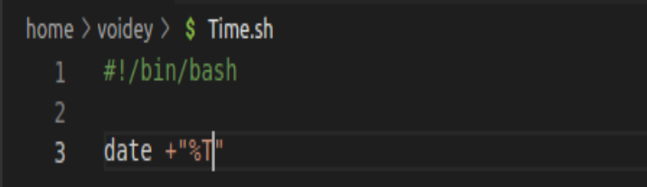
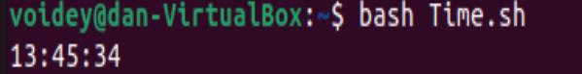
- Date Checker
This code checks the date within the Linux terminal, see code and output of code below:
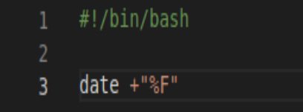
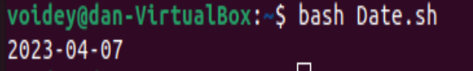
- Network Checker
Below is code that send a ping signal to www.google.com if you have a network it will read out “Network is up” and do the opposite for when no network is going by reading to the user “Network is Down”.

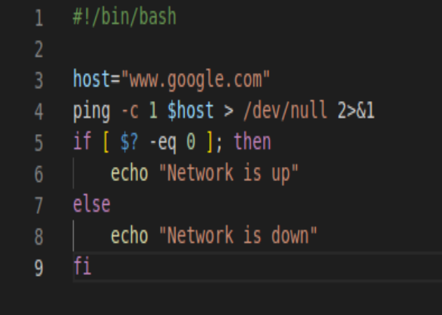
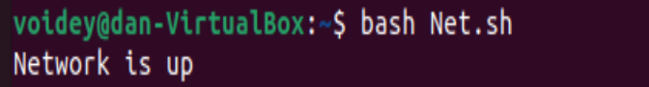
- Temp Checker
Check the current temp’s of the CPU of the powered device, see code and output below:
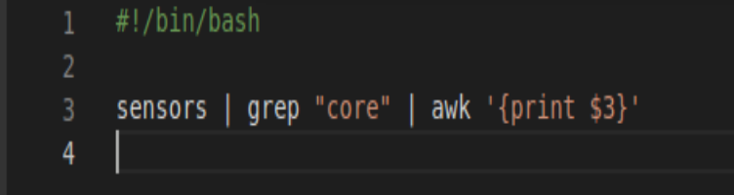
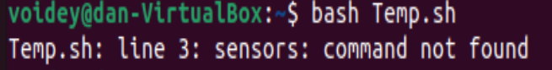
From the image above we can see we get this error due to cmd being ran within a VM.
- Uptime Checker
Please see code below for the uptime checker:
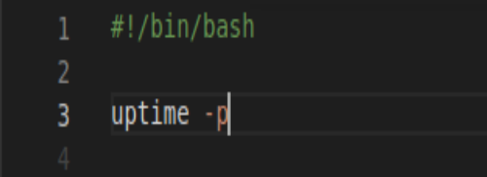
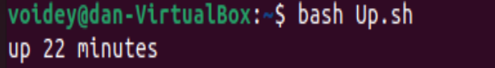

Conclusion

In conclusion, I found this assignment very challenging as I’ve never really had any experience with writing bash commands in Linux or in PowerShell.
In my overall experience I’ve found PowerShell to be more user friendly when executing any CMD’s and scripts, when presented with an error I found that looking online contains so much information in where and how to fix the error that has arisen such as forums and video tutorials.
Linux has a less friendly approach to usability and knowledge sharing with online resources very limited and over complicated with the installation of sudo and root privileges, this can make the experience seem frustrating and make the user sway more towards using a more familiar setting such as CMD and PowerShell.

Bibliography

[1]
S. Bigelow, “What is an Operating System (OS)? Definition, Types and Examples,” WhatIs.com, Jun. 2021. https://www.techtarget.com/whatis/definition/operating-system-OS

‌[2]
A. Singh, “Functions of operating system,” GeeksforGeeks, Feb. 07, 2019. [Online]. Available: https://www.geeksforgeeks.org/functions-of-operating-system/
[3]
“Operating Systems,” technologyrediscovery.net. https://technologyrediscovery.net/compFund/obcat.comp.os.html

[4]
“What is a command-line interface (CLI)?,” SearchWindowsServer. https://www.techtarget.com/searchwindowsserver/definition/command-line-interface-CLI
[5]
J. Walker, “How to Record Linux Terminal Commands With ‘script,’” How-To Geek. https://www.howtogeek.com/devops/how-to-record-linux-terminal-commands-with-script/
[6]
“Linux Commands Cheat Sheet: Definitive List With Examples,” Knowledge Base by phoenixNAP, Feb. 21, 2020. https://phoenixnap.com/kb/linux-commands-cheat-sheet
[7]
“How-to Run a PowerShell Script - All Options Explained,” LazyAdmin, Dec. 21, 2021. https://lazyadmin.nl/powershell/run-a-powershell-script/
[8]
“Useful PowerShell Scripts | Know List Of Most Useful PowerShell Scripts,” EDUCBA, Feb. 16, 2020. https://www.educba.com/useful-powershell-scripts/
[9]
“How to run bash script in Linux | Linux in a Minute,” www.youtube.com. https://www.youtube.com/watch?v=iViofyFir9o (accessed Apr. 07, 2023).
‌

‌

‌

‌

‌

‌
‌

‌

‌

‌

