

Changemakers: Creativity and Value Creation
Professions (BMHP5014)

Student Name: Ana Raquel Veloso de Sousa
Student number:2414272
Lecturer’s name: Laila Surani

Table of contents
- Introduction
- Definition Innovation, Creativity, Value Creation, Change
- Why these concepts are important health social care
- Mind map
- Self-Reflection of the Convergent and Divergent
- National health service of the Uk virtual wards
- Long waiting times
- Digital innovation health and social care
- Leadership framework
- Self-reflection
- Refence

Introduction
Innovation, creativity, value creation, and change are fundamental concepts for the development and growth of services in the health and social care sector. In this report, I describe the main concepts of innovation, creativity, value creation, and change, and why these concepts are important in the health field, and I also write about problems in the health field, such as long waiting times, showing my mind map, the causes, impacts, and solutions. Description of self-reflection on group activities in relation to convergent and divergent thinking. Discussion about innovation in the United Kingdom regarding patient guidance, understanding the creative aspects involved and the value of its creation for the use of services. Choose a current problem, for example, staff stress, digital exclusion, waiting times. Explore Digital Innovation in Health and Social Care by explaining how digital technology is being used to improve health or social care. Understand the NHS Leadership Framework, explaining the main components or behaviours of the NHS Leadership Framework. Finally, I will offer a reflection, based on my knowledge and experience in the healthcare field, that I can put into practice in my future professional life.

TASK1.
Innovation is a process of generating new ideas, methods, products, services, or solutions that have a positive impact and significant value, that improve something or solve a problem.
What is its important?
Important in an area of health and social care, introducing new ideas, technologies or ways of working to improve services, solve problems and meet patient needs more effectively.
Example:
- Telemedicine (Online GP Consultations) is a term used to describe the practice of telemedicine, in which patients consult healthcare professionals through video calls or mobile applications, without needing to travel to the clinic.

Creativity
Creativity is the capacity of how we think, understand its true depth in the world around us, and generate ideas and solutions.
What is its important?
Important in an areas of health and social care, creativity helps to provide a better, more effective service; new ideas and technology help to solve problems and meet patients' needs more effectively.
Example:
- Expressive Arts they promote emotional well-being and improve social skills; activities such as painting, music, dance, theatre, and writing are valuable tools in the health and social care fields, helping people express emotions and promote well-being.

Value Creation
Value creation is the essence of business success, fundamental to building a profitable and lasting company that transforms tangible or intangible resources into better results and products. (Thomas Donaldson, 2023), say during the 2019 Covid-19 pandemic some pharmaceutical companies had a responsibility to reach beyond the goal of financial optimization.
What is its important?
To create value in a health and social care sector to deliver the best possible patient outcomes by using resources effectively and improving quality of life, dignity, and well-being.
Example:
- Technology startup is a service- and value-based process that develops an advanced platform for sustainable business growth, resulting in more efficient and satisfying sales for high-value customers.
Change
Change refers to the process of transitioning from a current state to a new or improved way of working. A health and social care field, it involves adapting practices, systems, or behaviours to improve care.
What is its important?
Enables improvement a care quality and safety, helps organisations adapt to new policies and technologies.
Example:
Leadership can adapt as part of its change management strategy; a successful leader who inspires others builds their position with confidence and dedication and uses emotional intelligence to understand and support the team.

Task2

Mind Map

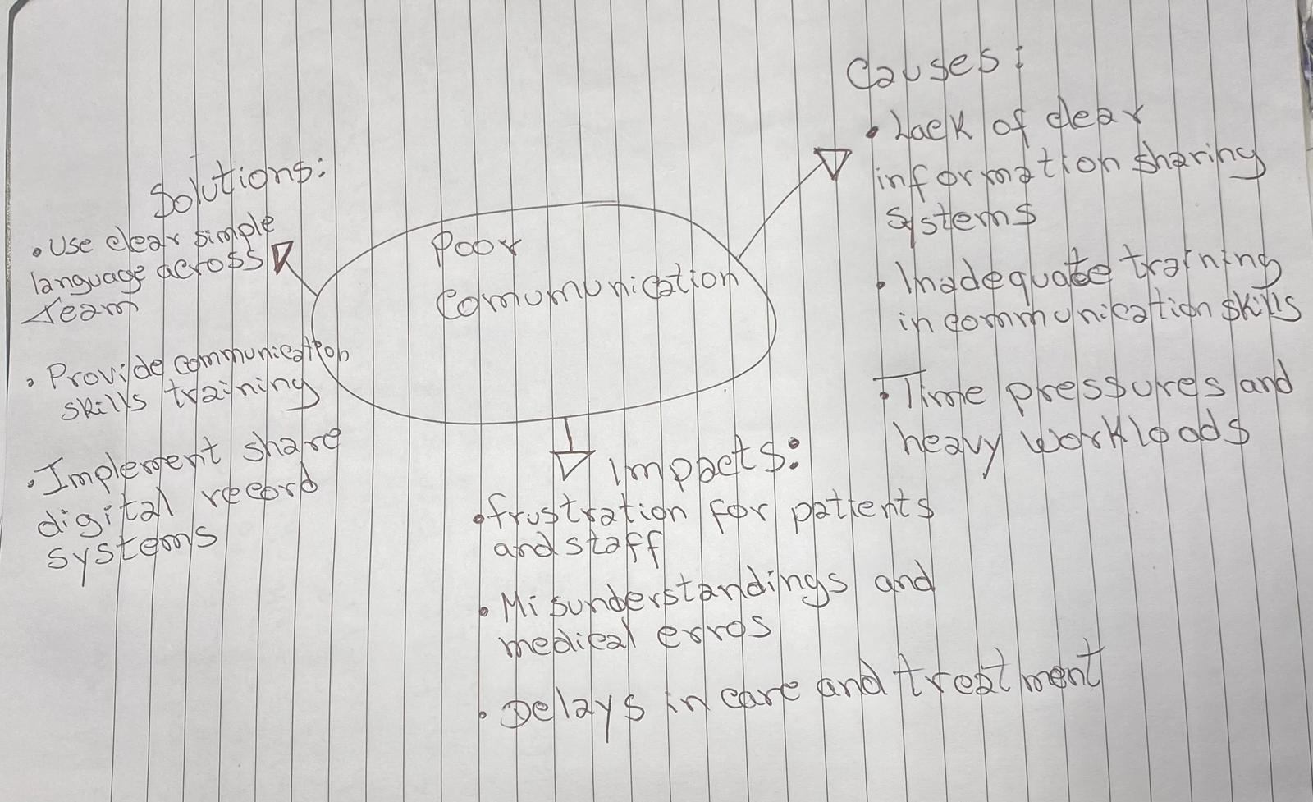

Poor communication and digital exclusion are major problems a health and social care because they negatively affect a quality, safety, and accessibility of services. Poor communication between professionals can lead to misunderstandings, delays in treatment, and increased risk of errors, which may harm patients. Digital exclusion also prevents some individuals, especially older adults and low-income groups, from accessing online services such as appointment booking or health information, increasing inequalities in care.The mind map highlights key causes such as lack of training, time pressures, and limited access to technology. It also shows impacts including reduced patient safety, frustration, and delayed care. Possible solutions identified include improving communication skills, using shared digital systems, providing digital support, and offering non-digital alternatives to ensure inclusive and effective care for all.
Task3
Self-reflection of the Convergent and Divergent

Divergent thinking refers to the ability to generate multiple creative ideas and explore different possibilities, while convergent thinking involves analysing and selecting the best solution among the available options (Guilford, 1967). In the activity, I used divergent thinking by suggesting different approaches to the problem and contributing creative ideas. I applied convergent thinking by analysing these ideas and helping my group choose the most favourable solution.

Reflecting on the experience, I realized that initially I had some difficulty expressing ideas freely, which limited my use of divergent thinking. I feel more confident in the convergent phase, where I was able to critically analyse the options; I find it easier to evaluate than to create ideas. I learned that teamwork benefits from a balance between creativity and analysis, as well as clear communication between groups. I also recognized the importance of developing confidence to participate more securely. Next time, I intend to be more involved at the beginning, share ideas without receiving them, and contribute to better group organization.

Taks4
National Health Service of the UK Virtual Wards
NHS Virtual Wards National Health Service, allow patients to receive hospital care at home through digital technology. This innovation emerged to reduce pressure on hospitals, decrease waiting times, and improve access to healthcare. Benefits include greater patient comfort, a lower risk of infections, and improved resource availability. (NHS ,2025) Virtual Wards were developed to reduce hospital admissions and increase the efficiency of the UK healthcare system.
What was the problem or need?
- Long waiting times for hospital admission
- Lack of hospital beds
- Increase in patients with chronic conditions and aging population
- Risk of hospital-acquired infections (such as COVID-19)
This is a strategy found to ensure patient safety in hospitals, reducing system overload and having empty beds.
How did creativity help solve the problem?
- Use of technology such as tablets, apps for monitoring
- Virtual consultations with healthcare professionals
- Multidisciplinary teams that monitor the patient remotely
- Rapid intervention if the patient's condition worsens

The beneficiaries were the patients, who received home care, reducing the risk of hospital infections; the healthcare professionals, who made faster and more effective decisions with less waiting time; the healthcare system, which now has more beds available; and the reduction in hospital admissions. Virtual wards demonstrate how innovation can be adapted and expanded to different areas, aligning with Rogers' theory about the dissemination of effective practices.

Task5
Long waiting times and the overload on the UK's National Health Service, it has faced long response times due to high demand, particularly after the COVID-19 pandemic. This puts people at risk of serious emergencies such as heart attacks and strokes (Redhead, 2025). The NHS Clinical Director of Urgent and Emergency Care said: the post-pandemic period has generated high bed occupancy and difficulties in discharging patients, with increased virus levels. Often, people end up leaving NHS waiting lists, but the NHS intends to develop a plan to improve urgent and emergency care services so that the NHS can serve everyone who needs our care. The improvements we can implement in the NHS marketplace include using technology to optimize referrals and implementing an intelligent system to reduce waiting times, as well as partnerships with the private and voluntary sectors. (Luigi Siciliani, 2025), say, waiting times can also generate negative spill-over effects on labour market outcomes. Using other outcome measures, they consistently found low to moderate effect sizes, but it is questionable whether the effects are statistically significant.

Task 6
Digital Innovation in Health and Social Care
Electronic Medical Records currently, interpreting analyses, such as how doctors, nurses, and social workers can consult the same clinical history in real time, requires laboratory results to analyse tests and avoid misdiagnoses, thus not affecting patients' health.
Effective communication with patients and colleagues is necessary to strengthen the relationship between professionals and patients, providing a safer and more reliable care experience that allows quick and shared access to patient information. This includes offering training on how to interact and demonstrate empathy with patients and their colleagues.AI tools need to be trained with diverse data to avoid biased diagnoses. Systems depend on the perception of usefulness and ease of use, essential factors for their success in practice.
Wearable Technologies such as smartwatches are used for monitoring and enabling the detection of changes in chronic diseases such as heart disease or diabetes. These devices accurately collect heart rate and physical activity data, helping patients and professionals make informed decisions. For example, the Apple Watch can detect irregular heart rhythms, contributing to the prevention of complications. This process generates a form of (photoplethysmography) that provides valuable data to determine an individual's heart rate. Wearables can improve self-care and reduce hospitalizations; these devices are adopted because they are useful and easy to use. (Mohsen Hosseini, 2023), say Smartwatches have become increasingly popular in recent times because of their capacity to track different health indicators, including heart rate, patterns of sleep, and physical movements.
Digital technology supports health prevention and promotion through mobile applications that encourage healthy lifestyles. These applications are effective when they are easy to use and useful, promoting behavioural changes and long-term disease prevention. For example, the NHS (National Health Service of the United Kingdom) allows patients to schedule appointments, access information, and monitor their health. These tools encourage physical activity, healthy eating, and stress management. Digital solutions increase citizens' engagement with their own health.
Task7
Leadership Framework
The Leadership Framework provides practical leadership guidance for healthcare and care workers, regardless of their role or position. The NHS draws inspiration from how to lead, compassion, communicating, evaluate information, share team performance, and collaborate to improve leadership across the entire healthcare system.
The NHS leadership structure is important because it allows professionals to acquire high-quality care, knowledge, skills, and leadership behaviours. This can foster motivation, make professionals feel valued and supported, and deliver good patient outcomes. NHS leadership is effective in improving safety and innovation in service efficiency, with all employees taking responsibility for demonstrating appropriate behaviour’s, seeking to contribute to the leadership process, and developing and empowering leadership among colleagues, helping to address challenges in the healthcare field.
Focus on the behaviours and concrete actions you can observe leaders practicing. This hands-on approach facilitates meaningful self-reflection and targeted development planning.

Leadership Behaviour leading with care focuses on empathy, compassion, and supporting the well-being of the team. A leader who demonstrates this behaviour builds trust and creates a safe environment where team members feel comfortable sharing ideas. This encourages creativity, as employees are more likely to suggest innovative solutions without fear of criticism. For example, a nursing leader who listens to team concerns and values ​​their contributions can inspire new approaches to patient care, such as improving communication or introducing digital tools. According to The King’s Fund, compassionate leadership improves team engagement, which is closely linked to better patient experiences and outcomes.

Task8
Self-Reflection
In this module, I concluded that my understanding of creativity, innovation, value creation in health and social care has become more practical and focused. Whereas I previously associated creativity with new ideas only, recognise it as solving real problems, such as reducing waiting times through innovations like Virtual Wards. A key activity that changed my perspective was analysing real NHS innovations, which showed how small changes can create significant value for patients and staff.
Using Gibbs Reflective Cycle, I reflected on how my thinking evolved from theory to application. I also connected this learning to the Everett Rogers theory, understanding how innovations spread when they are useful and easy to use.
In future placements, I will apply this by being open to digital tools and suggesting improvements in care delivery. This learning will shape my professional role by encouraging me to think critically, collaborate with others, and focus on creating value for service users.

Reference
Gibbs, G. (1988) Learning by Doing: A Guide to Teaching and Learning Methods. Oxford: Oxford Polytechnic.
Guilford, J.P. (1967) The Nature of Human Intelligence. New York: McGraw-Hill.
Donaldson. T, (2023). Value creation and CSR. Available: https://pubmed.ncbi.nlm.nih.gov/38625357/. (Access: (06.03.2026).
Hosseini., M, & Toktan, S. (2023). Smartwatches in healthcare medicine: assistance and monitoring; a scoping review. Available: https://pmc.ncbi.nlm.nih.gov/articles/PMC10625201/
Jain. N, (2023). What is Innovation? Definition, Types, Examples and Process. Available:https://ideascale.com/blog/what-is-innovation/.(Acess:04.03.2026)
Luigi, S. (2025). Waiting times for health services, health, and labour market outcomes. Available: Journal of Public Health, Volume 36, Issue Supplement_2, March 2026, Pages ii3–ii7,
NHS, (2023). Emergency hospital admissions reduced by virtual wards. Available: https://www.openaccessgovernment.org/emergency-hospital-admissions-virtual-wards-nhs-patients. (Acess:22.03.2026).
NHS, (2025). Virtual Ward Capacity and Occupancy statistics. Available: https://digital.nhs.uk/data-and-information/publications/statistical/mi-nhse-virtual-ward-capacity-and-occupancy-statistics/for-september-2025?utm_source=chatgpt.com.(Acess:22.03.2026)
NHS (2025). Waiting list falls , Available at : https://www.england.nhs.uk/2025/02/waiting-list-falls-as-nhs-staff-treated-record-numbers-last-year/.
Roger, A.A., Mtebi, N., Alice. A & John, k. Y, (2024). It's the patient that suffers from poor communication”: Analysing communication gaps and associated consequences in handover events from nurses’ experiences. Available: https://www.sciencedirect.com/science/article/pii/S266732152400091X.( Acess:20.03.2026).
Stephen. Andrew, (2023). Available:https://www.bing.com/videos/riverview/relatedvideo?q=definition+value+creation&mid=A9B8115A5C295B82316AA9B8115A5C295B82316A&mcid=467069C47F774C13811AE617C68FBC70&FORM=VIRE.( Acess:19.03.2026)
UK.ORG (2024). How to Use Expressive Arts in Health and Social Care. Available: https://carelearning.org.uk/blog/activity-provision/how-to-use-expressive-arts-in-health-and-social-care/.(Acess:04.03.2026). (Acess:04.03.2026)

