BA (Hons) International Hotel Management
Module Handbook Autumn Term 2025

Hotel Placement – Managing Hotel Administration
BMIH6004
Badrul Jamal 2126642
Level 6

Module Lead

Jessica Newport BA (Hons), MBA
Contents
Introduction 3
Gibbs reflective model 3
Conclusion 6
References 6

Introduction
Placement was in a massive urban hotel in the front office department where I was a Front Office Assistant. My primary roles included checking guests in and escorting them out of the facility, receiving queries, and assisting in guest complaints. I am placed within the Front Office Manager and the rest of the team members that closely helped me to learn and mentored my growth.
To make such a reflection, I selected the Gibbs Reflective Cycle (1988) since it provides a clear framework that gives the opportunity to examine the experiences, emotions, and education of mine. This reflection aims to evaluate how my professional and personal competencies have increased during the time I served as a Level 4 Housekeeping Department hire up to my current position as a Level 6 in the department. It will also reveal how I have put to practice the theoretical knowledge I have studied in working scenarios.

Gibbs reflective model
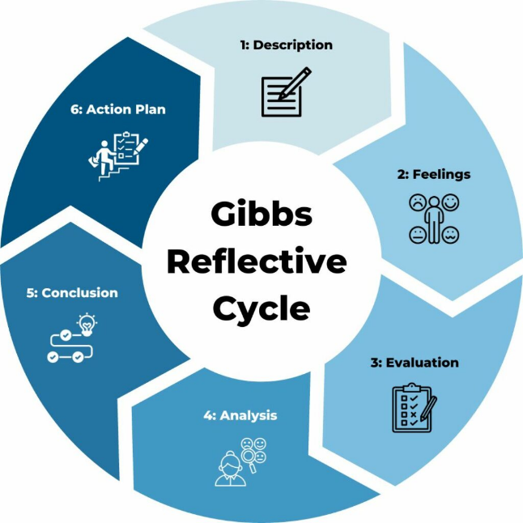
Figure: Gibb’s reflective model (source: twstraining.com)
Description
My activity at the Front Office Assistant was during the ten weeks of my placement, as my primary responsibilities were welcoming guests, checking in and out, answering questions, and resolving complaints. I had been collaborating with the Front Office Manager, who is the direct supervisor, and a Guest Relations Officer, and they both regularly gave feedback.
There were two outstanding experiences that I had. The former was when the guest got angry on the reason why his room was not ready at the expected time. The second one occurred in the case when my manager requested me to assist a new trainee to master the primary check-in procedures. The two scenarios were unfamiliar to me and forced me to apply my communicational skills and be a professional in stressful situations (Felce, 2019). My Level 4 placement, on the contrary, was within Housekeeping in a smaller hotel. Being concerned with room standards and adhering to instructions was my primary concern at the time. I was not in contact with very many guests. Relocation to the Front Office was a fair jump on the higher scale of the ladder as compared to my previous placement, as it required me to acquire more skill in interpersonal and customer service.
Feelings
Initially, I was really scared about working as a customer-facing worker. The guest complaint incident made me anxious as I did not want to go against what the guest wanted or offend her even more. Nonetheless, I also had a will in order to cope with the situation and demonstrate that I could be calm. The first thought that came to my mind was to seek a supervisor as soon as I could, however, I realized that it was a good time to practice what I had been taught about communication and problem-solving (Hagg, 2013). I was excited and at the same time unsure when requested to train the new team member. I was pleased to realize that my manager has put his trust on me, yet I feared that I would not be able to explain as I say or I would present the incorrect information. In the course of time, my confidence increased because of the positive feedback I got after being able to interact more with the trainee. I also began to like sharing the knowledge that I had and helping a person learn. These emotions revealed to me how confidence is achieved over a period of time through experience and contemplation and not within a single day.
Evaluation
In retrospect, both of these experiences were useful in their respective ways. The case in the complaint enabled me to remain calm, listen, and express empathy towards the guest. I apologized, and told of the cause of the delay, and got the room cleaned as soon as practicable. The guest received my reply and went ahead to thank me to have dealt with the issue in a polite manner. This has made me proud and I got a chance to have confidence that such situations I can handle in the future. In the training scenario, I realised that I had acquired a lot of knowledge as I have been in the replacement. I was reluctant to lead at the initial stages but as I lead the trainee in the processes of checking in and how to operate the system I realised how I have learned. The trainee was less uneasy and my manager has appreciated my initiative. Nevertheless, there were difficulties as well. There were moments when I was overwhelmed even with the trainee as I struggled to maintain my own endeavors at the time when the desk was busy. This taught me how to manage my time and seek the support where necessary.
Analysis
With the model offered by Gibbs, I will be able to see how my experience aligns with the theories I was able to learn about and what I already knew. At Level 4 Hospitality Operations Management, I acquired information that an excellent service refers to the ability to deliver the customer expectations or even surpass them. The lesson I learned was that where a guest did not find his room ready I should not simply make excuses but emphasized compassion, effective communication, and solve the problem fast. SERVQUAL model indicates that empathy and responsiveness are vital in the service and therefore I listened and made it my responsibility to rectify the situation (Hagg, 2013). The emotional-intelligence theory also enabled me to note that remaining casual allows me, and the guest, to be less concerned. I started by providing strict instructions followed by supportive style where I provided motivation to the trainee as she got more and more confident. I observe tremendous improvement, as compared to my Level 4 placement. Back, I mostly obeyed and performed manual labor, and now I am able to communicate effectively, solve, and manage relations all which is fundamental in hospitality professions.
Conclusion
In retrospect using Gibbs model, there was my personal and professional growth. I learned to be emphatic and emotionally contain when I made the complaint. The training experience demonstrated that I am able to mentor and coach others. They both play a crucial role in hospitality where even a single interaction counts. I feel better placed, self-assured, and independent compared with my Level 4 placement. This reflection also teaches me that I can learn something through making mistakes. I also know that there is more in communication than just talking, I must listen, identify feelings and solve problems.
Action Plan
I shall continue learning on my communication, leadership and organisational skills. First, I will also improve time management by prioritising and utilising checklists on hectic days. I will also request my supervisor to provide feedback in terms of my management of numerous tasks. Second, I will volunteer to mentor new employees or to be in charge of minor group projects. This will provide me with additional opportunities to talk clearly and supportively as a leader. Lastly, I will continue to apply the model by Gibbs once this placement is done so as to look back on other future occurrences. Reflection writing gives me the opportunity to reflect on the things that succeeded and those that failed. This would ultimately assist me in reflecting and improving hospitality as I learn by doing.

Conclusion
Recalling my Level 6 placement through Gibbs Reflective Cycle (1988) has demonstrated how much I have developed since I had the Level 4 experience. I have also enhanced my communication, problem-solving and leadership abilities particularly in situations involving complaints by guests and in assisting a trainee. These experiences have taught me to pay attention to others, be calmed down and flexible in a working hotel environment. My current placement has given me greater confidence compared with my previous placement, better understanding about myself and the ability to generalize what I have studied in theory to practice. The fact that, in response to continuous learning, reflection is an important element has also made me learn to use challenges as learning opportunities. I also would like to advance my skills in teamwork and customer service in the future and improve in managing my time and asserting. This position has enabled me to feel more confident about the idea of choosing a future career in hospitality management.

References
ASET (2017) Good Practice Guide for Workbased and Placement Learning in Higher Education. Sheffield: ASET.
Felce, A. (2019) ‘Managing the quality of higher education in apprenticeships’, Higher education, skills and work-based learning, 9(2), pp. 141–148.
Gibbs, G. (1988) Learning by Doing: A Guide to Teaching and Learning Methods. Oxford: Oxford Further Education Unit.
Hagg, E. (2013) Internship Guide: Work Placements Step by Step. 5th Ed. The Hague: Eleven International Publishing.
Vallen, G.K. and Valen, Jerome J. (2014) Check-In Check- Out: Managing Hotel Operations. 9th Ed. Harlow: Pearson Education Limited.
Wood, R.C. (2013) Key Concepts in Hospitality Management. London: SAGE Publications Ltd.

