CLOUD COMPUTING ADMINISTRATION

Name:Mihail Dimitrov Milchov, 2022635@student.uwtsd.ac.uk
Course: ACCA6025
Date:28/08/2024

Abstract
This project paper showcases how GLI organization can shift from an on premise to Azure cloud platform. The project paper starts by providing a comprehensive literature review and thereafter showcasing how the organization can migrate to Azure cloud platform. Also, the paper showcases how the GLI can practically implement some of the Azure services.

Introduction
In the current 21st century, the digital landscape is evolving rapidly. Since COVID-19, organizations are shifting from a traditional on premise infrastructure to a cloud computing environment. Specifically, this shift has been driven by the requirements working from home, an enhanced security, the need to innovate rapidly due to the increasing market demands. Greater scalability, and the dire need for a cost efficient operation. The Global Learning Institute commonly known as the GLI, one of the leading provider of online and in-personal educational programs, desire to migrate most of important IT infrastructure from the current legacy on premise to a Microsoft Azure cloud platform.
The decision by GLI to move to a cloud platform is a strategic one. The organization has identified various limitations with the current on premise such as lack of disaster recovery capabilities, high maintenance costs, and lack of scalability. According to the organization, the current on premise structure is not only expensive but it also lacks flexibility which lacks the current growing demands of a global education center.
Due to this the organization plans to move to a Microsoft Azure. The platform offers a comprehensive suite which aligns with its goals of operational efficiency, modernization, and enhanced security. By taking advantage of Azure’s cloud platform, the organization in this case aims at achieving a significant cost saving, improving service delivery, and streamline its operations. This monogram provides a detailed analysis of cloud migration process for GLI.
Background of Cloud Computing
Cloud computing, a concept first introduced in the early 2000s, has evolved into a foundational element of modern IT infrastructure. The cloud allows organizations to access computing power, storage, and applications over the internet, rather than relying on physical on-premise servers. This shift offers numerous advantages, including cost savings, enhanced flexibility, and improved disaster recovery capabilities. The cloud model can be classified into three main types: Infrastructure as a Service [IaaS], Platform as a Service [PaaS], and Software as a Service [SaaS]. Each of these models provides different levels of control, management, and flexibility, catering to the diverse needs of organizations.
The adoption of cloud computing has grown exponentially over the past decade. According to a 2023 report by Gartner, over 90% of businesses worldwide now use some form of cloud service. This widespread adoption is driven by the cloud’s ability to support remote work, scale operations efficiently, and provide robust security measures, all of which have become critical in today’s fast-paced digital environment.
The Global Learning Institute [GLI] and the Need for Cloud Migration
The Global Learning Institute [GLI], a leading provider of online and in-person educational programs, is facing challenges common to many organizations still reliant on traditional IT infrastructure. With a legacy on-premise setup, GLI struggles with high maintenance costs, limited scalability, and inadequate disaster recovery capabilities. These challenges are particularly pressing for an educational institution like GLI, which must continuously innovate and adapt to meet the evolving demands of a global student body.
In light of these challenges, GLI has strategically decided to migrate its critical IT infrastructure to Microsoft Azure, a leading cloud platform known for its comprehensive suite of services tailored to enterprise needs. This migration is not merely a technical upgrade but a significant step towards achieving greater operational efficiency, cost savings, and enhanced security. By leveraging Azure’s cloud platform, GLI aims to overcome the limitations of its current infrastructure, streamline operations, and better serve its students and staff in a rapidly changing educational landscape.
The concept of Total Cost of Ownership [TCO] plays a crucial role in evaluating the financial implications of migrating to a cloud platform. TCO includes not only the upfront capital expenditures but also the ongoing operational costs associated with maintaining IT infrastructure. These costs encompass everything from hardware and software maintenance to power consumption, cooling, and staffing needs. As Heinrich [2023] outlines, a comprehensive TCO analysis is essential for organizations to understand both the short-term and long-term financial impacts of their IT investments.
When comparing cloud providers, Microsoft Azure, Amazon Web Services [AWS], and Google Cloud Platform [GCP] are the industry leaders, each offering their own TCO calculators to assist organizations in estimating potential savings. These calculators allow businesses to input details about their existing IT infrastructure—such as the number of servers, storage requirements, and network usage—and compare these against equivalent cloud services.
Azure’s TCO calculator, for example, considers various factors, including hardware costs [e.g., servers and networking equipment], software costs [e.g., databases and operating systems], and maintenance expenses [e.g., software updates and hardware repairs]. It also accounts for energy costs, such as power and cooling for data centers, and disaster recovery costs, including backups and recovery solutions [Microsoft Azure, 2023]. By providing a detailed breakdown of potential savings, the Azure TCO calculator demonstrates that organizations like GLI can achieve significant cost reductions by migrating to Azure. For GLI, the estimated savings over five years are projected to be $344,325, highlighting the financial benefits of moving away from costly on-premise infrastructure.
Comparative Analysis of Cloud Providers
When considering cloud migration, it is essential to evaluate the offerings of various cloud providers to ensure that the selected platform aligns with the organization’s needs. Azure, AWS, and GCP each have unique strengths that make them suitable for different scenarios.

Microsoft Azure: Azure is often favored by enterprises that are heavily invested in the Microsoft ecosystem, as it offers seamless integration with other Microsoft products, such as Office 365 and Dynamics 365. Azure’s strengths lie in its robust support for hybrid cloud environments, which allows organizations to maintain some on-premise infrastructure while leveraging cloud services. Additionally, Azure’s strong focus on compliance and security, with certifications like ISO/IEC 27001 and HIPAA, makes it an attractive option for institutions handling sensitive data, such as educational organizations like GLI.

Amazon Web Services [AWS]: AWS is the largest cloud provider globally and is known for its extensive range of services and global infrastructure. AWS excels in offering a wide variety of tools and services, including advanced analytics, machine learning, and Internet of Things [IoT] solutions. However, AWS can be more complex to navigate due to the sheer number of options available, which might require a higher level of technical expertise to fully utilize.

Google Cloud Platform [GCP]: GCP is particularly strong in data analytics, machine learning, and artificial intelligence, thanks to Google’s expertise in these areas. GCP’s BigQuery, for example, is a powerful tool for processing large datasets, making it a preferred choice for data-intensive applications. However, GCP has a smaller market share compared to Azure and AWS, which could mean fewer third-party integrations and a smaller ecosystem of support services.

In GLI’s case, Azure’s strong integration with Microsoft’s suite of products and its focus on security and compliance make it the most suitable choice. The platform’s support for hybrid cloud environments also provides GLI with the flexibility to transition to the cloud at its own pace, mitigating risks associated with a full-scale migration.
Recent Trends in Cloud Migration
The COVID-19 pandemic has accelerated the adoption of cloud computing across various sectors, including education. Educational institutions have been compelled to shift to online learning platforms, necessitating a reliable and scalable IT infrastructure. According to a 2022 report by IDC, global spending on cloud services increased by 23% in 2021, with education being one of the fastest-growing sectors. This trend is expected to continue as institutions seek to enhance their digital capabilities and ensure continuity in the face of future disruptions.
For organizations like GLI, cloud migration is not just about reducing costs; it is also about future-proofing their operations. Cloud platforms like Azure offer the ability to rapidly scale resources up or down based on demand, which is particularly important in an educational context where enrollment numbers can fluctuate significantly. Moreover, cloud services provide enhanced data security, disaster recovery, and compliance with regulatory standards, all of which are critical for maintaining the trust of students, staff, and stakeholders.

Azure Total Cost of Ownership
Total Cost of Ownership commonly known as TCO technique, is a method for assessing comprehensive costs which are associated with operating and acquiring an asset over entire lifecycle. According to Heinrich, in IT infrastructure context, TCO concept entails not only the initial capital expenditure on software and hardware but also on the operational expenditure which is required for cooling, maintenance, power, staffing, and upgrades [10].
Gartner [2021] defines TCO as a technique of estimating intended finance to assists owners and buyers to determine both indirect and direct costs of a system or a product. The TCO model is specifically used to provide a holistic view of an organization expenses which are involved in maintaining IT infrastructure compared to the traditional costs models. Thus by incorporating both operational expenses and capital expenses one is able to provide a comprehensive TCO which results to understanding of both short and long term financial implications of an IT investment [10].
Various cloud providers have provided a TCO tool to estimate their potential savings by migrating to their cloud platforms. Azure for example provides Azure TCO calculator which showcases savings that an organization can experience by migrating to Azure cloud platform. The tool allows one to input certain details about their IT on premise environment. This includes the number of servers, the storage requirements, network usage, and databases. One then compares this with the equivalent Azure services.
According to Microsoft Azure [2023], the Azure TCO takes into account various factors which are hardware costs, this includes the networking equipment, storage devices, and servers. Second are the software costs which includes databases and operating systems. Third is the maintenance costs which includes hardware maintenance costs and software updates. Other costs which it takes into account include energy costs which includes the cost of power, cooling for the data centers and the disaster recovery costs which includes the cost of back-up and any recovery solutions [10].
Azure TCO cost estimation
The On premise assumptions in this case include three Linux physical servers, three windows physical servers. The windows server in this case each have a 400GB RAM with standard operating system. The Linux servers run on a 100GB RAM. Second, are the two database servers one which is a Microsoft SQL server and an SQL database. The Microsoft runs on an enterprise Microsoft license and on 250 GB RAM. The SQL server is on an SQL database though on a general purpose service tier. Third is the storage devices with a 300TB capacity. In this case there is the 100TB backup space and 50TB HDD which is archived.
By using the Azure TCO calculator the first process is to define the workload on the TCO calculator. This is as shown by the figures blow
Figure 1: Servers definition on the Azure TCO calculator
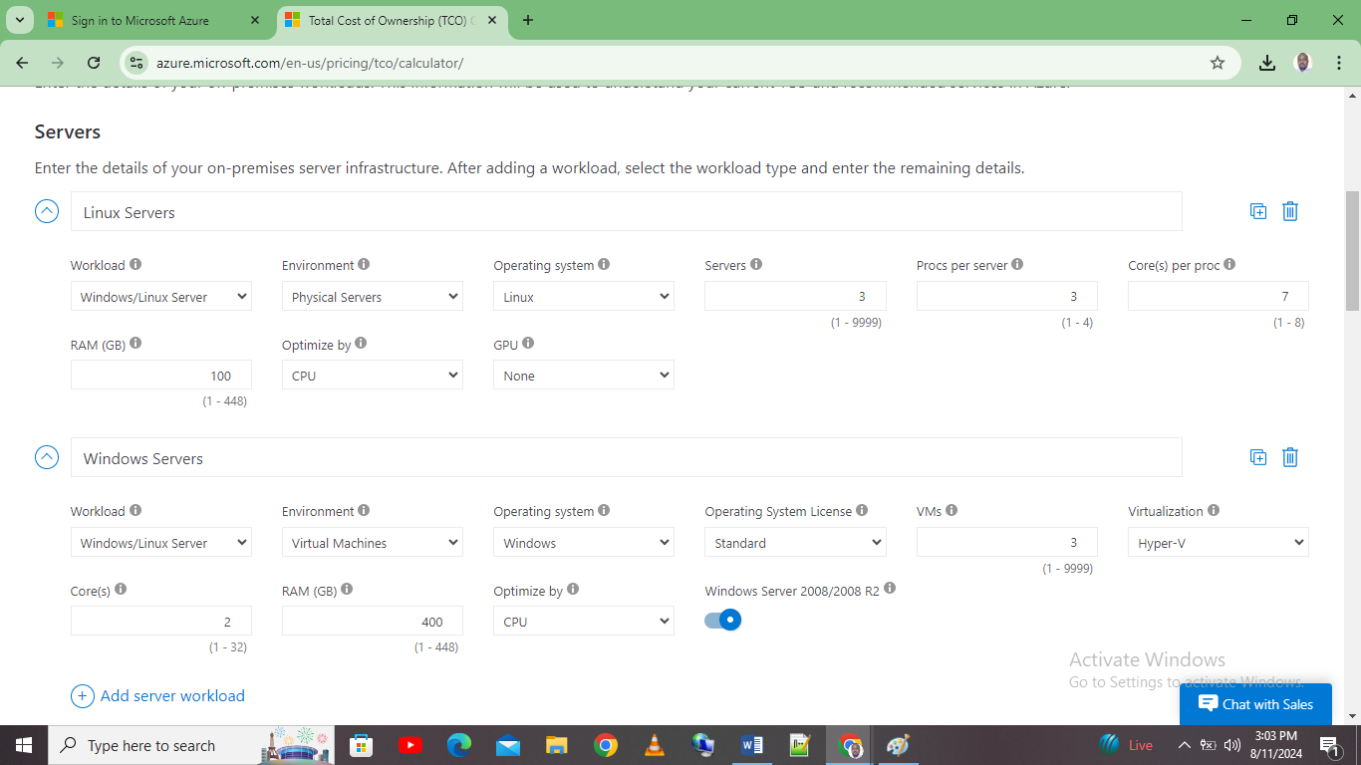
Figure 2: Database servers’ definition workload on the TCO
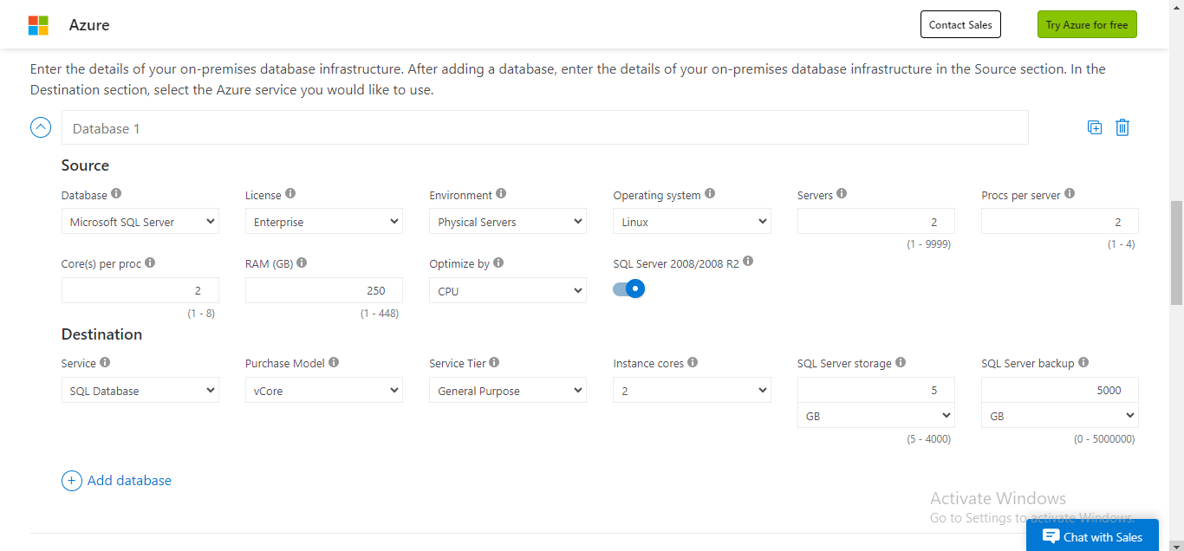
Figure 4: Storage and network definition on the Azure TCO
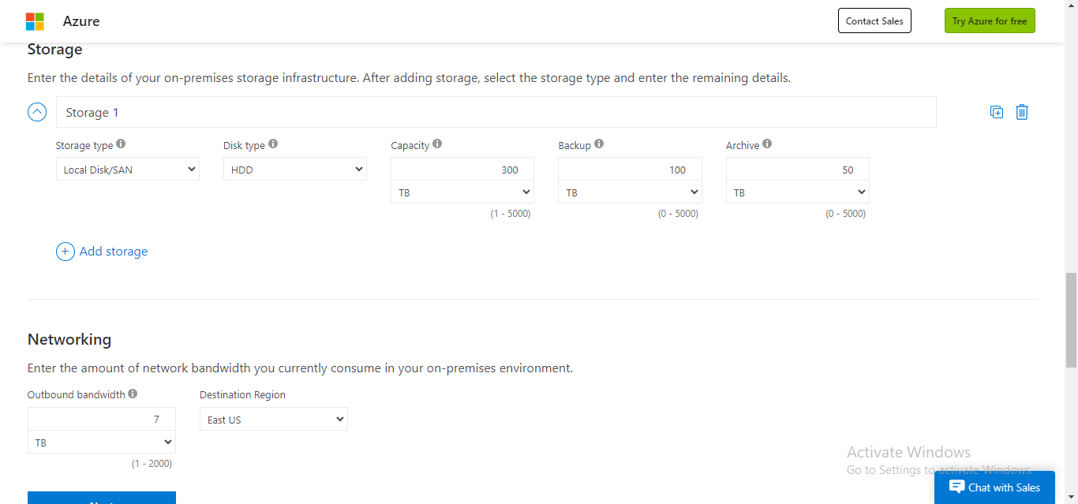

Figure 5: Electricity costs savings
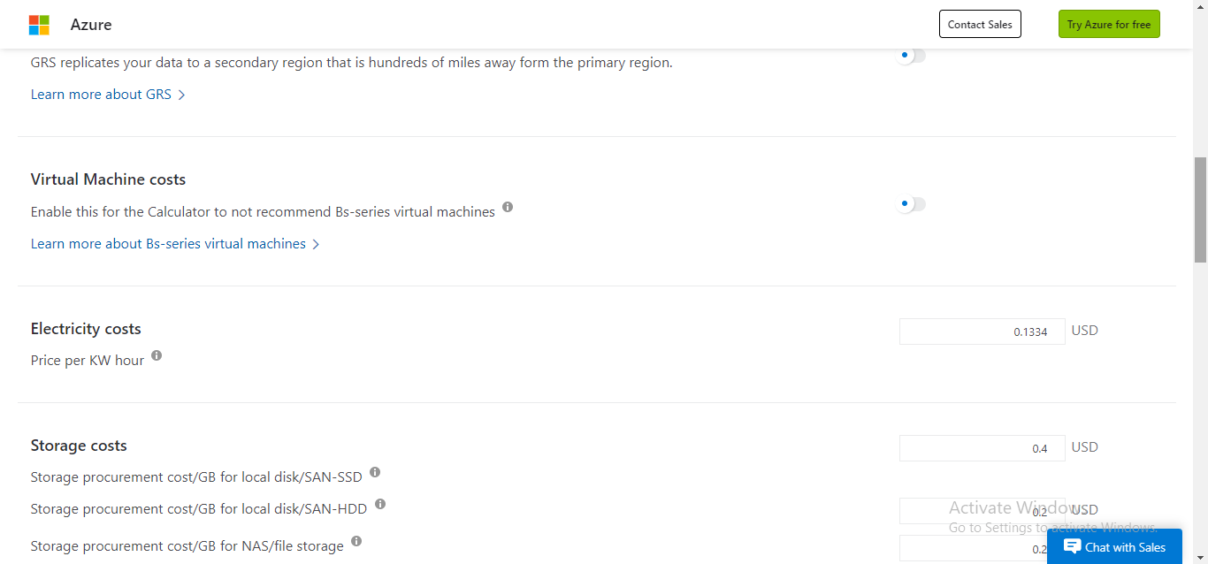
Figure 6: The IT labor costs savings
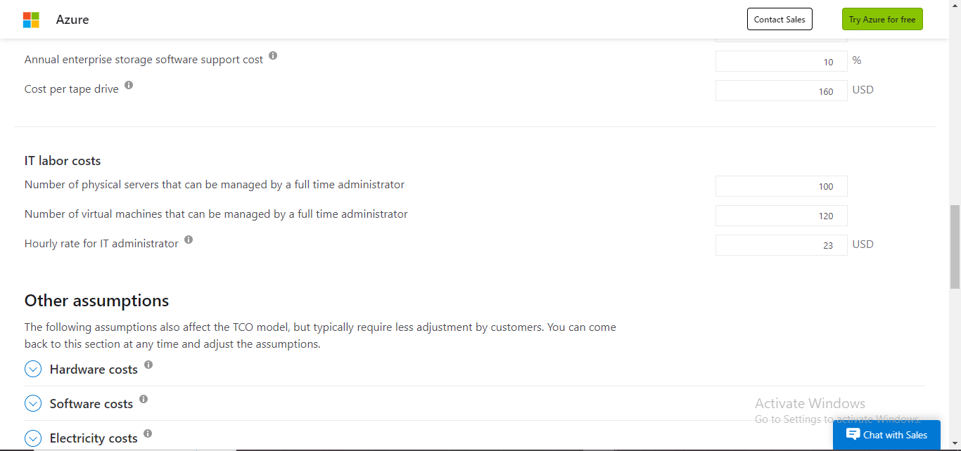

Figure 7: On-premise cost on storage as the Azure calculator
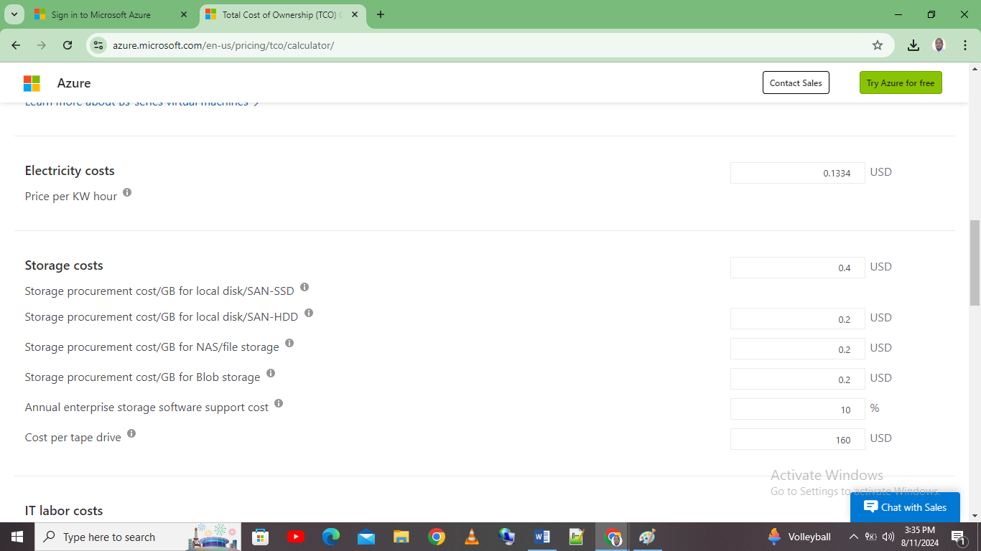

Figure 8: On-premise hardware cost as per the Azure TCO
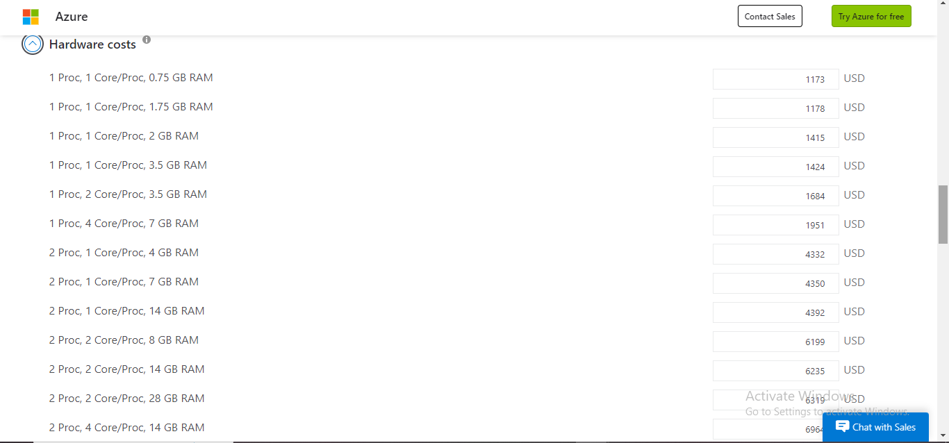

Figure 9: On-premise software costs as per the Azure TCO
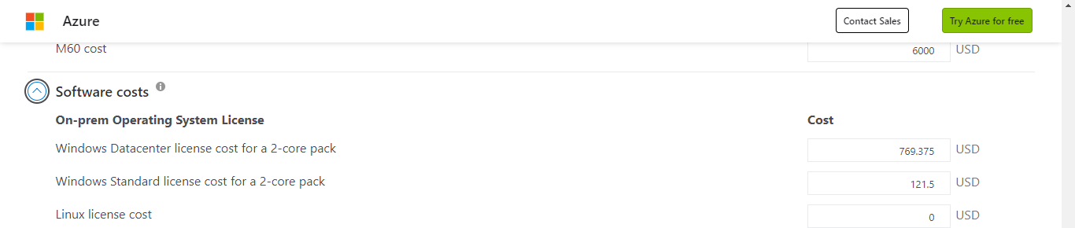
Figure 10: On-premise cost as per the Azure
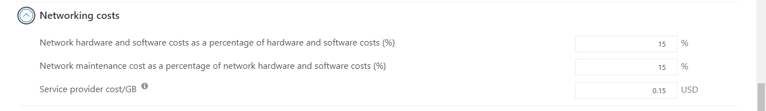

Figure 11: Azure Total Cost Owner [TCO] estimated cost savings calculation
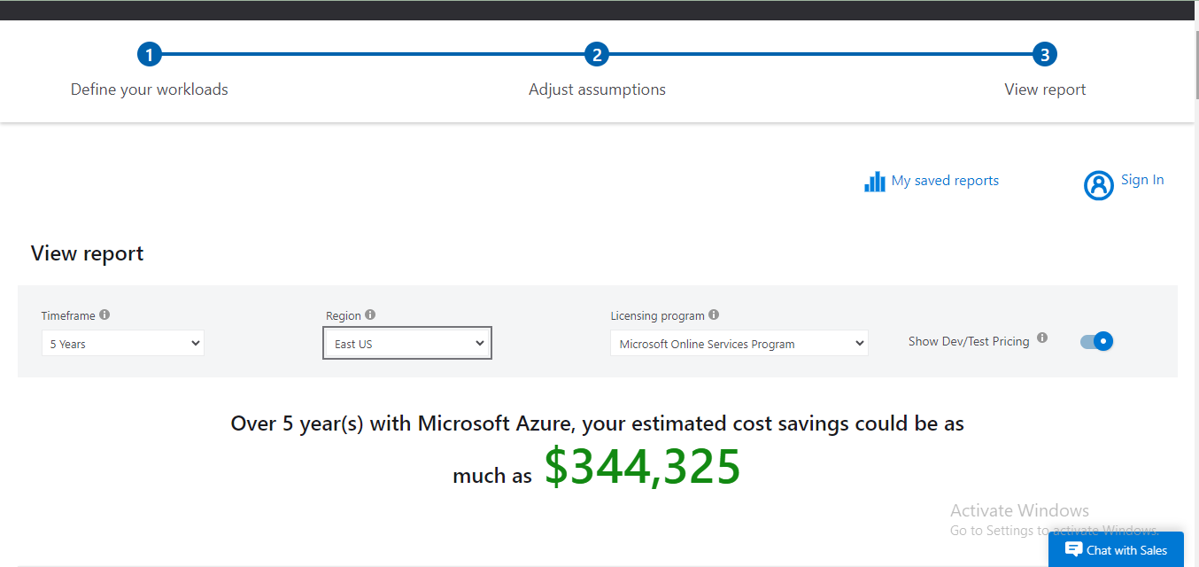
The decision by the Global Learning Institute [GLI] to migrate from a traditional on-premise IT infrastructure to Microsoft Azure represents a significant strategic shift with profound implications for the organization's operations, financial health, and long-term viability. This section critically analyzes the key factors driving this decision and justifies the migration by examining the anticipated benefits and potential challenges.
Financial Implications and Cost-Benefit Analysis
One of the primary motivations for GLI’s migration to Azure is the potential for significant cost savings, as demonstrated by the Total Cost of Ownership [TCO] analysis. Maintaining an on-premise infrastructure requires substantial capital investment in hardware, software, and data center facilities, coupled with ongoing operational expenses for maintenance, power, cooling, and staffing. Azure’s cloud platform, on the other hand, operates on a pay-as-you-go model, which enables organizations to convert these capital expenditures into operational expenditures. This shift not only reduces upfront costs but also allows for greater financial flexibility and predictability.
The Azure TCO calculator estimates that GLI will save approximately $344,325 over five years by migrating to Azure. These savings stem from several areas:

IT Labor Costs: By moving to Azure, GLI can reduce the need for full-time IT administrators to manage on-premise servers and infrastructure. Azure’s managed services, such as automated backups, updates, and monitoring, reduce the workload on IT staff, allowing them to focus on more strategic initiatives rather than routine maintenance tasks.

Energy and Cooling Costs: On-premise data centers consume significant amounts of electricity for both running servers and cooling them to prevent overheating. Azure’s global data centers are optimized for energy efficiency, reducing the overall power consumption and associated costs for GLI.

Hardware and Software Costs: The need to regularly upgrade hardware and software in an on-premise environment represents a substantial ongoing expense. Azure eliminates these costs by providing scalable, up-to-date infrastructure that can be adjusted based on demand, without the need for physical upgrades.

While the financial benefits are compelling, it is important to consider the initial costs of migration, which include the planning, execution, and potential downtime during the transition period. However, these costs are typically one-time expenses, and the long-term savings and operational efficiencies outweigh the initial investment
From figure 11, using the Azure TCO calculator, the estimated cost of savings for a period of five years is 344,325 dollars. This demonstrates that migrating from the current organizational on premise infrastructure to an Azure cloud service will result to a significant cost saving in this case, GLI will save 344,325 dollars for over five years by adopting Azure cloud platform. Some of the savings will come from IT labor costs which as shown by figure 6 are savings for paying a full time administrator which is usually done per hour. Additionally, the organization will save electricity which is currently estimated to be 0.14 dollars per KW hour. Other costs saved are the storage costs and other networking costs.
Azure Services
Azure File Storage
Azure File Storage is a type of managed cloud file system which is provided by Microsoft Azure platform. It allows one to create, scale, manage and files accessible though Azure CLI, SMB protocol, or REST API. For the organization in this case, GLI, adopting Azure File storage can go a long way in benefiting the learning institution. This Azure features can offer various advantages to the GLI in including robust security measures, high availability, and a scalable storage [10].
There are various features and benefits which comes with Azure File storage. First is that it comes with dynamic scalability. This will allow GLI to adjust its storage capacity as per their demand. This type of flexibility is essential for accommodating varying data loads which educational organization like GLI might experience especially during the peak times. For example, during online exam sessions or during the enrollment periods.
Second is that the platform comes with high redundancy and availability. With Azure file storage, GLI will benefit from the geo redundant feature commonly known as GRS. This replicates data across the various regions. The feature ensures GLI data remains accessible even in situations like regional outage. This in turn minimizes disruptions to staff and student. Also, it maintains business continuity.
Third, just like other cloud services, the Azure file storage uses the pay-as-you use model. This in turn will assists the organization in this case reduces costs of operation as it only charges for the uses that GLI uses. Also, in here the service eliminates the on premise storage hardware and all its associated maintenance costs. Third feature is that, the Azure File storage offers a seamless integrated on premise server and other Azure services. For the GLI case it means that the current existing applications have the ability of accessing Azure File shares without the need of modification.
Lastly is that the Azure File storage comes with an automated back-up for file storage. This ensures that critical data is backed up regularly without any form of manual intervention. This feature allows the organization to recover any form of data corruptions or accidental deletions.
Some of the security measures which comes with Azure File storage include encryption. This feature ensures that data which is encrypted both on transit and at rest using the AES-256 type of encryption. For the GLI organization it means that sensitive staff and student data is protected from unauthorized access thereby meeting regulatory compliance requirements such as GDPR and the FERPA.
Additionally, Azure File storage provides a robust access control technique via the Azure Active Directory commonly known as AAD. This means that GLI organization have the ability of enforcing role-based access control policies which ensures that only the authorized personnel can access certain files.
Third, Azure file storage comes with Advanced Threat Protection commonly known as APT. This feature has the ability of monitoring any cyber security threat like the ransomware. Also, with feature the organization is able to receive alerts and at the same time take actions before any form of breach occur.
Lastly, the Azure File Storage comes with certain industry practices and standards. This includes ISO/IEC 27001, SOC 1/2/3, and HIPAA. This indicates by using Azure File storage, GLI inherits these compliance standards and certifications to its practices thereby maintaining trust among its stakeholders [10].
Azure File storage implementation
Figure 11: Logging into Ms Azure account
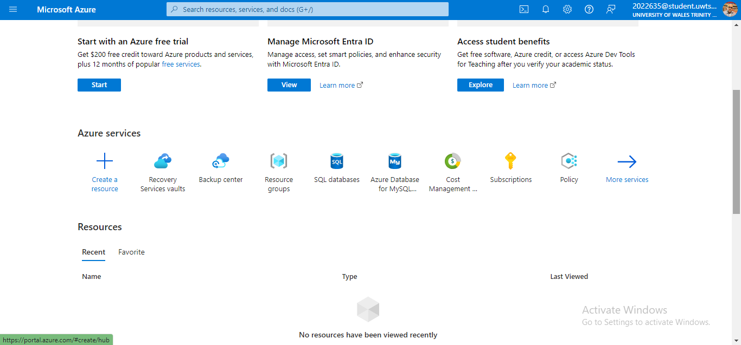
Figure 12: Creating Azure File Storage
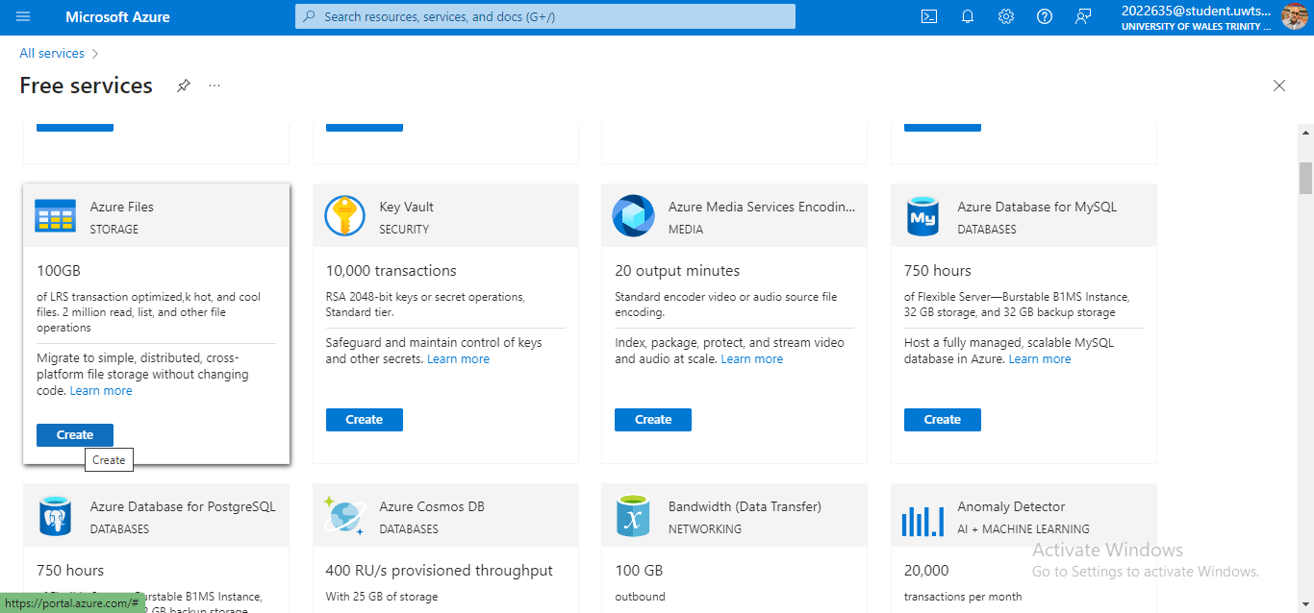
Stage 1: Preparation and Planning

Assessment and Inventory: Conduct a comprehensive assessment of the current on-premise infrastructure, including servers, applications, databases, and network configurations. Create an inventory of all assets, categorizing them based on their importance and complexity.

Migration Strategy: Based on the inventory, develop a migration strategy that prioritizes services and applications based on their criticality. GLI should consider adopting a hybrid approach initially, where some services are moved to Azure while others remain on-premise until the cloud environment is fully stable.

Resource Allocation: Allocate resources, both human and financial, to support the migration. This includes assigning dedicated project managers, cloud architects, and IT staff to oversee different aspects of the migration. Additionally, budget for potential costs such as data transfer, additional Azure services, and staff training.

Risk Management: Identify potential risks, such as data loss, downtime, or security breaches, and develop contingency plans. For instance, ensure that all data is backed up before migration and that fallback systems are in place to handle any disruptions.

Stage 2: Data and Application Migration

Data Migration: Begin by migrating less critical data to Azure to test the transfer process. Use Azure’s Data Migration Service [DMS] to facilitate the seamless transfer of databases and storage. Ensure that data integrity is maintained throughout the process by performing validation checks before and after migration.

Application Migration: Migrate applications in phases, starting with those that are less complex and have fewer dependencies. Use Azure’s App Service Migration Assistant to help identify potential issues and automate parts of the migration. For applications that are heavily customized, consider refactoring or re-architecting them to better fit the cloud environment.

Testing and Validation: After each migration phase, conduct thorough testing to ensure that applications and data are functioning as expected in the Azure environment. This includes performance testing, security testing, and user acceptance testing [UAT] to confirm that the services meet GLI’s operational requirements.

Stage 3: Integration and Optimization

Integration with On-Premise Systems: For services that remain on-premise, ensure seamless integration with Azure through hybrid cloud solutions. Azure’s Virtual Network [VNet] and ExpressRoute can be used to establish secure connections between on-premise infrastructure and the cloud environment, enabling smooth data flow and communication.

Optimization: Once the migration is complete, optimize the cloud environment by adjusting resources based on actual usage. This may involve scaling down unused resources, fine-tuning performance settings, and implementing cost management practices. Azure’s Cost Management + Billing tools can help GLI monitor spending and make adjustments to stay within budget.

Security Enhancements: Strengthen security by implementing Azure’s advanced security features, such as Azure Security Center, which provides unified security management and threat protection across cloud and on-premise environments. Regularly review and update security policies to protect against emerging threats.

Stage 4: Monitoring and Continuous Improvement

Ongoing Monitoring: Use Azure Monitor and Azure Log Analytics to continuously monitor the performance and health of the cloud environment. These tools provide real-time insights into system metrics, allowing GLI to proactively address any issues before they impact operations.

Continuous Improvement: Cloud environments are dynamic and require ongoing management. Regularly review the cloud setup to identify areas for improvement, such as optimizing resource usage, enhancing security, or integrating new Azure services that could benefit GLI.

Staff Training and Support: Provide ongoing training for IT staff to ensure they are up-to-date with the latest Azure features and best practices. Encourage a culture of continuous learning and adaptation, which is crucial for maintaining a robust cloud environment.
Figure13:Creating the Azure Storage Account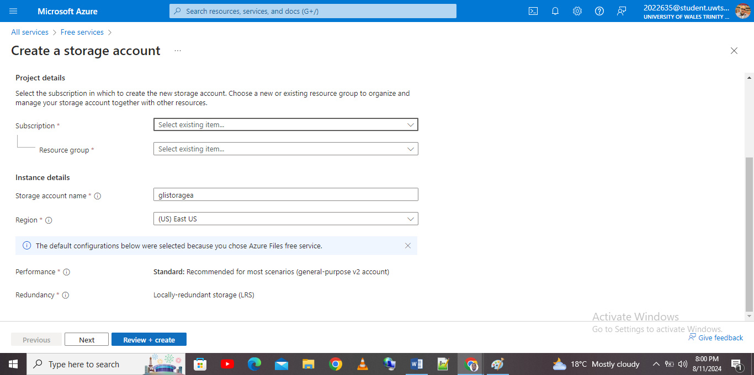
Figure 14: Selecting advanced features of the Azure File Storage
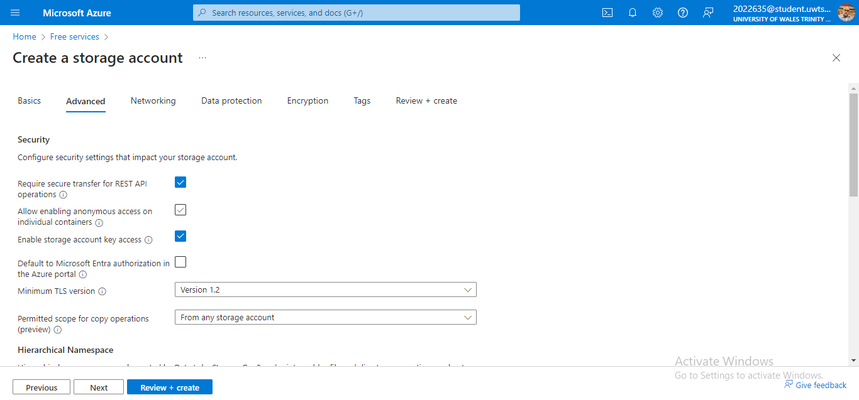
Figure 15: created Azure storage account
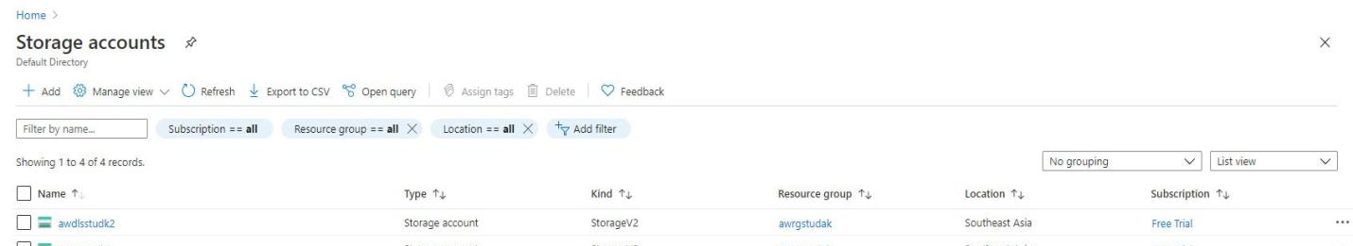
Azure SQL database
Before adopting any SQL database options, GLI, needs to evaluate all the available SQL database options in the Azure portal. The first option is the Azure SQL database. This is a fully managed SQL relational database service that solely based on Microsoft SQL server engine. This type of database is highly scalable. Also, most of the times it offers a high scalable, built high availability, automated backups [10]. Second, the Azure SQL database supports various service tiers. This includes the general purpose, hyper-scale and the business critical. This allows one to choose based on performance requirements. Third, the type of SQL database can scale out and up depending on the workload. For example, the hyper-scale tier offers a rapid scaling. Additionally, it has the ability of handling large database sets. Lastly, it offers advanced security features which includes managed identity, Azure defender for SQL, and data encryption. This provides additional security protection.
The second option is the Azure database for MySQL. This is a fully managed MYSQL Azure database. Specifically, this type of database is ideal for applications which requires open-source databases. Second, the type of database offers multiple pricing tiers like memory optimized, general purpose, and basic. This is done to cater for various performance needs. Other features with this type of database are providing a vertical scaling which is used to handle varying workloads although it is not as flexible as the Azure SQL database. Lastly is that it is suitable for applications using the LAMP stack.
Third type of database is the Azure database for PostgreSQL. This is a fully managed PostgreSQL database service which is widely known for its robust nature for advanced data types and its high performance capabilities. Additionally, the database comprises of advanced features like the JSONNB support, geo-spatial and full text. Also, it offers vertical scaling and supports read replicas [10].
In this case, GLI needs to adopts the Azure SQL database. With the Azure SQL database, the organization will be in a position to store user profiles. Also, the database offers a seamless integration with Azure services. This makes it well-suited for large scale applications like those which are highly needed by GLI. Also, the Azure SQL database specifically the hyper-scale tier will allow handling of large amounts of user data.

Sample implementation of Azure database
Figure 17: Creating Azure SQL database
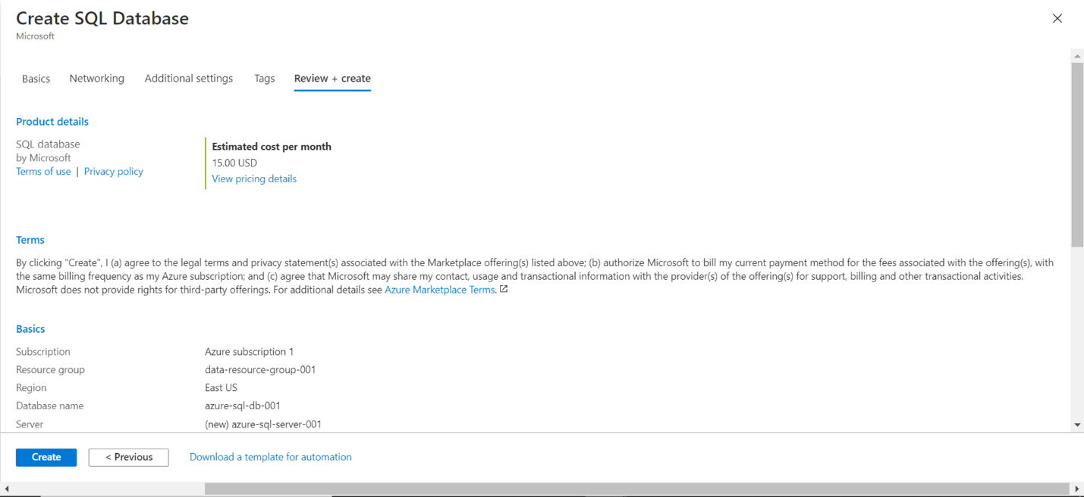
Figure 18: Created Azure SQL database
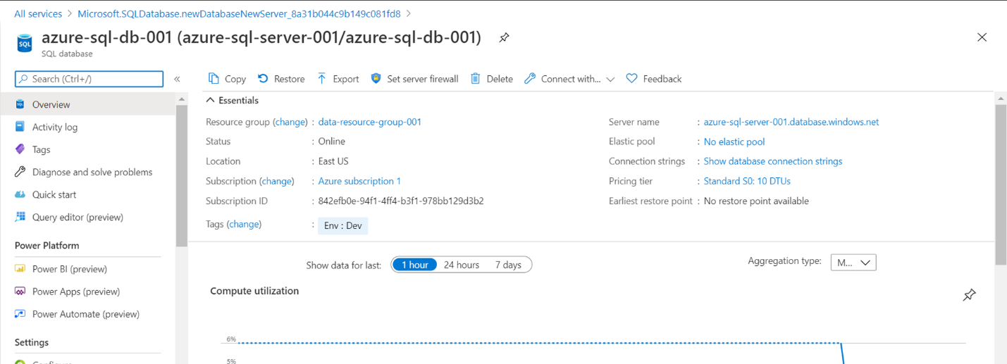

Azure Backup
First, it is important to note that Microsoft Azure Back-up is a type of Azure cloud based service which is used for data protection. Azure Back-up service feature contains several automated backups, secure data storage, and long-term retention. For the organization in this case, GLI, the Azure Back-up can be used to ensure that the institution important or critical data whether databases or file shares is protected against data loss due to disasters, corruption, or deletion [10].
First, the Azure back-up for Azure files allows GLI to create the Azure back-up policies for the Azure file shares. In here the organization can set up them up on weekly, monthly, yearly or even daily depending on the organizational needs for retention.
It is also important to note that Azure back-up contains several security measures. First is encryption, in here the Azure back-up is encrypted using the customer-managed or the Microsoft-managed keys. This is done to ensure that organizational data is secure both when at rest and when in transit. Second security measure is what is known as role-based access control commonly known as RBAC. In here the GLI organization can configure the RBAC security measure to restrict access to the back-up resources and at the same time ensure that only the authorized personnel can restore or even create back-ups. The last security measure with the Azure backup is the Multi-factor authentication commonly known as MFA. In GLI can enable MFA for accounts which have access to the Azure back-up operations.
Before implementing the Azure back-up; it is important to have in place all the considerations measures. First is cost management, the back-up costs in Microsoft Azure usually depend on retention and storage policies. This means that GLI needs to optimize all its policies. This is so as to ensure balance cost with the data protection needs. Second is validation and testing, GLI needs to regularly test all the back-ups and at the same time restore processes. This is done to ensure data is recovered in any disaster scenario. Lastly, is the compliance requirements. In here the organization needs to ensure that retention and back-up policies done follow the industry specific regulations.

Configuration of Azure back-up schedules
The Azure back-up for Azure files allows any organization to create back-up policies for the Azure file shares. To configure back-up schedules in azure one only needs to navigate the Azure back-up center in the Azure portal, click on Azure File shares as the workload, select the recovery services vault feature, defining the Back-up policy, and applying the policy to the desired file shares. This is showcased by the implementation below
Figure 19: Azure service center
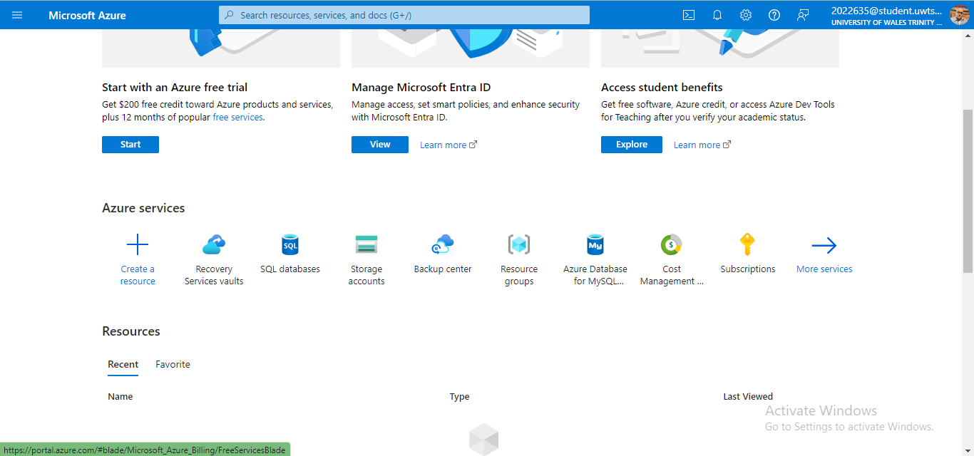

Figure 20: Create Azure Recovery faults
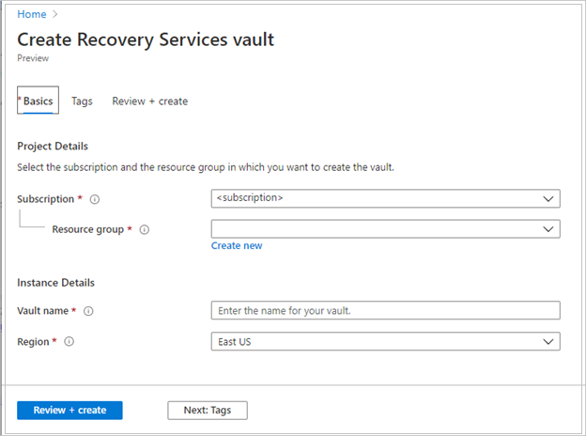
Figure 21: Azure back-up configuration settings
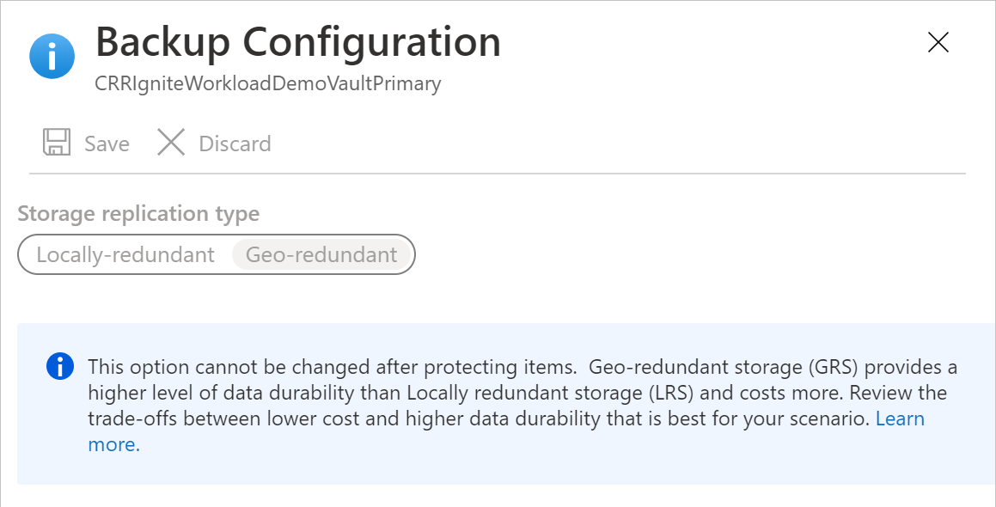

Azure Site Discovery
Azure Site Discovery commonly known as ASR is a disaster recovery service which enables one using Azure cloud platform to recover, failover, and replicate data and workloads to Azure in case of a disaster or outage. For the GLI educational institutional in this case, implementing ASR plan ensures business continuity by providing a back-up that is reliable and minimizing downtime [10].
ASR service in Azure cloud assists one applications to coordinate the recover and replication of virtual machines, databases, and the physical servers. In this the ASR service enables replicate GLI systems and organization data from the on premise environments and ensuring that one have a secondary Azure location in case of an outage [10].
ASR offers various benefits from GLI to minimize downtime by enabling a quick failover. This in turn ensures that any corrupted service is restored rapidly. Second, the service provides what is known as a failback and failover process. This in turn allows GLI organization to reduce manual effort involves in disaster recovery. Third by replication information or data to various Azure regions, GLI will ensure that its organization information or data is protected in the event of a regional disaster or a disaster. Forth ASR service is cost-effective as compared to the current physical data center. This means that GLI can take advantage of the ASR pay as you go model thereby paying only for the resources which are used in case of a disaster or during replication. The last benefit is that ASR service is complaint with the current industry standards. It also provides encryption for data at rest and in transit. This ensures that GLI educational institutional meets the current regulatory requirements and that it maintains a data confidentiality.
ASR protects storage accounts by replicating GLI’s primary storage accounts to secondary region. This in turn ensures that all the critical documents and files are available in case of an outage. For the Azure SQL database, the ASR service is able to replicate databases to a secondary region using the Geo-replication. This in turn ensures database is every time updated. ASR service has the ability of replicating the whole VM including the host operating system, applications, and database to a secondary Azure region. This will allow GLI educational institution in this case to recover the entire database and server in case of a disaster [10].
This means that ASR protects database and storage via Azure storage replication, automated failover, providing geo-replication capabilities. This ensures databases continuity. Also it ensures an automated recovery process by dictating the sequence of operations during a failover and a non-disruptive testing.
Critical analysis and Justification
Azure cloud service is highly scalable as compared to the current on premise. In this case it is the best as it allows GLI adjust its resources based on the demand. Also, as show cased it enables one to scale up or down as needed. For example, in case GLI organization experiences a sudden enrollment which requires additional processing power and storage; this case be met by using Azure as it the platform is able to scale resources perfectly without the need of additional resources.
Second, in case of a regional disaster which disrupts the primary data, the ASR service will enable an automatic failover which minimizes data loss and downtime

Further Implementation
Proof of concept
Creation of windows Virtual machine
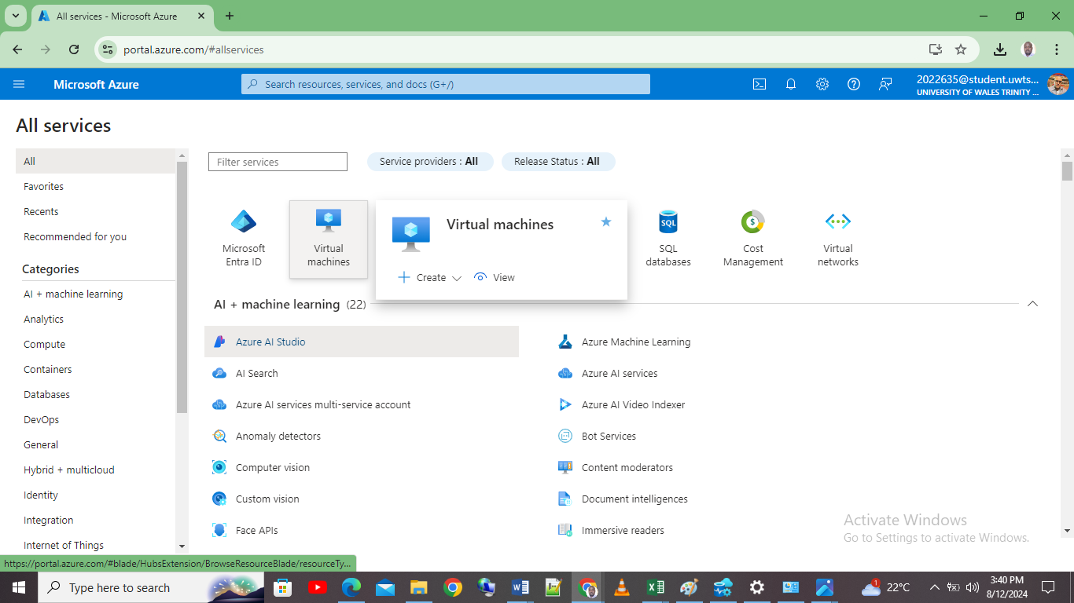
Selecting the windows VM
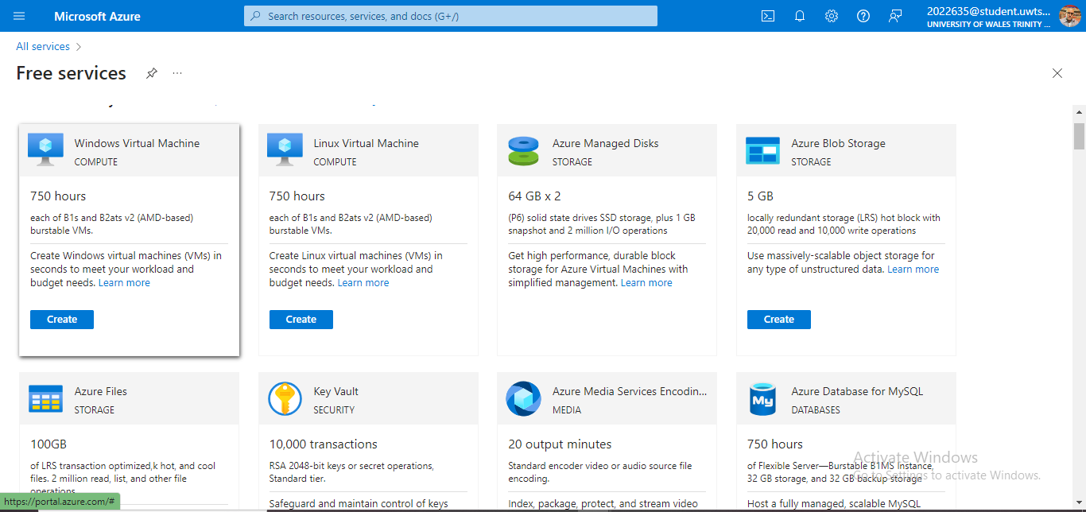
Conclusion
In conclusion, the Azure cloud platform provides the GLI organization with not only a cost effective solution but also a robust and scalable one. As showcased in this project paper, the Azure cloud platform meets the diverse needs of the organization.
Timelines and Key Milestones
The migration process should be structured around key milestones to ensure progress is tracked and any delays are addressed promptly. A typical timeline for GLI’s migration might look like this:
- Month 1-2: PoC development and testing.
- Month 3-4: Comprehensive assessment, inventory, and migration strategy development.
- Month 5-6: Initial data migration and testing.
- Month 7-9: Application migration and integration with on-premise systems.
- Month 10-12: Full-scale optimization, security enhancements, and final testing.
Risk Mitigation Strategies
Throughout the migration, GLI should be prepared to address potential risks:
- Data Loss: Implement robust backup procedures before starting the migration and validate data integrity after each transfer.
- Downtime: Plan migrations during off-peak hours to minimize the impact on users and have contingency plans in place to revert to on-premise systems if necessary.
- Security Breaches: Use Azure’s security features to monitor and protect data during the migration process, and conduct regular security audits
Thus by migrating to Azure platform, GLI organization will ensure meets in objectives at a cost effective manner. Also, it will enhance efficiency, support business continuity, and ensure data security. The recommended services to be used in this case are Azure SQL database which ensures availability of critical data, the Azure File storage which ensures a seamless transition from an on premise file shares to an easily recoverable location in case of data corruption of data loss

REFERENCES
[1] Heinrich, 'AIS Electronic Library (AISeL) - Hawaii International Conference on System Sciences 2023 (HICSS-56): A Total Cost of Ownership Model for Cloud Computing Infrastructure', Aisnet.org, 2023. [Online]. Available: https://aisel.aisnet.org/hicss-56/os/enterprise_system_integration/2/. [Accessed: 12- Aug- 2024].
[2] Gartner, M. Walterbusch, and F. Teuteberg, 'Costing of Cloud Computing Services: A Total Cost of Ownership Approach', 2012 45th Hawaii International Conference on System Sciences, Jan. 2021. doi: 10.1109/hicss.2012.186.
[3] Microsoft Azure, 'Analysis of The Utilization and Implementation of Cloud Computing Infrastructure Services on The Azure Microsoft Platform', Jurnal Mantik, vol. 5, no. 1, pp. 127–136, Apr. 2021. doi: 10.35335/mantik.Vol5.2021.1287.pp127-136.
[4] R. Ramakrishnan, et al., 'Azure Data Lake Store', Proceedings of the 2017 ACM International Conference on Management of Data, vol. 1, no. 2, May 2017. doi: 10.1145/3035918.3056100.
[5] A. Ruiz-Alvarez, and M. Humphrey, 'An automated approach to cloud storage service selection', Proceedings of the 2nd international workshop on Scientific cloud computing - ScienceCloud ’11, 2021. doi: 10.1145/1996109.1996117.
[6] P. Antonopoulos, et al., 'Azure SQL Database Always Encrypted', Proceedings of the 2020 ACM SIGMOD International Conference on Management of Data, Jun. 2020. doi: 10.1145/3318464.3386141.
[7] B. Ward, 'Availability for Azure SQL', Apress eBooks, pp. 373–439, Oct. 2020. doi: 10.1007/978-1-4842-5931-3_8.
[8] P. De Tender, 'Understanding Azure Site Recovery', Implementing Operations Management Suite, vol. 2, no. 1, pp. 121–138, 2016. doi: 10.1007/978-1-4842-1979-9_6.
[9] B. Chakraborty, and Y. Chowdhury, 'Introducing Azure Site Recovery', Introducing Disaster Recovery with Microsoft Azure, pp. 43–79, 2020. doi: 10.1007/978-1-4842-5917-7_2.
[10] P. De Tender, 'Microsoft Azure Essentials - Fundamentals of Azure', Google Books, 2015. [Online]. Available: https://books.google.com/books?hl=en&lr=&id=EfFxBgAAQBAJ&oi=fnd&pg=PA3&dq=Azure+Site+Discovery+&ots=1wLM2VOV00&sig=3hgFn8Lyb1FY4XdorWE5bjR-eNI. [Accessed: 13- Aug- 2024].

