

Module: Human Resource Management

Module Code: LCMB7000

Assignment Title: Assessment 2 (Human Resource Management)

Student Name: Miraj Ahmmed

Student ID: 2123801

Contents
Introduction 3
Overview of the organisation 3
Change management 4
Prosci’s ADKAR Change management model 5
Relevance and application in HR practice and policy 6
HR effectiveness measurement 7
Metrics for measuring HR effectiveness 7
Relevance and significant in the context of Primark 8
Compensation 9
Expectancy and reinforcement theory of compensation 10
Application and relevance of this HR strategy within Primark 11
Conclusions 12
Recommendations 13
References 14

Introduction
The manpower of an organisation is directed and co-ordinated by the direct provision of the human resource management. The HR department of an organisation formulates the effective human resource strategies so that the employees of the company can be utilised in an optimum manner. The objective of this report is to outline the appropriate HR strategies for Primark which is a renowned retain company of United Kingdom. The values, appreciation and sense of each kind of human resource strategies are critically evaluated in the context of the chosen organisation so that they can be suited for the company. Hence, the relevance of the HR strategies to the workplace context of Primark are also compared by conducting the secondary research on the company. Moreover, the relevant human resource theories and models tend to be applied effectively to support the discussions.

Overview of the organisation
Primark is a UK based multinational fashion retain company which started its business activities in June 1969. About 7.79 GBP has been generated as revenue by the company at the year ended 2021. The products of the company include foods, homeware, apparel, healthcare and various types of retail goods. The workplace of Primark is highly diversified as about 78000 employees are associated with the workplace of the company. The company follows the workplace diversification strategy to make the workplace diversified. The labour migration principle is also followed by the top management of Primark so that the skilled labours can be captured from various corners of the world. The business activities of Primark are mainly operated based on the market of Europe and United States. About 7.1% market share has been grabbed by Primark from the international retail sector as per supplying its value added products towards consumers.

Change management
As a human resource manager of Primark, the relevant change management practices tend to be undertaken in this context so that the high performance work environment can be managed in the proper manner. Having gathered knowledge about various management concepts and theories in the organisational context, I would like to apply it in the organisational context of Primark so that the company can enable to change its management structure to get the best output (Harrington et al., 2017). I need to identity the needs of organisational change necessary to the context of Primark so that the company enable to adopt new policies and strategies in the workplace.
Organisational Change Management (OCM) is considered as the structured approach for organisation that is undertaken by the organisation to change successfully of management policy and concepts. The organisational benefits through the relevant changes are considered in the effective manager by the HR managers so that the value added changes can be taken place. At the age of globalisation, the needs of organisational changes have been increasing rapidly. For instance, the change management needs to be practiced in the organisational context of Primark. Hence, the existing HR practices and different policies of Primark needs to be compared with the new policies to get superior benefits (Beardwell and Thompson, 2017). For example, the employee work hour, decision making process, marketing concepts, cultural changes, technological changes and various kinds of changes are effective for the context of Primark. On the basis of values of new HR policies, the required changes need to be implemented within the organisation. The effective change management theories and models are discussed in this report to conduct the relevant changes within Primark.

Prosci’s ADKAR Change management model
This change management model is developed by Prosci in 1998 as per his research on change project on over 30 companies. ASDAR is denoted as goal oriented change management model that has focus on the specific business result as per implementing change to the organisation. About five kinds of HR strategies are illustrated in this change management model which allows the organisation to upgrade the current human resource strategies (Green, 2009). The explanation of this change management model is denoted as follows:
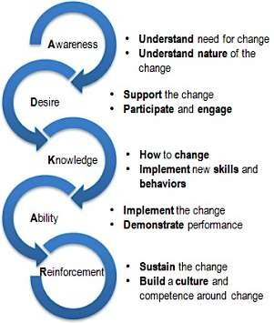
Figure: Prosci’s ADKAR Change management model
Source: (Hook and Jenkins, 2019)
Awareness: The HR management need to undertake the needs of change. For example, the possible benefits through the change management and its importance to the organisation are evaluated in this step. Moreover, the nature of change including external or internal changes are also decided in this stage (Harrington et al., 2017). The awareness of change enables the organisation to formulate proper plan about changes in organisation and add values.
Desire: How to implement the change in the organisation is mainly conducted in this step. The required components need to be assorted by the HR managements of Primark so that the change can be implemented successfully. Employee participation and engagement are highly desired to the change management so that the employees can be familiar with the changes in the organisation.
Knowledge: The process how to change the management policies and strategies are outlined in this case. Basically, the knowledge of change management is discussed with others so that all level of employees gets connected with the change management. required new skills and behaviours may also be outlined (Beardwell and Thompson, 2017). For example, the technological skill set and incentive knowledge can be shared with the stuffs to implement the chance the HR policies.
Ability: The ultimate change need to be executed in this step by the HR managers along with the employees of the organisation. The performance of the stuffs need also be demonstrated to change whether the changes in the organisation add values in the proper ways (Harrington et al., 2017). Clear management checklist should be provided by HR managers in the change management of the organisation.
Reinforcement: Finally, the change should be sustained by the organisation so that the better performance can be continued in long term. Building a culture and competency around the change need also be ensured by the management to reinforcement the changes so that it can provide the superior values to the organisation (Beardwell and Thompson, 2017).

Relevance and application in HR practice and policy
Prosci’s ADKAR Change management model is very effective to be implemented within Primark to undertake the change in the organisation. As Primark is carrying out the business activities in the retail industry of UK, the competition in the retail sector is very high. Hence, Primark is grabbing about only 7.1% market share. For this reason, the implementation of management policy and organisational strategies are required to get more output and securing its strategic position. ADKAR change management model can also increase the competitive edge of Primark to the retail sector and the company can grab more values from the market (Harrington et al., 2017). The changes of organisational culture, adopting new technologies, labour migration, re-designing management policies can be undertaken within Primark to enhance the business performance.

HR effectiveness measurement
Primark tends to find out the effectiveness of human resource so that the key organisational decisions can be taken smoothly. For instance, the analysis of effective of human resource strategies are required within Primark. As a HR managers of Primark, I will find out different HR measure techniques so that the actual performance within Primark can be determined in proper ways (Daft and Lane, 2015). The balance scorecard system, benchmarking, HR matrix and various strategies can be applied to Primark to get the effectiveness of different HR strategies of the company.

Metrics for measuring HR effectiveness
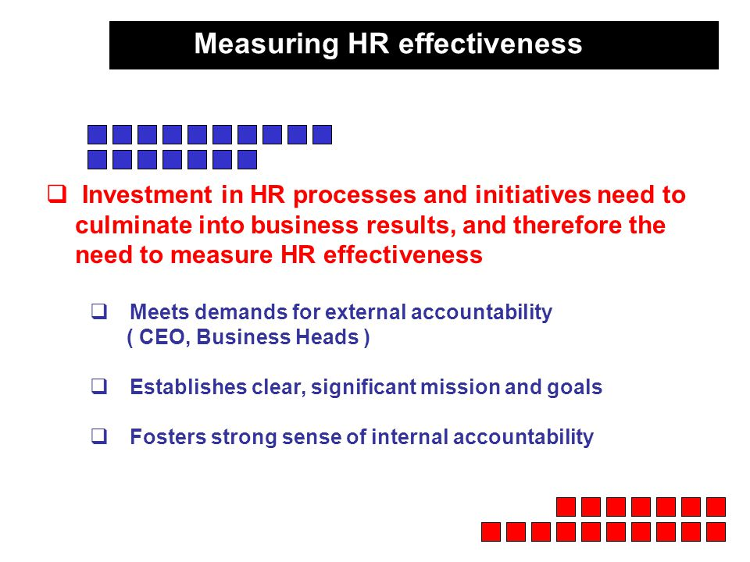
Using metrics of scorecard is effectively used by the organisations to assess the effectiveness of the HR approaches. The proper use of metrics can enable the organisation to determine how the organisational initiatives are successful to get the desired results. Hence, the clear and significance goals need to be set at the inception point. After that the strong internal accountability need to be set by the organisation so that the HR initiates can be implemented with proper transparency (Stack, 2013). Finally, the demands of external accountability need to be implemented to assess the organisational HR effectiveness.

Relevance and significant in the context of Primark
The application of scorecard metric is relevant to the context of Primark as the organisation has clear, significant mission and goals. The transparency is also maintained to the workplace of Primark. Having proper accountability to the organisation can enable the HR managers to assess the effectiveness of HR policies and initiatives. On the basis of score of various HR practices, the HR managers can assess their values and significance to the context of Primark (Kets et al., 2011). Hence, the managers of Primark can cut off the low scored HR practices and focus on the high score HR practices to get the best output in the effective manner.

Compensation
The entitlement to the employees as per financial and non-financial benefits from the organisation in return to their contribution to the workplace is denoted as compensation. The employees expect better compensation plan from the top management to fulfil their desire in the workplace. By playing roles as human resource management of Primark, the effective compensation plan will be deployed to the workplace of the company so that the employees can get the effective compensation and increase their commitment to the work (Fargus, 2010). Hence, the profit sharing schemes, adjustable salaries, employee perks, overtime payment, flexible work hour, vacation, personal days off, paid leaves and different kinds of compensation plan can be executed to the workplace of Primark to increase the commitment level of the stuffs of the organisation.
These kinds of compensations can increase the job satisfaction level of the existing employees of Primark and boost their performance. By this way, the organisational output level can also be increased by implementing the effective compensation plan for the employees. Moreover, the value added compensation plan may enhance the employee loyalty that is highly desired to the workplace of Primark. The regular payment to the employees may not be effective to them and hereby they can demand some extra payment or overtime to the workplace. Paying extra based on the performance of the employees can boost their satisfaction and their engagement to the workplace can be consolidated by this way. The reward system as per attaining benchmark of the organisation can be adopted within the workplace of Primark to motivate the employees. Primark can apply these kinds of compensation strategies to the workplace without any kind of discrimination so that the desired compensation plan can be implemented and it can fulfil the employee’s interest.

Expectancy and reinforcement theory of compensation
This theory is prescribed by Victor Vroom at 1964 and the expectancy theory assumes that the reward earning behaviour of the employees is repeated to the workplace. If the top management of the company allows rewards on the best performance of the employees, they can top performance can be continued for long run (Fargus, 2010). The employees are expected to do thing which allows rewards from the top management of the organisation. Hence, the expectancy of the employees is depended on their performance in workplace. The detailed explanation of expectancy and reinforcement theory are given below:
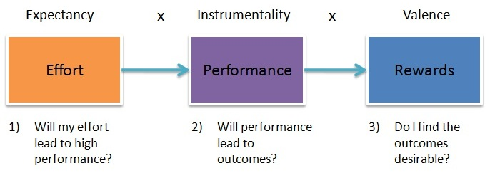
Figure: Vroom’s expectancy theory
Source: (Krukoff, 2016)
Expectancy: The expectancy can be described as the belief of the employees that can impact on their high performance to the organisation. Hence, the skills set at the job, correct resources and necessary supports are needed to the expectancy of the employees. The employees expect what about they get from the top management if they provide the high performance to the workplace (Krukoff, 2016). Their belief can be converted into practical if the proper supports can be provided by the HR managers in the workplace. Based on the belief of the employees, they can enable to maintain their commitment to the organisation.
Instrumentality: In this context, the instrumentality is the thought of the employees that if they perform well to the organisation they will be valued by the HR management of the company. Particularly, the instrumentality is called the relationship between the performance and outcomes of the stuffs. The human resource managers play the vital roles to make the employee perform as instrument to get the desired outcomes (Torrington, 2020). Having respect and trust between the employers and employees can also be played vital role to the instrumentality as the employee’s decision who will get reward in the workplace. The transparency is highly required among the HR managers to consider the performance of the employees in deciding about rewards.
Valence: The term valence is defined as ‘Value’ that refers the desirability of outcomes based on the employee performance in the organisation. The expectancy about values of the individuals in the workplace are not same. Different level of employee’s demand promotion, bonus, recognition and so on (Krukoff, 2016). For this reason, the HR manager need to determine which kind of value the individual holds and deciding about reward. Valence is also thought about the pressure the employees put to get the outcomes to the organisation.

Application and relevance of this HR strategy within Primark
Considering the improvement of modern technology, the criteria to increase the organisational performance has also been broadening in the recent age. For instance, the Vroom’s expectancy theory of compensation can be applied successfully to the workplace of Primark to get the best output than that of competitors in the market. Vroom believed that the increased effort by the employees can increase the organisational performance. Though this theory, Primark can increase the effort level of its employees so that the organisational performance can meet its standard (Torrington, 2020). The top management of Primark can focus on relationship building with its employees so that their effort can be increased to the work related context. By maintaining good relation with the employees, the management of Primark can enable to create string belief of the stuffs on top management.
By increasing engagement with the stuffs of Primark, the stuffs can believe their high performance with be valued by the organisation. The value proposition of the stuffs of Primark can also be focused in this context to assess different values of individual in workplace. The HR policy of Primark can be redesigned so that reinforcement can be implemented to the workplace of the organisation to get the high performance (Krukoff, 2016). By combining, the valence, expectancy and instrumentality of the stuffs, the employee commitment and motivation to the organisation of Primark can be ensured in the systematic manner. Thus, Primark can enable to get the high performance from its stuffs as per undertaking these employee compensation strategies.

Conclusions
In summary, the success of the business basically depends on the proper utilisation of the human resource and the effective application of these types of HR strategies are highly required to the organisation to add more values. The change management, compensation and assessing the HR effectiveness approaches are critically analysed to this report so that the management of Primark can practices these type of strategies to the organisation. There has scope for Primark to implement these HR strategies to get the optimum output.

Recommendations
- The skill set of the employees should be developed as per arranging proper training session to the organisation.
- Primark can implement the management by objective (MBO) approaches to implement change management to the organisation.
- The transparency and relevancy should be maintained strictly by the top management of the company.
- The strategic plans of Primark should be harmonise as per considering the external and internal factors.

References
Beardwell, J. and Thompson, A., 2017. Human resource management. Harlow: Pearson Education.
Hook, C. and Jenkins, A., 2019. Introducing Human Resource Management. Harlow, United Kingdom: Pearson Education Limited.
Green, M., 2009. Change management masterclass. London: Kogan Page.
Harrington, H., Conner, D. and Horney, N., 2017. Project change management. New York: McGraw Hill.
Krukoff, D., 2016. Compensation. Saskatoon, Sask.: Thistledown Press.
Daft, R. and Lane, P., 2015. The leadership experience. Australia: Cengage Learning.
Kets de Vries, M. and Korotov, K., 2011. Leadership development. Cheltenham, UK: Edward Elgar.
Fargus, P., 2010. Measuring and improving employee motivation. London: Financial Times Prentice Hall.
Stack, L., 2013. Managing employee performance. [Highlands Ranch, CO]: Productivity Pro.
Torrington, D., 2020. Human resource management. 11 ed. Harlow: Pearson Education.
Lussier, R. N. & Hendon, J. R., 2019. Fundamentals of Human Resource Management: Functions, Applications, and Skill Development. 2 ed. London: SAGE Publications, Inc

