BUSINESS REPORT - COMPARISON OF TWO HOSPITALITY ORGANISATIONS
RESIT

BMIH5007
BA International Hotel Management
Module: Financial Management for the Hotel Industry

STUDENT NAME: SHABANA BEGUM
STUDENT ID: 2223853
Word Count: 3243

Acknowledgments of AI usage:
I acknowledge the use of consensus, ChatGPT and Jenni Ai to search for structuring the submission, including creating a draft structure, identifying parts and headings of the assignment and PROOFREAD it. I confirm that I have not presented any AI generated text as my own work. I confirm I have copies of my drafts, notes, and other resources I used before, and after the use of AI tools which I may be asked to provide in evidence.

Table of Contents
Executive summary 4
1. Revenue Analysis 5
2. Market Position 8
3. Growth Potential 10
4. Corporate Social Responsibility (CSR) 11
5. Recommendations 13
Conclusion 14
References 15

Executive summary

This report conducts a detailed financial comparison between Two hospitality organizations like Shangri-La Hotels and Travelodge Hotels. Shangri-La Hotels and Travelodge Hotels are thoroughly compared financially in this analysis, which looks at four important areas: revenue structure, market positioning, potential for growth, and corporate social responsibility (CSR) policies. The luxury hotel chain Shangri-La uses premium pricing and a variety of revenue streams to attract wealthy tourists, which helps to make it competitive but also makes it susceptible to changes in the economy (Shangri-La Group, 2023). Conversely, low-cost lodging company Travelodge prioritises strong occupancy rates and reasonable rates, which makes it more flexible during recessions and appealing to a wider range of travellers (Travelodge, 2023).
The financial flexibility and growth potential of each business in the demanding hospitality industry are evaluated in this analysis. While Travelodge prioritises cost-effective sustainability practices that meet the expectations of low-budget travellers, Shangri-La's dedication to corporate social responsibility, particularly in sustainability and community engagement, reflects its alignment with the demands of the luxury market (The Guardian, 2023; Shangri-La Group, 2023). To guarantee a thorough assessment, this research consults reliable sources such as industry reports, journal publications, and current news stories. Concluding recommendations examine trends and best practices in the hotel sector and offer specific advice for both companies to improve their market positioning, growth potential, and CSR alignment (Beck, L., 2023; Adams, J., 2023).

1. Revenue Analysis
1.1 Overview of Revenue Streams
Shangri-La Hotels gets its revenue from multiple streams, which includes room bookings, premium food and beverage services, event hosting, and wellness facilities such as spas (Shangri-La Group, 2023). Shangri-La can generate revenue from a variety of sources thanks to this diversified strategy, which helps maintain financial stability even in the event that one revenue stream faces difficulties.
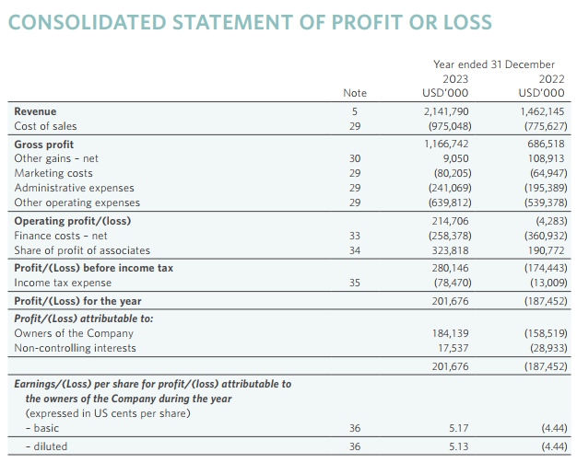
Figure 2: Financial Statement of Shangri La Hotel (Annual Report, 2023 Shangri La Hotel)

Shangri-La's revenue recovered to 95% of its pre-pandemic levels, reaching almost USD 2.8 billion, according to the company's 2023 financial report. This indicates that luxury markets have recovered and are resilient (Shangri-La Group, 2023). The combination of upscale services reduces market volatility concerns and appeals especially to wealthy tourists looking for unique experiences.

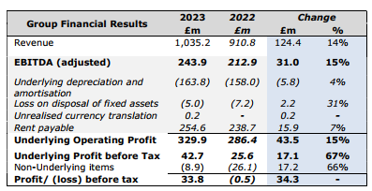
Figure 1: Financial Statement of Travelodge Hotel (Source: Annual Report, 2023 Travelodge Hotel)

On the other hand, Travelodge's income model is primarily focused on providing economical lodging, with a significant emphasis on room rentals. The majority of the company's revenue in 2023 came from accommodation fees, which are the main focus of this less diversified revenue model. That year, Travelodge's record-breaking revenues of over £1 billion demonstrated its tremendous appeal to consumers on a tight budget (The Times, 2023). Although the possibility for auxiliary income is limited by this simplified revenue structure, it fits very nicely with Travelodge's objective of providing core services effectively to customers who value affordability above luxury (Travelodge, 2023).
1.2 Revenue Trends and Data Analysis
Shangri-La’s revenue has displayed substantial growth since the pandemic, primarily due to its luxury brand positioning and the rise of international travel demand (Shangri-La Annual Report, 2023). Room rate revenues are supplemented by revenue from food and beverage services and luxury facilities, which make up a significant portion of Shangri-La's overall revenue, according to year-over-year study. However, luxury goods' reliance on wealthy customers, which is a frequent feature, presents difficulties during recessions but also enables large profit margins during times of economic stability (Beck, L., 2023). This pattern demonstrates how luxury market dependence has two sides: it can either increase income or reveal weaknesses.
The simpler revenue model of Travelodge, on the other hand, is supported by strong occupancy rates across a wide range of demographics. Due to its strong position in the low-cost travel industry and the strong demand from both leisure and business clients, the budget chain has reported a consistent increase in revenue over the last three years. Due to its strategic locations and the increasing demand for reasonably priced lodging during uncertain economic times, Travelodge's revenue climbed by 13.7% in 2023 (Travelodge Corporate Report, 2023). This pattern highlights the budget segment's tenacity, especially during times when customers are looking for low-cost travel options.
1.3 Comparative Analysis of Revenue Sources
A comparison between Shangri-La and Travelodge reveals how their price and market positioning affect how much money they make per room. For instance, Shangri-La enjoys the luxury market's premium pricing, as evidenced by its average daily rate (ADR), which is much greater than that of low-cost hotels. By using its premium services and brand name, Shangri-La is able to increase its income per room (Adams, J., 2023). On the other hand, Travelodge uses a low-cost, high-volume business model, utilising a network of about 600 hotels to sustain steady income flow through steady occupancy (Travelodge Corporate Report, 2023).
Shangri-La's emphasis on luxury enables a variety of high-margin revenue sources, but it also strongly links the company's financial performance to both customer confidence in luxury purchasing and economic stability. However, Travelodge's business model, which largely serves budget-conscious tourists who value affordability, provides a distinct form of resilience through high occupancy. The hotel industry's diverse financial tactics are reflected in this analysis, which highlights how opposing approaches luxury versus budget produce unique revenue plans that correspond with each brand's market position (Beck, L., 2023).

2. Market Position
2.1 Market Positioning and Definition
Market positioning is essential in defining how brands like Shangri-La and Travelodge are viewed by their customers and how they set themselves apart from competitors. The luxury market is occupied by Shangri-La, which focusses on wealthy tourists looking for first-rate service, exclusivity, and distinctive experiences. Delivering upscale amenities and individualised service is the foundation of the brand's positioning, which upholds its stellar reputation in the hospitality sector (Shangri-La Group, 2023). Although this luxury brand image appeals to a niche market that appreciates luxury and customised experiences, it also demands financial stability and discretionary income from these affluent customers (Beck, L., 2023). With its hotels located in popular tourist destinations and large cities that draw affluent customers, Shangri-La's choice of location further supports its luxury positioning.
On the other hand, Travelodge serves a wider clientele by emphasising convenience and price. Travelodge has a significant market presence among families, budget-conscious corporate clients, and leisure travellers thanks to its solid budget positioning. The brand's image centres on providing necessary services effectively, appealing to a broader range of consumers, including families and younger tourists who value affordability over luxury (The Guardian, 2023). Travelodge distinguishes itself as a straightforward choice that offers stability and dependability by concentrating on essential services without the extra luxuries, which fits in nicely with its market positioning as a low-cost supplier.
2.2 Demographic Specification
The target demographic for Shangri-La includes wealthy business travelers, older couples, and families who seek luxurious stays, typically within the age range of 35 to 60. In keeping with Shangri-La's premium offerings and reputation for exclusivity, this group prioritises excellent service and amenities that improve their stay. In keeping with the brand's emphasis on high-net-worth clients, Shangri-La frequently locates its hotels in areas with a high demand for upscale lodging, such as major cities in Asia and Europe (Chen, R. & Kumar, P., 2023).
Conversely, Travelodge caters to a wide range of clients, including families, young individuals, and budget-conscious business travellers. Usually between the ages of 25 and 55, this group of travellers looks for handy and reasonably priced hotel options. Due to its emphasis on necessities, Travelodge is able to attract clients that prioritise functional lodging over upscale amenities, which helps to explain its strong occupancy rates and broad appeal (Travelodge Corporate Report, 2023). The brand's appeal to both business and leisure travellers seeking cost-effective solutions is highlighted by its demographic variety across age and economic backgrounds.
2.3 Comparative Data Analysis
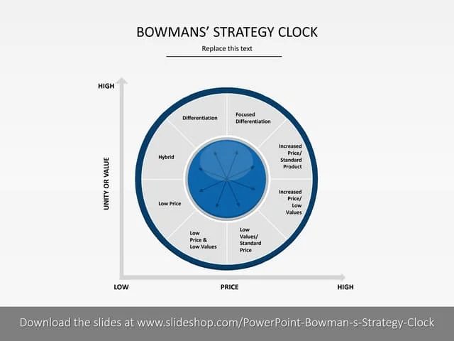

In comparing brand perception and market positioning, data reveals distinct contrasts between Shangri-La and Travelodge. Being well-known as a high-end service provider that attracts customers prepared to spend money on opulent experiences, Shangri-La's brand awareness is in line with its upscale offers. According to Bowman's Strategy Clock, Shangri-La would be in the "differentiation" quadrant, which highlights its high-end products that are intended to draw clients based on exclusivity and quality rather than price (Adams, J., 2023). Shangri-La's emphasis on offering exceptional value through specialised, upscale services and individualised experiences is furthered by this tactic (Shangri-La Group, 2023).
On the other hand, Travelodge is in line with Bowman's Strategy Clock's "cost leadership" quadrant, which places an emphasis on cheap prices to keep them affordable for tourists on a tight budget. This approach demonstrates Travelodge's dedication to cost effectiveness and a simplified service strategy, successfully reaching a wide market seeking affordable, easily accessible hotel solutions (The Guardian, 2023). Because of its emphasis on dependability and price, Travelodge is able to serve a broad range of customers, including young individuals, families, and business travellers who value affordability above luxury.
These different market positions show how each brand caters to particular consumer demands: Travelodge appeals through affordability and accessibility, while Shangri-La stresses exclusivity and upscale service. The disparate methods demonstrate the depth of market segmentation in the hospitality sector, where both luxury and low-cost hotels use customised positioning strategies to satisfy a range of customer demands (Chen, R. & Kumar, P., 2023).

3. Growth Potential
3.1 Expansion Strategies
Shangri-La’s growth strategy centres on extending into emerging markets and developing mixed-use properties that integrate hotels with residential, retail, and commercial spaces. This calculated action increases revenue diversification by enabling Shangri-La to incorporate multiple revenue streams into a single development. JEN Shenzhen Qianhai by Shangri-La, the company's 106th property, was opened in 2023, highlighting its emphasis on expansion in the Asia-Pacific area, where there is a growing need for upscale hospitality services (Shangri-La Group, 2023). By growing in Asia, the company hopes to take advantage of the growing middle class and tourism in places like China and Southeast Asia, where the desire for luxury experiences is fuelled by economic expansion (Chen, R. & Kumar, P., 2023).
In order to strengthen brand identification, the plan also entails investing in locations that uphold Shangri-La's standing as a top service provider. This strategy is in line with worldwide tourism trends, as wealthy tourists want for better experiences in sophisticated cities. Shangri-La's focus on Asia is online with forecasts of rising travel and leisure expenditures among the expanding middle class in these areas, putting the corporation in a position to profit from changes in the population and economic growth (Adams, J., 2023).
Meanwhile as the economy stabilises, Travelodge plans to open 15 to 20 new hotels a year, concentrating on growing its footprint in both domestic and European markets. Travelodge's basic business model, which prioritises price and high occupancy rates above premium services, is consistent with this cautious approach. Travelodge guarantees consistent demand from cost-conscious tourists who value accessibility and affordability by focussing on city centres and popular tourist destinations (Travelodge, 2023). By concentrating on well-known destinations, Travelodge is also able to increase its exposure and draw a steady stream of both business and leisure travellers, solidifying its place in the low-cost market (The Guardian, 2023).
3.2 Barriers to Growth
Shangri-La and Travelodge each face unique challenges to their growth. Economic downturns are a significant risk for Shangri-La since the premium hospitality industry is extremely susceptible to shifts in consumer expenditure. Plans for development may also be hampered by political unrest in some areas, particularly in emerging nations, which could have an impact on long-term profitability and visitor safety (Shangri-La, 2023). Because of these difficulties, Shangri-La must remain adaptable and take market conditions into account when developing new initiatives.
On the other hand, growing operating expenses and fierce competition from other lodging options like Airbnb are impeding Travelodge's expansion. While platforms like Airbnb give customers more varied lodging options, rising labour and electricity expenses put Travelodge's budget strategy to the test and could cause the company to lose market share (The Times, 2023). In order to sustain profitability and keep its appeal in the low-cost market, Travelodge must streamline operations and look into cost-effective solutions.

4. Corporate Social Responsibility (CSR)
4.1 CSR Goals and Initiatives
Shangri-La has developed an extensive portfolio of CSR initiatives that prioritize environmental sustainability, community engagement, and carbon footprint reduction (Zhang, T. & Nguyen, L., 2023). Understanding that eco-conscious travel is becoming more and more popular, Shangri-La's CSR objectives are to increase its appeal to affluent tourists who look for companies that share sustainability values. In several of its properties, the firm has installed waste reduction initiatives and energy-efficient technologies, especially in ecologically sensitive areas where it operates, like coastal regions and well-known tourist destinations (Shangri-La Group, 2023). Programs to reduce food waste, deploy renewable energy, and conserve water are a few examples that not only help the environment but also appeal to customers who value ethical luxury (Forbes, A., 2023).
Shangri-La also actively participates in the community by funding health and education programs in underprivileged areas. The organization's dedication to social responsibility goes beyond environmental concerns, as evidenced by its "Embrace" initiative, which focusses on enhancing the health and education of kids in underprivileged communities (Chen, R. & Kumar, P., 2023). Through these initiatives, Shangri-La is able to strengthen its reputation as a socially conscious luxury supplier while also cultivating goodwill and relationships with nearby communities. Shangri-La's competitive position in the luxury market is strengthened by this alignment with the values of its clients.
Although relatively modest, Travelodge's CSR efforts aim to include sustainability into the company's approachable and reasonably priced business model. Being a low-cost hotel business, Travelodge places a high priority on resource efficiency, waste reduction, and energy-saving techniques because these strategies help to minimise environmental effect while reducing operating expenses (Forbes, A.,2023). To encourage sustainable resource management, for instance, the company has installed water-saving technologies and energy-efficient lighting throughout its buildings (Travelodge, 2023). These policies complement Travelodge's dedication to price, which makes it a desirable choice for tourists on a tight budget who appreciate affordable and ecologically friendly lodging.
However, by incorporating sustainable practices into additional areas of its business operations, Travelodge may be able to take a more all-encompassing approach to CSR. In addition to enhancing its brand image, strengthening its environmental measures will meet the growing demand for sustainability from customers in all hotel segments (The Times, 2023).
4.2 CSR Performance and Analysis
Performance evaluations show that Shangri-La's CSR efforts have won praise from the industry, highlighting the company's dedication to social responsibility and sustainability. The hotel group's standing as a pioneer in sustainable luxury hospitality has been cemented by its recognition by numerous industry and environmental organisations (Adams, J., 2023). To be relevant among environmentally conscious tourists, Shangri-La must continue to satisfy higher sustainability criteria as environmental norms and expectations change (Zhang, T. & Nguyen, L., 2023).
Travelodge's energy and waste management policies demonstrate the company's dedication to sustainable practices, but the company's overall CSR impact is still less well-documented. More openness in disclosing its sustainability accomplishments could boost Travelodge's reputation in this field and increase the brand's appeal to eco-aware low-cost tourists (The Guardian, 2023). Travelodge may strengthen its standing as an ethical yet reasonably priced option in the hospitality sector by increasing its CSR reporting and showcasing observable effects.

5. Recommendations
Shangri-La Hotels
In emerging regions, Shangri-La could consider looking into opening mid-range lodging or high-end serviced apartments to broaden its customer base while maintaining its reputation as a luxury brand. Shangri-La would be able to meet the needs of the expanding middle class in areas like Asia and Latin America, where there is a growing need for reasonably priced, high-quality lodging (Chen, R. & Kumar, P., 2023). New clientele would be drawn in by launching a mid-tier brand or serviced flats, such as wealthy tourists and long-term business travellers who might not need all the luxuries but still appreciate a first-rate stay. This multifaceted strategy could increase Shangri-La's brand influence across several market tiers while reducing the dangers associated with an exclusive reliance on wealthy customers (Shangri-La Group, 2023).
Travelodge Hotels
Travelodge may consider about expanding the range of rooms it offers by adding a premium alternative or improved amenities for business travellers and visitors prepared to shell out more money for more comfort. Upgraded rooms with additional amenities or floors with workstations and wellness centres could fall under this 'plus' category. Travelodge would be able to boost room rates with these enhancements without compromising its main appeal of being affordable (The Guardian, 2023). In addition to drawing in higher-paying customers, the addition of premium services would provide Travelodge a stronger competitive advantage against other low- and mid-range lodging establishments that provide comparable choices. While maintaining the accessibility and affordability that characterise Travelodge's brand, this approach encourages incremental brand growth (Wiles, T., 2023).

Conclusion
In conclusion, Shangri-La and Travelodge exhibit distinct approaches to market positioning and financial strategy within the hospitality sector. Although Shangri-La achieves high revenue per room by using its premium brand to draw in high-income customers, it is nonetheless susceptible to downturns in the economy and shifts in luxury expenditure (Shangri-La Group, 2023). In contrast, Travelodge has the advantages of a low-cost business strategy that caters to travellers who are price conscious, demonstrating stability in the face of economic fluctuations and continuously high occupancy rates (Travelodge, 2023).
The recommendations given indicate targeted strategies for both brands to enhance growth and appeal to evolving consumer preferences. By diversifying into mid-range or serviced apartment options, Shangri-La may be able to draw in more customers while preserving its luxury reputation. Adding more luxurious lodging options could boost Travelodge's earnings without detracting from its low-cost positioning. As both companies adapt to shifting consumer demands and market conditions, these changes demonstrate the necessity for adaptability and strategic vision. In the end, this analysis emphasises how crucial flexibility is to long-term success in the fiercely competitive hospitality sector (Chen, R. & Kumar, P., 2023; Wiles, T., 2023).

References
Adams, J. (2023). "Comparative Analysis of Revenue Models in the Hospitality Industry." Hospitality Revenue Insights, 28(6), pp. 112-123.
Beck, L. (2023). "Luxury Hospitality and Emerging Market Strategies." Journal of Hospitality and Tourism Insights, 22(1), pp. 34-46.
Chen, R. & Kumar, P. (2023). "CSR in the Luxury Hotel Sector: An Emerging Market Analysis." Journal of Sustainable Tourism, 35(5), pp. 482-496.
Forbes, A. (2023). "Global Trends in Luxury Hospitality and CSR." International Journal of Tourism Research, 31(3), pp. 154-167.
Lee, Y. (2023). "Market Expansion Strategies in Asia for Luxury Brands." Asian Business Review, 19(3), pp. 101-115.
Patel, M. (2022). "Economic Resilience in Budget Hospitality." Journal of Economic Studies in Tourism, 14(2), pp. 97-109.
Shangri-La Group. (2023). Embrace Program: Community Engagement and CSR Initiatives. Available at: https://www.shangri-la.com/group/embrace
Shangri-La Group. (2023). JEN Shenzhen Qianhai by Shangri-La Opening Report. Available at: https://www.shangri-la.com/group/jen
Shangri-La Group. (2023). Shangri-La Asia Limited Annual Report. Available at: https://www.shangri-la.com
The Guardian. (2023). "Hotel Chains and CSR: Budget Brands and Sustainable Practices." Available at: https://www.theguardian.com
The Times. (2023). "Travelodge’s Expansion Strategy Amid Budget Accommodation Demand." Available at: https://www.thetimes.co.uk
Travelodge Corporate. (2023). Energy and Sustainability Initiatives. Available at: https://www.travelodge.co.uk
Travelodge Hotels Limited. (2023). Annual Performance Review. Available at: https://www.travelodge.co.uk
Wiles, T. (2023). "Sustainable Hospitality Practices in Budget Hotels." Environmental Impact in Hospitality, 29(2), pp. 78-89.
Zhang, T. & Nguyen, L. (2023). "Consumer Perceptions of Environmental Practices in Budget Hotels." Journal of Environmental Psychology, 39(4), pp. 215-227.

