LCMB7001
Marketing Management
Assessment 1

Table of Contents
1. Introduction 3
2. Communication channels to ensure current and future stakeholders’ expectations 4
2.1 Marketing communication 4
2.2 Marketing communication growth 7
2.3 Marketing tools 9
2.4 Stages in customer journey 10
2.5 Marketing options for British Petroleum 10
2.6 Brand equity model 11
2.7 Innovative marketing strategy 12
3. Conclusion 14
References 15

1. Introduction
By using marketing management, British Petroleum can be successful at ensuring proper customer connection. A significant amount of time can be saved by the support of using marketing management. In order to make marketing decision, it is very necessary to focus on the data and other aspects. With the support of marketing management, British Petroleum can be able to interconnect. British Petroleum is an organization which had been focussing on the marketing management operations based on available trends. For British Petroleum, cost effective is the primary factor which makes necessary impact on the operations. Because of the technological growth, marketing management media had got a lot of tools to focus on. Depending on the customer reviews and other processes, it can make impact on the perspectives of the marketing management.

2. Communication channels to ensure current and future stakeholders’ expectations

2.1 Marketing communication
E-commerce and marketing communication and management platform have been developed over the time because of applying various physical channel. From the physical channel to the marketing communication and management, total process had taken several process growth. It is very important to focus on various market trends and insights to make proper decisions about the marketing communication and management processes. A significant amount of time can be saved by the support of using marketing communication and management (Bagozzi et al., 2018). In British Petroleum, there are different types of challenges such as misinterpretation of the data. By using marketing communication and management, British Petroleum can be successful at ensuring proper customer connection.
In the aspect of employee interaction, proper level of trust will have to be established. British Petroleum is an organization which had been focussing on the marketing communication and management operations based on available trends. Marketing communication and management operations are important for going with the trend. By the physical channel, a strong public perception can be created by British Petroleum (Panchenko et al., 2020). This kind of public perception can help to gain better output on the marketing communication and management roles and prospects. All of these are actually becoming effective for British Petroleum to focus on various new operational trends. In the digital platform, the cost level is highly influenced as the level of cost is very low.
Companies are required to take their costs of operations lower than earlier. As the result, they are focusing on the marketing operations on effective manner. These focus on cost effectiveness matter had been ensuring the development of the marketing communication and management. Convenience is another tool which is possible on the marketing communication and management processes. Marketing communication and management tools are very much convenient in nature because it assures proper and quick interaction (Lepkowska-White et al., 2019). In British Petroleum, this method is being used because of the nature of the convenience. Over the time, the level of convenience is supporting to focus on the e-commerce and marketing communication and management operation in the long run.
Establishment of various technologies such as marketing devices, software, and other prospects had been making impact on the overall aspects of growth. It had been a very big trend for British Petroleum to focus as the growth on technology had been very significant. Depending on the customer reviews and other processes, it can make impact on the perspectives of the marketing communication and management (Park, 2020). All of these shared information can be very effective and efficient for the purpose of product management. To deal with these operations, different marketing communication and management aspects are depending on different significant processes. As the result, British Petroleum is being able to develop the proper and suitable marketing decisions.
There are three types of marketing channels which are available for the organizations like British Petroleum. Overall, it starts with the single marketing channel where an organization has a particular point of communication only. On the other side, multi-channel marketing is associated with the operations throughout different other links. Following this, omni channel marketing is also concerned about the multiple channels where the efforts are well coordinated. Omni-channel marketing has evolved from the single channel marketing process (Krasyuk et al., 2017). It had started when the organizations were getting focused on the market trends to focus on various platforms. On another side, the single channel marketing channel is very competitive and it can not include all the customers at the same place.
However, inclusion of these customers can also be concerned about marketing evolution and performance. So, British Petroleum is required to focus on the single channel marketing which can enable to bring successful results. After that, British Petroleum can also focus on the multi-channel marketing processes because it can support the organization to be competitive. In the multi-channel marketing process, British Petroleum can be successful at handling various marketing aspects and considerations (Kotler et al., 2021). This multi-channel marketing process doesn’t provide with a very complex or coordinated solution of the problems.
As the result, British Petroleum had started using the omni channel marketing because it provides with access to the different appearing customer needs and demands. In this way, British Petroleum can be successful at using the omni channel. Because of these omni channel marketing processes, British Petroleum is being successful at changing their wider strategies. To reduce the costs and meet the market demands, omni channel marketing process has evolved (Marinchak et al., 2018). In the prospects of the marketing communication and management, there are a lot of measurement techniques and performances available. These metrics are very much important to handle the marketing communication and management operations on various sides.
There are different performance measurement techniques available and these techniques will have to be concerned within marketing communication and management roles. Web analytics is one of the most effective tool which can be applied on British Petroleum. In the process of web analytics, there are different others tools which help to identify the patterns on the various websites. In any website, there are various website customer flow and these flows are often contacted with various prospects (Foroudi et al., 2017). There are web analytics such as website traffic, website traffic involvement, and so on. All of these web analytics are very important for measuring different flow of customers on the marketing communication and management aspect. As the result, web analytics can be concerned about the marketing communication and management processes significantly.
There are also key performance indicators associated with the financial and non-financial performance. In the financial performance, British Petroleum had been focusing on the cost per lead, and other issues. Depending on these costs and prospects, key performance indicators can be demonstrated and administered. There are also different non-financial performance which are connected within the processes of British Petroleum (Chernev, 2018). In order to focus on the financial performance indicators, British Petroleum is required to depend on the marketing communication and management perspectives on various roles.
So, by using KPI, British Petroleum can easily measure the performance of marketing communication and management. In order to make improvement on the marketing communication and management processes, British Petroleum can handle a lot of tools. These tools can be useful for ensuring the improvement on the aspects of marketing communication and management. In British Petroleum, for the marketing and promotional purpose, the organizations have seen to use both offline and online sources such as social media, print media, and mass media to promote their products so that they can reach their intended customers (Deepak and Jeyakumar, 2019). However, if they focus on the operations based on these previous aspects, marketing communication and management can be successful at making strong and positive impact on British Petroleum.
To improve the marketing communication and management practices and the overall business practices, British Petroleum has to implement the total marketing communication and management practices within the organization with importance. Using paid media roles, British Petroleum can train and turn its employees into a strong employee base and it will help British Petroleum to serve its customers with better quality marketing communication and management roles (Grewal, 2018). With the help of customer analysis, the employers and the strategic decision-makers of British Petroleum will be able to make decisions that will help the organization to solve its marketing communication and management problems. This will also assist the employers to design the company objectives that will align with the objectives of the employees within the organization.
If British Petroleum uses continuous inspection to its marketing communication and management facilities, chances are high that the organization can be able to bring changes in the whole process whenever needed. The organization will also be able to find out the differences between the results from the expected ones to the actual ones. These key aspects on British Petroleum can be successful at making impact on the performance development. It will help the organization to do better and mitigate the faults in the production process (Zimmerman and Blythe, 2017). In this place, British Petroleum will need to train their employees to understand the marketing communication and management operations. Here, British Petroleum can use these actions to make development on the marketing communication and management perspectives.

2.2 Marketing communication growth
In the growth of marketing communication on British Petroleum, there had been various marketing trends and insights. All of these marketing trends and insights are important for making better and effective decisions. These insights are taking part on the marketing communication perspectives.
Smartphone sales and increased online activities: British Petroleum is an organization which had been focussing on the marketing communication operations based on available trends. In the last 10 years, the sales of smartphone has tripled. On the other side, there are various social media tools such as facebook, instagram, twitter, and so on (Hollensen, 2019). All of these are actually becoming effective for British Petroleum to focus on various new operational trends. These new trends are also making significant changes on the processes of marketing communication.
Cost effectiveness and convenient: For British Petroleum, cost effective is the primary factor which makes necessary impact on the operations. There are various issues related to the cost and overall convenience. It is very necessary to focus on various operations on British Petroleum. In the digital platform, the cost level is highly influenced as the level of cost is very low. On the other side, these are easily accessible by customers from various perspectives (Parsons and Lepkowska-White, 2018). In this way, British Petroleum can be able to deal with the trends based on cost considerations. Convenience is another tool which is possible on the marketing communication processes. In British Petroleum, marketing communication helps to attain the convenience.
Technological growth: In the last few years, the growth of technology had been unreal. Establishment of various technologies such as marketing devices, software, and other prospects had been making impact on the overall aspects of growth. Because of the technological growth, marketing communication media had got a lot of tools to focus on. As the result, they had been successful at creating different operations from different social media roles and responsibilities (Kotabe and Helsen, 2020). So, it had been a very big trend for British Petroleum to focus as the growth on technology had been very significant.
Review and information sharing: For British Petroleum, review and information sharing had been playing a very big part. On the overall processes of British Petroleum, review is very crucial and those are done by the customers. Depending on the customer reviews and other processes, it can make impact on the perspectives of the marketing communication. Following this, there had been a lot of information which are regularly shared by the customers (Hutt and Speh, 2021). All of these shared information can be very effective and efficient for the purpose of product management. In this way, marketing communication trends had been influenced on British Petroleum.
Depending on these trends and insights, British Petroleum can focus on the growth on marketing operations.

2.3 Marketing tools
There are various hardware and software which can make impact on the marketing operations. Other than the physical channel, there are various tools and techniques that can be applicable for British Petroleum. In order to focus on the marketing operations, different focus on the physical channels will have to be provided. These focus on the physical channels are given below:
SEO and search engines: Search engine is used to search any webpage from the internet. For any organization like British Petroleum, it plays a very vital and effective role. In the search engine, optimization is also necessary to be carried because it helps to bring proper access to the customer information. Search engine is also concerned about the search engine optimization because it helps to deal with successful rise in the search result (Armstron et al., 2015). When search engine optimization is effectively used, it can actually help to make decision about various physical channels. These measurements are useful for the operations on British Petroleum in effective manner.
Social media handling techniques: There are various social media techniques associated with the handling processes. In most of the cases, social media supports to make decisions about the social media sales. There are various tools concerned about the social media such as Buffer, Sprout, and so on. As the result of these techniques, proper decisions on the social media operations can be arranged (Tkachenko, 2017). It is very useful to evaluate and measure the social media customer interaction. Overall, it supports to understand the competitor level of performance which supports to make suitable decisions.
Hardware: There are different available hardware that British Petroleum can use for the purpose of their operations. They can work to create a proper marketing which will take part on the marketing processes easily. So, British Petroleum will also be influenced by the hardware related factors because these enable customers to enter into the proper market segment (Blakeman, 2014). Associated with the process, it can also help to focus on various marketing requirements. All of these marketing requirements can be well met and arrange with the roles of customer engagement.
Offline channel: Offline channel is also very useful for an organization on various processes. In the offline channel, British Petroleum had been using the direct mail, billboard, and other methods. All of these methods help to assure and establish and effective interconnection issues. There are various print media which can be applied on offline channel (Data, 2018). As the result, it can help to assure effective type of interconnection between two or more parties. With the support of administering the offline marketing channel, a specific marking segment can be achieved and demonstrated.
In this way, the digital tools and hardware are concerned about the operations of the digital media to demonstrate ideas in contracting to the physical channel.

2.4 Stages in customer journey
In the customer journey phase, there are various steps and all of these steps are interconnected to each other. For British Petroleum, total customer journey is started with the awareness which starts with PR and radio advertisement. Following this, considerations will also have to be made when the customers will be making decisions. After that, they purchase the products and services of British Petroleum from ecommerce and other locations (Blakeman, 2014). They also get the retention depending on the FAQ, knowledge base locations, and community forums. These are the key stages of the customer journey connected with British Petroleum.
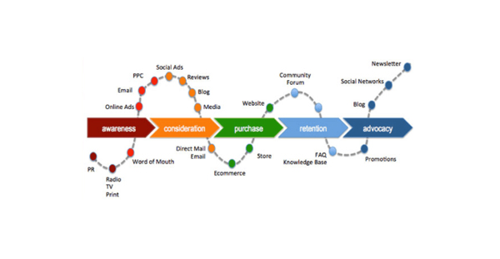
Figure: Stages in customer journey (Blakeman, 2014)

2.5 Marketing options for British Petroleum
Marketing management is very useful tool for the purpose of interacting with different individual parties. By the support of marketing management, it becomes very easy to focus on the interconnection. It is useful for dealing with the promotion of products on the digital ground. In this way, it can easily focus on the factors like social media marketing, and so on. Traditional marketing is concerned about the offline marketing as it supports to promote the business on the offline process. It is very important to deal with the traditional marketing to meet the demand of several market segments (Bagozzi et al., 2018). In this particular process, business organization usually uses the media such as television ad, billboard, and so on. In marketing management, cost is relatively very much lower and most of the operations of marketing management are depending on contents. A centralized market segment is required to be considered and different digital medias are used for marketing management.
By the support of marketing management, British Petroleum can achieve a lot of benefits and effective aspects. A significant amount of time can be saved by the support of using marketing management. With applying the marketing management, it becomes very easy to focus on the social media operations for decision making. On the other side, it is also useful for increasing the customer connection and interruption. By using marketing management, British Petroleum can be successful at ensuring proper customer connection (Lepkowska-White et al., 2019). It is also useful for understanding the information flow to focus on marketing management roles. These are the key benefits concerned about the marketing management on British Petroleum. Cost of traditional marketing is very high as traditional marketing is concerned about available products. Only traditional sources like newspapers and others are used and traditional marketing has no specific or centralized segments.

2.6 Brand equity model
In the brand equity model, four basic aspects of British Petroleum are being considered. At the beginning, the brand equity related discussions are concerned with the focus on which the targets are being given. As the discussion is implied, British Petroleum has branded themselves as an energy service provider. They have created an image of innovativeness on the processes. As the response of the brand, British Petroleum always brings the innovative products which can meet the customer demands (Bagozzi et al., 2018). So, these are the key aspects connected with the brand equity model of the British Petroleum.
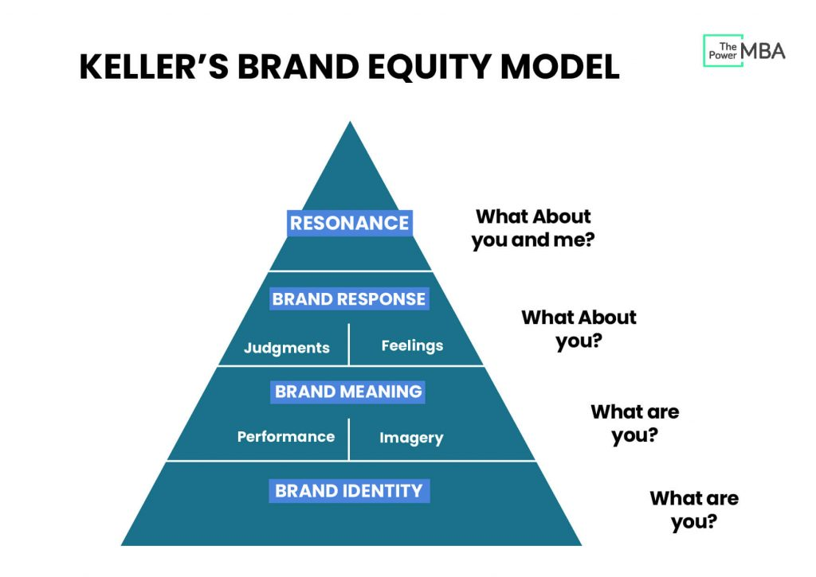
Figure: Brand equity model (Foroudi et al., 2017)
There are various challenges associated with the processes of the marketing management. In British Petroleum, there are different types of challenges such as misinterpretation of the data. In order to make marketing decision, it is very necessary to focus on the data and other aspects. So, when the data are misrepresented, it might make bad impact on the marketing aspects. Trust can be another challenge for the process of employee interaction. In the aspect of employee interaction, proper level of trust will have to be established (Foroudi et al., 2017). With the support of marketing management, British Petroleum can be able to interconnect. But, the gaps on the device communication can bring significant risk on the process.

2.7 Innovative marketing strategy
There are various basic marketing plans which are concerned about the multi-channel capabilities within British Petroleum. The marketing communication plan is:
Situation: In the last few years, it had been seen that the growth of marketing communication was very significant. There are various traditional marketing opportunities which are getting reduced significantly (Kotler et al., 2021). Alongside that, the traditional marketing process is also very costly and it had been making negative impact on operations.
Objectives: To achieve the marketing strategy, British Petroleum will need to focus on the various objectives. These are:
- Increasing the rate of online service users by 60%,
- Increasing the technology operations on British Petroleum by 40%,
- Increasing the online service sales by 40%.
These are the key aspects concerned about marketing objectives.
Strategy: There are various associated strategies that can make impact on the overall marketing operations of British Petroleum. Social media involvement will be the best strategy because it can help to reach the customers most easily. On another side, British Petroleum will also require to use the paid marketing strategy because it can reduce the cost with achieving the goals quickly (Panchenko et al., 2020). There are various processes in which British Petroleum can apply these two types.
Tactics: To focus on the total process, British Petroleum will require to handle the operations by bringing changes on their search engine optimization process. This kind of optimization can help to lead toward better result on various processes on British Petroleum (Park, 2020). These are the key tactics associated with the processes of British Petroleum.
Actions: In order to focus on the actions, British Petroleum will have to follow a set of guidelines. These guidelines are given following:
- British Petroleum will have to make sure that SEO is being carried successfully,
- British Petroleum will also require to deal with the paid marketing strategies which can close the promotional gaps,
- British Petroleum will also have to deal with the marketing skills and competencies on significant manner.
Control: Control is also very necessary for British Petroleum to focus because it supports to handle the particular demands of the marketing communication. By the support of this particular control, it can be useful for an organization like British Petroleum to follow the standard roles and regulations (Marinchak et al., 2018). These standard roles will have to be associated with the particular objectives of organizations by depending on the real impact.
These are the key available tactics and actions associated with the organization like British Petroleum.

3. Conclusion
Most of the operations of marketing management are depending on contents. Different digital medias are used for marketing management. A centralized market segment is required to be considered. When the data are misrepresented, it might make bad impact on the marketing aspects. Convenience is another tool which is possible on the marketing management processes. Because of the technological growth, marketing management media had got a lot of tools to focus on. Depending on the customer reviews and other processes, it can make impact on the perspectives of the marketing management. Search engine is also concerned about the search engine optimization because it helps to deal with successful rise in the search result.

References
Bagozzi, R. P., Rosa, J. A., Celly, K. S., and Coronel, F. (2018). Marketing-Management. Walter de Gruyter GmbH and Co KG.
Chernev, A. (2018). Strategic marketing management. Cerebellum Press.
Deepak, R. K. A., and Jeyakumar, S. (2019). Marketing management. Educreation Publishing.
Foroudi, P., Gupta, S., Nazarian, A., and Duda, M. (2017). Digital technology and marketing management capability: achieving growth in SMEs. Qualitative Market Research: An International Journal.
Grewal, D. (2018). Retail marketing management: The 5 Es of retailing. Sage.
Hollensen, S. (2019). Marketing management: A relationship approach. Pearson UK.
Hutt, M. D., and Speh, T. W. (2021). Business marketing management: B2B. South-Western, Cengage Learning.
Kotabe, M. M., and Helsen, K. (2020). Global marketing management. John Wiley and Sons.
Kotler, P., Keller, K. L., Ang, S. H., Tan, C. T., and Leong, S. M. (2021). Marketing management: an Asian perspective.
Krasyuk, I. A., Krymov, S. M., Medvedeva, Y., Chernisheva, A. M., and Lashko, S. I. (2017). Marketing management in retail chains. International Journal of Applied Business and Economic Research, 15(12), 83-91.
Lepkowska-White, E., Parsons, A., and Berg, W. (2019). Social media marketing management: an application to small restaurants in the US. International Journal of Culture, Tourism and Hospitality Research.
Marinchak, C. M., Forrest, E., and Hoanca, B. (2018). Artificial intelligence: redefining marketing management and the customer experience. International Journal of E-Entrepreneurship and Innovation (IJEEI), 8(2), 14-24.
Panchenko, V., Harust, Y. V., Us, Y. O., Korobets, O. M., and Pavlyk, V. V. (2020). Energy-efficient innovations: marketing, management and law supporting.
Park, S. (2020). Marketing management (Vol. 3). Seohee Academy.
Parsons, A. L., and Lepkowska-White, E. (2018). Social media marketing management: A conceptual framework. Journal of Internet Commerce, 17(2), 81-95.
Tkachenko, V. (2017). Formation of marketing management system of the enterprise. Baltic Journal of Economic Studies, 3(5), 208-213.
Zimmerman, A., and Blythe, J. (2017). Business to business marketing management: A global perspective. Routledge.

