Digital skills and research methods
-Final assignment-

Adrian Gigi Ciacareanu
Student number: 1710292
Group members:
- Adrian Gigi Ciacareanu (1710292)
- Adrian Viorel Topala (1713207)
- Florin Bucur (1712445)
- Lacramioara Intea (1713208)
- Robert Intea (1713209)
Name of business: Green Clean Swansea LLP.
Group Gmail: florin1712445@gmail.com
Password: dob04.06.92

Lecturer Shehla Khan
05/04/2019

University of Wales Trinity Saint David
Contribution audit
- Adrian Gigi Ciacareanu
Questions 6 and 7 in the Green Clean questionnaire.
Website: Contact page https://greencleanswansea.weebly.com/contact.html

- Adrian Viorel Topala
Questions 8 and 9 in the Green Clean questionnaire.
Website: Home page
https://greencleanswansea.weebly.com/

- Florin Ciprian Bucur
Questions 10 and 11 in the Green Clean questionnaire.
Website: Services page
https://greencleanswansea.weebly.com/services.html

- Lacramioara Intea
Questions 1 and 5 in the Green Clean questionnaire.
Website: About us page
https://greencleanswansea.weebly.com/about.html

- Robert Intea
Questions 2, 3 and 4 in the Green Clean questionnaire.
Website: Prices page
https://greencleanswansea.weebly.com/prices.html

Questionnaires
The questionnaire was entirely designed by the members of our group and the questions were chosen in order to establish our target audience and the preferences of our clients when it comes to green cleaning and eco- friendly cleaning services.
In this report I will make known to the reader two questions that have been introduced in the questionnaire by one of our group members. The first question is:
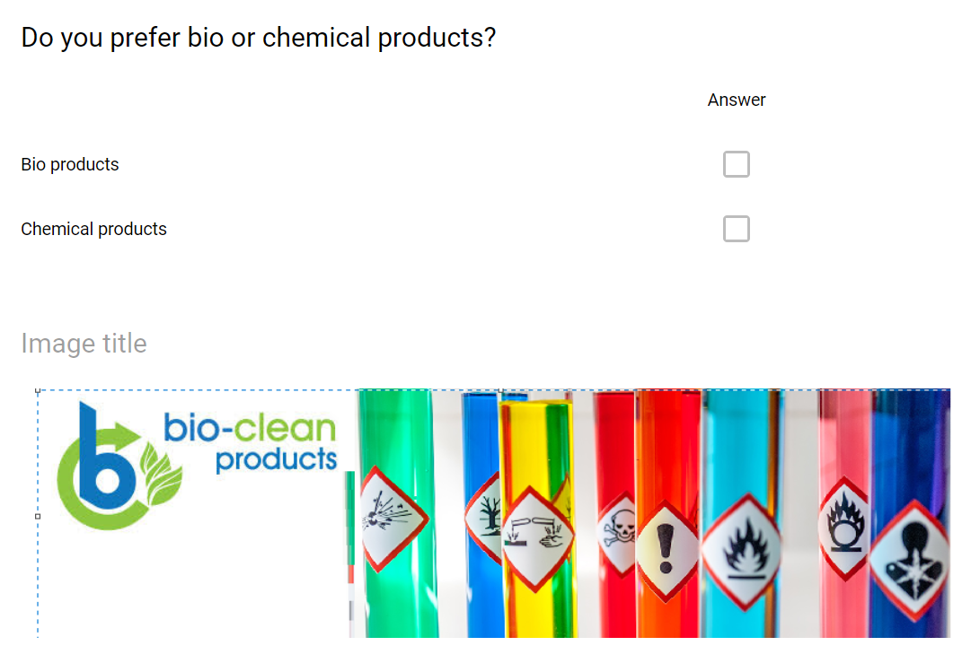
and it is very important for our business because gives us the opportunity to discover the preferences of our customers when choosing what kind of cleaning products they rely on: is it bio or chemical?
The second question that I found to be interesting as well was:
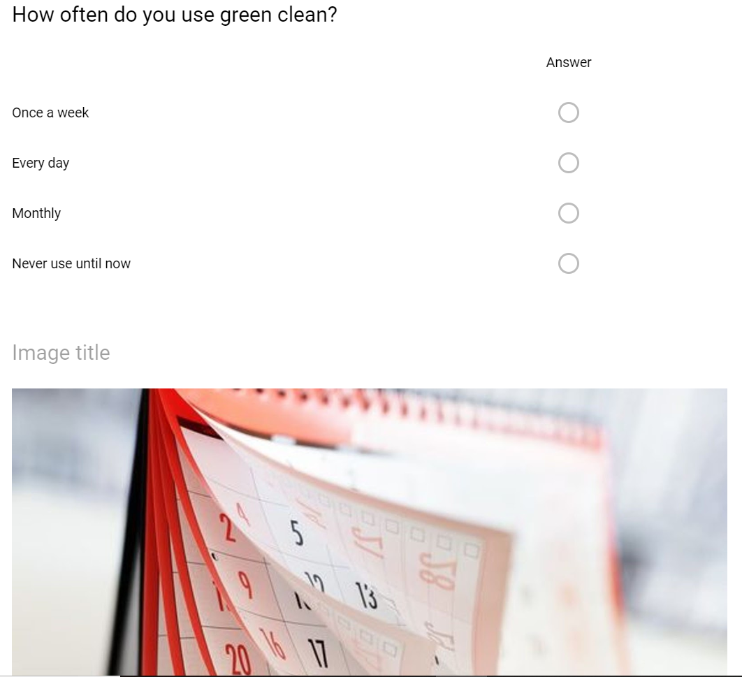

My contribution to the questionnaire is represented by two questions:
1)
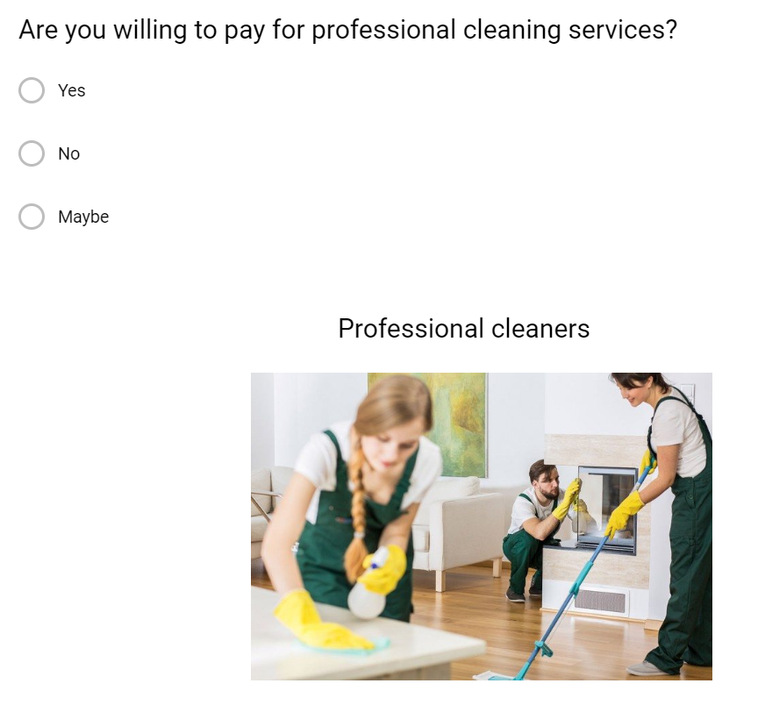
2)
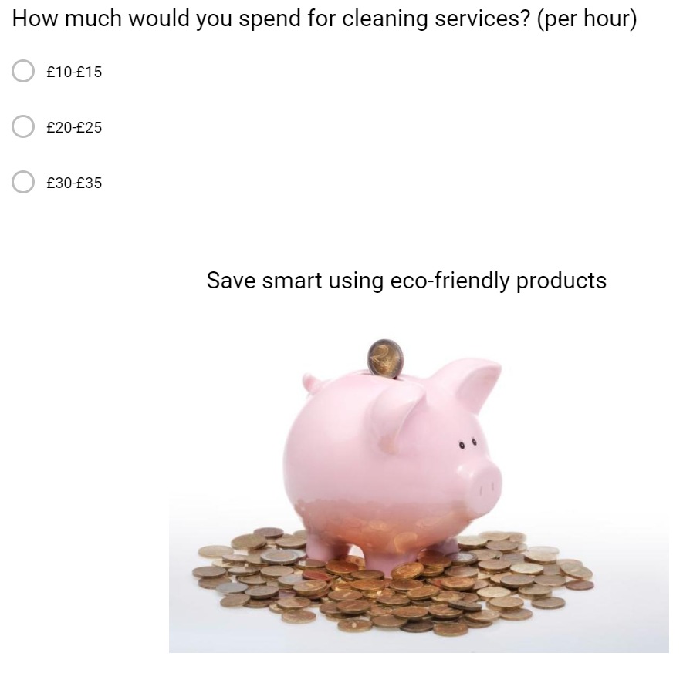

The reason for choosing these two questions was to find out if our customers do prefer the professional cleaning services rather than doing all the hard work by themselves and how much are they willing to pay for such services.
After creating this questionnaire, me and the other members of the group have decided to send it to some potential customers and looked forward to receive the answers.
I have to admit that I was very pleased with the answers for my first question and noticed that 58 per cent of these were positive and there were no negative answers.
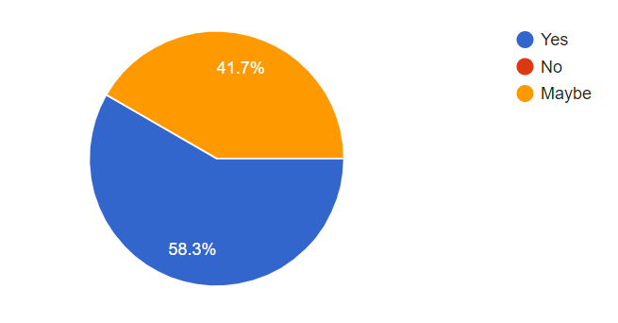

The feedback for the second question was more than welcomed given the fact that almost 42 per cent of the people that have been questioned said that are willing to pay between £20-£25 per hour for professional cleaning services.

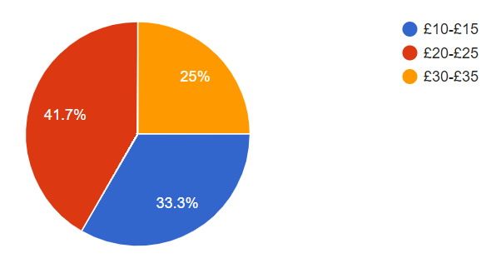

As a conclusion me and my business partners are very confident that our business will grow step by step and it will become a successful one.

Website
21st century is the century of speed, the century where everything happens at a fast pace and if any small entrepreneurs want to succeed they must be up to date with the trend and keep up with the technological progress. Once our business plan was created, the group members have decided to take things a little bit further in order to promote our business, and what is the best way to do this than to go online. With some help from weebly.com we have managed to create our own website, www.greencleanswansea.weebly.com, an online platform where our customers can find out some interesting facts about us and about our services. I was in charge with the Contact page, and I tried as much as I could to make it useful and entertaining for our online visitors. I have uploaded some cute pictures so that the customers understand that our company delivers green cleaning
 and that the products we use are eco-friendly and safe for the environment.



In addition to images I have included a contact form for our potential customers to fill and tell us more about the type of services they need and few more details like the address of the place that needs cleaning.
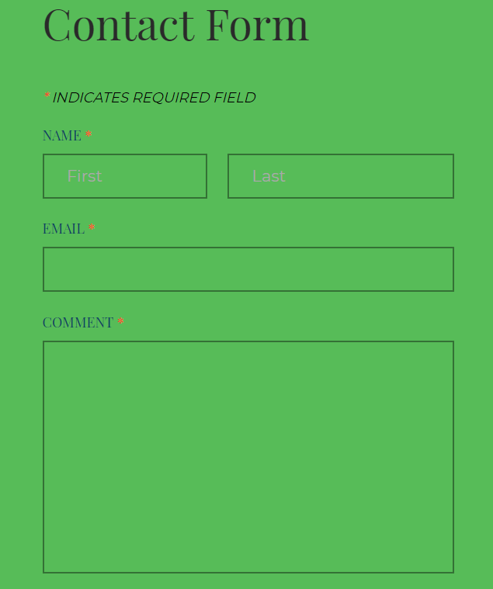

The gmail account used to create the website is: florin1712445@gmail.com
Password: dob04.06.92

