
Business Development Proposal Structure
Path B Business plan for an existing company
Student name: Hiraben Devshibhai Modhwadiya
Student ID: 2520086

A BUSINESS PLAN FOR WIPRO’S EXPANSION INTO
AGENTIC AI-AS-A-SERVICE FOR MID-MARKET ENTERPRISES
Table of Contents
1. Introduction 3
1.1 Problem and Opportunity Statement 3
1.2 Background and Context 3
1.3 Scope 4
1.4 Objective 4
2. Literature Review 5
2.1 Jobs-to-Be-Done (JTBD) Framework 5
2.2 PESTLE Analysis 5
2.3 Business Model Canvas (BMC) 5
2.4 Justification of Framework Selection for the Wipro Context 6
3. Methodology 7
3.1 Overview of Research Approach (Secondary Qualitative) 7
3.2 Opportunity Identification Process 7
3.3 Data Sources 7
3.4 Application of Frameworks (Step-by-Step Analytical Approach) 8
3.5 Ethical Considerations and Data Reliability 8
4. Initial Market Opportunity Analysis 9
4.1 Market Size and Structure 9
4.2 PESTLE Analysis 10
4.3 Jobs-to-Be-Done Analysis 13
4.4 Segmentation and Demand Signals 14
5. Limitations 16
6. Timeframe 17
7. Conclusion 18
Reference List 19

1. Introduction

1.1 Problem and Opportunity Statement
The Wipro large-accounting IT services business is starting to decelerate, as construction-adjusted FY26 revenue fell 1.6% in constant currency to $10.5 billion, and managers have forecasted a nearly identical flat IT services revenue in the September 2026 period. Nonetheless, AI transformation is in high demand, and bookings of IT services have increased by 14% to $16.4 billion (Chatterjee, 2026). The opportunity is that a subset of the market that is not heavily covered by the enterprise-based delivery model of Wipro: midsized clients who would not have access to large, consulting-based engagements.

1.2 Background and Context
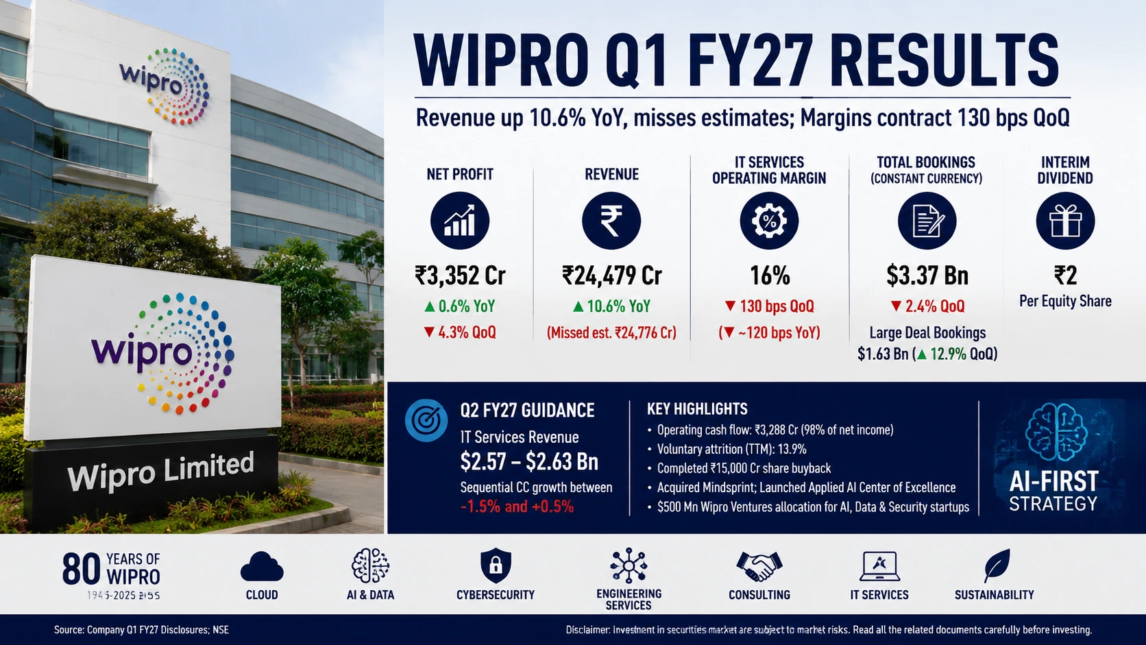
Figure 1: WIPRO financial highlights
(Source: Lodha, 2026)
In April 2026, Wipro launched an AI-Native Business & Platforms Unit to scale AI-led platforms, and was named a Market Leader in the HFS Horizons Agentic Services 2026 report. The gross revenue of Q1 FY27 is ₹244.8 billion, increasing 10.6% per-annum, demonstrating that AI-led deals are already generating growth across the enterprise level (Lodha, 2026).

1.3 Scope
This proposal explores the viability of a productised Agentic AI-as-a-service model to mid-market businesses, versus a large-account consulting model, which is currently implemented at Wipro.
In scope: Market demand validation, competitive positioning, external environment (PESTLE), customer needs (JTBD), and a preliminary business model design for a subscription-based, mid-market AI tier.
Out of scope: Detailed financial modelling and pricing, technical platform architecture, regulatory filings, primary data collection, and implementation planning. The analysis relies solely on secondary sources and does not extend to Wipro's large-enterprise or non-AI service lines (Wipro, 2026).

1.4 Objective
- To confirm unmet need for agentic AI-as-a-service by UK and European mid-market enterprises that are underserved by the Wipro large account consulting model.
- To create a priced-out, subscription-based agentic AI delivery layer that is different in pricing, scale, and onboarding than enterprise engagements at Wipro.
- To gauge its business suitability in revenue diversification and enhancement of margins in the face of declining big-deal growth of Wipro.

2. Literature Review

2.1 Jobs-to-Be-Done (JTBD) Framework
JTBD has an idealised conceptualisation of customers it positions the customers as being recruited to help achieve underlying tasks, the point is that the analysis is based on needs unfulfilled rather than the features of the product. Lewis, Hermida and Lorenzo (2024) state that the shift in perspectives of JTBD makes innovation oriented at discovering and meeting the unmet needs as perceived by the customers in their understanding, and thus makes it a demand-discovery instrument. Kalbach et al. (2024) build upon this both in concept and practice, illustrating in the instance of the Stepstone that JTBD can change the perspective of an organisation that was previously technology-oriented to focus more on the needs of its users (outside-in). Where these two are applied qualitatively, Moessner et al. (2024) use it quantitatively to estimate the market potential of an initial product idea, which Lewis et al. treats as purely conceptual.

2.2 PESTLE Analysis
PESTLE scanning ensures that macro-environmental is scanned using the political, economic, social, technological, legal and environmental forces. Its application in a systematic review by Olayiwola et al. (2025) classifies implementation barriers and considers PESTLE as an organising taxonomy, but not a predictive tool. Such combination is indicative of a broader criticism of PESTEL as Kansongue, Njuguna and Vertigans (2023) use PESTEL in concert with SWOT to evaluate deployment issues and this may be indicative of a general sense that PESTEL lacks any sense of prioritisation and therefore must be combined with other models. In contrast to these descriptive uses, Arroyabe et al. (2024) empirically connect the external environment to AI adoption in European SMEs with digital capabilities and innovation - shifting PESTLE-type external factors to the status of a checklist to a causal framework.

2.3 Business Model Canvas (BMC)
The BMC visualises value creation, delivery and capture along nine building blocks. According to the recent scholarship, consensus is that the traditional canvas is not suitable to digital affairs but disagrees on the solution. Matricano and Liguori (2026) suggest a redesigned digital business model canvas to project the key importance of digital technologies, and Bachmann et al. (2025) expand the canvas into digital sustainability, introducing the considerations of platforms, the supply-chain and the competition as the additional value-delivery dimension. Palmié et al. (2025) affirm that influence of the BMC has a long-lasting effect, as most business-model studies continue to embrace a multi-component conceptualisation coinciding with the canvas of Osterwalder and Pigneur. The opposition namely incremental augmentation (Bachmann et al.) and structural reconfiguration (Matricano and Liguori) indicates that the productised AI service model at Wipro is capable of adopting the BMC but needs to reconfigure blocks like revenue streams and key partnerships to deliver by subscription.

2.4 Justification of Framework Selection for the Wipro Context
The three frameworks are complementary although the three in that the JTBD provides the identification of the unmet mid-market needs, PESTLE provides the location of the needs in the external environment, and the BMC operationalises the response. In a systematic review of AI adoption in SMEs, Schwaeke et al (2025) prove that adoption is still uneven, which confirms a gap in demand that can be explored by JTBD. Griesch, Ritelmeyer and Sandkuhl (2024) specifically discuss AI as a Service in SMEs, which proves the applicability of a BMC-based service design, and Carayannis et al. (2025) associate AI and strategic foresight with SME resilience, reaffirming the role of PESTLE.

3. Methodology

3.1 Overview of Research Approach (Secondary Qualitative)
This proposal will follow a secondary qualitative research design, that is, the proposal will use the analysis of published materials instead of gathering primary data. This method suits a long-standing and publicly-traded corporation like Wipro, whose business plan, financial results and market place positioning have been widely reported within the channel of publicity (Mehrotra, 2026). A qualitative orientation enables the study to decipher strategic intent, competitive positioning as well as demand cues - aspects that quantitative-only approaches are not good at deciphering (Lim, 2025).

3.2 Opportunity Identification Process
The process of opportunity identification is funnelled and structured. The macro context scanned is first to set industry direction (AI adoption in IT services). Second, the internal status of Wipro is evaluated to find an opportunity of discrepancy between capabilities and market - that is, the high agentic-AI capability focussed on big accounts and the middle market has not been served sufficiently (Wipro, 2026a). Third, the gap determined is compared with demand evidence and competitor activity to verify that the gap is real and it can be overcome. The normalization of this is a process that makes the opportunity evidence based, not a guess, and reflects the outside-in logic that is reflected in the reviewed JTBD literature (Shabdin et al., 2024) .

3.3 Data Sources
The research relies solely on secondary qualitative data in the form of publicly accessible sources. Wipro is a company where the sources issued by the company are its FY26 annual report, Q1 FY27 earnings release, and official product pages of its Agentic AI and AI-Native Business and Platforms Unit. Market-sizing and adoption data are given by independent analyst and consultancy reports- Gartner, McKinsey, Mordor Intelligence, MarketsandMarkets, HFS Horizons and Grand View Research. The JTBD, PESTLE, and BMC frameworks are supported by peer-reviewed journal articles, and regulatory literature (i.e., EU AI Act) provides the legal background. Market commentary and competitive signaling from reputable business press, such as the Financial Express and Forbes, are added (Rikala et al., 2024)

3.4 Application of Frameworks (Step-by-Step Analytical Approach)
The models have been implemented in a sequential likelihood as opposed to being described.
- Step 1 - JTBD: Based on reported adoption barriers and the demand trends, the mid-market jobs and needs are extrapolated.
- Step 2 - PESTLE: The external forces (AI regulation, cost-of-service pressures, technology changes) are categorised to determine whether the circumstances are favourable to the opportunity (Küng, 2023).
- Step 3 - Business Model Canvas: The suggested subscription-based agentic AI service is aligned to the nine blocks, changing revenue streams, major partnerships and channels to the model of productised, lower-touch delivery (Orcun Sarioguz and Evin Miser, 2024).
The outputs feed onto each other, to create an integrated and not a fragmented analysis.

3.5 Risk Matrix
# | Risk | Likelihood | Impact | Severity | Mitigation
1 | Low mid-market trust in autonomous agents (only 23% scaled deployments) | High | High | Critical | Governed pilots, transparent SLAs, outcome-based guarantees
2 | Regulatory tightening (EU AI Act, data sovereignty) | High | Medium | High | Compliance-by-design, regional data hosting
3 | Agentic AI project cancellation (Gartner: >40% by 2027) | Medium | High | High | Modular delivery, phased ROI milestones
4 | Price pressure from no-code/low-code substitutes (38.9% CAGR) | Medium | Medium | Moderate | Tiered subscriptions, vertical specialisation
5 | Offshore delivery exposure to US–India trade policy | Medium | High | High | Nearshore hubs, hybrid delivery model

3.6 Ethical Considerations and Data Reliability
Since the research involves secondary data which is publicly available without any confidences, it does not create any participant-consent or privacy issues. However, reliability is proactively addressed. Credibility is a priority as sources that are credible preferred audited filings, peer reviewed or reputable analyst material over promotional content (Noble and Smith, 2025). Materials issued by the company are handled with due care as companies may have some degree of bias, which is countered by independent commentary.

4. Initial Market Opportunity Analysis

4.1 Market Size and Structure
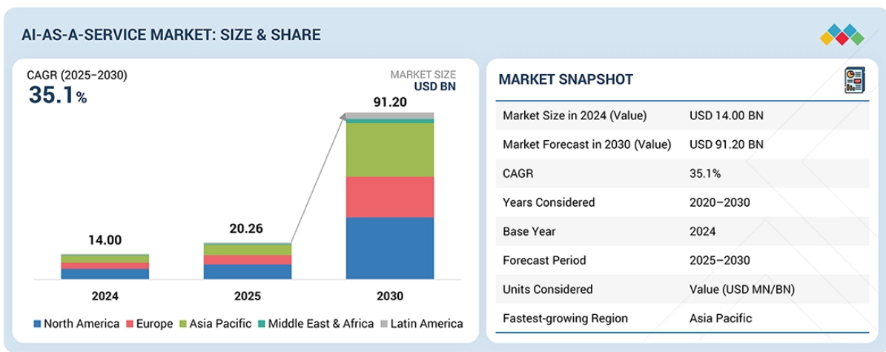
Figure 2: AI as a Service Market Size
(Source: Marketsandmarkets Research, 2026)
In the global AI-as-a-Service (AIaaS) market, the market size $20.26 billion in 2025 with a forecasted market size of $91.2 billion in 2030 with a growth rate of 35.1% with the small and medium-sized enterprise sub-segment reaching a higher CAGR of 36.8% (Marketsandmarkets Research, 2026).
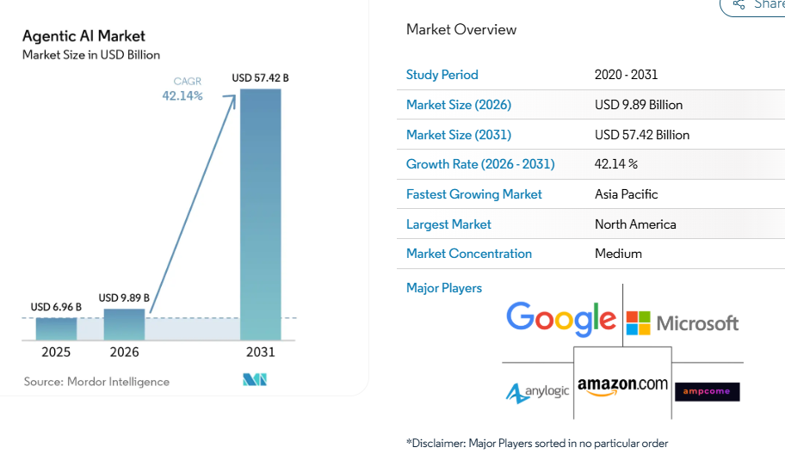
Figure 3: Agentic AI Market Size and Share
(Source: Mordor Intelligence, 2025)
The agentic-AI segment, which is smaller, stood at $6.96 billion in 2025 with the increase being $9.89 billion in 2026 and a forecast of $57.42 billion in the year 2031. In terms of structure, 65.05% of the agentic AI market in 2025 will belong to large enterprises, but SMEs will record a 43.55% CAGR - the gap to the medium-scale is relatively low. Here Wipro is competing on the basis of being an HFS Horizons Agentic Services (2026) Market Leader (Mordor Intelligence, 2025).
Accenture focuses on the mid-market with its Accenture Edge offering that is based on Google Cloud, providing companies with annual revenues between $300 million and 3 billion with the help of pre-built, industry-specific industry-specific agentic AI solutions to help businesses move their pilots to production quicker (Accenture, 2026). Infosys targets the same market with its Topaz Fabric and Agentic AI Foundry, which contains 200+ enterprise-wide AI agent reusables and launches pilot projects within 4-6 weeks (Infosys, 2025), and smaller, SME-targeted SaaS startups (e.g., Lindy, Relevance AI) worker tiers at just under $30-150 per user per month (TheCrunch, 2026).

4.2 PESTLE Analysis
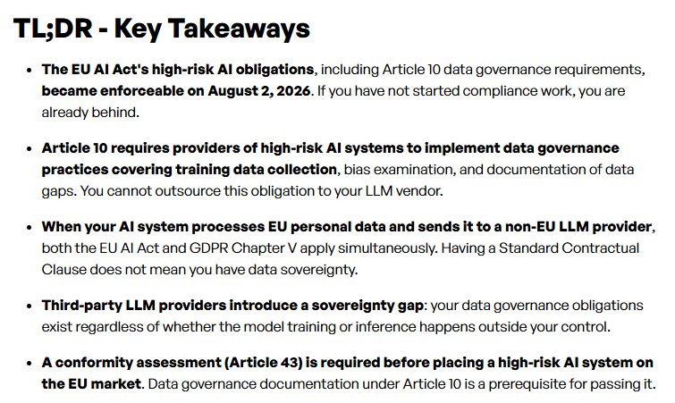
Figure 4: EU AI Act key takeaways
(Source: NeuralTrust Research Team, 2026)
Political — The policy of AI in government is transforming demand. The EU AI Act is rolling out the obligations in stages. The increased demands of data-sovereignty are augmenting expenditures of compliance (NeuralTrust Research Team, 2026). Moreover, the US immigration policy and the trade between India and the US will have impacts on the offshore delivery model by Wipro.
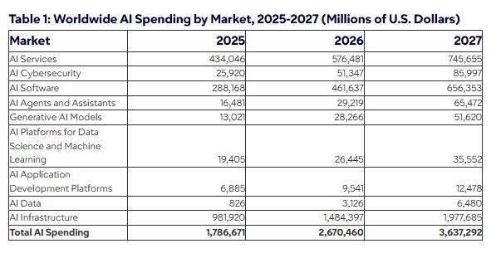
Figure 5: Worldwide AI Spending by Market, 2025-2027 (Millions of U.S. Dollars)
(Source: Gartner, 2026)
Economic — Client cost alert is still good. In constant currency, Wipro faced a decrease in revenue by 1.6% to 10.5 billion in FY26. Nonetheless, according to Gartner (2026), agentic AI expenditures will amount to 201.9 billion by 2026. This indicates that AI is already penetrating into client budgets.
Social — Trust of autonomous agents is not being established evenly in an enterprise. McKinsey claims that only 23% of organizations have expanded agent deployments. This is indicative of change-management and skills voids and this is experienced most by mid-market firms (Kelly, Harkness and Reis, 2025).
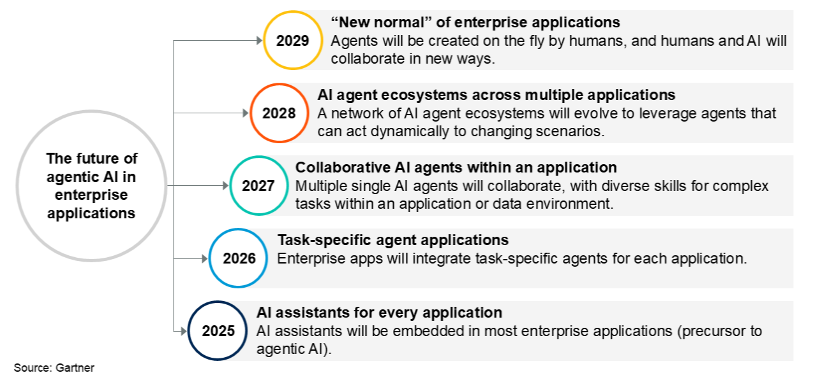
Figure 6: The Future of Agentic AI in Enterprise Applications
(Source: Gartner, 2025)
Technological — Gartner (2025) estimates that by the close of 2026 the task specific AI agents will have been added to 40% of enterprise applications. This eight fold growth makes it possible to offer lower-touch delivery which is productised.
Legal — Compliance is costly with data privacy regulations like GDPR. Exposure to intellectual property and being responsible for autonomous choices present additional risk. The consulting-based model proposed by Wipro will be able to transform this threat into a competitive advantage.
Environmental — The compute footprint and energy demand of AI is incompatible with the ESG objectives of clients. Shared, efficient AIaaS systems have fewer resources compared to custom, on-premise implementations (Fortuna et al., 2022).

4.3 Jobs-to-Be-Done Analysis
Functional jobs.
Mid-market consumers use AIaaS to automate repetitive tasks and utilize AI without the need to develop an infrastructure. This demand is real as indicated by the SME sub-segment forecast of 36.8% CAGR (Omoikhefe Aienloshan, 2024).
Emotional jobs.
Confidence is desired by buyers since an AI project fails frequently. By 2027, Gartner predicts the cancellation of more than 40% of projects involving agentic AI, thus clients demand controlled and predictable results.
Social jobs.
Companies desire to appear contemporary and remain competitive. The non-adopters feel like they are lagging behind since 77% of small businesses are currently deploying AI in at least one of their functions (Forbes Research, 2025).
Pains.
The clients incur high initial expenses, limited AI skills, and integration issues. Moreover, data quality is mentioned by 52% of the businesses as the largest obstacle to adoption (Irman and Putra, 2025).
Gains sought.
The customers desire predictable billing with subscriptions, speedy outcomes, integrated compliance, and quantifiable deliverables.

4.4 Segmentation and Demand Signals
Segments
There are three groups that are outstanding. To begin with, mid-market companies desire turnkey AI. Second, SMBs that are already digitally-mature have already experimented, with 83% of growing SMBs experimenting with AI and 78% planning to invest (Salesforce, 2025). Third, industry verticals are important, and the BFSI is expected to be the biggest end-user market in 2025.
Demand signals
Subscription AIaaS is a preferable option to clients who are cost-conscious compared to costly consulting. Small firms only employ AI after every 41% as compared to large firms, which employ AI after every 60%, but affordability is the main problem. No-code and low-code tools, which have a CAGR of 38.9, substitute custom builds. The most fast-growing, least-served pool is the SME segment with a CAGR of 43.55% (Agbaakin, 2025).

5. Limitations
This paper will use secondary data only and the results will be determined by the suitability and timeliness of the sources. The estimates of market-sizing for the artificial intelligence as a service (AIaaS) range across analyst firms 2025 $14 billion to $20 billion, as the definition of market-sizing varies significantly, and no hard figures exist to determine exact market-sizing levels. Wipro data published by the company might be biased with presentation. The speed of AI developments threatens to make even AI-developed data outdated soon, and no primary research was carried out, which constrained a direct assessment of mid-market readiness-to-pay (Grand View Research, Inc, 2026).

6. Timeframe
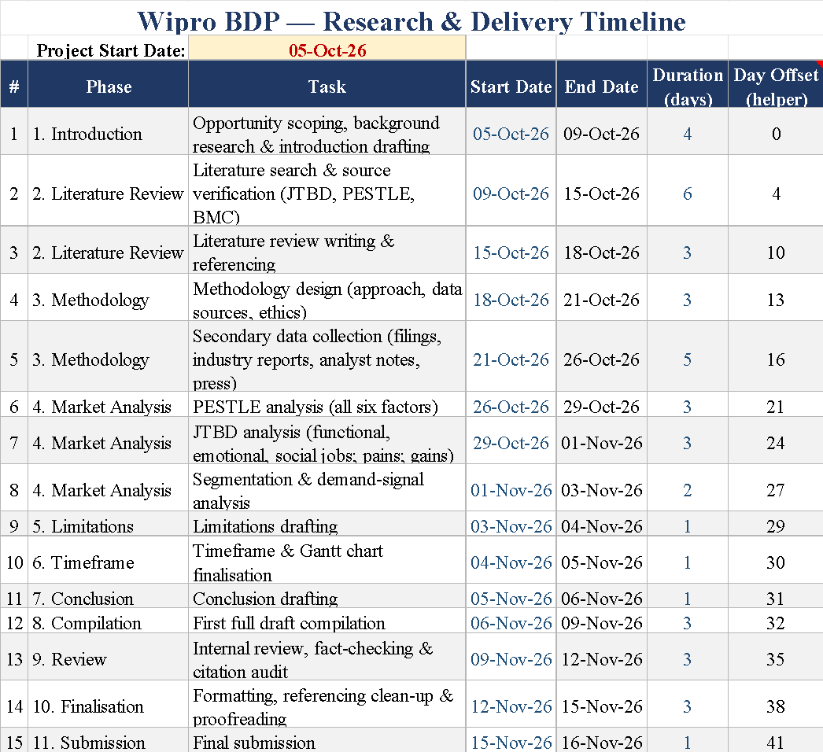
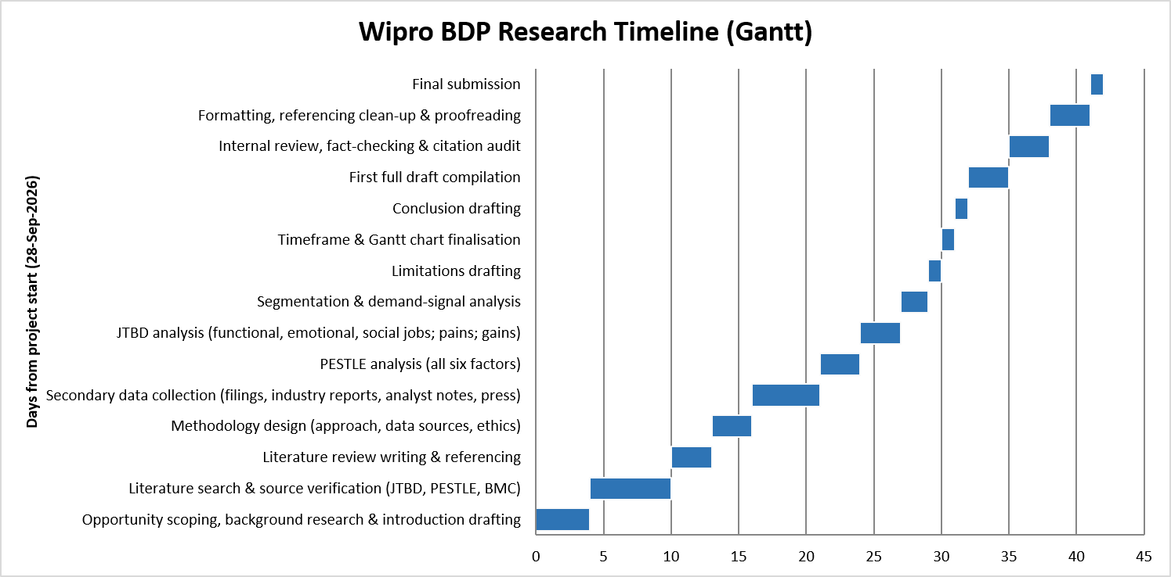
Figure 7: Gantt Chart
(Source: Self Created in excel)

7. Conclusion
This discussion validates a viable evidence-based opportunity. The market of AIaaS ($20.26 billion in 2025, 35.1% CAGR to 2030) and the agentic-AI segment (42.14% CAGR to 2031) are developing at a rapid pace, but large enterprises consume 65% of the spending, and thus, the mid-market (43.55% CAGR to 2031) is materially underrepresented. According to the JTBD analysis, an obvious unmet need is affordable, governed, enterprise-grade agentic AI (Grand View Research, Inc, 2026). PESTLE conditions are overall positive, and technological and expenditures tailwinds are potent, compensated primarily by economic caution. In Wipro, where FY26 revenue decreased by 1.6% and it possesses established agentic-AI capacity, productised mid-market level is a viable path to diversify income and counteract planar growth in large accounts - it can be accomplished under the recognised limits of the study.

Reference List
Agbaakin, O. (2025) Leveraging artificial intelligence as a strategic growth catalyst for small and medium-sized enterprises, Arxiv.org. Available at: https://arxiv.org/html/2509.14532v1
Arroyabe, M.F., Arranz, C.F.A., Fernandez, I. and Carlos, J. (2024) “Analyzing AI adoption in European SMEs: A study of digital capabilities, innovation, and external environment,” Technology in Society, 79, pp. 102733–102733. Available at: https://doi.org/10.1016/j.techsoc.2024.102733.
Bachmann, N., Thienemann, A.-K., Tüzün, A., Brunner, M., Tripathi, S., Pöchtrager, S. and Jodlbauer, H. (2025) “The evolution of the business model canvas for digital sustainability,” 6th International Conference on Industry 4.0 and Smart Manufacturing, 253, pp. 1012–1023. Available at: https://doi.org/10.1016/j.procs.2025.01.163.
Carayannis, E.G., Dumitrescu, R., Falkowski, T., Papamichail, G. and Zota, N.R. (2025) “Enhancing SME resilience through artificial intelligence and strategic foresight: A framework for sustainable competitiveness,” Technology in Society, 81, p. 102835. Available at: https://doi.org/10.1016/j.techsoc.2025.102835.
Chatterjee, P. (2026) Wipro sees bigger AI role for IT firms, The Financial Express. Available at: https://www.financialexpress.com/business/news/wipro-sees-bigger-ai-role-for-it-firms/4292773/
Forbes Research (2025) “Small firms are behind on AI adoption, but bullish on future returns,” Forbes, 15 December. Available at: https://www.forbes.com/sites/forbes-research/2025/12/15/small-firms-behind-on-ai-adoption-but-bullish-on-future-returns/
Fortuna, C., Din Mušić, Cerar, G., Andrej Čampa and Mihael Mohorčič (2022) On-premise artificial intelligence as a service for small and medium size setups. Available at: https://www.researchgate.net/publication/364526014_On-Premise_Artificial_Intelligence_as_a_Service_for_Small_and_Medium_Size_Setups
Gartner (2025) Gartner predicts 40% of enterprise apps will feature task-specific AI agents By 2026, up from less than 5% in 2025, Gartner. Available at: https://www.gartner.com/en/newsroom/press-releases/2025-08-26-gartner-predicts-40-percent-of-enterprise-apps-will-feature-task-specific-ai-agents-by-2026-up-from-less-than-5-percent-in-2025
Gartner (2026) Gartner Forecasts Worldwide AI Spending to Grow 49.5% in 2026, Gartner. Available at: https://www.gartner.com/en/newsroom/press-releases/2026-09-16-gartner-forecasts-worldwide-ai-spending-to-grow-49-point-5-percent-in-2026
Grand View Research, Inc (2026) Artificial intelligence as a service market size report, 2030, www.grandviewresearch.com. Available at: https://www.grandviewresearch.com/industry-analysis/artificial-intelligence-as-a-service-market-report
Griesch, L., Rittelmeyer, J. and Sandkuhl, K. (2023) “Towards AI as a service for small and medium-sized enterprises (SME),” Lecture Notes in Business Information Processing, pp. 37–53. Available at: https://doi.org/10.1007/978-3-031-48583-1_3.
Irman, D. and Putra, D. (2025) “AI adoption in business: Opportunities and challenges for start-ups,” International Journal of Business, Economics, and Social Development, 6(1), pp. 99–104. Available at: https://doi.org/10.46336/ijbesd.v6i1.881.
Kalbach, J., Wermuth, Y., Duda, S. and Florin Ciontu (2024) “Jobs-to-be-done at scale: Disrupting the status quo with customer focus,” Journal of digital & social media marketing., 12(3), pp. 262–262. Available at: https://doi.org/10.69554/njqq4314.
Kansongue, N., Njuguna, J. and Vertigans, S. (2023) “A PESTEL and SWOT impact analysis on renewable energy development in Togo,” Frontiers in Sustainability, 3(1). Available at: https://doi.org/10.3389/frsus.2022.990173.
Kelly, G., Harkness, L. and Reis, S. (2025) Agents for growth: Turning AI promise into impact, McKinsey & Company. Available at: https://www.mckinsey.com/capabilities/growth-marketing-and-sales/our-insights/agents-for-growth-turning-ai-promise-into-impact
Küng, W. (2023) “Using the PESTEL analysis to determine the effectiveness of new digital media strategies,” Advances in Economics Management and Political Sciences, 5(1), pp. 19–25. Available at: https://doi.org/10.54254/2754-1169/5/20220054.
Lewis, S.C., Hermida, A. and Lorenzo, S. (2024) “Jobs-to-be-done and journalism innovation: Making news more responsive to community needs,” Media and Communication, 12. Available at: https://doi.org/10.17645/mac.7578.
Lim, L. (2025) “Qualitative research methodology : Interview strategy,” 3(4), p. 53. Available at: https://www.researchgate.net/publication/396211538_Qualitative_Research_Methodology_Interview_Strategy
Lodha, N. (2026) Wipro dividend, AI push take center stage after Q1 earnings Miss, NiftyTrader News. Available at: https://www.niftytrader.in/markets/wipro-q1-dividend-ai-earnings-miss/
Marketsandmarkets Research (2026) AI as a service market size, share and global market forecast to 2023 | MarketsandMarkets, www.marketsandmarkets.com. Available at: https://www.marketsandmarkets.com/Market-Reports/artificial-intelligence-ai-as-a-service-market-121842268.html
Matricano, D. and Liguori, E.W. (2024) “Looking to the past, considering the present and preparing for the future: Digital Technologies and the business model canvas,” Journal of Management History, 32(3), pp. 345–361. Available at: https://doi.org/10.1108/JMH-05-2024-0069.
Mehrotra, A. (2026) Understanding Research, primary vs secondary data, and research design, Medium. Available at: https://medium.com/@ananyamehrotra1712/understanding-research-primary-vs-secondary-data-and-research-design-2c26ba3e21fb
Moessner, P., Haegle, R., Eiler, L. and Kloepfer, K. (2024) “Evaluate market potential of an initial product concept with jobs-to-be-done,” IEEE Engineering Management Review, 52(2), pp. 1–7. Available at: https://doi.org/10.1109/emr.2024.3353618.
Mordor Intelligence (2025) Agentic AI market size & share analysis - industry research report - growth trends, Mordorintelligence.com. Available at: https://www.mordorintelligence.com/industry-reports/agentic-ai-market
NeuralTrust Research Team (2026) Data sovereignty requirements under the EU AI act (2026), NeuralTrust. Available at: https://neuraltrust.ai/blog/data-sovereignty-requirements-eu-ai-act
Noble, H. and Smith, J. (2025) “Ensuring validity and reliability in qualitative research,” Evidence Based Nursing, 0(0), pp. ebnurs-2024–104232. Available at: https://doi.org/10.1136/ebnurs-2024-104232.
Olayiwola, K., Perera, S., Kagioglou, M., Jin, X. and Sharafi, P. (2025) “A PESTEL analysis of problems associated with the adoption of offsite construction: A systematic literature review,” Buildings, 15(13), pp. 2146–2146. Available at: https://doi.org/10.3390/buildings15132146.
Omoikhefe Aienloshan (2024) On-demand AI-driven predictive analysis: Bridging the gap for small and medium enterprises (SMEs). Available at: https://www.researchgate.net/publication/388543282_ON-DEMAND_AI-DRIVEN_PREDICTIVE_ANALYSIS_BRIDGING_THE_GAP_FOR_SMALL_AND_MEDIUM_ENTERPRISES_SMES
Orcun Sarioguz and Evin Miser (2024) “AI-powered business model innovation: Analyzing the implications of generative AI on value creation, operational efficiency and market dynamics,” World Journal of Advanced Engineering Technology and Sciences, 13(2), pp. 215–228. Available at: https://doi.org/10.30574/wjaets.2024.13.2.0564.
Palmié, M., Aebersold, A., Oghazi, P., Pashkevich, N. and Gassmann, O. (2024) “Digital‐sustainable business models: Definition, systematic literature review, integrative framework and research agenda from a strategic management perspective,” International Journal of Management Reviews, 27(3), pp. 346–374. Available at: https://doi.org/10.1111/ijmr.12380.
Rikala, P., Braun, G., Järvinen, M., Stahre, J. and Hämäläinen, R. (2024) “Understanding and measuring skill gaps in industry 4.0 — A review,” Technological Forecasting and Social Change, 201(123206), pp. 123206–123206. Available at: https://doi.org/10.1016/j.techfore.2024.123206.
Salesforce (2025) Small business trends (report), Salesforce. Available at: https://www.salesforce.com/small-business/smb-trends/
Schwaeke, J., Peters, A., Kanbach, D.K., Kraus, S. and Jones, P. (2024) “The new normal: The status quo of AI adoption in SMEs,” Journal of Small Business Management, 63(3), pp. 1–35. Available at: https://doi.org/https://doi.org/10.1080/00472778.2024.2379999.
Shabdin, N.I., Ya’acob, S., Abd Ghani, M.A. and Ab Rahim, N.Z. (2024) “The gap analysis fundamentals for digitalization strategic planning,” International Journal of Academic Research in Business and Social Sciences, 14(1). Available at: https://doi.org/10.6007/ijarbss/v14-i1/20580.
Wipro (2026a) Adopting AI & machine learning in business processes - Wipro, Wipro.com. Available at: https://www.wipro.com/business-process/artificial-intelligence-as-a-catalyst-in-business-process-services-hype-vs-reality/
Wipro (2026b) Boost enterprise agility with Wipro’s agentic AI solutions, Wipro. Available at: https://www.wipro.com/ai/services/agentic-ai//
Accenture (2026) Accenture Edge and Google Cloud bring scalable agentic AI solutions to mid-market companies. Available at: https://newsroom.accenture.com/news/2026/accenture-edge-and-google-cloud-bring-scalable-agentic-ai-solutions-to-mid-market-companies
Infosys (2025) Infosys launches over 200 enterprise AI agents, part of Infosys Topaz™ AI offerings and Google Cloud. Available at: https://www.infosys.com/newsroom/press-releases/2025/launches-enterprise-ai-agents.html
TheCrunch (2026) AI agents price: Full cost breakdown (2026). Available at: https://thecrunch.io/ai-agents-price/

