
UNIVERSITY OF WALES
TRINITY SAINT DAVID
TITLE: Emergent Leadership Skills for the Workplace
Module Code – BMSK6001

Student Name: Patrick Mokwe

Student ID: 1604804
Word Count: 4,254

Table of Contents
1.0 Introduction 3
2.0Discuss on leadership models, theories, and styles 3
3.0Key responsibilities of the leadership role 11
4.0 Evaluate different leadership styles in the context of own responsibilities. 12
5.0Repertoire of leadership styles in different situations and with different people 13
6.0Concept of emotional intelligence and how it applies to the leadership role 15
7.0 Importance of understanding one’s own strengths and limitations 16
8.0 Use and interpretation of techniques to identify characteristics, strengths and limitations 17
9.0 Importance of continuous self-development and identifying opportunities to develop oneself in the leadership role 18
10.0 Displaying confidence and self-assurance by emphasising personal strengths and showing a readiness to take calculated risks 22
11.0 Social awareness in terms of empathy, organisational and ‘political awareness, service to others 22
12.0 Relationship management in terms of inspiring others 23
Reference 24

Introduction
According to Shimonski (2014), emergent leadership in workplace refers to a group of member who are not appointed for the leadership role but their leadership skills develop time to time through the interaction of the group members. In addition, emergent leadership reveals in the actions which help to direct execution by assertion of initiative of an individual. Sleeth (2016) said that emergent leadership skill is very significant for workplace to provide better performance. Rubin and Bommer (2017) disclosed that emergent leadership skill in workplace increases team development (such as forming, storming, norming, and performing) by inspiring all to exercise the initiative. On the other hand, it promotes workplace diversity by welcoming diverse individuals to contribute them in different ways as well as offer diverse ideas and insights through their work. According to Corso (2015), emergent of ‘emerging’ leaders are high potential, confident, flexible and collaborative. The chosen organization for this assignment is DEN Security Group. DEN Security Group Ltd is a security provider company which has operated its business functions from 2015. DEN Security Group has 150 securities registered with SIA License (DEN Security Group Ltd, 2019). Moreover, this organization provides security services in several locations of London including South London and North East London. This organization offers different services to both private and public organizations including Gate House Duties Concierge Officer, Manned Guarding, Test Purchasing, Train Station Officers, Door Supervisors, Events Security, Retail officers, CSCS Construction Officers, Mobile Patrol/Unlock-Lock ups, Key Holding/Alarm response and CCTV monitoring (DEN Security Group Ltd, 2019).

2.0Discuss on leadership models, theories, and styles

Define Leadership in the Workplace
Armstrong (2015) said that leadership refers more than a particular job position in the workplace. Effective leadership in the workplace is a capability to impact the people to gain the effective results for a company and its people. Bennis (2015) said that a true leader have strong self-sense, understand the good qualities that spread positive influences to the people, and flexible with these qualities. DEN Security Group Ltd practices good leadership in its workplace (DEN Security Group Ltd, 2019).

Leadership models
There are a number of leadership models such as managerial grid model, four framework approach and others that are followed by business organizations which are described as follows:

Managerial/Leadership Grid model
According to iEduNote (2018), the Managerial Grid model was first developed by Dr. Robert R. Blake and Dr. Jane Srygley Mouton in 1964. This model is also known as Leadership Grid model. This model supports the managers to evaluate their leadership styles through the grid training system. The diagram of Managerial Grid model is given as below:

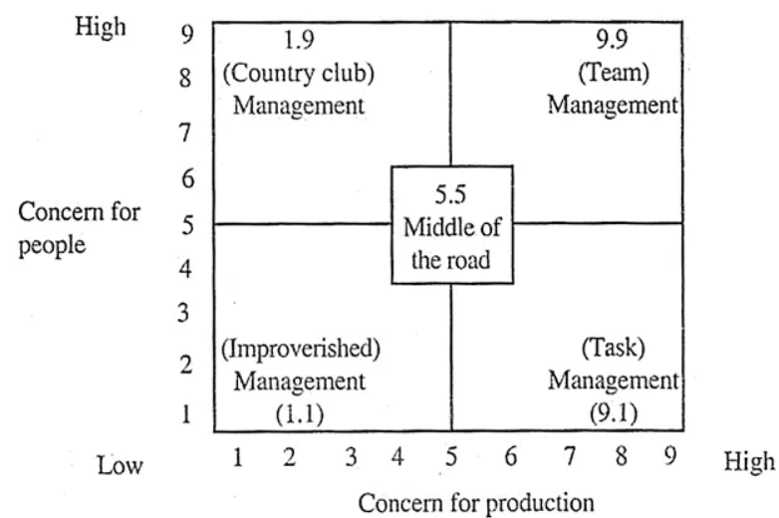
Figure: Managerial Grid Model Source: iEduNote (2018)
According to Leadership Central (2017), this model relies on two behavioural dimensions such as concern for people and concern for production. In addition, this model is presented as grid with ‘concern for production’ as X -axis and ‘concern for people’ as Y- axis; ranges from 1 (Low) to 9 (High).
This model includes quadrants including team leader, authoritarian leader, country club leader and impoverished leader which are described as following:
Team Leader (high task, high relationship) – Team leaders are strong on both tasks and people skills. The team leaders lead by the positive examples and work to develop a good team environment so as to the team members can gain the highest potential both as an individual and as group of members by focusing on collaboration or cooperation (Anastasia, 2018). Team leaders inspire their teams to fulfill their goals effectively, and develop the relationship between the team members.
Authoritarian Leader (high task, low relationship) – Authoritarian leaders are strong on tasks but weak on people skills. Authoritarian leaders are very task-oriented and are very hard on the workers (autocratic). Authoritarian leaders do not focus on collaboration or cooperation. These leaders show autocratic characteristics and strong on the tasks. They expect their team members of people to do what they said without asking any question (Rouse, 2018). Therefore, this is very difficult for authoritarian leader’s subordinates to develop their skills in the workplace.
Country Club Leader (low task, high relationship) – Country club leaders are strong on the people skills but weak on tasks. Country club leaders use the reward power to manage the discipline between the team members and inspire the team to fulfill its goals (Leadership Central, 2017). On the other hand, they are not able to employ punitive coercive and the legitimate powers. Thus, this incapacity results in fear for using legitimate powers that could threaten relations with other team members.
Impoverished Leader (low task, low relationship) – Impoverished leaders are weak on both tasks and people skills. Impoverished leaders use the management style known as “delegate and disappear”. Anastasia (2018) said that these leaders mainly permit their teams to do whatever they want to do and prefer to isolate them from process of the team by permitting the team to suffer from power struggles in the team.
In terms of DEN Security Group Ltd, this organization follows the Managerial Grid model because this helps the managers of this organization to evaluate their own leadership styles and show good performance in the workplace.

Four framework approach of leadership
According to nwlink (2018), the Four Framework Approach of leadership was first developed by Bolman and Deal in 1991. This model discloses that leaders represent their leadership behaviours in any one of the four types of frameworks such as structural, human resource, symbolic and political. The diagram of Four Framework Approach is given as follows:
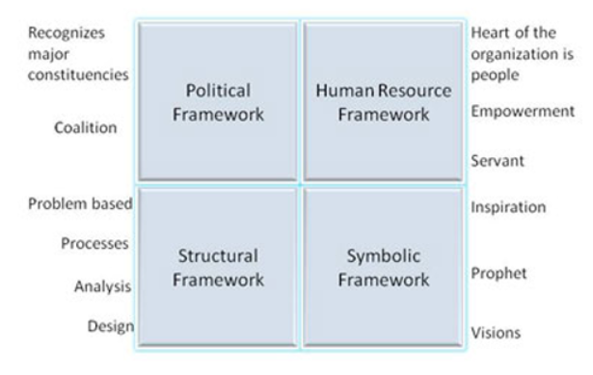
Figure: Four framework approach of Leadership Source: nwlink (2018)
Structural Framework – The structural leaders concentrate on strategy, structure, environment, experimentation, adaptation and implementation. In the effective leadership situation, leaders are the social architect whose leadership style is designed or analyzed. On the other hand, in the ineffective leadership situation, leaders are tyrant whose leadership style is detailed (Costa, 2014).
Human Resource Framework – The human resource leaders believe in the people and they are accessible or visible. In addition, they empower the people, increase the participation, share effective information, and create effective decisions in the organization (Costa, 2014). In the effective leadership situation, leaders are the catalyst and servant whose leadership style is empowerment, advocating and supportive. On the other hand, in the ineffective leadership situation, leaders are the pushover whose leadership style is fraud or abdication.
Political Framework – The political leaders explain what they want and evaluate distribution of power, and create links with the stakeholders. In the effective leadership situation, these leaders are advocate whose leadership style is team building and coalition (Costa, 2014). On the other hand, in the ineffective leadership situation, these leaders are hustler whose leadership style is management.
Symbolic Framework – The symbolic leaders observe the organizations as stage to play different roles, use different symbols to target the attention, and find out and communicate with vision. In the effective leadership situation, these leaders are prophet whose leadership style is motivation or stimulation (Costa, 2014). On the other hand, in the ineffective leadership situation, these leaders are fool whose leadership style is mirrors.
In terms of DEN Security Group Ltd, this organization follows this four framework approach of leadership in case of effective leadership situation to gain its business goals effectively.

Leadership Theories

Great-Man Theory
Thomas Carlyle was first established the Great Man theory of leadership in the 19th century. According to Dugan (2017), Great Man Theory focuses on two key assumptions: a) the great leaders are born to possess the certain traits which enable them to lead effectively and b) the great leaders can rise while need for them has become great.
MSG (2018) disclosed that Great Man Theory of leadership states that the great leaders are born but not made. According to this Great Man theory of leadership, leadership looks for certain traits such as persuasiveness, charm, high degree of intuition, commanding personality, judgment, intelligence, courage, action-oriented and aggressiveness which are of the nature that they cannot be learnt in the formal sense.

Trait Theory
Trait theory is mainly two types Allport’s trait theory and Cattell’s trait theory. However, the widely used trait theory is Allport’s trait theory which are discussed as follows:
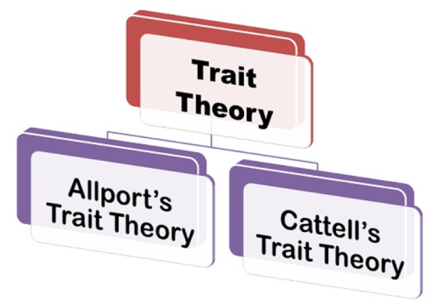
Figure: Two types of Trait theory Source: Business Jargons (2018)
According to Dugan (2017), in 1936, Gordon Allport was first developed trait theory. According to Gordon Allport trait theory, personalities of an individual can be considered through the distinction among common traits and personal dispositions. Kouzes and Posner (2016) said that the common traits focus on the six values including social, religious, political, economic, theoretical and aesthetic. The personal dispositions are three types such as cardinal traits, central traits and secondary traits which are described as follows:
Cardinal Traits: Cardinal traits are very much powerful, and a small number of people possess the personality controlled by a single trait (Useem, 2015).
Central Traits: Central traits are the common traits which are possessed by a number of individuals including friendliness, loyalty, kindness, agreeableness and others.
Secondary Trait: Secondary traits disclose that an individual behaves different ways than his normal behavior (Useem, 2015). For example, jolly persons can get despondent while people try to make joke on them.
In terms of DEN Security Group Ltd, this organization must follow these leadership theories in its business to practice leadership system effectively and efficiently.

Leadership Styles
According to Murphy (2015) said that leadership style means method of a leader to provide directions, implement plans, and motivate its people. Kippenberger (2015) disclosed that leadership style is a behavioural pattern which is adopted by a leader to influence his followers’ behaviour, he provides directions to his followers, and motivates his subordinates how to achieve their objectives or goals. There are different types of leadership styles such as autocratic style, democratic, laissez-faire style, transformational, transactional, and charismatic and others which are explained as following:
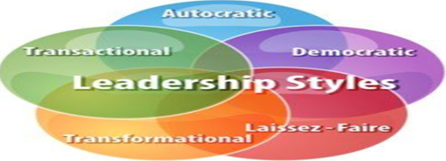
Figure: Different types of leadership style Source: Armstrong (2015)

Autocratic Leadership
Autocratic leadership is known as the authoritarian leadership. According to Bevoc (2017), autocratic leadership style is a type of leadership style which is mainly characterized by the individual control over the decisions and little input from the followers or group members. Murphy (2015) said that autocratic leaders make decisions by depending on their own ideas and they rarely take advice of ideas from their followers. In addition, autocratic leaders work in highly structured situation.

Democratic Leadership
Democratic leadership style is known as participative leadership style. According to Kippenberger (2015), democratic leadership style is a kind of leadership style in that the group members of followers take participative role to make decisions. This leadership style can apply in any kind of business organizations. Sandling (2016) said that in the democratic leadership style, both leaders and followers have the equal opportunity to share ideas freely, and make discussions. The democratic leadership style is the effective type of leadership style that leads to high productivity, increases the group morale and makes better contributions from the group members.

Transformational Leadership
As Bass and Riggio (2016) notes, transformational leadership style is a type of leadership style which can bring the positive changes in the followers or the subordinates. In addition, transformational leaders are very energetic, passionate and enthusiastic. Avolio (2017) said that the transformational leaders not only focus or involve with the processes but also help the group members or followers to become successful.

Cross-Cultural Leadership
As Murphy (2015) notes, the cross-cultural leadership style mainly exists where diverse cultures exist in an organization or the society. This leadership style has developed as the way to identify the front runners who work in modern-globalized marketplace. Armstrong (2015) said that the international business organizations need the leader who has the cross-cultural leadership style that can help him/her easily to adjust his leadership style to the diverse cultures. For example, United State is cross-cultural as there live and work diverse people who are from diverse cultures.

Laissez-faire Leadership
Laissez-faire leadership style is also known as the delegative leadership style. According to Cherry (2019), Laissez-faire leadership style is a kind of leadership style in that the leaders are laissez-faire as well as permit the group members or the subordinates to make decisions. Kippenberger (2015) stated that Laissez-faire leadership style is a type of leadership style which mainly leads to low productivity between the group members.

Transactional Leadership
Transactional leadership style is known as the managerial leadership style. Murphy (2015) said that this leadership style concentrates on role of organization, group performance and supervision. The leaders who focus on this transactional leadership style are used rewards and punishments to motivate their followers or group members. On the other hand, transformational leaders present their ideas or vision to their followers. Transactional leaders tell their group members of the followers what to do and when to do their activities.

Charismatic Leadership
In the charismatic leadership style, charismatic leaders manifest their revolutionary power. McCann (2016) said that charismatic leadership mainly involves the transformation of the beliefs or values of the followers. According to Sandling (2016), the key characteristics of a charismatic leader include good communication skill, good sense of humility, compassionate, confident, self-monitoring skill and others.
In terms of DEN Security Group Ltd, this is the security-provider organization and there work many employees who are from diverse cultures and background. In addition, this organization provides security services to the different locations of London to diverse people. Thus, DEN Security Group Ltd must follow the democratic, transformational and charismatic leadership styles in its organizations to motivate the employees in the workplace and also achieve its business goals and objectives successfully.

3.0Key responsibilities of the leadership role

Coach
Coaching is the key responsibility of a leader because the key job of a coach is to support the individuals to success in their life. Leaders work as the coach who prepares his/her followers or people to make success in the future (Dugan, 2017). DEN Security Group Ltd must train its managers on the coaching skill.

Spokesperson
A leader plays a role as the spokesperson in his/her organization. Spokesperson’s job is to formulate the business strategies and motivate its people properly (Kouzes and Posner, 2016). DEN Security Group Ltd must train its managers how to motivate the employees effectively in the workplace.
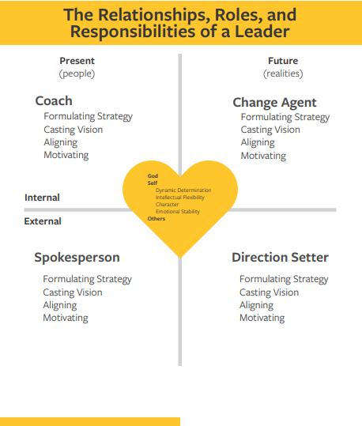
Figure: Relationships, roles and responsibilities of a leader Source: Armstrong (2015)

Change Agent
When the reality is presented to a number of extents in an organization, leaders play as the significant role as the Change Agent (Armstrong, 2015). The change agent evaluates the reality as well as changes the things which are not working properly.

Direction Setter
If the change agent is concerned with changing future which already has presented in the organization, then he/she plays a role as the direction setter. Direction setter can observe the organizational picture of the desired future.

4.0 Evaluate different leadership styles in the context of own responsibilities.
According to Armstrong (2015), leadership is the key concept which can be used to any work situation to understand the essential commitment from the team members to be capable to bring the goals or objectives of an organization in the collective spirit. Leadership circumstance, work nature, team members’ emotions and personality of the leaders are the significant requirements which have to be measured for the effective leadership. This must be conducted in the right environment with right persons and an application of the proper mix of the leadership styles for creating spirit or collective interest of the team members to achieve the organizational goal. In addition, this requires the opportunity for the adjustment so as to the leaders create space for the ideas or thoughts of the enhanced methods to deliver the collective goals. Kouzes and Posner (2016) disclosed that Leadership is considered as the collective responsibility to realize the goals of an organization. Thus, both leaders and team members must decide collectively the goals to realize the leadership style as well as working processes to achieve the organizational goals. This is the way to enhance collective spirit of the team members to achieve the organizational goal. As Useem (2015) notes, the democratic leadership style must be expanded between all of the executives and this must be combined in the proper way with other types of leadership styles including coaching, authoritative and affiliative styles. On the other hand, this will be in consonance with the Goleman’s exposition that proper mix of four styles would make sure the effective leadership through work environment (Dugan, 2017). The leaders or executives must be encouraged to condemn the use of the coercive leadership style. The leadership styles do not demonstrate team members’ free corporation. On the other hand, all of the leaders must create the opportunity for team members to open their different concerns which affect the emotional balance of them. Armstrong (2015) stated that this could be conducted by minimizing power distance between the team members, exercising the positive effects and discovering the productive recreation’s use. This would be ensuring that emotions of the team members are worked positively to enhancement of the goals of the organization. DEN Security Group Ltd must try to evaluate different leadership styles in its business organizations to attain the organizational goals and objectives effectively.

5.0Repertoire of leadership styles in different situations and with different people
In “Primal Leadership” book, Daniel Goleman described the concept of “Emotional Intelligence” that identifies six leadership styles (including visionary, coaching, affiliative, democratic, pacesetting and commanding) in a number of situations with diverse people. The effective leaders can transfer between these styles, and adopt one of that leadership styles which meet different situations’ demands. These are all the part of leader’s repertoire.
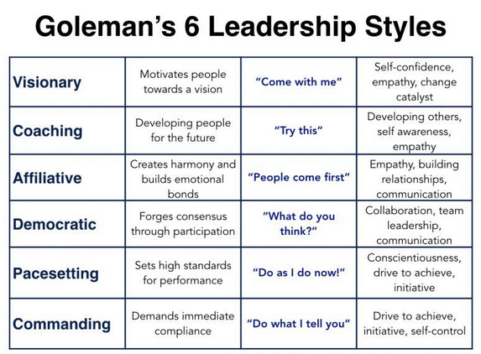
Figure: Goleman’s six leadership styles Source: Goleman et al. (2017)
Visionary: The visionary style is suitable when a business organization needs something new direction. This leadership style’s goal is to move the people to the new set of collective dreams. According to Goleman et al. (2017), the visionary leaders express whereas a team is going, and set the people to become innovate, and make them able to take the calculated risks.
Coaching: This leadership style concentrates on to develop the individuals, show them how to develop their performance, and also help them to link their goals to organizational goals. Goleman et al. (2017) said that the coaching leadership style is best suit with the employees who want to be innovative and want to develop their professional life. However, it can fail if it is considered as “micromanaging” a worker, and weakens his/her self-confidence.
Affiliative: This leadership style highlights on importance of team work, and makes harmony in team by linking people with each other. Goleman et al. (2017) argued that this leadership style is valuable when trying to improve the team coordination, develop the morale of the team members, develop communication or manage the trust in a business organization.
Democratic: This leadership style pulls on the knowledge and skills, and makes group commitment to result organizational goals. This leadership style works best while organizational direction is unclear, and leader needs to tap a team’s collective wisdom. Goleman et al. (2017) warned that this leadership style can be catastrophic in times of the crisis when the urgent events demand the quick decisions.
Commanding: This leadership style is the “military” type of leadership style but this is least effective. This is because this leadership style infrequently includes praise and often serves criticism, and it undercuts employee morale as well as job satisfaction. Goleman et al. (2017) argued that it is the effective in crisis when a crucial turnaround is necessary.

6.0Concept of emotional intelligence and how it applies to the leadership role

Emotional Intelligence
According to Freedman (2017), emotional intelligence means the ability of an individual to control his own emotions and holds the capability to manage others emotions. Emotional intelligence is the essential skill in the leadership. Bradberry (2016) stated that emotional intelligence includes five elements such as self-regulation, self-awareness, social skills, empathy and motivation. According to self-regulation, self-regulation is the step where a person thinks before speaking. This is the significant feature where a person can regulate himself/herself. This will also impact others in the positive way instead of the negative way. According to motivation, when an individual is motivated to do any tasks, he or she will be in the good position to impact others. It is essential for the individuals to work to their goals. Even if a person is faced challenges find out something better in that situation. According to empathy, a person is capable to put himself/herself in other’s situation this is then known as empathy. Bird (2015) said that each of the successful leaders knows how to empathise others, if he/she wants to earn respect. According to social skills, this is the significant aspect. Leaders must have the social skills. Leaders with social skills are capable to build rapport with other people that makes relationship comfortable.

Emotional intelligence in leadership role
Goleman et al. (2017) noted that in terms of emotional intelligence in the workplace, this is not the matter what the leaders want to do whether it is making a strategy or activating the teams to action because their success relies on how they conduct it. If the leaders fail to do the primal tasks to drive emotions in right direction, nothing they will work.
Emotional intelligence is related with the productivity or performance of the leaders. Bird (2016) said that the team members who feel emotionally supported from their leaders through their success or challenges will happy and active. Team members will celebrate their successes so that they will work hard together to be succeeded. On the other hand, effective emotional understanding as well as management will support the team members adhere and be productive and feel valued in the workplace.
A study by Freedman (2017) said that emotional intelligence is the key leadership skill and for the leaders to be effective. In addition, leaders must be masterful to manage their relations in the positive way rather than the negative way. Being the leader of the members of a team is to have the significant relation with these people. Bradberry (2016) said that emotional intelligence is the aspect that helps to get a person the leadership position in her/his job. However, he/she will need professional experience and knowledge. On the other hand, if a person takes the leadership role and have the high degree of emotional intelligence, she or he will be productive and successful in the workplace. Thus, it can be said that emotional intelligence is the key factor to get the good leadership role in both personal and professional lives.

7.0 Importance of understanding one’s own strengths and limitations
It is not uncommon for the people to relate them with others, and to feel inferior to them by depending their strengths and weaknesses. Buckingham (2015) said that every person is different from each other and people function in different ways by depending on their personalities. The successful leaders have the ability to understand who they are. The leaders have the realistic picture of their own strengths, weaknesses and set of different skills. There are a number of steps to understand own’s strengths and weaknesses.

Importance of understanding own’s strengths
To know own strengths is the significant issue for several reasons. Firstly, it is essential to find out what a person is good at because it will permit his/her to save time to re-learn different skills (Buckingham, 2015). If a person knows the skills or talents which are presented in his/her, then it will support a person to maintain his/her choices in the right way. Second, by understanding what a person is strong at can help him/her to aim high than before. Third, a person can discover his/her strong point will help that person to increase the self-confidence. As Mani (2017) notes, when a person feels confident, he/she can gain much more. Fourth, when a person feels good about himself/herself, he/she can do anything from the deep inside. A person must know his/her set of skills which will give his/her an edge that will ultimately make a happy person. Finally, when a person has taken time to analyse or identify his/her strengths, he/she can use these as the inspiration to guide others.

Importance of understanding own’s weaknesses
On the other hand, it is essential to understand one’s own weaknesses. According to Mani (2017), by analyzing or understanding one’s own weakness can support him/her to become responsible. In addition, when a person recognizes something that he/she is not proud of, then he/she must empower himself/herself to be responsible more. After that, by understanding one’s own weakness can also support him/her to overcome the weaknesses into the strengths. Finally, by understanding one’s own weaknesses can support his/her to develop the self-esteem.

8.0 Use and interpretation of techniques to identify characteristics, strengths and limitations
Different types of techniques and steps are used to identify one’s characteristics, strengths and weaknesses which are described as follows:

Discover What Makes a Person Tick
To discover one’s own strengths help a person to listen his/her emotions. However, this is not so simple and not so hard at the same time. According to Mani (2017), As the emotions are situated in human brain’s subconscious part, so it is difficult to discover his/her true feelings and the deep emotions. It is essential to pay attention to different areas in that a person can get the natural feeling that helps him/her to run everything smoothly and under control. However, the positive emotions will support a person to take a close look look into his/her passions. On the other hand, a person must be very careful. In some cases, these emotions are the result of the accomplished goal.

Identify What Do an Individual Suffer with
It is essential to identify one’s personal weaknesses also. According to identify one’s strengths, this is also essential to be quite straight-forward to identify the situations what make his/her to feel suffered. Buckingham (2015) stated that it is very crucial to identify one’s weaknesses to organize some times to give attention. However, it is essential for a person to consider the partnering with the people who is much better compared to a person’s deficits areas. This also helps to identify a person’s own characteristics also.

Do Personal Research among the Peers
Doing personal research is very significant to build the personal brand that helps to identify the one’s own characteristics, strengths and weaknesses. The same thinking applies when it comes to how to identify your strengths and weaknesses (Mani, 2017). Though it is essential to understand one’s own feelings first because she/he will get valuable or great insights about one’s core strengths and weaknesses by inquiring people what they consider about his/her. Moreover, he/she will discover how the outside opinions might differ from his/her own. A person should conduct research between the people who he/she has worked with the friends, peers or family.

9.0 Importance of continuous self-development and identifying opportunities to develop oneself in the leadership role

Importance of continuous self-development
According to Pavlina (2017), Personal development means the activities which help a person to improve his/her potential, talents, ability, employability and consciousness to understand the opportunities. In general, self-development means what persons do to improve himself/herself and their prospects in the life. There are a number of benefits for self-development in one’s life which are described as follows:
Gives clarity to the personal vision
Self-development permits a person to have the personal vision in future that provides him/her clear idea as in what situation a person will be in next few years (Pavlina, 2017). If a person knows his/her targets and destination in their life, then it will be easy for him/her to make a plan on how he/she will gain the life goals properly.
Sharpens existing skills and identify hidden talents
Self-development permits a person to improve his/her existing skills and identify the hidden talents. A talent is something that helps a person to do anything with relative ease, to feel comfortable to do anything without any need of the supervision.
Improves effectiveness in business
In case of business, self-development improves the business effectiveness. Self-development empowers the staffs to make the better results to fulfil their targets. A business organization must have the productive team to improve business effectiveness. Pavlina (2017) said that lack of the self-development targets the employees to reduce the work performance at workplace. Training developed self-development plan in the workplace that help to improve company’s brand image and targets the potential employees.
Drives motivation and satisfaction
In the workplace, self-development not just motivates the workers but also make them loyal in the business organizations (Pavlina, 2017). In the present days, money is not the thing to keep the people at the job. Employees want to learn different new things, put them in the practice and identify the result to improve business productivity. Self-development empowers the employees to take control on them.
Builds client and employee confidence
Self-development also increases the confidence of the employees at the workplace. The employee confidence aspect might seem as inconsequential. However, it is the significant issue to play how a business is perceived. Positive self-development increases the enthusiasm between the workers that ultimately help them to become confidence in the workplace (Pavlina, 2017).
Reduces staff turnover and improves unity
Self-development is the way to reduce the staff turnover in a business. On the other hand, self-development plan in the workplace also improves the unity of the business (Pavlina, 2017). Thus, it is essential for the business organizations to maintain the self-development plan and give training to its staffs properly.
In terms of DEN Security Group Ltd, this organization must focus on the self-development plan to develop its business performance and improve the employee confidence to fulfil the business objectives and goals.

Opportunities to develop oneself in leadership role
There are a number of opportunities to develop oneself in leadership role which are described as follows:
Keep a clear vision
A leader’s job is to set the clear vision to his/her for its team members who can follow. This is because leader’s vision not only improves the business performance but also benefit the team members (Vincent, 2016).
Be Passionate
The great leaders are not concentrated on to get the team members to finish the tasks but the leaders must be passionate and enthusiasm for their work. Leaders must let the people know to their work progress.
Maintain a positive attitude
Self-development helps to maintain the positive attitude in the leadership role. The great leaders must maintain their positive attitude to lead the followers in the proper way (Vincent, 2016). Self-development also helps one to develop his/her leadership role.
In terms of DEN Security Group Ltd, this organization must focus on the self-development plan to develop its business performance and improve the employee confidence to fulfil the business objectives and goals.

10.0 Displaying confidence and self-assurance by emphasising personal strengths and showing a readiness to take calculated risks
Self-confidence means a person’s abilities and skills. According to Malhotra (2016), a person has the ability to know his own strengths and weakness, and also have the positive view due to the self-confidence. In addition, a person can set the real goals or expectations, communicate aggressively, and can handle the criticism because of his/her self-confidence. Other ways, lack of the self-confidence can make a person feels self-doubt or distrusting others. Fennel (2015) stated that a person may feel sensitive to criticism and inferior without self-confidence. For example, a person can feel confident in different areas but lack of the confidence can make his/her feel motivated. Having the high or low self-confidence is connected to a person’s actual abilities, mainly depended on their perceptions. Lack of self-confidence might stop from a number of experiences. Finally, the people with lack of self-confidence may face difficulties in their life, and lose their strengths from the life.

11.0 Social awareness in terms of empathy, organisational and ‘political awareness, service to others
Social-awareness means aware of different problems which a person faced in his/her daily life. Goleman et al. (2017) said that the competencies linked with being socially aware described as follows:
Empathy: Empathy means understanding a person’s concerns, needs or emotions.
Organizational Awareness: Organizational awareness means the ability to understand business politics in an organization.
Service: Service means the ability to understand the needs of the customers.
According to Othmar (2016), the great leaders are very self-aware. This helps the leaders to build good relation with the followers. Social awareness is very intended to be manipulated. Being socially aware is the simple response to the people. Self-awareness helps people to develop their empathy and improve the organizational performance.

12.0 Relationship management in terms of inspiring others
Relationship management is the significant factor to inspire the others in the workplace to develop the organizational performance. Goleman et al. (2017) stated that the relationship management includes six key competencies such as inspiring others, inspirational leadership, influence, change catalyst, teamwork and collaboration, and conflict management.
Moreover, relationship management in the workplace helps to develop the staff inspiration, their different skills such as communication skill, problem solving skill, decision making skill, strategic thinking skill and other key skills. Relationship management is the essential factor for a business organization.
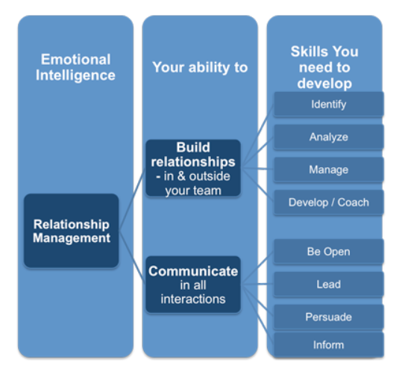
Figure: Relationship Management
In terms of DEN Security Group, this company must maintain the relationship management process in its business to maintain good relationship with the staffs and develop good communication between the managers the employees.

Reference
Avolio, B. J. (2017) Improving Organizational Effectiveness through Transformational Leadership. 1st Ed. Boston: McGraw Hill.
Armstrong, M. (2015) Armstrong’s handbook of management and leadership: developing effective people skills for better leadership and management. London: Kogan Page.
Anastasia (2018) Managerial Grid Model – The Essential Guide. Available at: https://www.cleverism.com/managerial-grid-model/. [Accessed on: 19 April 2019]
Bevoc, L. (2017) Autocratic Leadership: A Basic Introduction. 2nd Ed. Oxford: Oxford University Press.
Bass, B. and Riggio, R. (2016) Transformational Leadership. 2nd Ed. Harlow: Prentice Hall.
Bradberry, T. (2016) Emotional Intelligence. London: Sage Publication.
Buckingham, D. (2015) Now, Discover Your Strengths. 2nd Ed. Harlow: Prentice Hall.
Bennis, W. (2015) On Becoming a Leader. Harlow: Basic Books.
Bird, D. (2016) The Leader's Guide to Emotional Intelligence. 2nd Ed. Harlow: Policy Press.
Corso, A. (2015) The Key Qualities Of An Emerging Leader. Available at: https://www.workitdaily.com/qualities-emerging-leader. [Accessed on: 18 April 2019]
Cherry, K. (2019) What Is Laissez-Faire Leadership? Available at: https://www.verywellmind.com/what-is-laissez-faire-leadership-2795316. [Accessed on: 19 April 2019]
Costa, K. (2014) LEADERSHIP COACHING – THE FOUR FRAMEWORK MODEL. Available at: https://www.skills-universe.com/2014/04/16/leadership-coaching-the-four-framework-model/. [Accessed on: 19 April 2019]
Dugan, J. P. (2017) Leadership Theory: Cultivating Critical Perspectives. 1st Ed. Harlow: Policy Press.
DEN Security Group Ltd (2019) ABOUT DEN SECURITY GROUP LTD. Available at: https://www.densecuritygroup.com/about-us. [Accessed on: 17 April 2019]
Freedman, J. (2017) At the Heart of Leadership: How to Get Results with Emotional Intelligence. 3rd Ed. Boston: Prentice Hall.
Fennel, M. (2015) Overcoming low self-confidence. 2nd Ed. Harlow: Prentice Hall.
Goleman, D., Boyatzis, R. and McKee, A. (2017) Primal Leadership. 3rd Ed. London: Pearson Publication.
iEduNote (2018) Managerial Grid Model of Leadership Explained. Available at: https://iedunote.com/managerial-grid-model-leadership-styles. [Accessed on: 19 April 2019]
Kippenberger, T. (2015) Leadership styles. Oxford: Capstone Pub
Kouzes, J.M. and Posner, B.Z. (2016) The Leadership Challenge. 4th Ed. London: Jossey-Bass.
Leadership Central (2017) Managerial Grid Model - Also known as Leadership Grid. Available at: https://www.leadership-central.com/managerial-grid.html. [Accessed on: 19 April 2019]
McCann, D. (2016) Leadership Charisma: Step by step guide to be a successful charismatic leader. 3rd Ed. London: Kogan Page.
Murphy, M. (2015) Leadership Styles: How to Discover and Leverage Yours. 2nd Ed. Boston: Sage Publication.
Mani, M. (2017) Know Yourself: Know your strength and weakness. 3rd Ed. Boston: Policy Press.
Malhotra, M. (2016) How to Build Self-Esteem and Be Confident: Overcome Fears, Break Habits, Be Successful and Happy. 2nd Ed. London: Kogan Page.
MSG (2018) Great Man Theory of Leadership. Available at: https://www.managementstudyguide.com/great-man-theory.htm. [Accessed on: 20 April 2019]
Nwlink (2018) Learning Activity for Bolman and Deal's Four Framework Approach to Leadership. Available at: http://www.nwlink.com/~donclark/leader/framwork.html. [Accessed on: 19 April 2019]
Othmar, B. M. (2016) Self-Ignorance Is Your Problem. Self-Awareness Is Your Solution. – Success. 3rd Ed. London: Prentice Hall.
Pavlina, S. (2017) Personal Development for Smart People: The Conscious Pursuit of Personal Growth. 2nd Ed. London: Prentice Hall.
Rubin, R. and Bommer, H. (2017) Emotion recognition and emergent leadership: Unraveling mediating mechanisms and boundary conditions, The Leadership Quarterly, Vol. 21 (2), P.967‐973.
Rouse, M. (2018) managerial grid model (The Blake and Mouton Managerial Grid model). Available at: https://searchcio.techtarget.com/definition/managerial-grid-model-The-Blake-and-Mouton-Managerial-Grid-model. [Accessed on: 19 April 2019]
Sleeth, R. (2016) Empathy and the emergence of task and relations leaders, The Leadership Quarterly, Vol. 15 (3), P. 147–163.
Shimonski, R. (2014) Emergent Leadership: Let the Workforce Rise. Available at: https://www.linkedin.com/pulse/emergent-leadership-let-rise-robert. [Accessed on: 18 April 2019]
Sandling, J. (2016) Leading with Style: The Comprehensive Guide to Leadership Styles. 3rd Ed. London: Pearson Publication Limited.
Useem, M. (2015) The Leadership Moment. New York: Crown Business
Vincent, N. (2016) The Power of Positive Thinking. 2nd Ed. Harlow: Prentice Hall.

