BSc Computing
ACCA4023

L4 – Introduction to Web and Database Design
Jon Jones (2310528)
January 2024

Contents
Introduction 3
Requirements 3
Implementation 11
Screenshots of website 11
Validation 14
Evaluation 16
Website usability 16
Web Accessibility 16
Search Engine Optimisation 17
Evaluation of my website 18
References 20
Appendices 21
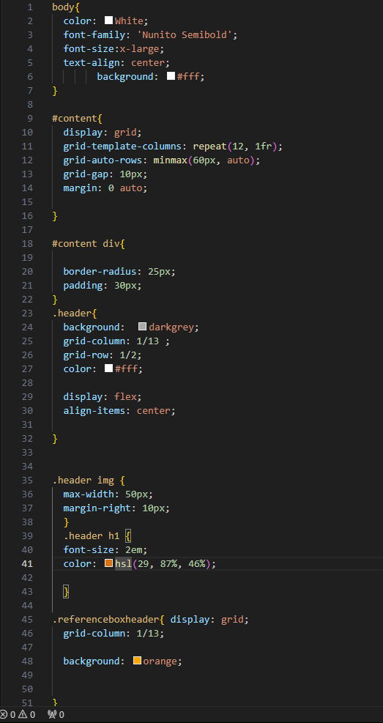 21

Introduction
This report is to outline the process of building a web site, an assignment given as part of L4 - Introduction to Web and Database Concepts.
It will outline the requirements identified for the website,
Implementation of the website from its design to and writing
The evaluation of the website from its functionality, its accessibility and search engine optimisation
A list of references will be provided to support any findings made in the report along with an appendices providing the full HTML & CSS code.

Requirements
The website for a fictitious gas company Gas Solutions loosely based on a family business I was involved in. The company provides residential gas and plumbing services along with auditing and consultancy services for housing associations.
Most of the work comes from the residential gas and plumbing services and this is achieved through repeat customer and word of mouth referrals.
It will not be their main method to gaining business and want to keep the maintenance and upkeep of the website to a minimum.

The idea of the site is to have an online presence. Research has found that “85% of consumers conduct research before they make a purchase online, and among the most used channels for research are websites (74%) [7]
- introduce the members of Gas Solutions,
- what services they have to offer,
- give examples of their work
- Have a method where they can collect any enquires from potential customers.

The services of Gas solutions are intended for anyone requiring Gas or plumbing services around Cardiff, Caerphilly, and their surrounding areas. From this we can assume the target audience will be anyone from 18 upwards. Such an age range means that it should be kept a simple as possible.
The website is really on required for potential customer in the surrounding area. Therefore, it does not need be hosted in different countries.

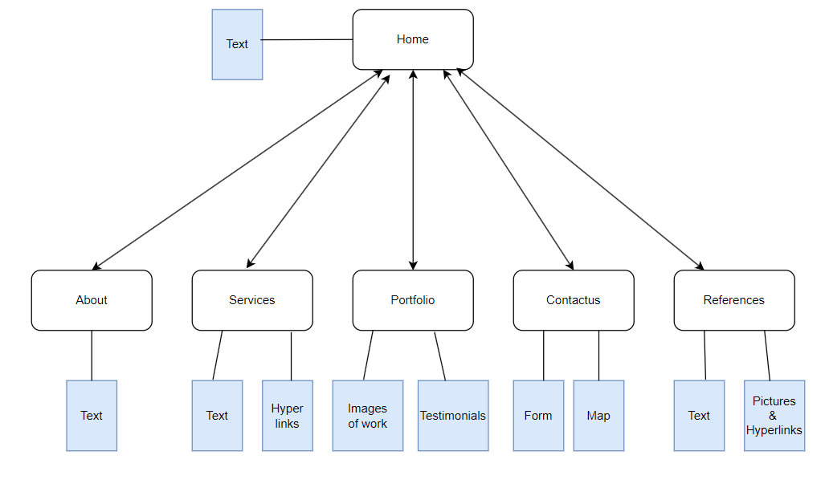
Figure 1 Gas Solutions Website design layout

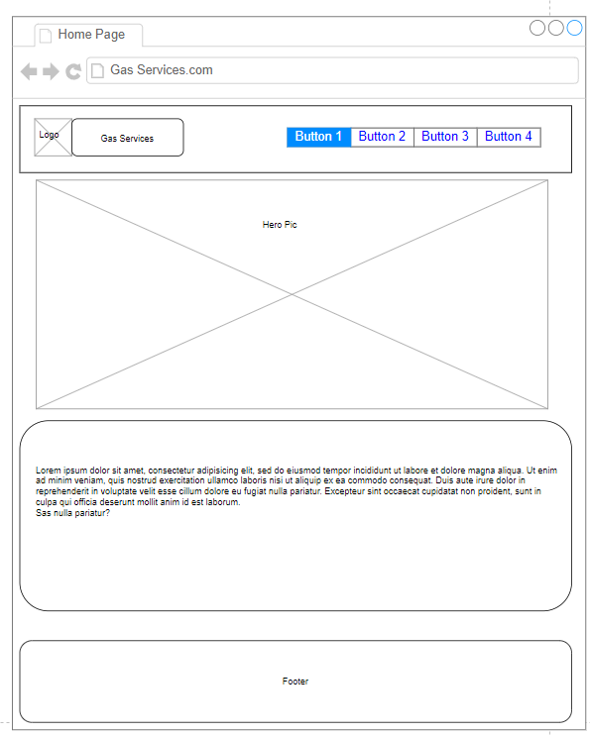
Figure 2 Home Page Wireframe

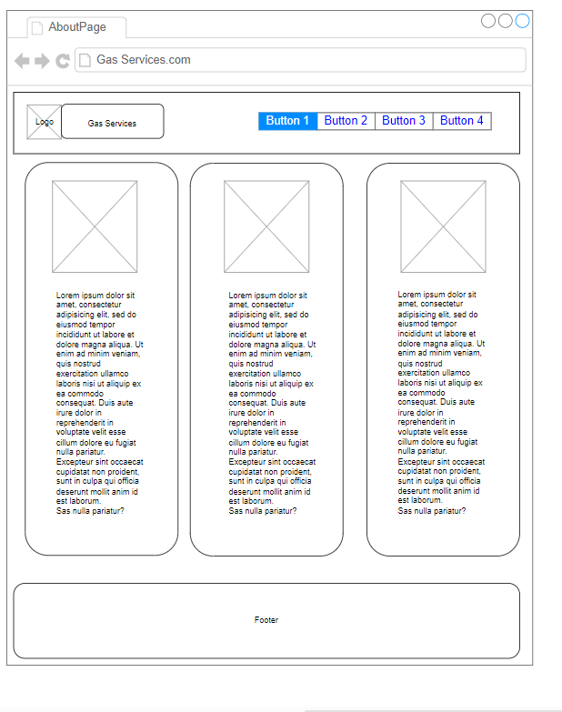
Figure 3 About us Wireframe

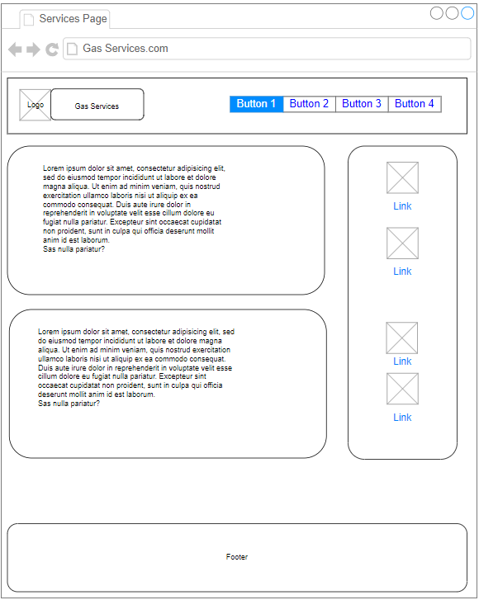
Figure 4 Services Wireframe

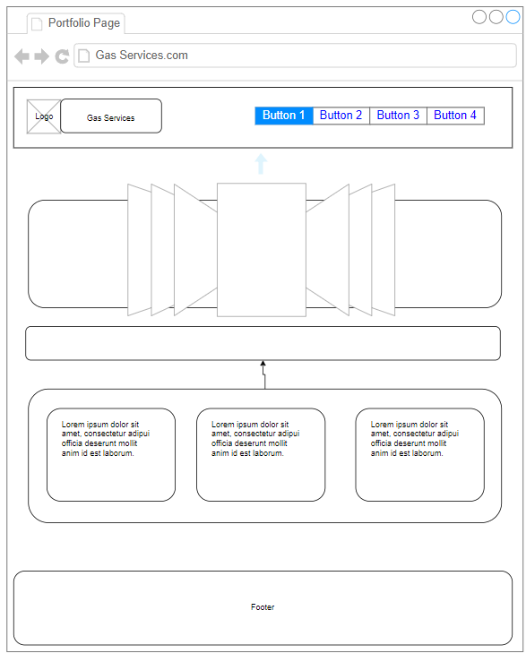
Figure 5 Portfolio Wireframe

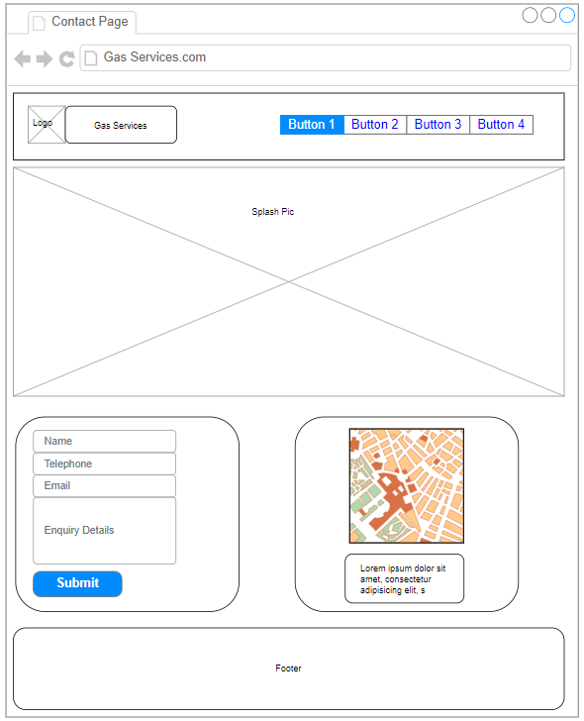
Figure 6 Contact us Wireframe.

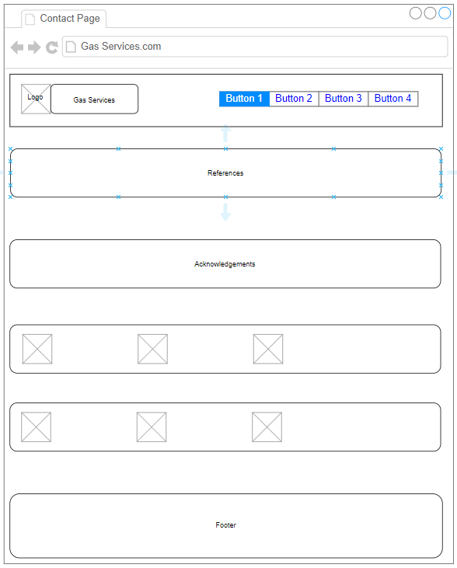
Figure 7 References Wireframe

Implementation

Screenshots of website

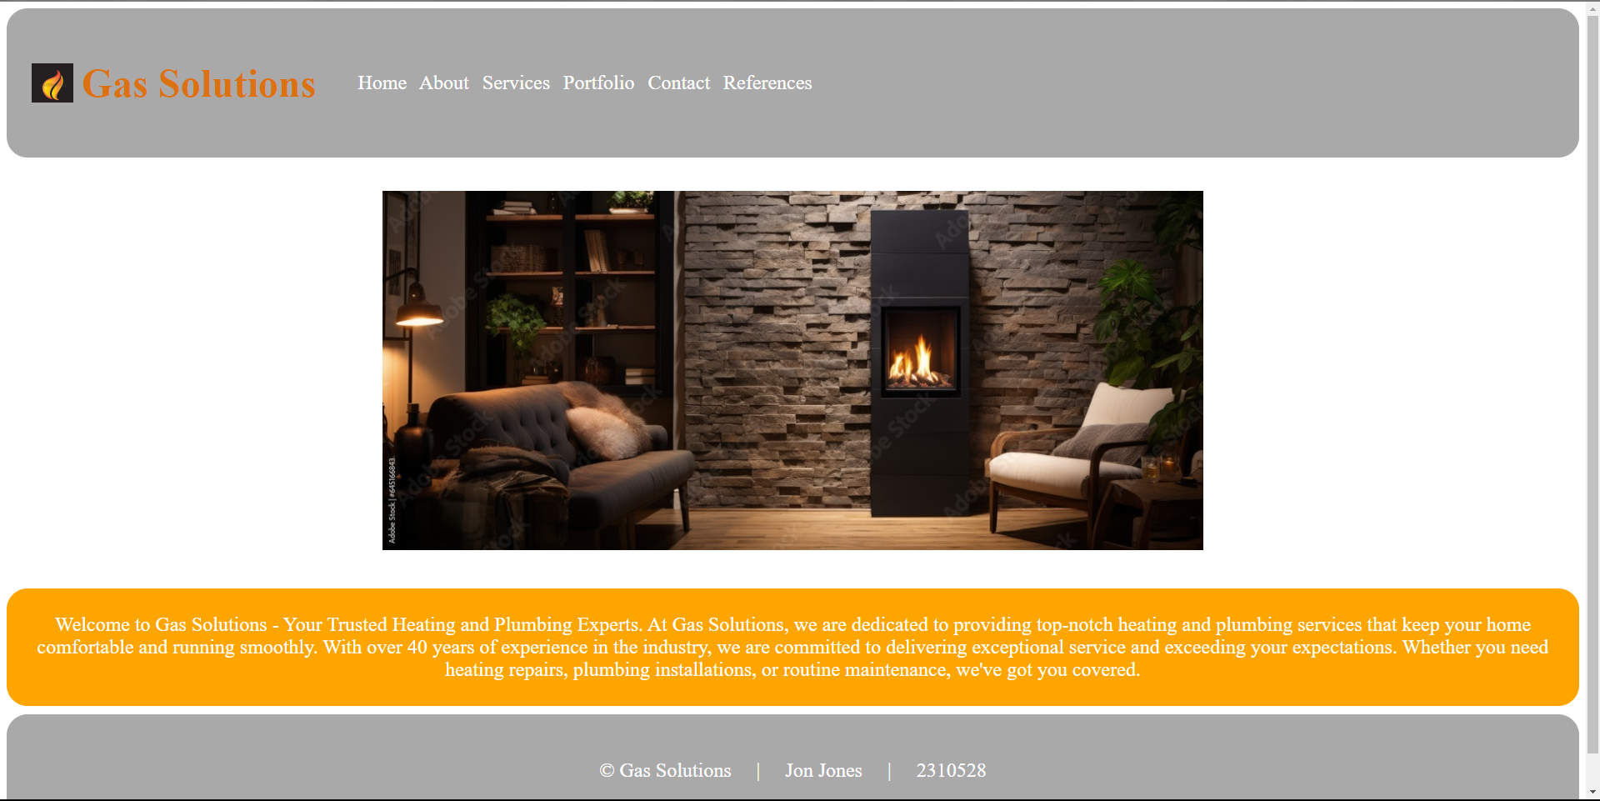
Figure 8 Home Page

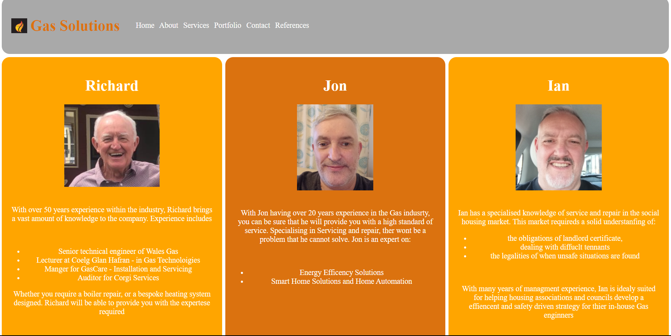

Figure 9 About Page

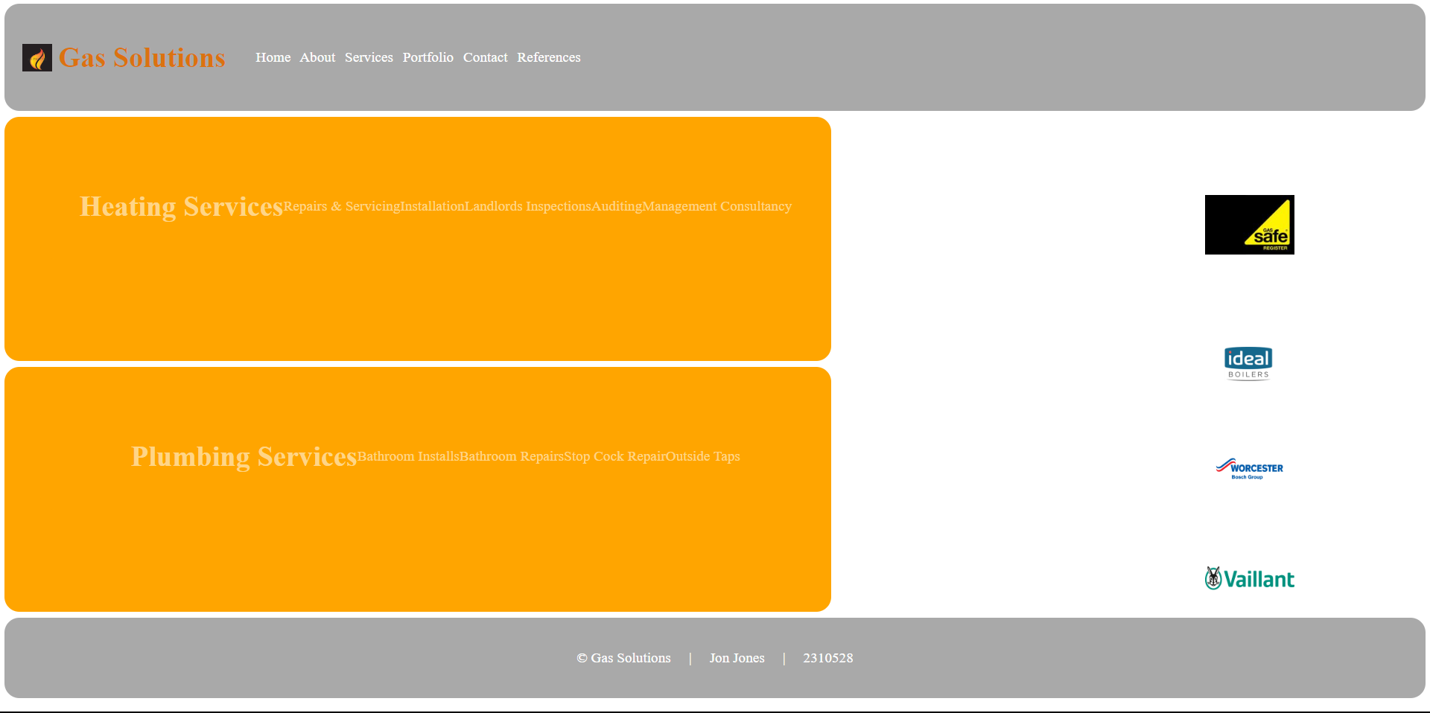
Figure 10 Services Page

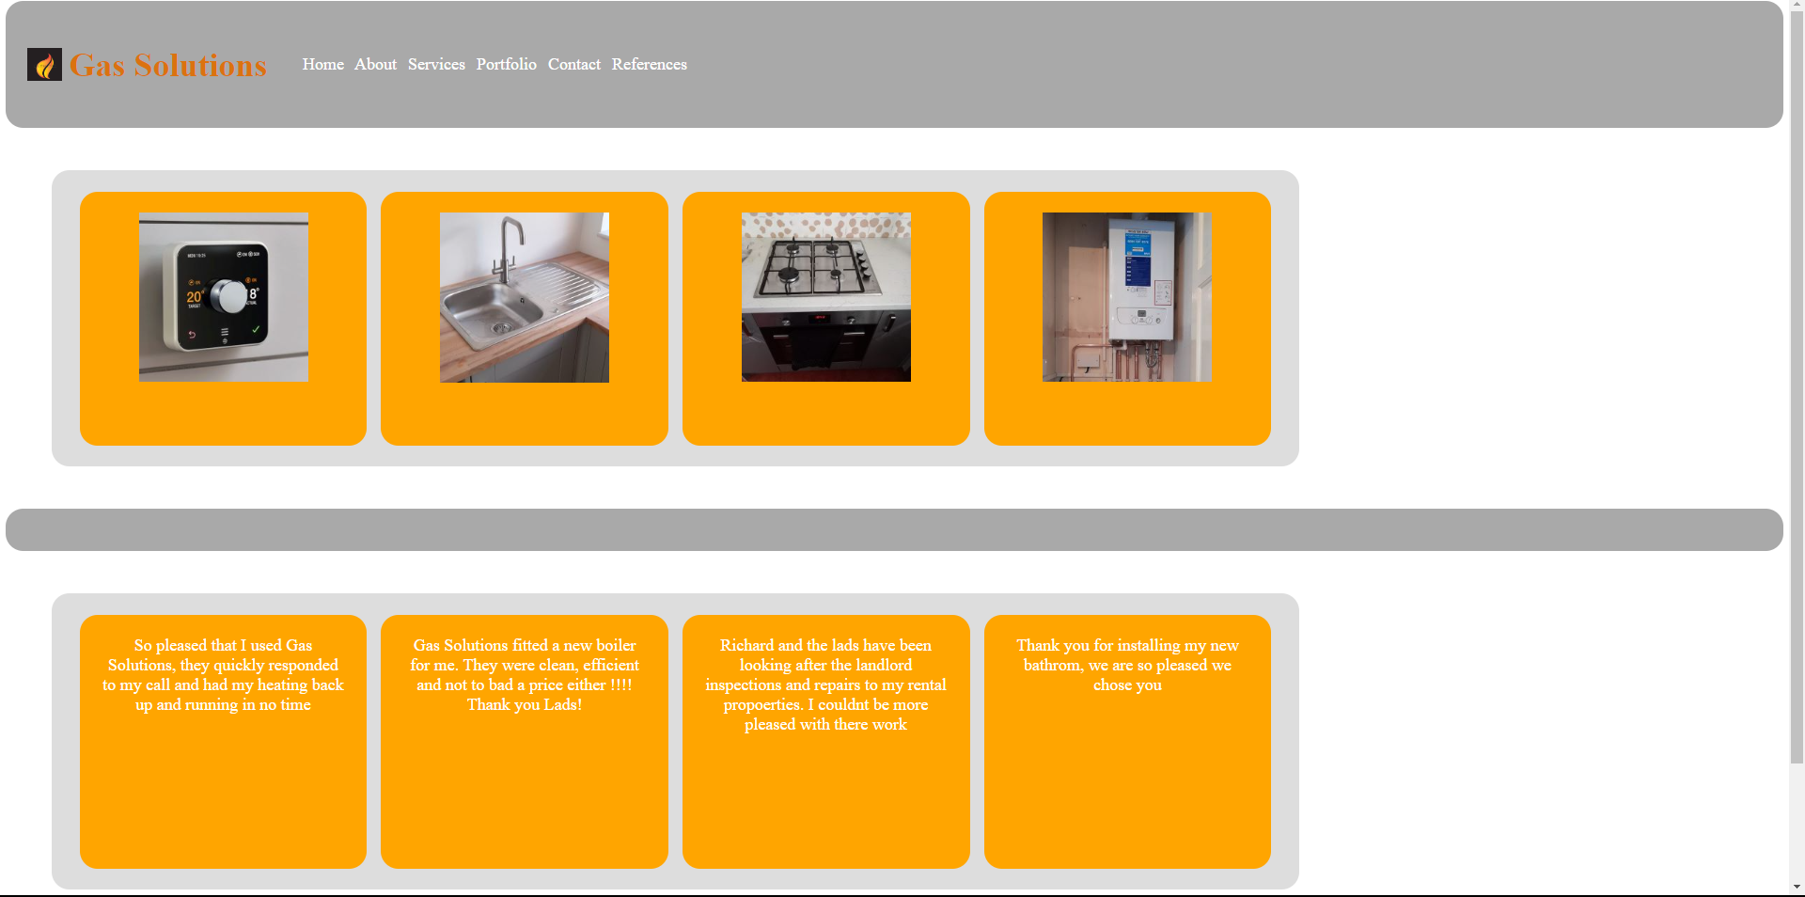
Figure 11 Portfolio Page

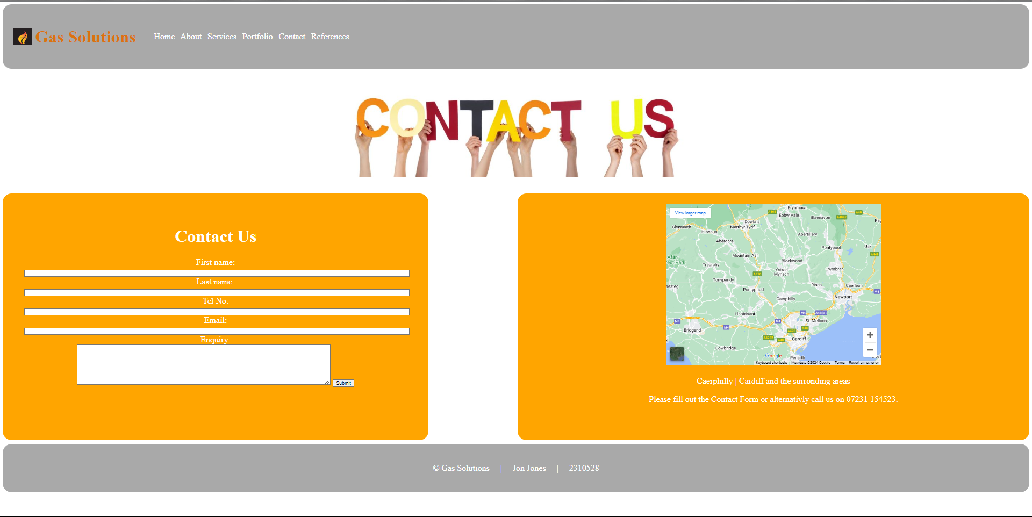
Figure 12 Contact us Page.

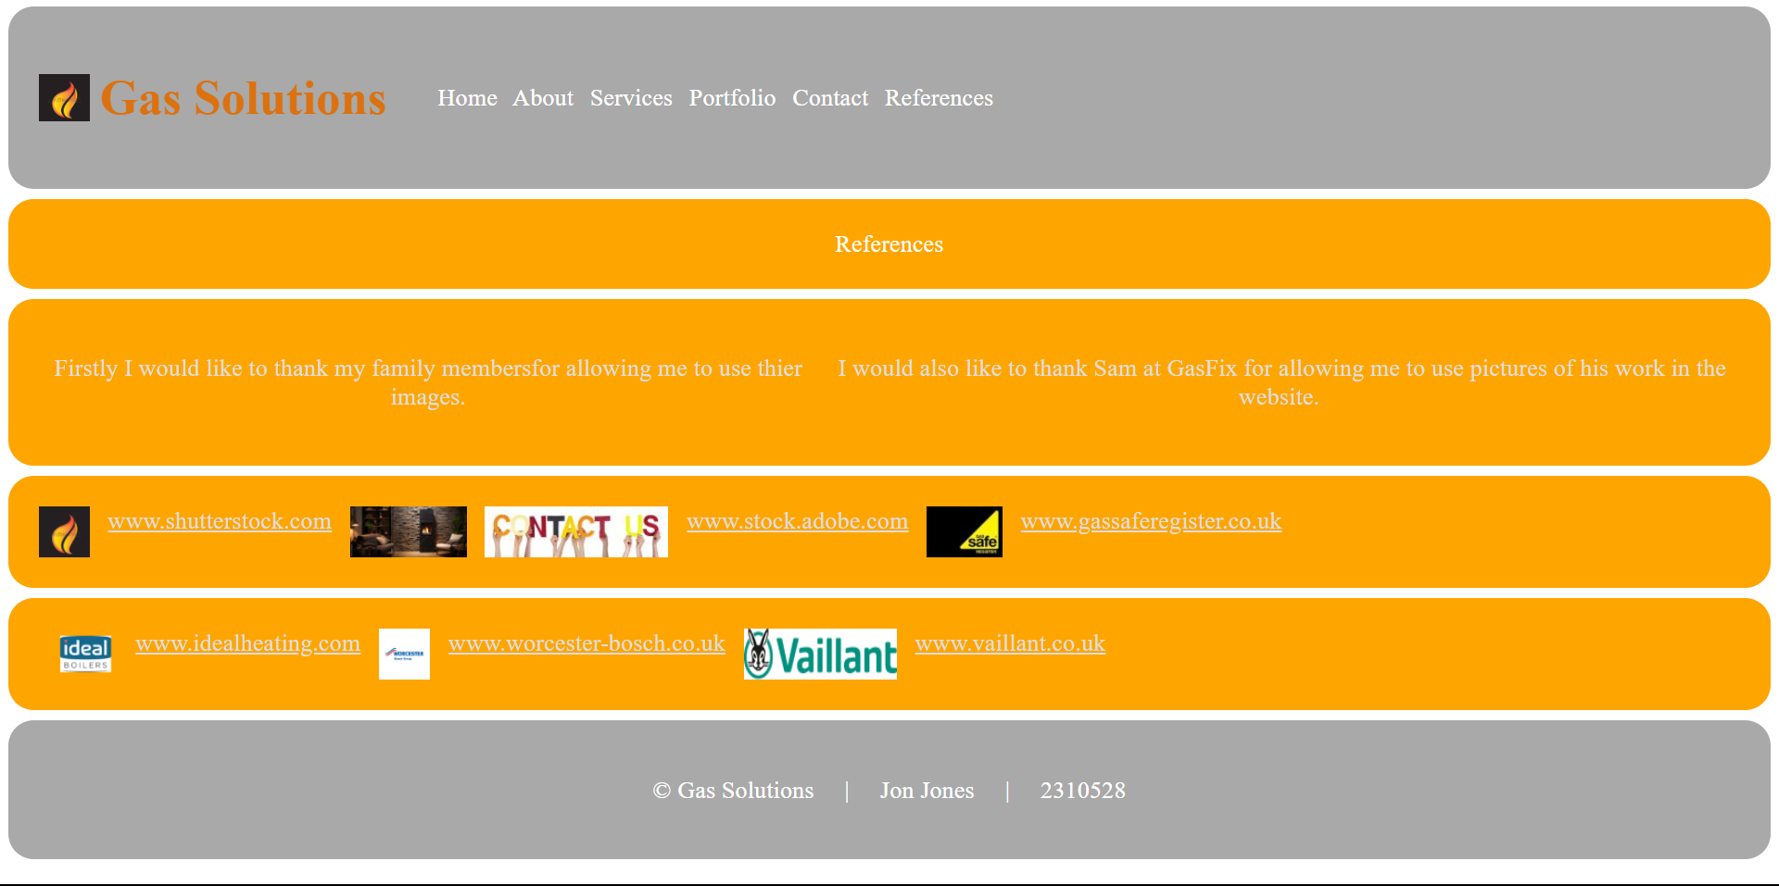
Figure 13 References Page

Validation

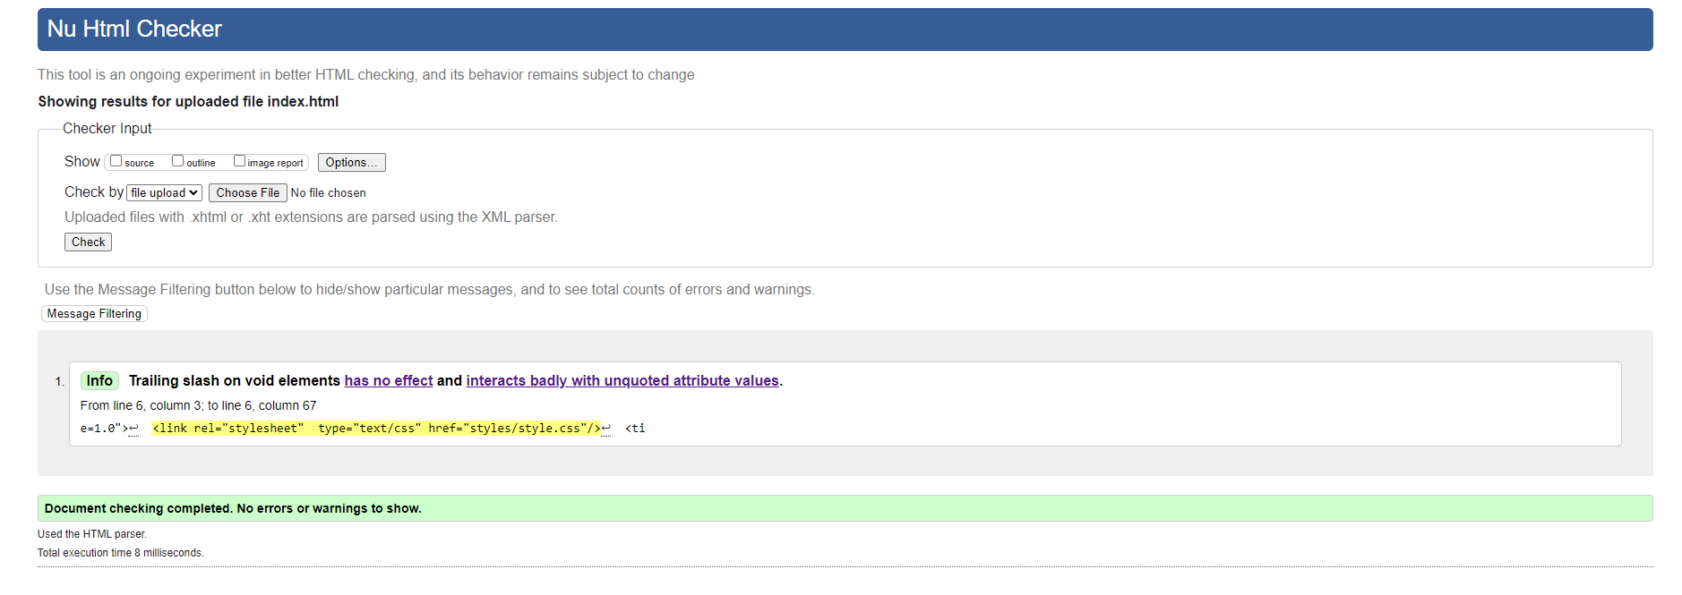
Figure 14 Results of HTML checker for Home Page

To resolve this issue, I simply removed the trailing slash.

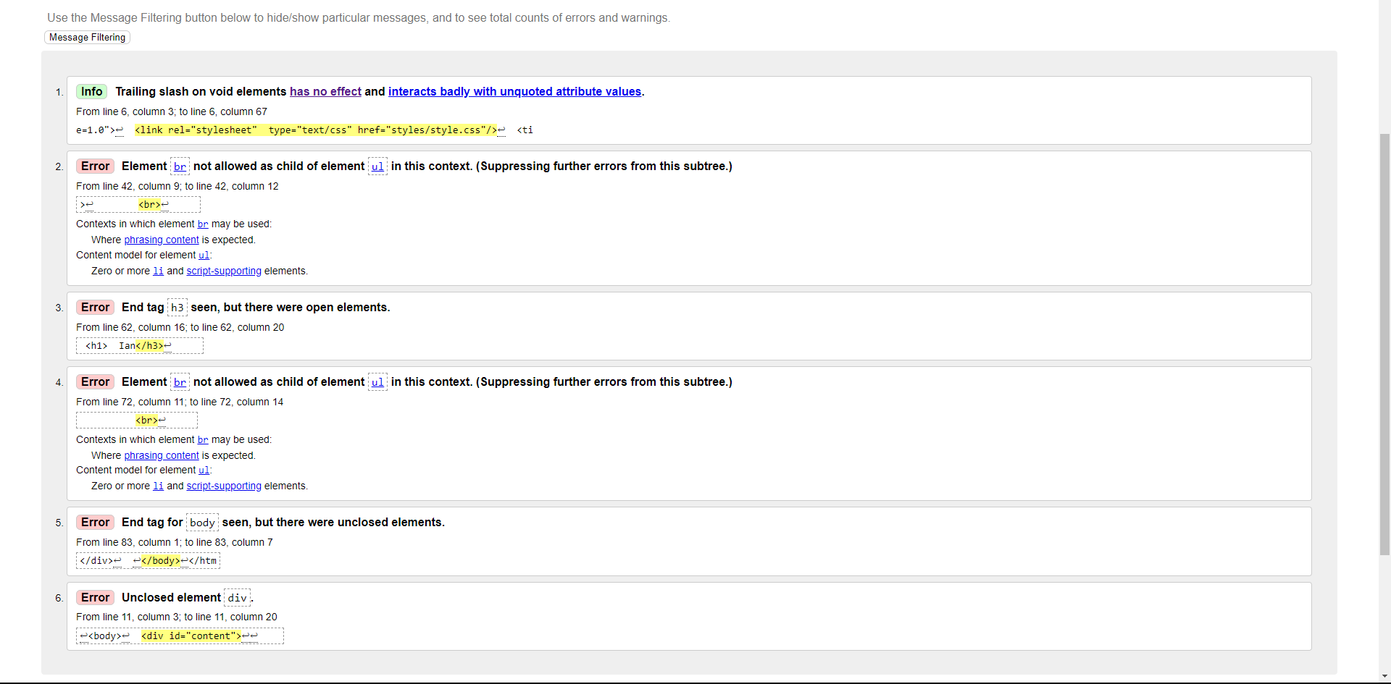
Figure 14 Results of HTML checker for About Page

Error 1 - Removed the trailing slash.
Error 2 & 4 - I had opened with a H1 tag but had closed it with a H3 tag. I amended the H3 back to H1.
Error 3 - I had used BR to space out the list. It was not required.
Error 5 & 6.- I had failed to close the “content” div.
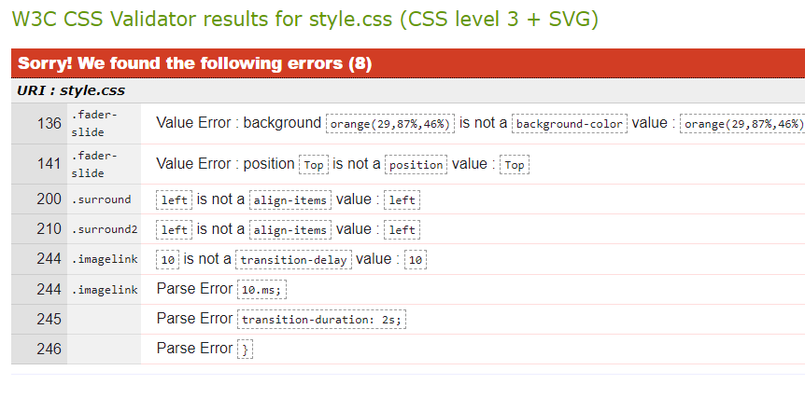
Figure 15 CSS Validator Results for the Style Sheet

136 – I amended from background to background- colour.
141, 200 and 200 - I had issues in getting things to align throughout the project. These were put in to try and correct the problem. They were removed and have not made a difference to the webpages.
244 245 246 - Relate to a transition delay I had put 10.ms instead of 10ms.

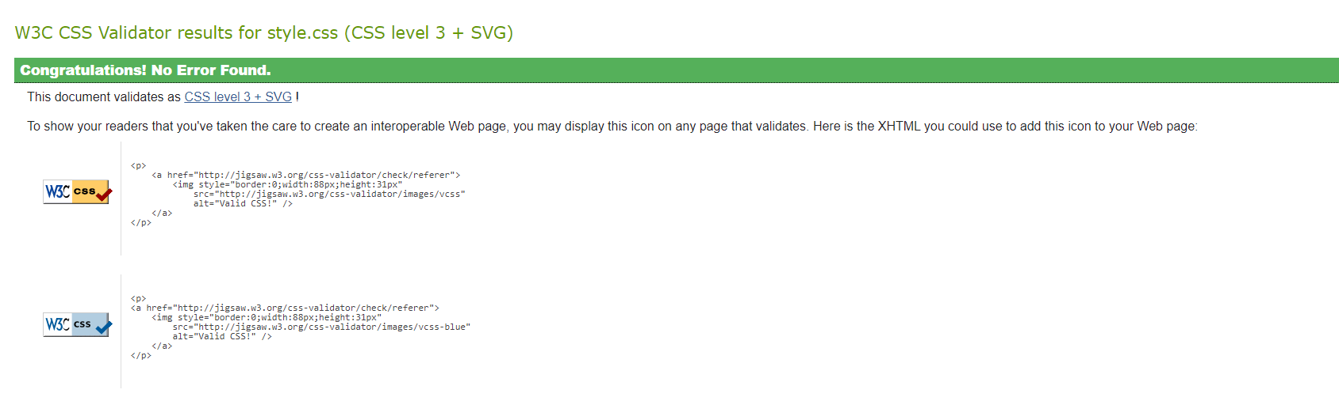
Figure 16 CSS Validator results for style sheet after removing the errors.

Evaluation

Website usability
In today’s world website usability is of vital importance. If the website is not providing the user with experience they anticipate, they are simply one click away from going to a competitor’s website. So how do we define Website usability? It can be broken down into
- The ease of understanding the Website.
- How quickly users can find what they are looking for.
- The ease of site navigation.

A study in 2006 found that the customers perceived usability of a website had a direct and positive impact on the degree of consumer trust and satisfaction. [11]

Testing website usability can be done by:
Comparative - This is where different versions of the web site are made users give feedback to which ones they prefer.
Explorative - This is where a website is design, they developers now what it should do. Its then handed to users to see if it does what the developers intended. This kind of testing can be used for finding bugs and trying to ‘break’ the website.

Web Accessibility
When designing a website, consideration should be given to how accessible it is for all users regardless of any disability.
There are several reasons for this including:
- Legal obligations to provide accessibility.
- An accessible web site can improve your Google Score
- 15% of the population are classed as disabled. A valuable potential market you are missing out on if you do not address accessibility.[8]

The W3C identifies the following categories of disability that should be addressed with web accessibility.
- Auditory
- Cognitive
- Neurological
- Physical
- Speech
- Visual
[9]

So how do we address the accessibility issues?
Contrast Checkers - Websites are available to check that there is enough contrast on your website for visually impaired users to see it correctly.
Semantic Tags – cleans up the format of your code, but also can be used with screen readers for visually disabled users.
Alternative descriptions for Images – again to for visually impaired people to understand the website.
Captions for audio and video clips - for the hard of hearing this can help convey what the video or audio clip is say. This can also be handy for non-disabled people.
Interactive elements are easily identifiable. - This is helpful for the visually impaired and those with cognitive disabilities

A clear and consistent navigation – Intuitive design for navigation allows those with cognitive issues grasp the how to use the website easier.

Search Engine Optimisation
It is not enough just to have an online presence to be successful. You also need to be found online. With so many of us having phone, tablets, laptops you can imagine that searching online happens daily for most of us.
Whatever your ‘flavour’ of search engine, they all do a similar thing. Based on your search input they try and come up with the most relevant sites for you. The search engine scores each web site. The better the score the higher up the top of the search results page (SERP)you will be.
Search Engine optimisation is art of getting the search engine to score you website higher.
A study in 2015 concluded that carrying out search engine optimisation led to scoring higher on the Search engine results page, providing more web traffic. [12]
Some ways a website can be optimised include:
Having a good user interface. Google is known to score how quicky someone leaves a website to go back to searching. The longer someone is at your site the higher the score.
Ensuring you have keywords throughout your web page. For example, if your website is to promote and get bookings for your Spanish Villa, it would be wise to have this in your website. Just saying Villa would not be specific enough.
Having links to reputable and relevant websites can assist. If they also have links back to your site that can help too. As it suggests that they feel that your website is relevant to them.

Evaluation of my website.
Initially I thought I had created a good website. I thought it was a good contrast of colours. A simple design with an easy navigation to any page.
I thought there wasn’t too much happening on the website which would suit the target audience. It had a form that would capture the data Gas solutions wanted and provided the user with a way to communicate with the company.
From a Search Engine Optimisation perspective, I felt there were enough key words to help identify them in a search and there were links to relevant and respectable websites.
Unfortunately, accessibility evaluation didn’t go too well.
Stating with a contrast checker (fig 17), it failed on all aspects of this. To me however I thought the colours worked well and was easy to read. If I was to redesign the site, I would probably make sure I tested the colours first to see that they pass the tests.

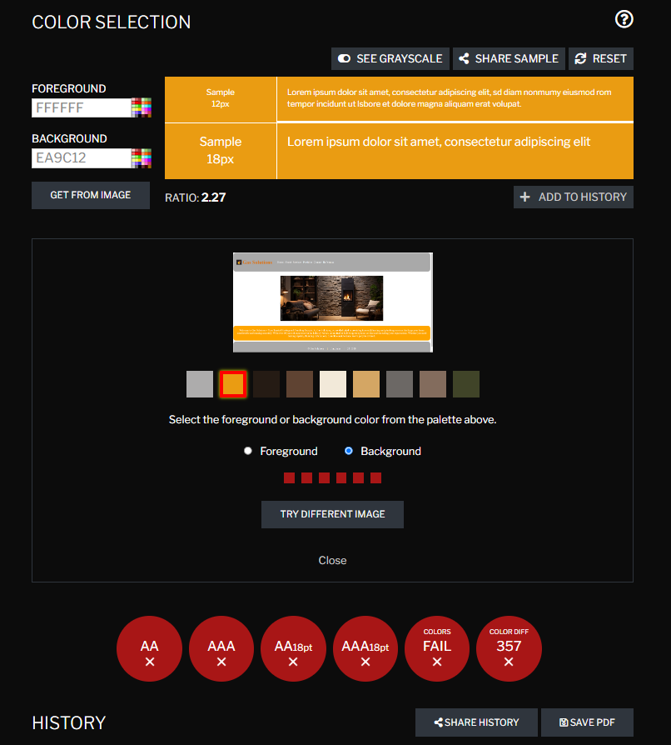
Figure 17 Contrast Checker Results

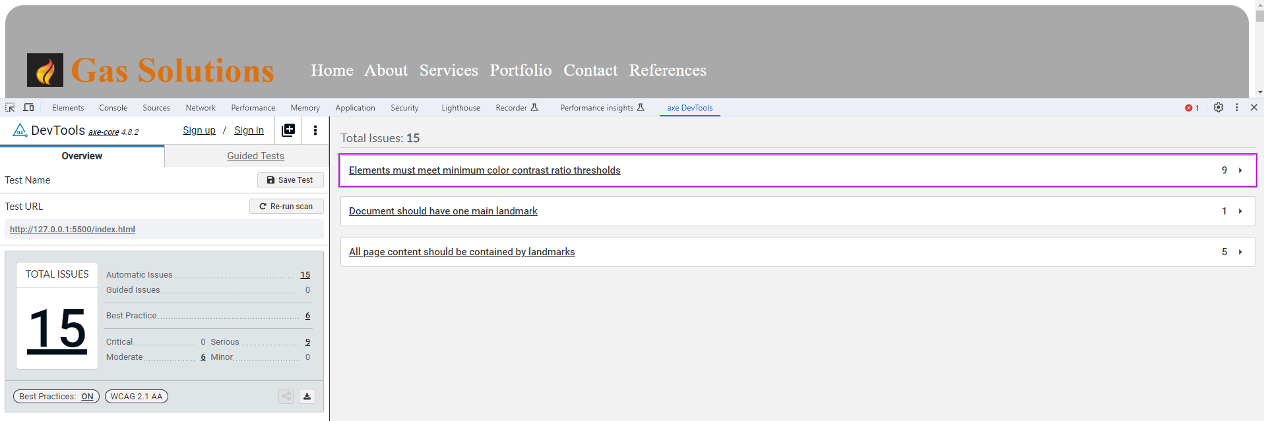
Figure 18 AXE Accessibility checker results

The AXE Accessibility Checker (fig18) didn’t fair much better. 15 errors were identified. 9 of these were serious and were also related to the colour contrast. Given more time I would go in and amend the colour scheme.
The next issue was with the document should have one main landmark in the document. This was added and the issue resolved.
I amended all the other pages for the main landmark in the document. They all had similar errors regarding colour contrast.
An area that I would have liked to concentrate on if I had more time would have been the responsive design. This where the web page changes how it looks depending on the device size. Whilst some elements of my website do adapt, some elements do not. The method by which these are controlled is the @media query. Setting the pixel width at which the website elements seem to break, you can then make the new settings. Unfortunately, I was not able to make it work with regards to the columns on the About Page. My intention was to stack them into rows.

In conclusion, I can say that I have really enjoyed this assignment. I feel that I have started to learn a lot in the different elements of web design. There are so many different elements to consider If I were to do another website I feel I would spend a lot more time in designing i.e. colours, responsive design.

References

[1] "Vaillant Boilers." https://www.vaillant.co.uk/ (used in website)
[2] "New Boilers | Worcester Bosch." https://www.worcester-bosch.co.uk (accessed Jan 14,). (used in website)
[3] I. Heating. "Ideal Heating | New Boilers, Heat Pumps & Heating Controls." Ideal Heating. https://idealheating.com/ (accessed Jan 14,).(used in website)
[4] "Adobe Stock." https://stock.adobe.com/uk. (used in website)
[5] "Gas Safe Register - The Official List of Gas Safe Registered Businesses - Gas Safe Register has replaced CORGI registration. Don't cut corners, only use a Gas Safe registered engineer." https://www.gassaferegister.co.uk/ (accessed Jan 14,). (used in website)
[6] "Stock Images, Photos, Vectors, Video, and Music." Shutterstock. https://www.shutterstock.com/ (accessed Jan 14,). (used in website)
[7] G. Paun. "Council Post: Building A Brand: Why A Strong Digital Presence Matters." Forbes. https://www.forbes.com/sites/forbesagencycouncil/2020/07/02/building-a-brand-why-a-strong-digital-presence-matters/ (accessed Jan 14,).
[8] R. Rutter, et al., Web Accessibility Web Standards and Regulatory Compliance, 1st Ed. Berkeley, CA: Apress, 2006.
[9] W. W. A. I. (WAI). "Introduction to Web Accessibility." Web Accessibility Initiative (WAI). https://www.w3.org/WAI/fundamentals/accessibility-intro/ (accessed Jan 14,).
[10] W. W. A. I. (WAI). "WCAG 2 at a Glance." Web Accessibility Initiative (WAI). https://www.w3.org/WAI/standards-guidelines/wcag/glance/ (accessed Jan 14,).
[11] C. Flavián, M. Guinalíu and R. Gurrea, "The role played by perceived usability, satisfaction and consumer trust on website loyalty," Information & Management, vol. 43, no. 1, pp.1-14, 2006. doi: 10.1016/j.im.2005.01.002. Available: https://www-sciencedirect-com.ezproxy.uwtsd.ac.uk/science/article/pii/S0378720605000169
[12] J. Zilincan, “SEARCH ENGINE OPTIMIZATION,” CBU International Conference Proceedings, vol. 3, 2015.

Appendices
Style Sheet
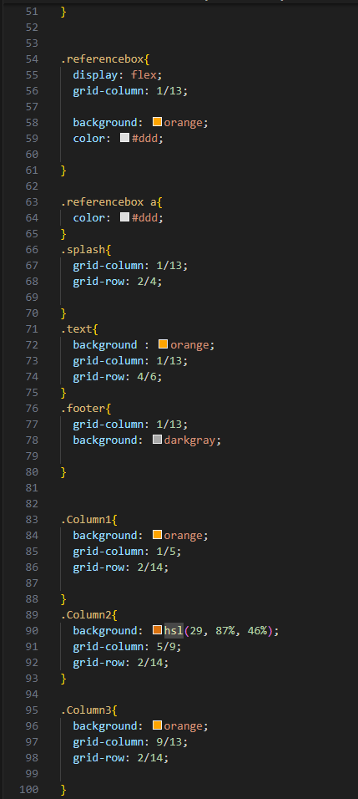
Style Sheet
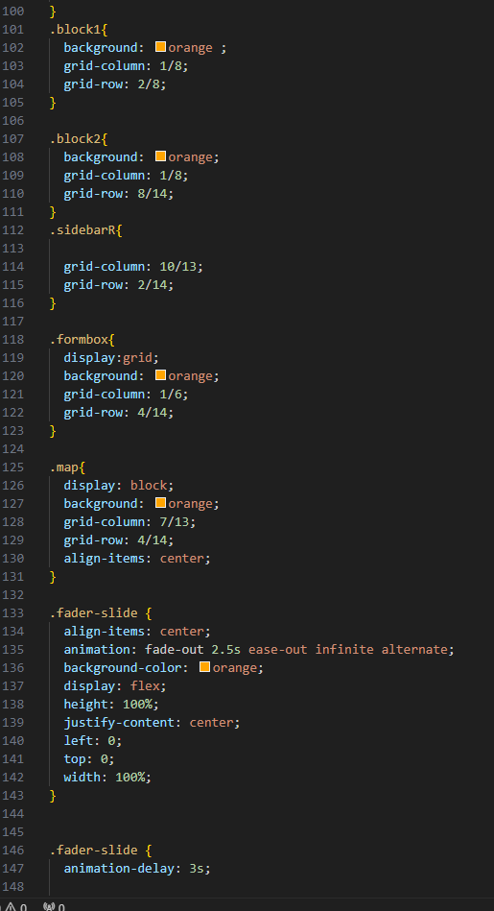
Style Sheet

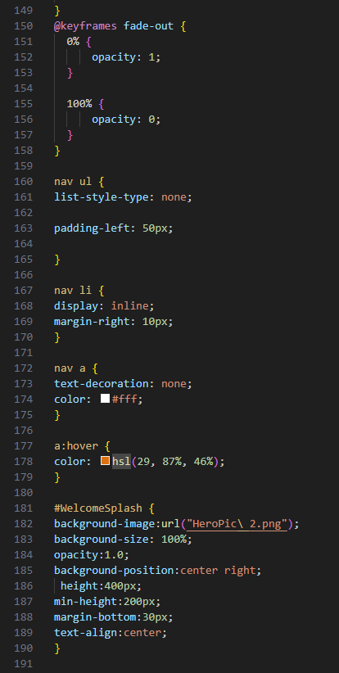
Style sheet

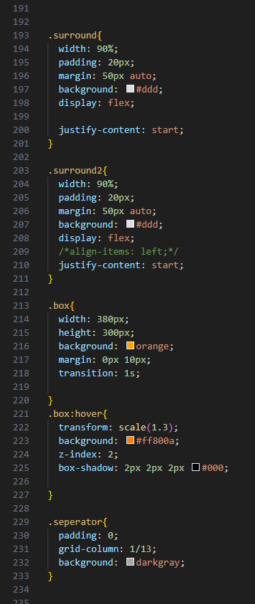
Style sheet
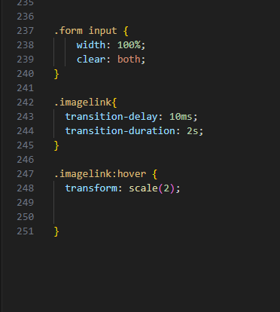
Style sheet
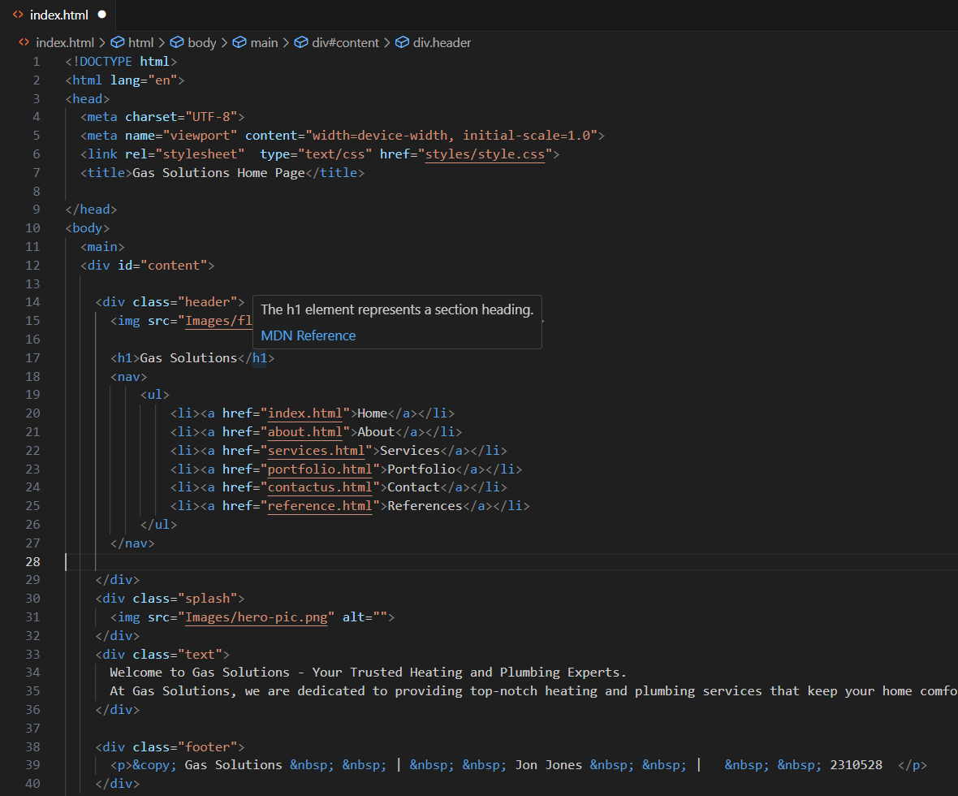
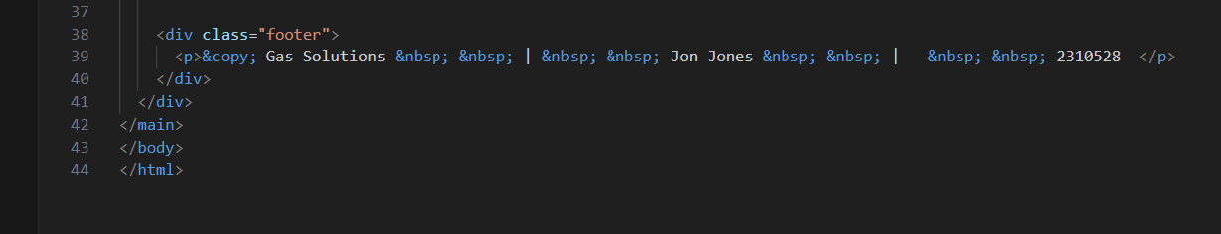
Index HTML

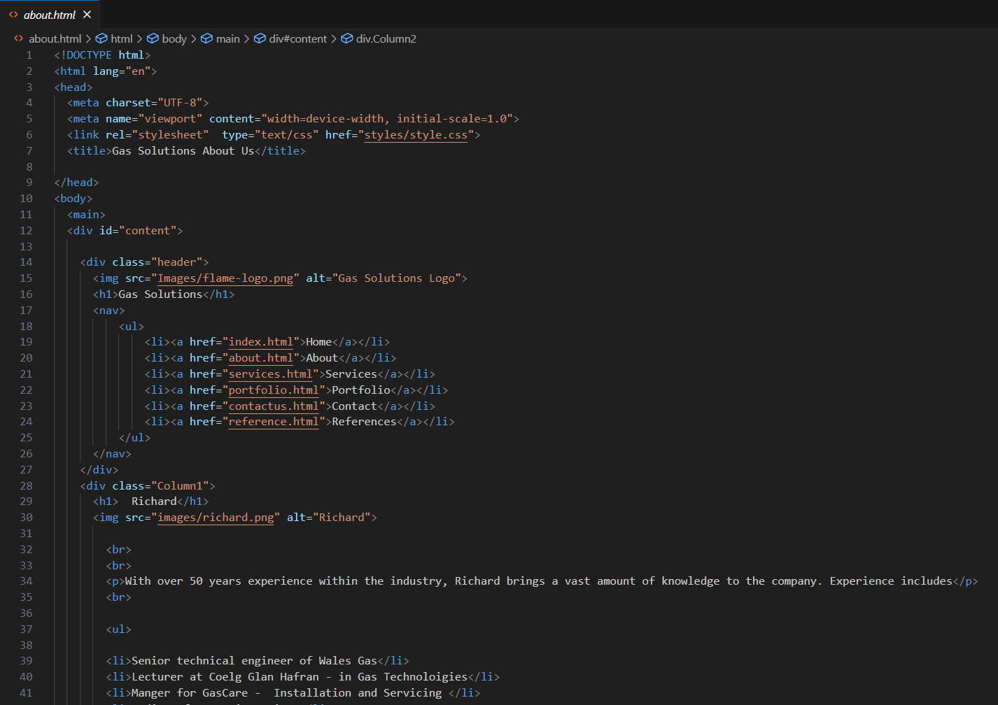
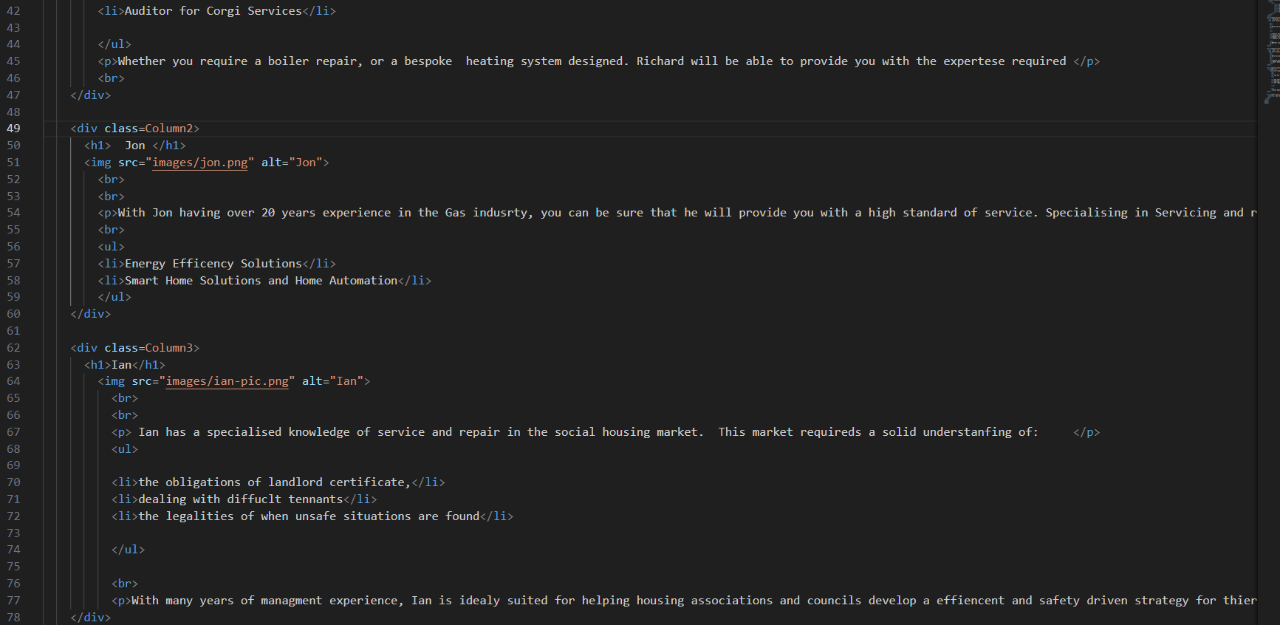
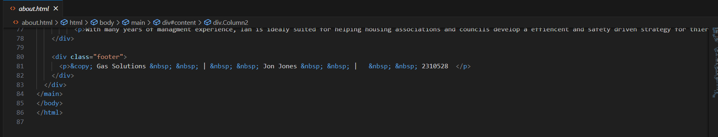
About HTML
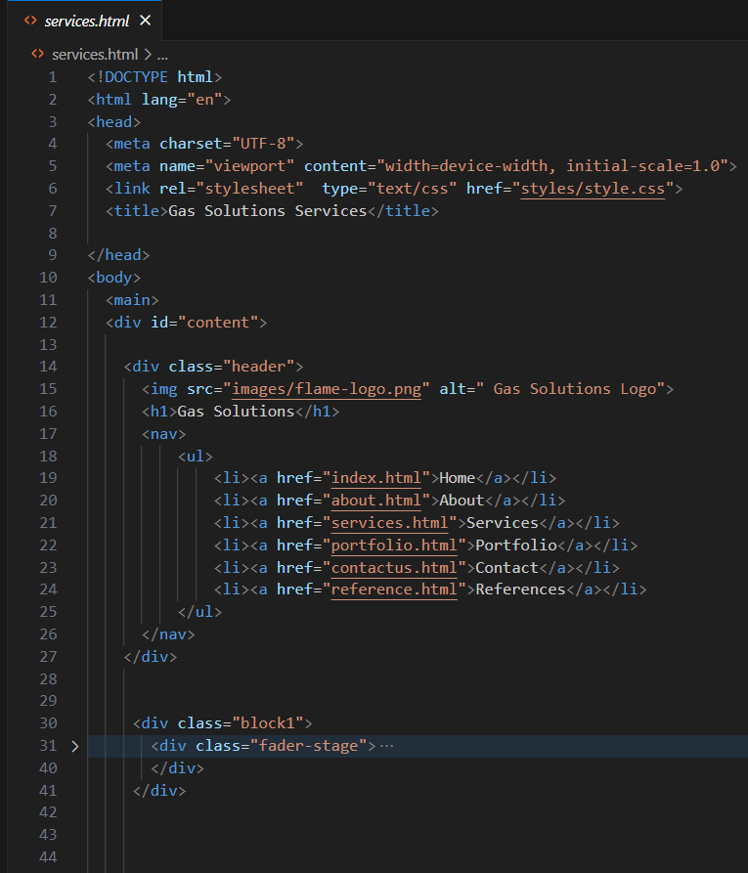
Services HTML
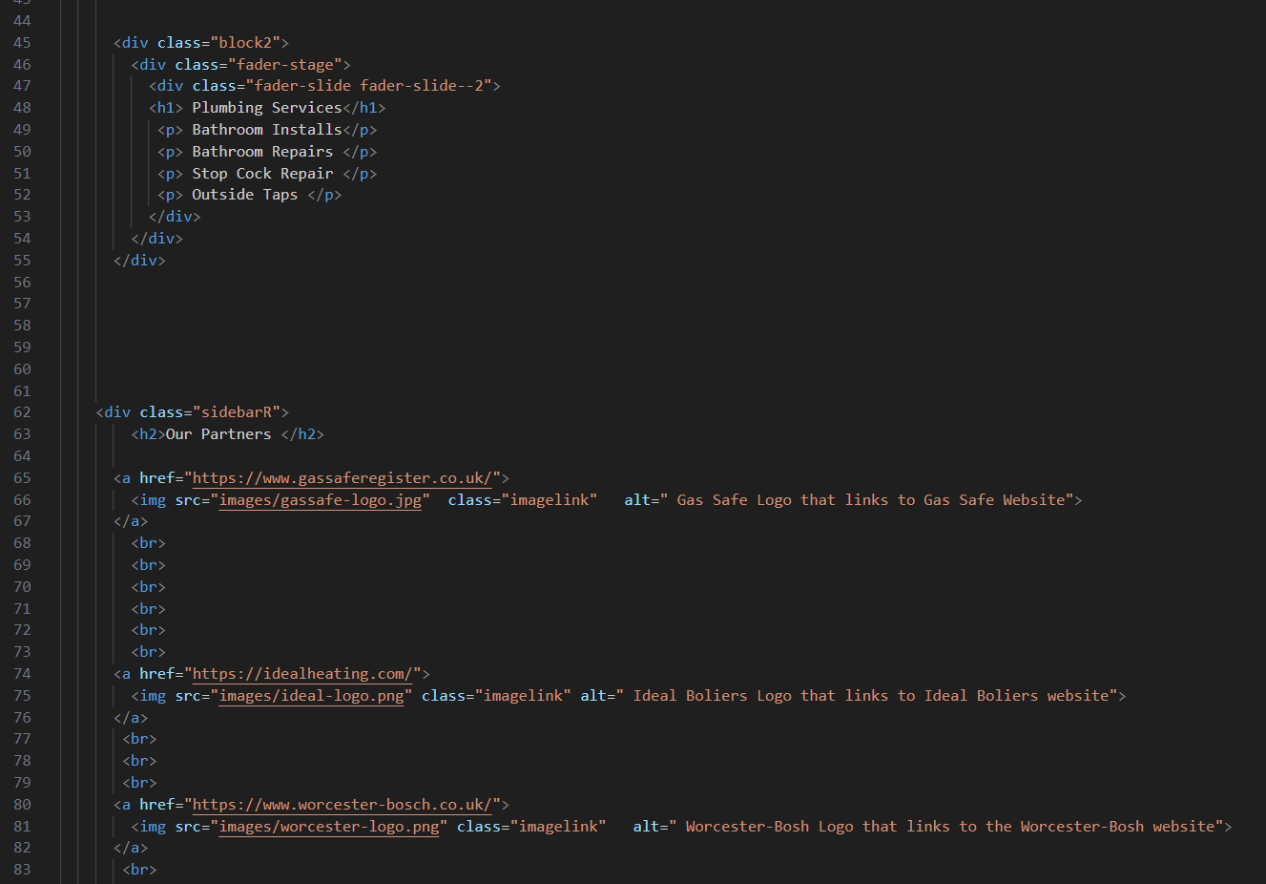
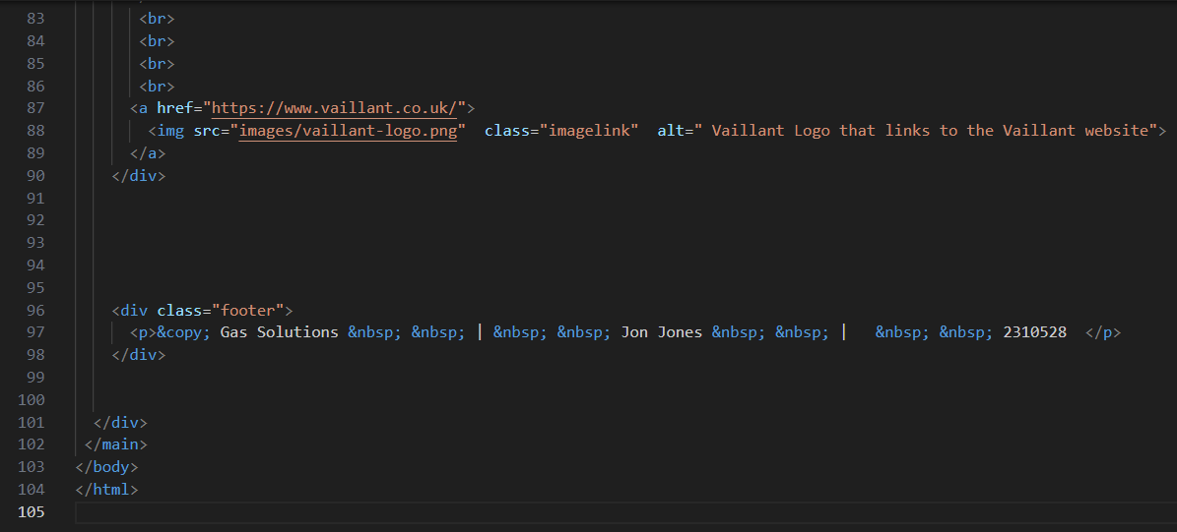
Services HTML

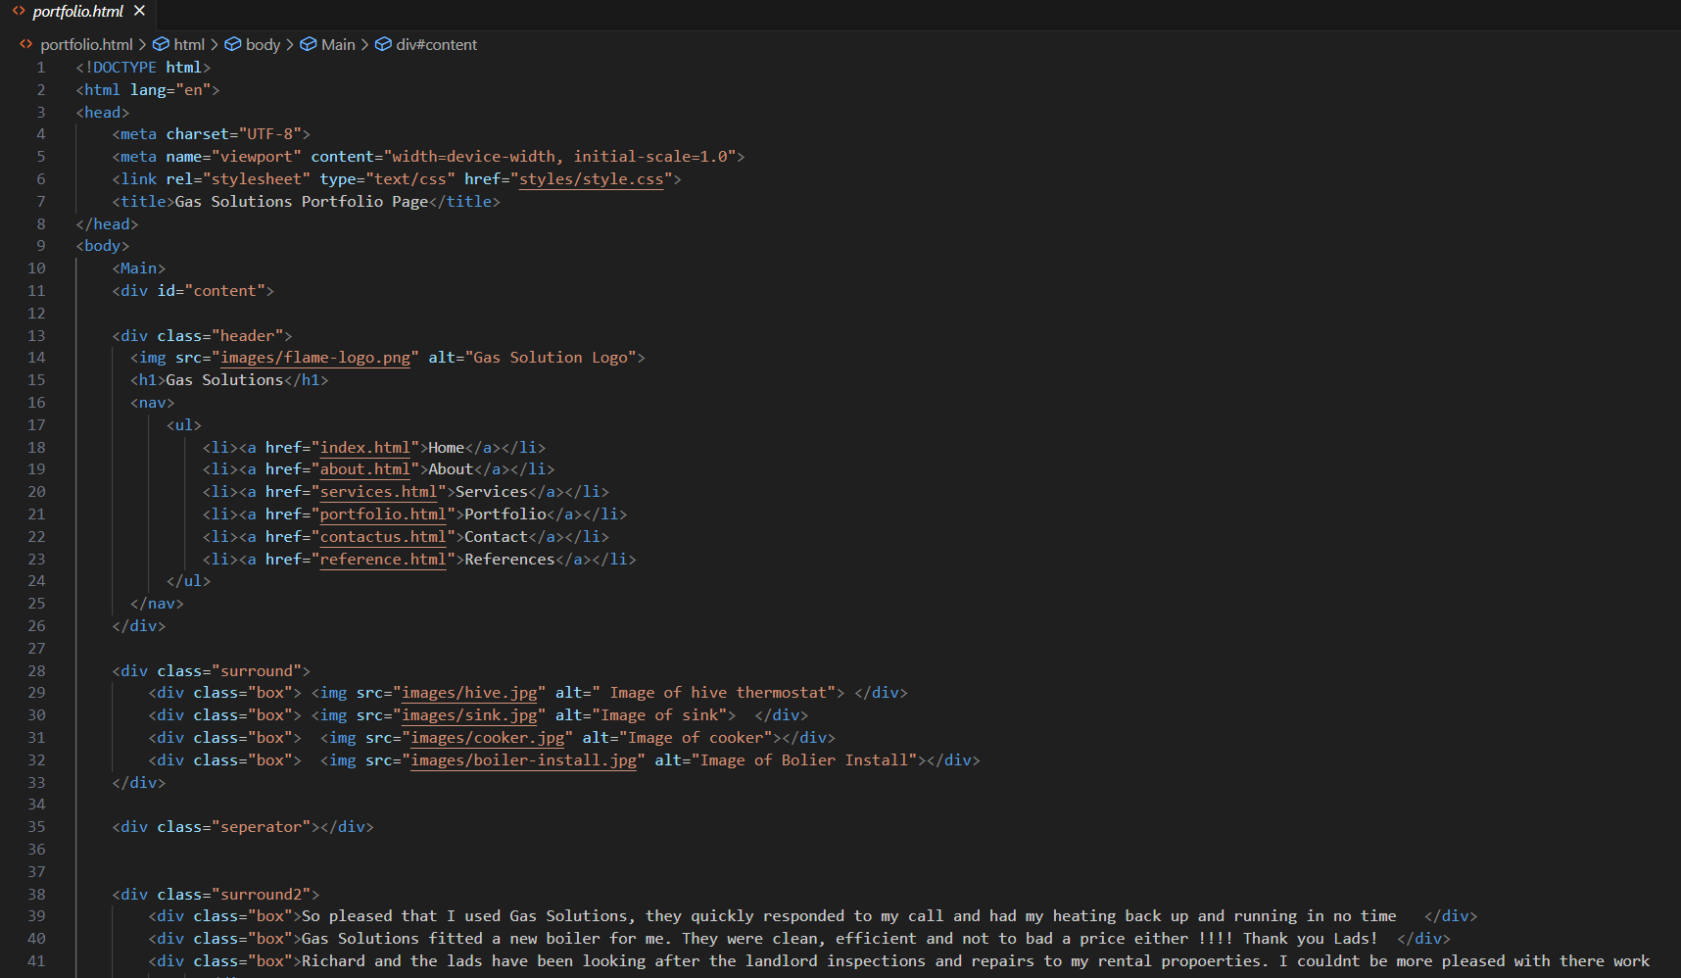
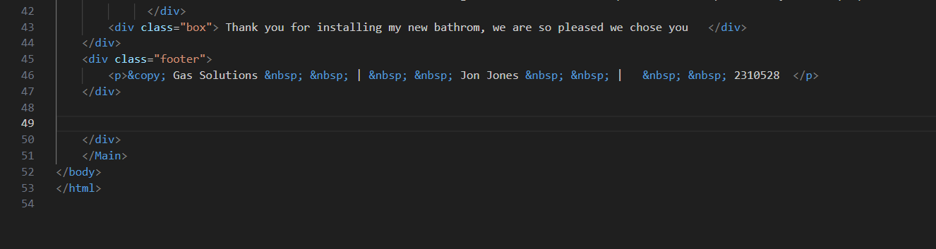
Portfolio HTML

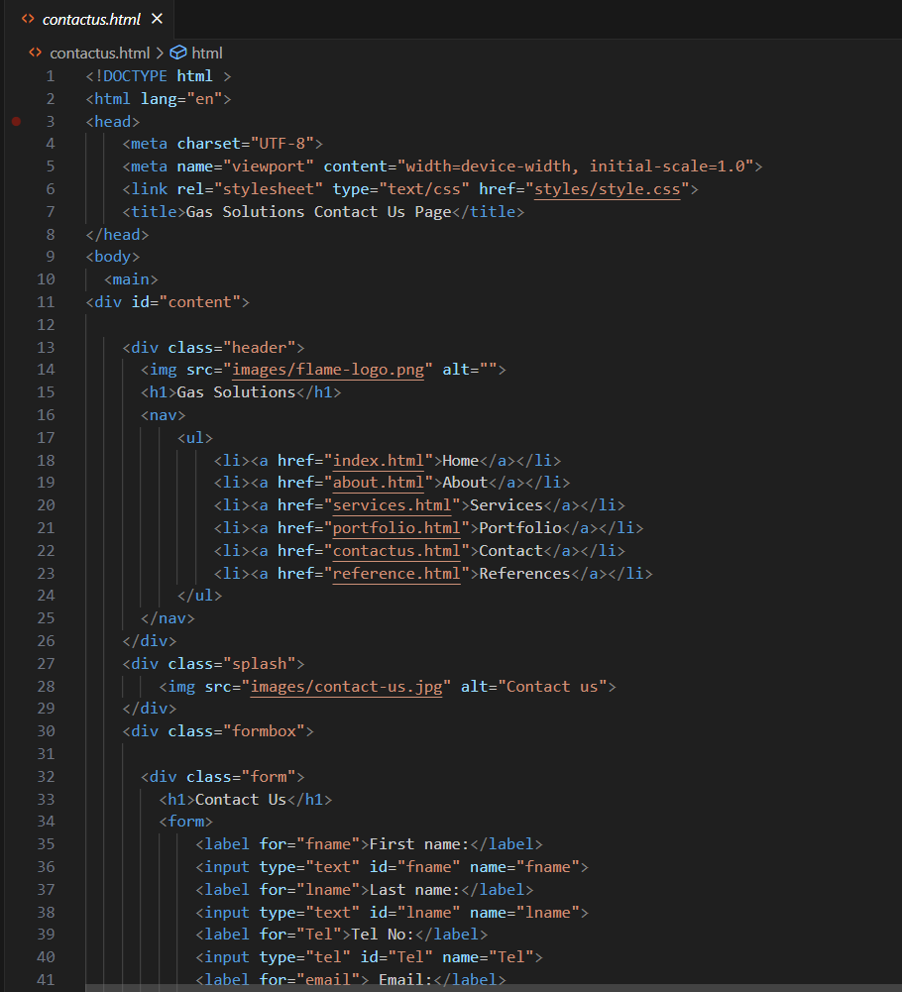
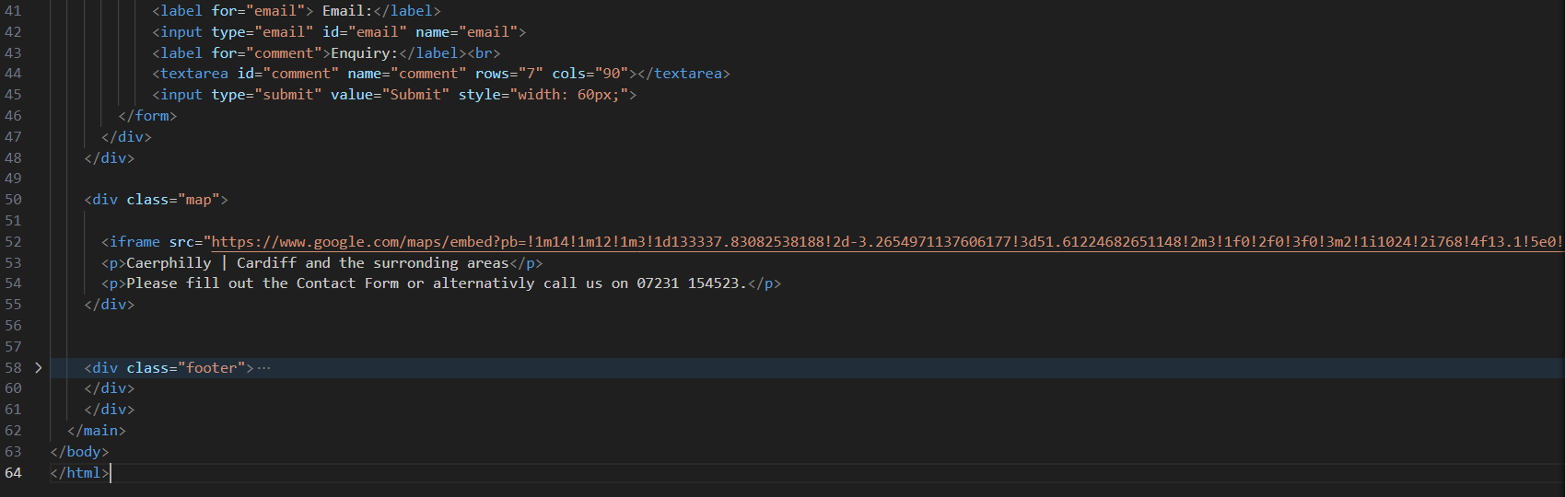
Contactus HTML

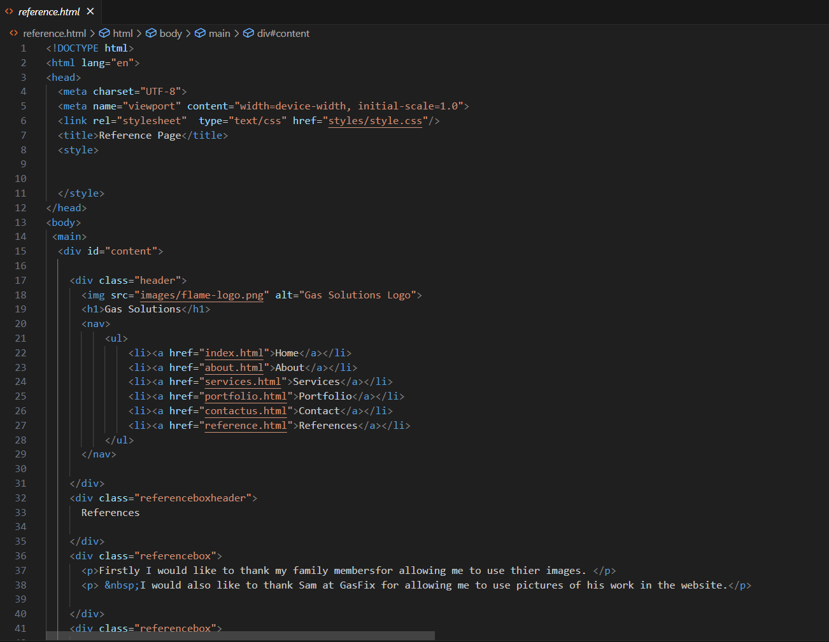
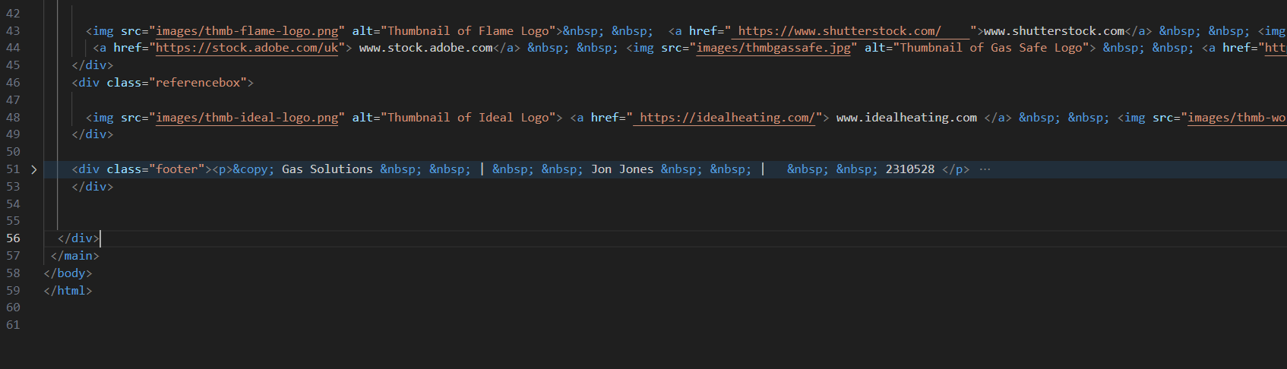
References HTML

