

Innovate Marketing Strategies in Toyota UK (Assignment 1)

Janeth Catherine Mosquera Restrepo
Student Number:1908748

Marketing Management
LCMB7001

Lecturer:
Tushara Balendran

09/01//2023

TABLE OF CONTENTS
INTRODUCTION 4
Toyota Background 5
Communication 5
Shannon and Weaver Model 5
Integrated Marketing Communication 6
New Toyota Yaris X Promotional Strategies 6
Online promotion Strategies 7
Offline promotion Strategies 8
Branding 9
Branding Equity 9
Keller’s Brand Equity Model 9
Brand Identity or brand Awareness 10
Brand Image 10
Brand Responses 11
Resonance or Brand Relationship 11
Toyota Brand Equity Model 11
Brand Identity or brand Awareness 11
Brand Image 12
Brand Responses 13
Resonance or Brand Relationship 13
Advantages And Disadvantages of the Keller’s Model 13
Customer Journey 14
Phases of Customer Journey. 14
Awareness 14
Consideration 14
Purchase 14
Service 15
Loyalty. 15
Customer Touchpoints 15
Toyota Customer Touchpoints 16
Customer Persona 16
Pre-purchase 16
Purchase 17
Post-purchase 17
Toyota Customer Journey Map 18
Strength And Weakness of Toyota Customer Journey Map. 18
Total Engagement Model 19
Recommendations 21
CONCLUSION 22
REFERENCES 23
APPENDICES 29
Brand awareness pictures 29
A 1. Toyota Instagram 29
A 2. Toyota Facebook 30

INTRODUCTION
To ensure that the firm thrives and remains sustainable in the current economic climate, it is more important than ever for enterprises to innovate continuously. Nevertheless, staying one step ahead of their rivals is challenging and calls for a targeted strategy. To create the best strategy, an organisation should focus their marketing strategy on customers and find out what they find unique in its products and services. Hooley (2020, p.46) states that differentiation is the unique motive a customer buys from you and no others.

Furthermore, strategies that work today might not work tomorrow due to consumers' behavioural changes; also, external, and internal factors affect a company. So, companies should focus on customer experiences through all interactions before, during and after a sale.

This report aims to increase brand awareness through new strategies for Toyota Yaris Cross and evaluate their customer journey through their IMC (integrated Marketing Channels).

This report is organised as follows: the first section will be about the company's background. Definition of communication, a diagram, and Shannon and weber model. Then a definition of IMC, Integrated Marketing Channels. Secondly, new promotional strategies. Thirdly, branding, branding equity definition and Keller's Brand Equity model. After that, customer journey, customer touchpoint definition, examples, and Toyota customer touch points. In addition, the Toyota customer journey map. The subsequent section will be about Total Engagement Model and recommendations to improve the customer experience. Finally, the conclusion of this report is about what this report suggests in the new strategies that Toyota should implement to have a competitive advantage.

Toyota Background

Toyota motor corporation is the parent company of Toyota motor manufacturing UK. Kichiro Toyoda founded the company in 1937 in Japan. From then to now, the company has grown its products and name. Toyota has over 50 manufacturing centres in multiple countries, such as Europe, Latin America, and Japan (Toyota Media, 2021). The company has a variety of products such as sports, commercial, hybrid and electric. The corolla was its most sales car in 2021 (Carlier, 2022), which left the company with a brand value of $54.11millons of dollars (Faria, 2022). This could be to their mission statement, that they will help build a future where all people have access to tools that enhance their movement within the society. They plan to use the latest technology to create products that help people without destroying the environment (Toyota, 2019).

Communication
Many theories try to give meaning to this term. According to Fuhse (2021), communication is a series of events that a person does to explain things. In addition, Griffins, and Dunham (2017, p. 47) state that “communication is the exchange of thoughts, information, or ideas that results in mutual understanding between tow or more people”. Another meaning from the Cambridge dictionary is the exchange of information with the help of emotions. In other words, communication is a process where ideas, feelings and information are exchanged to create innovative ideas, feelings, and knowledge.

Shannon and Weaver Model

Created by Claude Shannon, a Mathematician while working at Bell Laboratories and Warren Weaver, an engineer, called at the beginning Mathematical theory of communication (Weaver, 2017). This model states that they need to present specific elements to communicate effectively.

The following elements should be present: sender, receiver, channel, noise, encoder, and decoder. According to the model, the information is sent from the sender (person sending the message) to the receiver (person receiving the message). Information is made into a sign(encoder) that the sender thinks the receiver understands(decoder). All those messages were sent through different channels (mobile phones, letters, TV, Radio, computers, face-to-face) to avoid noise or barriers (physical problems of the channels, lack of concentration from the sender or receiver, oral problems language barriers); however, that is not always possible.

Only some things in life are perfect, and avoiding problems usually are not accessible. Marketing communication presents many obstacles, as previously mentioned; however, it is essential to know this to simplify and know the receiver to create the desired outcome.
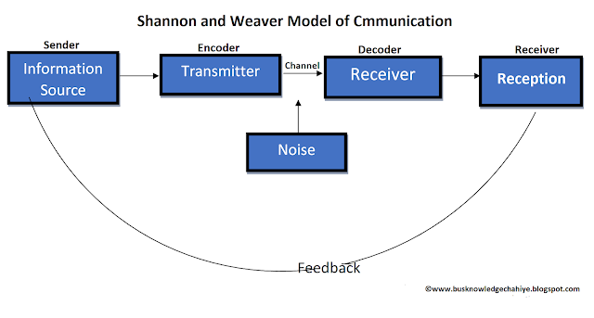
Source: https://jmcstudyhub.com/wp-content/uploads/2019/05/Shannon-and-Weaver-Model-of-Communication.png
Figure 1 Shannon and Weber Model of Communication.

Integrated Marketing Communication
The world is changing daily, and new frameworks are rising to interact with customers. Integrated Marketing communication is a framework that focuses on the communication between customers (new and existing) and companies. Also, the message must be coherent and appropriate to the audience receiving the message through a series of channels(Payne et al., 2017). Different channels can be used according to the marketing campaign's objective, such as online and offline tv ads, social platforms ads, blog posts, websites, packaging, events, email marketing, sponsorships, sales promotions, and public relations (Decker, 2022).

New Toyota Yaris X Promotional Strategies

Toyota has many new models in distinct categories. However, the Toyota Yaris X has been selected because it is a hybrid car with a modern design and features that reduce emissions into the air and the distance that operates with a battery instead of petrol. Brand awareness is indispensable for a company because they communicate to the consumers their products and quality. In addition, it helps to create a story that can relate to customers in a particular part of their lives.

Online promotion Strategies

- It is a new car with excellent hybrid features, so they should be referring to it on their website. It helps in the reduction of petrol consumption.
- The website should be interactive and show inside the car to give a real presence. This could be done with the use of VR to enhance the experience of the car.
- The advertisement should be more human, including people, not only the car and its capabilities, as shown in this dealer's YouTube channel. https://youtu.be/RhFv36Qq2A8
- The Instagram of jemca, one of the dealers, should be more interactive and use a message to engage the audience could be existing users or future users. There must include the factor “I want that car,” or when I need a car, I want that”

- 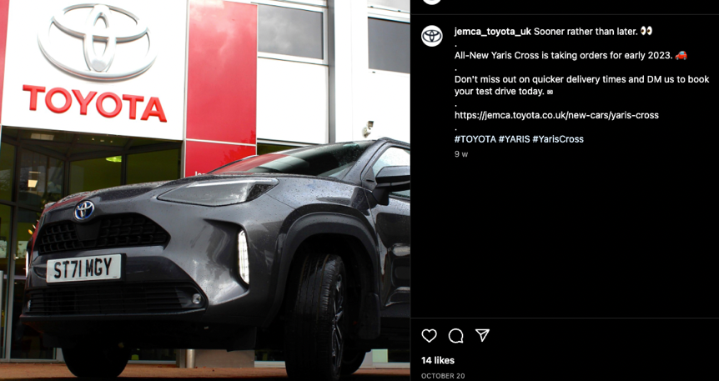
Source: Jemca Toyota UK Instagram
Figure 2 Toyota Instagram.

- Create a campaign with ads where the theme will pass from petrol to hybrid and then to electric. Showing the past, present, and future of cars and their benefits.
- Retargeting existing clients through email marketing promoting the new Yaris given a “try-out” to motivate customers to acquire the model next lease or recommend it to friends and family.
- Creation of community between different customers. A community to be proud and promote the car in their communities.
- Creation of clubs where the latest news in technology about electric car efficiency will be discus.
- The Ads should include more people happy and doing regular things. It should be as well segmented to younger generations, old generations, and women because the car is small and economy to ride.
- They indeed have Facebook (FB), Instagram (IG), Twitter, and YouTube, but for younger generations, TikTok is necessary to engage and create awareness of the recent technology and car. In TikTok, there are some videos of customers showing the cars, but it could be a clever idea if the dealers do it alone and at other times with the customers. They are supposed to feel trusty and authentic to the customers.
- In the newsletter should be a reminder of the services that the customers have and the ones he is not using.

Offline promotion Strategies

- Events where the community support or sponsor cause to benefit the environment or the community.
- Pamphlets show the efficiency of hybrid cars and how the buyer can benefit from having one as the new Yaris Cross Hybrid.
- Promote the car-to-car shows as "car girl culture", where their events are for anyone interested in everything related to cars. The club is directed to the female market to promote and motivate females to learn, meet people and have experiences with other car models.
- In those events, Toyota should give a discount by a certain time to the first people that answer a question. One example of a question: why is it called Toyota?
- Dealers should invite the neighbourhood people through flyers when a new car comes in.
- Flyers should have a QR code to confirm with the dealers how many people will be on a specific day.
- Dealers should promote the car on memorable days such as valentine, Christmas, and other important dates. Dealers do it now, but only online, so they should do it in the dealer shop.
- Invitations to participate in a day context to try out the car. This invitation could be to the neighbourhood of the dealer's shop or exiting customers.
- On the days of events in the community could be any small gift such as a cap, mug, pen with the logo of Toyota or a post of various models or the transition of the first car in the model to the most recent.
- Other gifts could be tailor-made as a shirt if you are a new customer.
- To acquire the new Toyota Yaris Cross Hybrid voucher in supermarkets to get inside the car. Because of insurance policies, the car should be driven only by dealers' personnel. However, it should be 30 minutes explaining the features and benefits of having a hybrid car as the Toyota Yaris cross. Sales promotion should be included in the previous campaigns.
- Have a machine as a drink dispenser, that gives try-out in a specific car to people who do an activity as jumping or dancing or karaoke.

Branding

Brands are perceived as a combination of existing assets that function as a symbol or name, creating a difference between one company onto another (Bailey and Milligan, 2022, p, 1). Also, a brand tells the consumer that a product or service always will have the same properties and advantages ( Kotler et al., 2019, p, 241). Consequently, branding is a process that transmits a story to consumers through colour, logos, and packaging that makes an id in the consumer's mind (Malinic, 2019, p, 18). Thus, a successful brand helps companies to be different and unique in the market and increase their value and profitability.

Branding Equity

Brand equity is the value that the brand has gained in the consumer through the branding of products and services (Bari and Shahzadi, 2022). Thus, the adding value of a brand is how people recognise a product or service through its physical features (label, colour, tagline, package) but also involves the feeling it emits as trust, high or lower quality, luxury or standard. Furthermore, brand equity is how a company create awareness of their products and services and its loyalty through the features and associations of the brand (Veselinova and Samonikov, 2018). For example, Apple has excellent brand equity because their customers are loyal; they make long queues to buy a new product released into the market and pay soaring prices for their products. This show that brand equity in a company creates a relationship between customers and brands and depends on the brand construction and how new and existing customers perceive it.

Keller’s Brand Equity Model

The model is also known as the customer-based brand equity (CBBE). According to Keller (2013, p, 69), the knowledge a consumer has over a brand it is what makes them created different preferences. In other words, with the model, a company can create a point of difference that makes it unique in the market. The model aims to create a relationship between the consumer and the brand (Sanz-Marcos et al., 2021). Also, Sanz-Marcos et al. state that the positive and robust response to the brand influences the feelings and ideas of consumers' actions toward the brand and creates loyalty.

The model consists of four levels as salience (brand awareness), brand meaning (performance and imagen), brand responses (judgments and feelings) and finally resonance (brand relationship).

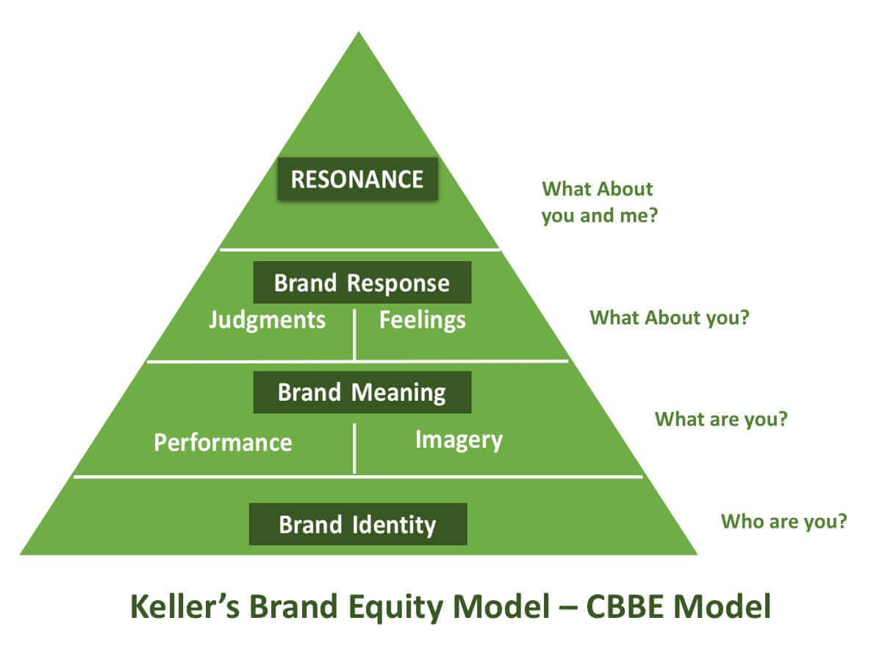
Source: https://www.qualtrics.com/experience-management/brand/keller-vs-aaker/
Figure 3 Keller’s Brand equity Model.

Brand Identity or brand Awareness

The first level in the model; and refers to the grade of knowledge a consumer has over a brand when considering buying (Koech et al., 2022). Also, the recalling of the brand in any contest (Keller, 2013, p, 75). The company must create a plan to expose the brand to the consumers using IMC and be different in a crowded, competitive market.

Brand Image

The second level of the model is divided into performance and imagery. The objective of this level is to create differentiation through the benefits, features, service, price, and images (Keller, 2013, p.75). in other words, what the brand wants to be known must be represented in its logos, tag line, colours, benefits, and features (Huang, 2022).

Brand Responses

The third level of the model consists of judgment and feelings. Brand judgments are the opinions of the consumers of the brand. These opinions could be positive or negative according to the experience with their products. In addition, Brand feelings are what emotions the brand can transmit to consumers (Keller, 2013, p,118). Thus, the opinion and feelings must be positive to increase loyalty and profits.

Resonance or Brand Relationship

The last level of the pyramid. It is the rational psychological connection that customers have over a brand (Keller, 2013, p, 120). As in every relationship, there must be characteristics that attract consumers and brands to obtain the benefits of creating loyalty and advocacy to influence others. However, brands need to work not only in the previous levels but create constant feelings of trust and love besides loyalty to add value to the brand (Robertson et al., 2022) through their customers' services.

Toyota Brand Equity Model

The following is the adaption of the Keller’s Brand Equity Model into Toyota Corporation.

Brand Identity or brand Awareness

Toyota brings to the market a variety of models in assorted sizes, colours, and prices. As stated, electric, hybrids, sports, SUVs, vans, and pickups (Toyota UK Magazine, 2022). The brand equity of Toyota corporation is the second globally (Statista, 2022) after Tesla. That means that their sales rose because of their brand campaigns. They use social media such as Facebook (FB) locally and in other countries, Instagram, and YouTube channel to present their new models and to show the car inside. High recognition in FB USA with more than four million likes, in FB UK with more than 400k like and FB global with more than 21 million likes (see appendix A 1). Instagram UK 134k, Colombia 125k, Tanzania 24k and USA more than 2 million (see appendix A 2).

Brand Image

There are two components that make the overall brand image.

Performance

The latest car comes with a safety system with a sensor that alerts the driver when something is not working or doing something dangerous on the road. As sounds tell the driver it is passing the line or if there is an obstacle in front or the back of the car. Toyota aims to reduce carbon print in its plants and the use of cars. They are experts in Hybrids (cars that run on petrol and auto rechargeable batteries). They also collaborate with programs that use solar panels in their plants. (Toyota Global, 2022). Their customer service is one of the best, according to the author and a couple of their friends. This can be seen in their website responses to comments, where they are professional and prompt to answer. In the time stamp, they took 9 hours to answer but according to the hour of the comment is predictable that the shop was closed. However, after opening, the comment was answered, see figure 4.
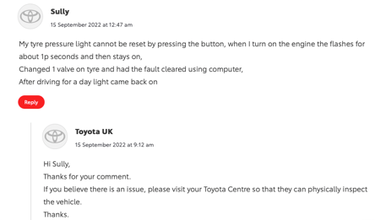
Source: https://mag.toyota.co.uk/how-does-tpms-work/
Figure 4 Toyota magazine comments.

Imagen

Toyota has a logo and tag lines for their brands. For example, their electric car and “bz” beyond zero. Also, Toyota, in general, “let us go places”(Toyota, 2022). As mentioned previously, has many models in varied sizes and colours.

Brand Responses

Toyota cars are considered with value with the technology they offer. See figure 5. The electric car starts at £43000, and the cheapest tesla with £47000. Hybrid cars have been positioned as accessible to buy, with sales of 2.5 million in 2021(Carlier, 2022).
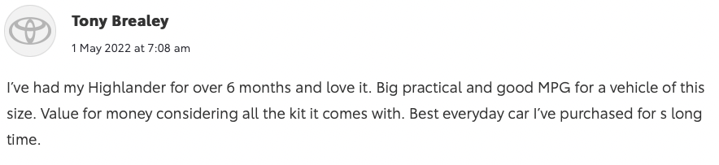
Source:https://mag.toyota.co.uk/yorkshire-vet-on-toyota-highlander-and-climate-change/
Figure 5 Toyota Magazine UK customer comments.

Resonance or Brand Relationship

Where most companies want to be, to go up from the bottom of the pyramid to the top, where loyalty to the brand should incur sales or being advocates with friends and families. In the following comment (see figure 6 below) on FB Toyota UK, a person tried a car and was happy with it but could not afford to buy one now. Moreover, another person congratulates Toyota for the models in the other comment. All of these demonstrate that people are aware of the brand, they have feelings toward their models, and now they are creating a relationship and being engaged in their social media.

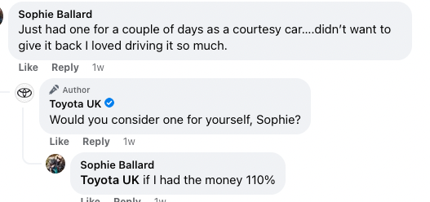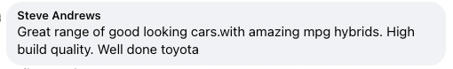
Source: Toyota Facebook UK, December 19, 2022. https://www.facebook.com/toyotauk
Figure 6 Facebook comments

Advantages And Disadvantages of the Keller’s Model

The model focuses on planning a relationship between the customer and the brand. This outcome is high brand equity in the market, making it competitive and profitable. Also, the model-specific goes in each level to work and facility the task to marketers building a solid brand.

However, it can be observed that the model is very centric on the customers, but that does not equal loyalty or buying of the product (Robertson et al., 2022). Also, the feelings and judgments are out of the control of the brand, and a bad one can damage the brand.

Customer Journey

Companies always try to sell products or services to consumers through marketing, which has become tiresome and invasive these days. So, brands are trying to get more personalised and give solutions to the specific pain point that future customers have through IMC campaigns. In addition, to obtain the customer's attention, companies need to know the customers and their interactions with the brand. So, the customer journey or buyer journey is a series of actions that customers make when interacting with a brand to achieve a particular goal (Hooley et al., 2019, p. 313). In other words, the customer journey helps companies get better services and listen to their customers feedback in the journey (Yachin, 2018).

Phases of Customer Journey.

There are many names to each stage, but the objective is the same.

Awareness

This is the stage where the brand is trying to be recalled and recognised by the consumer, and this could be through advertisements on different channels such as TV, newspapers, google and social ad (Hooley et al., 2019, p. 313). Also, a friend’s recommendations.

Consideration

The consumer asks friends and family about the brand and its products. In this stage, the consumer is looking for the solutions that a brand can give him. the search starts with a website that reviews the performance, quality and benefits of the products or services (CIM, 2022). Also, go to social media platforms to see the customers' satisfaction with the brand and the product.

Purchase

In this stage, the consumer is secure that the brand can give the benefits he is looking for and make the purchase through a web site, store, or app (Hooley et al., 2019, p. 313).

Service

In this stage, the consumer receives the product or service, converting it into a new brand customer. Customers expect support if they have queries or problems with the product or service, so excellent after-sales are primordial in this stage (CIM, 2022).

Loyalty.

In this last stage, the customer has made an opinion about the brand, the product or services and is ready to share it with the world. The opinion could be positive or negative depending on the brand's support and if the product fulfils the expectations (Hooley et al., 2019, p. 313).

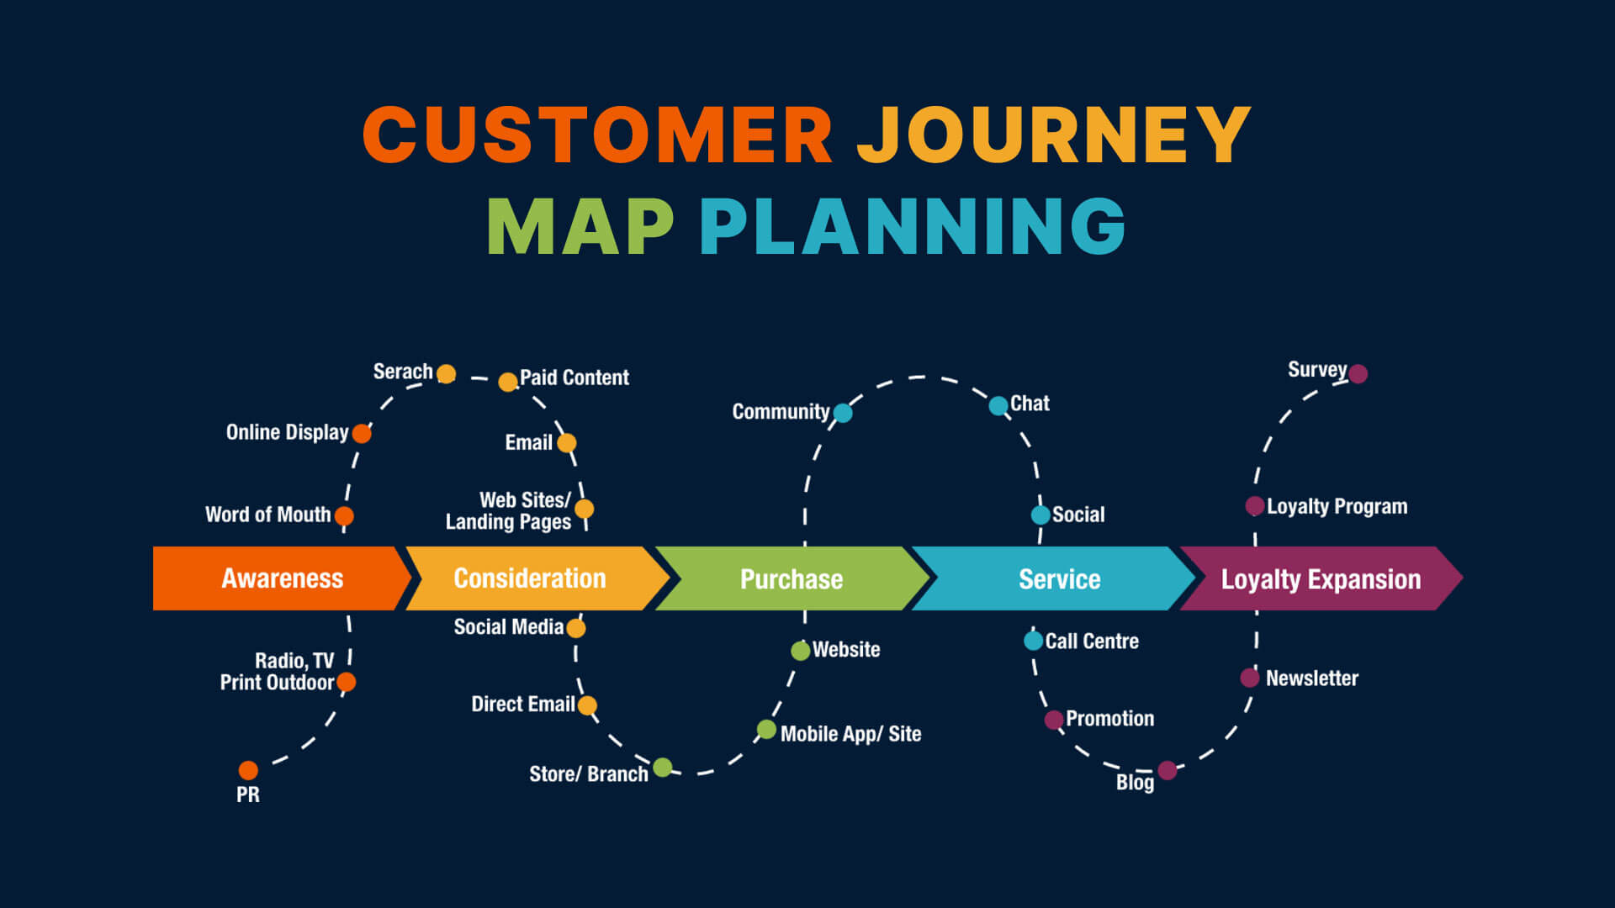
Source: https://www.sitecentre.com.au/blog/customer-journey-mapping
Figure 7 Customer Journey

Customer Touchpoints

Most brands nowadays want touchpoints accessible to consumers and customers to create a pleasant and straightforward experience while interacting. So, customer touchpoints are the point of contact that a customer has with the brand and can classify them according to the objectives during the customer journey as pre-purchase, purchase, and post-purchase. (Cambra-Fierro et al, 2021).Also, touchpoints could have long and short effects on customer appreciation of the brand. Furthermore, touchpoints should be reviewed because the data on consumers and customers is changing due to latest trends or social behaviours (Santos and Goncalves, 2022).

Toyota Customer Touchpoints

Before creating a customer map with a touchpoint is vital to know who the future customer is. Hence, creating a persona is ideal for being realistic with demographic and psychographic data (Vaughan, 2022). So, a customer persona will be created for the following representation of Touchpoint.

Customer Persona

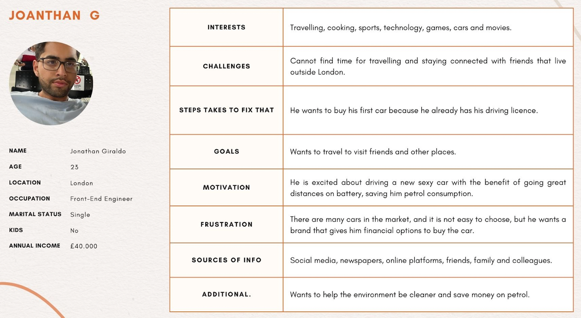
Source: created by the author.
Figure 8 customer persona

Pre-purchase

Jonathan is a young man that likes technology, cars, and the environment. He is interested in a small car with cost-saving fuel. He saw the Toyota Yaris cross on YouTube (1touchpoint). Then he starts looking for reviews of the car on YouTube (2 touchpoints) and then on TikTok (3 touchpoints). However, one of his friends has a BMW 3 and is comparing the Toyota Yaris cross hybrid and the BMW 3. After examining the monthly price and the miles driven by battery (4 touchpoints other website reviewing cars), he decides that the Toyota Yaris Cross is the best option for him see figure 8 below. So, he goes to the website (5 touchpoints) and starts looking at the design, colours, and other benefits of the car. On the website, he found the nearest dealer, and he decided to call them to book an appointment for a show of the car (6 touchpoints).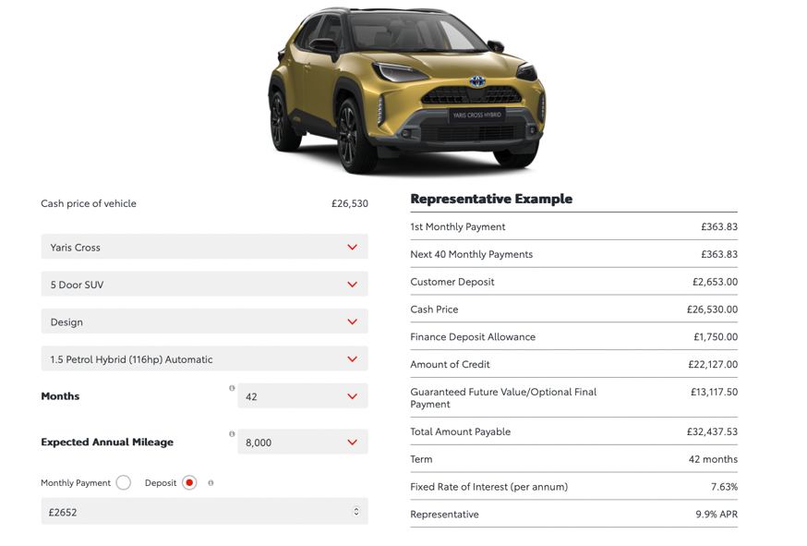
Source: https://forms.toyota.co.uk/quick-finance-quote-dealer?dealerID=06873
Figure 9. Toyota Yaris calculation.

Purchase

On the day of the appointment, he meets with Alex, the sales assistant at the Toyota dealer (7 touchpoints). She showed the colours and explained all the car's benefits, invited him to get inside the car and feel comfortable in it (7 touchpoints). After, she took him to give a driving test around the shop (8 touchpoints). When they return, she asks him about any doubts and answers them professionally (8 touchpoints). Jonathan decides to buy the car and apply for Toyota's financial services (9 touchpoints). So, he leaves and returns after receiving a call from Toyota telling him that his finance has been approved (10 touchpoints). He returns to the dealer to sign the paper, buy extras as SMART insurance (an insurance that covers in case of the car be writing-off), and change colour (11 touchpoints). After a few weeks, he receives a call informing him of its pickup day (12 touchpoints). On the day of pickup comes, everything is ready the late recommendations, and Alex was again amiable and ready to answer his doubts (13 touchpoints).

Post-purchase

He receives an email with the car's paper and reminds him of points of contact if he needs anything (14 touchpoints). After months of being with the car, he receives a call reminding him that the 8000 miles are to book an appointment for the services (15 touchpoints). On the day of the appointment, they picked up the car from his house (16 touchpoints), and at the end of the day, they brought it back (17 touchpoints). He receives every six months an email about new car promotions (18 touchpoints). After many months with the car, Jonathan finds that it saves him money in petrol because he compared it with his friend who has the BMW3. So, he started posting videos of his car on TikTok being an advocate of the brand (19touchpoint).

Toyota Customer Journey Map

The customer journey helps Toyota to find any challenges in each touchpoint. Toyota wants to give the customer a magnificent experience to their touchpoints.

 | Awareness | Consideration | Purchase | Service | Loyalty
Social Platform – YouTube | 1.New Customer looking for Toyota Yaris Cross.
Other Websites/ Web forums |  | 2.Looking for customer reviews.
Website |  | 3.Looking for Official Information.
Call from the customer |  | 4.The Customer book an appointment
Store |  |  | 5.Speaks with salesperson.
Driving Test |  |  | 6. Drive the car.
Financial Assistance |  |  | 7. Fill the application for the loan.
The product |  |  | 9.Receive the car.
Email Marketing |  |  |  | 10.Receive car papers.
Call from the dealers |  |  | 8.Finnance has been approved | 11.Booking service
Word of mouth or video sharing |  |  |  |  | 12.Happy with the car, share the car with others through TikTok.
Source the author
Figure 10 Toyota Customer Journey

Strength And Weakness of Toyota Customer Journey Map.

Building a customer journey map is difficult because only some consumers behave similarly and have similar needs. So, in this customer journey, the stages of awareness, consideration and purchase worked well for the customer. It has touchpoints that give confidence and trust to the consumer; in addition to giving the solutions that the customer is looking for, touchpoint 11, where the dealer calls to book an appointment to make the car's service, is an excellent service. This show that the brand care for the customer and its product. Digital interactions are here to stay and must be integrated into a customer journey to make the experience satisfactory for the customers, which also helps to care for other aspects of the customer journey as creating loyalty (Berg et al., 2022). Thus, using AI to determine how a customer journey could be personalised is a factor that could help companies to be competitive and profitable (Benjamin et al., 2019). In conclusion, even though the journey was not personalised, the touchpoints were relevant to the consumer, and the customer service helped to create a satisfactory experience.

However, in touchpoint 7, fill out the application for a finance loan; the process should be instant, not two weeks. Also, the website application gives an error, so you can only do it after going to the dealer. In addition, the post-purchase touchpoints are fewer, and the customer needs more communication and engagement with the brand. Creating an overall customer journey is the work of many departments. It should be not only one customer journey but varies with different customer personas, challenges, and solutions (Lotz et al., 2018). Lastly, weak touchpoints affect the customer's perception of the brand, resulting in a negative opinion. Furthermore, post-sales touchpoints should have customer support to create a positive attitude towards the product and the brand.

Total Engagement Model

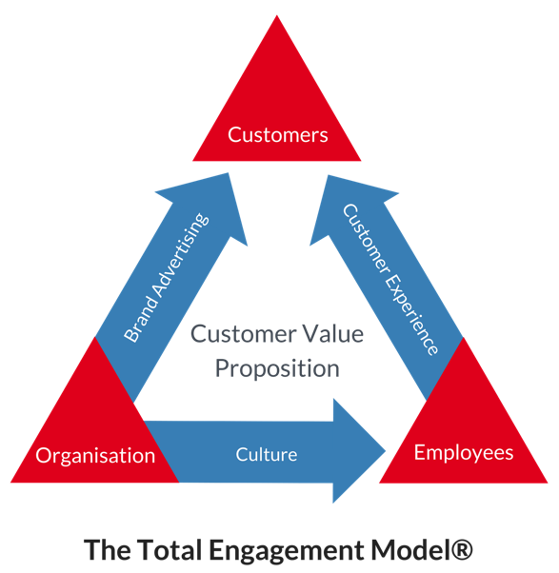
Source: https://www.engagedstrategy.com.au/home/total-engagement-model-round/
Figure 11 The Total Engagement Model

The customer engagement model outlines the progressive transformation of the value exchange among companies and their consumers (Roberts and Alpert 2010). Customers are the ones who have the power to make a company successful according to the value they receive from them. Also, four elements must be present to create customer engagement: internal culture, customer value proposition, brand, and customer experience.
Companies must clearly understand what they want from their customers and their needs. After that, they can create a culture where the employees have the knowledge and the proper behaviour to collaborate in customer acquisition and retention. When companies know what the customers need and want, they can create value for them by giving them solutions to their pain points. That way, they will choose the brand over other companies with the same products but different value propositions. If the brand is well known, customers want to try and see if there are unique, so the brand must be consistent with the logos, colours, values, vision, and mission statements showing what makes them unique and valuable. Lastly, the customer experience will help the customers identify the right product or service for their specific needs. Different emotions appear in the touchpoints through the customer journey, so, effectively, companies plan not only touchpoints from the physical part but from the customer side and their emotions.

In conclusion, providing experiences that the client values and focuses on their interests, desires, and aspirations contribute to engaging the customers and makes them loyal to recurring customers.

To illustrate this model, in Toyota the value proposition is to help people move through innovation and sustainability towards the planet (Toyota, 2022). This is demonstrated in the car's production, trying to save money, using low-cost materials and being efficient with the environment by creating electric and hybrid models. Furthermore, that value is translated by their employees' culture into the customer experience and reflected in the brand. Going to a dealer, their employees are friendly, knowledgeable, reliable, with excellent communication and willing to dissipate any doubts of the customer. In addition, Toyota has built a brand through their technology, reducing prices to be accessed by all and their customer services. Moreover, it put this in its advertisement to create a recognised brand. However, customer engagement is not equal in all customer journeys. In this phase, Toyota should put more effort into creating more touchpoints using IMC to keep the customers positive.

Recommendations

After the finding in this report about the customer journey, customer engagement and brand equity in Toyota corporation, some things can be improved to give customers and the brand more value.
As highlighted previously, the engagement after sales is reduced or zero just for specific points in buying the product. In this case, it is recommended that using IMC and its diverse channels (tv, sponsorships, email marketing, social platforms), to inform the customers about a new product, promotions and modern technologies that would benefit them. Also is indispensable that the customer has a voice where he can give his opinion about the car they have bought. Including feedback after sales is essential, but small questionaries with small gifts at the end of the month could incentivise and motivate the customer to look for this content. However, all of this should be measured and registered to analyse what works and needs improvement. Not all can be done simultaneously because it will create employee confusion. The use and frequency of email marketing for information, events and promotions should be a starting point.

.

CONCLUSION
This report focused on branding, and its value, its communication through different integrated channels (IMC). Also, the importance of customer interactions with a brand was discussed as to why the customer journey with its touchpoint and engagement benefits customers and companies. The conclusion of those findings is to reassure that customers are at the centre of any brand strategy to create and sell a product or service. Strategy without customer data (needs, wants, challenges) are not efficient in providing the service that will differentiate a brand from others. Customers have positive opinions if the brand has met their expectations and if they are trying to help them instead of only being a transaction. Brands should be aware of using everything that is a hand as AI to develop plans that could automatise simple and repetitive tasks and focus on resolving issues in the time they occurred. Thus, this will show customer empathy and could be perceived as a value and transform in loyalty or advocacy.

REFERENCES

Bailey, S. and Milligan, A. (2022) Myths of Branding: Dispel the misconceptions and become and a brand expert. 2nd edition. London: Kogan Page Limited.

Bari, M. W. and Shahzadi, I. (2022) ‘Employee-Based Brand Equity and Factors of Employee-Brand Association in Antecedents and Outcomes of Employee-Based Brand Equity’, IGI Global, pp, 1-15. Available at: https://doi-org.ezproxy.uwtsd.ac.uk/10.4018/978-1-6684-3621-9.ch001 (Accessed: 24 December 2022).

Benjamin, G. et al. (2019) How advance analytics can help contact canters put the customer first. Available at: https://www.mckinsey.com/capabilities/operations/our-insights/how-advanced-analytics-can-help-contact-centers-put-the-customer-first (Accessed: 27 December 2022).

Berg, J. et al. (2022) The state of customer care in 2022. Available at: https://www.mckinsey.com/capabilities/operations/our-insights/the-state-of-customer-care-in-2022 (Accessed: 27 December 2022).

Cambra-Fierro, J., Polo-Redondo, Y. and Trifu, A. (2021) ‘Short -term and long-term effect of touchpoints on customer perceptions’, Journal of Retailing and Consumer Services, 61. Available at: https://www-sciencedirect-com.ezproxy.uwtsd.ac.uk/science/article/pii/S0969698921000862 (Accessed: 26 December 2022)

Carlier, M. (2022) Best-selling car worldwide in 2021. Available at: https://www.statista.com/statistics/239229/most-sold-car-models-worldwide/ (Accessed: 10 December 2022).
Carlier, M. (2022) Toyota’s alternative fuel vehicle sales in 2021, by segment. Available at: https://www.statista.com/statistics/1181404/alternative-sales-of-toyota-by-segment/ (Accessed: 24 December 2022).

CIM (2022) Five Stages of Your Customers’ Buying Journey. Available at: https://www.cim.co.uk/content-hub/blog/five-stages-of-your-customers-buying-journey/ (Accessed: 26 December 2022).
Customer Journey [Figure 7] Available at: https://www.sitecentre.com.au/blog/customer-journey-mapping (Accessed: 28 December 2022)

Decker, A. (2022) The plain English guide to integrated marketing communications. Available at: https://blog.hubspot.com/marketing/integrated-marketing (Accessed: 22 December 2022).

Faria, J. (2022) Leading brands worldwide in 2021, by brand value. Available at: https://www.statista.com/statistics/264826/most-valuable-brands-worldwide-in-2009/ (accessed: 10 December 2022).
Fuhse. J., (2021) ‘Networks from communication’, in J. Fuhse (ed). Social Networks of Meaning and communication. New York: Oxford Academic. Available at: https://doi.org/10.1093/oso/9780190275433.003.0008 (Accessed: 24 December 2022)

Griffiths, B. A. and Dunham, E. B. (2017) ‘Communication’ in A. Maund, et al. (ed). Certificate in higher Education: Skills for the Workplace Student Yearbook. London: Sage.

Hooley, G. J. et al. (2020) Marketing Strategy and Competitive Positioning. 7th edition. Harlow: Pearson Education. Available at: https://r4.vlereader.com/Reader?ean=9781292276571# (Accessed: 26 December 2022).

Huang, Y. C. (2022) ‘How marketing strategy, perceived value, and brand image influence WOM outcomes-The sharing economy perspective’, Journal of Retailing and Consumer Services, 68. Available at: https://www-sciencedirect-com.ezproxy.uwtsd.ac.uk/science/article/pii/S0969698922001643 (Accessed:24 December 2022)

Jemca (2022) Dealer Homepage. Available at: https://jemcabromley.toyota.co.uk/business (Accessed: 10 December 2022).
Keller’s Brand equity Model [Figure 3] Available at: https://www.qualtrics.com/experience-management/brand/keller-vs-aaker/ (Accessed: 15 December 2022)

Keller, K. L. (2013) Strategic Brand Management: Building, Measuring and Managing Brand Equity. 4th edn. Harlow: Pearson Education Limited. Available at: https://archive.or/details/keller-strategic-brand-management/page/3/mode/2up (Accessed: 24 December 2022)

Koech, A. K., Buyle, S. and Macario, R. (2023) ‘Airline brand awareness and perceived quality effect on the attitudes toward frequent, flyer programs and airline brand choice, Moderating effect of frequent flyer programs’, Journal of Air Transport Management,107. Available at: https://www-sciencedirect-com.ezproxy.uwtsd.ac.uk/science/article/pii/S0969699722001612 (Accessed: 24 December 2022).

Kotler, et al. (2019) Principles of Marketing.8th edn. Harlow: Pearson Education Limited. Available at: ProQuest Ebook Central, https://ebookcentral.proquest.com/lib/trinity/detail.action?docID=5978379. (Accessed: 24 December 2022)

Lotz, S., Raabe, J. and Roggenhofer, S. (2018) The role of customer care in a customer experience transformation. Available at: https://www.mckinsey.com/capabilities/operations/our-insights/the-role-of-customer-care-in-a-customer-experience-transformation (Accessed: 27 December 2022).

Malinic, R., (2019) Book of Branding – a guide to creating brand identity for start-ups and beyond. London: Brand Nu Ltd.

Payne, E. M., Peltier, J. W. and Barger, V. A., (2017) ‘Omni-channel marketing, integrated marketing communications and consumer engagement: An international Journal’, Journal of Research in Interactive Marketing, 11 (2), pp. 185-197. Available at: DOI:10.1108/JRIM-08-2016-0091 (accessed: 22 December 2022).

Roberts, C. and Alpert, F. (2010) ‘Total customer engagement: designing and aligning key strategic to achieve growth’, The journal of Product and Brand Management, 19(3), pp. 198-209. Available at: https://www.proquest.com/docview/367186811?accountid=130472 (Accessed: 27 December 2022).

Robertson et al. (2022) ‘How deep is your love? The brand love-loyalty matrix in consumer-brand relationships,’ Journal of Business Research, 149, pp. 651-662 Available at: https://www-sciencedirect-com.ezproxy.uwtsd.ac.uk/science/article/pii/S014829632200491X (Accessed: 24 December 2022).

Santos, S and Goncalves H. M. (2022) ‘Consumer decision journey: Mapping with real time longitudinal online and offline touchpoint data’, European Management Journal. Available at: https://www-sciencedirect-com.ezproxy.uwtsd.ac.uk/science/article/pii/S026323732200127X (Accessed: 26 December 2022)
Sanz-Marcos, P., Jiménez, M. and Zambrano, R. E. (2021) ‘Application and use of the Customer-Bases Brand Equity (CBBE) model. Study of brand loyalty through the figure of the influencer,’ Methods, Revista de Ciencia Sociales, 9(2) pp. 200-218. Available at: http://dx.doi.org/10.17502/mrcs.v9i2.471 (Accessed:24 December 2022).
Shannon and Weber Model
of Communication [Figure 1] Available at: : https://jmcstudyhub.com/wp-content/uploads/2019/05/Shannon-and-Weaver-Model-of-Communication.png (Accessed: 10 December 2022).

Statista, (2022) Most valuable automotive brands worldwide by brand 2022. Available at: https://www.statista.com/statistics/267830/brand-values-of-the-top-10-most-valuable-car-brands/ (Accessed: 26 December 2022)

The Total Engagement Model [Figure 11] Available at: https://www.engagedstrategy.com.au/home/total-engagement-model-round/ (Accessed: 28 December 2022)
Toyota (2022) Tagline. Available at: https://www.toyota.com/brandguidelines/tagline (Accessed: 24 December 2022).
Toyota (2019) Toyota global vision. Available at: https://global.toyota/en/company/vision-and-philosophy/global-vision/?_ga=2.38803046.491424679.1672065774-317155469.1672065774 (Accessed: 10 December 2022).

Toyota (2022) Toyota Philosophy. Available at: https://global.toyota/en/company/vision-and-philosophy/philosophy/?padid=ag478_from_right_side (Accessed: 10 December 2022)

Toyota Facebook UK, comments [Figure 6]. December 19, 2022. Available at https://www.facebook.com/toyotauk (Accessed: 28 December 2022)

Toyota Global, (2022) Sustainability. Available at: https://global.toyota/en/sustainability/?padid=ag478_from_header (Accessed: 24 December 2022).

Toyota Instagram [Figure 2] Available at: https://www.instagram.com/p/Cj8GBG6jj0e/
(Accessed: 10 December 2022).

Toyota Magazine Comments. [Figure 4] Available at: https://mag.toyota.co.uk/how-does-tpms-work/ (Accessed: 24 December 2022)

Toyota Magazine UK (2022) Cars and More. Available at: https://mag.toyota.co.uk (Accessed:24 December 2022)

Toyota Magazine UK customer comments [Figure 5] Available at:https://mag.toyota.co.uk/yorkshire-vet-on-toyota-highlander-and-climate-change/ (Accessed: 15 December 2022)

Toyota Media (2021) Company Background. Available at: https://media.toyota.co.uk/wp-content/uploads/sites/5/pdf/1618251066ToyotaCompanyBackgroundv2.pdf (Accessed:10 December 2022).

Toyota Yaris calculation [Figure 9] Available at: https://forms.toyota.co.uk/quick-finance-quote-dealer?dealerID=06873 (Accessed: 28 December 2022)

Vaughan, P. (2022) How to Create Detailed Buyer Personas for Your Business [Free Persona Template]. Available at: https://blog.hubspot.com/marketing/buyer-persona-research (Accessed: 26 December 2022)

Veselinova, E. and Samonikov, M. G. (2018) ‘Defining the concept of Brand equity with radical transparency in Building Brand equity and consumer trust through radical transparency practices’, IGI Global, pp. 1-17. Available at: https://doi-org.ezproxy.uwtsd.ac.uk/10.4018/978-1-5225-2417-5.ch001 (Accessed: 24 December 2022).
Weaver, W. (2017) ‘Recent contributions to the Mathematical theory of communication: A review of general semantics’, Et Cetera, 74(1-2), pp. 136-157. Available at: https://www.proquest.com/docview/2677677123?accountid=130472&parentSessionId=TREeJQwmKcnJhdtkDktnTfbBRQyQWJE593iqxoY7LRM%3D&pq-origsite=primo (Accessed:24 December)
Yachin, J. M. (2018) ‘The ‘customer journey’: learning from customers in tourism experience encounters’, Tourism Management Perspectives, 28, pp. 201-210. Available at: https://www-sciencedirect-com.ezproxy.uwtsd.ac.uk/science/article/pii/S2211973618300795 (Accessed: 26 December 2022).

APPENDICES

Brand awareness pictures

A 1. Toyota Instagram

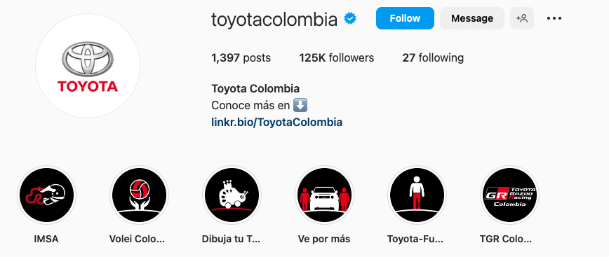

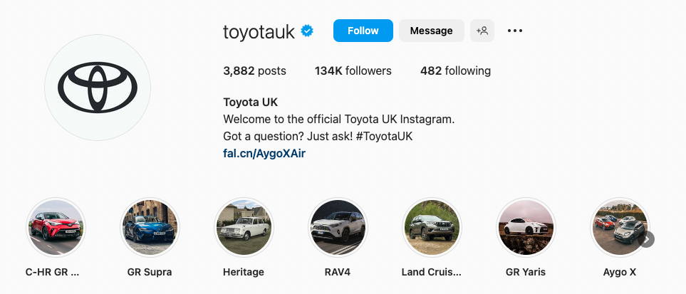

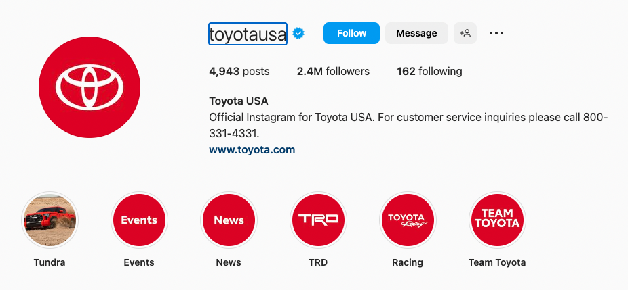

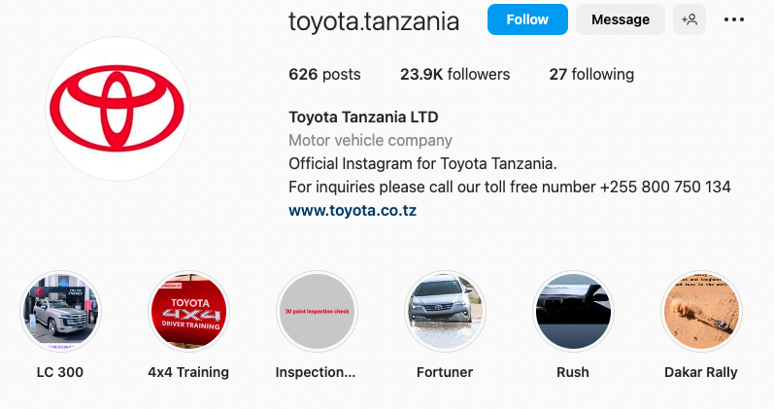

A 2. Toyota Facebook



