Taguchi Experimental Design
L5 Systems Engineering – ACDA2021
Alex Lamdin
28th April 2025

Table of Contents
- Introduction & Objectives
- Method and Apparatus
- Experimental Data
- Interpretation of Results
- Conclusion
- References & Bibliography
1 – Introduction & Objectives
When evaluating systems which feature multiple possible variables (factors) in order to find the optimal combination, it often results in a vast number of possible combinations being tested. This is extremely inefficient and can result in a system’s testing program taking an unreasonably long amount of time to complete. When applied to real-world commercial engineering scenarios, this inevitably has the potential to increase costs and delay final delivery of the system to the customer. When combined into complex, modern systems, this can have a “knock-on” effect, with each delayed component delaying the next and so forth.
The Taguchi Method, the namesake of Genichi Taguchi, seeks to provide a solution to this dilemma. It does this by utilizing orthogonal arrays to study the effects of multiple variables with a minimal number of experiments, whilst also identifying settings that are the most resistant to uncontrolled factors/variations that occur during real-world scenarios (“noise”). [1] This is achieved by testing pairs of variables at a time, rather than altering each factor one-by-one. For example, an experiment with three variables, each of which has two possible levels (high and low, strong and weak, position A and B etc). If this were to be worked through methodically, the number of experiments required would be 2³, so 8. Utilizing the Taguchi method, two variables are tested each time, and as such only 4 experiments are required.
The Taguchi method is best used when there is a number of variables which is both large enough to make it worthwhile, but not too excessive. Ideally there will be few interactions between these variables, and out of those being evaluated, only a few contribute significantly – the “Major” variables.
During the recent Systems Engineering Module, students were tasked to evaluate & determine the optimal combination of settings on a catapult, utilizing the Taguchi Method in order to demonstrate how it works and can contribute to the experimental design process.

2 – Method & Apparatus
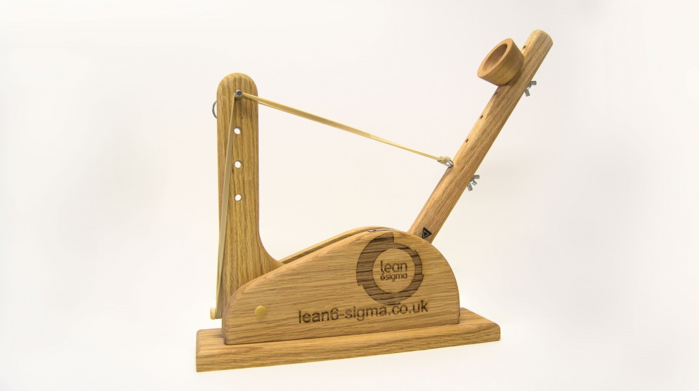
The catapult utilized during the experiment was a “Statapult”, a standardized design widely used for teaching the Taguchi Method, as well as other Design of Experiments (DoE) methods. It is shown in figure 1.
Fig. 1 – “Statapult” Catapult [2]
The catapult has become a widely adopted example for teaching design of experiments following the publication of a 1992 article “The Catapult Problem: Enhanced Engineering Modelling using Experimental Design”, in the Quality Engineering Journal. [3] The experiment seeks to take a catapult and determine which combination of variables results in the furthest
The catapult in question has five parameters which can be adjusted:
- The height of the rubber band’s front point.
- The position of the band’s anchor on the catapults arm.
- The position of the stop at which angle the catapult’s arm is stopped.
- The angle to which the arm is drawn back to.
- The position on the arm of the ball cup.
The first four of these were to be evaluated during the experiment, with two operators used to create uncontrollable variance, or “noise” to demonstrate the Taguchi Method’s ability to provide a robust set of optimal parameters least susceptible to this change.
Whilst the catapult design allowed for 4+ levels for each of these parameters, two levels were used in order to contain the experiment to the time slot allocated.

3 – Experimental Data
If a basic, full series of experiments were carried out to evaluate the 4 variables at 2 levels this would require 2⁴=16 experiments, however by utilizing the Taguchi method this was reduced to 8 experiments.
The decision was made by the experimental team to repeat these 8 experiments three times each in order to provide an average result for each, however this isn’t strictly necessary.
As such, the parameters used were:
- The height of the rubber band’s front point. – Positions 1 & 3
- The position of the band’s anchor on the catapults arm. – Positions 2 & 4
- The position of the stop at which angle the catapult’s arm is stopped. – Positions 1 & 3
- The angle to which the arm is drawn back to. – 140° & 170°.
A table was created to instruct the upcoming experiments using a 4 variable x 2 Level template provided at the start of the session. This can be seen below.
Experiment | Band Front Position (A) | Band Anchor Position (B) | AB Interaction | Stop Position (C) | Pull Back (D) | CD Interaction | Operator
Ex. 1 | 1 | 2 | 1 | 1 | 140 | 1 | A
Ex. 2 | 1 | 2 | 1 | 3 | 170 | 2 | B
Ex. 3 | 1 | 4 | 2 | 1 | 140 | 2 | B
Ex. 4 | 1 | 4 | 2 | 3 | 170 | 1 | A
Ex. 5 | 3 | 2 | 2 | 1 | 170 | 1 | B
Ex. 6 | 3 | 2 | 2 | 3 | 140 | 2 | A
Ex. 7 | 3 | 4 | 1 | 1 | 170 | 2 | A
Ex. 8 | 3 | 4 | 1 | 3 | 140 | 1 | B
Table 1 – Experiment Parameters
These experiments (1-8) were then carried out, with each experiment repeated three times as previously stated. The results gathered are shown in Table 2.
Experiment | Firing 1 Range (cm) | Firing 2 Range (cm) | Firing 3 Range (cm) | Average. Range (cm)
Ex. 1 | 145 | 132 | 235 | 170.7
Ex. 2 | 309 | 303 | 307 | 306.3
Ex. 3 | 112 | 115 | 107 | 111.3
Ex. 4 | 271 | 244 | 201 | 238.7
Ex. 5 | 132 | 132 | 131 | 131.7
Ex. 6 | 99 | 107 | 109 | 105
Ex. 7 | 127 | 132 | 112 | 123.7
Ex. 8 | 67 | 60 | 74 | 67
Table 2 – Experiment results
4 – Interpretation of Results
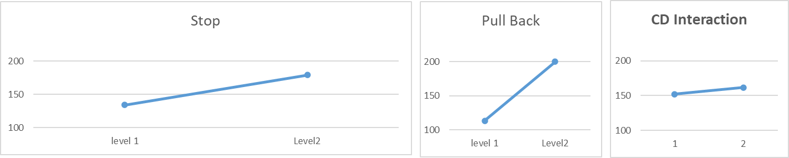
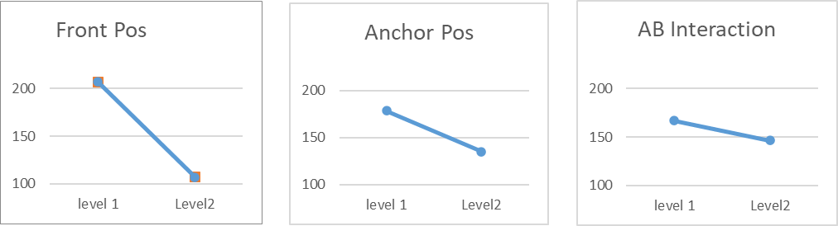
The results collected were analyzed utilizing the formulae in the temple and Graphs 1-7 were produced to visually show the effect each variable had on the range of the projectile, as well as which of the two variables compared in each pair had the most influence, and were thus the “Key Features”.
Graphs 1-7 – Results Collected
These allow us to easily draw the following conclusions:
- Level 1 (Position 1) of the front position resulted in greater range
- Level 1 (Position 2) of the anchor position resulted in greater range
- Of these two variables, the front position has a greater influence over the catapult’s performance; key feature 1 is the front position.
- Level 2 (position 3) of the stop resulted in greater range.
- Level 2 (170°) of pull back angle resulted in greater range.
- Of these two variables, the pull back angle has a greater influence over the catapult’s performance; key feature 2 is the pull back angle.
Now that the key features had been identified, a brief second set of experimentation was planned to further evaluate the effect of these on the range achieved. For the non-key features, they were set at the high-performing levels (position 2 for the anchor and position 3 for the stop). The parameters and results of these key feature experiments can be seen in table 3. The most consistent operator from the first set of experimentation was chosen to carry out all further firings.
Experiment | Front Pos. | Pull Back | Firing 1 Range (cm) | Firing 2 Range (cm) | Firing 3 Range (cm) | Average Range (cm)
Ex. 1 | 1 | 140 | 138 | 114 | 98 | 116.6667 | KF 1 :1 | KF2 :1
Ex. 2 | 3 | 140 | 60 | 53 | 71 | 61.33333 | 189.1667 | 89
Ex. 3 | 1 | 170 | 272 | 273 | 240 | 261.6667 | KF 1 :2 | KF2 :2
Ex. 4 | 3 | 170 | 140 | 189 | 152 | 160.3333 | 110.8333 | 211
 |  |  |  |  |  |  | mid each factor
 |  |  |  |  |  |  | 150 | 150
 |  |  |  |  |  |  | mid combined
 |  |  |  |  |  |  | 150
Table 3 – Key Factor Validation Experiments.
As can be seen above, altering the two key features had a significant effect on the minimum and maximum ranges achieved, with some deviation across the three firings. However, it can also be seen that the mid point of the (average) min. and max. ranges achieved by altering both factors is 150cm. As such, it stands to reason that if both key factors were set to a position half way between their level 1 and level 2 positions used in the experimentation carried out so far, then this should, in theory reach this averaged mid point range (150cm) consistently.
In order to validate this model, the mid-point positions of the two key factors were set (position 2 on the front position, and 155° of pull back) and three firings were conducted, the results of which can be seen below.
 | Front Position | Pull Back | Firing 1  Range (cm) | 2  Range (cm) | 3  Range (cm) | Average  Range (cm) | Target  Range (cm)
Ex. 1 | 2 | 155 | 120 | 142 | 135 | 132.3333 | 150
Table 4 – Optimum Robustness Performance Characteristics Experiment.
Whilst this isn’t an ideal result, two of the three firings were within 0% of the target figure, with one not, and thus lowering the averaged figure too. It is possible this firing’s result could be an anomaly, or that there were other noise factors affecting the result that weren’t taken into account in this simplified model.

5 – Conclusion
The Taguchi Method provides a useful tool in reducing the time, asset and financial burden of evaluating factors and variables in a design and determining the key factors therein. As such, it is commonly utilized within process improvement methodologies, such as Lean Six Sigma.
Within this example, it has been shown how it reduces the number of experiments required by half, and provides an easily-interpretable insight into the effects, both individual and combined, of altering variables within a design. We have also seen how it effectively identifies the key factors, thus allowing resources to be appropriately focused within the design and manufacturing processes to ensure that effort is focused where it is most needed to ensure a quality product that performs reliably with a high degree of robustness to noise.

6 - References & Bibliography
- S. Fraley, J. Zalewski, M. Oom, and B. Terrien, “14.1: Design of Experiments via Taguchi Methods - Orthogonal Arrays,” Engineering LibreTexts, May 19, 2020. https://eng.libretexts.org/Bookshelves/Industrial_and_Systems_Engineering/Chemical_Process_Dynamics_and_Controls_(Woolf)/14%3A_Design_of_Experiments/14.01%3A_Design_of_Experiments_via_Taguchi_Methods_-_Orthogonal_Arrays
- https://www.lean6-sigma.co.uk/training-aids/
- K. SCHUBERT, M. W. KERBER, S. R. SCHMIDT, and S. E. JONES, “THE CATAPULT PROBLEM: ENHANCED ENGINEERING MODELING USING EXPERIMENTAL DESIGN,” Quality Engineering, vol. 4, no. 4, pp. 463–473, Jan. 1992

