
Doctor of Business Administration
Assignment
Critical Literature Review for Doctoral Research
LCDB7009

An analysis of the changing perception of the Professional Identity of Teachers in China.

Module Leader: Dr Steve Griffiths
Ruixin Wang, Student Number:2130119

Table of Contents

Part 1 3
1.1 The Definition and Purpose of a Critical Literature Review. 3
1.2 The Rationale and Purpose of this Literature Review 4
1.3 The Content and Format of a Critical Literature Review. 4
Appendix 8
The Double Reduction Policy 8
Bibliography of Part 1 8
Part 2: An analysis of the changing perception of the Professional Identity of Teachers in China. 10
2.1 The Concepts of Teachers' Professional Identity 10
2.2 A Briefly Review of Recent Literature on Professional Identity under Different Approaches 11
2.3 Structural Views of Teachers' Professional Identity 14
2.3.1 Three-Dimensional Doctrines 15
2.3.2 Four-Dimensional Doctrines 15
2.3.3 Other Multidimensional Doctrines 16
2.4 Influencing Factors of Teachers' Professional Identity 16
2.4.1 Demographic Factors 17
2.4.2 Individual Factors 17
2.4.3 School Factors 17
2.4.4 Social Factors 18
2.5 The Gap, Bias, and Ecological Perspective 18
Bibliography of Part 2 21

Part 1

1.1 The Definition and Purpose of a Critical Literature Review.

There are different definitions of literature review in the academic field. Given (2008, p.485) defines literature as a composite art form in qualitative analysis; it requires the reader to attend to its details, and the reader needs to use their imagination to composite into the literature to understand its meaning, which in qualitative research exists as a vehicle for the data itself. Given (2008, p.487-489) expresses that a literature review is a plural format rather than a singular one, and this essential process stage could produce a coherent outcome in an academic field.

However, Gough et al. (2017, p.1–3) explain that a literature review is an essential secondary research method. While there are times when researchers do conduct primary research in uncharted territory, a review of existing research allows the researcher to understand what has been done, provides an opportunity to evaluate past research, to know what is known, what data has been rigorously argued, what questions may be the next step in the direction of research, and to generate new ideas to add to a particular area of research in the debate. Fink (2019, p.6–7) describes a literature review as an organised, precise, exact, and repeatable methodological process for identifying, evaluating, and summarising the work and records of completed researchers, scholars, and practitioners.

Booth, A. (2021, p.2–3) highlights the purpose of a literature review that it is not just to unearth the vast amount of information available in the past but to systematically review the most valuable knowledge and evidence that fits the research question, providing researchers with beneficial pros and cons and value-for-money references on different approaches and methods; sometimes the reviewed evidence can be disappointing, and the disappointing results provide researchers with a critical perspective and possible directions for future research. Piper (2013) argues that a robust and systematic literature review is necessary for research when faced with any problem; it not only identifies the current state, results and limitations of the study but also provides a possible direction for research through qualitative and quantitative assessment.

1.2 The Rationale and Purpose of this Literature Review

The school selection system overburdens families of students. It has high expectations of their student's performance, which leads to long-term physical and mental health problems for Chinese students, along with the burden of family education expenditures and increasing anxiety about their children's academic performance, which causes parents to be more concerned about their children's academic performance than their children's physical and mental health (Yang & Chen,2021). To remedy this problem, the ‘Double Reduction Policy’ posted (refer to Appendix 1) involves the control of homework in schools, rectifying out-of-school training organisations, reforming the student selection system, etc.

This brief literature review aims to find out the gap on impact on the professional identity of the Chinese teacher group under the Double Reduction Policy.

1.3 The Content and Format of a Critical Literature Review.

In terms of its content, Byrne (2016) distinguished the literature review into two types: 'systematic' and 'narrative'. While narrative literature reviews can cover a broader range of topics, they have also been criticised for lacking sufficient rigour and comprehensiveness, in addition to the fact that narrative literature reviews require an adequate number of reviewers to review a large number of scientific manuscripts and to meet the needs of a diverse audience, professional reviewers from different professional backgrounds; thus the narrative reviews could meet the demand for enhanced reliability and accessibility. Then, relevant literature reviews will be provided for both professional and non-specialist audiences.

Other formats can be used depending on the needs of the researcher. Grant & Booth (2009) identify 14 types. De Brun & Pearce-Smith (2009) prioritise search tools linked to formats. Different formats will vary in application depending on the research project, resources available (including time), the planned publication and level of research.

All have positive and negative attributes. Fig. 1 shows five types. On the sliding scale, a narrative review is fast and focused but may be too narrow and open to bias due to its restricted coverage. The systematic review is time and resource-consuming, but evaluates many methods, comprehensively covers the range of academic perspectives and reduces bias due to the range of sources covered.

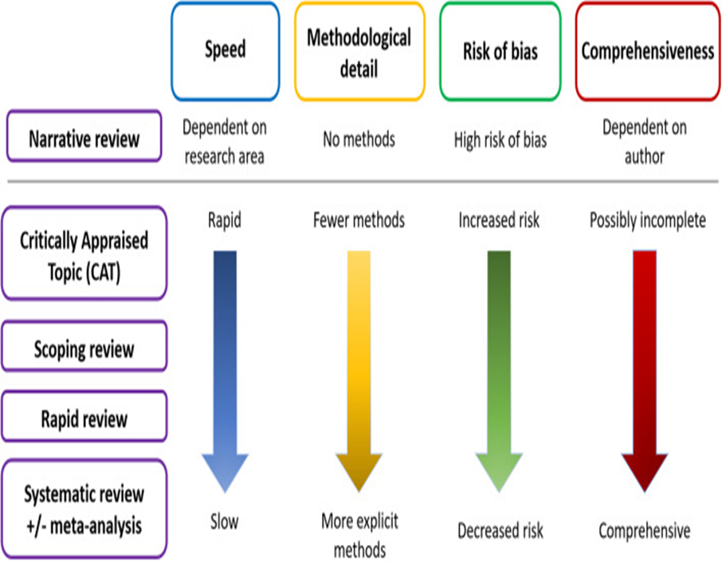
Figure 1. Evaluation of different formats of literature review (Source: Charles Sturt University, 2024)

Due to the need for more quality assessment tools for narrative review articles in academic research, Baethge et al. (2019) developed a narrative review article scale in the medical field called 'SANRA' to fill this gap. The SANRA scale uses a scoring system ranging from '0' (low standard) to '2' (high bar) to cover six areas: the first item is the importance of the review, and the second is the level of the purpose of the review. The third item is the level of search of the literature. The fourth is the level of presentation of the reference. The fifth is the level of evidence for the connection, and the last is the level of relevant endpoint data. The authors concluded that this short scale for assessing narrative reviews in the medical field could enhance the quality level of narrative reviews. They also encouraged researchers to use the tool as an adjunct to critical reviews and try it out in other research areas.
According to Fink (2019, p.5), a critical literature review involves several steps. The first step is to select research questions that could guide the determination of bibliographic databases and websites. The next step would be to choose search terms by asking experts which databases and phrases to use.

In contrast, Booth (2021, p.176-179) also indicates a literature review format called ‘SALSA’, including four stages. The first step is ‘search’, where researchers collect relevant information and literature based on their chosen topic. The second step is the ‘appraisal’, in which the researcher selects and identifies the material and literature in a targeted manner according to their preferred literature review method. The third step is ‘synthesis’, in which the researcher critically identifies past research outcomes and publications. The final step is ‘analysis’, in which the researcher identifies gaps, deficiencies and flaws in past research to uncover or refine the researcher's research questions and directions.

Regarding the review formats, Booth (2021, p.39-40) divides reviews into categories: critical, literature, integrative, and mapping. First, a critical review presents a comprehensive study and a vital quality assessment. It goes beyond simple description and involves a degree of analysis and conceptual innovation, often leading to a hypothesis or model. The second category is the literature review, which Booth (2021, p.39-40) describes as examining recent or current literature. It can cover various topics with varying degrees of completeness and detail. Literature reviews may also include research findings. It can also contain specific content obtained through the search process. It can also be evaluative. The most common form of synthesis is the narrative approach. Besides the previously stated two categories, he also explains the integrative review and mapping review. Integrative reviews are the most comprehensive research method, incorporating experimental and non-experimental studies to better understand the subject of interest. In addition, mapping reviews layout and categorise the existing literature and identify gaps in the research literature on which further reviews and primary research can be commissioned.

By contrast, Efron and Ravid (2019, p.18–24) summarise three approaches to literature review: systematic review, traditional-narrative review and Hermeneutic–Phenomenological Review. A systematic review can be used for qualitative studies but is more commonly found in quantitative studies. It is a rigorous, unbiased, organised, and replicable approach to literature review. Before such a literature review, the researcher must identify specific questions, which usually focus on theories and hypotheses that detect causal correlations and outcomes. The researcher conducts a disciplined, all-encompassing search to perform a relevant and comprehensive search for the literature review. Unlike a systematic review, a traditional-narrative review draws from a broader range of disciplines and encompasses different research methods, qualitative research, quantitative research, and various theoretical studies. It can be said that this review method is a pluralistic approach to criticism. It offers the researcher an all-encompassing, multi-faceted and coherent critical understanding. However, critics argue that traditional narrative reviews lack sufficient systematicity and scientific rigour and may involve many subjective researchers’ thoughts and more significant bias in the process of reviewing. Drawing on hermeneutic and phenomenological philosophical ideas, the hermeneutic-phenomenological review is an approach that explores the fusion of theoretical meaning and interpretive understanding of texts. However, critics argue that hermeneutic-phenomenological reviews, in which the researcher reflects a great deal of personal experience and social-cultural context into the fusion of research questions, can produce a strong bias and personal subjective perception, thus compromising the engagement with past literature and weaken the objectivity of the literature review.

Garrod (2023) explains that while both literature reviews and systematic literature reviews analyse an existing topic or field and identify gaps that the researcher can continue, a systematic literature review must look at the literature with a critical perspective; a systematic literature review can be a stand-alone article, whereas a literature review is often just a chapter section of a research article. The Preferred Reporting Items for Systematic Reviews and Meta-Analyses (PRISMA) statement was first published in 2009 and later updated in 2020 due to advances in terminology and methodology that have led to advances in identifying, selecting, evaluating, and synthesising research methodologies; this approach guideline allows authors to clearly explain why they are doing a review and what the authors have found based on a flowchart (Page. et al. 2021).

Although systematic literature reviews have the broadest methodological coverage, the least risk of bias and the most comprehensive, limited by time and effort, this short review in Part 2 belongs to the narrative review, as Yoko (2012) has used in her dissertation, which was discussed in the module session.

Literature databases include UWTSD's library, the Web of Science provided by Kunming University of Science and Technology's data provider 'Qing Li', and CNKI's core journals.

Appendix

The Double Reduction Policy
https://www.gov.cn/zhengce/2021-07/24/content_5627132.htm
In July 2021, the General Office of the Central Committee of the Communist Party of China (CPC) and the General Office of the Chinese State Council issued the Opinions on Further Reducing the Homework Burden of Students in Compulsory Education (Compulsory education in China is equal to the period from primary school which enrolment at the age of 6-7 years to middle school which graduation at the age of 15-16 years, and is also known as primary education.) and the Burden of Out-of-School Training (from now on referred to as the " Double Reduction Policy" by the General Office of the Communist Party of China Central Committee，2021）.

Bibliography of Part 1
Baethge, C., Goldbeck-Wood, S. and Mertens, S. (2019). “SANRA—a scale for the quality assessment of narrative review articles,” Research Integrity and Peer Review, 4(1). Available at: https://doi.org/10.1186/s41073-019-0064-8.
Booth, A. (2021). Systematic approaches to a successful literature review. Los Angeles: SAGE.
Byrne, J.A. (2016). “Improving the peer review of Narrative Literature Reviews,” Research Integrity and Peer Review, 1(1). Available at: https://doi.org/10.1186/s41073-016-0019-2.
Charles Sturt University (2024) Literature Review Guide. https://libguides.csu.edu.au/review/Types (Retrieved 30-05-24)
De Brun C. & Pearce-Smith, N. (2009) Searching Skills Toolkit: Finding the Evidence. Oxford, UK: Wiley-Blackwell. ISBN: 9781118463130.

Efron, S.E. and Ravid, R. (2019). “Chapter 2 Different Orientations to a Literature Review,” in Writing the literature review: A practical guide. New York: Guilford Publications, pp. 15–37.
Fink, A. (2019). Conducting research literature reviews: From the internet to paper. Los Angeles, CA: Sage.
Garrod, B. (2023). ‘What makes a good critical literature review paper?’, Tourism and Hospitality, 4(1), pp. 141–147. doi:10.3390/tourhosp4010008.
Given, L.M. (2008). The sage encyclopedia of qualitative research methods. Los Angeles: SAGE.
Gough, D.A., Oliver, S. and Thomas, J. (2017). An introduction to systematic reviews. Los Angeles: SAGE.
Grant, M.J. & Booth, A. (2009). A typology of reviews: An analysis of 14 review types and associated methodologies. Health Information & Libraries Journal, 26(2), 91-108. https://doi.org/10.1111/j.1471-1842.2009.00848.x
Page, M.J. et al. (2021). ‘The Prisma 2020 statement: An updated guideline for reporting systematic reviews’, Systematic Reviews, 10(1). doi:10.1186/s13643-021-01626-4.
Piper, R. J. (2013). ‘How to write a systematic literature review: a guide for medical students.’ National AMR, fostering medical research, 1, 1-8.
Yang Zhaoshan, Chen Huang. (2021). Thoughts on basic education triggered by "double reduction". Journal of Sichuan Normal University (Social Science Edition), 48 (06): 35-41. DOI:10.13734/j.cnki.1000-5315.2021.06.005杨兆山,陈煌. (2021) “双减”引发的对基础教育的几点思考. 四川师范大学学报(社会科学版), 48 (06): 35-41. DOI:10.13734/j.cnki.1000-5315.2021.06.005
Yoko, A. (2012). ‘Transparency in the Age of Truth: An Analysis of CSR/Sustainability Communications of Soap and Detergent Multinationals.’ Master. Dissertation. Swansea: University of Wales.

Part 2: An analysis of the changing perception of the Professional Identity of Teachers in China.

2.1 The Concepts of Teachers' Professional Identity

The conceptual analysis in the literature reveals that different scholars do not have a fixed and unified view on the definition of the concept of teachers' professional identity. Some scholars are concerned with teachers' professional identity characteristics, while others are more concerned with its dynamic nature. Characteristics, tension, process and dynamics constitute the scholars' abstract concept definition.

Kelman (1958) first introduced the concept of teacher professional identity as a value judgement based on perception. Similarly, Sachs (2001) argued that teacher professional identity is a set of characteristics imposed on the teaching profession by teachers, identifying the common traits and values that distinguish one group from others. In contrast, Coldron and Smith (1999) argue that teacher professional identities are unstable and cannot be understood as fixed or monolithic, with tensions existing between agency (the personal dimension of teaching and learning) and structure (the social 'given').

The Process theory, represented by Song and Wei (2006) and Olsen (2010), is a view of professional identity developed in the last thirty years. The former argues that teachers' professional identity is a process and a condition. The so-called "process" is the process by which individuals gradually develop themselves and affirm the role of teachers from their own practical experience; the latter proposes that teachers' professional identity is both a product and a process from the perspective of a product.

The Dynamics perspective or theory is one of the main streams proposed by some other scholars from the end of the last century, such as Huberman (1993), who proposed that a teacher's professional identity, i.e. how a teacher defines the self and the other, is a construction of the professional self and develops over different career stages of the professional life. A similar viewpoint put forward by Zhu (2012) states that a teacher's professional identity is a dynamic process in which individual teachers gradually develop an identity with the concept and meaning of the teaching profession and consciously adopt the specific behaviours required by the teaching profession in the course of their professional work in specific social environments and contexts.

In contrast to the above views, the concept of teacher professional identity roles was first proposed by Preuss & Hofsass (1991), who argued that teacher professional identity is equivalent to a role interpretation of the knowledge and skills teachers need to acquire. Further, regarding the formulation of roles, supportive evidence has been presented by Volkmann & Anderson (1998) and Zhang, Chen et al. (2012); the former argued that professional identity is a dynamic balance between a teacher's professional self-image and the roles that the teacher believes he/she must play. According to the latter, teacher professional identity is the process by which teachers internalise their professional roles as part of their selves, the process of establishing a harmonious relationship between the internalised professional roles and the rest of their selves, and its outcomes, and the process by which individual teachers internalise their professional roles as part of their selves.

Alternatively, the integrative approach, which focuses more on teachers' self-attitudes, as represented by Akkerman & Meijer (2011) and Li and Yan (2018), is a more widely accepted theory of teacher professional identity. The former argues that teacher identity is analysed in terms of the multiple-individual dimension, the stability-change dimension, and the social-personal dimension and that a synthesis of interpretations between these dimensions is a process of continuous negotiation and integration of multiple self-attitudes by teachers. The latter, on the other hand, takes an attitudinal perspective and sees teacher professional identity as an integrated attitude of the individual teacher towards his/her profession, an amalgam of cognitive, affective and behavioural dispositions of the individual teacher in the process of interaction and integration between the "personal" and the "professional".

2.2 A Briefly Review of Recent Literature on Professional Identity under Different Approaches

When studying the topic of professional identity, scholars often need to choose a specific professional group as the object of study. Elementary, secondary, university, and pre-service teachers are studied differently. Some scholars use quantitative methods to find the key factors affecting the professional identity of a group of teachers and make suggestions for their professional development. For example, in social identity theory, Chinese scholars Li et al. (2022) used the "Chinese Physical Education Teachers' Professional Identity Scale," which contains five dimensions. Similarly, He et al. (2022) used a group of pre-service teachers in China as a study to examine the factors that influence professional identity on the willingness to teach, and they found the following elements: teaching philosophies, teaching methods, and their perceptions of different temporal spaces, such as internships and on-campus teaching. The analysed factors form the social identity for specific occupations (Flubacher, 2020; Hassemer, 2020). He et al. (2022) also used quantitative analysis, after validity and reliability testing, multiple regression modelling methods between the factors of interest and the manner and extent of the correlation. The factors associated with professional identity as independent variables were derived from previous mature similarity scales and interviews with the study participants. The study found that the effect of professional identity on pre-service teachers’ willingness to teach was significant. The researchers concluded by giving suggestions for school management based on these findings. Hanna et al. (2022), examining the interrelationship between professional identity tensions and professional identity, found that at the inter-individual level, five of the nine investigated occupational identity tensions were negatively related to teacher identity. At the intra-individual level, no significant cross-lagged relationships were found. They concluded that the development of professional identity tensions and teacher professional identity were not automatically correlated (Hanna et al., 2022). The use of quantitative research professional identity theory raises potential issues of error and bias, with different researchers using scales asking for responses and selecting variables for research that are generated with the personal preferences and beliefs of the researcher.
In contrast, Rinne et al. (2023) used case studies to examine how student teachers' experiences reflect their interpretations of the professional identity of becoming teachers. They find that student teachers still interpret their professional teacher identity through their experiences. Thus, teacher education has only a limited impact on their interpretation of their professional identity. After systematic teacher education, the teacher students still hold on to their initial views of their professional identity. The findings are consistent both in Sweden and Denmark. The researcher goes on to suggest responses to teacher education programs for improvement. Similarly, Sánchez-Moreno et al. (2023) adopted a qualitative-interpretive academic stance, and the researchers used a comparative case study approach to examine the professional identity formation of three female principals in schools serving disadvantaged groups in Spain. As a result, the researchers found that gender and emotional factors complemented professional identity formation in these three headmasters, confirming the multiplicity and multilevel nature of professional identity and thus inferring that different experienced identity managers form different management patterns.

Feng et al. (2021) used a pragmatic perspective to collect data from a large multi-stage stratified random sample. They concluded that although the professional identity of Chinese GPs is at a high level, region, age, administrative position, career development opportunities, and job satisfaction are the most critical factors that impact professional identity. The study makes corresponding management recommendations to develop appropriate countermeasures according to the characteristics of different regions and to provide practical learning and training opportunities to enhance the professional identity of general practitioners, stabilise the available workforce, and improve the quality of primary health care services. Darici et al. (2022) used the data collection and processing methods of quantitative research in a mixed research methodology; they take a constructivist stance on the impact of undergraduate medical students' deconstructive practice on these students' professional identity as physicians. They find that conducting deconstructive training offline during a pandemic significantly reduces medical students' professional identity as physicians, reducing work engagement and management difficulties. The importance of medical students' offline practice for efficiently operating and managing healthcare systems is highlighted. In a similar but different example, Coventry et al. (2022) also followed the social identity theory concept of professional identity. They used a quantitative approach to study a random sample of doctors and medical students in the UK on the factors influencing doctors' professional identity, using a method known as 'Q-Methods' to identify the degree of interrelationship between different elements as a way of making recommendations for medical school curriculum and management, even though the ability of doctors to manage multiple patients holistically is vital to a well-formed professional identity of doctors.

In contrast, qualitative methods are also applied in professional identity research. Consorti and Consorti (2022) also study the construction of doctors' professional identity during the epidemic but adopt a phenomenological approach based on a hermeneutic qualitative study to understand the structure of the professional identity of Italian doctors and medical students according to Gilles Deleuze's 'empty square' theory. Adisaputri and Ungar (2023) have identified changes in the factors affecting doctors’ professional identity under the influence of the epidemic; the researchers have made recommendations to improve medical management in Indonesia. In the studies of nurses, researchers also used qualitative analysis based on the process of forming and reconstructing the professional identity of nurse leaders in the United States professional identity and nurse leaders in management improvement and leadership formation; two teams of scholars with partly the same membership not only found that (1) one's professional identity is foundational; (2) professional identity and functional roles are complementary; (3) leadership expands one's horizons; and (4) We must build bridges. Participants' responses suggest that one's professional identity is both dynamic and foundational and persists as an essential part of one's professional nursing life, but also indicate that using professional identity as a new way of conceptualising and thinking about providing for leadership practice and problem-solving and can be used as a new management strategy (Godfrey et al., 2023; Joseph, & Godfrey, 2023).

Besides teachers, doctors, and nurses, based on a social identity perspective, studies of professional identity for highly specialised occupational groups include other occupations. The police are an essential professional group that undergoes comprehensive technical education and training before becoming a police officer. It is common for academics to explore the professional identity of police groups from different perspectives (du Plessis et al.,2020; Jiang, 2021; Greenhill, 2023).

With the transformation of traditional paper media operations and the rise of new digital media, journalists, a traditional and highly specialised profession, are facing enormous challenges and changes in their working methods; it is common for academic circles to discuss the construction of a professional identity for journalists and their professional identity, as well as to propose targeted responses to the management of the profession (Hughes et al., 2021; Bossio, 2021; Josephi, and O’Donnell, 2022). In addition to the professional groups mentioned above, scholars have also studied the topic of professional identity among lawyers or law students (Alexander, 2023; Soubise, 2023), social workers (Hu et al., 2022; Levin et al., 2022) etc.

2.3 Structural Views of Teachers' Professional Identity

Throughout China's and international research, teacher professional identity is not a structure with a single dimension due to vague conceptual definitions, diversity of theories, research methods and perspectives. Scholars have different perceptions of specific structural frameworks and different perspectives of delineation. Scholars outside of China earlier devoted themselves to studying the structure of teachers' professional identity, and some of the more authoritative studies include those by Kremer & Hofman (1985), Meyer (1993), Beijaard (2000), and Brickson (2000). Later, Chinese scholars also enthusiastically participated in this field, such as Yu & Liu (2006), Wei (2008), Sun & Zou (2010), and Zhang et al. (2011). In general, the research results mainly focus on three levels: one is the three-dimensional doctrine, the second is the four-dimensional doctrine, and the third is other multidimensional doctrines.

2.3.1 Three-Dimensional Doctrines

The three-dimensional theory was proposed by Meyer (1993), who delineated the structure of teachers' professional identity as three dimensions: affective, continuous, and normative identity, while Beijaard (2000) initially divided it into three levels, depending on the perspective, from the subject matter taught, the relationship with the students, and the role of the teacher. Afterwards, from the perspective of teachers' knowledge acquisition, they identify themselves as subject matter experts, pedagogical experts, and educational experts. Brickson (2000) can be theoretically attributed to the individual, the collective, and the mutual, and each of these factors consists of four dimensions: cognitive, affective, behavioural, and social. Sun and Zou (2010) proposed that teachers' professional identity comes from professional cognition, professional emotion, and professional value, while Zhang (2011) put forward the three dimensions of professional-material me, professional-social me, and professional-spiritual me from a philosophical point of view; and Zhao (2012) analysed the perspective of intentional identity to analyse the extrinsic value identity, intrinsic value identity, and volitional Behavioural Identity based on the division.

2.3.2 Four-Dimensional Doctrines

The four-dimensional theory is the mainstream view of the teacher's professional identity structure. Scholars in China and abroad put forward different perspectives, which can be divided into two main types: the central and vocational principles. Among the major principles, the representative viewpoints are Kremer& Hofman (1985) of centrality, value, solidarity, and self-expression. Hamman et al. (2010) on interpersonal relationships, classroom management, teaching, professionalism, and Lamote & Engels. (2010) on teaching commitment, career orientation, task orientation, and self-efficacy; while the perspective of career principles is more common, Wei’s (2008) four-factor (occupational values, role values, occupational sense of belonging, and occupational behavioural dispositions); Fang and Mao's (2008) (occupational value identity, occupational emotional identity, Occupational Ability Identity, Occupational Social Status Identity); Occupational Will and Expectation, Occupational Will, Occupational Value, and Occupational Efficacy by Wang et al., (2010); Role Concept, Occupational Value, Occupational Pride, Occupational Self-Esteem by Li et al., (2013); Occupational Will and Expectation, Occupational Will, Occupational Value, Occupational Efficacy by Hu and Huang (2016).

2.3.3 Other Multidimensional Doctrines

Other multidimensional statements are constructed from more diverse perspectives, in which Kelchtermans & Vandenberghe (1993) described the structure of teachers' professional identity from five perspectives, namely job satisfaction, self-intention, task knowledge, self-respect, work motivation and prospects, while Starr (2006) had a more diversified delineation, affective (intrinsic satisfaction in teaching, sense of belonging to a group, sense of responsibility for education, and getting rewards from teaching), professional knowledge and skills (possessing knowledge and skills for teaching, and sharing experiences with learners), and cognitive (being a doctor as well as a teacher); whereas, according to Wang et al. (2008), the structure of teachers' professional identities ranges from teaching and learning, student development, school development, professional relationships and services, and personal growth and development specifically.

2.4 Influencing Factors of Teachers' Professional Identity

From a macroscopic point of view, teachers' professional identity is affected by a variety of factors in the process of dynamic development. China’s and other countries’ academic research results on the factors influencing teachers' professional identity can be summarised as internal and external factors. Internal factors consist of demographic and individual characteristics; external factors include social and school environment factors.

2.4.1 Demographic Factors

There are differences in professional identity among teachers of different genders. Studies have shown that female teachers have a higher level of professional identity than male teachers (Yu and Liu, 2006) and consider themselves more balanced among subject matter, teaching, and educational specialists (Beijaard, 2000). Also, teachers' professional identities vary in terms of teaching experience and title. The study by Zou et al. (2014) and others confirmed that teachers with different titles differ in professional values, role values, etc., and that teachers' different ages of teaching also make a difference in the performance of their professional identities. Polizzi (2015) found that demographic variables such as gender, years of teaching experience, title, and subject taught affect teachers' professional characteristics to some extent.

2.4.2 Individual Factors

Many people choose teaching as their career because, to a large extent, their interests, personality, and other factors play a role. In addition, it is also easier to be influenced by the subtle influence of others in their student days so that they initially form a professional cognition. For example, scholars such as Koster et al. (1995) found that many prospective teachers chose the profession because their respected teachers influenced them. Mbowane et al. (2017) used the Beijaard et al. model to describe teachers' professional identity regarding professional knowledge, attitudes, beliefs, norms, values, and affective and able dispositions. Interviews with physical science teachers were analysed using thematic analysis, which ultimately interpreted and linked response categories to themes of professional identity. Expo participation contributed to pedagogical knowledge, content knowledge (procedural and declarative or factual knowledge), and pedagogical content knowledge. Greenbrook & Ioannou (2020) found that personal factors influence the formation and development of teachers' professional identities, such as their interests, personality, upbringing, work experience, and attitudes towards the teaching profession.

2.4.3 School Factors

In discussing school factors, most scholars have included the school environment, organisational culture, management system and interpersonal relationships within their considerations. Beauchamp (2009) mentioned in her study that the school environment, the nature of the learner group, colleagues and school administrators may all impact the professional identity of new teachers. Qin et al. (2011) stated that the relationship between teachers and young children, colleagues and home relationships can affect teachers' professional identity. That is to say that interpersonal relationships in school are critical factors. Pu (2021) decomposed school factors into "individual factors" and "environmental factors", two dimensions and six factors. After investigation, it was concluded that the management mechanism, title evaluation, leadership relationship, teacher field, work environment and other factors affect teachers' professional identity. Darwiche (2015) observed that research proposals, resources, formal presentations, reviews of classroom outcomes, and continuing professional development incentives provided ongoing support for integrating scientific processes, practical skills, and a passion for careers in the biological sciences into the classroom.

2.4.4 Social Factors

Social factors include the policy system, social status, economic status, and professional prestige. Sugnure (1997) pointed out that immediate family, teaching personality, significant others, policy, and culture can influence a teacher's professional identity. Day's (2002) research shows that teachers in many countries are now faced with the intervention of educational policies such as curriculum reforms, quality assessment of education, etc., the implementation of which puts multiple pressures on teachers' work, which can have an impact on teachers' professional identity. The findings of Feng et al. (2010) show that four external factors, policy, university environment, social opinion, and essential other individuals, all affect the professional identity of free teacher trainee teachers. Allen et al. (2016) found that improving social identity so that teachers receive material satisfaction and spiritual upliftment from the community is essential for optimising the professional identity of private university teachers.

2.5 The Gap, Bias, and Ecological Perspective

Miles (2017) explained the logical relationship between the seven academic gaps, as shown in Figure 2.

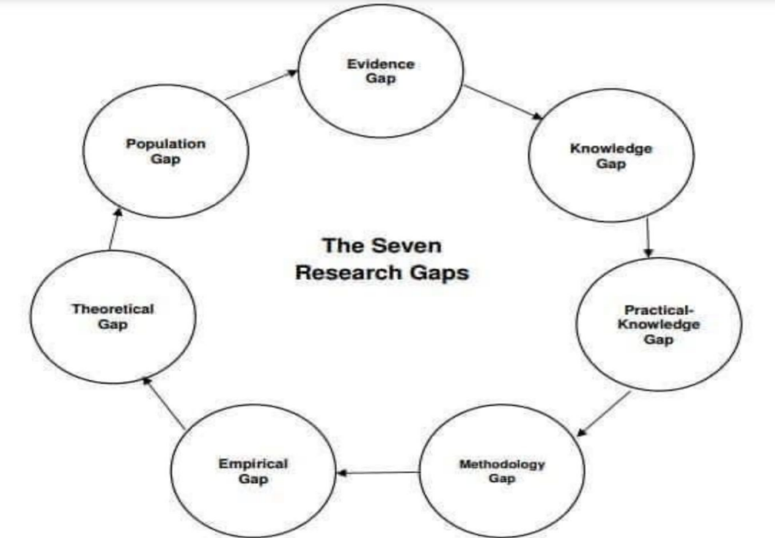
Figure 2. The Seven Research Gaps. Source: Miles, D. A. (2017) In Doctoral student workshop: finding research gaps-research methods and strategies, (pp. 1-15).

Through this narrative literature review, the researcher found that the research gaps mainly lie in the following: firstly, the teacher group in the education sector has received limited attention as a group that is more affected by the double reduction policy; secondly, most of the research on the professional identity of teachers focuses on the self of the teacher group, and lacks the influence of the environment in which the teacher group is situated; and thirdly, the research on the professional identity of teachers in China is dominated by the public sector and supplemented by the private sector, and lacks the comprehensive perspective that integrates the two groups.

This narrative literature review is biased in several ways. First, as a university lecturer in China. My emic position enables closer cultural understanding, while my etic perspective provides some analytical distance. With over three years of college teaching experience in China, I inhabit a complex insider-outsider location exploring primary school teachers’ professional identity in China after the ‘Double Deduction Policy’. My educational background grants me some cultural understanding and privilege. Yet my focus on virtual primary education contexts remains outside my expertise. Second, there is a lack of less specialised occupational groups in the process of sorting out the occupational identities of different occupational groups. Third, there is no systematic sorting out of occupational identity research using mixed research methods, etc.

Teacher education research has shifted from focusing on teachers' knowledge and teaching ability to addressing teachers' beliefs, emotions, professional aspirations and other professional development from a "whole person" perspective. Expanding research content and focus has also brought about thinking and innovation in the research paradigm, from the paradigm of natural science research, which focuses on condensing the research phenomenon into a small number of measurable variables and adopting mathematical and statistical methods to test the relationship between the variables, to the paradigm of entering the life and emotions of teachers and focusing on their individuality, contextuality and sociality. The paradigm is now shifting to the method, complementing one another. The ecological theory, widely used in social sciences, also emphasises the interaction between individuals and their environment, and it has attracted increasing attention in teacher education research.

The ecological theories put forward by the American psychologist Bronfenbrenner, whose main contribution is the ecosystem theory of human development, are of great significance to the study of teacher education. He argues that the developing individual is not a "blank slate" that is passively influenced by the environment but rather a dynamic entity that grows and continually enters and reconfigures the environment it inhabits and that the environment and the individual adapt to each other in a two-way interaction: the environment not only refers to the current situation that is relevant to the individual but also encompasses the relationship between these situations in order to create a larger environmental point (Bronfenbrenner, 1979).

Subsequent research on this subject will adopt an ecological perspective, and the research plan will follow, as shown in Figure 3.
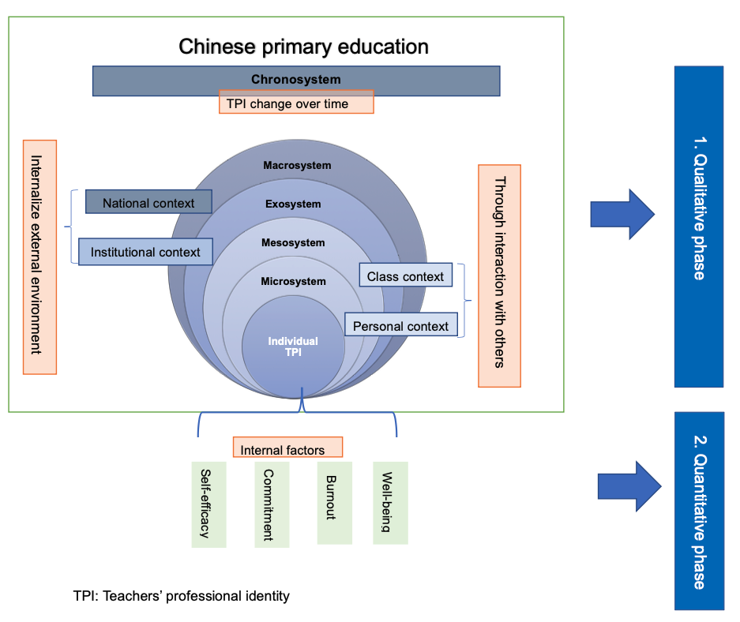
Figure 3. Ecological Perspective on the research plan of analysis of the changing perception of the Professional Identity of Teachers in China

The literature review for the thesis will be based in part on this short narrative literature review.

Bibliography of Part 2
Adisaputri, G. and Ungar, M. (2023). “Shifting professional identity among Indonesian medical practitioners during the COVID-19 pandemic,” Qualitative Health Research, 33(5), pp. 400–411. Available at: https://doi.org/10.1177/10497323231159614.
Akkerman, S. F., & Meijer, P. C. (2011). A dialogical approach to conceptualizing teacher identity. Teaching and teacher education, 27(2), 308-319.
Alexander, J. (2023) “Modelling employability through Clinical Legal Education: Building confidence and professional identity,” The Law Teacher, pp. 1–20. Available at: https://doi.org/10.1080/03069400.2023.2179306.
Allen, M. L., Ortega, L. E., Cushing-Leubner, J., Bigelow, M., Pergament, S., Hang, M., & Okuyemi, K. (2016). Feasibility results of a participatory teacher professional development intervention to promote positive youth development for Somali, Latino, and Hmong youth. Journal of Adolescent Health, 58(2), S45.
Beauchamp, C., & Thomas, L. (2009). Understanding teacher identity: An overview of issues in the literature and implications for teacher education. Cambridge journal of education, 39(2), 175-189.
Beijaard, D., Verloop, N., & Vermunt, J. D. (2000). Teachers’ perceptions of professional identity: An exploratory study from a personal knowledge perspective. Teaching and teacher education, 16(7), 749-764.
Bossio, D. (2021) ‘Journalists on Instagram: Presenting professional identity and role on image-focused social media’, Journalism Practice, pp. 1–17. doi:10.1080/17512786.2021.2001359.
Brickson, S. (2000). The impact of identity orientation on individual and organizational outcomes in demographically diverse settings. Academy of Management Review, 25(1), 82-101.
Bronfenbrenner, U. (1979). The ecology of human development. Cambridge: Harvard University Press.
Coldron, J., & Smith, R. (1999). Active location in teachers' construction of their professional identities. Journal of curriculum studies, 31(6), 711-726.
Consorti, F. and Consorti, G. (2022). “Elements and determinants of professional identity during the pandemic: A hermeneutic qualitative study,” Teaching and Learning in Medicine, pp. 1–14. Available at: https://doi.org/10.1080/10401334.2022.2080068.
Coventry, J. et al. (2022). “Medical student and trainee doctor views on the ‘good’ doctor: Deriving implications for training from a Q-Methods Study,” Medical Teacher, 44(9), pp. 1007–1014. Available at: https://doi.org/10.1080/0142159x.2022.2055457.
Darici, D. et al. (2022). “‘fun slipping into the doctor's role’—the relationship between sonoanatomy teaching and professional identity formation before and during the COVID‐19 pandemic,” Anatomical Sciences Education, 15(3), pp. 447–463. Available at: https://doi.org/10.1002/ase.2178.
Darwiche, H., Bokor, J., & Koroly, M. (2015). UF Center for Precollegiate Education and Training: University Partnerships for Teacher Professional Development. The FASEB Journal, 29, LB74.
Day, C. (2002). School reform and transitions in teacher professionalism and identity. International journal of educational research, 37(8), 677-692.
du Plessis, C. et al. (2020). ‘I’m still in the Blue Family: Gender and professional identity construction in police officers’, Journal of Police and Criminal Psychology, 36(3), pp. 386–396. doi:10.1007/s11896-020-09397-9.
Fang, M. J., & Mao, J. P.. (2008). Survey and analysis of the current situation of professional identity of university teachers in China. Research on Higher Education, 29(7), 56-61. 方明军, & 毛晋平. (2008). 我国大学教师职业认同现状的调查与分析. 高等教育研究, 29(7), 56-61.
Feng et al. (2021). Status Quo and Influencing Factors of Professional Identity Among General Practitioners in China, Medicine and Society, Vol．34 No．10 Oct． 2021. 冯晶, 申鑫, 吴健雄, 楼依玲, & 甘勇. (2021). 我国全科医生职业认同现状及其影响因素. 医学与社会
Feng, Z. Q., Jiang, Y., Du, Y.T, & Gao, Q. (2010). A study on the professional identity of free teacher trainees and its influencing factors. Journal of Hebei Normal University: Education Science Edition, 12(7), 69-75. 封子奇, 姜宇, 杜艳婷, & 高钦. (2010). 免费师范生教师职业认同及其影响因素研究. 河北师范大学学报: 教育科学版, 12(7), 69-75.
Flubacher, M. C. (2020). ‘Selling the self’: Packaging the narrative trajectories of workers for the labour market. International Journal of Multilingualism, 17(1), 30e45. Available at: https://doi.org/10.1080/14790718.2020.1682249
Godfrey, N., Poague, C., & Phillips, C. (2023). From Direct Care to Leader: What Happens to One’s Professional Identity in Nursing? Nurse Leader, 21(2), 146-150. Available at: https://doi.org/10.1016/j.mnl.2022.12.008
Greenbrook, J. T., & Ioannou, M. (2020). Docendo discimus: Forwarding Seeing the Patient as a Person to the Future Generation of Physicians. European Journal of Public Health, 30(Supplement_5), ckaa165-028.
Greenhill, N.J. (2023). ‘Professionalism in the Police Service’, Modern Policing, pp. 53–68. doi:10.4324/9781003368083-7.
Hamman, D., Gosselin, K., Romano, J., & Bunuan, R. (2010). Using possible-selves theory to understand the identity development of new teachers. Teaching and teacher education, 26(7), 1349-1361.
Hanna, F. et al. (2022). “The development of the relationship between professional identity tensions and teacher identity: A quantitative longitudinal study among Dutch primary student teachers,” Studies in Educational Evaluation, 75, p. 101199. Available at: https://doi.org/10.1016/j.stueduc.2022.101199.
Hassemer, J. (2020). The value(s) of volunteering: Asylum seekers' trajectories through language work in refugee assistance. International Journal of Multilingualism, 17(1), 46e61. Available at: https://doi.org/10.1080/14790718.2020.1682252
He, Z. et al. (2022)’ The influence of career identity on students' willingness to teach in teacher training colleges, China Economics of Education Review Sept2022, Vol.7,No.5 何赵颖,侯龙龙,潘艳萍,朱 涵 （2022）‘职业认同对师范院校在校生从教意愿的影响研究’，教育经济评论，2022年九月刊 Vol.7,No.5. Available at: https://kns.cnki.net/kcms2/article/abstract?v=3uoqIhG8C44YLTlOAiTRKibYlV5Vjs7iJTKGjg9uTdeTsOI_ra5_XQdVMgrgtI1B56o8ZqXIVbV_WgfagXl5SOD-NiwA985G&uniplatform=NZKPT
Hu, H. et al. (2022) “Professional Identity and turnover intention amongst Chinese social workers: Roles of Job Burnout and a social work degree,” The British Journal of Social Work, 52(3), pp. 1703–1723. Available at: https://doi.org/10.1093/bjsw/bcab155.
Hu, Wei-Fang, & Huang, Li. (2016). A study on teacher professional identity and its influencing factors of higher education teacher trainees. Educational Research and Experiment, (1), 82-86. 胡维芳, & 黄丽. (2016). 高校师范生教师职业认同及其影响因素研究. 教育研究与实验, (1), 82-86.
Huberman, M. (1993). The lives of teachers. Teachers College Press.
Hughes, S. et al. (2021). ‘Coping with occupational stress in journalism: Professional identities and advocacy as resources’, Journalism Studies, 22(8), pp. 971–991. doi:10.1080/1461670x.2021.1910543.
Jiang, Q. (2021). ‘Stress response of police officers during COVID‐19: A moderated mediation model’, Journal of Investigative Psychology and Offender Profiling, 18(2), pp. 116–128. doi:10.1002/jip.1569.
Joseph, M. L., & Godfrey, N. (2023). A New Mindset: From Tasks to Professional Identity. Nurse Leader, 21(2), 183-187. Available at: https://doi.org/10.1016/j.mnl.2022.12.007
Josephi, B. and O’Donnell, P. (2022). ‘The blurring line between freelance journalists and self-employed media workers’, Journalism, 24(1), pp. 139–156. doi:10.1177/14648849221086806.
Kelchtermans, G., & Vandenberghe, R. (1993). A Teacher Is a Teacher Is a Teacher Is a...: Teachers' Professional Development from a Biographical Perspective.
Kelman, H. C. (1958). Compliance, identification, and internalization three processes of attitude change. Journal of conflict resolution, 2(1), 51-60.
Koster, B., Korthagen, F. A. J., & Schrijnemakers, H. G. M. (1995). Between entry and exit: How student teachers change their educational values under the influence of teacher education. Choc démocratique et formation des enseignants en Europe, 156-168.
Kremer, L., & Hofman, J. E. (1985). Teachers’ professional identity and burn-out. Research in education, 34(1), 89-95.
Lamote, C., & Engels, N. (2010). The development of student teachers’ professional identity. European journal of teacher education, 33(1), 3-18.
Levin, L., Roziner, I., & Savaya, R. (2022). Professional identity, perceived job performance and sense of personal accomplishment among social workers in Israel: The overriding significance of the working alliance. Health & Social Care in the Community, 30(2), 538-547.
Li, X.C., Liu, J.J. & Lin, X.M.(2022). “Study on the relationship between professional identity and professional development of physical education teachers in higher education institutions, ”education and vocation, (October 2),pp73-76. 李向朝, 刘锦军, & 蔺新茂. (2022). 高职院校体育教师职业认同对专业发展影响关系研究. 教育与职业, (10 月下), 73-76.
Li, X.Y., & Yan, H.B. (2018). Model construction and scale development of teachers' professional identity. Teacher Education Research, 30(2), 72-81. 李笑樱, & 闫寒冰. (2018). 教师职业认同感的模型建构及量表编制. 教师教育研究, 30(2), 72-81.
Li, Y., Y. Dong, J. Yuan, & J. Yan. (2013). Elements and Measurement of Teachers' Professional Identity in Primary and Secondary Schools. Psychological Research, 6(1), 87-92. 李晔, 董英, 袁晶, & 严俊. (2013). 中小学教师职业认同的要素与测量. 心理研究, 6(1), 87-92.
Mbowane, C. K., De Villiers, J. J., & Braun, M. W. (2017). Teacher participation in science fairs as professional development in South Africa. South African journal of science, 113(7-8), 1-7.
Meyer, J. P., Allen, N. J., & Smith, C. A. (1993). Commitment to organizations and occupations: Extension and test of a three-component conceptualization. Journal of applied psychology, 78(4), 538.
Miles, D. A. (2017, August). A taxonomy of research gaps: Identifying and defining the seven research gaps. In Doctoral student workshop: finding research gaps-research methods and strategies, Dallas, Texas (pp. 1-15). file:///C:/Users/steve/Downloads/Miles2017.pdf

Olsen, B. (2016). Teaching for success: Developing your teacher identity in today's classroom. Routledge.
Polizzi, S. J., Jaggernauth, J., Ray, H. E., Callahan, B., & Rushton, G. T. (2015). Highly qualified or highly unqualified? A longitudinal study of America's Public High School Biology Teachers.
Preuss, E., & Hofsass, T. (1991). Integration in the Federal Republic of Germany: Experiences related to professional identity and strategies of teacher training in Berlin. European journal of teacher education, 14(2), 131-137.
Pu, Y. (2021). Influence of School Factors on Teachers' Professional Identity - A Survey Based on Beijing Compulsory Education Teachers. Educational Measurement and Evaluation. 蒲阳. (2021). 学校因素对教师职业认同的影响——基于北京市义务教育阶段教师的调查. 教育测量与评价.
Qin, X.F., Sun, Y.F., & Tan, X.Q. (2011). Living Conditions of early childhood teachers in different school systems. Research on Preschool Education, (10), 28-33. 秦旭芳, 孙雁飞, & 谭雪青. (2011). 不同办园体制下幼儿教师的生存状态. 学前教育研究, (10), 28-33.
Rinne, I. et al. (2023). “‘when you get out there, you don't have a Toolbox’. A comparative study of student teacher's identity development in Swedish and Danish teacher education,” Teaching and Teacher Education, 122, p. 103958. Available at: https://doi.org/10.1016/j.tate.2022.103958.
Sachs, J. (2001). Teacher professional identity: Competing discourses, competing outcomes. Journal of education policy, 16(2), 149-161.
Sánchez-Moreno, M., López-Yáñez, J. and Toussaint-Banville, M. (2023). “Professional Identity Formation of Female School Principals: Gender and Emotionality Connections,” Management in Education, 37(1), pp. 13–24. Available at: https://doi.org/10.1177/08920206211016454.
Song, G. W., & Wei, S. H.. (2006). Analysis of factors affecting teachers' professional identity. Psychological Development and Education, 22(1), 80-86. 宋广文, & 魏淑华. (2006). 影响教师职业认同的相关因素分析. 心理发展与教育, 22(1), 80-86.
Soubise, L. (2023) “Professional identity, legitimacy and managerialism at the Crown Prosecution Service,” Legal Studies, pp. 1–18. Available at: https://doi.org/10.1017/lst.2022.47.
Starr, S., Haley, H. L., Mazor, K. M., Ferguson, W., Philbin, M., & Quirk, M. (2006). Initial testing of an instrument to measure teacher identity in physicians. Teaching and learning in medicine, 18(2), 117-125.
Sugrue, C. (1997). Student teachers’ lay theories and teaching identities: Their implications for professional development. European journal of teacher education, 20(3), 213-225.
Sun, L., & Zo,B., (2010). The structure and measurement of teachers' professional identity in primary and secondary schools. Educational Research and Experimentation, (5), 80-84. 孙利, & 佐斌. (2010). 中小学教师职业认同的结构与测量. 教育研究与实验, (5), 80-84.
Volkmann, M. J., & Anderson, M. A. (1998). Creating professional identity: Dilemmas and metaphors of a first‐year chemistry teacher. Science Education, 82(3), 293-310.
Wang, X. Q., Zeng, L. H., Zhang, D. J., & Li, S.. (2010). A preliminary development of a professional identity scale for teacher trainees. Journal of Southwest University: Social Science Edition, 36(5), 152-157. 王鑫强, 曾丽红, 张大均, & 李森. (2010). 师范生职业认同感量表的初步编制. 西南大学学报: 社会科学版, 36(5), 152-157.
Wang, Y.A, Zheng, G.H, & Zhu, M. (2021) Career support: Social identity theory and new dimensions of occupational identity. Social Development Research, 1, 52-75. 王晔安, 郑广怀, & 朱苗. (2021). 职业支持: 社会认同理论与职业认同的新维度. 社会发展研究, 1, 52-75.
Wei S.H.,(2008) Research on teachers' professional identity [D]:[Doctoral dissertation]. Chongqing: Southwest University. 魏淑华.教师职业认同研究[D]:[博士学位论文].重庆:西南大学,2008.
Yu, H.H., & Liu, Y.W., (2006). A study on the status quo of young teachers' professional identity in secondary schools (Doctoral dissertation, Hunan Normal University).于慧慧, & 刘要悟. (2006). 中学青年教师职业认同现状研究 (Doctoral dissertation, 湖南师范大学).
Zhang, L.P, Chen. J.J, & Liu.Y.H. (2011). Development of a professional identity scale for rural teachers. Contemporary Education Forum: General Edition, (9), 10-12.张丽萍, 陈京军, & 刘艳辉. (2011). 农村教师职业认同问卷的编制. 当代教育论坛: 综合版, (9), 10-12.
Zhang, L.P, Chen. J.J, & Liu.Y.H. (2012). Connotation and structure of teachers' professional identity. Journal of Educational Science, Hunan Normal University, 11(3), 104-107. 张丽萍, 陈京军, & 刘艳辉. (2012). 教师职业认同的内涵与结构. 湖南师范大学教育科学学报, 11(3), 104-107.
Zhao, H.Y., Lan, Y.T., Zhang, X.F., & Zhang, Y.. (2012). Development of the Teacher Professional Identity Scale for Free Teacher Training Students. Psychological and Behavioural Research, 10(2), 143. 赵宏玉, 兰彦婷, 张晓辉, & 张燕. (2012). 免费师范生教师职业认同量表的编制. 心理与行为研究, 10(2), 143.
Zhu F.P. (2012) Research on professional identity and organisational identity of Chinese university teachers [D]:[Doctoral dissertation]. Chengdu: Southwest University of Finance and Economics. 朱伏平.(2012)中国高校教师职业认同与组织认同研究[D]:[博士学位论文].成都:西南财经大学.
Zou, H.M, Wu, X.Z, & Liu, Y.W, (2014). The influence of junior middle school teachers' personal background factors on their professional identity: A survey of eight middle schools in Changsha. Basic Education, 11(6), 69-77. 邹慧明, 武晓宙, & 刘要悟. (2014). 初中教师个人背景因素对其职业认同之影响——基于对长沙城区 8 所中学的调查. 基础教育, 11(6), 69-77.

.

