University of Wales Trinity Saint David

Course Title



Application of Computer Aided Engineering Processes
Computer Aided Engineering (ACDB5007)

Adam Mayo

2112088

04/2023

Lecturer: Andrew Noble

Contents
List of Tables 4
Table of figures 4
Abstract 5
1.0 Introduction 6
1.1 Aims 6
1.2 Objectives 6
2.0 Background Information 7
2.1 Purposed problem 7
2.2 Material investigations 7
2.3 Software comparisons 8
2.4 Factors affecting simulations 9
3.1 Mesh-independent study 10
3.2 Simulation setup 11
4.0 Validation 16
5.0 Results & Analysis 17
5.1 Copper results 17
5.2 Gold results 18
5.3 Tungsten results 20
5.4 Overview 22
6.0 Conclusion 24
7.0 References 26
8.0 Appendix 28
Appendix A 28
Appendix B 28
Appendix C 29
Appendix D 29
Appendix E 30
Appendix F 30

List of Tables
Table 1, Material Data 12
Table 2, Validation results 14

Table of figures
Figure 1, Polyhedral (green), Tetrahedral (blue). [6] 10
Figure 2, 50x50x25 mm target. 11
Figure 3, NATO 7.62 bullet. 11
Figure 4, Total stress Copper 16
Figure 5, Total deformation of Copper 16
Figure 6, Total deformation overview of copper 17
Figure 7, Velocity trace Copper 17
Figure 8, Total Stress Gold 18
Figure 9, Total deformation of Gold 18
Figure 10, Total deformation Overview Gold 19
Figure 11, Velocity trace Gold 19
Figure 12, Total stress Tungsten 20
Figure 13, Total deformation Tungsten 20
Figure 14, Total deformation Overview Tungsten 21
Figure 15, Velocity trace Tungsten 21

Abstract
This report discusses computer-aided engineering and sets out to explore how well a computational environment can be used to solve a real-world problem. The process of identifying what software package to use for this problem highlighted, the differences were identified and what was the best situation to use each software type. Firstly, the objects within the problem were imported into a workbench that is compatible with simulations, which highlighted some considerations during that process.
To prove the validity of the results achieved by the software within this report, a validation study was conducted. This study proved that the mathematics associated with the solver, are comparable to real-world results and that it can be used to simulate further studies. For the simulations to perform the best a mesh independent study was conducted. This enhanced the results produced by best mapping the geometries with a mesh type that would correctly interact with the forces within the problem. The results from the simulations performed how the research suggested the object would deform but might not have had the right physical parameters set to see real damage to other objects. Several questions remain to be answered, so additional simulation work should be conducted using more material data from trusted sources to generate more accurate results. In addition, advanced simulation software that requires large computational resources should be considered.

1.0 Introduction
Computer-aided engineering (CAE) has developed over recent years and made progressions that make it a vital process within engineering. Involving computers will automate engineering calculations [1], which is useful for the analysis of computer-aided design geometries. This automation aids all parts of the engineering life cycle from design and innovation to manufacturing and delivery. However, CAE does have its limitations that will be discussed during this report.

The report uses a real-world problem for a simulation software package to model, the accuracy of this model will be identified and criticised for future developments. The problem that the report is aimed towards, is how different materials will act and perform as a metal jacket for a NATO 7.62mm bullet. Data that is discussed will arise from academic and trusted sources to be compared to the simulations that have been conducted and presented during this report.

1.1 Aims
This report will utilise CAE to explore how well a computational environment can model/ simulate a real-world problem. To prove that the mathematics of the software is realistic a validation study will take place, to ensure the validity of the software. This should be performed using the same analytical solver or similar, the results of this can then be used as a percentage to justify how well the simulation recreates realistic results.

1.2 Objectives
- To evaluate a mesh-independent study.
- To identify how well different bullet materials act when impacting a target.
- Simulations within the report shall include a static-structural and a kinematic solver.

2.0 Background Information

2.1 Purposed problem
This report will focus on how a projectile with differing mechanical properties can affect a mathematical solver's results. For this experiment, a NATO 7.62mm bullet was chosen to investigate as is popular with militaries across the world. A key feature of this ammunition is its metal jacket protecting the lead core of a bullet from any deformation effects during impact with the target. If the lead core was to deform the penetration abilities of the bullet would be reduced. Additionally, metal jackets are used on small arms to protect against the build-up of lead within the barrel [2].
For penetration, it is important to consider how the increase in the strength of the projectile, normally imposes weight implications that require more energy to impart an effective velocity onto the bullet.

2.2 Material investigations
The metal jacket of a bullet is normally comprised of copper as it is a malleable metal, that is easily available in a cheap way across the world. Pure copper will be the baseline simulation to compare other results, whilst acknowledging that a copper alloy is most commonly used as a metal jacket. Other metals explored within this report are gold and tungsten, to demonstrate that the simulation can produce a range of results depending on the material in use. Gold is expected to perform poorly as it is too malleable and ductile, upon impact it should deform easily leaving the lead core unprotected, reducing the penetration of this bullet. Tungsten, on the other hand, is a hard dense metal that should keep its shape leading to a good penetration performance [3]. Tungsten is widely accepted as a good penetrating material in cooperated within amour piercing rounds, which penetrate far into strong targets. However, tungsten is normally used in addition to other materials like carbide to ensure provide additional benefits to the barrel [4] and as tungsten carbide was not a material available within ANSYS, therefore it was not used in simulations.

2.3 Software comparisons
As ballistic problems require advanced analysis, the problem cannot be satisfied with the use of analytical methods, so simulations are implemented. This is also in accordance with the modernisation of ordnance munitions and explosives, OME the industry is pushing for more concepts to be proven within simulations before imparting a large financial backing into real-world trials and development.

For simulations an array of software packages are available, but software choices stem from the problem the user wants to solve. Packages such as LS-DYNA, AUTODYN, ABAQUS and ANSYS explicit dynamics, create numerical models that simulate physical processes seen within the materials.

LS-DYNA is useful when dealing with dynamic loading but should not be the solver for this problem as it relies on explicit time integration schemes that require small time steps to maintain numerical stability [5]. Therefore LS-DYNA proves too costly in terms of time and resources for problems that involve nonlinearities, but it is a proven bullet impact simulation software [6].

ABAQUS is a good finite element analysis, FEA software, that can perform implicit and explicit time algorithms. The impact solver in particular is used for non-linear static and low-speed dynamic events, that give highly accurate stress solutions [7]. ABAQUS explicit solver is good for fast transient dynamic problems [7], but is costly in terms of computational resources, that this report did not have access to.

For impact analysis, the explicit dynamics within ANSYS will be the most relevant solver type it can offer [8]. The explicit dynamics solver is used to evaluate dynamic simulation involving high-velocity impacts that undergo large nonlinear, transient dynamic forces [9]. The explicit dynamics uses explicit time integration steps to handle large deformations, stresses, shockwave propagation and non-linear behaviour [10]. The explicit method can be used for simulating elements being deleted from simulations from a strain value. The solution at a timestep is not based on a previous timestep so it is not required to converge at the previous point [11]. The stability of the results in the explicit solver is controlled by the smallest characteristic length in a single time step, often referred to as the Courant-Fredrichs Lewy condition. The solver will use the material’s speed of sound data if available or use its young modulus and density to approximate it, the larger the speed of sound within the material the smaller the time step that should be used would be [12].

2.4 Factors affecting simulations
The problem with simulation analysis studies lies within the amount of detail that has gone into modelling every factor that can heavily influence the generated data. These can be from the geometry of the target plate not being perfectly flat as it is on the simulation software. Whereas in the real-world materials have imperfections causing them to have uneven surfaces that cause stress lines within a material. The main way to combat this would be to 3D scan a target and use a mesh that models it well.

A feature that is not modelled at all in this simulation would be the thermal effects generated by the friction of the bullet against the plate. This would introduce thermal expansion to the target, which increases the surface area and volume of the target, degrading the target material. this needs to be modelled as the accuracy of the simulation is only as good as the amount of detail that has gone into modelling small or insignificant factors.
3.0 Methodology

3.1 Mesh-independent study
The mesh sizing of an analytical solver has a range of effects on the results produced as it can enhance the accuracy of results with a fine mesh [13]. However, studies with fine meshes drive up the resource requirements to calculate the simulations. With greater resource demands the duration of simulations increases with time, which poses difficulty on time-limited projects. In most cases, an automatically generated meshes are used as the software decides on the most effective mesh shape for the geometry of the object [14]. Excellent meshes will have varying densities depending on areas of interest to the user, this saves on computational resources and time during simulation runs.

However, within functional mode analysis, FMA differing mesh types can be used like tetrahedral or polyhedral, as seen in Figure 1. These offers differing interior representations. A tetrahedral mesh can better capture the curvatures and irregularity of surfaces, making it more suited towards modelling fluid dynamics and complex geometries.

Another limitation of tetrahedral meshes is they often give poor accuracy when dealing with stresses [15], but they can automatically be created which saves time in making complicated geometries. The major advantage of a polyhedral mesh is that it has many neighbouring cells, which will allow better stress gradients within a material to be simulated [16]. The exchange interactions over a large number of faces will reduce any numerical diffusion caused by nonlinear forces, so a more accurate solution can be accomplished with a lower amount of mesh elements [16]. Although the stated benefits of each mesh type are identified it would be possible to combine polyhedral and tetrahedral meshes to suit complex geometries and offer a greater flexibility in element size and shape around an area of interest.
But as computational power is a big determining factor for the simulation within this report, a tetrahedral meshing was used to mesh the bullet and the target.
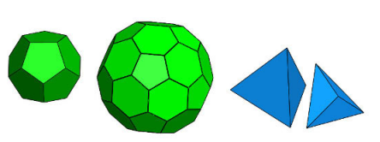
Figure 1, Polyhedral (green), Tetrahedral (blue). [16]

To justify a suitable mesh size for this report 3 mesh sizes were compared against a real-world example (0.01mm, 0.02mm and 0.05mm). These 3 varying sizes were chosen to represent a course, fine and automatically generated mesh.

The results of the testing were compared to the validation study conducted in 4.0 Validation. The best results were collected using the finer mesh, but the automatic mesh did perform well. However, it was not shown in this study but having too fine of a mesh can introduce rounding errors which accumulate and translate to the next element increasing the error. It was proven that having too big of a mesh does have the ability to hide detail and reduce the accuracy as fewer interactions are occurring. For most simulations, it is best practice to conduct a mesh-independent study for the geometries involved within the simulations, for the best results.

3.2 Simulation setup
For the simulation a target material is needed for analysis, the options may be to use ballistic gelatine [17] or a metal target plate. As this simulation is evaluating metal jacket materials, impact gelatine is not used because metal targets will put up more resistance [3]. To create a target, Solidworks was used to make a 3D model [18], which consisted of mild steel. The dimensions of the target were 50mmx50mmx25mm (XYZ) presented in Figure 2. However, a real-world target plate would be twenty times bigger, as bullets have natural deviations which would make hitting a plate reliably hard. Therefore, in a simulation, the plate can be smaller as it is guaranteed to hit with a higher accuracy, which allows for quicker simulations. As it would take too much computational power to simulate a whole plate when only a limited area is significantly affected. The target is made up of mild steel which is used regularly in the ballistics industry [19].

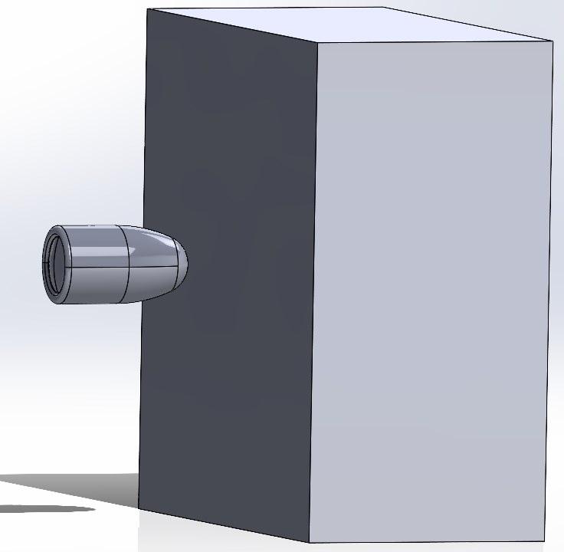
Figure 2, 50x50x25 mm target.

The 7.62mm NATO (Figure 3) bullet model was found online, as Grabcad is advised as a reputable source of 3D models with accreditations to the creators [20]. This model was in the form of a STEP file which was imported to Solidworks and tweaked slightly by removing the bullet casing. The bullet does use 2 parts that are in contact with each other to recreate the lead and metal jacket geometries. The bullet must be accurately modelled to real-world dimensions, with the correct curvatures and finer details so that simulations produce representable results.

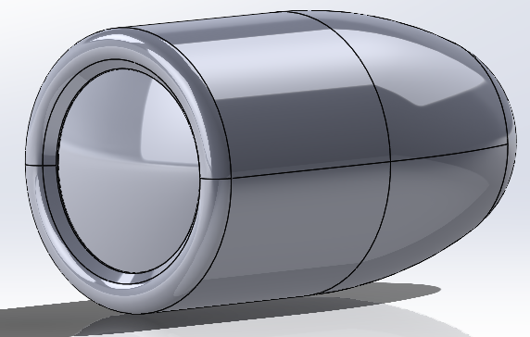
Figure 3, NATO 7.62 bullet.

The assemblies made within Solidworks were then exported into ANSYS so that the material properties could be assigned to the different components. The materials used are defined in Table 1, Material Data, it is important to have accurate material properties within the simulations as it is important for the results to be realistic and comparable to real-world testing.

The mesh is also created within ANSYS using the previously discussed 3.1 Mesh independent study to determine the 0.01mm mesh size that is correct for the demands of this simulation. The boundary conditions of the simulation affect the accuracy of the simulations as it defines the way parts interact with each other. Fixed supports were used on the target to emulate the target being fixed in a testing rig to stop any impact forces pushing the target around. With the target being fixed, the bullet will use all its energy to penetrate through the target, and not push the target out the way. However, it is not fully correct to completely fix the target as this would not be possible in the real world due to physical factors. Therefore, the simulation is modelling an ideal scenario, which will put high forces on the bullet.

Table 1, Material Data
Material Name | Assignment | Material data source
Low alloy steel, AISI 4140, normalized | Target plate | Granta EDUPack 2022R2  Edition: level 3
Lead-antimony alloy, Hard lead 95-5, cast | Bullet core | Granta EDUPack 2022R2  Edition: level 3
Coated copper, copper, lead coated | Bullet metal jacket | Granta EDUPack 2022R2  Edition: level 3
Gold | Bullet metal jacket | ANSYS Workbench:  “Equation of state and strength properties of selected material”. Steinberg D.J LLNL. Feb 1991
Tungsten | Bullet metal jacket | ANSYS Workbench:  “Equation of state and strength properties of selected material”. Steinberg D.J LLNL. Feb 1991

The bullets in this report will have velocities of 800 m/s, as a typical NATO 7.62mm bullet will have these velocities of 715 m/s - 810 m/s [21]. Studies have been conducted with similar intention but for target analysis have used projectile speeds of 945 m/s [22], at 800 m/s the projectile should not complete full penetration of the target. From this, we can expect no full target penetration of the target, which implies the bullet should see a large resistance and its higher stresses will be analysed within this report.

However, the report may be further expanded in future investigations by incorporating a thermal study at the same time as the explicit solver, this will alter how the target will deform and propagate stress waves. Thermal effects would be expected to degrade materials within the simulations, leading to different results produced in this report.

4.0 Validation
While using ANSYS Explicit dynamics, it is important to validate the solver's calculations. Validating is the process of quantifying a solver’s accuracy compared to a real-world example. This process can involve hand calculations compared to physical data or other computational solvers that have already been validated. As ANSYS Explicit use nonlinear calculations in its simulations, it would be ideal to validate it with a nonlinear problem [23].

However, some difficulties were faced trying to validate this explicit dynamics solver as the validation description was missing some material properties which didn’t allow it to work. To prove that ANSYS is capable of modelling a real-world problem, a static-structural analysis validation was conducted using a bending cantilever with an axial force [24].

This validation was proven numerically within the verification example and confirmed ANSYS’s ability to model real-world data accurately as the results generated are displayed in Table 2, Validation results. However, the results only validated it in the Y axis, they conflict in the X axis. For the simulation software to be out by this amount suggests an error in the validation example as perhaps the wrong units were used, which would create a better-fitting result. Unfortunately, the validation example could be right, which proves how poorly ANSYS performs as simulation software.

Table 2, Validation results
Solver method | Deformation in the X axis | Deformation in the Y axis
Numerical Calculation | 0.012mm | 3557.478mm
ANSYS | 21.349mm | 3555.6mm
Accuracy percentage | N/A | 99.99472%

5.0 Results & Analysis

5.1 Copper results
The results from the copper-jacketed bullet are shown below. These show that copper does partially fragment upon impact, denoted by the red nodes found in Figure 4. The copper can also be found to induce deformations in the target (Figure 5) from 2.4395e-3m – 3.4838e-3m and a maximum of 0.0027919. Overall, (Figure 6) this result shows what a standard penetration can be expected from a NATO 7.62mm bullet and how the metal jacket has performed. Figure 7 is the associated velocity of the bullet during the simulation.

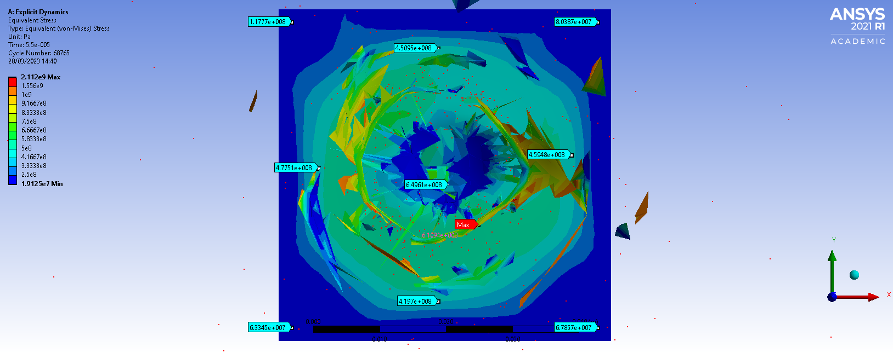
Figure 4, Total stress Copper
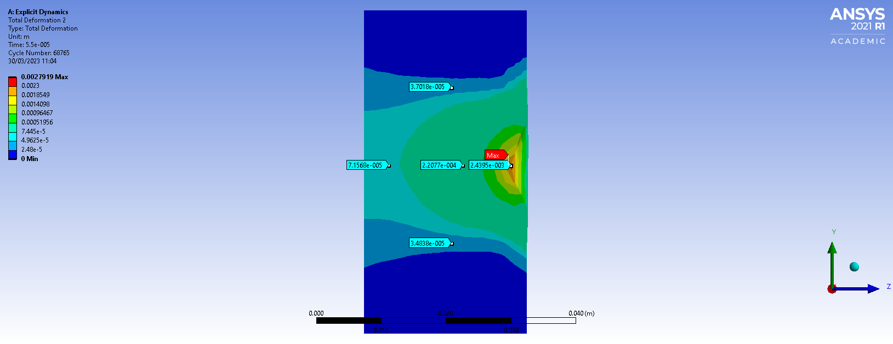
Figure 5, Total deformation of Copper
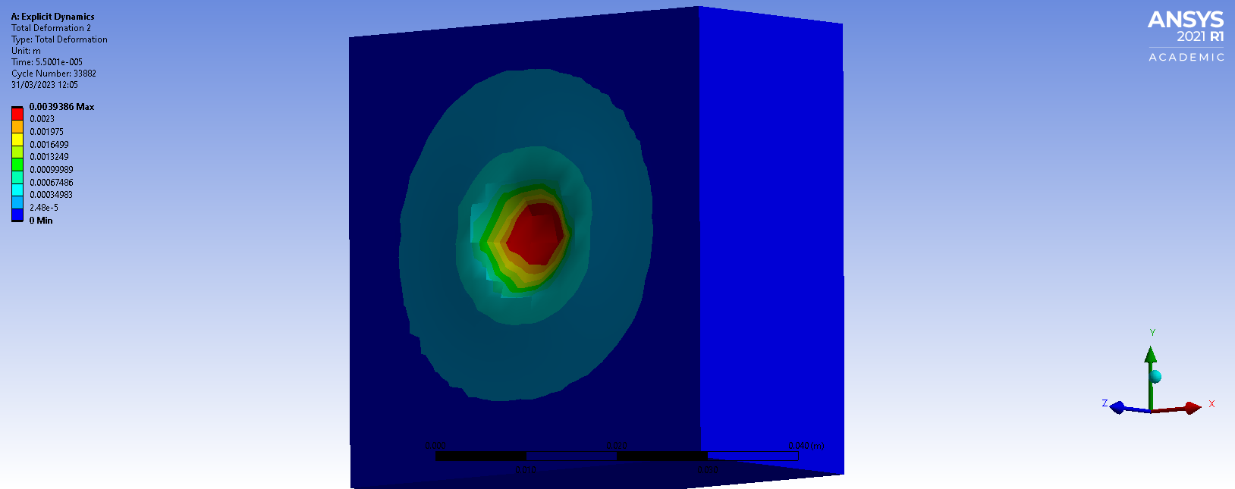
Figure 6, Total deformation overview of copper

Figure 7, Velocity trace Copper

5.2 Gold results
The findings from the gold jacket, show that it has heavily fragmented upon impact (Figure 8), this was expected due to the physical properties of the material, proving that ANSYS is good a modelling deformation within the bullet. One interesting finding was that the penetration was greater than the results from 5.1 Copper results. But gold has deformation effects shown by Figure 9, ranging from within the target 2.2274e-3m – 3.1857e-5m and a maximum of 0.039386m. But the visual analysis of both copper (Figure 6)and gold targets (Figure 10) shows a similar amount of penetration in the target. However, the result in 5.3 Tungsten results suggests something is not accurate with the gold simulation as it was not expected to outperform the other jackets. This may be attributed to the choice of gold material not being what type of gold we expected. A solution to this may be to gather material data from a more trusted source such as GRANTA or other academic literature. Figure 11 relates to the velocity of the gold bullet in this simulation.

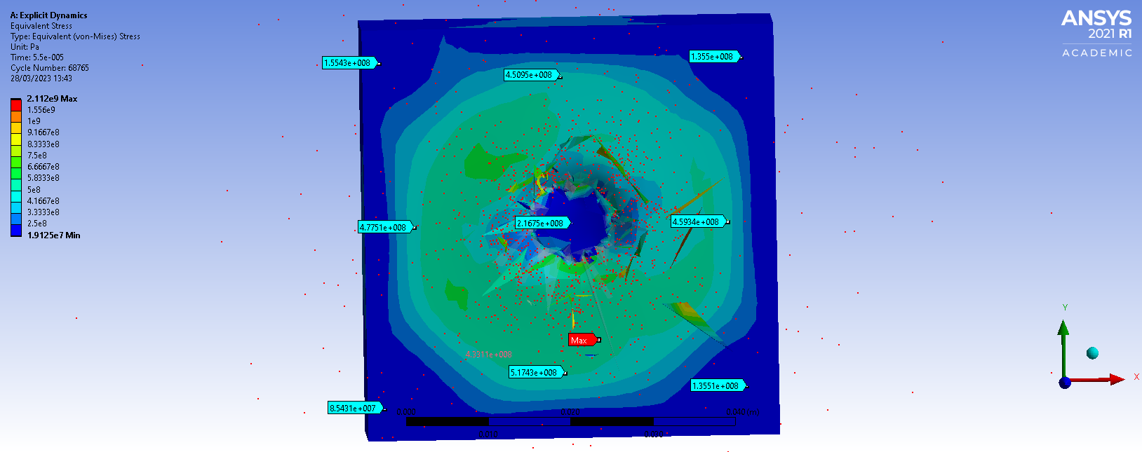
Figure 8, Total Stress Gold
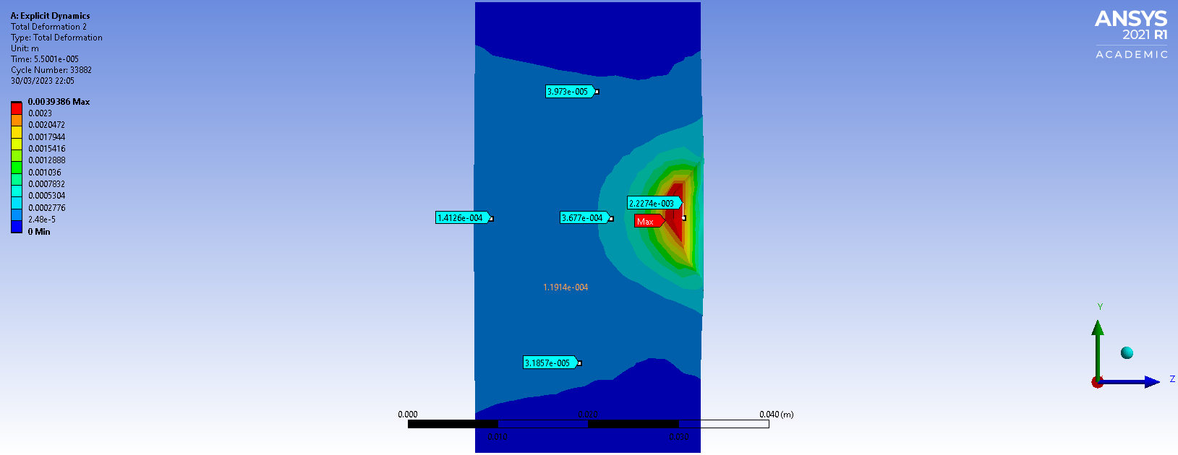
Figure 9, Total deformation of Gold
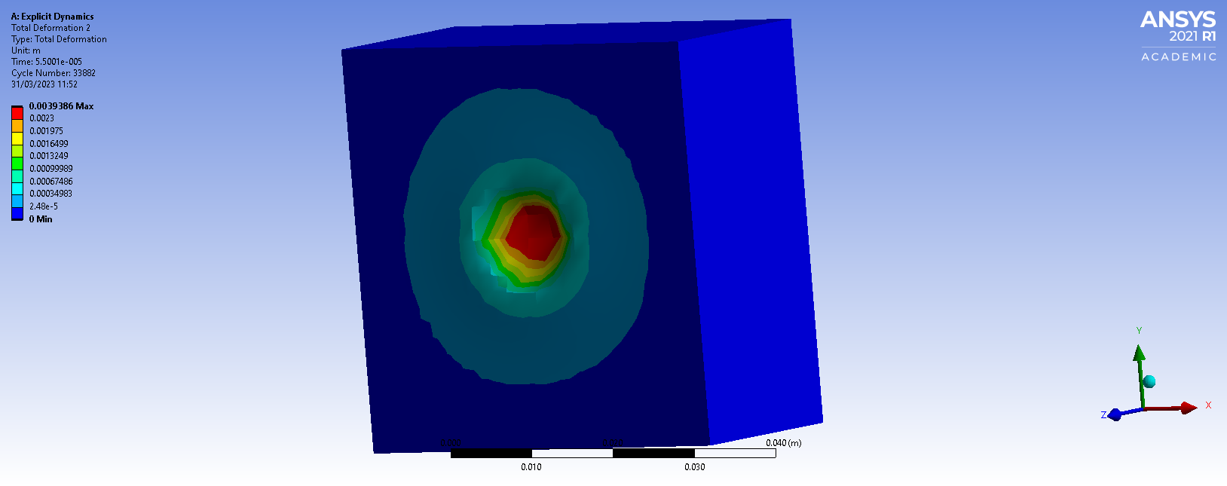
Figure 10, Total deformation Overview Gold

Figure 11, Velocity trace Gold

5.3 Tungsten results
The results of the tungsten jacket show that the jacket deformation was modelled well as it has remained strong and not significantly fragmented as shown in Figure 12, this would infer a high depth of penetration. Unexpectedly, the ranges of deformation within the target (Figure 13), are 3.4315e-3m – 5.4096e-5m and a maximum value of 0.003415m. These results are lower than the ones produced in the 5.2 Gold results. However, the visual comparison in Figure 14 shows a higher penetration within the tungsten target. Tungsten has performed well as a jacket choice for the 7.62mm bullet, however, due to cost implications it is not a viable round for mass production across militaries. It may be considered for specialist applications where penetration is important, such as use in armour piercing rounds with other materials to make it an alloy. Figure 15, shows the velocity of the tungsten bullet.

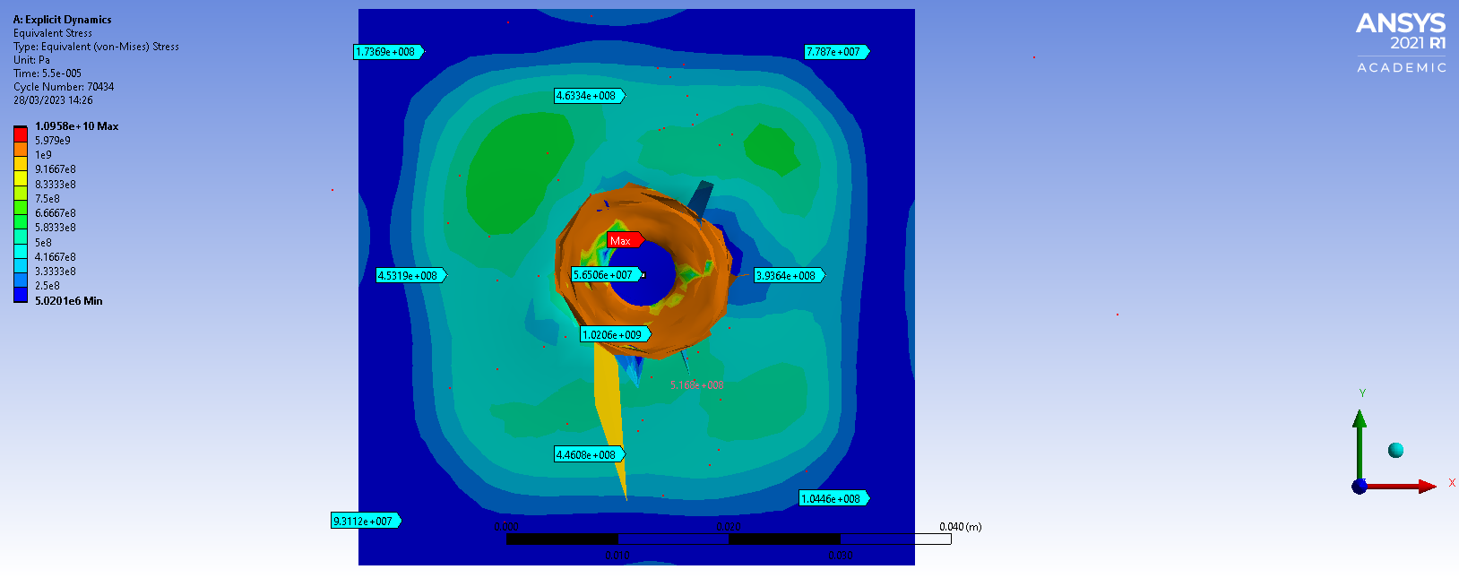
Figure 12, Total stress Tungsten
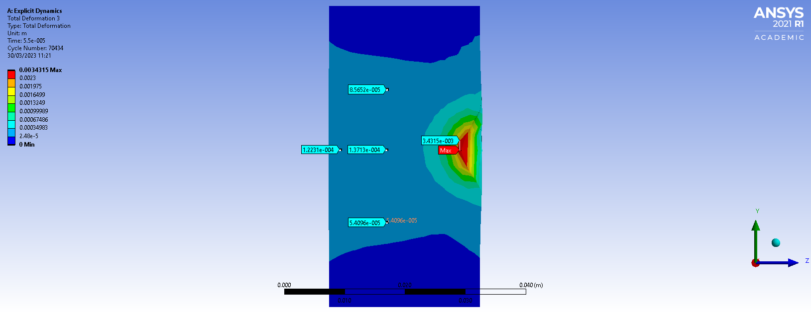
Figure 13, Total deformation Tungsten
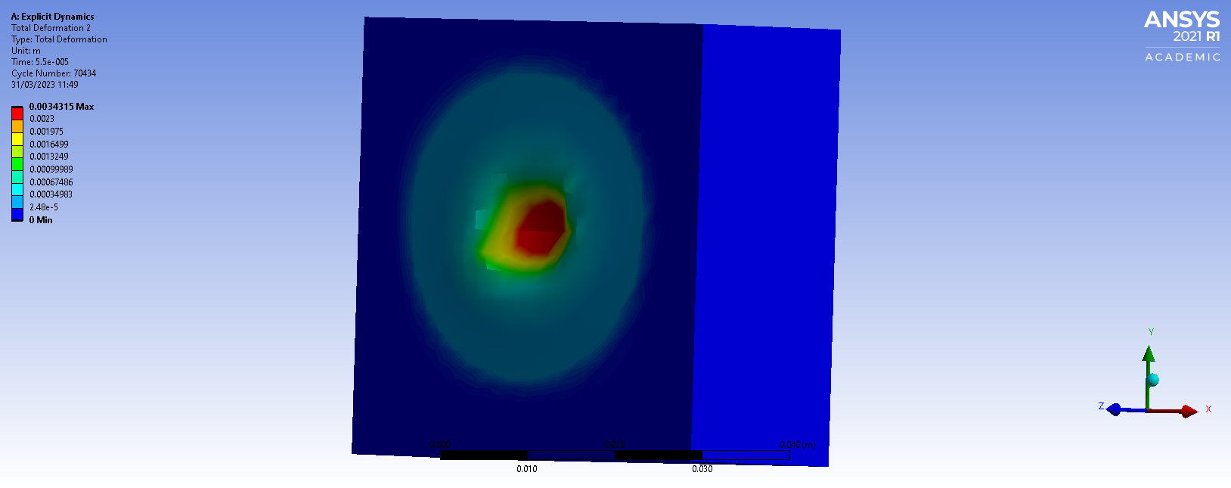
Figure 14, Total deformation Overview Tungsten

Figure 15, Velocity trace Tungsten

5.4 Overview
All three simulations are not ideal as the velocity trace of the bullet shows that the bullet speeds up after slowing down. In reality, this would not occur, but it most likely occurred due to a node of the target being deleted leaving a void for the bullet to speed up into, causing it to then slow down again when it comes into contact again. In addition to this analysis comparing the 3 velocity traces, it can be inferred that the simulation has failed to model the correct deformation within the target as gold and copper have the same velocity traces. This may be attributed to not enough material data about the gold and copper materials being provided as the source of the materials was from ANSYS not GRANTA which provides more accurate data on the materials.
These findings may be somewhat limited by the choice of target material, the mild steel that was used is too strong, so it did not show a lot of variation in results with the different metal jackets. To better highlight the effects of changing the metal jacket, another target material must be considered that will allow the jacket choice to have more influence on it. Most of the deformation effects were minimal so the variation between different materials was not distinguishable.

6.0 Conclusion
This report set out to assess the feasibility of CAE to simulate real-world problems for critical analysis of explicit dynamics, which will enhance the understanding of the limitations or factors that affect the results obtained. This was achieved by comparing three different materials as jackets of a projectile, which undertook different mechanical deformations for analysis.

To fully explore CAE, many finite element analysis software was discussed to show the benefits and limitations associated with each software package. These showed that simulations can save a lot of time by proving why certain designs are poor or perform in an unexpected way early on. Software should be used on well-researched subject areas to validate the results that are generated. It is found that the best practice is to use multiple simulation software to correlate and compare results to ensure validity.

The software available and the budget available greatly affects the output as well as different mesh densities and types. As well as the model geometries which are important to be modelled correctly to the right size with the correct internal interactions.

The simulation software used in this report was ANSYS, this was due to it being widely accepted within the impact analysis sector. However, this report was unable to prove the validity of the explicit solver, so a simpler solver was used. This solver was not fully validated as the validation example is not realistic, it is believed that shows results in the validation are in the wrong units.

Despite this limitation, the analysis from the simulations shows that ANSYS performs well in modelling the deformation of the bullet. This was because the results matched up with what was expected to happen. But the penetration results within the target were not expected as gold produced the highest results, which suggests an error within the simulation. The errors may have started from a lack of material data being provided, which highlights how important it is to ensure everything is correctly entered for the type of solver that the software is using. As if a Slover is missing material data it cannot accurately model the object. During the report, it also became clear that regardless of how sophisticated the software is, there are extra steps/ procedures you have to go through to maximise the results seen by simulations.

Whilst the report, did not fully explore all the different simulation software, it did highlight the benefits of using a simulation as opposed to a real-world experiment. Limitations of computer modelling were introduced and proven by the difficulties faced in the simulation within the report.

The study should be repeated using a more advanced simulation software where additional parameters, such as thermal expansion can be analysed. Additionally using a softer target material will highlight the disparities between results better. This can then be compared to a real-world study to validate the results seen. This would then further prove a simulation’s reliability and accuracy, in bullet impact analysis.

7.0 References

[1] | A. Kolbasin1 and O. Husu, “Computer-aided design and Computer-aided,” vol. 170, June 2018.
[2] | AMMO.com, “FMJ Advantages: Full Metal Jacket Bullet vs. Regular Bullet,” [Online]. Available: https://ammo.com/bullet-type/full-metal-jacket-fmj#:~:text=As%20a%20lead%20bullet%20engages,be%20fired%20before%20accuracy%20degrades.. [Accessed 26 04 2023].
[3] | A. EIDeeb and A. Elmeselhy, “Ballistic Behavior of Developed 12.7x99 mm Tungsten Carbide Core AP Projectiles against High Hardness Steel Armor,” 2021.
[4] | F. Erninge, “Tungsten Carbide Armor Piercing Technology,” 2015.
[5] | B. Zentai and Á. Veress, “Verification and Validation of Static Structural and Explicit Dynamic Simulations Respectively for Plastic Products with Especial Care for Automotive Application,” 19 April 2018.
[6] | L. Turhan, Ö. Eksik, E. B. Yalçın, A. Demirural, T. Baykara and V. Günay, “Computational simulations and ballistic verification tests for 7.62mm AP and 12.7mm AP bullet impact against ceramic metal composite armours,” 2008.
[7] | TECHNIA ADDNODE GROUP, “Abaqus Unified FEA,” [Online]. Available: https://www.technia.co.uk/software/simulia/abaqus/. [Accessed 27 04 2023].
[8] | N. Babu, A. P. Singh, N. S. Reddy and D. Murpani, “SIMULATION OF BALLISTIC IMPACT ON DIFFERENT COMPOSITE SAMPLES OF BULLET PROOF VEST,” International Conference on Design, Automation, and Control, 2020.
[9] | ANSYS, Inc, “Ansys Explicit Dynamics,” 2021. [Online]. [Accessed 27 04 2023].
[10] | Mechead, “What is Explicit Dynamics in Ansys?,” 9 July 2019. [Online]. Available: https://www.mechead.com/what-is-explicit-dynamics-in-ansys/. [Accessed 22 04 2023].
[11] | H. Norrgard, “RandSIM,” 11 12 2020. [Online]. Available: https://blogs.rand.com/randsim/2020/11/explicit-dynamics-and-ansys-part-i.html. [Accessed 28 04 2023].
[12] | ANSYS, “Discussion of Implicit and,” 2022.
[13] | N. Gukop, P. Kamtu, B. Lengs, A. Babawuya and A. Adegoke, “Effect of Mesh Density on Finite Element Analysis Simulation of a Support Bracket,” FUOYE Journal of Engineering and Technology, 2021.
[14] | W. Widyastuti, H. I. Ramadhian, M. I. P. Hidayat, A. P. Wibowo and H. Ardhyanata, “Bullet Frangibility Factor Quantification by Using Explicit Dynamic Simulation Method,” 2022.
[15] | G. Liu and N. Trung, “Smoothed Finite Element Methods,” p. 6, 2016.
[16] | M. Sosnowski, J. Krzywanski and R. Gnatowska, “Polyhedral meshing as an innovative approach”.
[17] | Y. Wen, C. Xu, Y. Jin and R. Bratra, “Rifle bullet penetration into ballistic gelatin,” Journal of the Mechanical Behavior of Biomedical Materials, 2016.
[18] | Dassault Systems, Introducing Solidworks, 2015.
[19] | K. Senthil, M. Iqbal and N. Gupta, “Ballistic resistance of mild steel plates of various thicknesses against 7.62 AP projectiles,” International Journal of Protective Structures, vol. 8, no. 2, 23 March 2017.
[20] | C. Haas, 7.62x51mm NATO, 2015.
[21] | P. Knudsen, J. Vigsnaes, R. Rasmussen and P. Nissen, “Terminal ballistics of 7.62 mm NATO bullets: experiments in ordnance gelatin”.
[22] | D. Mohotti, T. Ngo, N. R. Sudharshan and P. Mendis, “Analytical and numerical investigation of polyurea layered aluminium plates subjected to high velocity projectile impact,” p. 3, 2015.
[23] | Dlubal Software, “NAFEMS NL 7 – Lee´s Frame Buckling Problem,” 2022. [Online]. [Accessed 24 04 2023].
[24] | Dlubal Software, “ Bending Cantilever with Axial Force,” 2015. [Online]. [Accessed 24 04 2023].

8.0 Appendix

Appendix A
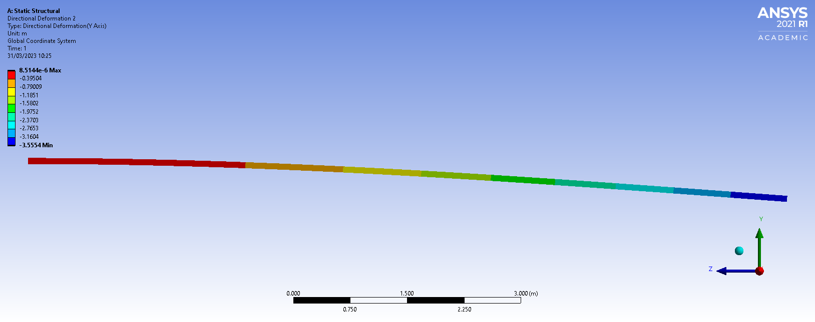
0.02mm mesh results in the Y plane.

Appendix B
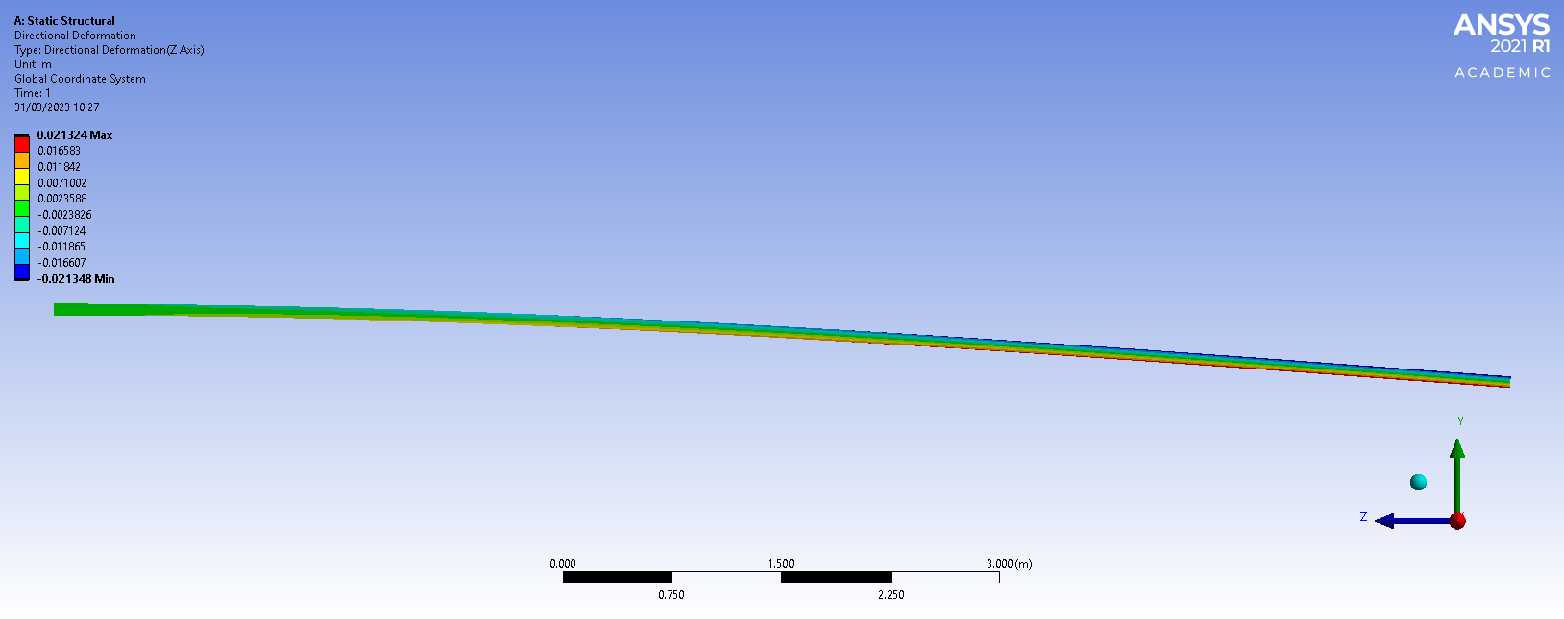
0.02mm mesh results in the X plane.

Appendix C
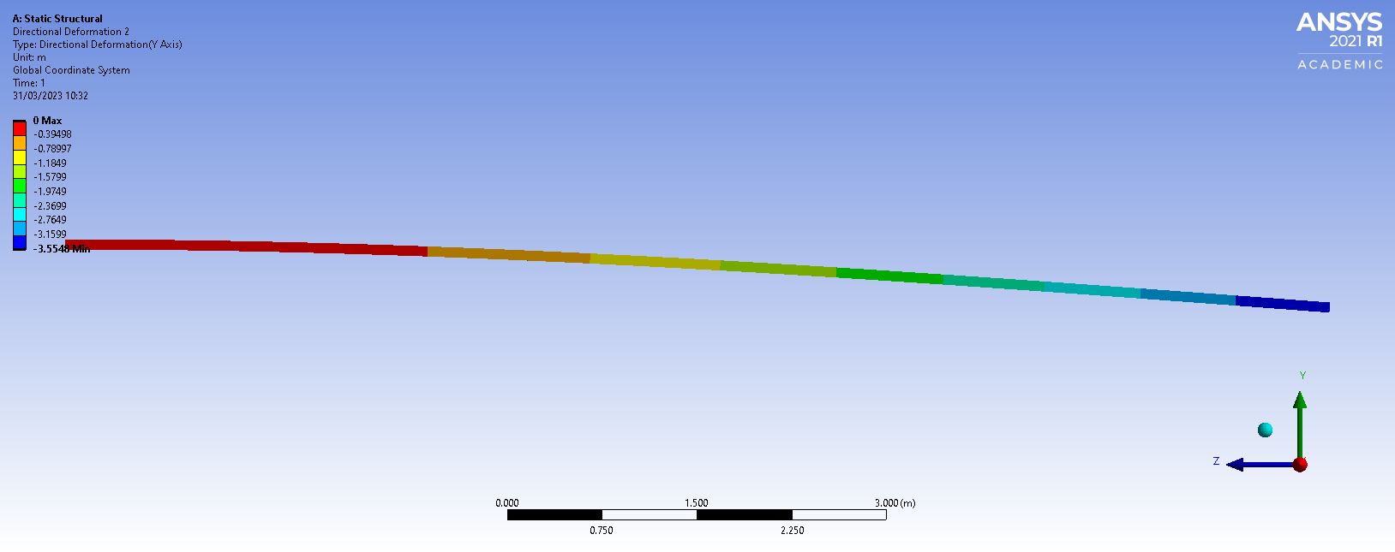
0.05mm mesh results in the Y plane.

Appendix D
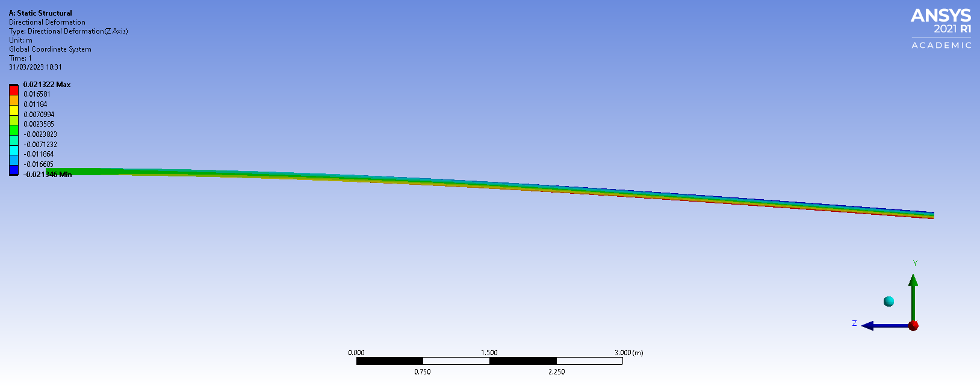
0.05mm mesh results in the X plane.

Appendix E
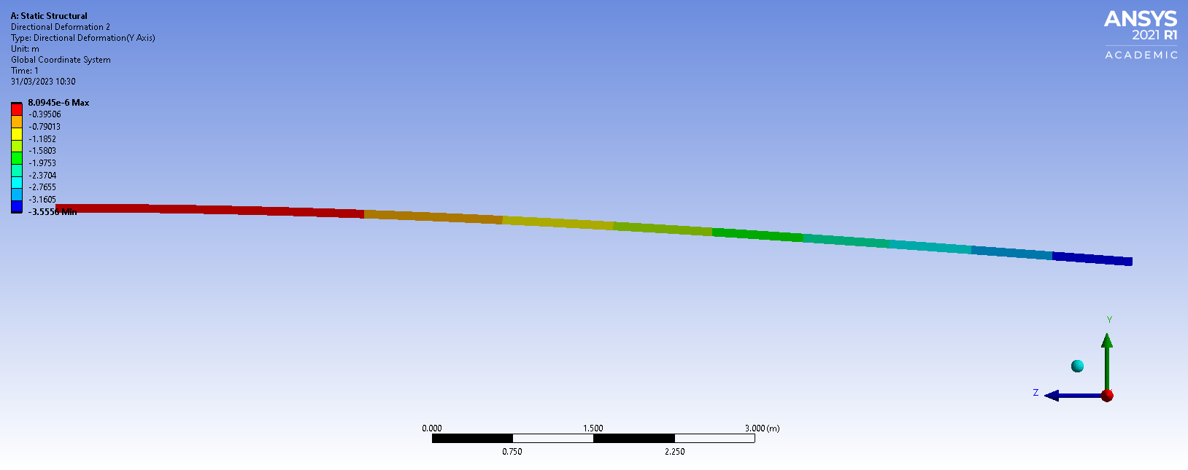
0.01mm mesh results in the Y plane.

Appendix F
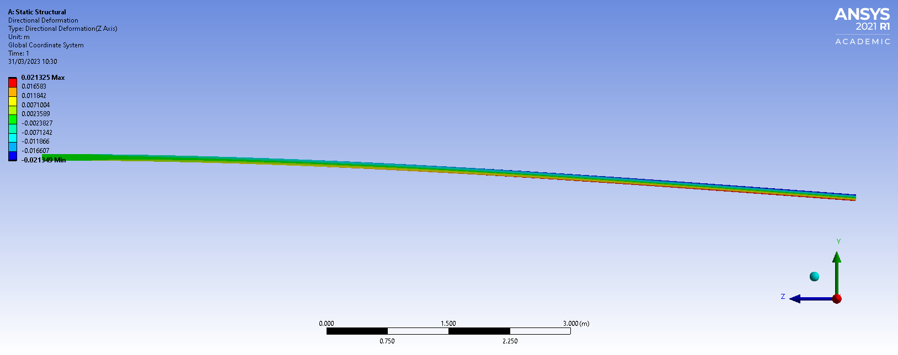
0.01mm mesh results in the X plane.

