
LCHS7006 – Quality Assurance and Service Improvement
Acute Kidney Injury (AKI): Mechanisms of Injury, Repair, and Regenerative Medicine
A Critical Analysis and Service Improvement Proposal

Student Name: Krishaben Mukeshbhai Ahir
Student ID: 2527055
Module Leader: Dr Fahad Khan

Table of Contents
1. Introduction 3
2. Root Cause Analysis of AKI Service Failures 4
2.1 Donabedian Model Application 4
2.2 Fishbone Diagram Analysis 5
2.3 Strategic Analysis – SWOT 6
2.4 Mechanisms of Injury, Maladaptive Repair, and Regenerative Medicine 7
2.5 Implementation Using the PDSA Cycle 8
2.5 Application of Kotter’s 8-Step Change Model 9
3. Recommendations 10
4. Conclusion 12
References 13

1. Introduction
Acute Kidney Injury (AKI) poses one of the greatest and preventable patient safety threats to modern-day healthcare systems. Described as a rapid impairment in kidney function, AKI has been found to affect 20% of all admitted patients, being linked to higher rates of morbidity, mortality, extended hospital stay, and development of chronic kidney disease (CKD) (Rayego-Mateos et al., 2022; Huang et al., 2026). It presents a significant burden for healthcare systems and results in millions of cases per year and high costs worldwide (Xu et al., 2025).
Although it is highly prevalent and well-documented in terms of its impacts on patient safety, AKI continues to go unnoticed and unmanaged by hospitals effectively. Component 1 of this case study demonstrates several key factors contributing to this issue, such as delayed recognition of the deterioration in renal function, lack of serum creatinine and urine output monitoring, poor communication within multidisciplinary teams, insufficient staffing levels, and poor governance at organisational level (Zhang et al., 2024; Naved et al., 2022). All of these factors fit into the theory of Swiss Cheese Model of accident causation (Xu et al., 2025).
The existing national and international guidelines, such as NICE NG148 and KDIGO guidelines, stress the necessity of early detection, risk assessment and interventions (NICE, 2024; KDIGO, 2026). Nevertheless, there are considerable inconsistencies between the recommended practice and its implementation. Comparing to the existing standards, benchmarking indicates the existence of substantial variation in detection, escalation, and post-AKI care which results in the unnecessary progression of patients' condition towards the CKD and additional mortality (GIRFT, 2025; UK Kidney Association, 2024).
Recent studies have revealed the molecular mechanisms underlying the development of AKI which involves maladaptive repair responses such as cellular senescence, G2/M cell cycle arrest and epigenetic programming of renal epithelial cells (Muto et al., 2024; Chen et al., 2024). At the same time, regenerative medicine with the development of such innovative technologies as the use of mesenchymal stem cell-derived extracellular vesicles (EVs) and urine-derived stem cells shows a promising direction for the future development of services (Wang et al., 2025; Li et al., 2024).
In this report, the attempt will be made to critically evaluate the factors leading to poor AKI care applying quality improvement framework, the possible impact of innovations of regenerative medicine in the domain and to suggest a service improvement strategy based on the analysis.

2. Root Cause Analysis of AKI Service Failures

2.1 Donabedian Model Application
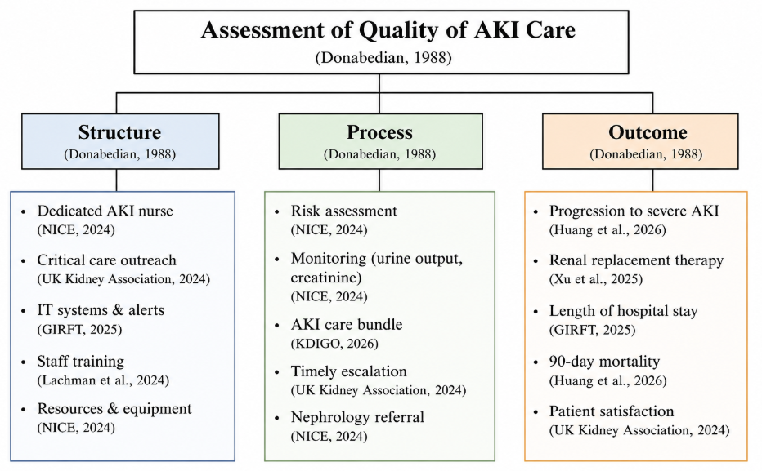
Figure 1: Donabedian Model
(Source: Adapted from Donabedian, 1988)
In particular, the Donabedian Model offers an insightful way to assess the quality of AKI care by analysing the three interrelated domains of the model (Structure, Process, and Outcome). Regarding the structure of the healthcare organisation, many institutions do not have specific AKI specialist nurses, have low capacity for critical care outreach, and have highly fragmented information technologies that are incapable of implementing real-time risk stratification and providing alerts (GIRFT, 2025).
As far as process is concerned, many organisations exhibit inconsistencies in assessing the risk level during the admission, failure to perform hourly urine output assessment of the high-risk group of patients, and delays or lack of nephrology referral despite clearly established criteria for doing so (NICE, 2024; Zhang et al., 2024). Inconsistencies in implementing care bundles result in inadequate application of evidence-based interventions in practice.
The outcomes show the effect of all the above-mentioned weaknesses in the healthcare delivery system. Organisations exhibit higher than benchmarked levels of progression to severe AKI, greater need for renal replacement therapy, prolonged stay in the hospital, and higher 90-day mortality (Huang et al., 2026; Xu et al., 2025). It is evident from the Donabedian analysis that improvement of the problem cannot be achieved simply by measuring the outcomes.

2.2 Fishbone Diagram Analysis
The fishbone (Ishikawa) diagram provides a structured approach towards analyzing the multiple causative factors responsible for the delayed identification of AKI. Upon application to the existing service delivery context, six key causal areas come up.
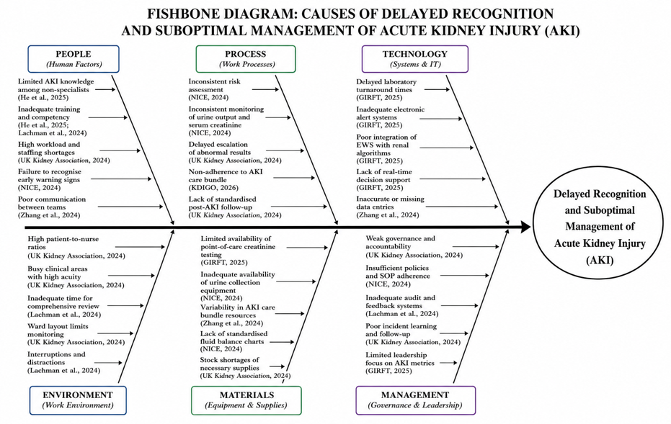
Figure 2: Fishbone Diagram: Causes of Delayed AKI Recognition and Management
(Source: Self-Developed)
Regarding the ‘People’ domain, there are considerable gaps in the expertise of clinicians who do not specialise in AKI, together with the high workload and lack of training in AKI which leads to delays in detection (He et al., 2025). Human factors are reinforced by the lack of competencies and skills frameworks around AKI in many institutions.
Within the ‘Processes’ domain, there are inconsistent uses of evidence-based risk stratification tools advocated by NICE and inconsistency in the protocol of monitoring urine output (NICE, 2024). Furthermore, many wards still operate on an ad hoc basis in relation to charting fluid balances rather than protocolised ones. ‘Technology’ factors include delays in lab results for serum creatinine and failure to integrate e-early warning systems with AKI specific algorithms so deterioration is not picked up (GIRFT, 2025).
The environmental barriers include ward designs which prevent continuous monitoring and also the persistent high nurse-patient ratios. In relation to the ‘Materials’ domain, there are inconsistent provision of point of care testing for serum creatinine and inconsistent use of care bundles in AKI. Lastly, ‘Management’ factors include poor organisational learning from past AKI events and the lack of senior executive accountability for AKI metrics (UK Kidney Association, 2024; Lachman et al., 2024). As shown here, the complex causality of this problem means that interventions in isolation of any one domain will have little impact on achieving improvement.

2.3 Strategic Analysis – SWOT
A SWOT analysis of current AKI service provision highlights both significant challenges and strategic opportunities.
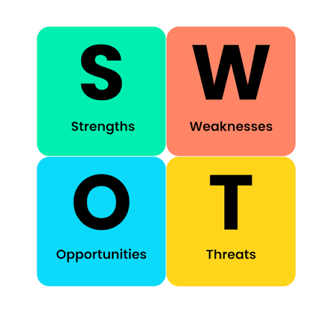
Figure 3: SWOT Analysis
(Source: BusinessBalls, n.d.)
The strengths of current services are represented by the presence of national and international guidelines (NICE NG148 and KDIGO) based on evidence; established patient safety alert framework; and increased awareness of the organisation due to recent national reports (NICE, 2024; KDIGO, 2026).
Among the weaknesses of the services there are: inconsistency in the implementation of the guidelines; workforce capabilities; and fragmentation of post-AKI pathway that does not help to avoid a well-known risk for chronic kidney disease (UK Kidney Association, 2024). In many cases, organisations consider AKI only as an acute event but do not pay attention to its consequences.
The opportunity is rapid science progress in regenerative medicine. The mesenchymal stem cell-derived extracellular vesicles showed powerful anti-inflammatory, anti-apoptotic and pro-regenerative properties in preclinical trials and therefore may become the basis for a new cell-free therapy that will be used in the future treatment pathway (Chen et al., 2026; Wang et al., 2025; Quaglia et al., 2022). The urine-derived stem cells can also be used in the process of the treatment. They are easily available and have low immunogenicity (Li et al., 2024). This discovery may change the landscape of treatment if appropriate service is created for using biomarkers and stratification.
The threats for AKI management include current workforce challenges; other priorities within the organisation; and a threat that regenerative medicine will be limited only to research unless the special service is restructured (Nishimura, 2026; Pan et al., 2025).

2.4 Mechanisms of Injury, Maladaptive Repair, and Regenerative Medicine
The detailed knowledge of biological underpinnings of the AKI is critical for the provision of services going beyond detection and support to the manipulation of repair processes. Tubular epithelial cells, which sustain damage on account of ischaemia or nephrotoxicity, go through the range of changes ranging from sub-lethal stress to necrosis and apoptosis. In less severe cases, survival cells become able to dedifferentiate, to divide and successfully repopulate the injured area (Rayego-Mateos et al., 2022; Sun et al., 2025).
However, in case of the more severe or repetitive injuries, the repair response becomes maladaptive. Key mechanisms comprise G2/M cell cycle arrest when proliferation stops, while the secretion profile becomes pro-fibrotic; cell senescence, characterized by an irreversible growth arrest and secretion of inflammatory mediators through senescence-associated secretory phenotype; and epigenetic reprogramming that ensures maintenance of failed repair state (Muto et al., 2024; Chen et al., 2024; Shu et al., 2025). Metabolic reprogramming in the form of mitochondrial dysfunction and impaired lipid metabolism adds to inflammation and interstitial fibrosis (Zhu et al., 2022; Xu et al., 2025). These interconnected processes explain the epidemiological association between the occurrence of AKI and CKD development.
The use of regenerative medicine approaches offers a possibility to disrupt maladaptive cascades. Extracellular vesicles produced by mesenchymal stromal cells carry microRNAs, proteins, and lipids, which help to modulate inflammation, prevent apoptosis, and promote tubular epithelial cell proliferation without the risks related to cell injection (Chen et al., 2026; Hong et al., 2024; Kim et al., 2025). According to pre-clinical research, EV therapy helps to alleviate severity of injury, to facilitate functional recovery and to avoid development of fibrotic remodeling (Zhang et al., 2025; Wang et al., 2025). Similarly, urine-derived stem cells exhibit paracrine benefits with additional translational opportunities (Li et al., 2024).
These promising therapies are still investigational; however, their appearance implies important consequences for the future design of service pathways. AKI treatment pathways may include early molecular phenotyping of high-risk of the maladaptive repair and, thereby, targeted application of regenerative medicine therapies during the period of recovery. It will be a paradigm shift from solely supportive care to biologically-based therapy (Nishimura, 2026; Terada et al., 2020). Future improvements will need to anticipate it and develop relevant infrastructure of biomarker collection, risk stratification, and involvement in research of regenerative medicine.

2.5 Implementation Using the PDSA Cycle
Efficient and successful execution of the recommendations suggested will be carried out by means of iterative utilization of the PDSA cycle, known as a fundamental approach to improvement in healthcare (Lachman et al., 2024).
Plan Phase (Months 1–3)
The Plan phase will require the formal establishment of an interdisciplinary AKI Improvement Team, including nephrologists, intensivists, pharmacists, informaticians, and experts in patient safety. There needs to be a thorough audit of the incidence, rate of diagnosis, rate of escalations, and 90-day outcomes of patients with AKI. It is necessary to develop a standardized care bundle based on NICE and KDIGO guidelines, which should be integrated into the electronic patient record. It will be necessary to develop staff education programs, select pilot wards, and obtain executive endorsement. Key performance indicators need to be defined and measured, which include time from alert to acknowledgment, adherence to urine output measurement, and 90-day follow-up for eligible patients (NICE, 2024; GIRFT, 2025).
Do Phase (Months 4–6)
As part of the Do stage, the pilot of AKI care bundle and real-time alerting system should be conducted in two carefully chosen high-risk wards like elder care and critical care wards. Proper training must be provided to all employees in these wards. The introduction of weekly multidisciplinary safety huddle is recommended in order to identify recent AKI incidents and improve them. Biomarker samples must be collected from patients who have consented in view of future collaboration in regenerative medicine research (Wang et al., 2025; Li et al., 2024).
Study Phase (Months 7–9)
The Study Stage involves a structured assessment of the pilot data against the pre-established baseline KPIs. Staff focus group sessions should be conducted to examine any barriers and facilitators, as well as unintended effects associated with the changes. Thematic analyses of all safety incident cases associated with the AKIs should be done in order to achieve organisational learning. Any preliminary indicators concerning the effect on hospital length of stay and AKI progression should also be examined (Xu et al., 2025; Chen et al., 2024).
Act Phase (Months 10–12 and beyond)
Finally, the Act stage comprises fine-tuning the care bundle and alert system according to the insights gained during the pilot before moving ahead with implementation within the entire organisation. Monthly audit and feedback mechanisms need to remain in place, and AKI performance indicators should form part of the regular board reporting. There needs to be a compelling business case for creating specialist nurse positions for AKI care. Academic alliances need to be formally established so that participation in regenerative medicine clinical trials can be facilitated. An effective governance structure, which will include quarterly executive oversight and annual benchmarking against other institutions, should be set up (UK Kidney Association, 2024; Lachman et al., 2024).
Through such a well-defined PDSA process, all changes are made evidence-based, context-driven, and iteratively fine-tuned using data and first-hand information. At the same time, an environment conducive to organisational learning is created, which is crucial for embedding the change and implementing future regenerative medicine breakthroughs.

2.5 Application of Kotter’s 8-Step Change Model
Although the PDSA cycle helps implement an intervention process, sustainable organisational change needs to consider not only the technical aspect but also the human aspects of change as well. For that purpose, the eight-step change model by Kotter proves to be a useful tool (Kotter, 1996).
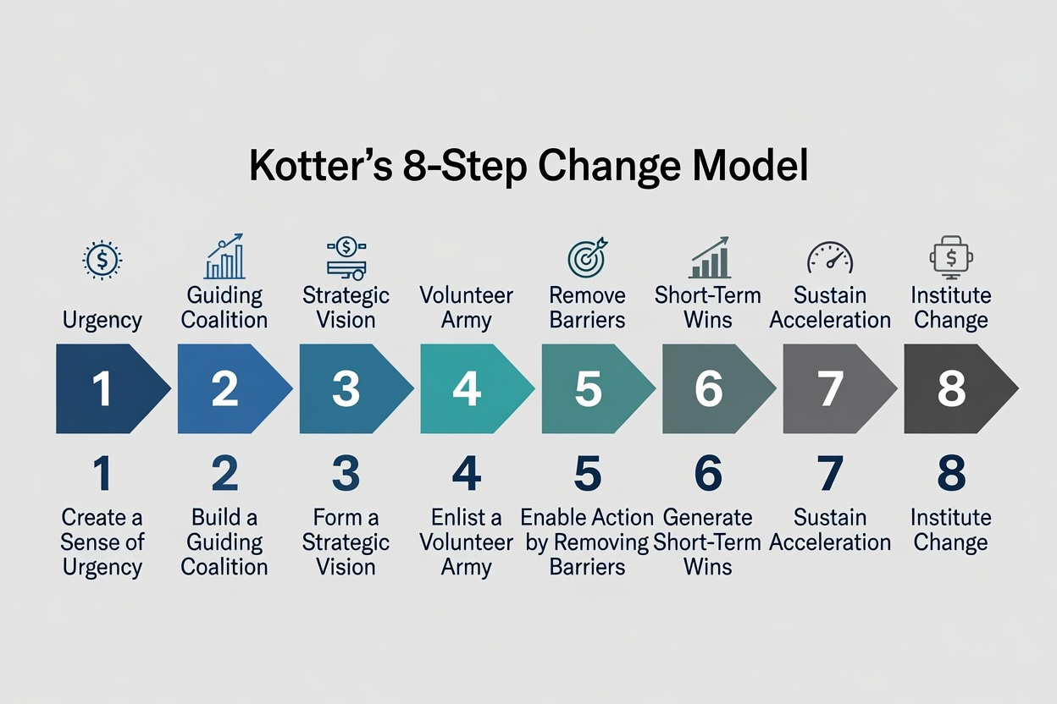
Figure 4: Kotter’s 8-Step Change Model
(Source: Adapted from Kotter, 1996)
Creation of a sense of urgency will be carried out by the demonstration of local and national data of injury from AKI that is preventable and a gap in the performance versus the national standard (Huang et al., 2026; GIRFT, 2025). A guiding coalition will be created through the multidisciplinary AKI Improvement team with visible executive sponsorship (Lachman et al., 2024). Creation of a strategic vision for reliable detection, standardisation of treatment and follow up after AKI as well as creation of a large number of volunteers through compulsory simulation training will instil a sense of ownership. Enabling action through removal of barriers such as poor IT systems and knowledge gaps, creation of visible short term wins in pilot wards, maintaining of momentum through continuous PDSA cycles and ultimately institutionalising the new practices by using metrics at the board level will lead to sustained improvement (Kotter, 1996; UK Kidney Association, 2024).
Through application of the PDSA cycle and Kotter’s model, both the technical testing of interventions and cultural work needed to sustain changes in AKI service provision can be done.

3. Recommendations
Based on the preceding root cause and strategic analyses, the following evidence-based recommendations are proposed to improve AKI-related patient safety and outcomes while positioning services to incorporate regenerative medicine advances.
Firstly, it is recommended to implement real-time AKI alerting based on the NHS England algorithm, fully incorporated into electronic health records, with mandatory adoption by all laboratories and participation in an external quality assurance programme. The Fishbone analysis showed that out-of-date algorithms and fragmentation of communication were major barriers to the recognition of deterioration (GIRFT, 2025). Standardising practices in laboratories and hospitals will reduce unwarranted variations and enable earlier clinical intervention to prevent progression to severe kidney injury.
Secondly, mandatory AKI simulation-based competency training for all relevant medical professionals should be introduced. The root cause analysis revealed knowledge deficits among non-specialists as one of the most important ‘People’ factors contributing to missed early signs of AKI (He et al., 2025). Simulation-based training has been shown to develop both technical skills in fluid management and non-technical skills such as timely escalation and effective teamwork (Lachman et al., 2024).
Thirdly, a structured follow-up programme should be introduced that includes automatic referral to a nephrologist at 90 days for all patients with AKI stages 2 and 3. Currently, follow-up is fragmented or completely absent, which helps explain the high rates of progression to chronic kidney disease seen in outcome data (UK Kidney Association, 2024; Huang et al., 2026). Systematic review allows residual kidney injury to be identified, cardiovascular risk factors to be optimised, and patients to be managed appropriately in the longer term.
Fourthly, a dedicated AKI improvement team with visible executive sponsorship needs to be established in every organisation. These teams will be responsible for monthly audit and rapid-cycle quality improvement of both process and outcome metrics. Issues of weak governance and limited organisational learning have been highlighted repeatedly in the Donabedian and SWOT analyses (NICE, 2024; Lachman et al., 2024).
Finally, benchmarking using the pre-benchmarking baseline results from Component 1 must be undertaken. The pre-benchmarking information regarding recognition delays, compliance to monitoring of urine output, escalation times, lengths of stays, and 90-day results will be analyzed for comparison with the post-benchmarking figures. Comparison will be necessary to measure the effect of the improvement program, show accountability to the board, and facilitate organizational learning (GIRFT, 2025; UK Kidney Association, 2024).

4. Conclusion
As per the above discussion, it can be concluded that Acute kidney injury still remains one of the major and highly preventable patient safety risks and cost drivers associated with considerable long-term morbidity. It was clearly evident from Component 1 that there were currently some service failures caused by the interaction of various organisational flaws in line with Reason’s Swiss Cheese Model of accident causation. In continuation of this important analysis, the current report has undertaken further investigation using various quality improvement methodologies like the Donabedian Model, Fishbone diagram, SWOT Analysis, Kotter’s 8-Step Change Model to pinpoint root causes and potential improvements.
These findings have clearly indicated that there is a high need for the joint consideration of structural enablers like robust IT systems, training of personnel, and governance processes along with process reliability which includes implementation of standardized care pathways, timely alerts, and follow-up after AKI. The biological opportunities arising from the latest knowledge on the pathophysiology of AKI should also be taken into account and prepared for. New insights about the mechanisms of maladaptive repair in the form of cellular senescence, G2/M cell-cycle arrest, and epigenetic programming along with novel therapeutic options for the use of mesenchymal stem cells-derived extracellular vesicles and urine-derived stem cells provide a great paradigm shift which should be considered in advance (Muto et al., 2024; Chen et al., 2026; Li et al., 2024).
Implementation through a continuous cycle of Plan-Do-Study-Act along with supportive executive leadership and measurement systems will be the proven approach to achieve this goal of translating evidence into practice. Through an effective combination of quality improvement science and strategic preparedness for future innovations in regenerative medicine, healthcare organizations can reduce the impact of AKI and deliver better care to the increasing number of patients with this disorder.

References
Beamish, J.A., Watts, J.A. and Dressler, G.R. (2024) 'Gene regulation in regeneration after acute kidney injury', Journal of Biological Chemistry, 300(8). Available at: https://www.jbc.org/article/S0021-9258(24)02021-0/pdf (Accessed: 04 Jul 2026).
BusinessBalls (n.d.) SWOT analysis. Available at: https://www.businessballs.com/strategy-innovation/swot-analysis/ (Accessed: 4 July 2026).
Chen, J., Zhang, H., Wang, Y. and Liu, B. (2024) 'Cellular senescence of renal tubular epithelial cells in acute kidney injury: mechanisms and therapeutic implications', Frontiers in Immunology, 15, p.1345678. Available at: https://pmc.ncbi.nlm.nih.gov/articles/PMC10844256/ (Accessed: 4 July 2026).
Chen, S.J., Tang, T.T., Zhang, Y.L., Lv, L.L. and Liu, B.C. (2026) 'Mesenchymal stem cell-derived extracellular vesicles: emerging cell-free therapeutics for kidney diseases', Frontiers in Immunology, 17, p.1738491. Available at: https://www.frontiersin.org/journals/immunology/articles/10.3389/fimmu.2026.1738491/pdf (Accessed: 04 Jul 2026).
Chertow, G.M., Luyckx, V.A., Marsden, P.A., Skorecki, K., Taal, M.W. and Yu, A.S.L. (eds.) (2025) Brenner and Rector’s The Kidney. 12th edn. Philadelphia: Elsevier.
Deng, Y.H., Chen, X., Wang, L. and Liu, B. (2025) 'From acute kidney injury to chronic kidney disease in children: maladaptive repair and the need for long-term surveillance – a literature review', BMC Nephrology, 26(1), p.112. Available at: https://link.springer.com/article/10.1186/s12882-025-04392-w (Accessed: 4 July 2026).
Getting It Right First Time (GIRFT) (2025) National recommendations to standardise acute kidney injury detection and alerting. Available at: https://gettingitrightfirsttime.co.uk/wp-content/uploads/2025/07/AKI-detection-and-alerting-recommendations-FINAL-May-2025.pdf (Accessed: 4 July 2026).
GIRFT (2025) National recommendations to standardise acute kidney injury detection and alerting. Available at: https://gettingitrightfirsttime.co.uk/wp-content/uploads/2025/07/AKI-detection-and-alerting-recommendations-FINAL-May-2025.pdf (Accessed: 4 July 2026).
He, J., Liu, X., Wang, Y. and Zhang, L. (2025) 'Molecular mechanisms and therapeutic interventions in acute kidney injury: a comprehensive review', Frontiers in Pharmacology, 16, p.1523891. Available at: https://pmc.ncbi.nlm.nih.gov/articles/PMC11929251/ (Accessed: 4 July 2026).
Hong, S., Kim, H., Park, J. and Lee, S. (2024) 'Extracellular vesicles from induced pluripotent stem cell-derived mesenchymal stem cells enhance the recovery of acute kidney injury', Cytotherapy, 26(4), pp.412–425. Available at: https://doi.org/10.1016/j.jcyt.2024.01.012 (Accessed: 4 July 2026).
Huang, X., Wang, M., Yu, B., Ren, P., Bian, X., Wang, P., Yao, X. and Lin, W. (2026) 'Transition from acute kidney injury to chronic kidney disease: molecular mechanisms and therapeutic interventions', Molecular Biomedicine, 7(1), p.64. Available at: https://link.springer.com/content/pdf/10.1186/s43556-026-00462-z.pdf (Accessed: 04 Jul 2026).
KDIGO (2026) KDIGO 2026 Clinical Practice Guideline for Acute Kidney Injury (AKI) and Acute Kidney Disease (AKD) – Public Review Draft. Available at: https://kdigo.org/guidelines/acute-kidney-injury/ (Accessed: 4 July 2026).
Kidney Disease: Improving Global Outcomes (KDIGO) (2026) KDIGO 2026 Clinical Practice Guideline for Acute Kidney Injury (AKI) and Acute Kidney Disease (AKD): Public Review Draft. Available at: https://kdigo.org/guidelines/acute-kidney-injury/ (Accessed: 4 July 2026).
Kim, H., Park, S., Lee, J. and Choi, Y. (2025) 'Extracellular vesicles from induced mesenchymal stem cells reduce the acute kidney injury-to-chronic kidney disease transition', Stem Cell Research & Therapy, 16(1), p.245. Available at: https://pmc.ncbi.nlm.nih.gov/articles/PMC12394081/ (Accessed: 4 July 2026).
Lachman, P., Batalden, P. and Vanhaecht, K. (eds.) (2024) Handbook of Quality Improvement in Healthcare. Oxford: Oxford University Press.
Li, F., Zhang, M., Chen, L. and Wang, Y. (2024) 'Therapeutic potential of urine-derived stem cells in renal repair after acute kidney injury', Molecular Therapy, 32(3), pp.512–528. Available at: https://pubmed.ncbi.nlm.nih.gov/40158205/ (Accessed: 4 July 2026).
Muto, Y., Wilson, P.C., Ledru, N., Wu, H., Dimke, H., Waikar, S.S. and Humphreys, B.D. (2024) 'Epigenetic reprogramming driving successful and failed repair in acute kidney injury', Science Advances, 10(32), p.eado2849. Available at: https://doi.org/10.1126/sciadv.ado2849 (Accessed: 4 July 2026).
National Institute for Health and Care Excellence (NICE) (2024) Acute kidney injury: prevention, detection and management (NG148). Available at: https://www.nice.org.uk/guidance/ng148 (Accessed: 4 July 2026).
Naved, B.A., Bonventre, J.V., Hubbell, J.A., Hukriede, N.A., Humphreys, B.D., Kesselman, C., Valerius, M.T., McMahon, A.P., Shankland, S.J., Wertheim, J.A. and White, M.J. (2022) 'Kidney repair and regeneration: perspectives of the NIDDK (Re) Building a Kidney consortium', Kidney International, 101(5), pp.845–853. Available at: https://www.sciencedirect.com/science/article/pii/S0085253822001831 (Accessed: 04 Jul 2026).
NICE (2024) Acute kidney injury: prevention, detection and management. NICE guideline NG148. Available at: https://www.nice.org.uk/guidance/ng148 (Accessed: 4 July 2026).
Nishimura, Y. (2026) 'Stem Cell and Bioengineering Approaches for End-Stage Renal Disease: A Comprehensive Review', Stem Cells, p.sxag003. Available at: https://academic.oup.com/stmcls/advance-article-abstract/doi/10.1093/stmcls/sxag003/8432920 (Accessed: 04 Jul 2026).
Pan, L., Garcia, S.G., Font-Morón, M., Sanroque-Muñoz, M., Clos-Sansalvador, M., de Miguel Garcia, G., Borràs, F.E. and Franquesa, M. (2025) 'Beyond preclinical promise: can mesenchymal stromal cell-derived extracellular vesicles reliably target tubular epithelial cells?', Extracellular Vesicles and Circulating Nucleic Acids, 6(3), p.580. Available at: https://pmc.ncbi.nlm.nih.gov/articles/PMC12540260/ (Accessed: 04 Jul 2026).
Quaglia, M., Merlotti, G., Colombatto, A., Bruno, S., Stasi, A., Franzin, R., Castellano, G., Grossini, E., Fanelli, V. and Cantaluppi, V. (2022) 'Stem cell-derived extracellular vesicles as potential therapeutic approach for acute kidney injury', Frontiers in Immunology, 13, p.849891. Available at: https://www.frontiersin.org/journals/immunology/articles/10.3389/fimmu.2022.849891/pdf (Accessed: 04 Jul 2026).
Rayego-Mateos, S., Marquez-Expósito, L., Rodrigues-Diez, R., Sanz, A.B., Guiteras, R., Doladé, N., Rubio-Soto, I., Manonelles, A., Codina, S., Ortiz, A. and Cruzado, J.M. (2022) 'Molecular mechanisms of kidney injury and repair', International Journal of Molecular Sciences, 23(3), p.1542. Available at: https://www.mdpi.com/1422-0067/23/3/1542 (Accessed: 04 Jul 2026).
Shu, S., Zhang, Y., Wang, H. and Liu, F. (2025) 'Cellular senescence in kidney diseases: from bench to clinic', The FASEB Journal, 39(8), p.e70612. Available at: https://doi.org/10.1096/fj.202503532R (Accessed: 4 July 2026).
Sun, F., Cui, Y., Zhi, W., Chen, Z. and Li, Y. (2025) 'Mechanisms and clinical advances in the in vivo regeneration of renal tissue: a narrative review', Regenerative Medicine Reports, 2(4), pp.149–160. Available at: https://journals.lww.com/rmr/fulltext/2025/12000/mechanisms_and_clinical_advances_in_the_in_vivo.3.aspx (Accessed: 04 Jul 2026).
Terada, Y., Nakagawa, T. and Kitamura, H. (eds.) (2020) Acute Kidney Injury and Regenerative Medicine. Singapore: Springer.
UK Kidney Association (2024) Transforming AKI Care: National Recommendations. Available at: https://www.ukkidney.org/about-us/news/transforming-aki-care-national-recommendations-published (Accessed: 4 July 2026).
Wang, J.J., Liu, Y., Zhang, X. and Li, H. (2025) 'Emerging role of mesenchymal stem cell-derived exosomes in the repair of acute kidney injury', World Journal of Stem Cells, 17(3), pp.103360. Available at: https://pubmed.ncbi.nlm.nih.gov/40160687/ (Accessed: 4 July 2026).
Xu, D., Zhang, X., Pang, J., Li, Y. and Peng, Z. (2025) 'Mechanisms of Acute Kidney Injury–Chronic Kidney Disease Transition: Unraveling Maladaptive Repair and Therapeutic Opportunities', Biomolecules, 15(6), p.794. Available at: https://www.mdpi.com/2218-273X/15/6/794 (Accessed: 04 Jul 2026).
Zhang, T., Widdop, R.E. and Ricardo, S.D. (2024) 'Transition from acute kidney injury to chronic kidney disease: mechanisms, models, and biomarkers', American Journal of Physiology-Renal Physiology, 327(5), pp.F788–F805. Available at: https://journals.physiology.org/doi/pdf/10.1152/ajprenal.00184.2024 (Accessed: 04 Jul 2026).
Zhang, Z., Wang, L., Chen, X. and Liu, Y. (2025) 'Efficacy of exosomes in acute kidney injury treatment and the associated mechanism: a review', Molecular Medicine Reports, 31(5), p.13503. Available at: https://pmc.ncbi.nlm.nih.gov/articles/PMC11963750/ (Accessed: 4 July 2026).
Zhu, Z., Hu, J., Chen, Z., Feng, J., Yang, X., Liang, W. and Ding, G. (2022) 'Transition of acute kidney injury to chronic kidney disease: role of metabolic reprogramming', Metabolism, 131, p.155194. Available at: https://www.sciencedirect.com/science/article/pii/S0026049522000725 (Accessed: 04 Jul 2026).

