

Data Handling & Business Intelligence
(LCBB5000)
Yavor Petrov 2110946 | 4/30/24 | Dr Xavier Matieni

Table of Contents

Table of Figures 2
Part 1 3
Sales Trends Over the Months 3
November 4
December 5
Most Frequently Purchased Products 6
Purchases per Transaction 7
Most Profitable Customer 9
Overall 9
Geographical Segmentation 10
Strategy Recommendations 11
Part 2 13
Student Segmentation by Gender 14
Reduced/Free Lunch Qualification 15
Mean and Median of Students Reduced/Free Lunch Qualification 16
K-Means Clustering 17
Pre and Post-Test Scores Boxplot Visualisation 1
Pre and Post-Test Scores Boxplot Visualisation Based on Lunch Qualification 2
Relationships Between Students Who Qualify Reduced/Free Lunch and Student Gender, Pre and Post-Test Scores 3
Relationships Between Students Who Do Not Qualify for Reduced/Free Lunch and Student Gender, Pre and Post-Test Scores 4
Relationships Between Student Lunch Qualification and Student Gender, Pre and Post-Test Scores 5
Advantages and Disadvantages of SPSS and Excel 6
Advantages of SPSS 7
Disadvantages of SPSS 7
Advantages of Excel 7
Disadvantages of Excel 7
References 8

Table of Figures

Figure 1 - Sales Trends Pivot Tables 3
Figure 2 - Sales Trends for November 2019 4
Figure 3 - Sales Trends for December 2019 5
Figure 4 - Top 30 Most Frequently Purchased Products 6
Figure 5 - Customer Purchases per Transaction (minor segmentation) 7
Figure 6 - Customer Purchases per Transaction (major segmentation) 8
Figure 7 - Most Profitable Customer Overall 9
Figure 8 - Most Profitable Countries 10

Part 1

In this modern age, many aspects of our lives are centred around the market economy. Purchasing products has become as simple as a click of a button and many people use their computers or phones to order a product online so it can be brought to their home or business even if it comes from the opposite side of the planet.
According to the “Journal of Retailing and Consumer Services”, global e-commerce during the COVID-19 pandemic increased by 26,4% and reached US$ 4,3 Trillion (Shaw, et al., 2022). Those numbers grew to US$ 6,4 Trillion, and e-commerce makes up 22% of the retail sales across the globe (Ang, 2021). This data and the growing trend of e-commerce show us that a deeper understanding of how our business performs is not just an advantage, but a necessity and this report will examine a sales transaction data set of a UK-based e-commerce gift shop.

Sales Trends Over the Months
By analysing the data set we have extracted sales trends for November and December. All data has been cleaned from cancelled orders and returns and the final numbers represent the total revenue per transaction day for the month the chart represents. A total of 4724 entries were identified that do not qualify for the data pool based on predetermined criteria.

Date | Sum of Price |  |  | Date | Sum of Price
11/17/2019 | £29,374 |  |  | 12/01/2019 | £13,079
11/18/2019 | £26,079 |  |  | 12/02/2019 | £13,430
11/20/2019 | £28,985 |  |  | 12/04/2019 | £10,176
11/21/2019 | £26,706 |  |  | 12/05/2019 | £23,767
11/22/2019 | £32,499 |  |  | 12/06/2019 | £14,840
11/23/2019 | £16,505 |  |  | 12/07/2019 | £11,256
11/24/2019 | £16,781 |  |  | 12/08/2019 | £20,446
11/25/2019 | £14,223 |  |  | 12/09/2019 | £9,540
11/27/2019 | £11,527
11/28/2019 | £16,051
11/29/2019 | £18,937
11/30/2019 | £15,265
Grand Total |  | £252,933 |  | Grand Total | £116,534
Figure 1 - Sales Trends Pivot Tables

November

- Transactions for the month of November began on the 17th with the last transaction occurring on the 30th of that same month.
- The business operated for a total of 12 days during the month.
- The highest revenue for the month was on the 22nd at the amount of £32,499.
- The lowest revenue for the month was on the 27th at the amount of £11,527.
- The Grand Total Revenue for the entire month of November was £116,534.
- The sales trend for November indicates a gradual decline in total revenue per day.

Figure 2 - Sales Trends for November 2019

December

- Transactions for the month of December began on the 1st with the last transaction occurring on the 9th of that same month.
- The business operated for a total of 8 days during the month.
- The highest revenue for the month was on the 5th at the amount of £23,767.
- The lowest revenue for the month was on the 9th at the amount of £9,540.
- The Grand Total Revenue for the entire month of November was £252,933.
- The sales trend for December indicates a minor growth in total revenue per day.

Figure 3 - Sales Trends for December 2019

Most Frequently Purchased Products

This segment will examine and analyse the products sold by the gift store and focus on the most frequently bought products during November and December.
- The company has sold 2,264 unique products in various quantities.
- The company has registered a total of 46,160 transactions.
- Of those 46,160 separate transactions, 3232 (~7%) included products from the top 30 most frequently purchased products list.
- The most frequently purchased product is “Rabbit Night Light” of which different quantities were sold 206 times.

Figure 4 - Top 30 Most Frequently Purchased Products

Purchases per Transaction

Analysing how many purchases were made per transaction reveals the following information:
- In 965 transactions ≤100 items were purchased.
- In 940 transactions 100 – 500 items were purchased.
- In 166 transactions >500 items were purchased.
This histogram demonstrates that 2/3 of overall transactions purchase less than 500 items.

Figure 5 - Customer Purchases per Transaction (minor segmentation)

A histogram, defined by a smaller bin width and more precise overflow and underflow bin values gives us an even more analytical view of how many purchases, customers make per transaction. From the following chart, we can extrapolate the following conclusions:
- Most client purchases vary between the range of 50 to 250 (~48%) items per transaction.
- Second-highest range includes purchases of 50 (~23%) or fewer items per transaction.
- The third-highest range includes purchases of between 250 to 450 (~11%) items per transaction.
- The remaining ~18% are distributed amongst 4 ranges that include purchases of 450 to >1000 items per transaction.
Based on the same principle, ranges can be redefined into new histograms to further pinpoint the behaviour of the business’s core client audience.

Figure 6 - Customer Purchases per Transaction (major segmentation)

Most Profitable Customer

In order to make a correct evaluation of the most profitable customers the data was sorted by customer number and the following formula was used to calculate the revenue generated per customer:
Σ Revenue = Price * Quantity
Total revenue generated by all customers is £4,371,790

Overall
- The following graph displays the top 10 most profitable customers with
no segmentation applied.
- Most profitable customer has generated a revenue of £1,002,718 which is ~23% of the total revenue generated.
- The most profitable customer has generated ~90.5% more revenue compared to the 2nd most profitable customer.

Figure 7 - Most Profitable Customer Overall

Geographical Segmentation

We can examine customer profitability by segmenting the market by country and identify the most profitable customers per country in order to target accordingly the strengths and weaknesses of generating profit outside of our core market.
- The following graph displays the top 10 most profitable countries.
- The most profitable country is the United Kingdom with generated revenue of £3,901,029 which is ~89% of the total revenue.
- The rest of the countries from the data set have generated a revenue of £470,761 which is ~11% of the total revenue.

Figure 8 - Most Profitable Countries

Strategy Recommendations

By sorting through the data provided by the business and analysing the results we have gained an inside glimpse into its essence. Using this information, we can generate recommendations based on its strengths and weaknesses. The following steps can be applied to the business processes at any point in time.
- Seasonal Sales Strategy
The sales data shows a significant increase in revenue in December compared to November. This could be due to the holiday season. The business should consider creating special holiday promotions or bundles to further boost sales during this period (Catania, 2023).

- Product Focus
The “Rabbit Night Light” is the most frequently purchased product. The business should consider creating marketing campaigns around this product to increase its visibility and sales. Furthermore, upselling, or cross-selling related products can increase sales (Chisel blog, n.d.).

- Sales Trend Analysis
The sales trend for November indicates a gradual decline in total revenue per day, while December shows minor growth. The business should investigate the causes of these trends. It could be due to factors such as stock availability, pricing, or marketing efforts. The strategy must be adjusted accordingly to maintain consistent sales growth (Nguyen, 2022).

- Inventory Management
With 2,264 unique products sold in various quantities, effective inventory management is crucial. The business should focus on stocking more of the top 30 most frequently purchased products, as they make up about 7% of all transactions and ensure that it has sufficient stock to cater to large orders (>500 items). This could help it attract and retain high-volume customers (Hayes, 2024).

- Customer Retention
Since the business operated for only 12 days in November and 8 days in December, the business should consider strategies to retain customers and encourage repeat purchases throughout the year. This could include loyalty programs, regular newsletters, or personalized recommendations (Matthews-El & Bottorff, 2024).

- Customer Segmentation
The business should consider segmenting customers based on the number of items they purchase per transaction and tailor their marketing and sales strategies to each segment. For example, offering bulk discounts to customers who typically purchase more than 500 items per transaction (Jolaoso, 2023).

- Product Bundling
Since most transactions involve the purchase of 50 to 250 items, the business should consider creating product bundles within this range. This could encourage customers to purchase more items per transaction (Chapman, 2023).

- Loyalty Programs
The most profitable customer has generated ~23% of the total revenue. The business should consider implementing a loyalty program to reward high-spending customers and encourage repeat purchases (Peekage, 2022).

- Geographical Targeting
The United Kingdom is the most profitable country, generating ~89% of the total revenue. The business should consider focusing its marketing efforts on this region, but also explore strategies to increase sales in other countries (Intuit Mailchimp, n.d.).

- Personalized Marketing
The business should consider using gathered data on the most profitable customers to develop a customer-specific approach. This could include suggesting items that align with their previous purchases or providing price reductions on the items they prefer the most. (Adobe Experience Cloud Team, 2023).

Part 2

Optimisation has become a key pillar in the operation of not just businesses but also in many private or public institutions. In this section of the report, we will examine and analyse a data set containing data from a survey of 2,133 school students and their scores on pre-test and post-test. We will use this data to determine if students qualify for reduced/free lunch or do not qualify for reduced/free lunch. Furthermore, we will determine what relationships exist between reduced/free lunch and student’s gender, pre-test, and post-test scores.
For the purposes of this analysis, we will implement the use of SPSS, which is a statistical analytics software, developed by IBM. And lastly, we will compare the advantages of using SPSS and Excel for conducting data mining and data analysis.

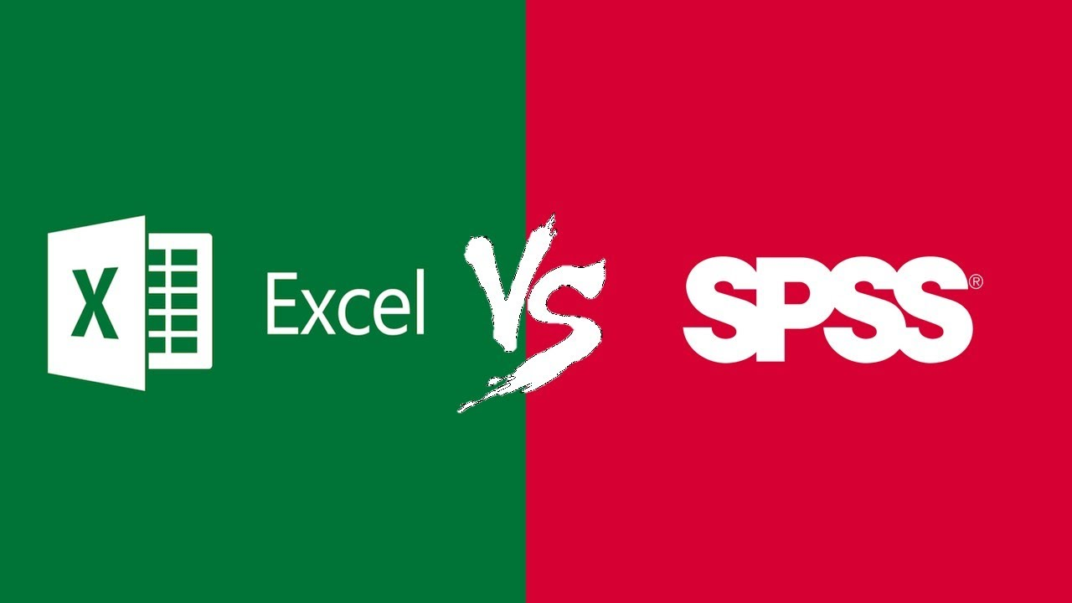

Student Segmentation by Gender

- According to the provided data, the survey includes a total of 2,133 students.
- Of the 2,133 students, 1,056 students or 49.5% are categorised as female.
- Of the 2,133 students, 1,077 students or 50.5% are categorised as male.

Key: Female=1, Male=2
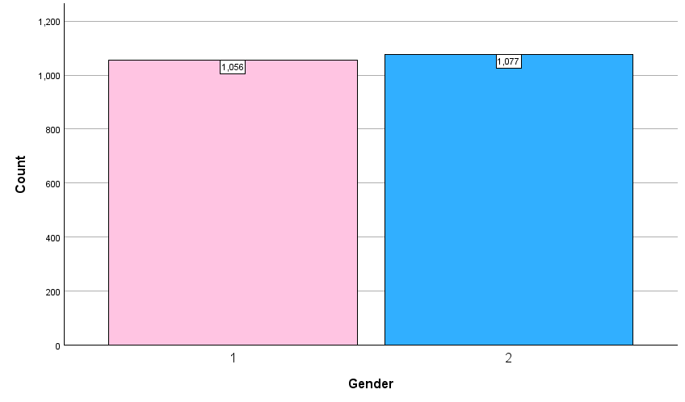

Gender
 |  | Frequency | Per cent | Valid Percent | Cumulative Percent
Valid | 1 | 1056 | 49.5 | 49.5 | 49.5
Valid | 2 | 1077 | 50.5 | 50.5 | 100.0
Valid | Total | 2133 | 100.0 | 100.0

Reduced/Free Lunch Qualification

- The qualification criteria were not specified by the school that has provided the data.
- Of the 2,133 students, 1,215 students or 57% do NOT QUALIFY for a reduced/free lunch.
- Of the 2,133 students, 919 students or 43% do QUALIFY for a reduced/free lunch.

Key: 0=Does not qualify, 1=Qualifies
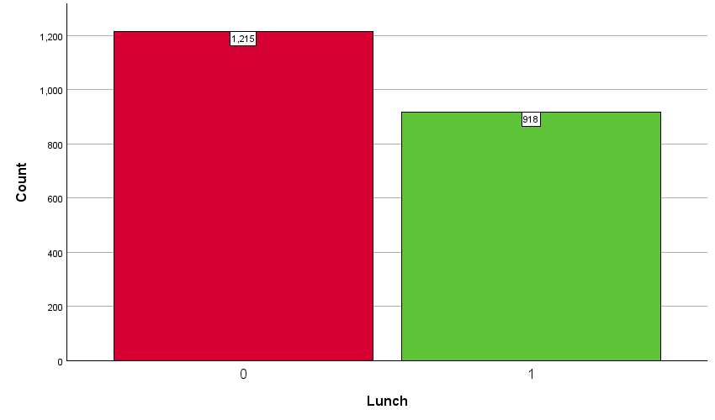

Lunch
 |  | Frequency | Per cent | Valid Percent | Cumulative Percent
Valid | 0 | 1215 | 57.0 | 57.0 | 57.0
Valid | 1 | 918 | 43.0 | 43.0 | 100.0
Valid | Total | 2133 | 100.0 | 100.0

Mean and Median of Students Reduced/Free Lunch Qualification

Analysing the data has given us the following results:
- A mean of 0.43 indicates that on average, 43% of the students qualify for reduced/free lunch.
- The median is 0.00. This means that when the data is ordered, the middle value is 0, indicating that more than half of the students do not qualify for reduced/free lunch.

Statistics
Lunch
N | Valid | 2133
N | Missing | 0
Mean |  | .43
Median |  | .00
Variance |  | .245

K-Means Clustering

Initial Cluster Centres
 | Cluster
 | 1 | 2
Pretest | 23 | 93
Posttest | 35 | 100

Final Cluster Centres
 | Cluster
 | 1 | 2
Pretest | 43 | 65
Posttest | 55 | 78

Number of Cases in each Cluster
Cluster | 1 | 993.000
Cluster | 2 | 1140.000
Valid |  | 2133.000
Missing |  | .000

Iteration History
Iteration | Change in Cluster Centres
Iteration | 1 | 2
1 | 30.191 | 33.606
2 | .885 | .791
3 | .611 | .532
4 | .212 | .181
5 | .227 | .200
6 | .150 | .128
7 | .000 | .000
Convergence achieved due to no or small change in cluster centres. The maximum absolute coordinate change for any centre is .000. The current iteration is 7. The minimum distance between initial centres is 95.525.

The K-Means Clustering analysis has divided the data into two clusters based on the Pretest and Posttest scores. The centres of these clusters represent the average Pretest and Posttest scores for each cluster. The number of cases in each cluster tells us how many students fall into each category. This information can be useful for understanding the distribution of scores and identifying patterns or trends in the data. The data received from the K-means clustering analysis is represented by boxplot graphs by its correlation to other variables provided in the survey data set.

Pre and Post-Test Scores Boxplot Visualisation

Representation of student pre-test scores and post-test scores indicating an overall improvement in performance in post-test scores. This simplified visualization represents the overall range of scores of all 2133 students and serves as a reference point for performance based on both scores and will be further segmented in the following observations.

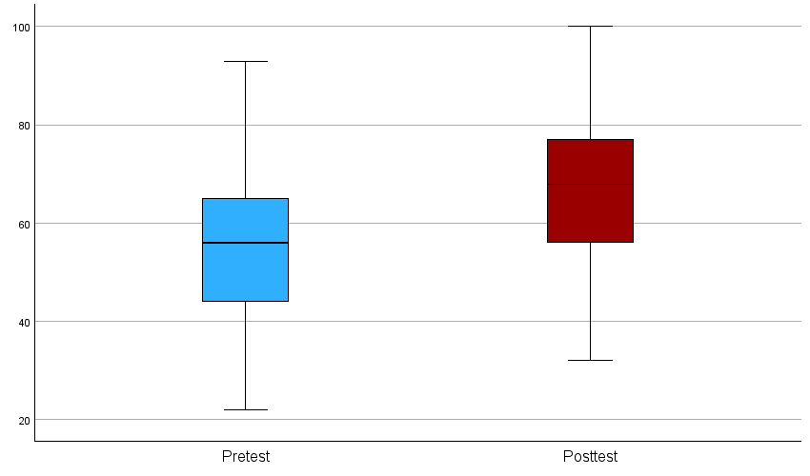

Pre and Post-Test Scores Boxplot Visualisation Based on Lunch Qualification

Based on lunch qualification we can conclude the following:
- Students who do not qualify for a reduced/free lunch have higher pre-test scores than students who qualify for a reduced/free lunch.
- Students who do not qualify for a reduced/free lunch have higher post-test scores than students who qualify for a reduced/free lunch.
- Students who do not qualify for a reduced/free lunch have higher pre-test scores than students who qualify for a reduced/free lunch on post-test scores.

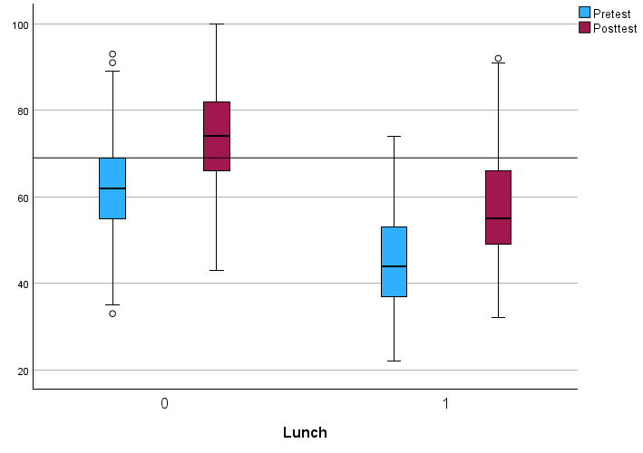

Relationships Between Students Who Qualify Reduced/Free Lunch and Student Gender, Pre and Post-Test Scores

Based on the following boxplot graph we can conclude the following:
- From the students who qualify for a reduced/free lunch, male students have slightly higher pre-test scores than female students.
- From the students who qualify for a reduced/free lunch, both male and female students on average have equal post-test scores.

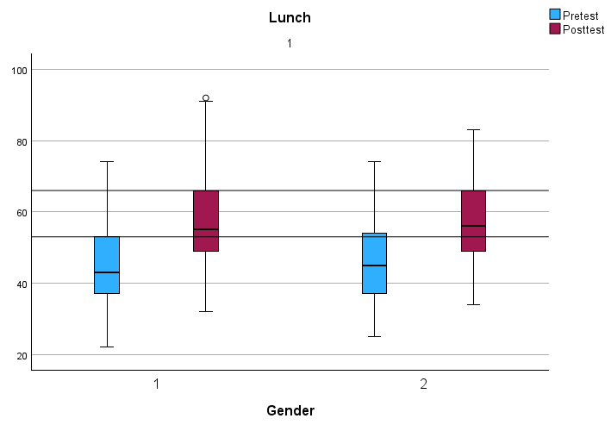

Relationships Between Students Who Do Not Qualify for Reduced/Free Lunch and Student Gender, Pre and Post-Test Scores

Based on the following boxplot graph we can conclude the following:
- From the students who do not qualify for a reduced/free lunch, female students have slightly higher pre-test scores than male students.
- From the students who do not qualify for a reduced/free lunch, female students have slightly higher post-test scores than male students.

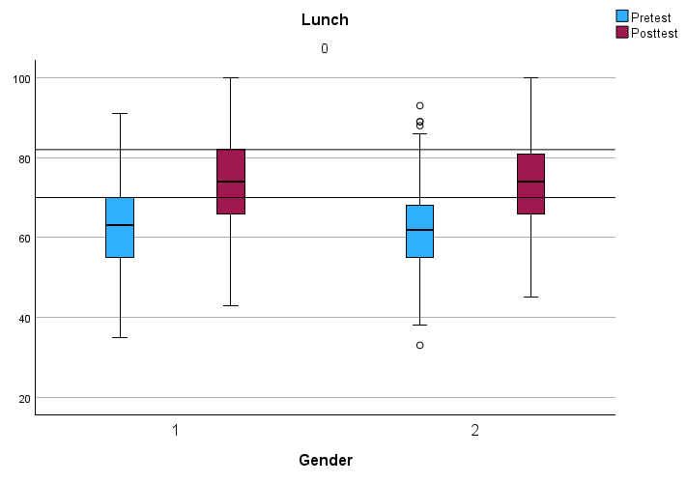

Relationships Between Student Lunch Qualification and Student Gender, Pre and Post-Test Scores

Based on the following boxplot graph we can conclude the following:
- Male students who do not qualify for a reduced/free lunch have higher pre-test scores than students who qualify for a reduced/free lunch.
- Male students who do not qualify for a reduced/free lunch have higher post-test scores than students who qualify for a reduced/free lunch.
- Female students who do not qualify for a reduced/free lunch have higher pre-test scores than students who qualify for a reduced/free lunch.
- Female students who do not qualify for a reduced/free lunch have higher post-test scores than students who qualify for a reduced/free lunch.

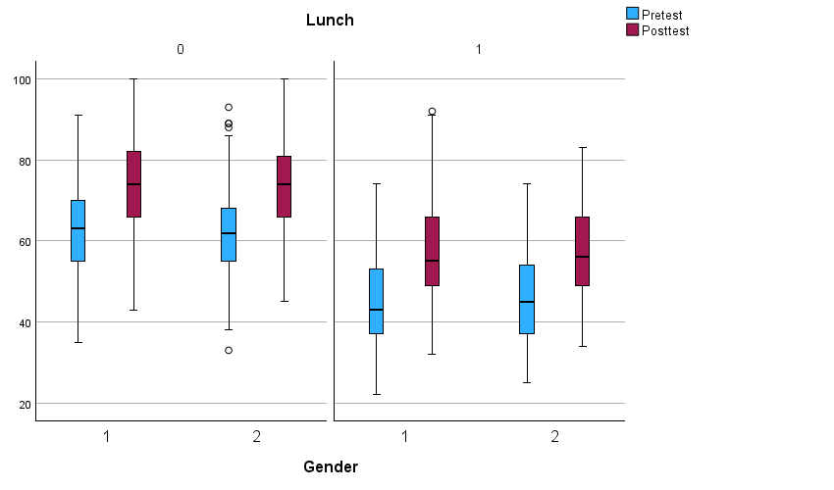

Advantages and Disadvantages of SPSS and Excel

During the writing of this report, both Excel and SPSS were used to examine and process different data sets and based on the analysed data, create graphs, charts, and various other tables. Although both tools were used, they both have advantages and disadvantages.
Criteria | SPSS | Excel
Ease of Use | - Simplistic  - Beginner-friendly syntax  - User-friendly UI  - Menu-driven | - Widely used.  - Familiar UI  - Steep learning curve due to syntax
Data Analysis | - Comprehensive statistical capabilities  - Complex statistical tests  - Data research and experiment simulation  - Decision-making | - Instant batch calculations  - Simple and complex equations  - Large amount of data processing
Data Management | - Simple spreadsheet layout with comprehensive data management capabilities  - Plethora of built-in data management tools | - Easy-to-use data management tools that allow the creation of logical spreadsheets and creation of charts  - AI integration
Security | - File password protection | - File password protection  - Macros disabled by default
Cost | - Expensive license | - Low-cost user license
Integration | - Limited integration capability with other software | - Full integration with MS Windows, Office 365 products, Cloud services (Azure, AWS, Google, etc.), and many other industry-standard applications.

References

Adobe Experience Cloud Team, 2023. Guide to marketing personalization — benefits, examples, and more. [Online]
Available at: https://business.adobe.com/blog/basics/marketing-personalization#:~:text=Marketing%20personalization%20is%20a%20strategy,was%20made%20just%20for%20them.
[Accessed 03 05 2024].
Ang, C., 2021. Timeline: Key Events in the History of Online Shopping. [Online]
Available at: https://www.visualcapitalist.com/sp/history-of-online-shopping/
[Accessed 02 05 2024].
Catania, L., 2023. Seasonal Marketing Strategies: Utilizing What Every Season Has to Offer. [Online]
Available at: https://www.business.com/articles/seasonal-marketing-strategies-utilizing-what-every-season-has-to-offer/
[Accessed 03 05 2024].
Chapman, L., 2023. What is product bundling? And how can it improve your product and boost sales?. [Online]
Available at: https://www.productmarketingalliance.com/product-bundling-strategy/
[Accessed 03 05 2024].
Chisel blog, n.d. What are Types of Product Strategies for Businesses. [Online]
Available at: https://chisellabs.com/blog/types-of-product-strategies-for-businesses/#:~:text=option%20for%20you!-,What%20is%20Product%20Focus%20Strategy%3F,than%20focusing%20on%20new%20ones.
[Accessed 03 05 2024].
Hayes, A., 2024. Inventory Management Defined, Plus Methods and Techniques. [Online]
Available at: https://www.investopedia.com/terms/i/inventory-management.asp
[Accessed 03 05 2024].
Intuit Mailchimp, n.d. What Is Geotargeting and Why It’s an Important Advertising Strategy?. [Online]
Available at: https://mailchimp.com/resources/what-is-geotargeting/#:~:text=Geotargeting%20is%20a%20type%20of,appeals%20to%20your%20target%20audience.
[Accessed 03 05 2024].
Jolaoso, C., 2023. Customer Segmentation: The Ultimate Guide. [Online]
Available at: https://www.forbes.com/advisor/business/customer-segmentation/
[Accessed 03 05 2024].
Matthews-El, T. & Bottorff, C., 2024. 14 Customer Retention Strategies That Work In 2024. [Online]
Available at: https://www.forbes.com/advisor/business/customer-retention-strategies/
[Accessed 03 05 2024].
Nguyen, L., 2022. Sales Trend Analysis. [Online]
Available at: https://revenuegrid.com/blog/sales-trend-analysis/
[Accessed 03 05 2024].
Peekage, 2022. All You Need to Know About Customer Loyalty Program Strategies: From Theory to Practice. [Online]
Available at: https://peekage.com/blog/loyalty-program-strategy
[Accessed 03 05 2024].
Shaw, N., Eschenbrenner, B. & Baier, D., 2022. Online shopping continuance after COVID-19: A comparison of Canada, Germany and the United States. Journal of Retailing and Consumer Services, LXIX(1), pp. 1-2.

