University of Wales Trinity Saint David
Wales Institute of Science

ACHA4010

Ethan Davies
2405602
13/04/25
Contents
1 Task 3 1
1.1 Scope Time Division Calculations (3) 1
1.2 Function Generator output square wave (3) 1
1.3 Capacitor charge and discharge wave marked at correct points. (3) 1
1.4 Basic Capacitor Calculations (3) 1
1.5 Capacitor discharge table (2) 1
1.6 Plot log(V) Gradient (2) 1
1.7 Gradient Calculations and Compare(4) 1
1.7.1 Gradient Calculations 1
1.7.2 Comparison table 1
1.8 Capacitor Uses (5) 1
1.9 Inaccuracies Question (4) 1
2 References 2

Figure 1: Square wave 2
Figure 2: Sin Scope Wave 2

Task 3

Scope Time Division Calculations (3)T
The following Calculations are used for Scope time divisions:
$$τ\left(Period\right)=\frac{1}{f}$$
$$\frac{time}{Devision}=\frac{\frac{1}{f}}{10}$$
$$\frac{Time}{Division}=\frac{\frac{1}{250}}{10}=400 ×{10}^{-6}$$
Answer =0.0004

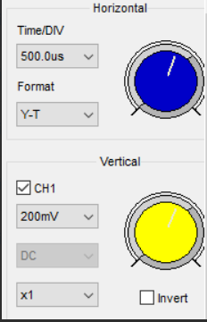

Function Generator output square wave (3)
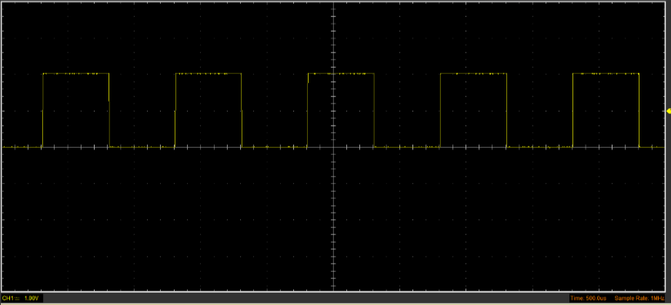
Figure 1: Square wave

Capacitor charge and discharge wave marked at correct points. (3)
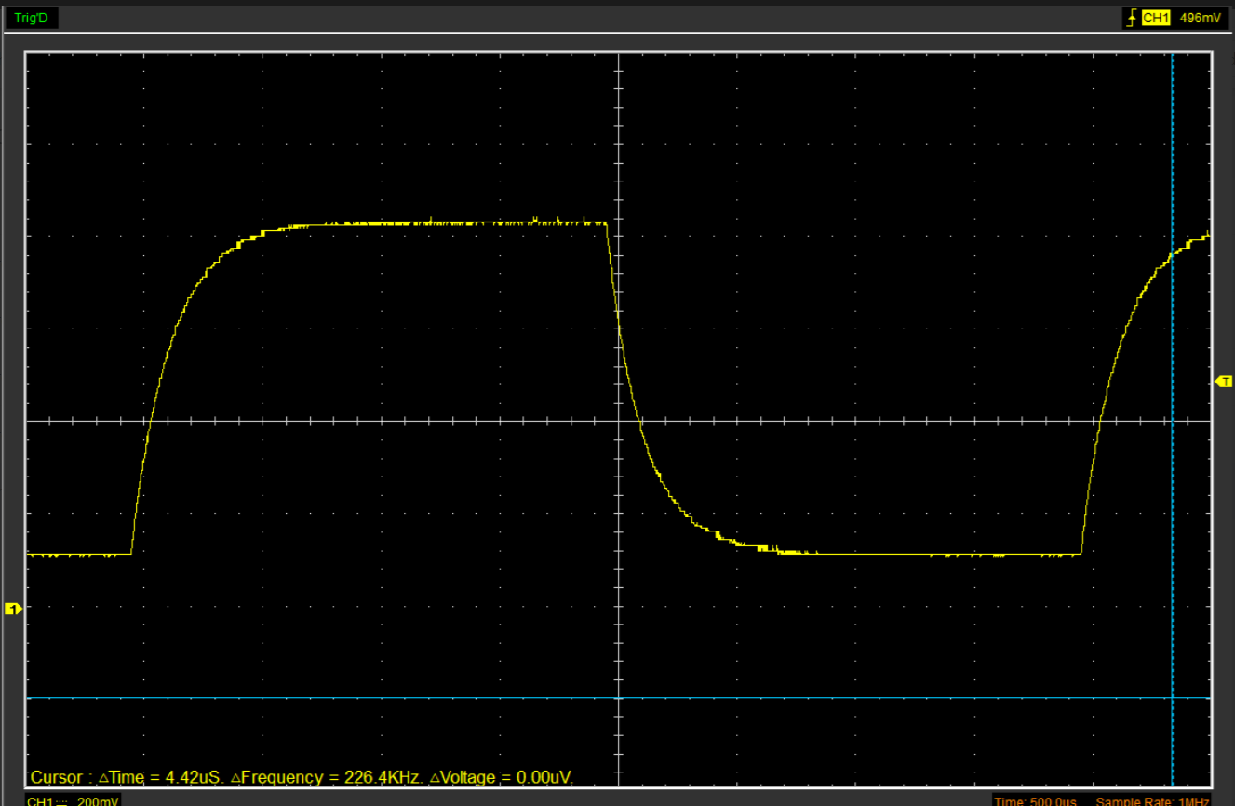
Figure 2: Sin Scope Wave

Basic Capacitor Calculations (3)
$$C=\frac{τ}{R}$$
$$C=\frac{60 ×10^{-6}}{100}$$
$$Answer=0.602μF$$

Plot log(V) Gradient (2)

Gradient Calculations and Compare(4)

Gradient Calculations

Comparison table
 | Capacitance | Delta | Percentage difference
Actual | 1 µF | x | X
Marker Calculation | 0.0602$μF$ |  | 177.29%
Gradient Calculation

Capacitor Uses (5)
There are a few common uses of capacitors, as seen listed below:
- Filtering noise in power supply
  - Capacitors can smooth out voltage ripples in DC power supplies. When being rectified, the capacitor charges and discharges to fill in the gaps in the voltage. This provides a more consistent voltage, especially for sensitive components like ECUs.
- Smoothing voltage in rectifiers
  - When placed across power supply lines in a circuit. It suppresses electrical interference, also known as noise. This is crucial in the engine management systems where electromagnetic noise can affect sensors
- Timing circuits (e.g. blinkers)
  - Capacitors combined with resistors are used in the ignition and wiper delays. Resistor-capacitor timing circuits are used to produce delays, These RC systems are also found in indicators, automatic lights, and windscreen wipers.
- Ignition systems (capacitor discharge ignition)
  - Capacitors can protect sensitive electronics from voltage spikes. As stated before, the ECU has
- Audio crossover networks
  - Capacitors are also used in passive circuits to split audio signals into different frequencies, allowing control of the high, mid, and low frequencies individually. Allowing for sound clarity and efficiency.
- Storing energy for power boosts
  - In some heavy vehicles, large supercapacitors are used for power-hungry devices like electric motors. They assist in stabilizing voltage and prevent batter voltage sag,
- Sensor filtering (MAP, MAF sensors)
  - Capacitors are used in MAPs and MAFs to reduce false readings and improve drivability and control the engine accuracy
- ECU voltage regulation
  - As previously stated, capacitors are used in ECUs. They specifically smooth voltage ripples from the battery or alternator and protect memory and sensitive microcontrollers from voltage burnouts or drops.
- Motor start-up assistance
  - Electrical motors used throughout an automotive vehicle require high torque when starting. Capacitors can assist with a phase shift, creating a rotational magnetic field or a boost in current during the initial startup of the motor
- Decoupling in audio and radio systems
  - Capacitors in audio and radio systems can filter out AC noise from a vehicle’s power lines and supply, as well as prevent feedback between different electrical systems.
  - Furthermore, they are crucial in radio systems as they isolate radio frequencies. Preventing crosstalk or any other interference. Ensuring a clear reception.

Inaccuracies Question (4)
Measurement inaccuracies may occur due to multiple factors:
- Oscilloscope resolution
  - A limited vertical resolution can affect the accuracy of voltage readings.
  - Furthermore, incorrect settings can significantly impact the accuracy of the measurements. If the scale is too small or too large, the signal details are hard to read.
- Component Tolerances
  - Capacitors have tolerances of +/- 10% or more.
- Probe calibration
  - Incorrect settings or poorly calibrated probes will affect accuracy.
  - When testing fast-changing waveforms like square pulse signals shown in figure 1, it is crucial that the probe is fully compensated, as a high tolerance is required to properly measure these waveforms.
- Temperature variation
  - Capacitance changes as heat increases and decreases during extended periods.
- Interference
  - Testing environments involving multiple electronic devices can introduce distortions in the electrical signals.
- Human Error
  - Further errors will occur due to human error when placing markers on the wave forms
  - Manual interpretation of waveforms such as cursor placement can mean the incorrect reading is taken into the data, botching the results. Even though these values may be similar, the percentage amounts vary significantly
These are all possible reasons why inaccuracies or errors will occur during testing.

References
Singh, A. (2025). Types of Capacitors with Symbol, Classification and Applications. [online] Hackatronic. Available at: https://www.hackatronic.com/types-of-capacitors-with-symbol-classification-and-applications/ [Accessed 08/04/25].
Semiconductor Review (2024). Semiconductor Review |Unveiling the Vital Role of Capacitors in Electronic Circuits. [online] Semiconductor Review . Available at: https://www.semiconductorreview.com/news/unveiling-the-vital-role-of-capacitors-in-electronic-circuits-nwid-843.html [Accessed 08/04/25].
Leading Electronic Component Supplier from China | Weishielectronics. (2024). What Are Capacitors Used For? 8 Applications of Capacitors You Know. [online] Available at: https://weishielectronics.com/what-are-capacitors-used-for/ .[Accessed 08/04/25]

‌

‌

‌

