By Mathew Jones (2317425) – Software Engineering
Introduction to web and data concepts (ACCA4023)
Developing an MS Access Database for Coastal Tourism Management
Contents
Section A 2
Question 1. 2
Question 2. 3
Question 3. 4
Question 4. 5
Question 5. 5
Question 6. 6
Question 7. 6
Question 8. 8
Section B 9
Question 9. 9
Question 10. 10
References 11

Section A

Question 1.

Database Administrator: They can be a single person, or a team and they define the schema and control the database. Below are some of tasks they do:
- Creating, managing, and giving permissions to user accounts.
- Prevent unauthorised access, data breaches and other security threats by putting in security measures.
- Ensuring work is backed up by a recovery control system to prevent loss of data and if there is a failure, restoring said data.
- Managing system quality
- Technical support.

Application Developer: They use software languages to work on the back-end of programmes. They tend to work on online websites and make interacting with the database easier for Naïve users. Other roles they have are:
- Programme design
- Debugging
- Testing

Database designers: They design the structure of the database before the database is created or inputted with data. Below are some the tasks they do:
- Manage what data is to be stored and decides what data relates to each other.
- That different user groups requirements are met.
- Ensure all user groups are satisfied with the design.

Management: Managers also known as casual/ temporary users will use the database from time to time. They will access the database to analyse new data. Below are some tasks they complete:
- Analysing data trends that will assist the business.
- Planning events and activities using said data.
- Making reports based on performances

Naïve users: They would be the front-line workers. They have no idea of DBMS, as an application program has been written to make accessing data as simple as possible. Below are some tasks they complete:
- Accessing data such as customer information, booking details and other relevant data.
- Dealing with customers queries, issues and providing excellent service
- Inserting and managing reservations, updating customer details and processing booking
Customers can also be Naïve user.

Sophisticate user: They know about DBMS and what it can offer. Additionally, they may know how to use queries and/or write application programmes. Examples of some sophisticated users are scientists and business analysts. Below are some tasks they may complete:
- Creating marketing campaigns based on customer demographics and preferences based off data gained from DBMS.
- Measuring how successful the marketing campaign was

Question 2.

Manager: They will need access to everything on the database and are responsible for data analysis, ensuring staff levels are good and training staff.

Team leader: They will need access to Employee details, booking details and customer details. They are responsible that employees are working effectively, trained and customer are satisfied.

Sales department: They will need access to view customer details and book customers holidays. They are responsible for updating customer details, preferences and ensuring customers are satisfied.

Marketing department: They need access to data to view trends, demographics, preferences and to see if past marketing campaigns have been effective. They are responsible for developing and promoting marketing campaigns.

Human Resources: They will need access to employee details to ensure all details are correct and are responsible that all employees are working safely and effectively.

Accounting: They will need access to employee details, payment details and booking details as they are responsible for paying the employees, sorting out taxes and ensuring all payments have been received.
Hotels managers: They require access as they need to know about customer numbers, specific requirements, reviews, and customer preferences to improve their service quality. Hotels managers are responsible for managing their hotels and ensuring the customers have a good time there.

Events managers: They will need access to find out how many customers will be coming to events and look up reviews on passed events. Events managers are responsible for managing events, dates they are taking place and ensuring customer satisfaction.

Customers: They will require access to the front end to create an account, login, book a hotel, events and leave reviews.

Question 3.

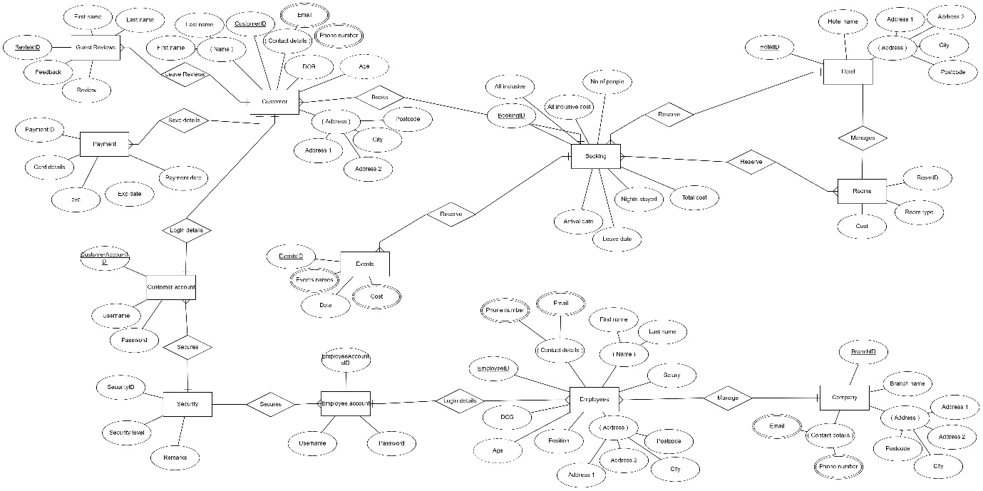

I linked company with employees as the company manages. In company I saved the name of the company as well as it addresses and contact details and for employees it was similar except for their names, date of birth, job position and salary. I included these because they are essential details. I then linked Employee/customer accounts and security as these are going to be for DBMS security. The attributes are security, usernames and password which are important data to ensure security. Customer is the next entity, and it is very similar to Employees. Employees is linked to Guest reviews and payments. In payments the attributes are about card details and when payments are made, guest reviews are for saving reviews from previous customers. The attributes are of a similar nature. Next is Bookings which holds all the data for when someone is going on holiday, for how long and the price. There are three other entities, and they are Events, hotels, and rooms. Hotels and rooms are separated as the hotels have different rooms and it would make storing it a lot easier. The attributes are about hotel address, names, what kind of rooms and the pricing. Finally, the Events entity is what the event name is, the date and the cost.

Question 4. Relational database schema
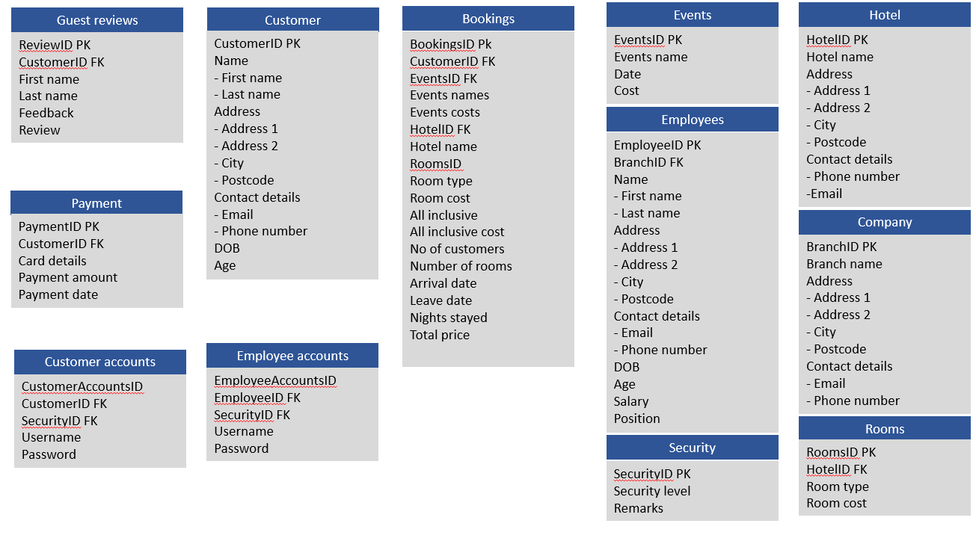
Question 5. Database management system
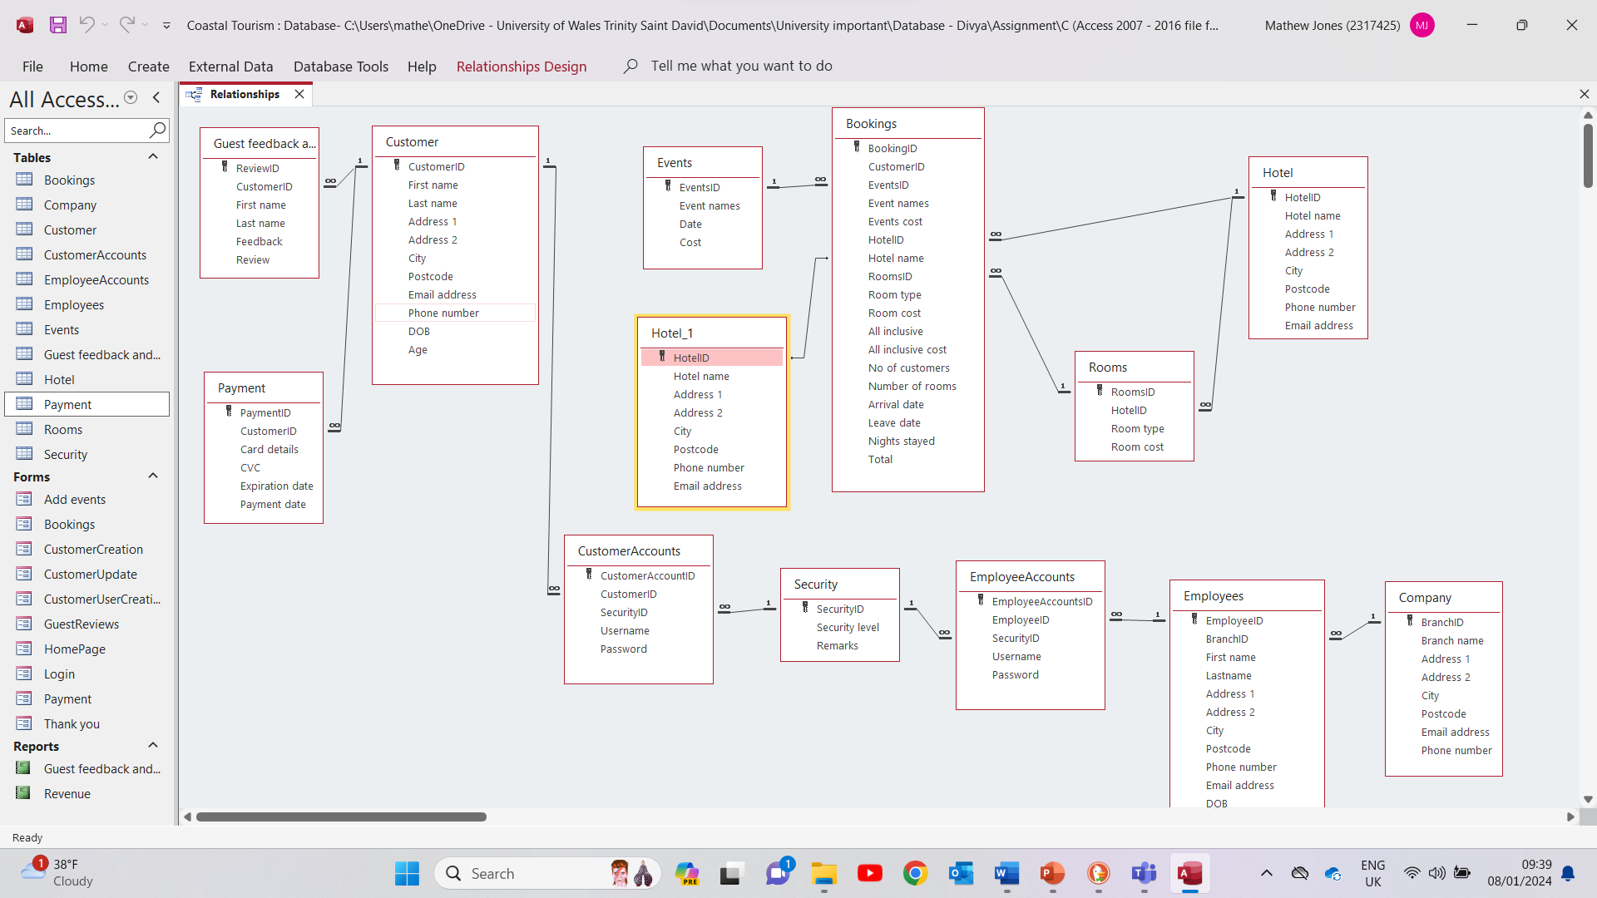

Question 6.

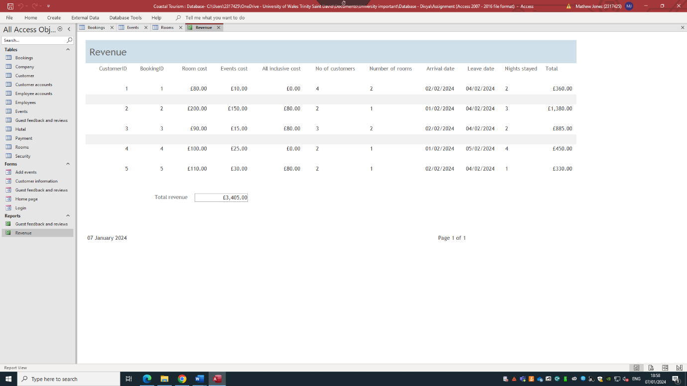
This is a calculation of the total revenue for the first week of February.

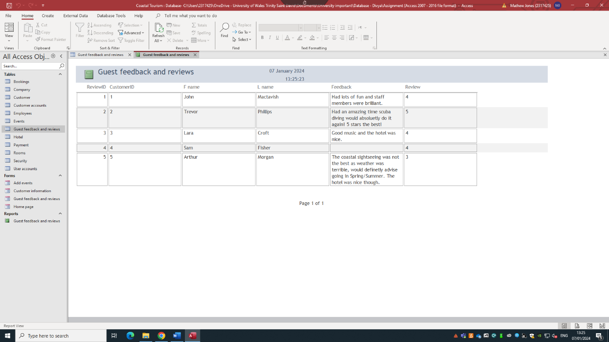
B.
This is a report of all the reviews from guests.

Question 7.

A.

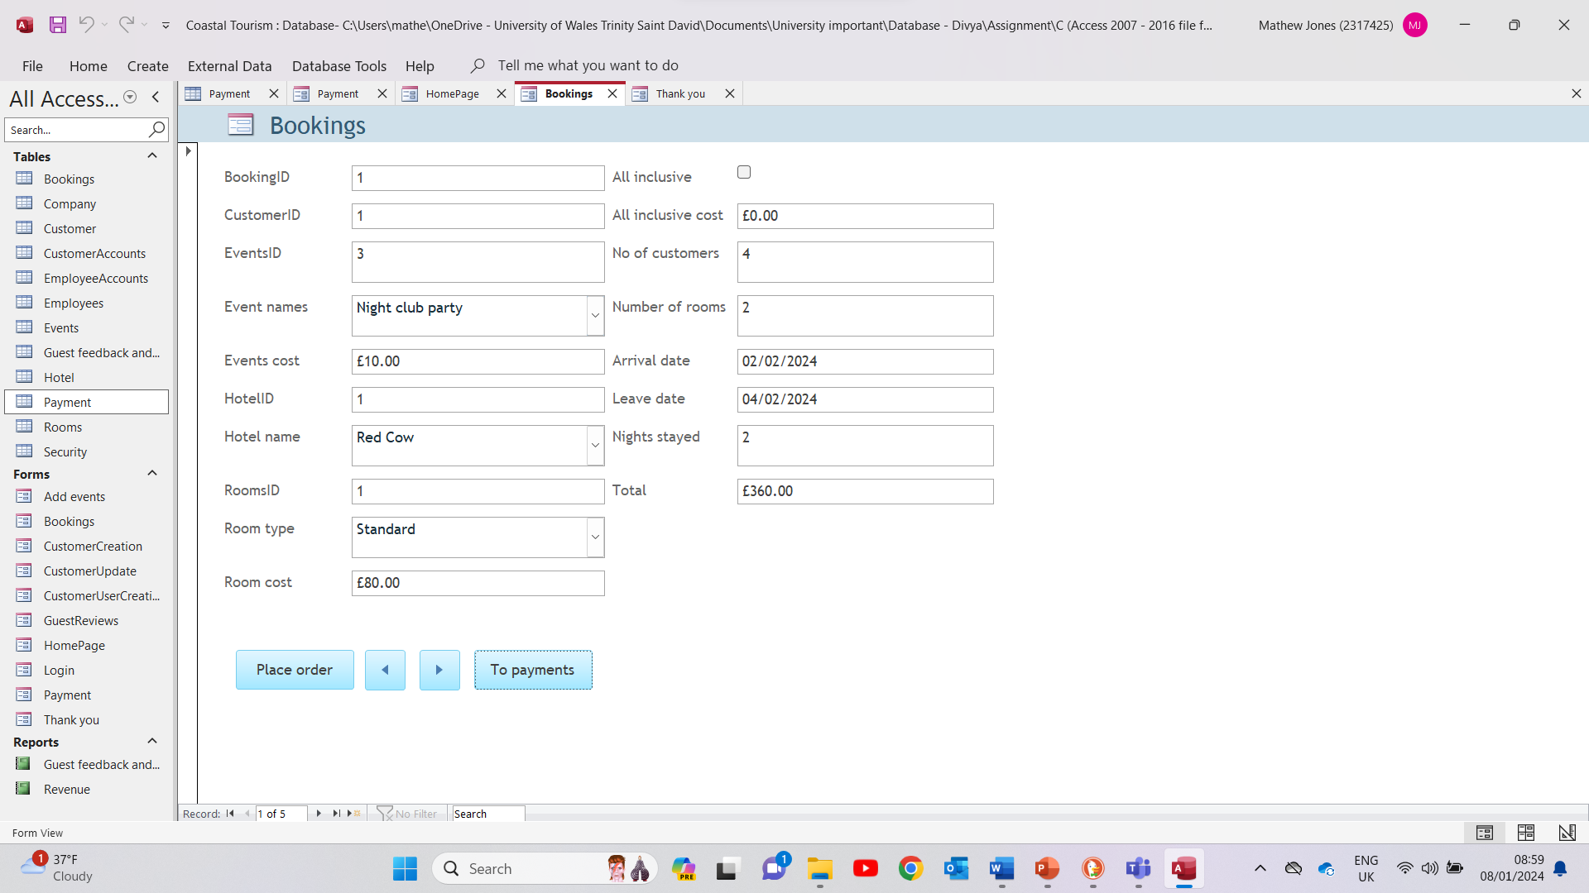
This is my reservation form for customers to book a holiday.

B.

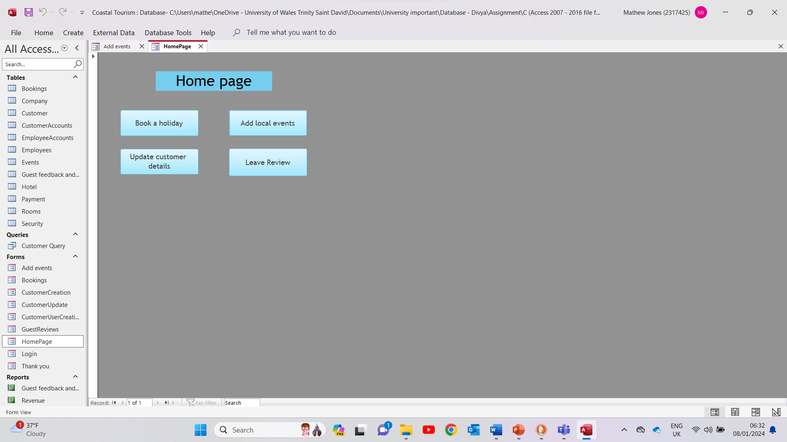
On the Home page click on Add local events.
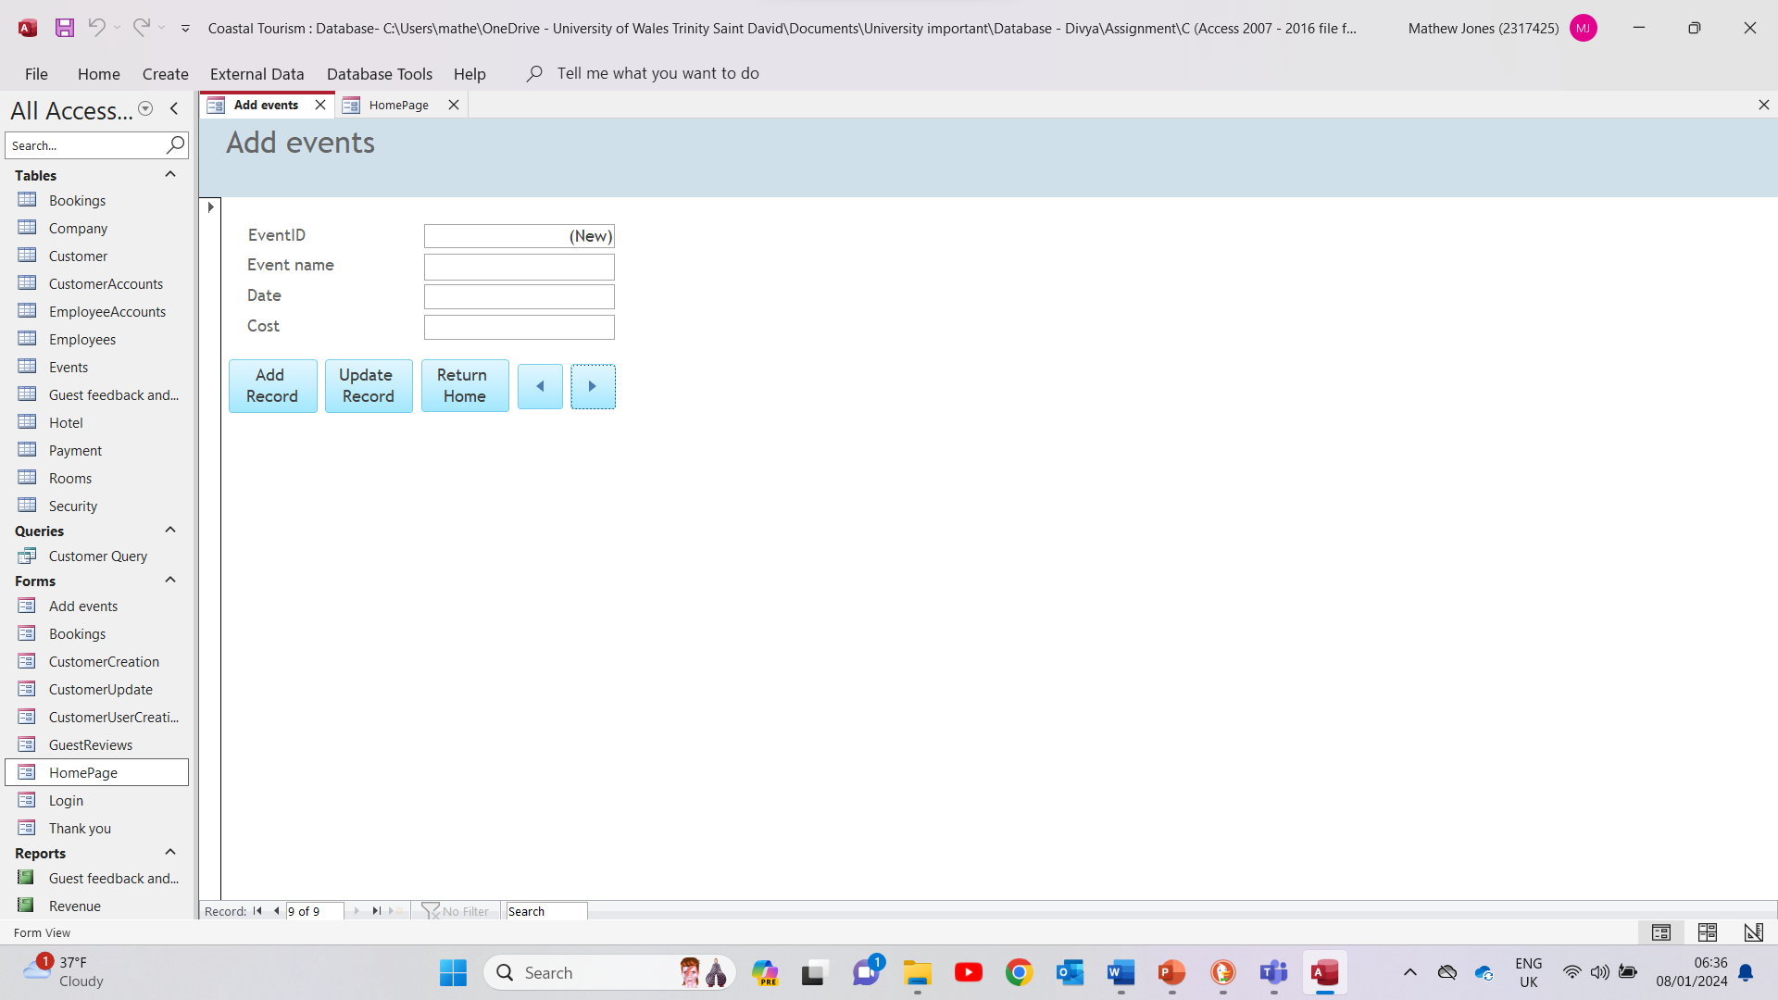
It will take you this page where you can add and update new events in the area.

Question 8.

A.

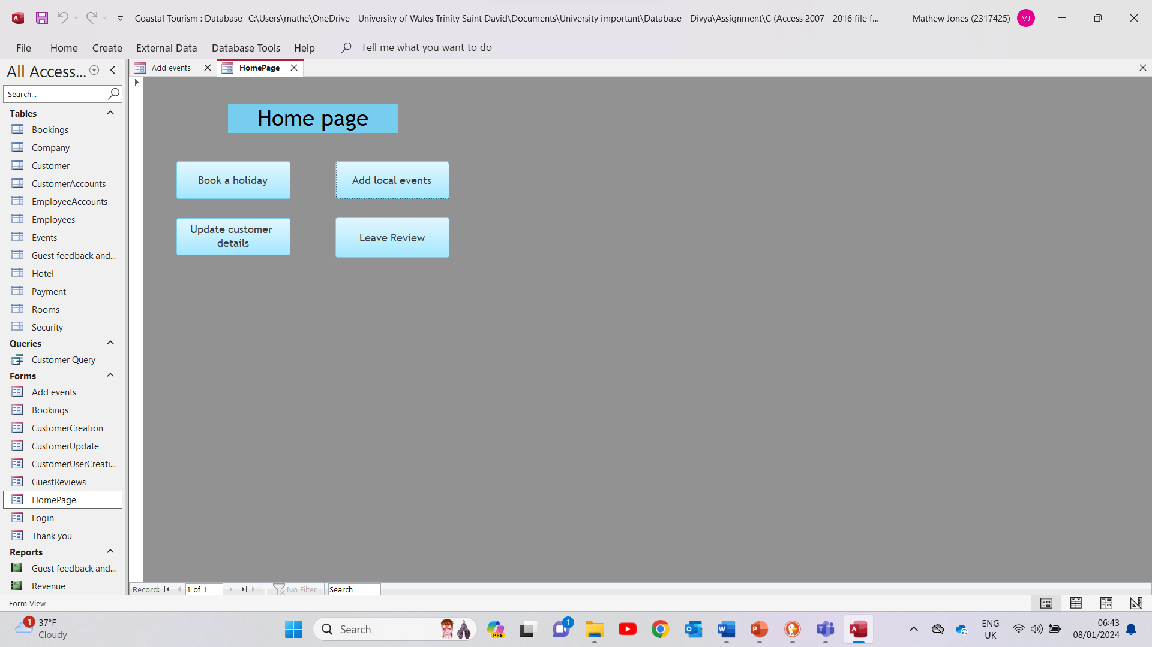
After logging in, you are able to update your customer details, add local events, book a holiday and you can leave a review.

B.

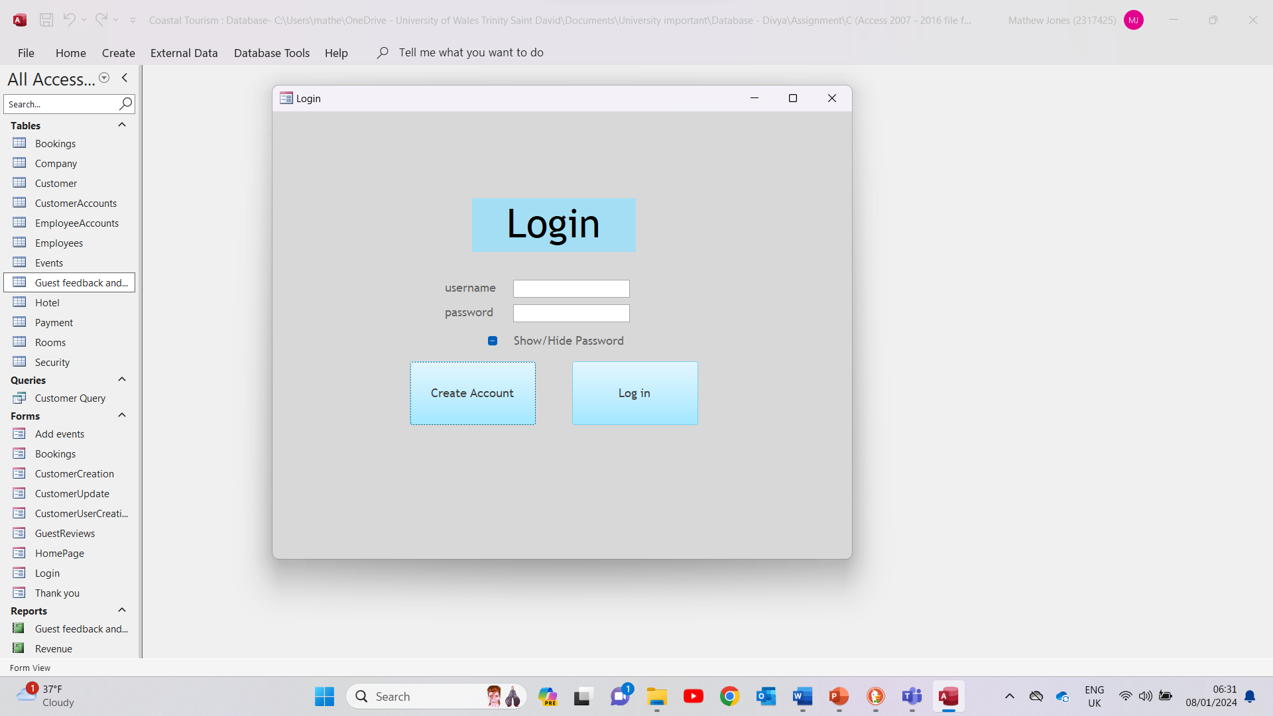
After opening my database, it will take you to the login screen where you can create a new account or log in.

Section B

Question 9.

Having a database can help remove or limit inconsistencies in data. Once a data is stored you will only need to store it once. It will be available to everyone who has access which will improve the efficiency and effectiveness’ by not having so many different copies of the same file and other departments will also be to look at data from different departments. This access can be restricted by using a username and password system. This will improve security and you can restrict what information certain people can access. For example, a manager will be able to access more of the database than a sales assistant. All these points make the company more productive as less time is being spent on repeated tasks and saves the company money.

Database management systems (DBMS) have three-levels of architecture which provide data independence. This allows different levels to be unaffected when changes are made to one and improves maintenance as the entire system does not need to be shut down. Additionally, they use a concurrency control protocol; this prevents two or more users interfering with the same data. This is beneficial as if there were multiply users updating the same data or 1 updating and 1 or more reading there could be a loss of data and/or a loss of integrity. Databases also make it easier to backup and recover data if a hardware/software issue were to happen

The system also allows for the implementation of guidelines in various aspects like data formats, naming conventions, documentations standards, date procedures, and access rules. This standard may be from departmental, organisational, national, or international entities. DBMS allows for improved data integrity as you can put constraints in place. If there were multiple branches you could make these constraints to all of them or even just one branch. For example, ensuring employees’ salaries are not below the minimum wage. [1]

Question 10.

To transition from a manual data management to a computerised system will initially be a challenge as DBMS is a complex software and there will be a sizable amount of data. Planning and implementing how this data will be stored is essential and what data is important, as if not done right the data quality will be inferior. [2]

The company will have to invest in training for staff members as they only know the previous system, as well as employing a database administrator, designer, and developer. The system will require annual maintenance, but this cost should be offset by employees not having to spend so many work hours adding duplicate data. The procurement of data may be a challenge initially but communicating with the local community, business and tourists should alleviate this challenge. [2]

“There are dozens of studies showing that digital documents reduce cost and improve quality and efficiency when compared to their paper counterparts” [3] The overall benefits of a database management system are it’s reduced data duplication which saves work hours, allows multiple users on the system at the same time, makes it easier to manage data and makes companies more efficient and productive. [4]

References
[1] T. Connolly and C. Begg, Database Systems: a practical approach to design, implementation, and management, Sixth, global edition. Ed. Boston: Pearson, 2015.
[2] A. Razmi-Farooji, et al., "Advantages and potential challenges of data management in e-maintenance," Journal of quality in maintenance engineering, vol. 25, no. 3, pp.378–396, 2019. doi: 10.1108/JQME-03-2018-0018. Accessed: Jan 8, 2024, [Online].
[3] C. Foot. "The enterprise advantages of automated data collection." Tech target. https://www.techtarget.com/searchdatamanagement/feature/The-enterprise-advantages-of-automated-data-collection (accessed 7/1/).
[4] A. Bohnert. "What Is a Database Management System? A Brief Guide." HackerRank Blog. https://www.hackerrank.com/blog/what-is-dbms-introduction/ (accessed Jan 7,).

`

