
Skills for the Workplace
Module Assignment Submission
Student Name: | Donna Stock
Student Number: | 2007575
Module No: | BMSK4007
Module Title: | Digital Skills and Personal Branding

Statement of Confirmation of Authenticity
By the act of making this submission, the student declares that this is the work of the student named above. The work has not, in whole or in part, been knowingly presented elsewhere for assessment, or where assessment has been built on a previous assessment, this has been identified. Where materials have been used from other sources it has been properly acknowledged. If this statement is untrue, the student acknowledges that an assessment offence has been committed.
Attention is drawn to the plagiarism and unfair practice policies of both the University and of ILM.
Permission for ILM to use this script
ILM uses learners’ submissions – on an anonymous basis – for assessment standardisation. By submitting, both the centre and the learner agree that ILM may use this script on condition that identifying information is removed. However, if you are unwilling to allow ILM use this script, please refuse by ticking the box: □

Table of Contents
What has been the impact of 21st Century Technologies on the modern workplace? 3
Evaluate the appropriate use of modern technologies and social media in the workplace generally 4
Explore the use of modern technologies and social media in own workplace 6
How can Personal branding help YOU? 8
Your LinkedIn Profile to promote your Personal Brand 8
Evaluate the value of other social media platforms to enhance networking and career prospects 10
Examine the impact of Personal Branding on your own employability 11
Discuss personal and professional security and safety online. 11
References 13
Appendix 1 14
Appendix 2 15

What has been the impact of 21st Century Technologies on the modern workplace?

In my recent research and evaluations into 21 century Technologies and social media platforms within the workplace, I have found that some businesses depend on it so much within the workplace. (10 ways Technology has reshaped the modern workplace) (Quick FMS by Amit Prasad (oct 2018)

Twenty first century technology advancements have completely reshaped the modern workplace by making their businesses processes highly integrated and much more streamlined. Especially more so in small and medium size businesses which are run by less staff.
Small businesses relay on technology like nothing else before to overcome whatever barriers that used to occur have now been overcome with the help of modern technological advancements, which have helped businesses in running their tasks smoothly, efficiently and performing much better than ever before.
Technologies in the modern workplace is like a facilitator that keeps the workflow smooth, easier and on track, which means everything is run in a more efficient manner which keeps everything up to date and helps strengthen business profitability too.
Mobile technology has now become indispensable in the modern workplace, here are some advantages and disadvantages to mobile tech in work…. due to its versatility and offers a large range of benefits, you should consider both the positives and negatives using mobile technology within the workplace. There are several mobile devices that can be used in the workplace such as laptops, iPad, netbooks, wireless debit\credit payment terminals and smartphones. Advantages and benefits of using mobile tech can lead to, higher efficiency and productivity, improve networking capabilities, the ability to accept payments wirelessly.
Some of the main disadvantages that come with using mobile tech in the workplace are increased IT security needs as portable devices are vulnerable to security risks, especially if they hold sensitive or critical business data. Costs of new technology devices are costly to purchase and also require maintenance and long term upkeep, not to mention that some staff my need additional training and instructions on how to use these new mobile technologies.

Evaluate the appropriate use of modern technologies and social media in the workplace generally

In my evaluations into Modern day technologies, I have found that social media and modern technologies are generally used in an appropriate way to help and encourage communication between employees and help to share work related ideas, which then increases engagement between employees whilst at home or at the workplace. With Social medias such as Facebook, LinkedIn, WhatsApp and Instagram, employees have a range of platforms with ability to help encourage casual conversations between colleagues and help build healthily workplace relationships, it is the quickest and easiest way encourage employees to interact with their co-workers outside of working hours this also boosts employee morale and engagement, with your work teams especially, social media could help massively improve them as they grow closer together building good friendships and repours with other work employees.

There are so many benefits of using social media platforms within the workplace and at home, here are some of the advantages of harnessing social media platforms in the workplace.
*Helps improve employee recognition and retention
*Boost employer personal brand
*Enhance employee learning
*Strengthens workplace relationships
*Brings down productivity
Social media is a powerful communication tool for employees, helping them to collaborate, share ideas among other colleagues, share work related ideas and solve problems faster. Social media can be very beneficial to employees in the workplace as well as employees working from home, employees who use social media for work are more engaged, and are most likely to leave their current jobs, as it exposes them to other greater job opportunities and raises their profiles among different recruiters.
When using social media within the workplace there are some key considerations to consider, here are some Dos and Don’ts:
Dos
*Know the applicable laws
*Provide a social media policy
*Protect your trade secrets
*Train key employees
*Consistently monitor
Don’t
*Seek protected information out about an employee.

Explore the use of modern technologies and social media in own workplace

At MrDapper Ltd my place of work we use several 21st Technologies such as:

*Instagram
*Facebook
*Booksy
*Zoom

We also use a Professional Photographer to take Professional pictures of our unisex self-care and beauty treatments, Shaves, haircuts, beard cuts and our hot towel shaving pamper treatments for our social media advertising, to show our audience our top high end professional treatments. As well as using platforms such as booksy to show the staffs individual availability for booking, changing, and cancelling appointments, to show our opening and closing times, as well as also creating Profiles of the Mr dapper team for our new and existing clients to book in with their favourite barber and beautician.
Booksy appointment booking, and payment system app is fantastic for use at Mr dapper as it also is a per paid system, so the staff and business don’t lose money from no show clients.

At Mr Dapper there’s no real need to use a large amount of web conferencing systems, but the ones we do like to use are Zoom as its very reliable and easy to use and then there’s WhatsApp, which is great, quick, easy, and convenient.

Zoom is used more now than ever before due to the current Covid 19 situation, we use zoom systems to hold staff company meetings and I've also used it to see and discuss product lines and up-coming products within our salon suppliers Ashton & Fincher and salon direct.
How we at Mr Dapper Ltd. use modern technology in my place of work:

We use Instagram and Facebook for advertising and promotion, posting pictures of Haircuts, Shaves, fades, eyebrow waxing, Products we use and sell, plus our opening and closing times.
We also have a work iPad that we use all day everyday as our appointments booking system. We use our Instagram story on our page to advertise and so that more people can see us and observe the high standards of cuts, shave, fades, waxing & beauty treatments etc. produced by our Barbers and Myself.

I have recently spoken to my boss and asked if we should also be using Pinterest, as I use it and think it's fantastic. He said that it’s something we will be looking into once the salon side of the business is more Established.

We rely on these technologies to help us run the company efficiently, smoothly & up to date daily. They also help us to provide a higher quality of service. With considerably increased communication through social media platforms, we can reach a wider range of new potential clientele than we would have been able to reach in the past.

The only negative impact I feel really, is that it can be somewhat interfering in after work hours when there's a consistency of 'Like' notifications on our social media platforms.

This can be easily resolved by turning of your notifications off in the evening when in your home life settings.
I have to keep a strong work life balance as I have a busy family of four, so I prefer to turn mine off in the evening whilst attending to my family and then back on at 6am every morning, to make I've not missed any inquiries messages, or important notifications.

The Cloud based Software that we use at Mr Dapper Ltd, are Gmail, Hotmail and Zoom. We use Gmail & Hotmail for all emails regarding the company such as, Salon Warehouse invoices, Accountancy emails, Vat invoices, salon retail offers and receipts from our booking app Booksy etc.

Also, between us staff we use cloud-based software such as Video & Web Conferencing such a Zoom for our communication when it comes to the company.
As we are all friends at Mr Dapper, we also use WhatsApp as quick communication between our selves.
We are also all use iPhones, which we use to take quick pictures and screen shots, emails, and client contact numbers are also stored in our iPhone then saved and backed up to the cloud.
As a backup in case Technology fails and crashes at any point, we keep a paper document filing cabinet system as well.

In my researching into web conferencing, I found an article that I was quite surprised by, as I didn’t realise how many web conferencing systems there are.

Systems such as Big Blue Button, Web huddle, Zoho meeting, Miko go, Meeting Burner and there's Zoom and Google Hangouts that I am familiar with as we sometimes use zoom for company meetings etc. (eLearning Industry. Article by Papp’s. Christopher. February 6, 2013, updated November 2015)
We don’t use a large amount of web conferencing systems at Mr Dapper Ltd. But one of the ones we do use is Zoom. We use Zoom more now than ever before due to the current COVID-19 situation.
Zoom is used to hold our staff meetings as unlike WhatsApp there can be more than two persons in a meeting in using zoom, I have also used zoom meetings myself, with our Hair & beauty suppliers Ashton & Fincher, where I have been able to see new Salon product lines, promotions & even discuss and book there in warehouse beauty courses.

We use WhatsApp Multiplatform messaging app. As it is useful to use, we use it to send work rotas, work related questions, images of products, haircuts, shaves and beauty before & after treatments results between clients and staff, we also use it for work related ideas, product updates and the New Salon refurbishments that are underway.
We find WhatsApp to be quite effective and just makes it so easy to do all these things and that’s why we really like to use it at Mr Dapper Ltd.

How can Personal branding help YOU?

Personal branding is a great way to put yourself out their which, also helps you set a great first impression among new employers and employees, one that can set you apart from the rest.
Effective personal branding will differentiate you from the other competition and allow you to build trust and stronger work bonds with prospective clients and employers.

Your LinkedIn Profile to promote your Personal Brand

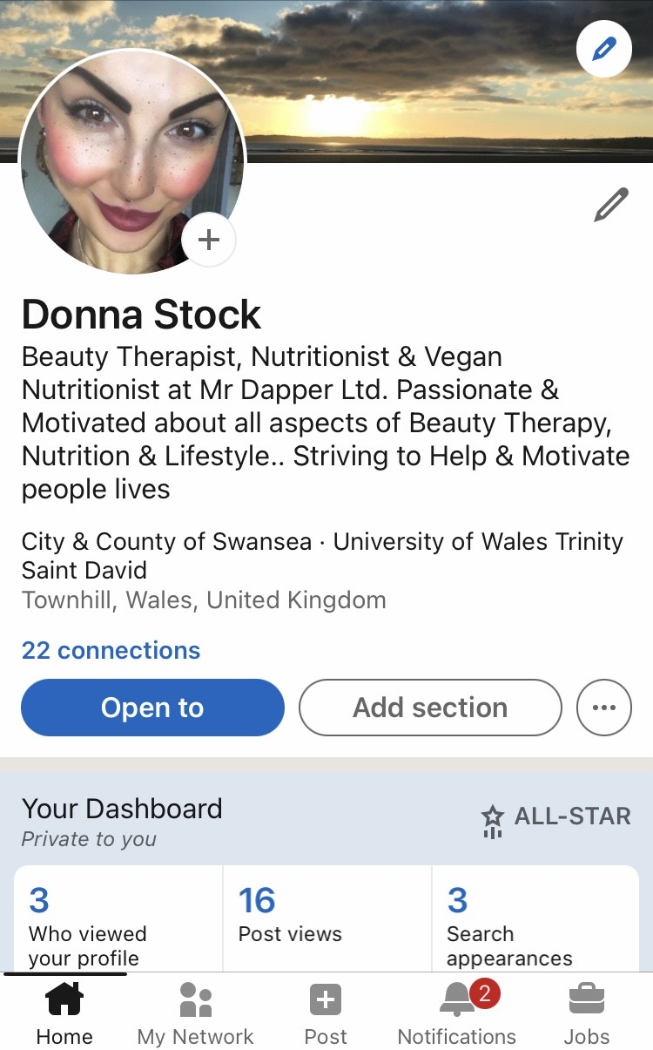
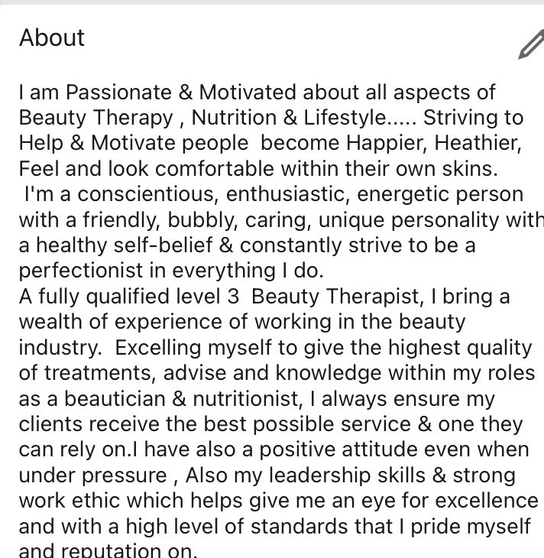

Evaluate the value of other social media platforms to enhance networking and career prospects

In my evaluations into social media platforms, networking, and career prospects I have found that Facebook events can be a great way to build your professional networking, you can just simply type in Facebooks search bar for upcoming work and industry-related events, then you can invite the new friends that you have met in the industry groups you’ve joined that suit your skills and employability. This will help give you a great opportunity to meet your new connections on a face-to-face meeting via Facebooks networking platform.
WhatsApp is so popular now because in enables smartphones to let you hold web-based version calls and holds as many as 16 persons at a time. It is also a good alternative to zoom for smaller companies as it uses end-to-end encryption.
You can also send and share pictures, videos, contacts & video call from WhatsApp.

The power of networking though social media platforms is a process of building relationships, and the strongest ones are built over a period. And having a great strong network will help build over time and help identify interesting, exciting, and new relevant opportunities.

Examine the impact of Personal Branding on your own employability

Personal branding encouraged me to designing and build my profile on networking platform LinkedIn which not only helped me for this module but has helped me gain new knowledge in my semi permeants make up industry in microblading and machine.
LinkedIn has also helped enhance my employability and has helped me gain and achieve another job working in Swansea city and country of Swansea council in the licensing department within environmental health.

Discuss personal and professional security and safety online.

Personal and professional safety online is extremely important, and we must be aware of this, in my recent research into what we can do to keep ourselves safe online professionally and personal. In my research I found an article (by Gabriel Weinberg jan11th 2008) making it so simple with online step by steps to dramatically reduce online tracking and keeping personal information safe for both yourself and colleagues with DuckDuck go app. Which is a great easy to use internet privacy company. I have also learnt a few safe practices like keeping different passwords for personal and work accounts. Not allowing outside networks to connect to my devices and to download a password wallet that is encrypted. I won’t be connecting my personal social media accounts to my business ones to firstly stay professional but for my own personal safety. I will also be going on a GDPR and data protection course so I can learn to properly store and protect customer’s personal and professional information. I have also looked into a leased internet line which would give even greater cyber security but until then I download and use Norton security on all of devises to stay on top of any virus or malware. This data could potentially be used and sold by companies to cold call you and try to sell you different services. It could also be used for fraud and identity theft so is import that none of your personal information is shared online.

References

Quick FMS Facilities Management Software by Prasad Amit (October 2018) Technology advancements 21st century workplace.
Quora (promoted by Duck Duck Go) By Weinberg Gabriel Updated January 11 CEO and Founder, Duck Duck Go (2008 present) Online Safety Privacy Company.
(eLearning Industry) Article by Papps. Christopher. (February 06. 2013) (Updated November 2015) Web Conferencing.
Quora (promoted by duck and go) by Gabriel Weinberg updated January 11th CEO and founder,duckduckgo (2008 present)
Forbes Caroline Castrillon February 12th, 2019
Finextra blog article 24 April 2017.
NIBuinessinfo.co.uk

Appendix 1

Here is my current CV

Donna-Marie Stock
45, Geiriol Road,
Townhill,
Swansea
South Wales
Sa1 6Qp

Tel: 07761 596400
Email: vintagelady15@gmail.com

Personal Profile

I am conscientious, enthusiastic, energetic, and hard working with a healthy self-belief and constantly strive to be a perfectionist in everything I undertake.
A fully qualified Level 2 Beauty Therapist, I bring a wealth of experience of working in the beauty industry, including owning and running my own beauty business, where I carried out various beauty treatments, for example-spray tanning, waxing and semi-permanent make up.
As a beautician, I always ensure that my customers receive the best possible service that they can rely on. I have experience of both working in a team environment and using my own initiative. I pride myself on being able to think on my feet as change is required.
I have a positive attitude even under pressure, strong work ethnic and leadership skills, with an eye for excellence and high level of standards and therefore believe your Salon will benefit from my skills and leadership.

Work experience
Beauty Therapy Salon owner
Various part time jobs, coffee shops, bars, and retail

Qualifications and Training
Current Study

Certificate in Higher Education Skills for the Workplace
ILM Leadership and Management Level 4
BA Leadership and Management Skills for the Workplace

VTCT Level 2
Cosmetic make-up,
Health and Safety
Employment Standards
Broadway Centre, Gower
Level 2 VTCT depilatory waxing course.
Qualified in Spray tanning, Ear piecing, minx nails, lash and brow tinting,

Qualifications in Health and Safety
Facials, Semi-permanent eyelashes.
Academy of Hair and Beauty

Sun Kissed Training Academy
Semi-permanent make up (Microblading etc.)

Taking the Plunge
Business Wales

BTEC Level 2
Health and Social Care - Distinction
Swansea College

GCSE Core Subjects
Child Development Grade B
Olchfa School

Hobbies and Interests
Mix martial arts
Going to the gym and keeping fit and healthy
Nutrition and herbal nutrition
Make up, treatments and therapies
Taking pride in myself and my appearance
Listening to Music,
Reading and researching interesting facts on mind, body, and soul
Walks in the woods
Arts and Crafts

References

Mr Christopher Wayne Barnes - Owner of Mr Dapper Ltd.
Mr Dapper Ltd
2 Plymouth Street,
Swansea
South Wales

Appendix 2

Here are some images I have screen shot of social media platform Instagram that Mr and Mr Dapper have used in my workplace to help engage with our audience of followers to provide new and old clients the best services in town. Instagram is also used to help promote the business, advertise, generate new clientele, staff profiles, our services, pictures of our work, opening and closing times and booking system Booksy.



