

Student Name: Talaviya Vivek
Student ID: 2509583

Module Name: Marketing Management
Module Code: LCMB7024

Lecturer’s Name: Laila Maazouz
Work Count: 2615

Term 1

Table of contents
Element 1: Brand Extension Poster Presentation 3
Element 2: Develop a Segmentation, Targeting, Differentiation, and Positioning (STDP) Analysis for the brand extension 4
Element 3: Marketing Mix 8
Element 4: Reflection 10
References 13

Element 1: Brand Extension Poster Presentation
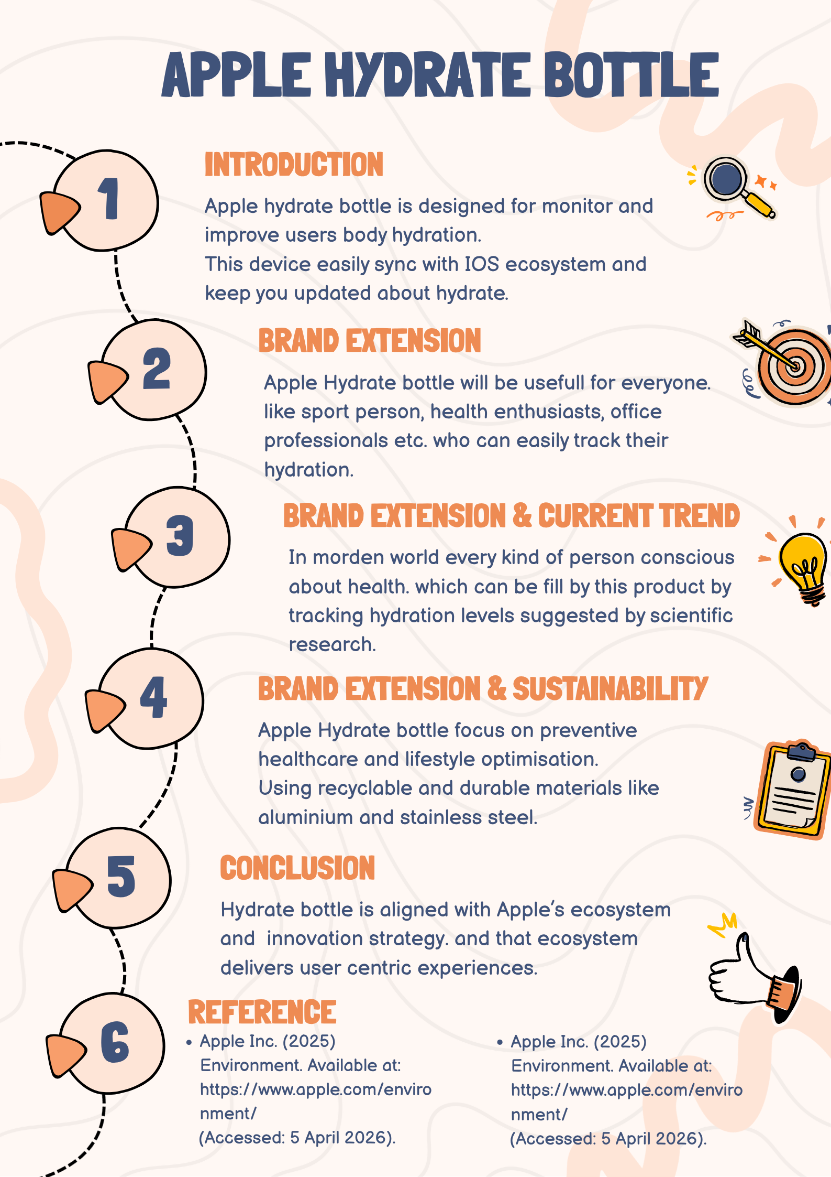

Element 2: Develop a Segmentation, Targeting, Differentiation, and Positioning (STDP) Analysis for the brand extension
Identification and description of key market segments
Geographic variables
Key geographic variables associated with rising demand for hydrate bottles largely comprehend increasing penetration of digital infrastructure with the adoption of app connected smart bottles. For instance, the global smart bottle market was operating with a value of USD 2.8 billion during 2025 alongside denoting 10.7% annual growth rate from 2025 to 2036 (Future Market Insights, 2026). In this case, rising demand for smart bottles are clearly reflected across the urban region having extended health awareness as well as a digitally focused consumer market. As an example, the North-American continent along with Asia-Pacific markets accounted for preferred geographic region experience in rising preference of smart bottles like hydrate bottles (Future Market Insights, 2026). Hence, the geographic variables for Apple Hydrate Bottles are signifying markets having strong health awareness in North America and Asia.
Demographic variables
Demographic consequences associated with Apple Hydrate Bottles clearly denote predominant consideration of the health conscious as well as tech-savvy consumer segment. For instance, a recent survey has clearly denoted the preference of around 56% of the Gen Z customers towards health fitness and awareness (Mckinsey, 2024). Alongside this, the ongoing trend of digitization is also contextually driving the focus of the customer segment to consider digital platforms. For example, 90% of the Gen Z consumers are applying and using digital platforms with a concise focus over health and nutrition (Innova, 2026). This evidence is clearly reflecting the demographic sequences of health awareness and digitisation as prime drivers of demographic aspects for Apple Hydrate Bottles.
Psychographic variables
Psychographic segmentation of Apples Hydrate Bottles clearly indicates the health conscious and wellness speaking population with deep commitment to physical health. As an example, the case of the sport persons and athletes can be considered alongside health enthusiasts with a comprehensive vision of real time tracking of hydration statistics (Wei, 2024). In this case, Apple would target addressing physical healthcare and monitoring attributes for health aware populations with the advanced hydrate bottles.
Behavioural variables
The behavioural variables for Apple Hydrate Bottles have precisely reflected sustainable behavioural patterns across the current Gen Z customer segment. For instance, hydrate water bottles are complying with the UN SDG 3 “Good health and well-being” and SDG 9 “Industry, Innovation and Infrastructure” (UN, 2026). Referring to this understanding, the behavioural variables for Apple Hydrate Bottles denote the wider sustainable consumer market preparing health awareness and health monitoring with real time tracking of hydration.
Detailed explanation of target audience
Profile and background | - Name- Anthony Mathews    - Age - 25  - Monthly income- $35,000-$40,000  - Suburban resident
Goals | To experience seamless integration of technology advancement in order to empower user experience with tech-savvy products and offerings
Behaviour | - Increasing preference of digitisation  - Enhanced emphasis towards sustainability
Motivation | - Experiencing the combined features of digital technology under the measure of sustainability with recyclable materials
Pain-points | Addressing critical consumer needs of comprehending data driven and real time approach to understand the level of hydration in human body
Table 1: Consumer persona
(Source: Self-developed)
Referring to the aforementioned consumer persona, the tech-savvy and sustainability oriented population has been reflected as the prime target audience for Apple Hydrate Bottles. For instance, the current sustainable vision and targets are also aligned with the combination of digital technologies such as digital access, AI and IoT, cloud, blockchain and extended reality (UNEP, 2026). In this current case, the market trends of digitalisation and sustainability are concretely referred to for explaining the target market for Apple Hydrate Bottles.
Differentiation from market competitors
The concept of differentiation would be applied by Apple through a contextual emphasis over sustainability through utilising recyclable and durable materials for the hydrate bottles. For example, the preference of stainless steel is certified as a sustainable material with the features of recycling and immediate disposal for supporting environmental welfare (IMOA, 2026). This unique proposition of sustainability and environmental friendly materials is adding a greater value to empower differentiation for Apple Hydrate Bottles from the existing market competition.
Positioning of the brand extension
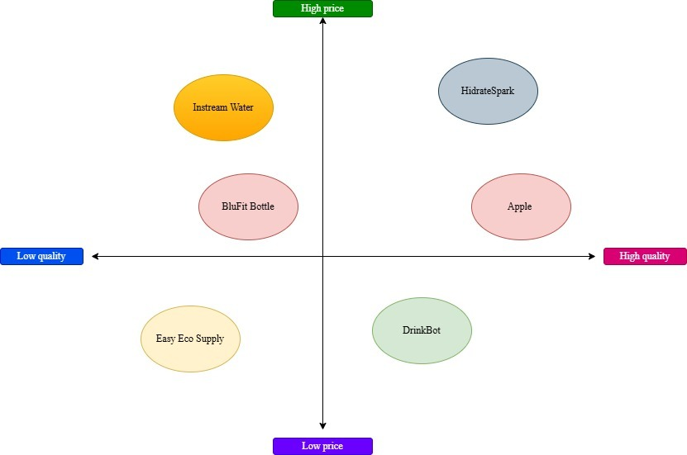
Figure 1: Positioning diagram for Apple Hydrate Bottle
(Source: Self-developed)
Referring to Figure 1, Apple has been positioned with high pricing and quality for hydrate bottles. For this purpose, Apple would consider an omnichannel positioning approach by integrating both traditional distribution networks and online channels. Yang and Hu (2024) has denoted the values of omnichannel strategy to empower market growth opportunities by integrating traditional and digital channels. Hence, explicit market growth opportunities are certified for Apple with omnichannel integration for hydrate bottles.

Element 3: Marketing Mix
Product
Brand extension of the Apple requires effort to maximise the reach of Apple Hydrate Bottle, so that Apple enthusiasts are well aware of the essential addition to the brand. Successful brand extensions happen when appropriate market research, consumer segmentation, localization of campaigns, strategic partnerships, and technology are aligned for the new product that affects the brand extension (Luyang, 2024). Contextually, the localisation of brand campaigns for Apple Hydrate Bottle is performed through the hyperactive digital and online platforms chosen for marketing. Strategic partnerships with Instagram influencers additionally improve the brand value as their existing followers are emotionally attached to their content and their personal brand. Ozioko (2025) states that influencer marketing through endorsements are 37.3% a key driver for consumer engagement at Apple in addition to UGC content. Contextually, for Apple Hydrate Bottle, influencer marketing endorsements can prove to be a heavy accelerator for the brand extension.
The product category for this present perfect denotes hydrate bottles having the features of preventive healthcare and lifestyle optimisation. In this case, the hydrate bottles would disclose sustainable preparation and manufacturing with the inclusion of stainless steel and Aluminium. The product is Apple Hydrate Bottle that focuses on tracking hydration levels while using sustainable materials like stainless steel and aluminium that are recyclable and durable. There are six decarbonisation approaches to structural alloys used in consumer electronics including aluminium and stainless steel alloys that reduce carbon impact (Lessard et al. 2025). Referring to this concern, Apple would be focusing on enhancing product features with substantial research and development programmes in order to empower its accountability with more advanced features of data driven tracking.
Price
The Apple products are generally purchased by high-income individuals who are technology enthusiasts. Apple uses a premium pricing strategy to maintain brand value and product differentiation effectively (Rahmat, 2024). Contextually, the price is friendlier to the existing Apple users and Apple enthusiasts which is having a premium affordable range. The premium pricing of Apple Hydrate Bottle is justified with the data processing that the bottle requires in order to track the hydration levels alongside branding value. Feng (2024) states that consumers who are brand loyal to Apple are ready to pay the high value of the premium Apple products providing Apple more flexibility and bargaining power in pricing. Contextually, the Apple Hydrae Bottle derives the bargaining power of its product from Apple as it is a brand extended product. Therefore, the premium pricing of Apple products allows Apple Hydrate Bottle to function in the same premium segment without hurting the consumer sentiments with pricing injustice.
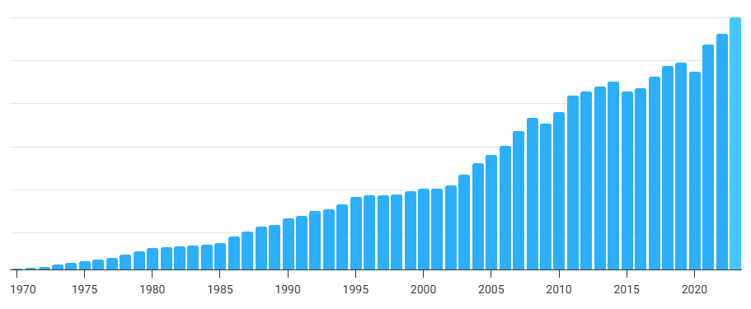
Figure 2: World consumer spending stats
(Source: Macro Trends, 2026)
Referring to the introduction of hydrate water bottles from Apple, a dynamic or premium pricing strategy would be applied. Kopalle et al. (2023) has clearly articulated the concept of dynamic pricing strategy to enable significant benefits including the consequences of price adjustment on the basis of market demand. The application of dynamic pricing is also expected to empower competitive growth for Apple based on rising profitability and sales volume based on price adjustment. Apparently, the global consumer spending power has also reported 6.65% growth during 2023 as compared to 2022 with USD 59.977 trillion (Macro Trends, 2026). Increasing consumer spending ability is also acting as a supportive factor for indulging dynamic pricing from the perspective of Apple. In this case, Apple would also be able to establish long term and sustained competitive advantage from the market rivals with the extension of financial reveals resulting from dynamic pricing for hydrate bottles.
Place
The Apple Hydrate Bottle will be available in offline retail Apple stores, website of Apple, third-party websites showcasing Apple products and e-commerce websites. Apple products have channel accessibility through integrated marketing communication to reach mass audiences for extensive sales and revenue (Malik and Walia, 2022). The product being a sustainable recyclable product due to its aluminium and stainless steel materials tends to attract the modern generation, especially young millennials and Generation Z. Dragolea et al. (2023) state that Generation Z is the most interested consumer segment in sustainable products who are consumers of green marketing practices. The green marketing of Apple Hydrate Bottle is to keep all marketing digital and online that reduces the need for offline traditional marketing practices reducing effective marketing costs and time. Additionally, the availability of the product in all Apple stores, both online and offline, alongside e-commerce websites tend to attract the regular Apple visitors for extensive sales. Thus, the above-mentioned channels tend to improve the sales and revenue of Apple through Apple Hydrate Bottle as a part of brand extension.
Promotion
Apple Hydrate Bottle needs to be promoted through every successful online digital channel for maximising revenue through maximisation of reach. The selected promotion channels are Facebook, Instagram, LinkedIn, e-mail, OTT ads, Google Ads and YouTube. The digital promotional sequence would be featured completely by Apple for promoting the launch of hydrate bottles. The social media channels would be referred to for promoting the hydrate bottles of Apple. The reason behind considering social media channels define its explicit market engagement as total social media advertising spending was USD 276 billion during 2025 (Guttmann, 2025). Hence, rising market engagement and focus is justifying the inclusion of social media as a prime promotional channel including platforms like Instagram and Facebook for digital promotion.

Element 4: Reflection
Apple being a widely used and preferred technology brand allowed me to extensively understand their psychology while developing the Apple Hydrate Bottle. Contextually, the Kolb Reflective Model, Concrete Experience, Reflective Observation, Abstract Conceptualisation, and Active Experimentation are the four stages of experiential learning (Rahmi, 2024). Using the Kolb reflective model, I ensure that I reflected on the observations during development of the product concept noting the concrete experiences while experimenting with the initial product ideas. Therefore, I understood that effective reflection of observation of failures of initial models of the product ensures better designing of the forward models making the product industry-legitimate.
Concrete Experience: I experienced that Apple products require enough attention to human behaviour that is often eluded in the case of other brands. I understood that regular and unnoticed human behaviour that evolves with the evolution of technology is the underscore to development of brand extension to Apple products. Technological innovations have deep behavioural implications leading to complications forcing trade-offs leading to inequity dimensions (Sovacool et al. 2022). I noted that the inequity dimensions for Apple Hydrate Bottle were hydration routines, timely check-ins and irregular thirst patterns that we addressed with the product.
Reflective Observation: I observed that Apple products are smarter than other branded products due to their skills of understanding trends related to the growth of human evolution with the evolution of technology. This observation allowed me to elevate the product design best fitted for the gym and fitness enthusiasts based on their habits both mental and physical. Technology-driven initiatives that care about human evolution are pivotal in driving expansion of the product market (Attah et al. 2024). Therefore, I made it absolute that I innovated the hydration bottle with technology adaptable for Apple with the inclusion of human evolution as per technological advancements.
Abstract Conceptualization: The abstract conceptualisation of the Apple Hydrate Bottle came to me through continuous reflection of my fitness habits during the day that made me want a better hydration system. I understood that design conceptualisation of the Apple Hydrate Bottle was possible since I paid minute attention to how my body reacted to dehydration or during the requirement of hydration. Monitoring hydration levels is crucial to maintenance of health and prevention of dehydration where extensive research is in-process (Belabbaci et al. 2025). As a result, I designed the Apple Hydrate Bottle around active monitoring of hydration levels of the body through other Apple products that people use, alongside the bottle. Therefore, pairing various Apple products together with the Apple Hydrate Bottle I was able to conceptualise a strong Apple ecosystem in each household.
Active Experimentation: I noticed the limitations of the other bottles in the market that provided hydration however failed to provide an Apple level understanding of the hydration needs for conceptualisation. The limitations and correlation to other Apple products allowed me to experiment with the designs of the Apple Hydrate Bottle. The main focus of Apple that sets them apart from other brands is their strong R&D while maintaining focus on the creation of their brand ecosystem in each household (Doan and Phan, 2025). Therefore, I deeply analysed and experimented with the hydration-based human habits to evolve the final design of the Apple Hydrate Bottle as a brand extension project for Apple.

References
Apple, (2026). List of Apple products. Available at: https://apple.fandom.com/wiki/List_of_Apple_products (Accessed: 28 April 2026).
Attah, R.U., Garba, B.M.P., Gil-Ozoudeh, I. and Iwuanyanwu, O., (2024). Best practices in project management for technology-driven initiatives: a systematic review of market expansion and product development technique. Int J Eng Res Dev, 20(11), pp.1350-61.
Belabbaci, N.A., Anaadumba, R. and Alam, M.A.U., (2025). Recent advancements in wearable hydration-monitoring technologies: scoping review of sensors, trends, and future directions. JMIR mHealth and uHealth, 13, p.e60569.
Doan, T.N.T. and Phan, M.T., (2025). Analysis of Apple’s competitive advantage: An RBV perspective. International Journal of Research in Education Humanities and Commerce, 3(5), pp.108-118.
Dragolea, L.L., Butnaru, G.I., Kot, S., Zamfir, C.G., Nuţă, A.C., Nuţă, F.M., Cristea, D.S. and Ştefănică, M., (2023). Determining factors in shaping the sustainable behavior of the generation Z consumer. Frontiers in Environmental Science, 11, p.1096183.
Feng, J., (2024). Microeconomic Analysis of Consumer Behavior and Firm Pricing Strategy. Journal of Humanities, Arts and Social Science, 8(5).
Future Market Insights, (2026). Smart Water Bottle Market. Available at: https://www.futuremarketinsights.com/reports/smart-water-bottle-market (Accessed: 27 April 2026).
Guttmann, A., (2025). Social media advertising and marketing worldwide – statistics & facts. Available at:https://www.statista.com/topics/1538/social-media-marketing/?srsltid=AfmBOorxmst2ee4aDHglyPUA1GjZAMw4wEempKqESH7QmBwQbWjlV2yc (Accessed: 28 April 2026).
IMOA, (2026). Supporting presentation for lecturers of Architecture/Civil Engineering. Available athttps://www.imoa.info/download_files/stainless-steel/issf/educational/Module_11_Sustainability_en.pdf?m=1592476644& (Accessed: 28 April 2026).
Innova, (2026). Gen Z Lifestyles Trends and Attitudes in the US & Canada. Available at: https://www.innovamarketinsights.com/trends/gen-z-lifestyles/ (Accessed: 27 April 2026).
Kopalle, P.K., Pauwels, K., Akella, L.Y. and Gangwar, M., (2023). Dynamic pricing: Definition, implications for managers, and future research directions. Journal of Retailing, 99(4), pp.580-593.
Lessard, J., Darunte, L. and Jayanathan, S., (2025). Decarbonizing structural alloys in consumer electronics: case studies at Apple. Journal of Sustainable Metallurgy, 11(4), pp.3550-3563.
Loken, B., Joiner, C. and Houston, M.J., (2023). Leveraging a brand through brand extension: A review of two decades of research. Brands and brand management, pp.11-42. (Accessed: 28 April 2026).
Luyang, L., (2024). Brand Extension and Brand Asset Management: Challenges and Responses in Cross-Border Operations. Academic Journal of Business & Management, 6(4), pp.66-71.
Macro Trends, (2026). Apple Revenue 2012-2025 | AAPL. Available at: https://www.macrotrends.net/stocks/charts/AAPL/apple/revenue (Accessed: 28 April 2026).
Macro Trends, (2026). World Consumer Spending. Available at: https://www.macrotrends.net/global-metrics/countries/wld/world/consumer-spending (Accessed: 28 April 2026).
Malik, R. and Walia, L.K., (2022). Comparative Analysis between Communication and Distribution Channels of APPLE and AMUL. International Journal of Research in Multidisciplinary Studies (IJRMS), pp.13-16.
Mckinsey, (2026). CURATED READS FOR GEN Z—AND THEIR Z-CURIOUS COLLEAGUES. Available at: https://www.mckinsey.com/~/media/mckinsey/email/genz/2024/01/2024-01-23d.html (Accessed: 27 April 2026).
Ozioko, E.A., (2025). Content Marketing as an Advertising Strategy: An Analysis of Brand Awareness and Audience Relationships at Apple. Mdooter Journal of Communication and Digital Technologies, 2(2), pp.44-55.
Rahmat, H.K., (2024). Unveiling The Power Of Price Elasticity: The Key To Successful Business Strategies And Pricing Decisions. Al-Isyraq: Jurnal Bimbingan, Penyuluhan, dan Konseling Islam, 7(3), pp.1047-1056.
Rahmi, W., (2024). Analytical study of experiential learning: Experiential learning theory in learning activities. EDUKASIA Jurnal Pendidikan dan Pembelajaran, 5(2), pp.115-126.
Sovacool, B.K., Newell, P., Carley, S. and Fanzo, J., (2022). Equity, technological innovation and sustainable behaviour in a low-carbon future. Nature human behaviour, 6(3), pp.326-337.
UN, (2026). THE 17 GOALS. Available at: https://sdgs.un.org/goals (Accessed: 27 April 2026).
UNEP, (2026). Digitalization for Sustainability. Available at: https://www.unep.org/topics/digital-transformations/digitalization-sustainability (Accessed: 28 April 2026).
Wei, L., (2024). The science of hydration: its impact on endurance and performance in athletes. Revista de Psicología Del Deporte (Journal of Sport Psychology), 33(2), pp.67-75.
World Bank, (2026). Global digitisation in 10 charts. Available at: https://www.worldbank.org/en/news/immersive-story/2024/03/05/global-digitalization-in-10-charts (Accessed: 28 April 2026).
Yang, Z. and Hu, D., (2024). Digital technology-empowered omnichannel integration: a review and research agenda. International Journal of Retail & Distribution Management, 52(4), pp.407-424.

