06.05.2022
ACCA4002_2114954

Data Analysis & Visualisation - Assessment 2


Student name: Stefania-Loredana Gălbău
Teacher name: Koushik Modak

Table of Contents

Introduction 3
Description of the data including a set of descriptive statistics: 3
Developing a set of testable hypotheses for the experiment: 4
Selecting a test to be used to test these hypotheses: 5
Test the hypothesis to significance level: 5
Test for p = 0,10 5
Test for p = 0,05 6
Test for p = 0,01 6
Finding out whether there are outliers in the data set: 7
Finding factors that might have affected the results of the experiment: 8
Conclusion 8
References 9

Introduction

In this report the given table data of class test results of students displays the comparison of achievements when the students use traditional materials to help them learn and when the students use online app to help with their studies.
The elements determining hypothesis power have been examined, as well as the many factors that can affect the hypothesis, as well as the methods and recommendations for better hypothesis testing. Outliers in data are explored, as well as their effects; deleting outliers can aid in better hypothesis testing.

Description of the data including a set of descriptive statistics:

A concise description of the data is provided by descriptive statistics [1]. The column ‘student’ in the table shows the student count serially. ‘Test score before using app’ column shows the result of each student when students used traditional materials to study and ‘Test score after using app’ column shows result of each student when they use the online app to help their study.

Fig.1: Test score – visualization.
This is the visualization of the score ‘Test score before using app’ and ‘Test score after using app’. The line chart shows the variations of their students.
From the initial overview of this test score from the table, the score where high most of the time when students used the online app.
Some set of descriptive statistics will help to understand the outcome of the result more clearly.
The set of sorted test score of 40 students before using app: {5, 6, 6, 6, 7, 8, 8, 8, 9, 9, 10, 10, 11, 11, 12, 12, 12, 12, 12, 12, 13, 14, 14, 14, 14, 15, 15, 15, 16, 17, 17, 17, 17, 17, 17, 17, 18, 18, 19, 20}
The set of sorted test score of 40 students after using app: {4, 9, 9, 10, 10, 10, 11, 11, 12, 13, 13, 14, 14, 14, 14, 15, 15, 15, 15, 15, 16, 16, 17, 17, 17, 17, 17, 18, 18, 19, 19, 19, 19, 20, 20, 20, 20, 20, 20, 20}
The mean of test score of 40 students before using app: (sum of test score of 40 students before using app)/40 = 510/40 = 12.75
The mean of test score of 40 students after using app: (sum of test score of 40 students after using app)/40 = 612/40 = 15.30
The median of test score of 40 students before using app: Average of the two numbers in the middle = (12+13)/2 = 12.50
The median of test score of 40 students after using app: Average of the two numbers in the middle = (15+15)/2 = 30
The mode of test score of 40 students before using app is 17
The mode of test score of 40 students after using app is 20
From the above descriptive statistics, it can be clearly seen that the result of mean, median and mode of test score of students after using the app is higher in each calculation than the mean, median and mode of test score of students before using the app. And so, it can be said with confidence that the app is helping student bringing more achieved result and the company should continue to develop the app.

Developing a set of testable hypotheses for the experiment:

In science, a testable hypothesis is one that may be verified or rejected by experimentation, data collecting, or personal experience [2]
A hypothesis is an educated guess, statement, assumption or claim about the value of a parameter of something in the world. We will develop a null hypothesis and an alternative hypothesis for the experiment.
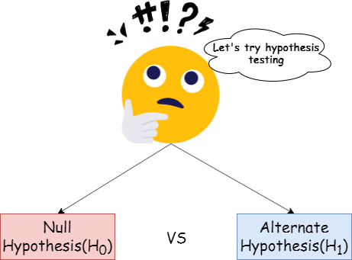
Fig.2: Hypothesis

Null Hypothesis (H0): The average test score after using the application is not higher than the average test score before using the application.
Alternative Hypothesis (H1): The mean test score after using the application is greater than average test score before using the application.

Selecting a test to be used to test these hypotheses:

We will apply the One Tailed Z Test on these hypotheses to find out the correct hypothesis. One Tailed Z Test is the suitable test for the hypothesis set to test. One Tailed Z Test are usually used when the testable data amount is large. One Tailed Z Test steps includes both null hypothesis and alternative hypothesis which matches with the selected set of hypotheses. The test result of One Tailed Z Test is also more accurate and acceptable. Hence, One Tailed Z Test result will prove which hypothesis is the correct one.

Test the hypothesis to significance level:

Test for p = 0,10

One Tailed Z Test for significance level 0.10:
Step-1: State the null hypothesis. The mean value of test score after using app is 12.75.
so: H0 = 12.75.
Step-2: State the alternative hypothesis. The mean value of test score after using app is 15.30.
so: H1 > 12.75.
Step-3: State the alpha level which is this case 0.10.
Step-4: Level of 0.10 is equal to a z-score of 0.26
Step-5: Standard deviation of the data set is 4.05. Use the following formula for test statistic:
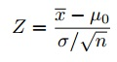
= (15.30-12.75)/(4.05/√40)
= 3.98

Since Step-5 value is greater than Step-4, the null hypothesis will be rejected, and alternative hypothesis will be accepted in this case.

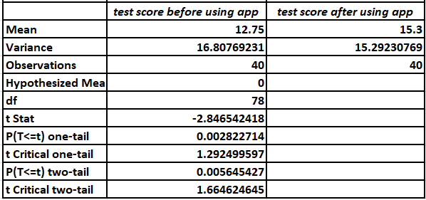
Fig.3: Test for p = 0,10

Test for p = 0,05

One Tailed Z Test for significance level 0.05:
Step-1: State the null hypothesis. The mean value of test score after using app is 12.75.
so: H0 = 12.75.
Step-2: State the alternative hypothesis. The mean value of test score after using app is 15.30.
so: H1 > 12.75.
Step-3: State the alpha level which is this case 0.05.
Step-4: Level of 0.05 is equal to a z-score of 0.13
Step-5: Standard deviation of the data set is 4.05. Use the following formula for test statistic:
= (15.30-12.75)/(4.05/√40)
= 3.98

Since Step-5 value is greater than Step-4, the null hypothesis will be rejected, and alternative hypothesis will be accepted in this case.
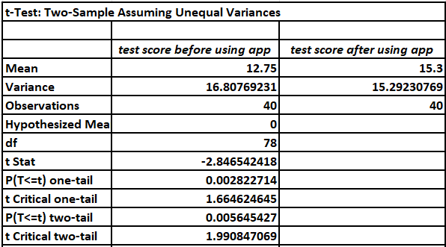
Fig.3: Test for p = 0,05

Test for p = 0,01

One Tailed Z Test for significance level 0.01:
Step-1: State the null hypothesis. The mean value of test score after using app is 12.75.
so: H0 = 12.75.
Step-2: State the alternative hypothesis. The mean value of test score after using app is 15.30.
so: H1 > 12.75.
Step-3: State the alpha level which is this case 0.01.
Step-4: Level of 0.01 is equal to a z-score of 0.0255
Step-5: Standard deviation of the data set is 4.05. Use the following formula for test statistic:
= (15.30-12.75)/(4.05/√40)
= 3.98

Since Step-5 value is greater than Step-4, the null hypothesis will be rejected, and alternative hypothesis will be accepted in this case.

From the above testing results, it can be stated that alternative hypothesis is accepted in every case clearly.
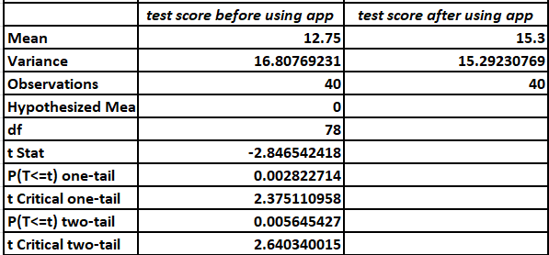
Fig.3: Test for p = 0,01

Finding out whether there are outliers in the data set:

Outliers are data points in a data set that are distanced from other data points. In other words, outliers are the unusual values in a data set.
1. Let’s find out whether there any outlier in test score before using app data set:
The set of sorted test score of 40 students before using app: {5, 6, 6, 6, 7, 8, 8, 8, 9, 9, 10, 10, 11, 11, 12, 12, 12, 12, 12, 12, 13, 14, 14, 14, 14, 15, 15, 15, 16, 17, 17, 17, 17, 17, 17, 17, 18, 18, 19, 20}
Median of the set = (12+13)/2 = 12.50
First half of the data set = {5, 6, 6, 6, 7, 8, 8, 8, 9, 9, 10, 10, 11, 11, 12, 12, 12, 12, 12, 12}
Median of the first half of the data set, Q1 = (9+10)/2 = 9.50
Second half of the data set = {13, 14, 14, 14, 14, 15, 15, 15, 16, 17, 17, 17, 17, 17, 17, 17, 18, 18, 19, 20}
Median of the second half of the data set, Q3 = (17+17)/2 = 17
Now, IQR = Q3 - Q1 = 17 - 9.50 = 7.5
So, Minimum value of the data set = 5 and Maximum value of the data set = 20
To find out any outliers in the data set the following formulas will be applied:
Formula-1: outlier < Q1 - 1.5(IQR) = outlier < 9.50 - 1.5(7.5) = outlier < -1.75
There aren't any values in the data set that are less than -1.75.
Formula-2: outlier > Q3 + 1.5(IQR) = outlier > 17 + 1.5(7.5) = outlier > 28.25
There aren't any values higher than 28.25.
So, test score before using app data set doesn't have any outliers.

2. Let’s find out whether there any outlier in test score after using app data set:
The set of sorted test score of 40 students before using app: {4, 9, 9, 10, 10, 10, 11, 11, 12, 13, 13, 14, 14, 14, 14, 15, 15, 15, 15, 15, 16, 16, 17, 17, 17, 17, 17, 18, 18, 19, 19, 19, 19, 20, 20, 20, 20, 20, 20, 20}
Median of the set = (15+15)/2 = 30
First half of the data set = {4, 9, 9, 10, 10, 10, 11, 11, 12, 13, 13, 14, 14, 14, 14, 15, 15, 15, 15, 15}
Median of the first half of the data set, Q1 = (13+13)/2 = 13
Second half of the data set = {16, 16, 17, 17, 17, 17, 17, 18, 18, 19, 19, 19, 19, 20, 20, 20, 20, 20, 20, 20}
Median of the second half of the data set, Q3 = (19+19)/2 = 19
Now, IQR = Q3 - Q1 = 19 - 13 = 6
So, Minimum value of the data set = 4 and Maximum value of the data set = 20
To find out any outliers in the data set the following formulas will be applied:
Formula-1: outlier < Q1 - 1.5(IQR) = outlier < 13 - 1.5(7.5) = outlier < 1.75
There aren't any values in the data set that are less than 1.75.
Formula-2: outlier > Q3 + 1.5(IQR) = outlier > 19 + 1.5(7.5) = outlier > 30.25
There aren't any values higher than 30.25.
So, test score after using app data set doesn't have any outliers.

Finding factors that might have affected the results of the experiment:

Factors are also called as variables that can influence the outcome or result of an experiment. Such as variables that are constantly changed for the experiment, variables we measure to determine the outcome of the experiment and variables that are hold or set as constant to produce a valid and authentic experiment [3].
These variables or factors can influence and even can change the outcome of the experiment. Like a variable is constantly changed in the experiment. This will surely manipulate the outcome of the experiment. To prevent this, the variables of the experiment should be fixed. Variables we measure to find out the result of the experiment is the most important fact for the outcome. So, getting any other result than the desired and accurate one, the suitable variable needs to be set for the experiment. And constant variables should also be selected upon required parameters. Following these steps, the factors can be controlled, and the experiment will produce the desired and correct outcome.

Results

It can be observed from their observations that both scenarios of t-start and probability are investigated, and the results show that the null hypothesis cannot be rejected.
There is no outlier because all numbers are related to the influence and can even modify the experiment's outcome.
The result demonstrates that authenticity exists at each significance level, with the highest probability value being the most accurate.

Conclusion

The T-test sample is made in the following way: the 'Test score before using app' column shows the result of each student when they studied using traditional materials, and the 'Test score after using app' column shows the result of each student when they studied using the online software.
It can be concluded that greater numbers are required for effective hypothesis testing.

References

[1] | A. Hayes, " Descriptive Statistics Definition.", 2022.
[2] | A. Marie Helmenstine, " How to Write a Testable Hypothesis.", 2019.
[3] | Stattrek.com, Variables in Statistics., 2022.

