  Swansea Mumbles Road Development  Fundamentals of construction technology | module  Fundamentals of construction technology  michael sutton  Quantity surveying

  - Introduction:
The site is located in Swansea on mumbles road, it is currently being used to house a Tesco’s superstore and its conjoined car park. This Tesco’s is being moved to a new site where the Debenhams store in the quadrant shopping centre used to be. In its place Jarvis hotels is looking to build a five story hotel and conference centre with 400 rooms, a bar, and a restaurant. With no previous geological investigation documentation a topology survey is needed before the construction of the new hotel can commence. This report will provide a phase 1 preliminary desktop study, recommendations for the topology survey and advise on foundation types appropriate for the project.
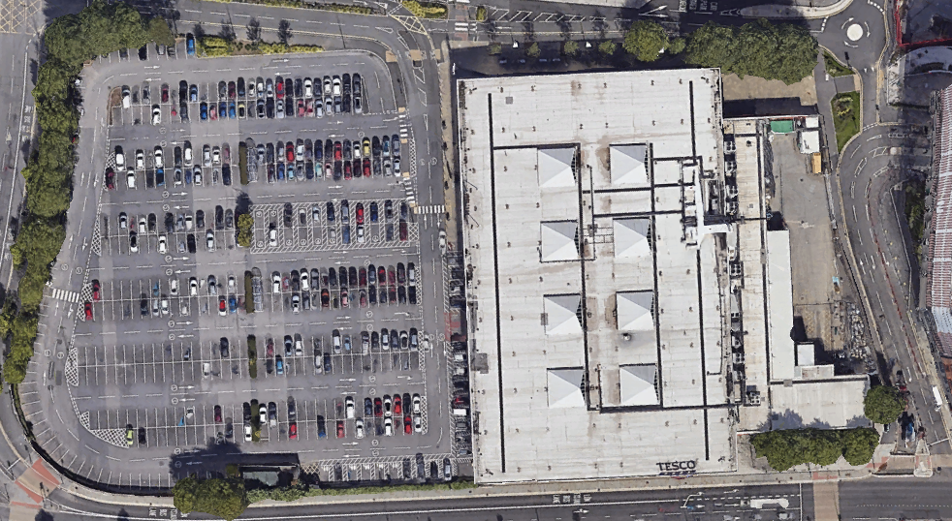
(google earth 2024)
Preliminary desktop study:
  - Historical land use:
  - Swansea’s castles:
Swansea castle can be dated back to 1106 when the English king Henry I passed lordship of Gower to henry Beaumont. The original stronghold would have been made from wood and earth in a motte and bailey style. Following Swansea castle the Normans would erect many other castles in Swansea including one at Oystermouth. Attacks on Swansea can be dated back to 1116 which is the first historical record that includes a fully erected Swansea castle. Welshmen were able to entirely destroy the external walls together the tower was successfully defended. The castle was then rebuilt and handed down to Rodger de Beaumont in 1119. The next attempt by the Welsh to capture Swansea was successfully carried out in 1136 but was recaptured by Rodgers younger brother, Henry de Neuburg, 2 years later. Following several more changes of hands and attacks on the castle in 1217 the de Braose family captured Swansea and banished Anglo-Normans. This created a period of piece which led to the beginning of Swansea castle being rebuilt into a stone structure. In 1257 the town of Swansea and oystermouth castle were burned down however power stayed in the hands of the de Braose family. Its unclear how significantly this damaged Swansea castle but documentation suggests that the rebuild was finished in 1287. The threat of attack calmed down in the following years of the 13th and 14th centuries, which allowed for Swansea castle to be built into a comfortable residence. However it was believed to be neglected under William de Braose which made Oystermouth castle the preferred residence. In 1400 the great Welsh uprising saw the Welsh rebel forces occupying Swansea. With their power the necessary repairs to Swansea castle and its moat were carried out. Ten years later an assessment was carried out and the results found that the castle was not suitable for repairs. This made the owners less likely to stay in Swansea castle and by 1583 Swansea castle was documented as “dilapidated and destroyed”.
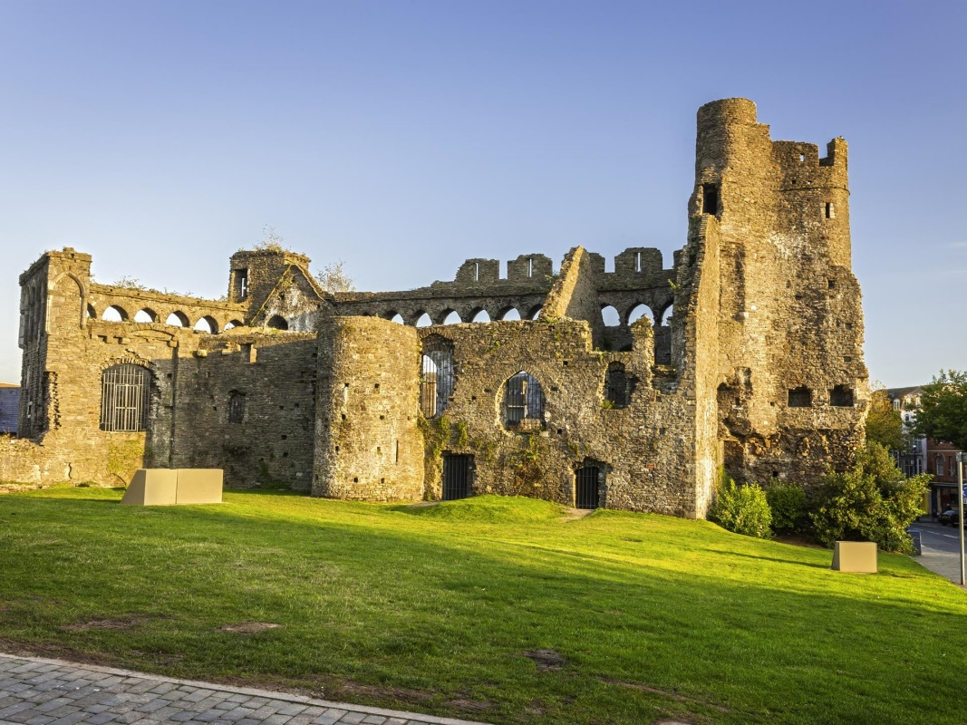
(Visit Wales 2024)

  - Mumbles railway:
Mumbles railway was constructed in 1804 allowing for the limestone that was being mined in mumbles to get to the docks in Swansea. From here the limestone was transported across the globe majorly expanding Swansea limestone industry. The trainline consisted of goods carriages on rails being pulled by horses. Construction of the railway was completed in 1806 however the trainline was not open to the public until 1807 marking the first paid passenger railway service in the world. The idea of a passenger service came from the local children catching a ride on the train when it was only used to transport goods. The end of the railway almost came in the late 1820’s with the introduction of Turnpike road that ran parallel to it and saw traffic taking a preference to it. In 1826 the pavilion trains ceased to run leaving the tracks to become derelict for some years. in a turn of events George Byng Morris decided in 1855 to reinvest into the railway and reopened the passenger carriage services with hoarse led carriages. The railway then saw steam power from 1877 until 1928 when it was electrified. In 1960 with coaches becoming the popular mode of transport in the area the trainline finally closed, before this the mumbles railway was the longest running railway in the world. (Phil Carradice 2011)
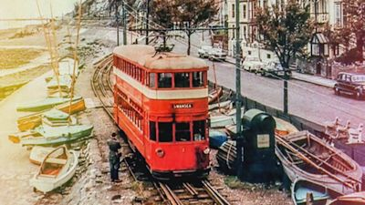
ITV News (2023)
  - Gasworks:
In 1840 Swansea gas light company discovered that the gas works in Dyfatty were too small to meet the high demands of the Borough of Swansea. They were also not in the most optimal position, thus the decision was made to relocate the gasworks. Swansea gas light purchased land called Burrow Field No.6 for £150 in July 1941. With the development of the new site the Dyfatty gasworks were taken down. Production of gas on the new site began in 1842, this production was able to adequately supply gas to Swansea until 1890 when it was deemed necessary for expansion and updates on the site. In 1914 preparations were made for new gasworks to be constructed in Morriston, however this was delayed by WW1. 10 years later in 1924 the Moriston gasworks were finally operational, which followed with the oystermouth gasworks closing a in 1925. The site continued to house 4 gas holders until 1941 when an incendiary device was dropped by the Luftwaffe onto one of the 4 causing it to catch fire. The other 3 gas stores were still standing until1999. (Coflein 2024)
  - Tesco’s:
In 1999 The supermarket chain Tesco’s bought the land from Swansea gas light company for £13.5 million at the time the most valuable acre for acre land in Wales. Tesco’s spent 1.3 million clearing the site of the gasworks and opened its doors in 2000. The Tesco’s supermarket and conjoined car park are still standing and operational till this day. (Robert Dalling 2020)
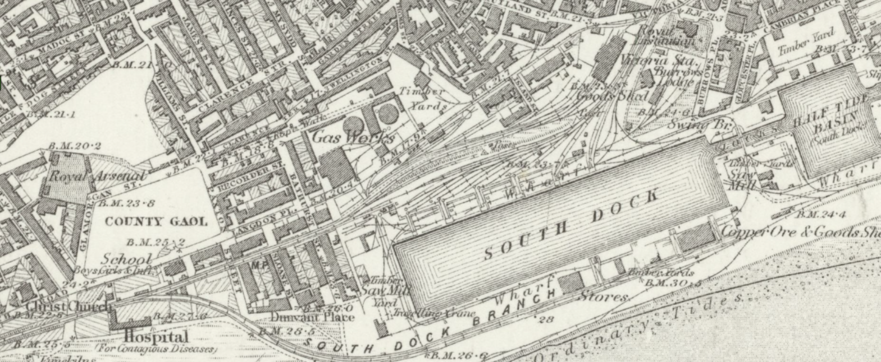
(National library of Scotland, 1884)
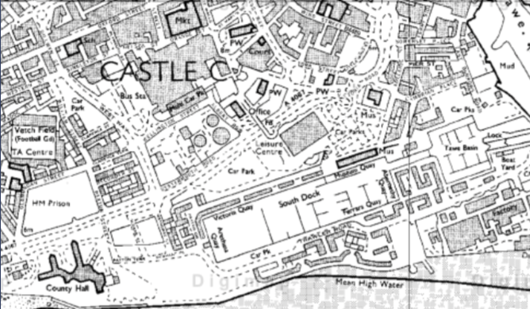
(Digi map 1980)
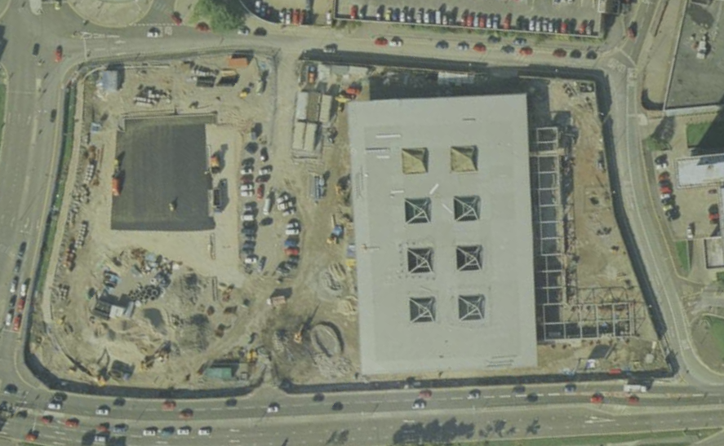
(google earth 1999)
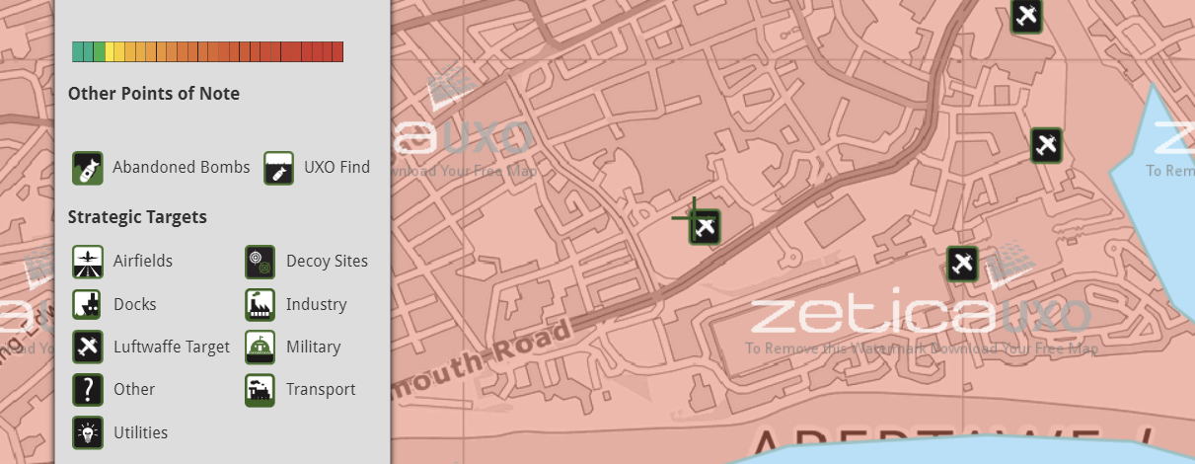
(Zetica 2024)
  - Geology:
From the below Geological maps from Digi maps we gain pivotal insights into the ground conditions on the site. We can see that the bedrock is made up of Mudstone, Siltstone And Sandstone which is consistent with the sites costal positioning. These 3 soil types are sedimentary rocks made up of granular materials that have been deposited and compressed by the sea over time. Due to these rocks being formed in layers it is not uncommon for fossils to be found within their structures. (the geological society 2024) the map also shows us that there is blown sand which is sand that has been blown ashore in the wind. (British geological survey 2024) the last thing the map tells us about the land is that it includes Undisclosed landscaped ground. This shows us that there have been changes made to the ground in the past that may affect structural feasibility for the site.
Permeability is a rating that states if water can and how it flows through rock. From the two permeability maps provided below we can gain insights into the likely moisture content of the ground on the sight. Both the maximum and minimum permeability maps show a rating of moderate permeability. This is consistent with the sites positioning with the coast however a moderate level of permeability does not offer a large amount of threat to foundations.
The flood risk map shows no indications that the site is at risk of flooding, however due to its close proximity to the sea that cannot be completely overruled.
Rock type:
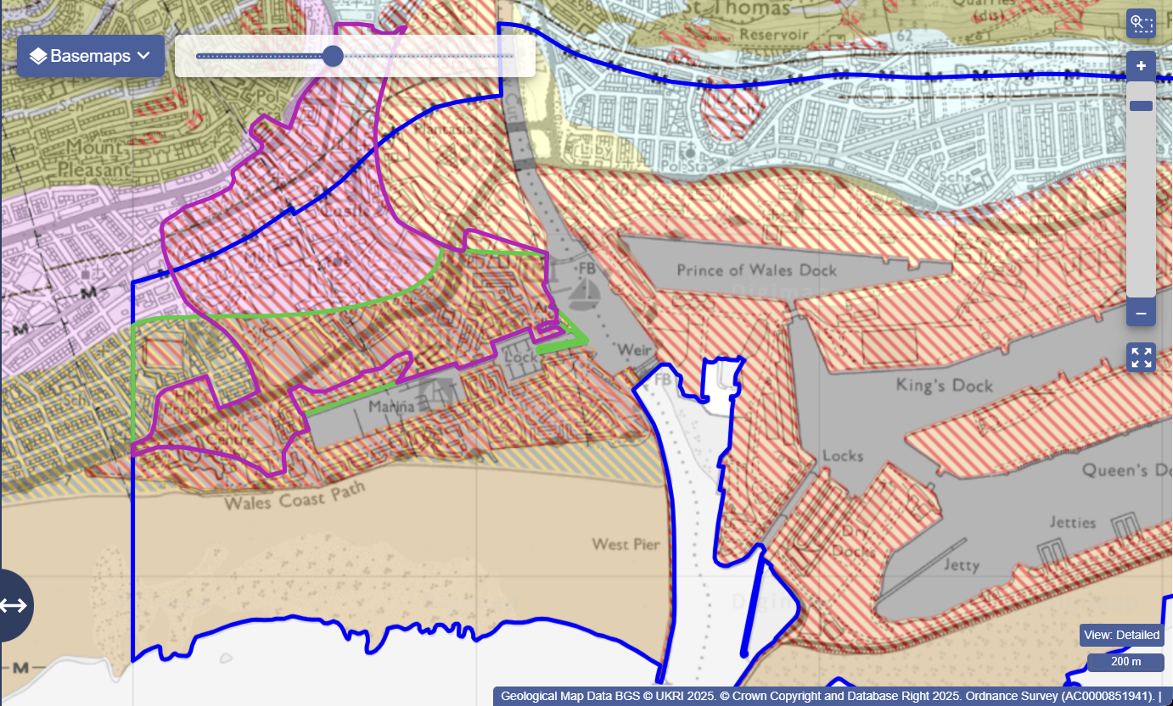



Maximum permability:
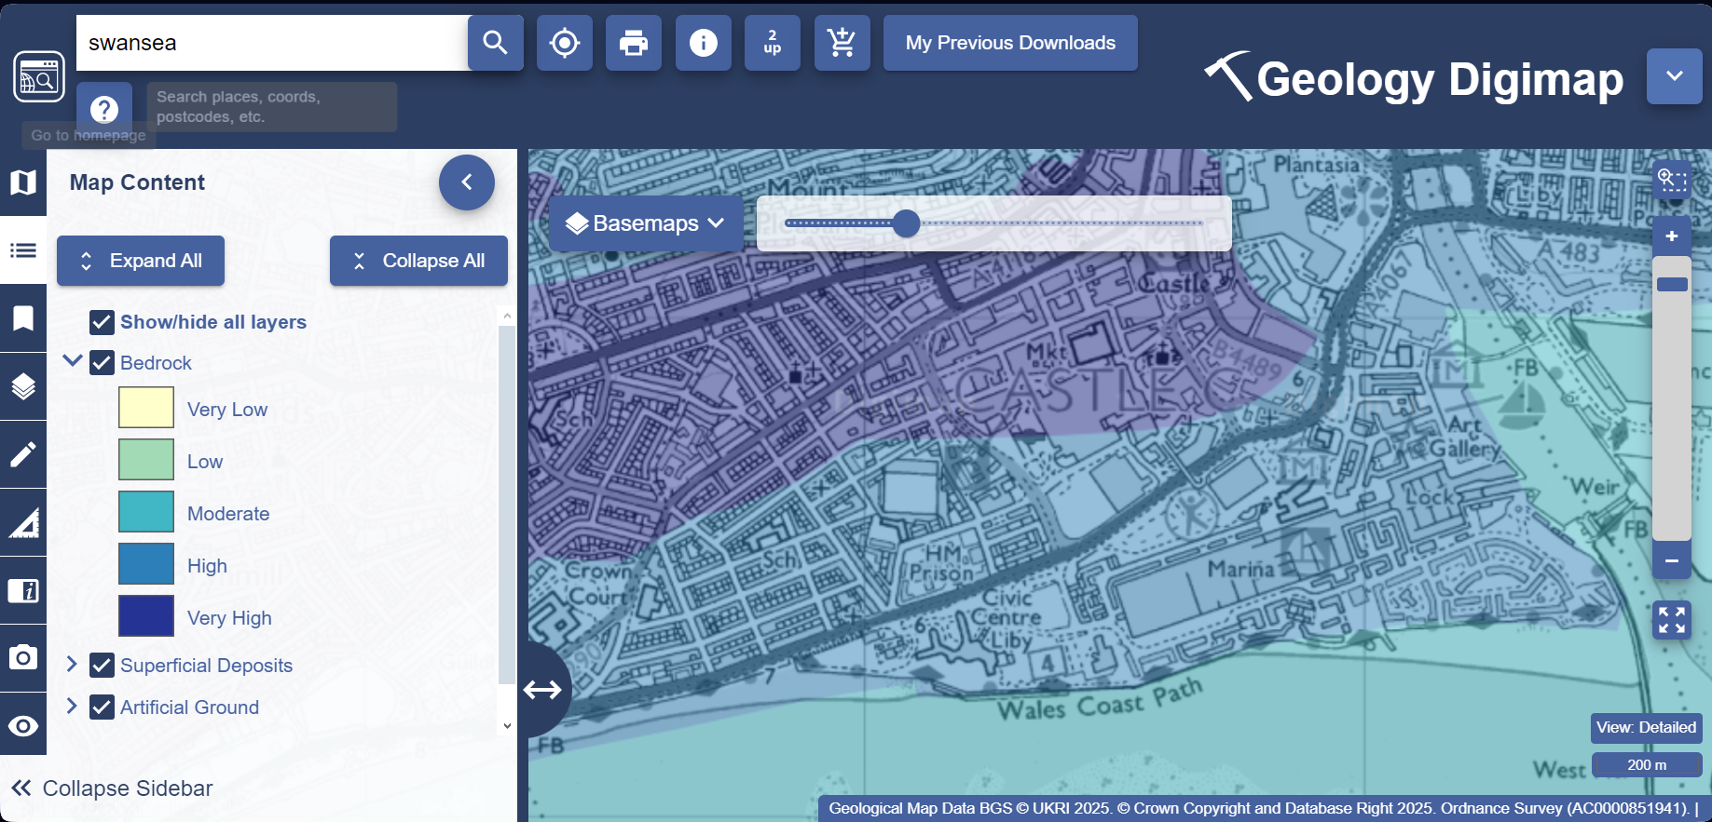
Minimum permability:
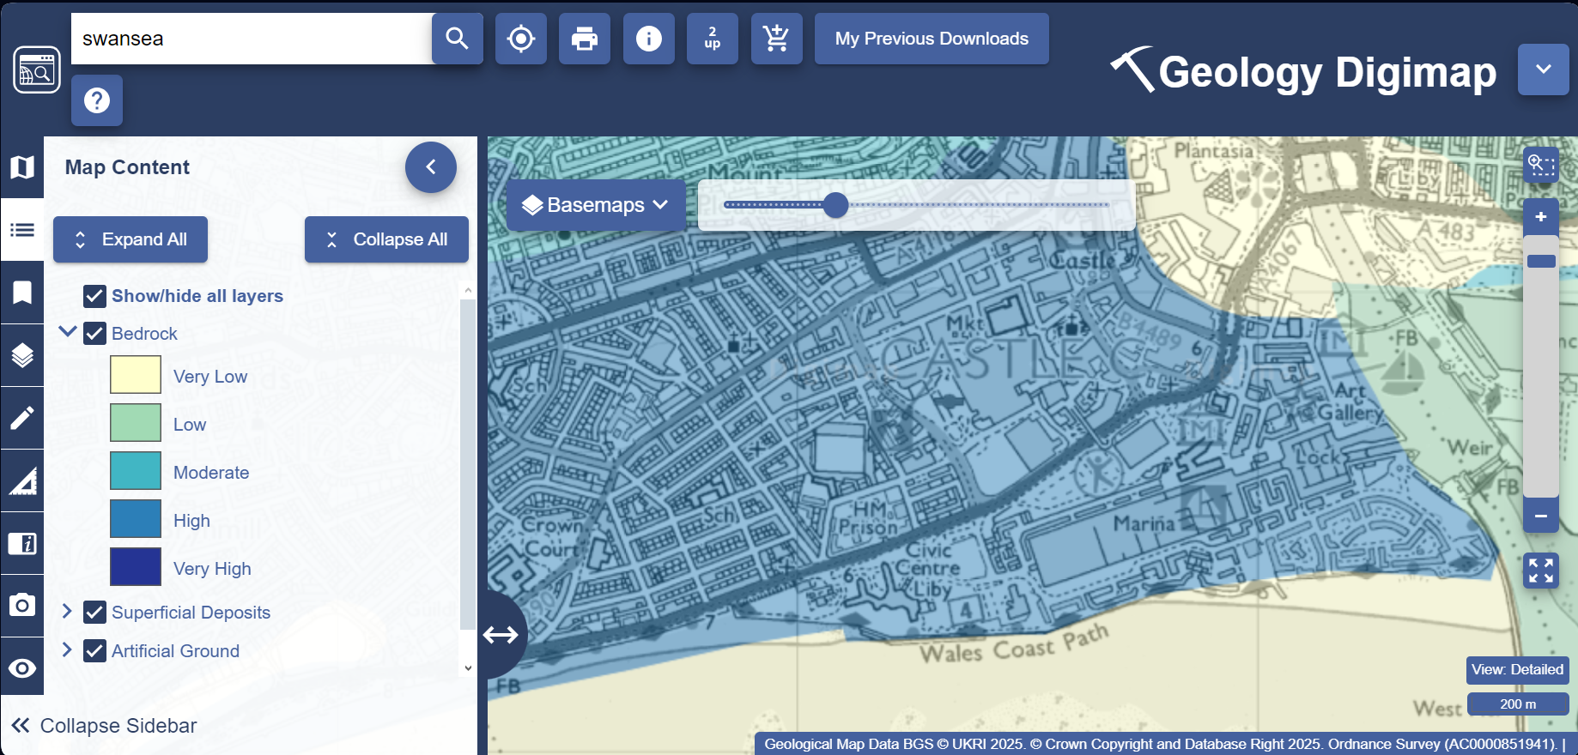
Flood risk:
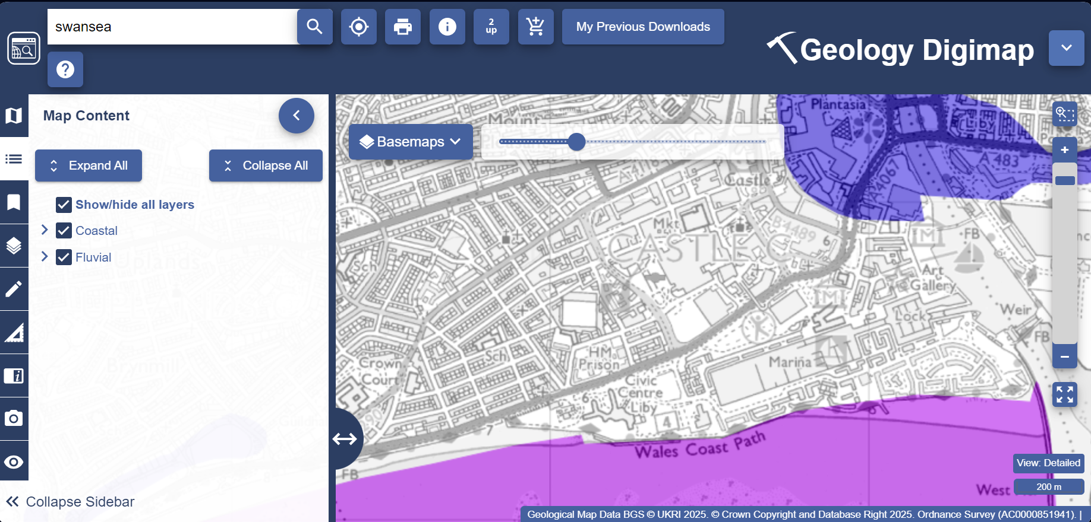
(Digi maps 2024)
  - Recommendations for a Detailed Site Investigation:
This section of the report aims to give educated recommendations for the next phase of the site investigation. This includes the types of investigations, building regulations and considerations of the effect of the practices on different factors.
Necessary recommendations:
- The team selected for conducting the tropology survey should be familiar with RICS standards for conducting a survey, and be of a reliable competence to conduct the survey.
- The team should be provided with the Phase 1 preliminary study, and information relating to the project and its scope.
- A JCT contract should be written up and signed before the works are to be completed.
Building regulations; Operational standards rules:
- 1.2 systems and controls used in the investigation must be effective and up to date.
- 1.3 Prior to and during the investigation all relevant personal must be informed on any works taking place.
- 1.8 all data collected must be stored in a format that can be shared electronically.
- 2.1/ 2.2 building control functions must be appropriately targeted to the investigation including any persons involved.
- 3.2 / 3.3 all plans must be submitted to and authorised by the relevant authorities.
- 3.7 a risk-based approach must be taken in order to ensure safety.
- 3.9 any data presented must be backed up by evidence.
- 3.10 data and evidence must be date time and location marked.
- 4.1 any issues or accidents that occur during the investigation must be recorded.
Social considerations:
- The site is in a public area thus the team must conduct themselves in a respectable manner and aim to keep obstruction to a minimal level.
- With the neighbouring housing noise levels will need to be kept to a minimum and if necessary occupants will need to be informed of works.
Significant recommendations:
- A vertical borehole with a diameter of 200mm and a depth of 15 metres is to be extracted and a borehole log to be completed. A borehole gives vital detailed insights into the soil types, which will inform on the structural features of the site. (J. Delay 2010)
- Ground penetrating radar (GPR) to be used and results to be analysed and summarized by the team. GPR scatters electromagnetic waves through the subsurface. These waves will come into contact with either changes in layers of soil or buried objects and the waves will partially reflect back producing an image of the subsurface. These images can be in either 2d or 3d depending on the capabilities of the technology used, it is recommended if within budget to use 3d. (M.L. Wang 2022)
- Soil testing kits are used to test soil for contaminants in the form of heavy metals, hydrocarbons, and other contaminants. These contaminants can have an affect on the structure of the soil, even causing it to break down. With the previous Gass works on the site it is highly likely that the soil will contain contaminants. Soil is to be taken from the ground and sent to a lab to be analysed for contaminants. (Oakshire environmental 2024)
Less significant recommendations:
- The site is located in an urban area, there is no woodland or large trees visible in or around the site from satellite imagery. There are smaller trees planted in and around the car park and towards the rear of the building. these should be measured and If trunk girth exceeds 74mm an additional survey will need to be carried out of a tree survey to British standards. (RICS 2014)
- With the results from the preliminary Unexploded Ordinance survey, the likelihood of finding unexploded material can be ruled out. Thus there is not a necessity for further investigation, which would create unnecessary costs to the client. (Phil Baptie 2019)
  - Borehole Log:
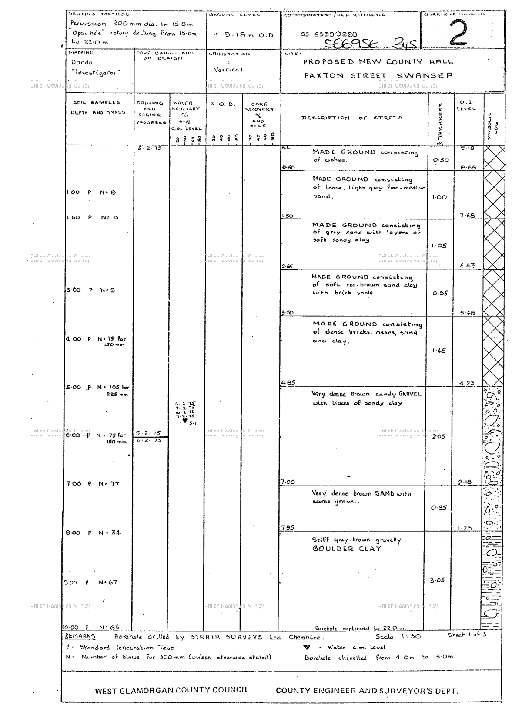

BGS ID: 370246 : BGS Reference: SS69SE345

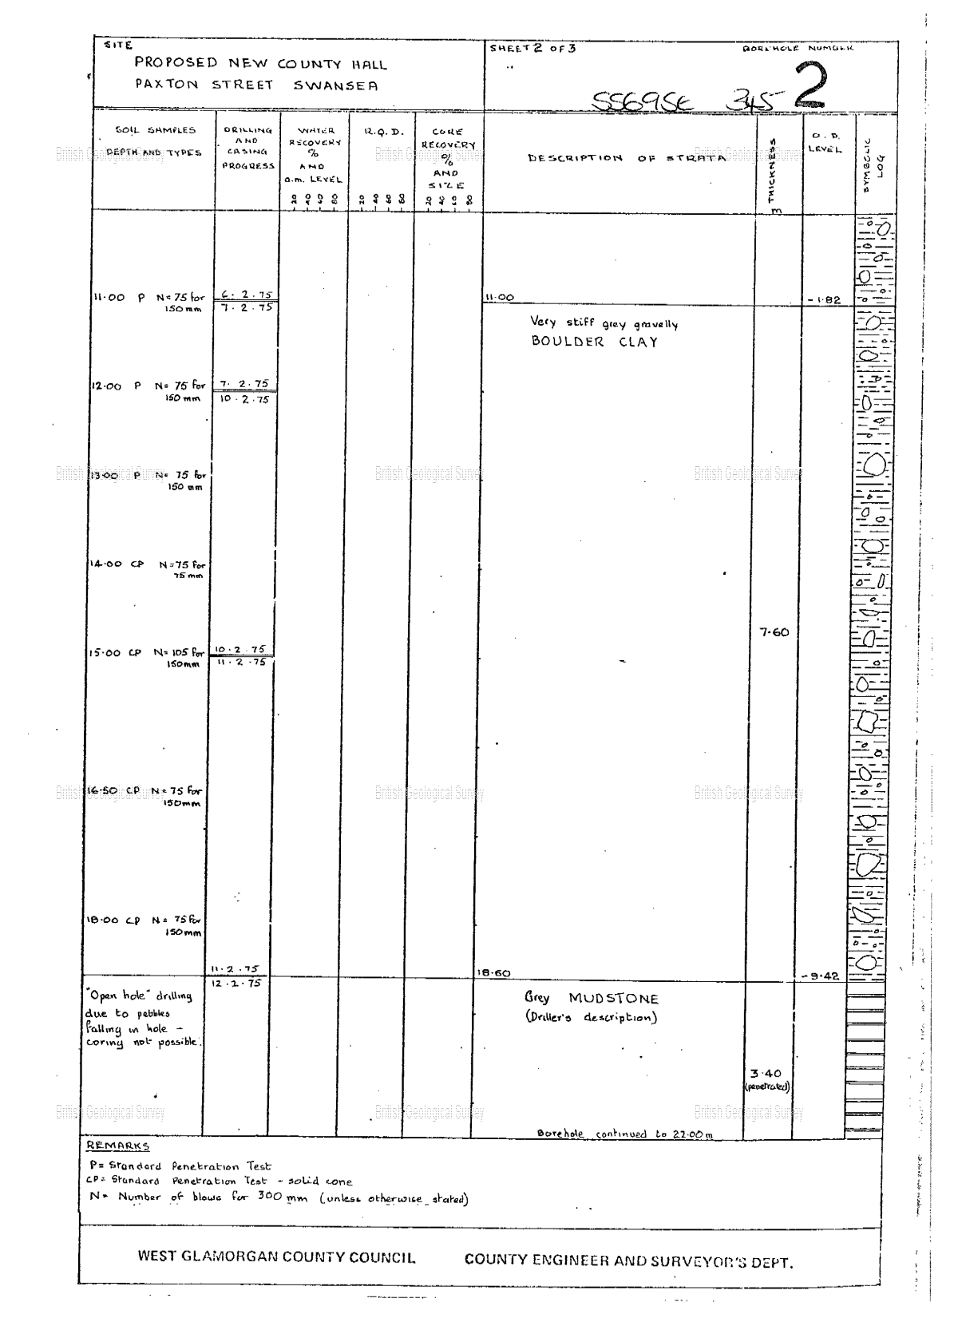

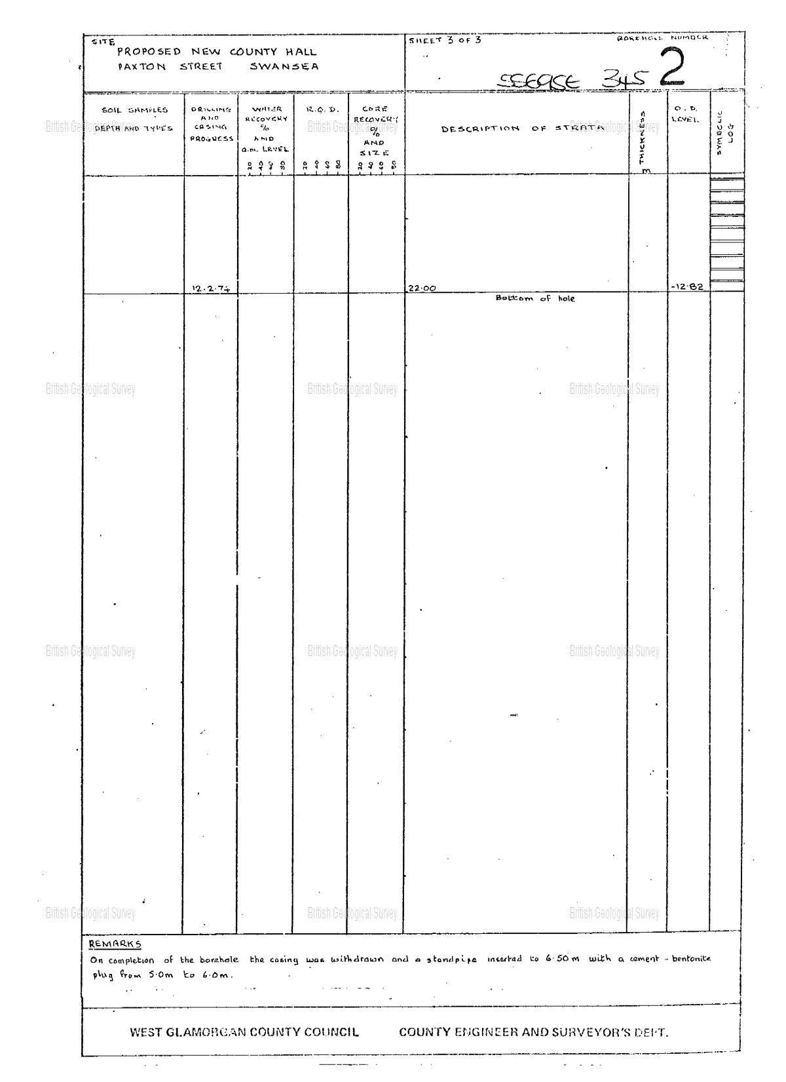

  - Foundation Type Recommendation:
My recommendation for type of foundation for this project is driven steel piles consisting of a diameter between 0.5-1m. below is a brief description of piles followed by justification for the selection of this foundation type based on the preliminary study and the borehole log provided.
Pile foundations transfer the load from structures into compatible soil layers that can only be found at depth. They come in various shapes and sizes and can be bored or driven into the soil using a pile drive. These piles transfer concentrated pressure into the soil where it is not possible to spread it via use of shallow and wide foundations. The piles will also help to improve the density of the soil as they are made from dense materials such as wood, steel and concrete. Materials are selected based on the specific load of the project and availability of materials in the area. Piles consist of 3 parts; the top of the pile (pile head) the middle (the shaft) and the bottom (pile toe). The pile is then connected to the structure through a part called the pile cap. Piles can either be cylindrical or conical, the cross sections can vary in shape, and can be either solid or hollow. Piles can be used in their own or as a set, these sets can be in clusters or in lines, how the piles are set out will determine the direction of force that the piles will take. (Fellenius, B.H. 1991)
Pile foundations are appropriate for this site under a number of factors:
- The moderate permeability of the soil means it is not appropriate to place foundations above the water a.m. level. This level is at 5.7m meaning that shallow foundations will not be appropriate. thus piles are needed to support the structure from lower levels.
- With the above analysis of the provided borehole log we see loose materials and softer soil down to 18.5m. these layers wont be able to support a 400 room hotel thus must be bypassed to the layer of dense mudstone.
- With the history of the site containing Gasworks it is to be assumed that the soil will be of a certain level of contamination. This could cause issues with the softer layers of soil meaning the foundations will need to go deeper than these layers.
- The Site being in a retail area diminishes issues with noise constraints meaning they should not be an issue for the construction process. Thus drilled piles will be applicable as is wanted with the soil types.

  - Conclusion:
The phase 1 preliminary study found that the site is located in an area with rich history, with the battles over Swansea castles and the mumbles railway being a pinnacle in pavilion travel via rail. With the limited access to details surrounding the Tesco’s building communication with Tesco’s should be made to gain any archival material that they may possess. Ultimately the tropological investigation will be vital in any decisions made on foundation types. However this report should provide significant information necessary for moving forward with the project.

  - References:
- Google earth (2024) Google earth satellite search. Available at: https://earth.google.com/web/search/swansea/@51.6167374,-3.94432925,11.31754762a,225.19420435d,35y,326.25213661h,0t,0r/data=CiwiJgokCWDaKBOfOFPAEeNv0aCtYlPAGRp_-LtHBWVAISyt4TbXtGRAQgIIAToDCgEwQgIIAEoNCP___________wEQAA
- Medievel heratige (2024) Swansea – castle. Available at: https://medievalheritage.eu/en/main-page/heritage/wales/swansea-castle/
- Visit Wales 2024 Swansea castle. Available at: https://www.visitwales.com/attraction/castle/swansea-castle-cadw-1443742
- Phil Carradice (2011) The Mumbles Railway. Available at: https://www.bbc.co.uk/blogs/waleshistory/2011/03/the_mumbles_railway.html
- ITV News (2023) Vanished Wales: How Swansea's Mumbles Railway became the world’s first passenger rail service. Available at: https://www.itv.com/news/wales/2023-04-14/the-welsh-city-that-was-home-to-the-worlds-first-passenger-railway
- Coflein (2024) Swansea Gas Works Depot, William Street, Swansea. Available at: https://coflein.gov.uk/en/site/85432/?term=swansea%20gasworks
- Robert Dalling (2020) What was there before these giant Swansea supermarkets arrived. Available at: https://www.walesonline.co.uk/lifestyle/nostalgia/what-before-giant-swansea-supermarkets-18275878
- National library of Scotland (1884), OS Six-inch England and Wales, 1842-1952. Available at: https://maps.nls.uk/view/102342508
- Digi Maps (1980) Historic Digi map. Available at: https://digimap.edina.ac.uk/roam/map/historic
- Google earth (1999) Historical imagery. Available at: https://earth.google.com/web/search/swansea/@51.6169484,-3.94400867,7.67131872a,428.69533458d,35y,326.25213959h,0t,0r/data=Cj4iJgokCWDaKBOfOFPAEeNv0aCtYlPAGRp_-LtHBWVAISyt4TbXtGRAKhAIARIKMTk5OS0xMi0zMRgBQgIIAToDCgEwQgIIAEoNCP___________wEQAA
- Zetica (2024) Unexploded ordinance map. Available at:
- https://zeticauxo.com/guidance/risk-maps/
- the geological society (2024) Sedimentary rocks. Available at: https://www.geolsoc.org.uk/ks3/gsl/education/resources/rockcycle/page3458.html
- British geological survey (2024) Blown sand. Available at: https://webapps.bgs.ac.uk/lexicon/lexicon.cfm?pub=BSA
- Digi maps (2024) Digi maps geology. Available at: https://digimap.edina.ac.uk/roam/map/geology
- RICS (2014) Measured surveys of land, buildings and utilities. Available at: https://www.rics.org/content/dam/ricsglobal/documents/standards/measured_surveys_of_land_buildings_and_utilities_3rd_edition_rics.pdf
- M.L. Wang, R. Birken (2022) Sensing solutions for assessing and monitoring roads. Available at: https://www.sciencedirect.com/topics/materials-science/ground-penetrating-radar
- Oakshire environmental (2024) Contaminated Soil Testing Kits For Domestic & Professional Clients. Available at: https://www.oakshireenvironmental.co.uk/soil-testing-kits#:~:text=Soil%20testing%20kits%20can%20be,whether%20your%20land%20is%20contaminated.
- Phil Baptie (2019) Surveyor's guide to unexploded ordnance. Available at:
- https://ww3.rics.org/uk/en/journals/land-journal/surveyors-guide-to-unexploded-ordnance.html
- J. Delay (2010) Clay geological repository systems: characterisation and site surveying technologies and techniques. Available at: https://www.sciencedirect.com/topics/engineering/borehole
- Fellenius, B.H. (1991) Pile Foundations. Available at: https://link.springer.com/chapter/10.1007/978-1-4615-3928-5_13

