

Financial Management for Hotel Industry

Sustainable Business Revenue Generation Plan

Assignment 2
Name: Roussebelle Miesi
ID: 2022878

Table of Contents
Introduction 3
An argument for or against outsourcing Marriott International's housekeeping department 4
Insourced team VS outsourced team 4
Employee’s abilities 5
Cost implications 5
Results 7
Sustainability 7
Consistency 8
Guest Experience 9
Conclusion 11
References 12

Introduction
The high standard of service provided by Marriott International, which is one of the most well-known hotel chains in the world, is one of the qualities for which the company is most recognised. Within the scope of this investigation, a comparison will be conducted between the insourced and outsourced cleaning teams that Marriott International utilises, as well as their respective skill sets, costs, results, sustainability, consistency, and overall guest experience. Our opinion regarding whether or not Marriott International should outsource its housekeeping services is influenced by the factors discussed above.

An argument for or against outsourcing Marriott International's housekeeping department

Insourced team VS outsourced team
By handling its housekeeping, Marriott International can have direct control over the employment and management of its employees (O’fallon and Rutherford, 2019). This provides the company with increased control as well as the opportunity to construct a team that adheres to its core principles. Because Marriott directly employs insourced teams, they may have a higher level of dedication and commitment. There are some drawbacks associated with outsourcing housekeeping. Housekeeping staff would need to be recruited, educated, and managed by Marriott (Jackson, 2018). Without adequate training and control, this process can be time-consuming and result in variances in the quality of service provided. Managing an in-house team can be complicated and expensive due to factors such as payroll and benefits as well as scheduling.
The fact that Marriott outsources its housekeeping enables the company to select specialised cleaning services. These firms have a significant amount of experience in the hospitality cleaning industry as well as well-established practices (Iannuzzi and Sacchetto, 2020). Due to the availability of professional training programmes, they can instruct their staff in effective cleaning methods, proper product utilisation, and industry standards.

Figure: Insourced team VS outsourced team
Source: (Jackson, 2018)
By contracting out its cleaning services to these professional companies, Marriott may save money. Keeping a brand's reputation intact necessitates that all of its sites provide service at a constant level (Francis, 2019). Through the use of outsourcing, Marriott can scale up or down depending on demand without having to keep a significant in-house crew even when occupancy levels are low.
Insourcing the Housekeeping department provides direct control and may align with Marriott's principles, whilst outsourcing provides specialist experience, consistent service quality, and workforce flexibility (Chakravarti, 2018). Additionally, insourcing the Housekeeping department provides direct control. The needs and priorities of Marriott International should determine whether the company should insource or outsource.

Employee’s abilities
By contracting out cleaning, Marriott International acquires devoted cleaners for the hospitality industry. These hotel housekeepers have received specialised training to uphold high standards of cleanliness (Matias, 2022). They are aware of hotel requirements and industry norms. To do their task swiftly and effectively, outsourced housekeepers use efficient and effective cleaning techniques. The toilets, flooring, furniture, and fixtures in hotel rooms are meticulously cleaned and sanitised. Additionally, outsourced workers possess the specialist skills required for excellent housekeeping. All rooms must be cleaned, dusted, and sanitised. They prepare beds beautifully, with impeccable sheets and a welcoming appearance. To make visitors feel at home, they also know how to replenish towels, toiletries, and other supplies.
To meet hospitality standards, insourced personnel may need more guidance and training. While some team members may have the necessary experience, others may require further coaching and assistance in learning housekeeping skills (Do, 2020). The level of service may drop, and training times for new employees may increase. Marriott International can ensure top-notch housekeeping by contracting out the work. This enhances the whole experience, brand reputation, and customer satisfaction.

Cost implications
Marriott International may save money by contracting out housekeeping. The organisation spends less on employing, educating, and managing personnel as a result of outsourcing. It is expensive to hire in-house housekeepers. Money is spent on advertising, screening, interviewing, and onboarding (Sadhale, 2021). By outsourcing, Marriott reduces these costs because the cleaning company employs professionals. The workforce that the cleaning company has in place enables worker deployment quicker and more effective.
Less training is required while outsourcing. Well-developed training programmes are available for hospitality cleaning companies (Chakravarti, 2018). Their housekeepers receive training and certification. Without developing and offering internal training courses, Marriott might profit from this expertise. Housekeeping outsourcing allows for flexible personnel. The cleaning firm workforce can easily change depending on hotel occupancy levels. During periods of high demand, additional employees can rapidly and thoroughly clean rooms. To save money, staff can be cut when there is little occupancy. By matching staffing to demand, this flexibility reduces expenses.
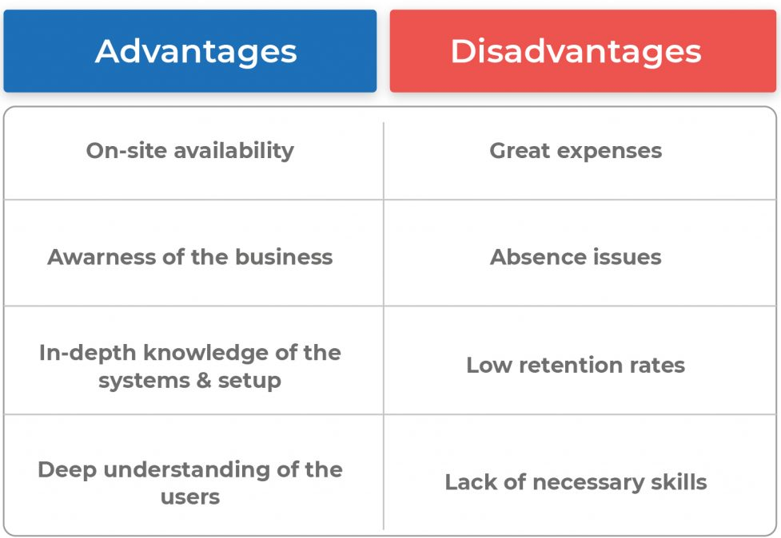
Figure: Advantages and disadvantages of in-house team
Source: (Chakravarti, 2018)
In contrast, outsourcing housekeeping is more expensive. Budgeting is required by Marriott for hiring, training, pay, benefits, and management (Hanna, Niemenmaa and Salonen, 2011). It's challenging to manage an internal workforce, so these costs add up. By contracting out housekeeping, Marriott International saves money on hiring, training, and staffing. These savings improve the financial efficiency of the firm.

Results
By outsourcing housekeeping, Marriott International may improve sanitization, hygiene, quality, and guest satisfaction. To clean better, specialised cleaning companies utilise cutting-edge tools and technology (Choy, Cheng and Yu, 2021). They give exceptional results by utilising state-of-the-art tools and adhering to market trends. Equipment for cleaning high-touch surfaces, carpets, and floors is also included. To exploit cutting-edge technology, Marriott may outsource.
Green cleaning supplies are often used by outsourcing companies. They put sustainability first and employ non-toxic, biodegradable cleaning supplies. As a result, the hotel's environmental goals are met and the rooms stay tidy (Sharma and Kaushik, 2021). Quality control is quite good with outsourcing. Cleaning companies adhere to Marriott's standards for procedures and inspections. They routinely audit and assess performance. This technique guarantees that various properties adhere to or exceed criteria for cleanliness and maintenance.
Room cleaning is expedited by outsourcing housekeeping. Rooms may be cleaned and prepared fast by professionals. As a result, guests are more satisfied because they can easily check into tidy, well-maintained rooms (Brazil et al., 2023). In contrast, in-house housekeeping teams might require more guidance or training, which would slow down room turnaround.
By outsourcing, Marriott International may improve cleanliness, quality assurance, the rate at which rooms are cleaned, and technology (Sadhale, 2021). These upgrades improve customer satisfaction, online reviews, and the reputation of the hospitality industry. For equivalent results, insourcing might need expensive tools and specialised knowledge.

Sustainability
The environmental goals of Marriott International are promoted by outsourcing housekeeping. Cleaning companies prioritise sustainability and lessen their negative environmental effects. Ecologically sound cleaning supplies are crucial. Non-toxic cleaning supplies are used by contracted cleaners (O’fallon and Rutherford, 2019). These products are better for the environment, the workers, and the visitors. By employing green cleaning techniques, Marriott may lessen pollutants and enhance cleanliness.
Specialised cleaning businesses also invest in energy-efficient equipment. Cleaning tools that are energy-efficient and modern utilise less water and electricity. Resource utilisation is optimised by using high-efficiency vacuums, low-flow cleaning tools, and automated systems. Through outsourcing, Marriott can lower its energy use and environmental impact (Matias, 2022). By contracting out housekeeping, Marriott reduces waste. Recycling and waste management are skills that cleaning companies excel at. They separate, recycle, and get rid of the trash. Marriott can encourage a circular economy and lessen garbage sent to landfills by using efficient waste management.
Insourcing the Housekeeping department may require more staff and resources to implement sustainable practices (Jackson, 2018). Marriott would need to establish waste management systems, purchase energy-efficient equipment, and train staff members on environmentally friendly housekeeping. It is simpler to outsource than to handle these up-front costs and ongoing maintenance. Working with environmentally friendly outsourcing companies could help Marriott increase its sustainability (Iannuzzi and Sacchetto, 2020). Environmental stewardship is demonstrated through using eco-friendly cleaning supplies, energy-saving machinery, and reducing trash. This satisfies the demands of environmentally conscious customers who might pick a hotel based on its sustainability policies.
Finally, by applying green practices, outsourcing housekeeping helps Marriott International achieve its sustainability goals. Marriott may lessen its environmental effect and draw in eco-conscious visitors by using eco-friendly cleaning products, energy-saving technology, and trash reduction strategies by specialised cleaning businesses (Hanna, Niemenmaa and Salonen, 2011). To achieve results as sustainable as insourcing, it may be necessary to make significant investments and maintain efforts.

Consistency
Outsourcing housekeeping ensures consistent service for Marriott International's hotels. To ensure superior cleaning and maintenance, specialised cleaning companies utilise defined techniques and training. For a brand to build trust, consistency is essential (Francis, 2019). Through outsourcing, Marriott can make use of cleaning services for the hospitality industry. These companies are aware of the particular demands of the sector. They design and carry out cleaning techniques that are unique to Marriott. This ensures consistent upkeep and cleaning across all properties.
In contrast, outsourcing housekeeping internally could result in inconsistent service quality. The cleanliness and maintenance of a property may be impacted by various training programmes, cleaning procedures, and quality control systems. Consistency can harm the brand's reputation and customer pleasure (Do, 2020). Through outsourcing, Marriott can communicate with the cleaning company and set expectations for performance. KPIs and service level agreements can guarantee that the outsourced supplier cleans continuously. Additionally, the cleaning company can execute regular audits and inspections to track performance and quickly address any deviations from standards.
Consistency in service is required at Marriott International. Customers of Marriott expect a certain level of service and experience. By outsourcing the Housekeeping role and working with professional cleaning companies, Marriott can keep its diverse portfolio of properties well-maintained, clean, and guest-pleasant (Choy, Cheng and Yu, 2021). Consistency among homes is ensured by outsourcing housekeeping. Cleaning companies that use standardised procedures, training, and quality control deliver reliable service. Because of its consistency in brand image and guest expectations, Marriott International is a leader in the hospitality industry.

Guest Experience
By contracting out housekeeping, Marriott International may raise customer satisfaction. Numerous rooms can be cleaned and prepared promptly by a specialised cleaning firm. This enables visitors to swiftly check into tidy, well-maintained accommodations. With their skills, outsourced cleaning companies guarantee cleanliness and attention to detail (Chakravarti, 2018). These businesses use regulated cleaning methods and instructions to regularly and thoroughly clean each room. They are familiar with the requirements for hotel room cleaning and have practical expertise.
Marriott can concentrate on its core skills, such as customer service and experience, by outsourcing housekeeping. Marriott may outsource housekeeping to expert cleaning companies to concentrate on visitor happiness (Brody, 2016). Customers' stays might be memorable if they receive personalised service, trained staff, and other conveniences. On the other hand, outsourcing housekeeping could result in problems that reduce guest happiness. In-house staff might require additional training and supervision to meet the requirements of the hospitality business. Customers could get dissatisfied as a result of inconsistent service and delayed room cleaning.
By outsourcing, Marriott can keep its properties clean and provide excellent service and attention to detail. Enhancing visitor experiences can increase customer satisfaction, loyalty, and word-of-mouth advertising (Brazil et al., 2023). To match guest expectations, Marriott outsources housekeeping. By rapidly, completely, and painstakingly cleaning rooms, housekeeping is outsourced to increase guest pleasure. Specialised cleaning companies offer reliable service, which raises customer satisfaction and gets them great reviews. Marriott International can provide visitors with extraordinary experiences by putting a priority on client services and leveraging contracted contractors.

Conclusion
Outsourcing Marriott International's housekeeping department offers several enticing advantages when compared to in-house teams in terms of staff skills, financial considerations, outcomes, sustainability, consistency, and guest experience. With outsourcing, you can access cleaning companies that specialise in the hospitality industry, which produces cleaner results that are also more productive. These businesses work with professionals in hotel cleaning. By engaging contractors for contracted housekeeping, Marriott International may raise customer satisfaction. The costs of hiring, training, and management, as well as the administrative burdens, are reduced by outsourcing. Costs can be cut by adjusting staffing levels to meet hotel occupancy. With these savings, Marriott's profits can increase without sacrificing service. When housekeeping is outsourced, specialised cleaning organisations use cutting-edge cleaning technology, tools, and eco-friendly ingredients to improve results. The quality assurance procedures used by these businesses guarantee that all properties uphold Marriott's standards. With quicker response times, outsourced suppliers increase customer satisfaction. Marriott International's sustainability goals are achieved through outsourcing by utilising the eco-friendly practices of expert cleaning businesses. By adopting environmentally friendly cleaning products, energy-saving technology, and trash-reduction strategies, Marriott may be able to draw eco-aware visitors. Consistency is ensured for a global brand like Marriott International by outsourcing housekeeping. A consistent visitor experience is guaranteed across all locations by the standardised techniques, training, and quality assurance used by cleaning services. Customer satisfaction is increased by outsourcing housekeeping since it provides cleanliness, fast service, and attention to detail. Specialised cleaning companies streamline guest check-ins and maintain clean rooms. As a result, customer happiness, repeat business, and word-of-mouth are improved.

References
Brazil, C.K., Pottorff, T.A., Miller, M. and Rys, M.J. (2023). Using the Rapid Upper Limb Assessment to examine the effect of the new Hotel Housekeeping California Standard. Applied Ergonomics, 106, p.103868. doi:https://doi.org/10.1016/j.apergo.2022.103868.
Brody, D. (2016). Housekeeping by Design. University of Chicago Press.
Chakravarti, B.K. (2018). Hotel management. New Delhi: A.P.H. Pub. Corp.
Choy, M., Cheng, J. and Yu, K. (2021). Evaluating the environmental sustainability strategies of the housekeeping department: the case of an international hotel chain in Hong Kong, China. Tourism Critiques: Practice and Theory, 2(1), pp.115–132. doi:https://doi.org/10.1108/trc-01-2021-0001.
Do, L. (2020). A guidelines for Vietnamese students to work in Finnish Housekeeping Industry. [online] www.theseus.fi. Available at: https://www.theseus.fi/handle/10024/341526 [Accessed 15 May 2023].
Francis, B. (2019). Practical Hotel Management. With notes and comments on Hotel Law. [By F.B. Bourne-Newton.]. London: Newton & Eskell.
Hanna, L., Niemenmaa, T. and Salonen, R. (2011). Sairaalahoidossa olevien ikääntyneiden lonkkaleikkauspotilaiden suun terveydentila ja suun terveyden ongelmat. [online] www.theseus.fi. Available at: https://www.theseus.fi/handle/10024/34377 [Accessed 15 May 2023].
Iannuzzi, F.E. and Sacchetto, D. (2020). Outsourcing and workers’ resistance practices in Venice’s hotel industry: The role of migrants employed by cooperatives. Economic and Industrial Democracy, p.0143831X2096022. doi:https://doi.org/10.1177/0143831x20960227.
Jackson, E. (2018). Hotel management. New York, Ny: Larsen & Keller.
Matias, S.S.C. (2022). The role of hospital hospitality management in implementing hospitality practices in hospitals: A study about a Portuguese private health care group. repositorio.iscte-iul.pt. [online] Available at: https://repositorio.iscte-iul.pt/handle/10071/27460 [Accessed 1 Apr. 2023].
O’fallon, M.J. and Rutherford, D.G. (2019). Hotel management and operations. Hoboken, N.J.: Wiley.
Sadhale, M. (2021). The Changing Role of Housekeeping Department in Hotels Post COVID-19 Pandemic. 212.169.38. [online] doi:https://doi.org/978-81-951936-0-8.
Sharma, S. and Kaushik, T. (2021). Aesthetically clean to clinically clean – A study on new housekeeping practices in Delhi hotels beyond COVID-19 pandemic. Worldwide Hospitality and Tourism Themes, ahead-of-print(ahead-of-print). doi:https://doi.org/10.1108/whatt-05-2021-0069.

