Am I a contemporary artist?
I've only just stepped into the field of art, and there is absolutely no comparison between me and a contemporary artist, but I’ll work towards it. Artists often have very different ideas from ordinary people. They often have a unique way of thinking and knowing the world. So how is an artist defined? In short, artist is a worker who has high aesthetic ability and creative skills and has achieved a certain level of success in the field of art.
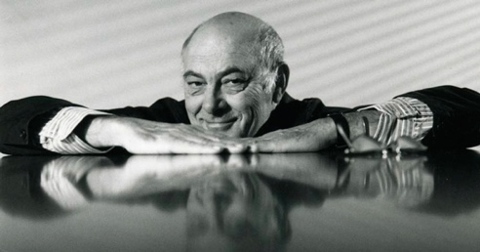
I've seen artworks of Alan Fletcher online before. He is one of the most influenced persons in the field of graphic design in the UK, his unique design style is featured by complex typography, strong color contrasts, distinctive geometric shapes, symbols and so on. Alan Fletcher has also emphasized the concept of “less is more”. He focuses on using expressive typography with a strong visual language. In his career, he and his colleagues have designed for many well-known brands.
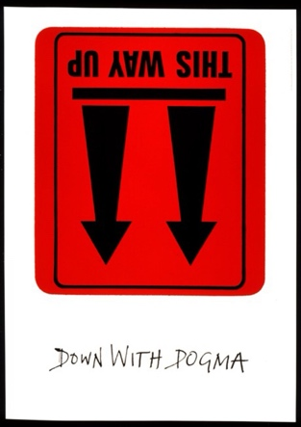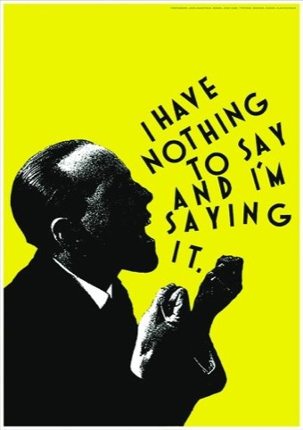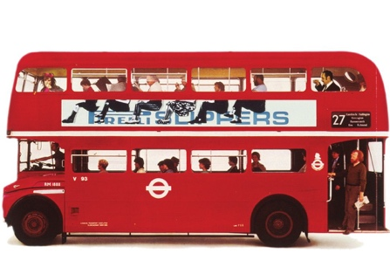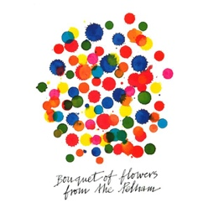
I look at these pieces from a viewpoint of beginner, I feel like this is a minimalist style. This artist designed a simple and clear poster with no unnecessary elements. Simplify the visual language so that it is expressed only in the form of structural relationships or colors.

His process of design:
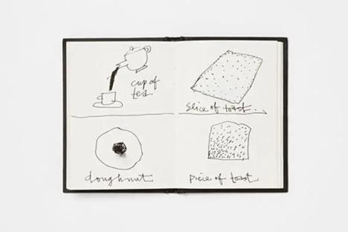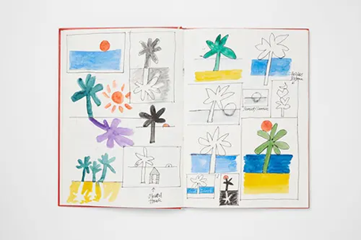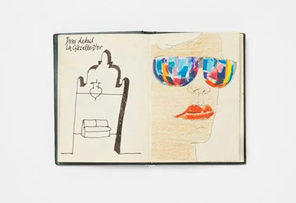
The drafts which he designed bring me a lively, fun, harmonious design style. Good ideas come from life. After seeing the poster designed by the artist, I’m inspired.

My original design:
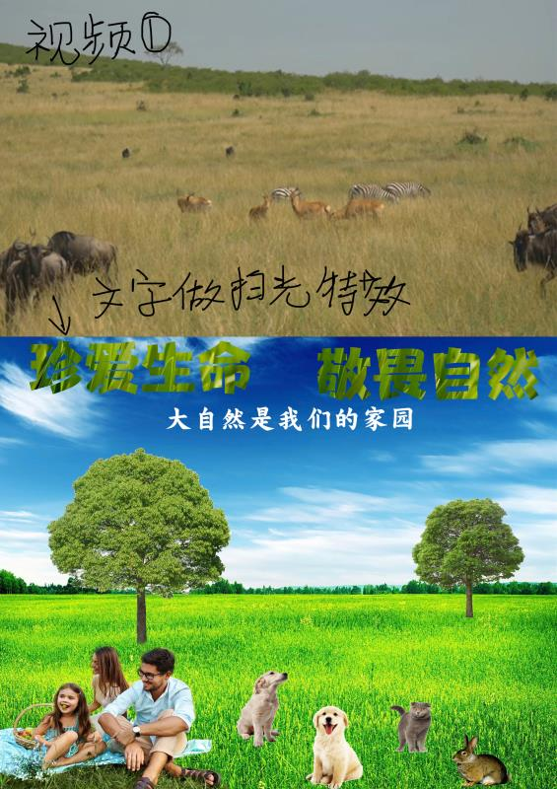
At first I put all the elements together, but it looks disorder and the meaning not to express clear. Until I saw artworks design of Alan Fletcher, he uses strong color contrasts and delicate typography to give us a clean visual experience. Therefore, I was inspired. Then, I try to remove unnecessary elements. It becomes the following to show the final work.

My practice:
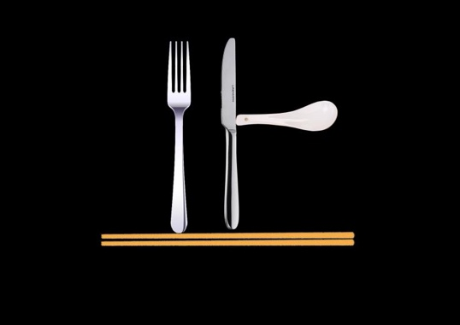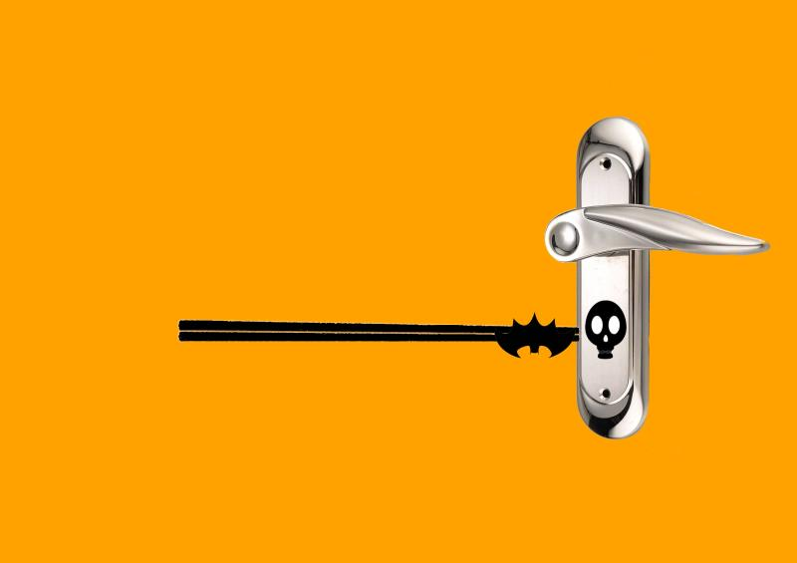
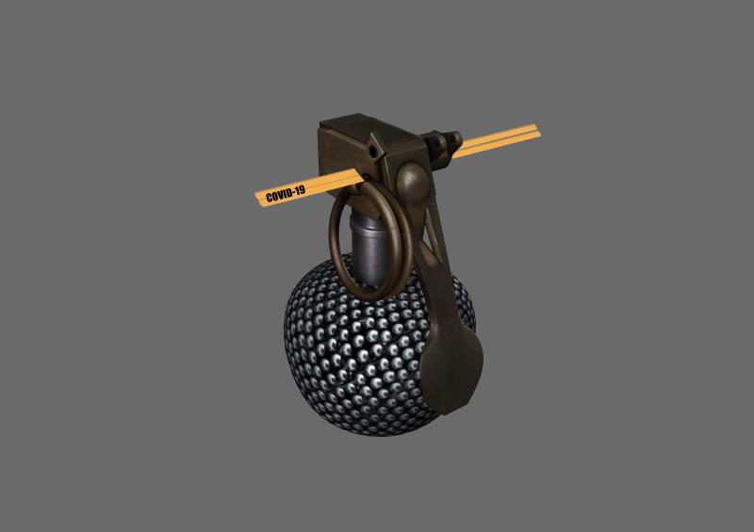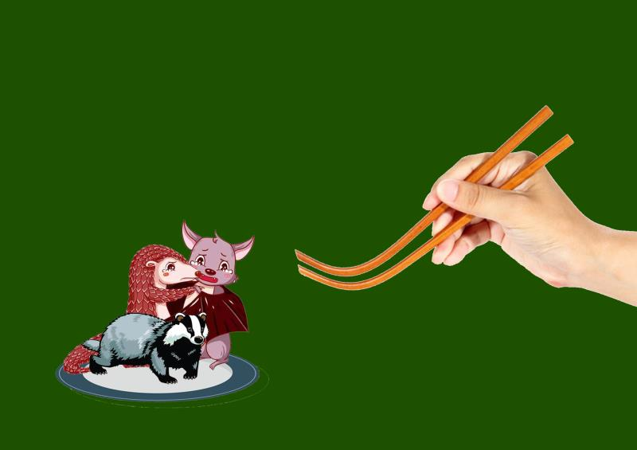
My artwork which I did are assignments during the school. I designed these posters around 2020, during the COVID-19 period when some people were eating wild animals. Hunting wildlife is inhumane behavior. Wild animals same as humans, are life on earth and should be respected and protected. So, my purpose in making these posters is appealing to people to protect wild animals, meanwhile, we are also protecting ourselves.
My tutor guided my design, and although I collected these image elements from the internet, it shows what I was thinking at the time. We can see that all four images have elements of cutlery, they are the tools that we use to pick up food in our lives. Seeing them reminds us of the various delicacies of the restaurant industry. In the first picture, I used the cutlery to form a ‘stop’ word; the second picture, wild animal is held by chopsticks as like a key, it will open greed of door; the third picture, this bomb in front of us is a sign that eating wild animals is tantamount to self-destruction; the last picture, eating large numbers of wild animals can also be met with wild animal resistance. Above four images with these simple elements, it is all a direct show that people should to ban the killing of wild animals.

In addition to the work designed by this artist, I’ve seen other people’s work. Such as ‘Saul Bass’, ‘Paul Rand’ and so on
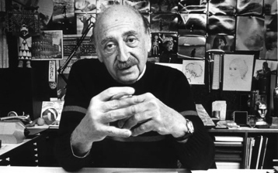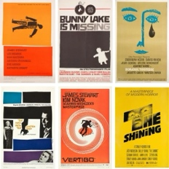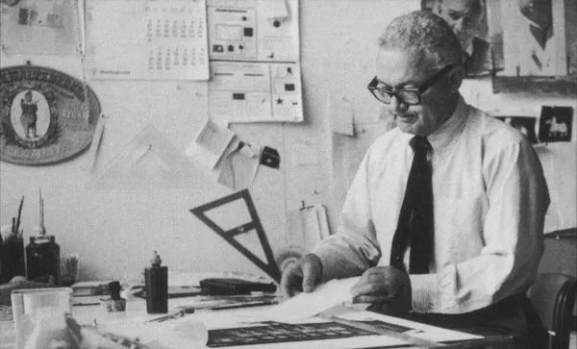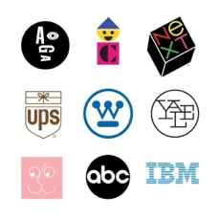
Now, I am a beginner in the field of art. I will study hard and learn from the experience of other artists. Making artworks better in the future.

