  reflection  Coaching and Mentoring | Anna Misiak-Ali (2311228)  University of Wales. Trinity Saint David.

I confirm that I have not presented any AI generated text as my own work. I confirm I have copies of my drafts, notes, and other resources I used before, and after the use of AI tools which I may be asked to provide in evidence.

Contents
Introduction 3
Reflection and Gibbs Reflective Cycle 5
Description 5
Feelings 6
Evaluation 6
Analysis 7
Conclusion 8
References 9
Appendices 10

Introduction

Atkinson, Watling, and Brand (2022) state that coaching is a strategy that allow companies to help employees to improve skills, performance, and overall effectiveness at work through process of open questions, feedback, and goal setting. The main point is to focus on the future strategies that allow employees to unlock individual’s potential. Rahimi (2025) says that coaching skills have significant impact on organisational performance. According to Ebrahimi (2024) coaching can be internal and external, but it can be difficult in both scenarios. Internal coach be bias due to knowledge about employees but sometimes that knowledge can help to resolve problems. External coach is impartial but might not be familiar with coachee problem or the company issues. Management should choose better option for the company and its employees. Knowles (2021) states that tangible coaching is measurable, and we are able to see results like increase sales, skills and achieving goals. Coachee sees effects that helps to increase productivity. However intangible coaching focuses on emotions, potential, focuses on things that we cannot measure. Coachee can understand what stopping him/her from achieving desire outcome, can help to work on internal restrictions/limits (Morgan, 2022).
ProCare Nursing Ltd. provide training for its care workers, but those trainings are in small groups and focus only on topics related to work like medication training, self-defence training required in mental hospitals and care homes for autistic children and young adults (Homecare, 2025). Management at ProCare did not offer coaching sessions before covid in 2020. These coaching sessions would be helpful especially while collaborating with clients with learning disabilities and mental disorders. I wonder why ProCare never established coaching as one of the ways to improve service for our clients. It is widely acceptable and use in healthcare departments. It can be beneficial for coach to learn new techniques from people who manage their inconvenient situation before said Parsloe (2022). Hospitals provide coaching sessions for its nurses to improve their work in challenging times like Covid-19. NHS provide several coaching sessions for patients with chronic diseases to help them manage their lives, provide coaching to enhance motivation, goal setting (diet, activity, stress). It improve self-care, reduce complication (NHS England, 2023). Coaching is also available for healthcare professionals (nurses, managers) to develop leadership skills, resilience, teamwork according to Costeira et.al. (2022).
After thinking about it I need to know what is the difference between coaching, mentoring, and training. Coaching differ from mentoring. While coaching is short-term session focused on developing specific skills, improve performance and usually applied to work-related issues. It is more formal with clear goals and measurable outcomes (Hunaiti, 2024). Richardson et.al. (2023) states that mentoring is long-term personal and career development. There is no specific timeline. Mentoring is less formal, more flexible. Mentor is someone more experience, which share personal knowledge and wisdom. Training is a process of teaching-learning specific skills that allow to complete task. It is usually job related that help to equips employees with the skills needed for their current or future roles (BBC, 2025).

Reflection and Gibbs Reflective Cycle

Reflection I can describe as critical analysis of an experience that can help to improve work or learning skills. Reflection is thinking calmly about something, contemplating combined with analysis. It is a valuable skill that can help learners and professionals gain experience, confidence, and self-awareness according to University College London (2025). There are many reflective models, but I would like to follow Gibbs Reflective Cycle. It is a six-step model created by Graham Gibbs (1988) for systematic learning from experience. It guides us through describing the situation, analysing feelings, evaluating, analysing situations, drawing conclusions, and planning action, helping us transform experiences into practical knowledge and improve future behaviour, emphasizing the role of emotions in this process (University of Derby, 2025).

Description

Durning our lectures I have learnt one of the coaching models which is Instant Payoff Model. This model was introduced by Max Landsberg in 1997. The main focus is on fast coaching approach that helps solve immediate problems. The sessions usually last 15 minutes. Instant Payoff Coach Model has 5 steps. First step helps coachee to describe the specific problem or situation by giving examples. Second step is to see how success would look like to coachee if the problem were solved. After that the third step is to categorise blocks/obstacles that stops coachee from achieving desire results. There are three blocks :
- 1st block is in the coachee, it can be skills, motivation, attitude.
- 2nd block is in others, their behaviour towards us, stressing manager.
- 3rd block is the situational blocks that can be describe as resources, external factors, deadlines.
The fourth step is to brainstorm diverse ways to overcome obstacles and agree on actions. As the last step, I the coach am setting schedule with the coachee to check on the actions taken and regular feedback check (Management Encyclopedia, 2015). On 24th of November I had taken a part in coaching practical test. As a group of four people we were coaching each other. I was coaching ‘Rani’ as part of my test.

Feelings

At the beginning of the coaching session, I felt stresses. As a part of my practical exercise, I prepared questions that could help me to coach ‘Rani.’ I knew exactly what is the process of using Instant Payoff Model but during my first question by accident or by stress I combined two questions in one and that made me feel more stressed at the beginning. I tried to fix this mistake by later asking questions from my list. I calmed down a little but still in my mind I felt that I could manage that better. I could sympathise with ‘Rani’ on her problem which was conflict resolution. I too do not like conflicts and trying to resolve them make me stressed. I recognise my own emotions while coaching ‘Rani’. I felt empathy and wanted to give her ideas how I would solve the problem. This experience help me to understand my own weaknesses and strengths, gave me triggers to explore coaching model more, as one of the tools to help develop clients skills and performance.

Evaluation

This experience help me to understand what are my strengths while performing coaching session. I am able to use Instant Payoff Model, and I know the steps that are required to complete this task. I feel that when I speak to others we should let them know through our actions that they are welcomed and can feel comfortable sharing their problems. Our body language also says about our engagement, I make sure that person I speak with see my empathy.
As for my weaknesses there is definitely room for improvement. I need to be confident in asking open questions. I need to practise how to ask questions that will make coachee understand what I want from them. I need to exercise more this model to fluently move to another part after asking all the questions (issues) that are needed to be addressed. I have to let coachee speak and do not offer help or answers when they need to find that themselves or want to hear what they need from themselves. I have tendencies to speak over while speaking with other people, I have to stop that because it can discourage others from sharing their thoughts.

Analysis

As part of my reflection, I would like to say that after analysing all aspects of Instant Payoff Model I can say that I performed well. I am still learning and this experience gave me a lot to think of. I definitely need to pay more attention to what ‘Rani’ was saying and give her time to answer. It would be helpful to prepare actual contract so I could explain in depth everything including that this session is fully confidential but if there is something that need to be forwarded due to safety reasons I will have to refer for support. Instant Payoff Model has structure, allows mostly open questions. I have followed the structure and allow ‘Rani’ to explain to me what her block are, we agreed on actions and timing. Unfortunately, I did ask several closed questions, but I think due to stress I have not notice that. Coaching sessions require knowledge of the process and issues that have to be solved, it can help in asking correct questions.

Starr (2021) states that good coach should have the ability to actively listen, ask relevant questions, and demonstrate empathy to build trust and guide the client to find their own solutions. At the same time, they demonstrate self-awareness, patience, objectivity. Deep understanding of the coaching process and the result-oriented mindset about achieving change in a SMART way, as well as strong people skills like adaptability and creativity which help to be more flexible and tailor methods to meet individual needs.
During coaching session, I have learnt something about myself. I have welcomed ‘Rani’ in friendly open manner. I have followed the structure and mostly asked open questions, but it happened that I asked closed questions or did not wait for ‘Rani’ to answer and gave her ideas myself. I should not do that as it stops ‘Rani’ to think through her problem but given ready answers she might not appreciate. Similar statement I have heard from Coachseansmith (2020), he speaks about letting people to find solution to their problem themselves as all the answers are within them, just need to be discover. I have summarised and clarified what ‘Rani’ was saying that shows good listening skills. I displayed empathy to show support by nodding and keeping eye-contact to confirm my engagement. I do have a problem with speaking over someone, and it is due to meeting with people that are not really interested in dialogue. I met people that only perform monologue and this makes me feel like an audience and not companion to have a conversation with. I tent to throw words in between someone is talking to be heard and make my point. I need to simply let them talk and if they want my input in the conversation they will ask for my opinion, but if not then let them talk.
Throughout the time many coaching models were developed. I would like to compare two models I have learnt recently. First model was used during coaching session. The Instant Payoff Model is focused on immediate problem solving by quickly identifying a current issue and defining the desire outcome. It help to identify blocks (internal, external, situational) and brainstorm solutions. This model helps to take actions fast and in short period of time seek achieving goals. It focuses on tangible progress, does not allow for deep skill-building behavioural change (Management Encyclopedia, 2015).
The GROW Model is a popular, simple coaching framework (Goal, Reality, Options, and Will/Way Forward). It helps structure the conversation with the coachee, leading from problem definition, through situation analysis, to a specific action plan and commitment to implementation. It is a self-analysis tool that uses questions to guide the coachee to discover solutions on their own (Forbes Coaching Council, 2022).

Conclusion

This experience revealed how much coaching is important in work setting as well as daily life. I learnt that asking correct questions can help coachee to find solutions to their problems. Now I know more how challenging coaching can be. I learnt that we could measure coachee skills when there is increase in productivity, but we cannot measure things like potential, emotions because those feelings are inside coachees to discover themselves. Those are the internal blocks coachees have to fight themselves. I can only help to uncover them. At the beginning of the coaching session, I felt stressed as I wanted to perform well, in the end I have practise questions and recommendations to ‘Rani’s’ problem. But due to stress I could not do this. Later I realised that reading questions many times does not give me the ability to perform well without actual talking with ‘Rani’. I should hold meeting with the learner to confirm what ‘Rani’ expects from me during coaching session (Elliott, 2025). This was like an eyeopener. After thinking about it I came to conclusion that I need to know more about coaching, and ways to increase my performance. I wonder if I could redo coaching session, will I repeat the same mistakes? Would I remember what I had done and avoid making it wrong again? My next steps are reading more literature, practise with my colleagues. I will from now on try always ask open questions and avoid throwing words in between someone is talking to practise my coaching.

References
Atkinson, A., Watling, C.J. & Brand, P.L.P.(2022) ‘Feedback and coaching,’ European Journal of Paediatrics, 181, pp.441–446. https://doi.org/10.1007/s00431-021-04118-8
BBC (2025) Training - CCEA. Available at: https://www.bbc.co.uk/bitesize/articles/zxgkp9q#zh4wfdm (Accessed 11 December 2025).
Bryant, H. (2024) 6 Coaching Questions Every Great Manager Uses (With Examples). Available at: https://youtu.be/ZnirM4l2Z0A?si=-ldnir2cVC6hF9zT (Accessed: 12 December 2025).
Coachseansmith (2020) Great Questions to Use When Coaching Someone | Coach Sean Smith. Available at: https://youtu.be/npxHkoNwM3U?si=36v51BfC_Qg7EYFH (Accessed: 12 December 2025).
Costeira, C., Dixe, M. A., Querido, A., Vitorino, J., & Laranjeira, C. (2022) ‘Coaching as a Model for Facilitating the Performance, Learning, and Development of Palliative Care Nurses’, SAGE Open Nursing, PMID: 35860191. Available at: https://doi.org/10.1177/23779608221113864
Ebrahimi, M. (2024) ‘Inside workplace coaching: A brief overview,’ Skills Academia Research and Insights Collective for Excellence. Available at: https://dx.doi.org/10.2139/ssrn.5032419 (Accessed: 9 December 2025).
Elliott, M. (2025) Coaching for Improved Performance. Available at: https://ucq.ac.uk/coaching-improved-performance/ (Accessed 11 December 2025).
Forbes Coaches Council (2022) ‘5 Executive Coaching Models Used by the Best Coaches’ Forbes, 27 October. Available at: https://councils.forbes.com/blog/best-executive-coaching-models?_gl=1*1mp37r2*_ga*M0diSUVDTVFpUDg1dE (Accessed 11 December 2025).
Homecare.co.uk (2025) Procare Nursing Agency Ltd (Dom Care). Available at: https://www.homecare.co.uk/homecare/agency.cfm/id/65432181246 (Accessed: 4 December 2025)
Hunaiti, Z. (2024) ‘Empowering Healthcare Leaders: Coaching for Leadership Development’, Encyclopedia, 4(4), pp. 1752-1759. Available at: https://doi.org/10.3390/encyclopedia4040115
Knowles, S. (2021) ‘Benefits of Coaching’, In: Positive Psychology Coaching. Springer, Cham. pp. 67-77. Available at: https://doi.org/10.1007/978-3-030-88995-1_5
Management Encyclopedia (2015) The Tao of Coaching – highlights. Available at: https://managerpedia.wordpress.com/2015/09/01/the-tao-of-coaching-highlights/ (Accessed: 12 December 2025).
Morgan, K. (2022) 'Soft skills': The intangible qualities companies crave. Available at: https://www.bbc.co.uk/worklife/article/20220727-soft-skills-the-intangible-qualities-companies-crave (Accessed 11 December 2025).
Mulligan Brothers Interviews (2022) Best Advice for up-and-coming coaches- Bill Beswick Sports psychologist. Available at: https://youtu.be/w3r5weMfbIM?si=P6MJyaOfeGFtZIBj (Accessed: 12 December 2025).
NHS England (2023) Supported self-management: health coaching guide. Available at: https://www.england.nhs.uk/long-read/health-coaching/ (Accessed: 10 December 2025).
Parsloe, E. (2022) Coaching and mentoring practical techniques for developing learning and performance. 4th edn. KoganPage.
Rahimi, S. (2025) ‘Examining the Moderating Role of Problem-Solving on Coaching Skills and Organisational Performance (Case Study: Knowledge-Based Company, Production of Electronic Printed Circuit Boards in Yazd Province)’, International Journal of Sustainable Applied Science and Engineering, 2(1). Available at: https://bgsiran.ir/journal/ojs-3.1.1-4/index.php/IJSASE/article/view/140 (Accessed: 12 December 2025).
Richardson, C., Wicking, K., Biedermann, N., & Langtree, T. (2023) ‘Coaching in nursing: An integrative literature review’, Nursing Open, 10(10), pp. 6635–6649. Available at: https://doi.org/10.1002/nop2.1925
Senn, F. (2025) Coaching. The science. The undisputable evidence.: Everything you wanted to know about coaching, but you were afraid to ask. Editorial Neurosoft.
Starr, J. (2021) The coaching manual. 5th edn. Pearson Education Limited.
University College London (2025) Develop academic reflection skills. Available at: https://www.ucl.ac.uk/short-courses/staff-resources/course-design/design-learning-activities/develop (Accessed 9 December 2025).
University of Derby (2025) Gibbs Reflective Cycle. Available at: https://libguides.derby.ac.uk/develop-at-derby/resilience/gibbs-reflective-cycle (Accessed: 9 December 2025).

Appendices

Practical Coaching Exercise: marking form

Name: Anna Misiak-Ali
Feedback by Rhiannon Akers
1. Engagement with Literature Skills
Have they followed the Instant Payoff model in the correct order? YES
- Current issue or problem
- Desired outcome
- List obstacles/blocks (existing in coachee, existing in others, blocks in the situation)
- Jointly brainstorm possible next steps
- Agree an approach, actions and timing
Have they incorporated appropriate elements of other models(e.g. E for engage from ELECTRIC)? YES
Comments and examples:
You opened the session in a friendly, open manner and explained model you would be using. You referred to confidentiality but it could have been beneficial to clarify what this means. For example, if any welfare concerns would need to refer for support..
You clarified the problem, asked what the coachee’s ideal outcome would be and asked about blocks.
You revisited each of the blocks when referring back to solutions and agreed on actions with timings.

2. Knowledge and Understanding Skills
Have they shown an understanding of the Instant Payoff Model? YES
Correct interpretation of each part of the model, including blocks? YES
Appropriate Use of Open, Probing and Closed Questions, appropriate use of pauses, asks permission to make suggestions to the coachee if the coachee is struggling with solutions? YES
Comments and examples:
You mentioned a coaching contract at the start but it would have been useful to briefly explain the contents as well as confidentiality.
You utilised a variety of questions such as “has anything happened recently?”, “anything stopping you?” and “do you think this is achievable?” This demonstrated your ability to probe appropriately. Further probing could have been beneficial when the coachee mentioned not wanting ideas.
Many of your questions were closed as opposed to open so be mindful to frame your questions to allow open answers.
You broke the blocks down into categories and followed the model appropriately overall.

3. Cognitive and Intellectual Skills

Have they retained focus throughout, not reading notes, not fiddling with pen or looking distracted? YES
Have they responded appropriately to questions? YES
Have they followed a logical structure? YES
Does the conversation flow well? YES
Comments and examples:
Good eye contact with the coachee throughout
Displayed empathy, showed that you care by nodding and using non-verbal cues
You summarised and clarified to show you were listening.

4. Practical Application Skills
Have they used encouraging language, warm and open body language, nods of the head, murmurs of encouragement, appropriate energy levels to match and mirror the coachee? YES
Is there evidence of building rapport? YES
Comments and examples:
Encouraging language and praise, made the coachee feel comfortable.
Displayed active listening for the most part but did speak over the coachee towards the start of the session.

5. Transferable Skills for Life and Professional Practice
Overall, have they performed well and managed the conversation? YES
Did the coachee do most of the talking and come up with their own solution? YES
Good time management (kept to 15 minutes)? 13 minutes
Comments and examples:
The session lasted slightly less than 15 minutes but the conversation flowed well and followed an appropriate structure.
The coachee did the majority of the talking and the onus was put on them. You offered advice to the coachee which is fine when they are struggling to come up with solutions themselves. You asked for permission but could have allowed further time for the coachee to agree.
You did well to also clarify confidence levels and agree follow up.

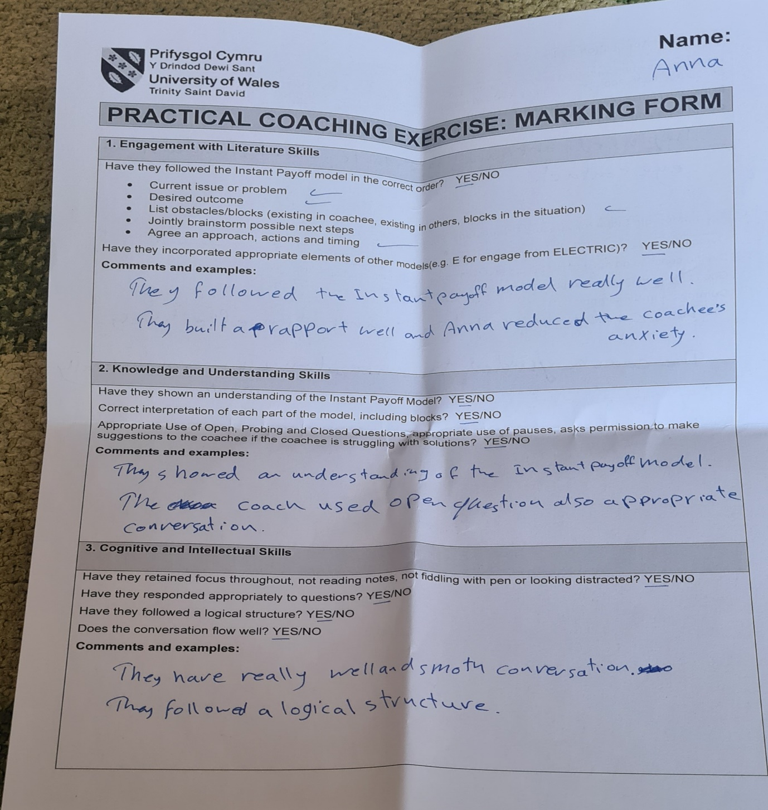
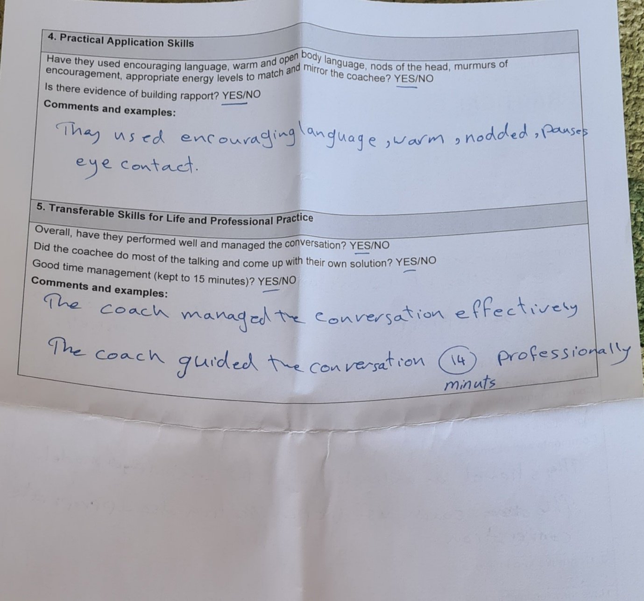

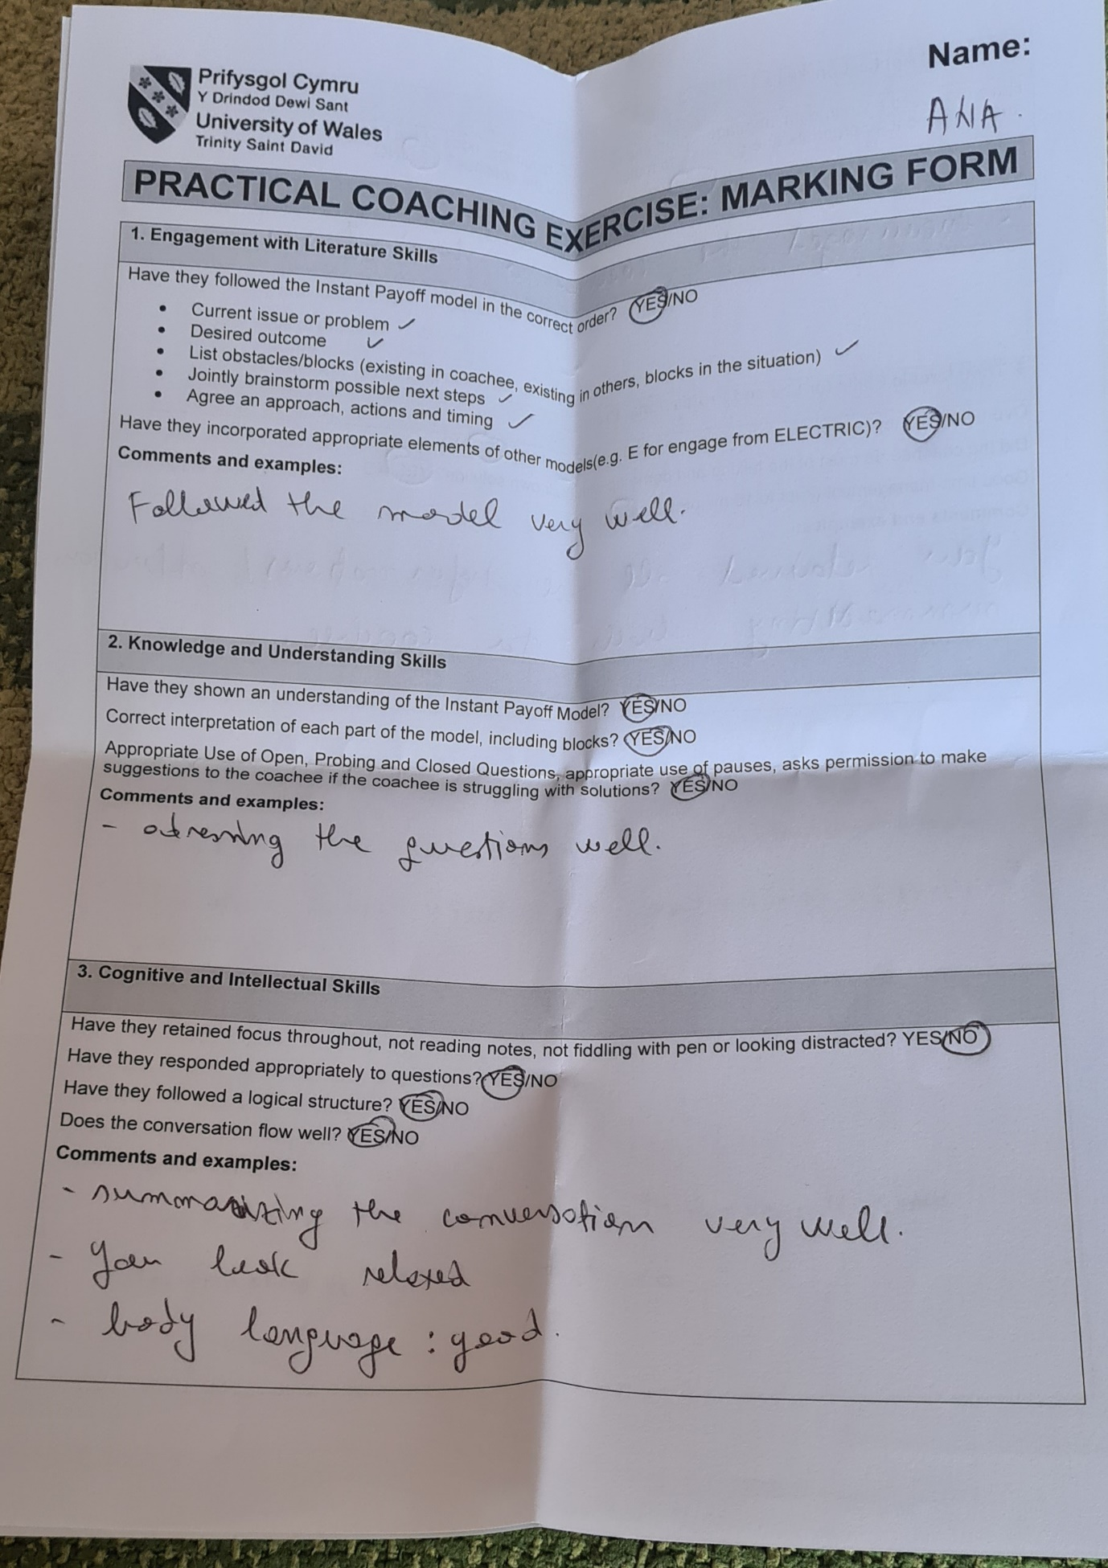

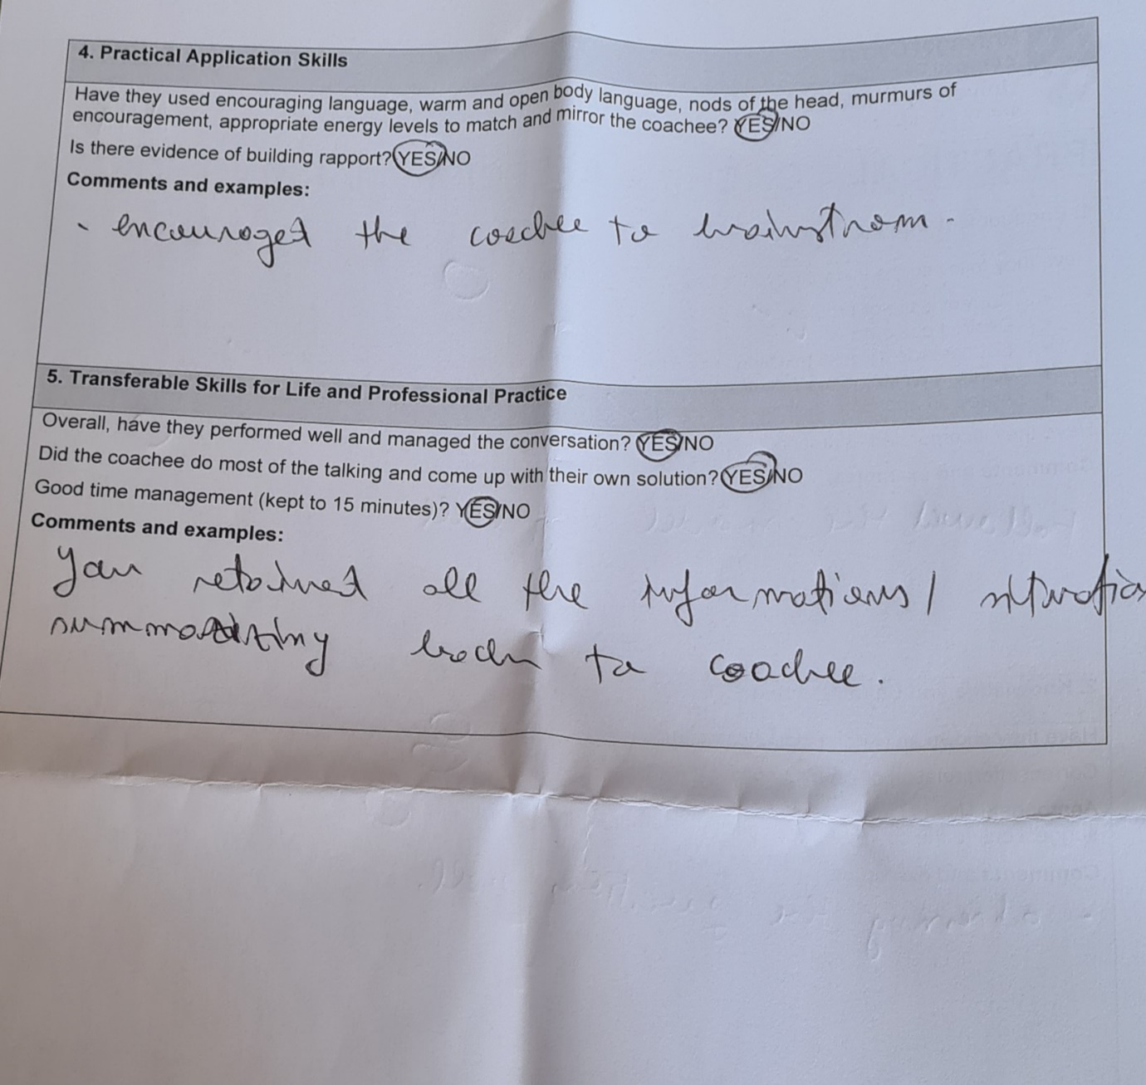

PERSONAL DEVELOPMENT PLAN
What do I want/need to learn? | What will I do to achieve this? | What resources or support will I need? | What will my success criteria be? | Target dates for review and completion
I need to improve my questioning skills as I did ask several closed questions my coachee during the practical exercise (as highlighted by my observer). This is a skill that invite exploration according to Senn (2025). | I will read book Starr, J. (2021), specifically the section where she speaks about good coaching skills.  I will watch the following video on YouTube and will critically analyse how I can apply this to Coaching: https://youtu.be/w3r5weMfbIM?si=Vpf39fgj_ZgTo_pe  https://youtu.be/ZnirM4l2Z0A?si=yGpSHEjcDaP33AaJ  I will try out the above techniques with my coachee via a role-play in 4 weeks’ time. | Access to a computer and phone. Support from my student fellows . We can support each other and try again performing role play with different topics and swap coachees. | I will have positive feedback from my coachee regarding asking open questions and active listening ( do not speak over) compared to last time.  I will be more confident using Instant Payoff Model while taking to my peers or at work. | Review on 30th January 2026, following the role-play session with my coachee.

