William Scott (1703620)

L5-Creative Practice 3.
Outreach Workshop. M5X101568 Lecturer: Mike Johnson. BA Music Technology. 2018/19 (Year 2)

We were required to take an outreach program into schools and colleges to introduce and teach basic sound design and technology techniques to students. We were to use computer recording and processing software plus analogue sound creation devices and tools.
The program was to be split into group sections. Each section would cover a different aspect of the project. Music, special effects, foley and dialogue. The program was to last for approximately one hour. Foley was the specific aspect worked on by my group.
The aim of the project was to be fun, imaginative, informative, hands on, interesting, and inclusive. Giving an insight to and hopefully stirring an interest, in sound for the moving image.
The program was designed to give students a taste of sound design and creation, the opportunity to make and apply music, foley, sound effects and dialogue with encouragement, support and advice from the teams.
The students should leave with a ‘can do’ attitude towards the possibilities of applying sound to film using even the most basic facilities.
Risk Assessment.
Volume levels, trip hazards (wires, cables ect.), electrocution, foley objects.
Wires and cables should be routed away from walking areas and taped down where that is not possible.
Wires, cables and plugs should be inspected for signs of damage, misuse and wear. Any faulty items should be repaired or replaced.
Volume levels should be kept reasonably low particularly when using headphones.
Use of foley objects should always be handled with care and supervised by a team member.

The primary anticipated audience was be teenagers and young adults, however, anyone from about 8 years up could gain from and enjoy the experience.
A clip was chosen that we believed was inoffensive and suitable for the audience. We agreed on approximately one minute 30 seconds of the children’s animated film, Wall-E.
The success of the project was highly dependent on preparation and practice. I created and applied sounds, including music and special effects, several times in anticipation of the workshop.
I made a cue sheet (attached) but, in the end, though worthwhile as an exercise, in practice it seemed unnecessary and it wasn’t used.

As the piece we were working on was very short it was simpler to move from one sound event to the next. On a larger project, where it would be necessary to occasionally break off and come back later, a cue sheet would be very useful as a reminder of what had been done and what still needed attention. Breaking a video or film into small, manageable sections makes a lot of sense. Creating a cue sheet also helps increase familiarity with the project.
To save time it was worthwhile creating templates of regions based on the cue sheet into which libraries of automation could be dragged and dropped. Using this technique meant that short, rapid sounds, in the final mix could begin life as quite long recordings which were controlled by the automation. Explosions for example or the rapid shaking of Wall-e's head did not require the recordings to have short attack and decay. They did not require synchronising with the action on screen. The attack and decay could be automated from the library. Fade ins and fade outs were included in the automation templates.
The students were shown how to adjust automation with a single example but were not required to be involved in automating all the sound variations in the video clip which would have been very time consuming.
The Wall-e clip was studied beforehand individually and collectively by the team to establish what we considered were the likely sounds we’d be installing.
The scene was set in a barren landscape and a devastated cityscape, uninhabited except for two small contrasting robots. Wall-E, a rusty, caterpillar tracked character and Eva, pristine, high tech and highly strung in that she was prone to shoot first and ask questions later.
We needed to find ways to create analogue sounds that could pass as convincing servos, ambient breeze or wind, caterpillar tracks, shots, blasts and explosions in such a way that we could transport the creation devices from one venue to another and replicate the sounds simply, easily and without health hazard.
We picked a variety of inert objects from around our homes. These included, plastic boxes containing dried beans, some coins and screws. Small re-chargeable electric screwdrivers, a pair of drum sticks, polythene sheets, a piece of slate and other random bits and bobs.
We spent several hours in the studios creating sounds from the items we had selected
We also made recordings individually at home.
By coincidence, the weather was windy at the time and I took advantage of that fact to make some field recordings. Aerosol cans containing mixer ball bearings made very satisfactory caterpillar track sounds when rolled across the floor and were even better over embossed lino tiles.

The foley group was predominately concerned with the Wall-E sounds, his rusty rattles and servos, the atmospheric noises of wind and a few explosions. At least for my home-based practice sessions, these did not need to be high quality recording and I used an Olympus DM-770 handheld voice recorder. It was small, portable and easy to use.
The materials we took were more than adequate for the workshop. We could probably have got away with taking even less. We did use a downloaded explosion sound, but this was not necessary. Simply vocalising an explosion noise, blowing on the mic, rubbing our hands on the internal mic of the Mac and layering up had an equally satisfying result and was more in keeping with the point of the exercise. We used that method on one of the three versions at the workshop. Blowing gently on the Mic gave a good ambient environmental wind noise too.
The students made all the noises. We directed them and because we’d already practiced and had a preconceived idea of what sounds and techniques worked, we were maybe a little too controlling. However, time was short so a nudge in the direction of something we knew worked was justified if a little narrow minded.
The students seemed interested asked questions and were fully involved in all the decisions. They had fun, laughing and joking throughout.
Working on the preparation for the Outreach Workshop has helped develop my knowledge, experience and skills using the DAW. It also opened my eyes to what can be achieved with minimal equipment when creating sounds which can be applied to moving images.
I don’t think I’ve learned anything new about myself through this experience. I’ve already been employed to lecture students and although it was a long time ago, the workshop confirmed what I already knew. I feel comfortable giving ad hoc tuition but it’s not something I’d particularly want to do on a full time or even regular basis. Occasional lectures or giving advice to friends and acquaintances is about as far as I’d like to go with training sessions.
I’ve been aware for a long time how useful teaching can be in consolidating and clarifying one’s thoughts about one's area of expertise in a way that can be explained to a novice in layman's terms. It forces lecturers to refine their ideas and focus on what’s important specific to the task. The Workshop has been a recap of my previous experiences.
I think I got more satisfaction and enjoyment from the practice and preparation for the workshop than I did from the performance on the day. It was nice meeting the students and working with my colleagues from U.W.T.S.D. It was interesting to see how the other students presented their work and it was good to give and receive support from the rest of the team.

I would have liked to have had more practiced giving the workshop. Missing the trip to Cardiff was a distinct disadvantage. I lacked some confidence in the work I’d prepared and put too much faith in the other presenters. I think going to the Cardiff session would have highlighted strengths and weaknesses in advance of an assessed showing. The strengths could have been built upon and the weaknesses eliminated or at least reduced.
The students were not to know this and were, I think, quite pleased with the end results but I would have been happier knowing the show was, for my part, the best I could have done.
I allowed someone else to lead over all. Not a bad choice in that it took the pressure off me but not what I’m used to. I don’t feel proficient with the DAW and as we had limited time it was probably the best decision, but I felt a little disappointed with myself. As a one-time thing it was ok. More experience would have sharpened things up, made us more time efficient and allowed more leeway for the participants to experiment.
The workshop gave a point to the module, but I don’t feel it was necessary. Putting sound to moving images is an achievement on its own.
I think everyone gained something from the show. The students who lectured, with one or two exceptions, will never have led a class before so it was something new and I’m aware of at least one of the U.W.T.S.D. students who will be considering teaching as a career. I think everyone enjoyed at least some aspect and it’s another tool to put in our arsenal of experiences.
For me the most useful part was the recording and working on the DAW. The technical side of things is where I feel weakest and most want to learn.
Other than some of the benefits of teaching I’ve mentioned earlier, the actual presentation was not in itself useful to me and was in fact, something of a distraction. I have already taught college students and at present I don’t see that as something I would do again. I would have been happy to apply sound to a moving image and seen that as a useful exercise.
I’m trying to think of what I acquired from running the workshop and I can’t think of anything much. It was fun but I would have had as much fun without the workshop. It has not changed my perspective on teaching. Any work on sound creation, manipulation, processing and DAWs is good but teaching? It’s too early for me. There’s so much more I need to learn first. I could not have run the class on my own and certainly not within the time frame.

It’s clear I’m rather torn about this project. Working on the foley for the project and composing some music for the clip as a personal enterprise gave me great satisfaction.
There’s no denying delivering the workshop was enjoyable but not entirely music technology.
Music technology is such a massive subject. There’s so much to learn. Manipulating sound, sound processing, recording, mixing and mastering all take a huge amount of practice and experience to become good at. For me, anything that gets in the way of that is something of a nuisance.

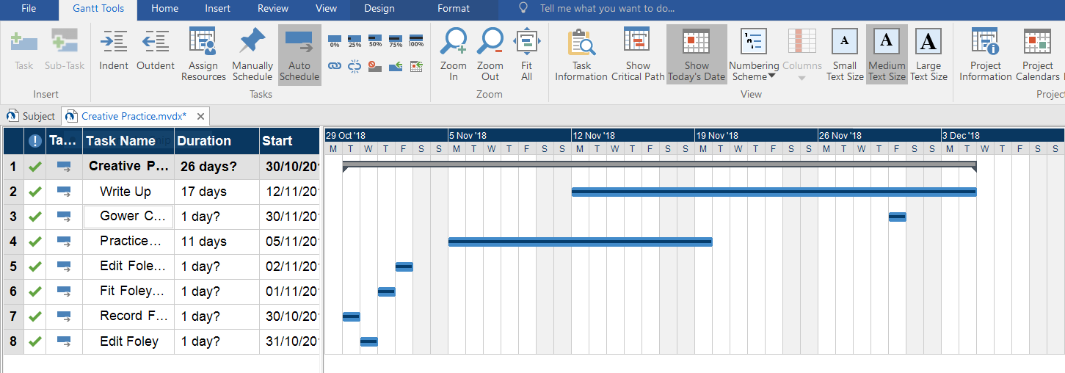

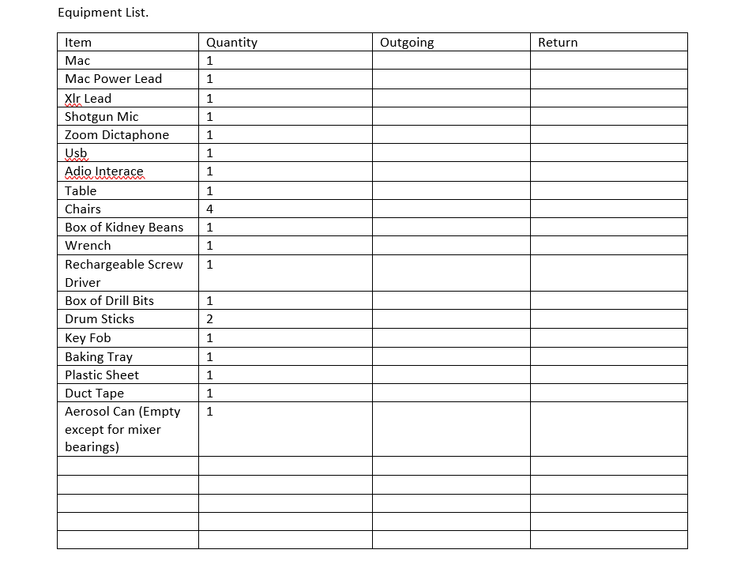

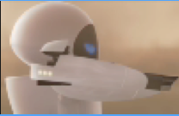00:01:23-00:04:02 | 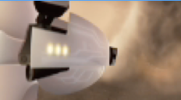  00:06:02 | 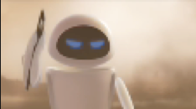  00:07:14 | 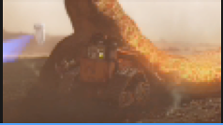  00:16:02 | 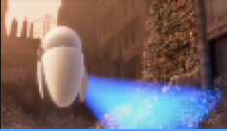00:25:15 | 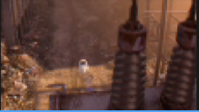00:28:11 | 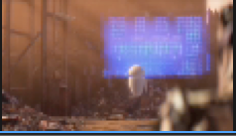00:30:16 | 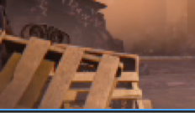00:32:10 | 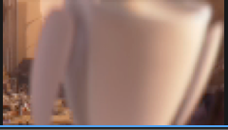00:36:23 | 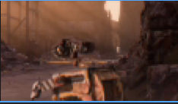00:41:10
Blank fading to Eva. She’s fired her weapon. The area is open, desolate landscape.  Sounds:-Ambient wind/breeze Debris falling? | Change of angle. Ambients continue. Smoke billows. Target is visible.  Sounds:  Red hot sizzle. | Eva begins to holster her weapon with a twirl.  Sounds:  Whirl | From behind and close to the blast area. Weapon holstered.  Searing, heat, molten metal. Eva in the distance turns and moves off. Pan left, Walle shaking with fear. In the background Eva goes on her way.  Sounds: Hissing. Rattles | Eva is now in a built-up area. Rubble and dereliction. She’s scanning as she passes. Paper like items waft in the breeze.  Sounds: Eva hover and scan? Ambient breeze. Paper rustle. | We look down on Eva from atop a power sub-station as she has stopped moving but continues to scan.  Sounds: Scan but slightly more distant. Ambient. | As she scans we take up a concealed position some distance behind her. Walle is stealthily approaching but at first we can’t see him then he moves into view  Sounds: Distant scan. Ambient. Walle tracks, rattles. | Walle peeps out from behind a pallet.  Sounds: Servos. | We move close to Eva as she scans.  She stops scanning and appears to be despondent having detected nothing. 3 blue lights followed by 1 red. She moves off passed the camera.  Sounds: Scan. Ambient. Light noises beep? Scan off noise? | We’re behind Walle as he cranes his neck and watches Eva go out of sight. He sets off in persuit.  Sounds: Servos. Walle movement, tracks, rattles.

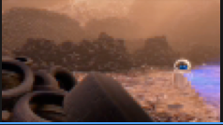00:45:22 | 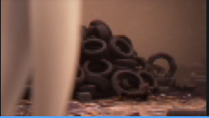00:50:10 | 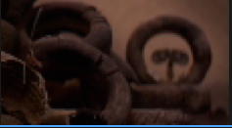00:59:05 | 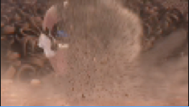00:59:22 | 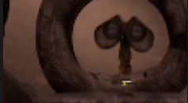01:00:15 | 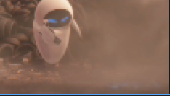01:04:16 | 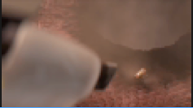01:07:10 | 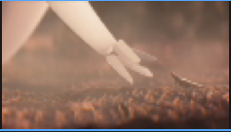01:10:22
Scene opens with scan lights on a pile of tyres and pans right to find Eva in an area surrounded by piles of tyres.  Sounds: Eva scanning. Ambient. | Camera is close to and in front of Eva. She moves forward and passed the camera. In the background we see Walle raise his head to covertly watch her.  Sounds: Eva noises. Ambient. Servos quiet and distant. | Wall-E sees a cockroach scuttle out from a pile of tyres just in front of him which sets off towards Eva.  He shakes his head to warn the insect.  Sounds: Servos, scuttle, | Eva spins around and fires!  Sounds:  Shot, explosion.  Falling debris | Walle is shocked and his head zips up and down.  Sounds:  Servos, falling debris | Eva remains still and on alert aiming at a hole in the ground.  Sounds:  Ambients only. | Cockroach pokes his head out of the hole. Cautiously at first then approaches Eva and shakes off dust.  Sounds:  Scuttle noises | Eva holsters weapon and offers a hand in friendship.  Sounds:  Holster whirl. |  |  | Ambient noises throughout. Changes occur as the action moves from the initial open area to the derelict city scape.

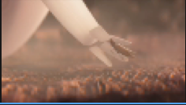01:12:05 | 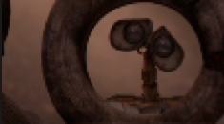01:13:10 | 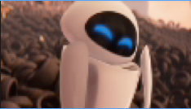01:15:22 | 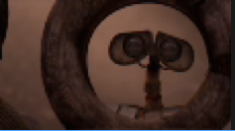01:17:10 | 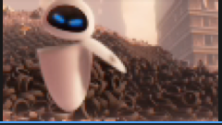01:18:08 | 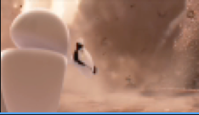01:22:07 | 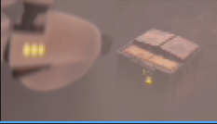01:32:09
Cockroach jumps on Eva and scampers around her.  Sounds: Scampering ‘roach. Different timbre due to Eva’s surface. | Walle is curious about Eva’s change in attitude. He tilts his head one side to the other.  Sounds: Servos. | ‘Roach scampers. Eva is tickled and giggles.  Sounds:  Scampering ‘roach. Female robot giggle. | Walle laughs...a bit too loud.  Sounds: Male robot laugh. Servos. | Eva hears. Instantly switches to attack mode and fires at Walle’s hiding place. Walle makes a run for it.  Sounds: Blast, explosion, falling debris, servos at full speed. | Eva has 2 more shots at Walle. Blasting piles of old car tyres leaving Walle nowhere to hide.  Walle looks side to side and retreats into his ‘shell’.  Sounds: Blast, explosion, falling debris, servos at full speed. | Eva approaches Walle. As she closes in on him, we can hear his quaking rattles. He opens his shell to peek. Fades to black.  Sounds: Rattles and servos. Ambient noises.  Fade out.

Images. Wall E[Video]. Available at: https://www.youtube.com/watch?v=kNb_hHoATiY (Accessed: 9 October 2018)

