Programme: BA Business Management

Module: International Business Communication
Lecturer: Charles Nwaogwugwu

Student Name: Mustafa Mustafa

Student Number: 1920425

Module Code: LCBB6001

Assignment 1

Table of Contents
Introduction 3
China: The Largest Developing Country 3
Analysis of International and Intercultural Communication 4
Hofstede’s Six Cultural Dimension 4
Critical Evaluation of Cultural Sensitivity 6
Importance of Networking 7
Communication barrier in China 8
Recommendation 9
Conclusion 10
Reference 11

Introduction
Businesses around the world are expanding every day. Because of the ever-developing technologies countries are getting connected easily and new market fr products and services are increasing. Organizations and companies are trying to sell their products in these new markets. They are starting businesses through joint ventures or opening new subsidiaries in other countries. As labour and raw materials are less expensive in developing countries, organizations are trying to take this benefit and attract a huge number of customers from these countries. There is a large market in developing countries for western companies in developing countries as most of these countries have huge populations. In developing countries lots of challenges are faced to star a new business. Company managers need to know the political and economic conditions of the host country. Cultural barrier is one of the most common barrier among all other barriers. Different countries have different cultures and norms. It is essential to understand the way of communication in the culture of the host countries for selling products and doing business there. Without understanding the culture and norms of a country, starting a business can lead to failed business communication. The objective of this report is to analyse the culture of a developing country, where the company will shift its business. For this, the company has decided to start its business in China. This report will analyse the cultural challenges that the company may face and finally will provide recommendations to overcome those challenges (Mcril, 2019).

China: The Largest Developing Country
China is the second largest economy in the world. Technological development, large capital investment and quick productivity growth are the reasons behind the economic growth of the country. In 2021, China’s GDP was almost 17.46 trillion USD. China ranked second globally and among the BRIC nations, where there are India, Russia and Brazil, China was top in terms of the GDP. China's per capita GDP rose to over 12,359 USD in 2021. Foreign direct investment in China is increasing rapidly over the last decade which plays a vital role in the economic growth of the country. According to the Ministry of Commerce, China's actual usage of FDI in 2021 totalled US$173.48 billion in US dollars, an increase of 20.2% compared to the previous year.
Culture of China is very much diversified. Liang Qichao, who is a chineese scholar said that the civilization of China is one of the ancient civilization just like Babylon, India and Egypt. Its history is 3600 years old and its geographic area is also diversified. The world benefits much from the diversity and uniqueness of Chinese culture, which has been harmoniously incorporated. On the Chinese mainland, the Han make up the majority of the population (Statista, 2022).

Analysis of International and Intercultural Communication
While doing business in a foreign country, it is important for successful cross-cultural communication. The elements affecting cross-cultural corporate communication include language, contexting and face-saving, social organization, concept of autority, nonverbal communication behavior, and time conception.

Hofstede’s Six Cultural Dimension
Amng different frameworks, there is a cultural framework named Hofstede’s cultutral frame. This is used widely to ana lyze the culture of the country. The score ranges from 0 to 100.
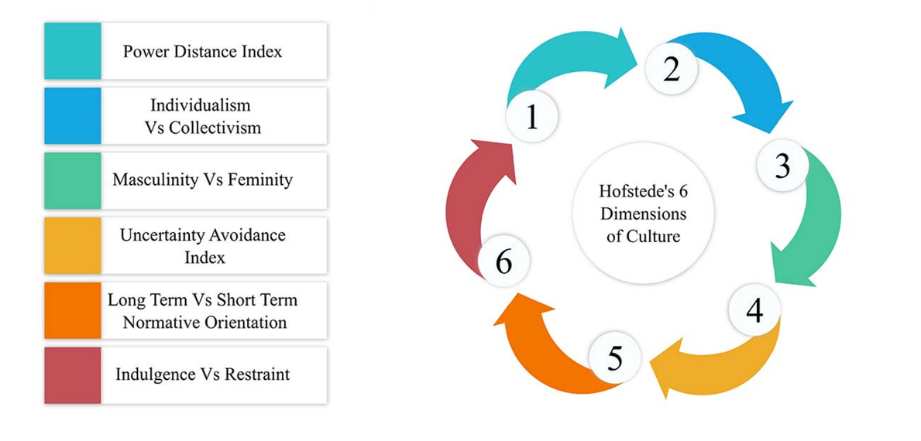
Power Distance Index: The power distance index indicates the degree of acceptance and rejection of difference between the people by a society or a culture. According to the rating, China has a cultural society that accepts social inequality as the PDI score is 80. People's ability to lead and take initiative is generally perceived favorably, and they are influenced by formal control and penalties. People shouldn't aim higher than their position (Hofstede Insights, 2022).
Individualism vs. Collectivism: An individualist society tends to think abut themeseleves and their families. On the contrary, a collectivist society thinks about the group. In this type of society, people stay loyal to the group. Chinese people belong to a collectivist society and therefore they try to act in favour of their society. Because of this, sometimes they are more commited to their colleagues rather than to their organizations. Personal relationship is more important for the Chinese people in the rganization. As a result, during hiring and promotions are based on closeness and personal relation. (Hofstede Insights, 2022).
Masculinity vs. Feminity: The presence of masculine culture in society shows that its members are achievement- and success-driven. A society is considered to masdculine when the index has a high score. On the contrary it is considered to be feminine when the score is low. That is they are driven by caring for others and success in life is based on the quality of life. China has a high score in this index. The most important factors that drives the people of the society of China are achievement and success (Hofstede Insights, 2022).
Uncertainty Avoidance Index: Chinese are adaptable and entrepreneurial. According to this index, Chinese people love to take challenges and they are also fond of uncertainty. Many people are entrepreneur and earn their livelihoods by doing business. These business are mainly family owned business as Chinese people like to give priority to their close people (Hofstede Insights, 2022).
Long-term vs. Short-term Normative Orientation: The society which ranks low in the scale are normative society. This type of society are wary of social change. But the socities those have high score are more practical. For future preparation, they give importanc eon putting effort in modern education. China is a pragmatic society as its score in this scale is 87, which is quite high. People in this type of society can waiky adjust to new situationand circumstances. Besides they fcus on saving and investment are persist to complete their job successfully (China, 2022).
Indulgence vs. Restraint: In this scale, China’s score is only 24. It indicates that the Chinese society is a restrained society. This type of scities are basically pessimistic. They do not spend leisure time enough and they also restrict the satisfaction of their wishes than Indulgent societies do. People with this perspective feel that enjoying themselves is somewhat bad and that their activities are constrained by social norms (China, 2022)

Critical Evaluation of Cultural Sensitivity
The lines between domestic and international work assignments are gradually becoming hazier due to the global economic environment, yet cultural differences are still a challenge in both situations. Being sensitive to cultural differences eases the transition. Being aware of and understanding cultural differences is referred to as cultural sensitivity.
For a company in the United Kingdom evaluation of cultural sensitivity is important before starting a business in China. Concepts of inequality in society, and the concept of individualism are some major areas where cultural differences exist between two countries. British people believes in eqwuality. They think that everyone should be treated equally and fairly. They also try to avoid inequality in the society. On the contrary, inequality is acceptable in Chinese society and they also think that people should not go beyond their rank whle doing any work. A company must recognize and respect its role in Chinese society as a foreign company entering the market. It will leave a good impression on the Chinese market if it respects people who are in positions of authority and show that the people of the UK company recognize and value their position (Chinahighlights.com, 2022).
The British are fond of being individual. But the people of China are the opposite. They strive to behave in society's best interests and are very collectivist. This is another cultural challenge that British businessmen will find in China. Due to this mentality, the business must approach Chinese customers differently than British ones. When engaging with Chinese consumers, one needs to be aware that different messages will connect with them. Just because they think collectively doesn't mean they don't make personal purchases. In the UK, we are content to move forward without needing to know what will happen next. The opposite is true of the Chinese. They want stability above excitement and need a structure and a strategy (McAlaney et. al, 2020)

“Saving Face” is another important Chinese culture that differs from the western. The term "face" (also known as "miànzi") in Chinese refers to a way of perceiving respect, dignity, and social standing. Someone can "lose face" by being impolite in their words or actions, but they can "give face" by making kind gestures like gifts, honors, and other shows of decency. Compared to "Western face," the Chinese face is more relational and directed. The western view is more individualized and self-centered. The term "Western face" primarily refers to their ego. In another word, it is more concerned with what other people think than it is with one's own sense of dignity or ego. Chinese faces can be inherited or acquired, in opposed to Western faces. It might be taken or misplaced. Personal morality is more significant to British people than honor or face. Chinese culture is not built on rules or customs; rather, it is founded on interpersonal connections. Chinese "ethics" have never been founded on universally accepted notions of right and wrong. They are more grounded in the present, or what the West calls "situational ethics." (Chinahighlights.com, 2022).

Importance of Networking
For any kind of business, networking is essential. Different foreign companies in China need to understand the importance to become successful in China. Many entrepreneurs try to establish to set up personal relations with the Chinese people as they know that the Chinese give more value to personal connections and sometimes its importance is more than business partnership or relation. In China, the concept is called Guanxi. Guanxi refers to the relationships formed when two like-minded individuals work together on a personal level to accomplish a mutually beneficial business aim (That's Mandarin, 2022).
Successful networking in China helps a foreign business firm to get a competitive advantage. The firm can align with the rules and policies of China when it will have proper knowledge about the people and authority managing it. This can be learned through networking which helps to get a competitive advantage. Another benefit of networking is to meet the demand of customers. China has a diverse customer market, and to meet this diverse demand networking is important. People in Jiangsu may have a different type of acceptance than people living in Shanghai. Guanxi enables the foreign company to collaborate with the small, locally owned businesses that drive the economy in rural China so that the company may quickly gain market share there. Networking increase trust with partners. This is beneficial for both parties. This trust will help the foreign company to get into the Chinese business easily. Practising Guanxi at the business level helps to maintain a good relationship with the suppliers and distributors, which is essential to making profitable business deals with the partners. It also helps the negotiation process easier for the company. In any global market, foreigners frequently find it difficult to forge strong government and sectoral links like the local businesses do. In China, this is still the situation. Guanxi in government can reduce these difficulties (Nolan & Rowley, 2020).

Communication barrier in China
For a business entering China, effective communication can be one of the toughest obstacles. An inability to communicate effectively in this market can swiftly hurt the performance, waste time and money, and ultimately lead to the failure of the brand to gain traction abroad. The first obvious impediment to genuine connection with Chinese markets may be language, yet language and culture are closely connected. There are many different cultures, customs and dialects in China. It is challenging to understand the language of the customers with different dialects. As already discussed before, face-saving is an important concept in Chinese communication. They will not say negative things directly so that the other party are not disrespected, but this is often mistaken by foreigners that they are agreeing with the foreign company’s proposal. That is not always the case. Another communication problem is that Chinese people need clear instruction for any task. A failure to provide step-by-step instruction may result in the unsuccessful completion of a task. According to the power distance index, Chinese people accept inequality and they do not perform anything going beyond their rank, which can go against the top hierarchy of the organization’s management. As a result, there is a chance of miscommunication with them (Ordorica, 2022).
One of the numerous obstacles preventing global corporations from reaching Chinese consumers is the language barrier. Key leaders and business managers must be fluent in Chinese if their companies plan to operate in China. Due to the difficulty of learning the Chinese language and the necessity of using it when conducting business, this presents another difficulty. Although Mandarin Chinese is the official language of the nation, people who speak a variety of regional dialects will continue to interact with international businesses. It interferes with effective communication and comprehension among locals from different parts of the nation (Ordorica, 2022).

Recommendation
To make a successful entrance into Chinese business, it the importance of understanding the cultural gap and language barrier is important. In this section of the report, there are some recommendations to enable the company to succeed in China.
- Understanding power distribution in the culture is important
- Understanding the value of collectivism
- Communicating while keeping in mind that China is a restrained society
- Not discussing sensitive issues like democracy, freedom of speech, Taiwan etc.
- Understand the concept of face-saving
- Not giving any negative feedback immediately
- Providing clear instructions and asking feedback questions.
Understanding the power dynamics is crucial because Chinese organizations are hierarchical according to rank and age. It is necessary to communicate business matters with employees of the proper rank. It's critical to comprehend the significance of collectivism to Chinese culture. The British need to be more cautious about this because they are the reverse and are used to living in an independent culture. In Chinese culture, relationships are significant. Guanxi, or networking and connection, is crucial for business. By nurturing Guanxi, the company lowers risks, failures, and setbacks. Another important piece of advice is to realize how conservative Chinese society is. Understanding that Chinese people regard leisure time less and rarely engage in enjoyment is crucial for effective communication. It would be foolish to bring up delicate subjects in business communications with Chinese partners. As Chinese people maintain saving face they may give a flat negative response or just nod their head which does not mean that they agree with the business proposal. Similarly, directly giving negative feedback to a Chinese proposal may have negative consequences. Executives can overcome their language barrier with the help of qualified interpreters, especially during commercial talks. Professional translators can faithfully interpret official business documents and meeting transcripts (Staff, 2022.)

Conclusion
International business communication cannot be ignored while starting a business in a foreign land. Proper business communication is essential for a successful negotiation. To do business in China, the world’s second-largest economy, the hurdle of carrying on effective business communication can be done by understanding the cultural dimensions of the country. Foreign countries should be aware of cultural differences. Networking is an important tool to understand the differences. To attract customers and gain a competitive advantage in the market foreign companies should be careful to gain the trust of the Chinese people. A comprehensive approach to perfect communication can help a foreign company succeed in China.

Reference


