

Strategic Planning and Delivery Considerations for Winter Enchantment Festival

Module Name
International Meetings Management for the Hotel Industry (BMIH6007)

Lecturer’s Name
Kathryn Flynn

Student’s Name: Mohammed Ali Hayder
Student ID: 2210332

Word Count
2548 words

Declaration
I confirm that I have not used any AI tools in the research and creation of this assignment. I confirm that I have not presented any AI generated materials as my own work. I confirm I have copies of my drafts, notes, and other resources I used, which I may be asked to provide in evidence.

Contents
Introduction 4
The Event Cycle 5
Event Concept 6
Aim and Objectives 7
Event Management 8
Event Budget 10
Industry Trends, Issues, and Impacts of the Festival 10
Situational and Cultural Considerations for Winter Enchantment Festival 11
Conclusion 14
Reference List 15

Introduction
The UK event industry is growing and contributing to its economic growth. Organising an event is always challenging due to changing environments and guest preferences (Getz and Page, 2019). The report provides a strategic plan for Winter Enchantment Festival. Winter Enchantment Festival is a unique event which will be organised in York, the UK. The main theme of the event is winter. Therefore, all activities will be designed based on the theme. The overall plan including the budget and external factors analysis is provided in the report for making strategic decisions of the event management.

The Event Cycle
The event cycle is an important phase of the event management. It is a clear framework that guides the management in planning, organizing, and executing the event successfully (Jones, 2017). The management also needs support for analyzing the post-event activities to determine the achievement of the event goals and objectives. Usually, there are four main stages in an event cycle as explained in the EMBOK model (EMBOK, 2019). These stages are initiation, planning, implementation, and closure. The four stages of the event cycle are explained below for the Winter Enchantment Event:
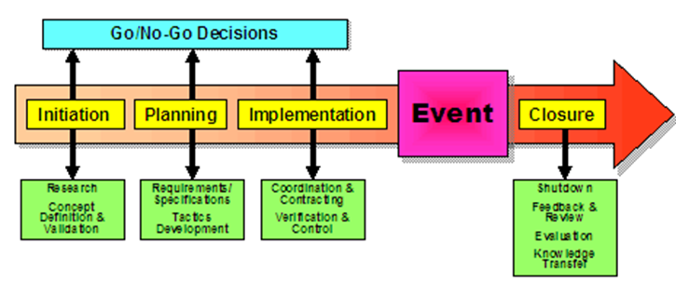
Figure 1: EMBOK model phase
Source: (EMBOK, 2019)
- Initiation: It is the first stage when event managers generate ideas for the event (Jones, 2017). As event theme, objectives, targeting, and preferences of different activities for the specific event are conceptualized in this phase. The Winter Enchantment Festival will be organized based on the winter theme. There will be a fine blend of art, culture, technology, and fantasy for the people of all groups in the UK. The event organizers value the creativity and innovation of partners so they will ensure adequate facilities for the partners so that they can showcase their products and innovations (Richards, Marques and Mein, 2015).
- Planning: Planning is the second stage of the event cycle (Jones, 2017). This phase determines how the logistics will be structured to bring efficiency in the event of task completion. The planning also provides budgeting for each activity and the allocation of resources within the different activities of the event effectively (Getz and Page, 2019). The Winter Enchantment Festival will be organized in a venue in York. Therefore, businesses around the area will be ideal for making partnerships as this will offer more flexibility and greater access to the organizer to manage the assets efficiently. The event organizer should coordinate with the staff and technology providers to ensure that there is no disruption in the event due to technological failure or staff shortage.
- Implementation: Execution is the third stage of the event cycle. The management of the Winter Enchantment Festival must ensure that the event is executed according to the plan. By doing so, it can have smoother event operations and a mechanism to address all the issues related to the event activities (Jones, 2017).
- Closure: It is the final stage of the event cycle (Richards, Marques and Mein, 2015). In this phase, the management is required to analyze the event activities. They can take feedback from the event attendees, assess financial outcomes, and evaluate the goal achievement to conclude whether the event was successful (Getz and Page, 2019).

Event Concept
A clear event concept is crucial to develop and execute the event plan (Preston, 2012). The Winter Enchantment Festival will be organized to offer an immersive and exceptional experience to the event attendees. People attending the festival can have a magical experience, live performances, interactive arts, and technological innovations. All such arrangements will captivate visitors (Curtin, 2013).
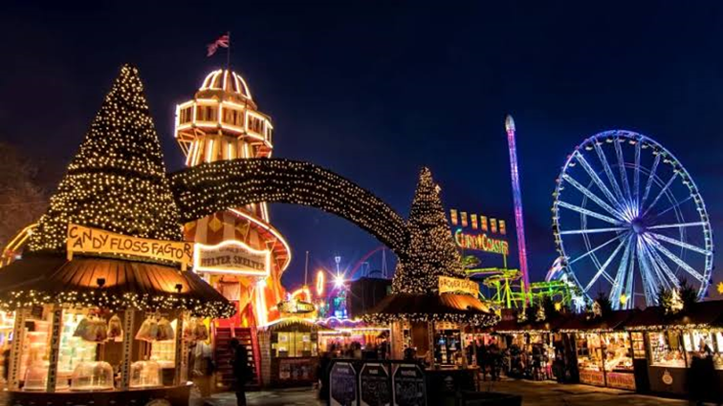
Figure 2: Event in London
Source: (Winter Event, 2024)

The event concept is aligned with the growing trend in the hospitality and tourism industry in the UK. People are now more interested in experiential tourism. Experiential tourism is different from traditional tourism because the tourists get involved with interactive activities in experiential tourism while in traditional tourism, they remain passive observers of the tourist attraction (Godovykh and Tasci, 2020). The cutting-edge technologies, live performances, and art installations will create the opportunity for the tourists to become interactive and have an immersive experience.
The Interactive art installations are inspired by a winter theme and the guests are allowed to engage with the artwork. The event management will transform the venue into a snow-covered landscape by installing high-quality digital projection (Gretzel et al., 2015). There will be motion sensors that keep track of the visitor’s movements and change the landscape based on their movements. Live musical performances by local artists, ice sculpting, and different shows are scheduled for the entire day of the festival. Augmented reality (AR) installation will provide an immersive experience to the attendees about the winter scenes (Jung and tom Dieck, 2017). The itinerary for the event is as follows:

Aim and Objectives
The Winter Enchantment Festival has a clear aim and three objectives to achieve. The main aim of the festival is to create a unique and immersive winter festival in York to attract a diverse group of people and provide them with a seamless experience. The three SMART objectives of the festival are as follows:

Event Management
Event management is a process of planning and execution of planning to achieve the event goals (Getz and Page, 2019). Effective event management is crucial to make the Winter Enchantment Festival successful. In event management, the allotment of tasks among different departments and teams, allocation of necessary resources, and leading the team are the most important tasks to perform. The event activities must align with the event’s aim and objectives (Arcodia and Whitford, 2006). The key event management activities are explained below:
Operational Management
It is the core activity of the event. The operation manager has to set up the venue, coordinate people and logistics, manage staff, and ensure the security of the event attendees (Getz and Page, 2019). For venue setup, York Museum and York Racecourse are two ideal places. The manager can choose one of the venues. Before choosing the venue, the key considerations should be adequate lighting, sound systems, and decoration facilities. The partners and businesses should get adequate space to set up their art installations and assets (Arcodia and Whitford, 2006). Event attendees may require comfortable and convenient seating arrangements during their visit. Effective and efficient logistics are crucial to make an event successful (Preston, 2012). It helps managers to provide resources within the due time. The required materials, equipment, and supplies will be managed by partnering with local businesses and artists. Staff plays a leading role in implementing the event plan. Hence, the management must recruit skilled and experienced staff to perform the different duties. For example, the hospitality staff should have the skills such as interpersonal skills, empathy, and communication skills to handle the guests properly (Fox et al., 2014). The technical staff must have the experience to manage equipment and technologies. The security personnel should be able to increase the security of the people and help them if visitors encounter any problems. There will be a high level of security by undertaking initiatives such as crowd control, emergency response, and medical services. The event will be accessible to everyone and so there should be wheelchair accessibility and security measures to the mobility and seating arrangement of the public. The management must make the event inclusive by targeting people of different cultures and ages. The food options should be offered aligning with their diverse needs (Fox et al., 2014).
Planning Management
The strategic planning for the Winter Enchantment Festival will cover the event’s marketing aspects, sponsor management, and collaboration with local businesses and industry partners. The 7Ps of marketing mix is relevent for the event. The marketing manager should focus on product (event offerings), price, place, promotion, people, process, and physical evidence.
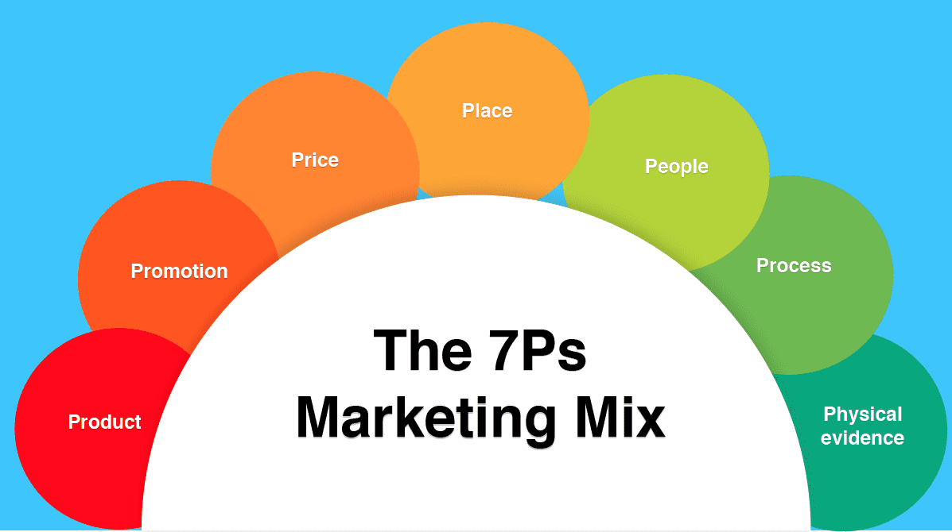
Figure 3: 7Ps of marketing mix
Source: (Hanlon, 2023)
Marketing activities will target people who are interested in winter activities and festivals and those who prefer experiential tourism (Fox et al., 2014). The event management should apply a digital marketing strategy. In digital marketing strategy, social media platforms such as Facebook, Instagram, and TikTok will be used (Achen, 2017). Campaigns on the Winter Enchantment Festival using hashtags should be conducted on these social media platforms. Interactive content such as videos on the event’s storyline and behind-the-scenes can be posted to catch the audience’s attention. The management may encounter people to share their ideas and feedback to improve the event’s experience. The management team should continuously share blogs on the website of the festival. Various influencers have a large fan base on social media sites. Partnership with those influencers would be very useful in increasing the number of visitors (Casaló, Flavián and Ibáñez-Sánchez, 2020). In addition, early bird discounts should be given to secure the targeted sale of the tickets for the festival. The management should also collaborate with local vendors and suppliers to promote local culture and heritage to international audiences (Preston, 2012). To make the strategic plan for the festival viable, the management needs to manage sponsors within the UK as well as international sponsors. The money coming from the sponsors helps the management to execute the planning and strengthen the management financially.

Event Budget
A budget is a financial plan for the event. In this section, the total cost of the event will be explained as well as total revenue will also be forecasted below:
Table 1: Cost and Revenue for the Event
Source: Author
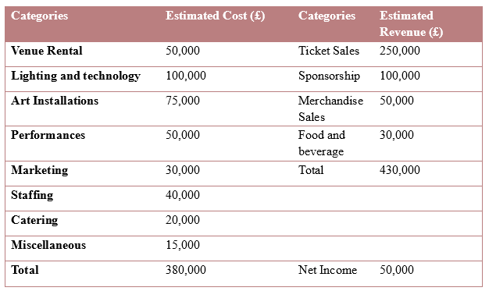
The accommodation, seating, and arrangement of the festival will require to rent York Museum Gardens for £50,000. To make the event fascinating and magical, the management may spend £100,000 on lighting and technologies. Calculating other expenses in the table, the festival will have a total cost of £380,000. Without securing a net profit, it will not be possible to organize the event. Revenues will be generated from four sources. The primary source of revenue generation is ticket sales. Fees from sponsors, merchandisers, and sales of food and beverage will total the revenue of £430,000. Hence, there will be a net profit of £50,000. The net profit indicates that the event is financially viable.

Industry Trends, Issues, and Impacts of the Festival
Analyzing the industry trend is necessary to ensure that the event organized is relevant to the people’s needs and expectations (Richards, Marques and Mein, 2015). The current trends that can influence the festival are explained below:
- Experiential Tourism: Tourists are now more interested in experiential tourism which means they like to get engaged with the event, interact with the event activities, and desire to receive personalized tourism experiences. Tourists in the UK have demonstrated a strong trend for experiential tourism (Yiannakou et al., 2022). The Winter Enchantment Festival has structured the festival’s activities to align with this specific trend. Interactive art installations and AR technologies are some examples of experiential tourism. Offering an immersive and unique experience to the people can have a long-lasting impact on the event attendees. It can enhance the guests’ satisfaction and transform them into loyal visitors to the event (Garcia Henche, 2018).
- Sustainability: Sustainability is another crucial trend that has a significant impact on the UK’s tourism and hospitality industry. Most of the audiences who are younger consider sustainability aspects in their decision-making process. Because this particular group is more aware of sustainability. Understanding the importance of the trend, the event management should undertake the necessary steps to use sustainable products and materials in the event. Sustainability practices can significantly reduce the environmental impact of the event. They can enhance the reputation of the event in the industry (Malheiro et al., 2020). On the other hand, failure to meet sustainability requirements can result in financial penalties as well as loss of reputation of Winter Enchantment Festival.
- Maintaining Competitiveness: The event industry has several events to execute. These events show intense competition. Without having an effective strategic plan, it is not possible to attract attendees and make the event successful (Richards, Marques and Mein, 2015). The UK has several events during the winter season. There are many well-known events such as Christmas Events and Winter Wonderland Event. Understanding the market trend, the event management should ensure that the Winter Enchantment Festival has a unique idea to execute an exceptional guest experience (Ahmad, 2024).

Situational and Cultural Considerations for Winter Enchantment Festival
The PESTEL analysis framework is widely used for analyzing the situational factors within an industry. In PESTEL analysis, situational factors such as political, economic, social, technological, environmental, and legal factors are assessed (Aziri and Ismaili, 2020). These factors are analyzed below:
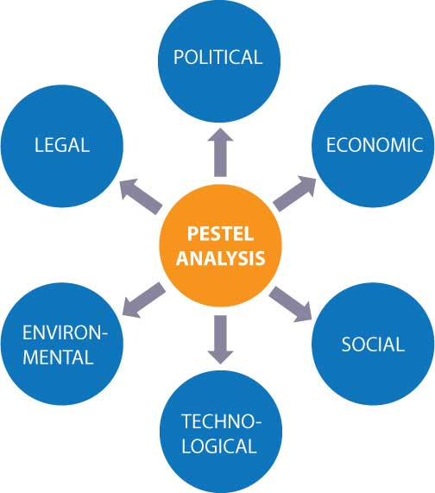
Figure 4: PESTEL Analysis
Source: Author
- Political Factors: Event management should have a clear understanding of the local government regulations regarding hosting an event. Winter Enchantment Festival should comply with all regulations including environmental regulations and safety regulations. It should obtain the required permits to avoid any disruptions. The local authorities in York are supportive (Visit Britain, 2024). Their support can positively impact the event. It can increase its credibility and make partnerships with different industry partners and stakeholders.
- Economic Factors: The economic situation of the UK can significantly impact the revenue generation of the festival. Pressing economic conditions and rising inflation rates can affect public spending. People might adapt to discretionary spending in which they are less likely to spend their money on entertainment (BBC News, 2024). Acknowledging the economic issue, the Winter Enchantment Festival will make its ticket affordable for all groups of people.
- Social Factors: The social trend and family-friendly arrangements of the event will positively impact various age groups. People will find the opportunity to engage with the community (Fox et al., 2014). Tourists visiting from other countries can experience the rich culture and heritage of the destination.
- Technological Factors: Different types of technologies such as AR can make the visitors’ experience immersive. Interactive art installations and other event activities can be organized with the help of the UK’s emerging technological advancements (Government of UK, 2023). Winter Enchantment Festival’s technology integration is the unique selling point for the event which can attract a significant number of visitors.
- Environmental Factors: York’s magical winter environment is crucial to organizing such a grand event. With proper planning, the event management team should overcome challenges arising from snowfall and rain as these can disrupt outdoor activities. Moreover, the event should also ensure that sustainability commitments to save the environment are maintained (Silvers and O'Toole, 2020).
- Legal Factors: The UK has a functioning legal system that guides how businesses and organizations should perform their operations. Winter Enchantment Festival should comply with all legislation and regulations such as health and safety regulations, hygiene, and waste disposal. In addition, legal contracts should be made with vendors and industry partners (NI Business Info, 2024).
Cultural Factors
The event management should resonate local cultures and heritage with the Winter Enchantment Festival by constructing event activities relevant to the chosen theme and cultural factors. York has a rich cultural heritage. The local tradition, craft, and history can be positioned within art installations, performances, and lighting arrangements (Allen et al., 2010). The various celebrations can also communicate the culture with the attendees. The event should be an inclusive place where everyone can attend. Community engagement will ensure that the event is more interactive and has achieved its goal (Fox et al., 2014).

Conclusion

Reference List
Achen, R.M. (2017). Measuring Social Media marketing: Moving Towards a relationship-marketing Approach. Managing Sport and Leisure, 22(1), pp.33–53. doi:https://doi.org/10.1080/23750472.2017.1379883.
Ahmad, M. (2024). Winter Events in the UK 2024: from Festivals to Christmas. [online] Imperial Ride. Available at: https://www.imperialride.com/blog/winter-events-in-the-uk-2024-from-festivals-to-christmas [Accessed 18 Oct. 2024].
Allen, J., O’Toole, W., Harris, R. and McDonnell, I. (2010). Festival & Special Event Management. 5th ed. Milton, Qld: John Wiley & Sons Australia, Ltd.
Arcodia, C. and Whitford, M. (2006). Festival Attendance and the Development of Social Capital. Journal of Convention & Event Tourism, 8(2), pp.1–18. doi:https://doi.org/10.1300/j452v08n02_01.
Aziri, B. and Ismaili, R. (2020). Business environment analysis as a key stage in the process of strategic management. ECONOMIC VISION-International Scientific Journal in Economics, Finance, Business, Marketing, Management and Tourism, 7(13-14), pp.99-110. Available at: https://eprints.unite.edu.mk/665/1/9%20faqe%2099-110.pdf
BBC News (2024). What Is the UK’s Inflation Rate and Why Is the Cost of Living Going up? BBC News. [online] Available at: https://www.google.com/amp/s/www.bbc.com/news/business-12196322.amp [Accessed 18 Oct. 2024].
Casaló, L.V., Flavián, C. and Ibáñez-Sánchez, S. (2020). Influencers on Instagram: Antecedents and Consequences of Opinion Leadership. Journal of Business Research, 117, pp.510–519. doi:https://doi.org/10.1016/j.jbusres.2018.07.005
Curtin, S. (2013). Lessons from Scotland: British Wildlife Tourism demand, Product Development and Destination Management. Journal of Destination Marketing & Management, 2(3), pp.196–211. doi:https://doi.org/10.1016/j.jdmm.2013.09.002.
EMBOK (2019). EMBOK - event management body of knowledge - phases. [online] Embok.org. Available at: https://www.embok.org/index.php/phases-page [Accessed 07 Nov. 2024].
Fox, D., Gouthro, M.B., Morakabati, Y. and Brackstone, J. (2014). Doing Events Research : from Theory to Practice. London: Routledge, Taylor & Francis Group.
Garcia Henche, B. (2018). Urban Experiential Tourism Marketing. Journal of Tourism Analysis, 25(1), pp.2–22. doi:https://doi.org/10.1108/jta-01-2018-0002.
Getz, D. and Page, S.J. (2019). Event Studies : theory, Research and Policy for Planned Events. 4th ed. London: Routledge.
Godovykh, M. and Tasci, A.D. (2020). Customer experience in tourism: A review of definitions, components, and measurements. Tourism Management Perspectives, 35, p.100694. doi:https://doi.org/10.1016/j.tmp.2020.100694
Government of UK (2023). Technology - great.gov.uk International. [online] www.great.gov.uk. Available at: https://www.great.gov.uk/international/content/investment/sectors/technology/ [Accessed 18 Oct. 2024].
Gretzel, U., Sigala, M., Xiang, Z. and Koo, C. (2015). Smart tourism: Foundations and Developments. Electronic Markets, [online] 25(3), pp.179–188. doi:https://doi.org/10.1007/s12525-015-0196-8.
Hanlon, A. (2023). How to Use the 7Ps Marketing Mix? - Smart Insights. [online] Smart Insights. Available at: https://www.smartinsights.com/marketing-planning/marketing-models/how-to-use-the-7ps-marketing-mix/ [Accessed 7 Nov. 2024].
Jones, M. (2017). Sustainable event management: A practical guide. Routledge.
Jung, T.H. and tom Dieck, M.C. (2017). Augmented reality, Virtual Reality and 3D Printing for the co-creation of Value for the Visitor Experience at Cultural Heritage Places. Journal of Place Management and Development, 10(2), pp.140–151. doi:https://doi.org/10.1108/jpmd-07-2016-0045.
Malheiro, A., Sousa, B.B., Liberato, D. and Liberato, P. (2020). Sustainability in tourism and hospitality: Trends and challenges. In 35th IBIMA conference education excellence and innovation management: A 2025 vision to sustain economic development during global challenges (pp. 15545-15555). IBIMA. Available at: https://www.researchgate.net/profile/Pedro-Liberato/publication/343294642_Sustainability_In_Tourism_And_Hospitality_Trends_And_Challenges/links/5f21b653299bf134049252e7/Sustainability-In-Tourism-And-Hospitality-Trends-And-Challenges.pdf
NI Business Info (2024). Legal Requirements for Tourism Businesses | nibusinessinfo.co.uk. [online] www.nibusinessinfo.co.uk. Available at: https://www.nibusinessinfo.co.uk/content/legal-requirements-tourism-businesses [Accessed 18 Oct. 2024].
Preston, C. (2012). Event Marketing : How to Successfully Promote events, festivals, conventions, and Expositions. 2nd ed. Hoboken: John Wiley & Sons.
Richards, G., Marques, L. and Mein, K. (2015). Event Design : Social Perspectives and Practices. Abingdon, Oxon ; New York, Ny: Routledge.
Silvers, J.R. and O'Toole, W. (2020). Risk management for events. Routledge.
Visit Britain (2024). Tourism Sector Deal. [online] VisitBritain.org. Available at: https://www.visitbritain.org/introduction-tourism-britain/tourism-sector-deal [Accessed 18 Oct. 2024].
Winter Event (2024). Winter Events in the UK 2024: from Festivals to Christmas. [online] Westway Ride London. Available at: https://www.westwayride.com/blog/winter-events-uk-2024-festivals-christmas/ [Accessed 7 Nov. 2024].
Yiannakou, A., Apostolou, A., Birou-Athanasiou, V., Papagiannakis, A. and Vitopoulou, A. (2022). Branding Places through Experiential Tourism: a Survey on the Features of the Experiential Product and Enterprises in Greek Regions. Tourism and Hospitality, 3(2), pp.435–450. doi:https://doi.org/10.3390/tourhosp3020028.

