Student ID: 1605788
Student Name: Anwar Miah
Project ID: BMSK5003_LON
Professor Name: Yajesh Kumar

Understanding and Engaging in the Customer Experience

Table of Contents
Understanding and Engaging in the Customer Experience i
Introduction 1
1. Critically analyses the factors that impact your organization's ability to maximize customer value 2
2. Critical understanding of your organizations quality processes and its effectiveness in meeting customer requirements. 9
Conclusion 16
Reference 17

Introduction
Every company wants a good customer base of their own. That’s why they maintain certain policies and strategies to maximize customer value so that customers may remain loyal to them (Soin, 2011). They seek for developing a quality process for meeting up customers’ requirements. Primark is a fashion retailer in the UK. It has established its business in London for nearly fifty years. They have been a prominent retailer in the fashion sector. They are one of the most reputable organizations in the UK for maintaining a good work environment for employees and offering quality products to the customer which helps them in forming a strong brand name. In this report, there will be a discussion on how their ability to maximize customer value gets impacted by several factors. To gain a good customer base, Primark needs to offer quality products to the customer. This report will talk about the quality process of Primark and its effectiveness in the company approaches.

Critically analyses the factors that impact your organization's ability to maximize customer value
A companies performance and its productivity are both directly and indirectly influenced by each and every component existing in the market. An organization can be influenced by both positive and negative attributes of these components (Besterfield, 2014). To produce better quality service, it requires a better input from the company. Factors and components of the market have an impact on the capability of maximizing customer’s value. Identifying effective strategies and performing operational activities effectively are the main criteria needed for increasing customer’s value. In this regard, Primark, a retailer based organization, has identified different strategies for further development and adding customer’s value more. These strategies are discussed below:

Feature mind maps

Feature mind map refers to the diagram that is utilized to create visually organized information (Westland, 2012). A mind map is a hierarchical image of several branches that shows interlinkages between each other. Primark has an increased rate of customer value. The main reason for it has been discovered that -
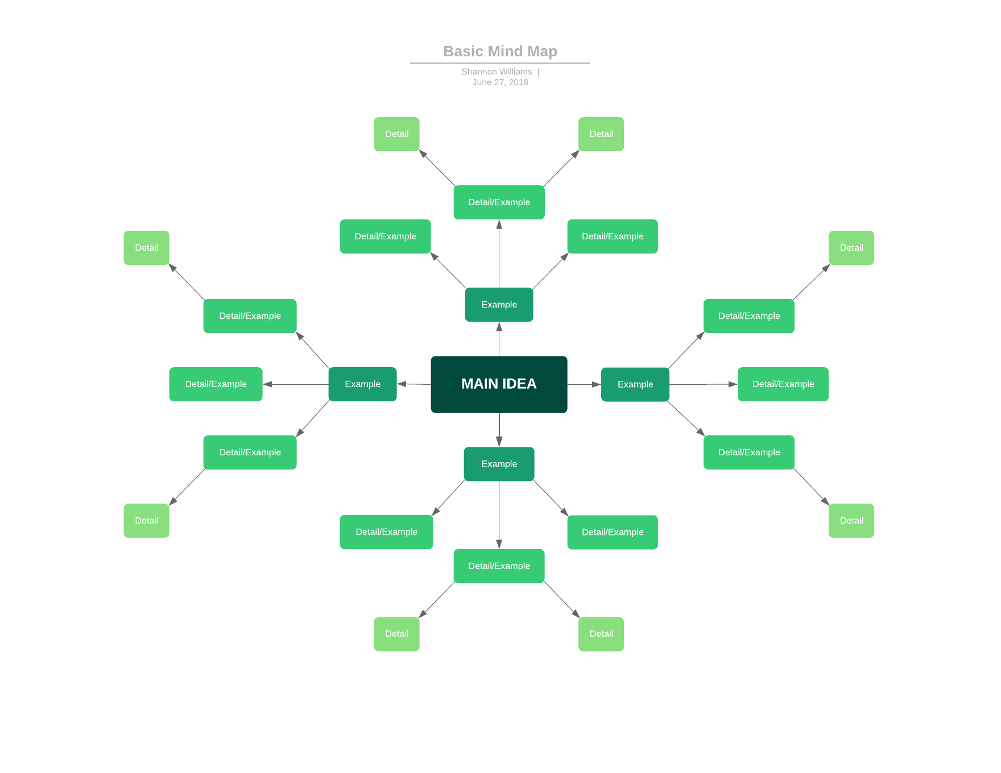

Figure 1: Feature Mind Map
Source: (Johnson, 2018)
Primark has maintained several things to retain the customer. Primark has adopted taking feedback scopes from the customer. The customer would give feedback to the Primark authority and they overcome those factors by maintaining proper plans and implication. Another reason is customers want services through technological resources. Primark has developed their IT sector. One more thing that helped to maximize customer value is rewarding a loyal customer. Customers who purchase products or services from Primark frequently are Primark’s loyal customers. They always desire preference from Primark. After rewarding them, these customers felt that they are valuable to the company and remain loyal towards it.

SWOT analysis
SWOT analysis refers to a tool that identifies the strength, weakness, opportunities, and threats of an organization (Neil, 2017). Primark is a global retailing company. Examining their SWOT analysis will help to understand their reason for maximizing customer value.
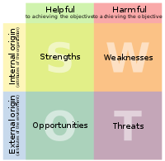
Figure 2: SWOT analysis
Source: (Ptizer, 2018)
Strength: Primark is one of the largest and profitable retailers across the world. It has won several awards for its best output in the retail sector by providing the best quality service to the customer. Primark has set a strong brand name in the market which has achieved brand recognition throughout the world. Additionally, Primark has improved its use of technology that attracts the customer to shop with them.
Weakness: There is a huge competition among the retail industry. There has been an increased rate of retailer companies in the UK. Too much competitive pressure leads Primark to lessen their price of the products or services. This reduced price increases the number of the customers but this ultimately reduces the gross profit for the company. Disposable income is lessening day by day. As a result, people are less interested in buying products which are luxury and not a necessity.
Opportunities: In some countries where Primark has not established their brand name in a strong way, there is a scope of establishing the brand name by providing better quality service. Primark may opt for merging with another established brand to capture the market out there. Primark is still a growing company, so there is a demand for it to be the retailer of new emerging products and services. So, it can be the retailer of new products to increase the product line of them.
Threats: There is a huge competition among the retailers in the UK. Retail giant shops are offering products at a low price with a wide variety of products. In this case, growing companies like Primark face a great problem as their product line is comparatively less than the bigger ones, so, they cannot offer products or services at a lower price, it will reduce the profit greatly. The political condition is not stable and so is the market, hence rules and regulations are frequently changing. In this case, if more tax and other fees are imposed on companies, growing companies like Primark will face bigger problems to earn a profit after deduction of taxes and related fees.
Value chain analysis
Value chain analysis refers to the elements of the internal environment that has impacts on the company’s benefits and customer’s services in several sectors (Walters and Rainbird, 2014). Value chain analysis includes verification of data, identifying of problems, managing task inside and outside of the organization, and proper execution of all works. Primark is benefitted by using this approach in several ways. They can maintain the proper balance of products and quality by differentiating and satisfying customer’s needs and demands. The value chain analysis of Primark is discussed below:
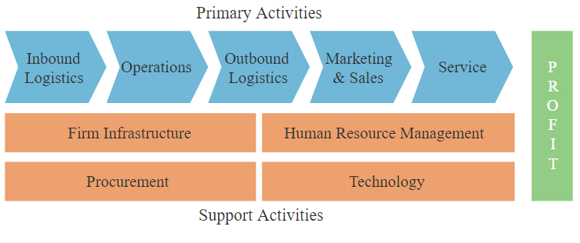
Figure 3: Value Chain Analysis
Source: (Jurevicius, 2018)
Operational management: Operational management refers to the administrative activities aimed at highest possible efficacies in an organization (De Beer and Rossouw, 2015). It has a direct impact on the output of the organization and its productivity. To maintain the productivity actively runs in the organization and make profitable output, the operational activities should be managed by an operational management team. To run own organizational activities smoothly in a profitable way, Primark has taken different approaches to maintain so that they may impact profitably in the organization. They have taken several approaches like Kaizen, TQM, and the capacity management for the better analysis.
Marketing and sales management: The aim of marketing management is to identify the customers’ needs and demands and make the products or services available to the customer and let the customers know about the products or services. It works for promoting the products to the customer by creating awareness, sales and establishing a brand image in the market. An effective marketing activity works for retaining customers from the market. It helps to maximize customer’s value by promoting the brand and developing the quality of the product. Primark believes that they can establish their brand image in the market by adopting effective and strong marketing policies that will end up increasing sales in the market. That’s why Primark emphasises in that development.
Supply chain management: Supply chain management refers to the process of implementing supply chain effectively for increasing customer’s value and achieving sustainable competitive advantage. Products in a company are increased for increasing customer value. Every company including Primark should emphasize supply chain management because this team is engaged in the management of products and movement of them to other places. They are engaged in the production and collecting raw materials swiftly. Primark has an increased number of customers for their better supply chain management. Thus, they have increased customer’s value in the market.
Human resource management: Human resource management is the procedure of managing people in an organization to have a competitive advantage. Before implementing strategies in other areas, an organization needs to develop its human resource and strengthening this side. Because an effective human resource may bring about better output from the organization. Human resource management has the focus on developing human resources that help to get a good customer base, as strong human resource management produces better quality services and products that attract the customer to be the purchaser of a certain company. Primark has a good customer base in the market for its smooth operation. This has been possible for them to retain as they emphasize on developing human resources which bring about better quality products and services.
External environment
The external environment contains every element that is outside of the organization. One of the major tasks of business is to look for opportunities in the market. And based on that findings, they utilize these opportunities. These opportunities are influenced by the components of the business environment. Primark is working to utilize these opportunities for achieving customer’s value. At the same time, they are working to resolve the threats of the environment by converting them into opportunities. These threats are sometimes uncontrollable and unpredictable. Primark measures these threats on the basis of their experiences and risks. Their continuous work for betterment helps them to sort out problems and resolve them and at the same time to increase the customer value in the market. Primark has sorted out several factors that may assist their organization by identifying threats and opportunities.
PESTEL Analysis: PESTEL analysis refers to the analytical tool that is used to analyse and govern the external marketing environment by the marketers. It is formulated by those components which have a direct impact on the organization.
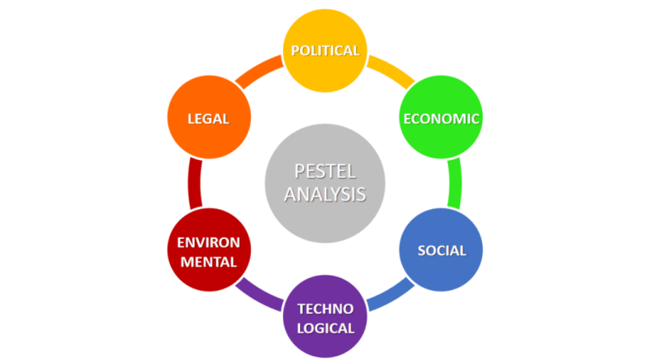
Figure 4: PESTEL analysis
Source: (Pérez, 2018)

Political factor: Political factor includes how government and its rules and regulation intervene the business activities. That’s why the political factor has a direct impact on business. Different countries have different types of rules and regulation. To create customer value and increase this, Primark is operating its business in more than 30 countries., their goal is to serve globally. For operating business in different countries, Primark has to obey regulation in according to each country’s system. If this company can easily adapt to every country’s regulation, then it may be able to adapt in business culture easily and can tackle the uncertain business situation in a meantime.
Economic actor: Economic factors shape decision-making for a business in a particular country. Every country has their own economic affairs which have an impact on its businesses. It also impacts interest rates, economic growth, and exchange rates etc. Primark is running its business in different countries. They have a particular economy according to their business culture pattern. In the UK, there is a very stable economy in business. So, here Primark is able to sustain its business for a longer period of time. But countries like in middle east countries, there is the very unstable economy, so their business model needs to be changed regularly in order to tackle the situation, as exchange rates, spending pattern, disposable income have a direct impact on business.
Social factor: Social factor is known as a socio-cultural factor also which includes the beliefs and attitudes of the population. It contains values, norms, the tradition of the society. In the UK, every company has to show a respectful attitude towards their socio-culture. Primark has maintained a very good business by considering its socio-culture. They promote their business, serve their customer, and fulfil customers’ demands and needs according to the culture. That’s why they have been able to maximize customer’s value.
Technological factor: In this era of globalization, technologies have been used in businesses at its best. Technology has a direct impact on the operation, system, serving and activities of a business. Primark is adopting technology in their business replacing manual tasks. It helps them have extra attention of customers. Customers are now demanding services through the use of technologies. Primark is trying to cope with that and they are now serving their customer through the medium of technology as well. This helps them retain their customer and satisfy the customer and at the same time increase the number of loyal customers. The use of technology in business helps Primark, maintain a good customer relationship with the customer through an upgraded communication strategy.
Environmental factor: Environmental factor includes the availability of raw materials, after the impact of setting factories, pollution etc. Primark doesn’t have any factory, they do not pollute the environment by any carbon or else. That’s why they have a good customer base for maintaining the safety of the environment. By utilizing waste materials in further growth, they have maximized the value of customers.
Legal factor: In this era, people are more concerned about their rights, laws and security. They accuse the company which violates the law or provide a harsh impact on them. Legal factors include consumer rights, rules and regulation, the safety of the product etc. since the time of establishing, Primark has the goodwill of providing goods and services that preserve safety for the customer. It helps to increase value. They have not violated any law. Thus, Primark has achieved a maximized customer value both in the national and international base.

2. Critical understanding of your organizations quality processes and its effectiveness in meeting customer requirements.
Quality process refers to the set of procedures that are maintained to produce quality products. It includes a quality target that will be delivered to the customer. The quality process ensures that customers are satisfied with the quality of the products or services. Primark has identified the needs and demands of the customer to deliver according to them. These help the company to increase its effectiveness.
Identification of the customer’s needs
Customers seek products or services based on what they desire to have from the company. Different strategies make the people select only one product among all the verities of the products. Needs and demands of the product vary from person to person. Before making the decision of purchasing a product, a customer looks for the positive recommendation of the products from anybody. They prefer to select the products to purchase based on the quality, customer’s service, information and the empathy of the company. The authority of Primark has sorted out the needs and demands of the customer, and according to that, they produce and supply product in the market. This helps to increase the effectiveness of meeting the customer’s needs.
Leadership theories
Leadership theories play an important role in maintaining effective quality management in the organization. By utilizing and maintaining different leadership theories in the organization, Primark can increase their profit and managing human resources mostly. In Primark, there are different types of leadership theories that are being used in this organization for better quality output.
Situational leadership model: Situational leadership refers to a leadership style where the leader becomes the most effective and influential person in the organization. Situational leaders are not selected as leaders by formal meeting or in any official procedure. They are selected from the demand of situation all by ownself. In Primark, meeting up a suitable leadership style is the main preference of this company. Directive leadership style is one of the most common leadership styles. Directive leader refers to the leader who emphasizes on company’s goal and works towards achieving it.
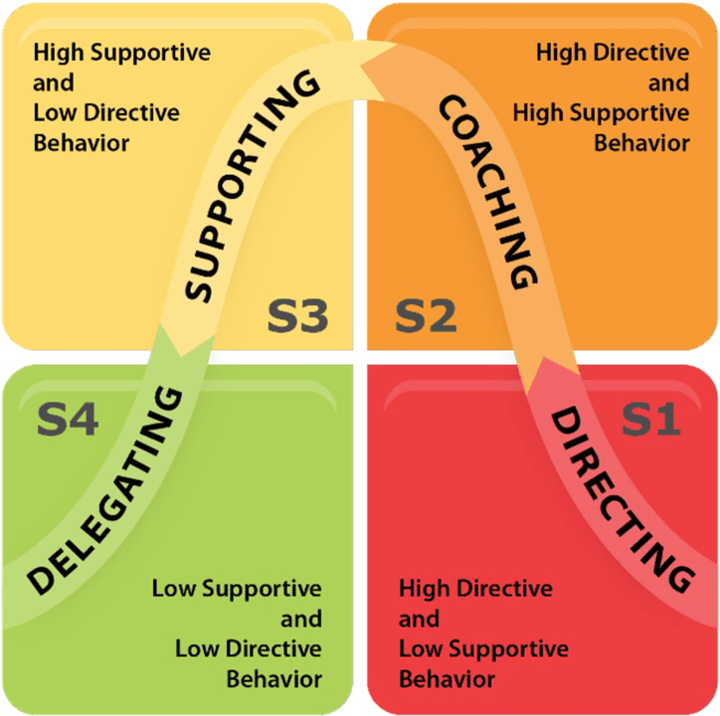
Figure 5: Situational Leadership
Source: (Steindl, 2018)
In Primark, directive leaders are less interested in what employees can perform, rather they prefer to pressurize people for doing the required work. They are not as supportive of their employees. Another style is supportive leadership style. In this style, the leaders get their work done by motivating and supporting the employees. They don’t become rude to the employees rather they prefer a well-balanced friendly environment in the company so that employees may work here from the bottom of their heart. Participative leadership style is the mixture of supportive and directive leadership style. In Primark, these leaders are very supported towards their employees thinking that employees are less educated and trained that’s why they need more concentration from the upper-level employees. In Primark, authority always gives concentration on their employees, they seek for the betterment of their employees. If the employees are less trained or unknown in the working process, they arrange training sessions to train them by supporting.
System leadership model: System leadership style is a model that refers to the leader who arises to meet up and keep balanced situation among employees, top-level management, team etc. This leadership helps to reduce conflict among people in the organization and improving the professional relationship among all. To increase the quality management in Primark, the authority needs to sort out the problems and resolve them out. If there is any conflict or misunderstanding, the system leader works there to maintain the peaceful situation over there and at the same time resolve the conflicts by attaining several steps.
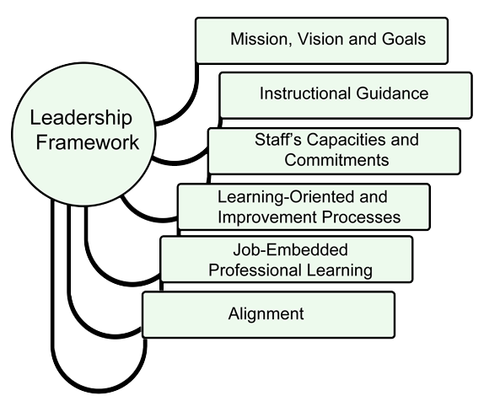
Figure 6: System leadership style
Source: (Thomas, 2018)
The system leaders work to develop the innovation process and sustain quality management in Primark for better output. In this way, the authority of Primark has chosen system leadership style to maintain quality in the process.
Operational theories
Operational theories work to smoothen the activities held in the organization. It has a direct impact on the quality process of the company. The best input in operational theories may end up having greater customer satisfaction. It increases customer service and quality of the products or services. Primark has concentrated on effective and smooth operational theories to increase their quality of the products.
Operation management:
Operational management refers to the sector of management where the design of management is done in the production of the goods or services and the whole process is controlled (Chopra, 2015). Operational management helps a company increase its efficacy in the quality process in the company. Primark has used operation management in producing its goods and services to satisfy the demands and needs of the customers. Several techniques that Primark has followed are given below:
Total quality management: Total quality management refers to the system of management where every employee in the organization gives words that they will be committed to maintain the quality of the goods and services and work on developing quality.
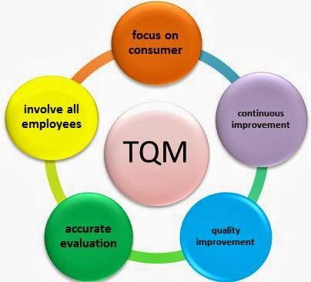
Figure 7: Total quality management
Source: (Ashikujjaman, 2018)
Total quality management works to interlink the function of production and operation for producing a better quality product (Oakland and Morris, 2013). The authority of Primark has decided to divide a shift for maintaining total quality management only to sustain their quality control in the company.

Control and Distribution System: Control and distribution system refers to the automated system where every task and method is ordered through a machine (Distribution system symposium, 2010). It eases the procedure of supplying the final goods and services to the ultimate consumers. Smooth production and swift method of delivery increase the quality of the product. It is the process of managing the development system inside the company and controlling the overall movement of goods, raw materials etc. and increases the betterment of supply chain management. In Primark, the authority here divides their role of managing everything into two different sections – control system and distribution system. Control system in Primark includes maintaining the quality of the products and working on developing the quality of the goods and products. The distribution system in Primark works for making every procedure smooth in the company. It enables the company to collect their raw materials from the sources easily, through transportation management and supply the goods and services to the final consumer of Primark. Proper management of control and distribution system leads Primark offer quality product to the customers.
Kaizen: Kaizen refers to the procedure where there is continuous improvement in all the functions of business and there is unity from the CEO to the factory workers (Imai, 2011). It is a Japanese word, which means ‘Improvement’. Kaizen works to produce more goods and services at a minimum cost. It works for reducing the production cost of goods. A developed Kaizen in a company leads the company to have better customer value as kaizen decreases the production cost and increases the demand of the product, so there is profit maximization as well. In Primark, the authority has developed Kaizen in their work. That’s why they have decreased production cost and increased the quality of products. Thus they assure the maximization of quality on the company.

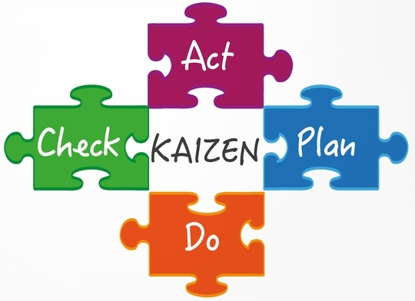
Figure 8: Kaizen
Source: (Imai, 2011)
The very first step that Primark does in following Kaizen is analysing the whole condition of the business. Then it determines the team and quality of the services. After this, they implement their decision in business and calculate the result. According to the feedback, Primark takes decisions again on what to do to reduce the flaws and increase quality. Thus, they continuously improve their quality and system procedure.
Capacity management: Capacity management system refers to the process where the capacity to produce a good quality product is managed and related activities are operated effectively (Ashikujjaman, 2018). Proper capacity management helps the company utilize its storage at its best. It reduces the chances of wasting raw material rather it increases the scope to utilize the raw material at the highest point. By using materials properly, a quality product is ensured.
In Primark, the authority makes sure that their raw materials are used properly without creating any wastage. They are supplied with smooth operation of the supply chain and through the manufacturing process, they are converted into final goods. Primark identifies the amount of the goods demanded from the customer before producing. According to this, they produce products which ensure the quality.
Six Sigma: Six Sigma is an approach where the company focuses on the per unit production by increasing the overall production and through it reducing the production cost of the company (Pyzdek and Keller, 2013). This procedure aims at increasing total production of goods and services and decreasing per production cost including the fixed cost. Greater production will lead to reducing the fixed cost spread on each produced product and service.
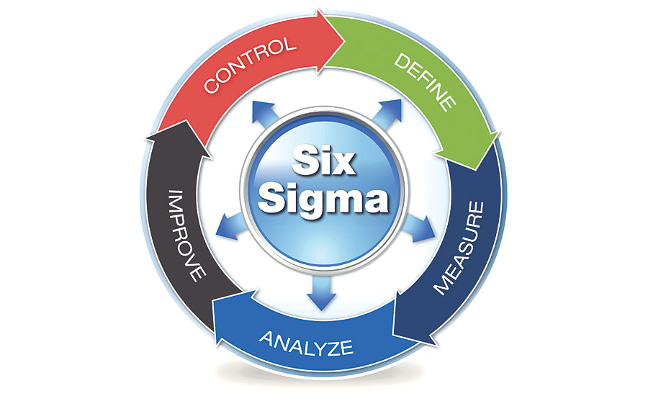
Figure 9: Six Sigma
Source: (Pyzdek and Keller, 2013)
Primark follows six sigma method to increase their overall production and reduce the optimum production cost. They identify the chosen area, analyse it for measuring the ultimate condition of their company. After analysing they select the area to improve their production followed by controlling the overall procedure. Thus, six sigma assists Primark in increasing quality products at a reduced cost.
Stock and logistics management: Stock and logistics management is the process of managing the right level of stock at the warehouse and maintaining the proper operation in the company (Liu, 2012). It is an integral part of operational management. To satisfy the demands and needs of the customer, the company needs to identify the exact number of demand. According to that, they calculate the amount need to be extracted from the warehouse or the stock reserving place. Logistics management then takes that amount of products from the warehouses and its responsibility is to make avail the product at any place. In Primark, to maintain a proper stock and logistics management, stock management identifies the needed amount of the customer demands and logistics management then collect the products from the warehouse and deliver them to the outlet. Smooth logistics management increases the quality of the product.

Conclusion
If the company wants to satisfy the needs and demands of the customers, it has to produce better quality products and efficient services in order to address the demand for particular goods. Essentially, to secure a sustainable customer base, the company must regularly improve their service quality offered to the customers and increase the value of the customer in the market (Chopra, 2015). When the offered value is increased, customers will get attracted and feel interested in buying the product from the brand. Primark has established their brand name in the market by providing good quality products and services to their customers. At the same time, they have maintained a smooth operation in their official activities that ease the way to deliver a quality product in a swift manner. This report has discussed the factors that have an impact on maximizing customer value, as well as the quality process and its effectiveness in the fashion retail company Primark.

Reference
Ashikujjaman, M. (2018). Principles of Total Quality Management in Library Management. [online] Library & Information Science Network. Available at: http://www.lisbdnet.com/principles-of-total-quality-managemen/ [Accessed 23 Dec. 2018].
Besterfield, D. (2014). Quality control. Pearson.
Chopra, S. (2015). Supply chain management.
De Beer, A. and Rossouw, D. (2015). Focus on operational management.
Distribution system symposium. (2010). Denver: American Water Works Association.
Imai, M. (2011). Kaizen. Istanbul: BRISA.
Johnson, a. (2018). 9 Top Business Analysis Models | Lucidchart Blog. [online] Lucidchart.com. Available at: https://www.lucidchart.com/blog/business-analysis-models [Accessed 23 Dec. 2018].
Jurevicius, O. (2018). Looking at your Value Chain will make you Smarter. [online] Strategic Management Insight. Available at: https://www.strategicmanagementinsight.com/tools/value-chain-analysis.html [Accessed 22 Dec. 2018].
Liu, J. (2012). Supply chain management and transport logistics. Milton Park, Abingdon, Oxon: Routledge.
Neil, R. (2017). Sanofi-Aventis SWOT Analysis.
Oakland, J. and Morris, P. (2013). Total Quality Management. Hoboken: Taylor and Francis.
Pérez, E. (2018). PESTEL Analysis (PEST Analysis) EXPLAINED with EXAMPLES | B2U. [online] B2U - Business-to-you.com. Available at: https://www.business-to-you.com/scanning-the-environment-pestel-analysis/ [Accessed 22 Dec. 2018].
Ptizer, A. (2018). swot - Google Search. [online] Google.com. Available at: https://www.google.com/search?q=swot&safe=active&source=lnms&tbm=isch&sa=X&ved=0ahUKEwjY-6-4vLXfAhWKTX0KHQuQBiMQ_AUIDigB&biw=775&bih=559#imgrc=lHLLEvCxc73dbM: [Accessed 23 Dec. 2018].
Pyzdek, T. and Keller, P. (2013). The six sigma handbook.
Soin, S. (2011). Total quality essentials. New York: McGraw-Hill Publishing Company.
Steindl, C. (2018). 9.4 Situational Leadership. [online] Catalysts. Available at: https://www.catalysts.cc/the-catalysts-way/9-4-situational-leadership/ [Accessed 23 Dec. 2018].
Thomas, R. (2018). System Leader. [online] Edugains.ca. Available at: http://www.edugains.ca/newsite/curriculum/systemleader/systemleader.html [Accessed 23 Dec. 2018].
Walters, D. and Rainbird, M. (2014). The value chain. [Bradford, England]: Emerald Group Pub.
Westland, J. (2012). Global Innovation Management. Basingstoke: Palgrave Macmillan.

