Word Count:2500
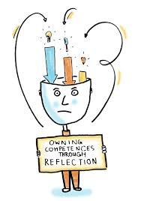
Principles of Teaching, Learning and Emergent Technologies (PTLET)
M6X02268/PCET6001
Reflective essay based on 30 MINUTES micro-teach
By Ruth Amery: 1502935
The aim of this reflective essay is to critically analyse and reflect on a personal 30-minute micro-teach, constructed, and delivered for professional assessment and peer group review. Regarding the preparation and delivery of teaching, there will be a specific focus on the use and value of emerging new technologies to holistically aid and improve learning. This will be considered in conjunction with more traditional methods of teaching by reviewing relevant literature associated to both approaches, and moreover, the educational learning strategies within adult learning.
The underpinning theoretical framework model implemented for this evaluation is the reflective cycle of (Gibbs, 1988) - Appendix 1.
Learning is an accumulative process of learning new things, expanding through personal experiences, and furthermore, reflecting and adapting our behaviour as a result (Kolb, 1984). Conforming to Gibbs’ reflective cycle, stage 1 (description), placed me at the front of the classroom to deliver a personalised 30-minute micro teach (28th September 2017: 9am) as part of my PCET assessment program to fellow peers. Prior to this I had produced a lesson plan mapping out my objectives, lesson detail and intended learning outcomes. This included the intention of meeting relevant Higher Education Academy (HEA) standards and planned evaluation strategies. This can be identified with the ‘ASSURE’ planning model (Crawley, 2005): Managing the internal and external environments to effectively facilitate student-centred learning, by considering the following:
Analysis of students - entry level, age, gender, ethnic group; previous knowledge – foreseen as being limited in regard to my micro-teach audience; specific circumstances or needs; and preferences and styles of learning (hands-on/visual for example). All of which could be associated with anticipated difficulties. In my case this was the challenge of maintaining student focus and timing limitations.
Stating learning objectives (specific, measurable, actionable, relevant and time-bound – SMART objectives).
Selecting learning resources and teaching approaches (appropriate to topic and students’ needs – presentation, accessibility and clarity).
Utilising resources and methods…

Requiring student involvement (helping them learn rather than attempting to ‘teach’ them.

Evaluating and revising – reflecting to improve (Crawley, 2005).
Building from my Business Management background I opted to present the topic of market segmentation. This was based on my perception that it would be generally relatable to the class as consumers, who come into contact with marketing processes on a daily basis, even subconsciously. This led to the formulation of my learning objectives (L/O), the aim being that by the end of the session the class would be able to: Identify what a market segment is (L/O1); identify key/main categories used to segment the market (L/O2); practically apply this knowledge in a group activity (L/O3); and identify one advantage and disadvantage of market segmentation (L/O4). These objectives also allowed me to acknowledge the HEA professional standards and areas of activity (A1, A2, A3 and A4) – as seen in the Higher Education Academy (2011) Framework: Appendix 2.
I delivered my presentation using an online delivery platform (SWAY) providing definition on the topic, drawing from my own previous learning experiences, and involving my class of peers through some pre-prepared class/group activities. The cognitive domain of Bloom’s taxonomy provides a hierarchical structure to learning, with each level requiring a firm foundation being proceeded from the level below – Appendix 3 (The University of Utah, 2018). Traditionally methods of teaching were more teacher-centred (for example ‘chalk and talk’), using repetition and memorisation techniques, leaving decision making, problem solving, and critical thinking underdeveloped (Cambridge Centre for Sixth Form Studies, 2018). It was an intentional of mine to implement a more student-centred approach to learning through formative assessment. Formative assessments can be used to explore and measure learners’ comprehension, enabling the teacher to distinguish a way of developing this understanding; it is specified based on the action the teacher takes generated from the information gained (Council for the Curriculum, Examinations & Assessment (CCEA), 2018). Such assessments can increase student motivation and accomplishment; by meeting the information requirements of students’ through engagement in their own learning, complemented by frequent and regular feedback (Chappius, 2009). I added an online video (OpenViewVenture, 2010), to highlight the way this topic can be applied practically in an evolving business environment, to further build awareness.

I then used an online quiz (Kahoot) to measure the level of knowledge gained. There is evidence to suggest that game-based student response systems (GSRS) can improve interaction, motivation, attention and classroom dynamics (Méndez and Slisko, 2013). However, challenges may arise from having the time necessary to use and apply such technologies, develop appropriate content, and provide beneficial and opportune feedback. This could have a negative impact if not managed accordingly in regard to the allocation of time and content (Licorish et al., 2018).

My intention for using the Kahoot was to allow a summative assessment. According to The National Foundation for Educational Research in England and Wales - NFER (2018), this “sums up what a pupil has achieved at the end of a period of time, relative to the learning aims”.

As a result, the class seemed to enjoy and learn from the lesson overall, confirmed by predominantly positive feedback. The only negatives – fed back by the tutor - were that I could have been more decisive when organising the groups, and more confident in my own abilities. It is recognised that there is a variation of routes concerning learning; such as the pace, strategies, and modes of learning. Information and communication technologies (ICTs) can be influential in lending themselves to this, in regard to forming and sustaining diverse learning methods - but is very much dependent on teachers’ ability to use it proficiently for pedagogical tenacities, as opposed to that of just supporting the status quo (European Schoolnet, 2006; The Manila Times, 2008). The subject material, delivery methods and technology used met the HEA core knowledge standards K1, K2, K4, K5 and professional values V1 and V2.

During stage 2 (feelings), I could identify with being outwardly confident, but internally nervous. I felt prepared and organised, which relieved some of my anxiety, and was confident in the design and content of my presentation. I felt that using SWAY was a good use of emergent technology that would assist in maintaining interest. Microsoft SWAY Office promotes the fact that you can add videos, photos, and other multimedia content that is incorporated to your device and the world wide web; using a design engine that dynamically adjusts to help captivate the relevant audience (Microsoft, 2018).
However, innovation can be both stressful and challenging, as it may upset founded routines that many individuals identify and align their performance with (Somekh, 2007).

Upon starting my presentation, I was deliberating the various possible things that could go wrong. My concerns included technological difficulties, and my nervousness being obviously displayed through my body language, or my voice and projection. Even though I have attained the knowledge in this area, I am aware that I suffer with a lack of self-confidence at times, especially when questioned.

My peers and assessor (Christian Felices) helped make me feel slightly more relaxed by joining in with the activity, adding volume to the number of groups involved. My peers got on with the task in hand and were working collaboratively, which positively encouraged me as the activity and presentation went on.

Regarding the desired learning outcomes, I did have initial concerns that these might not be met. I was worried my nervousness might interfere with my thought and knowledge processes, or that the quiz would possibly be perceived as too simple for the intended audience. I was confident, however, that I had adequately considered and prepared everything necessary for the event, including a contingency back-up option to be implemented if required. This ensured that I did feel relatively confident regarding the content of my material.

Upon completing the event, I felt elated that everything had gone to plan as far as possible, and that the concerns I had were unfounded. The fact that my peers believed I came across as confident has made me realise that what I perceive about myself and my presentation skills is not the full picture. It has made me aware of time management within my events, and to allow a little extra to cover any unforeseen eventualities which would impact on this.

Stage 3 (evaluation): The session filled the whole half an hour. During the event, there was some minor confusion regarding the picture handouts and their link to specific brands, which I had not considered fully, and required some clarification. This did help bolster my confidence levels through using my knowledge to give an immediate response.

I was a little disappointed that some of the class did not get all the answers correct for the interactive quiz used at the end. This was intended to measure their level of learning, and I felt the quiz was easy enough that their results could have been better. On reflection, this could have been due to their initial misinterpretations confusing them, combined with the time limit imposed on the quiz, hastening them for a response. However, it could also reveal my increased expectations of learners based on my own knowledge of a topic; or equally, an omission of a clearer explanation.

I did have a power point alternative prepared as a back-up, which would have forced me to clarify a wrongly answered question. This would, however, have limited the involvement of the whole group, eliminating the competition element of the quiz, which I intentionally wanted to include to add fun to the lesson. The use of this technology however did enable me to view the content of the whole quiz and student answers. On reviewing the result data presented, I was able to confirm that the last two questions containing pictures for the purpose of getting the class to identify the specific segment the pictures were aimed at had definitely impacted on their final results, and perhaps could have been made clearer.

I recognise the negative impact on the learning potential derived from my own distractions; this being my inability to provide suitable feedback at the necessary time during the quiz, due to the time restraints of the whole presentation. However, as the majority of the class got a large proportion of the quiz questions correct, along with the positive feedback, I felt suitably gratified.

Stage 4 (analysis): The lesson plan was well prepared which helped me manipulate my time wisely (it also helped that I had my phone on a stop-watch setting so I could judge where I was time wise at a glance). I considered cultural needs and used my limited language knowledge to greet the class in Welsh at the start of my lesson (V1).

The peers were very engaging and compliant. Whilst gaining feedback from the individual group tables as to how they were progressing with the learning of my topic, I initially had thought to dismiss the feedback from the assessor, in order to comply with time restraints.
After more thought, I reconsidered this, recognising that his knowledge and experience would add depth to the learning outcomes, which I believed to be of benefit for the whole class, and was of more importance as a whole.

I could have clarified some of the picture handouts before the lesson to avoid that slight confusion that arose, due to not considering all elements of the task and handout pictures. The quiz was a bit rushed at the end due to time constraints, which I could have managed better had I reduced the activity time allowance slightly, and by providing more clarity from the outset. Time restraints also prevented me giving a summative conclusion regarding the objectives of the lesson. I should also have been more decisive when allocating the groups for the activity, and not over deliberated so much.

A couple of people were late arriving after the task had started, but I was able to de-brief them on it quickly and efficiently due to the supply of prepared and printed additional handouts for the groups to refer back to. My peers picked up on an element of confusion as to whether they were looking at the product just as a product or as a specific brand, which I cleared up with them quite early on in the task. This was due to my oversight of their, as yet, limited knowledge of the topic I was presenting. I had not considered the students perspective and was being presumptuous.

Stage 5: (conclusion - synthesis) A lot of the minor issues that arose throughout the presentation could have been avoided with a greater consideration from a student perspective on my part, which would have prompted more time to clarify issues at the start. The experience has taught me that I am more than able to react to unforeseen scenarios in a professional way, and do not need to worry so much about my portrayal of confidence, but rather should have a little more self-belief.

Stage 6 (action plan): If I was to encounter the same event again, I would take more care not to make assumptions regarding learners’ knowledge. I would hope to be more aware of the potential confusion between items and brands, for example Dyson being a vacuum cleaner and not a ‘hoover’, which in itself is a brand. Through improved self-belief, I would be more decisive in my delegations. I would also definitely ensure to include feedback when needed, and a summary of lesson objectives to conclude and ensure learning needs have been fully met.

I have enjoyed the whole experience of preparing, delivering and reflecting upon the process of a micro-teach event. I can identify requirements for future events or adaptations required. I have used reflective practice to identify my strengths and weaknesses, and how I can positively use this knowledge to be of benefit in future. Reviewing and evolving; I have identified how much I would change – going forward, I would consider more effective questioning, a better presence and voice projection, being more assertive in my awareness of my environment in-turn providing more encouragement and praise to the learners. I would be mindful not to over assume learner knowledge when considering activities to reduce the need for additional clarification. I would use emerging technology again to enhance the learning experience. However, should I wish to expand in my range of these, I would certainly do my research to make sure it was implemented appropriately to maximise benefits and reduce disruption.

Appendix 1
Gibbs (1988) reflective cycle:



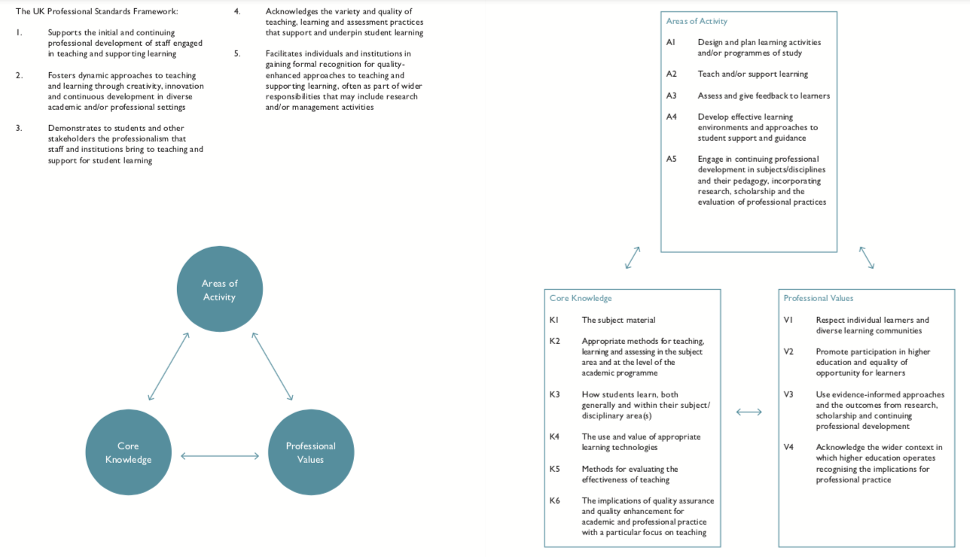
Appendix 2
Higher Education Academy (2011) Framework:

Appendix 3
The University of Utah (2018) – The cognitive domain of Bloom’s taxonomy.
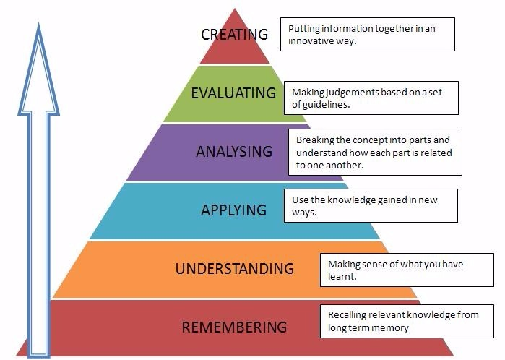

References

Cambridge Centre for Sixth Form Studies., (2018). Traditional vs modern teaching. [Online]
Available at: https://www.ccss.co.uk/news/traditional-vs-modern-teaching/
[Accessed 12 October. 2018].

Chappius, J., (2009). Seven Strategies of Assessment for Learning. Boston: Pearson Education Inc..

Council for the Curriculum, Examinations & Assessment (CCEA)., (2018). What is Formative Assessment?. [Online]
Available at: http://ccea.org.uk/curriculum/assess_progress/types_assessment/formative
[Accessed 08 October 2018].

Crawley, J., (2005). In at the Deep End - A survival Guide for Teachers in Post Compulsary Education. London: David Fulton Publishers Ltd.

Diab, S. and Sartawi, B., (2017). Classification of Questions and Learning Outcome Statements (LOS) into Bloom's Taxonomy (BT) by Similarity Measurements Towards Extracting of Learning Outcome from Learning Material. International Journal of Managing Information Technology, 9(2), pp.01-12.

European Schoolnet, (2006). The ICT Impact Report: A review of studies of ICT impact on schools in Europe: European Communities.

Gagne, R., (1985). The Conditions of Learning. Fourth ed. New York: Holt, Rinehart & Winston.

Gibbs, G., (1988). Learning by Doing: A guide to teaching and learning methods. Further Education Unit ed. Oxford: Further Education Unit. Oxford Polytechnic.

Higher Education Academy, (2011). The UK Proffessional Standards Framework: Guild HE and Universities UK.

Kolb, D., (1984). Experimental Learning: Experience as the Source of Learning and Development. Englewood Cliffs(New Jersey): Prentice-Hall.

Licorish, S., Owen, H., Daniel, B. and George, J., (2018). Students’ perception of Kahoot!’s influence on teaching and learning. Research and Practice in Technology Enhanced Learning, 13(1).

Microsoft, (2018). SWAY. [Online]
Available at: https://sway.office.com
[Accessed 05 October 2018].

OpenViewVenture, (2010). What is Market Segmentation?. [Video]
Available at: https://www.youtube.com/watch?v=pxcNVrwkroU
[Accessed 08 October 2018].

Somekh, B., (2007). Pedagogy and Learning with ITC-Researching the art of innovation. Oxon: Routledge.

The Manila Times, (2008). Reaction paper from an educator: CyberEd: Is it the best option for educational reform?. Manila: Content Partnership Pty Ltd.

The National Foundation for Educational Research in England and Wales, (2018). An introduction to formative and summative assessment. [Online]
Available at: https://www.nfer.ac.uk/for-schools/free-resources-advice/assessment-hub/introduction-to-assessment/an-introduction-to-formative-and-summative-assessment/
[Accessed 08 October 2018].

The University of Utah., (2018). Bloom's Taxonomy for Learning Outcomes Learning Outcomes Assessment - Undergraduate Studies - The University of Utah. [online]
Available at: https://ugs.utah.edu/learning-outcomes-assessment/blooms-taxonomy.php [Accessed 12 October. 2018].

