Sandra’s Pest Assignment task 2- 2018



APRIL 2018

MODULE NAME: Global Business Enviroment Task 2
Project Name: Pest of Swansea stadium managemnt company
Name: Grazia Martone
Student Number: 1703121

Introduction
This assignment I aim to show how the factors of PEST apply for Swansea Management Company.
I will include the current external challenges and opportunities faced by SSMC and looking at the question how the PEST environmental forces impact on the Swansea Stadium Management Company (SSMC) at an operational level. I hope to find out how much certain factors can affect an organisation. As a class we visited the Swansea Liberty Stadium, this gave us a wider understanding of how things get done on the ground. The SSMC was set up in April 2005, the company looks after all the ground work and oversea the running of the company. The Liberty Stadium in owned by the Swansea Government but SSMC run the building. The SSMC work with 2 sporting clubs the FMC and the Premier Club to ensure the stadium is running smoothly.
The SSMC has 2 different directors from City and County of Swansea, and two directors from Swansea City Football Club and Ospreys Rugby. The board members will regularly meet to review and discuss and then actively manage all the progress made.
The SSMC has many roles to ensure are done a few are the safety, maintenance, cleaning, operation and commercial activity of the Liberty Stadium.
A PEST analysis can be used as a strategic tool to give a wider and more depth understanding of a market growth and decline, the potential and the direction of operations also the organisations position. It will understand the political, economic, social and technological factors of an organisations environment. PEST analysis can be used to scan the environment of a business and adjust their plans to minimize threats and capitalize on opportunities.
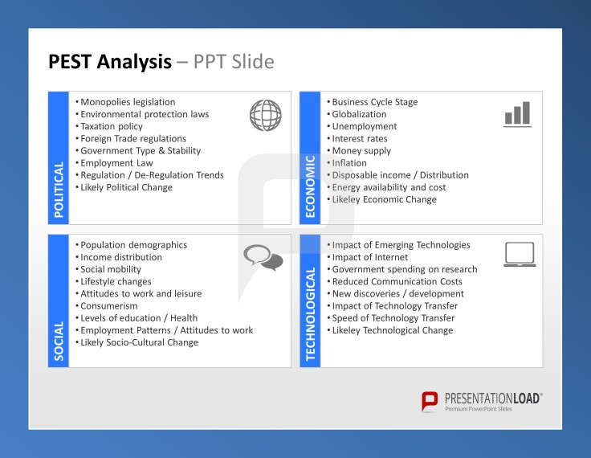 Pinterest. (2018). BUSINESS ANALYSIS // POWERPOINT TEMPLATES. [online]

The PEST analysis will apply to SSMC as it is a large organisation and need to take these into consideration. The Political factor will affect the running of SSMC as there are many reasons, a big issue is Terrorism as it is affecting the whole world now, as SSMC put on many events with famous singers coming to Swansea this is huge opportunity for many people to come from all over the country, this can be a threat as terrorists can see this as an opportunity to strike. And this can affect many individuals with trauma making people avoid these bug events or games being played at the stadium this can affect the income and profit being made massively as it will put people of if recent terrorism has happened in similar events. To avoid this high security checks are put into place and reassurance from the public services can put individuals mind at ease. The past 10 years terrorist attacks have caused significantly decline in foreign exchange receipts and it is affecting the increase in government costs and to gain political advantages over the UK government officials (Neumayer, 2004). Terrorist attacks can affect potential income as many individuals would rather stay at home for their safety. As SSMC is a big income for the city as it holds 20,970 individuals this is a major factor to affect the economy. According to (Elvis Picardo, 2018) the UK receipts dropped by 12.9% from the September 11, 2001 attack. The Tourism Industry Emergency Response group said that the spending by overseas individuals in UK is likely to decline by 300 million because of July 7th, 2005 bombing in London.
Brexit is also a massive effect on organisations Since the UK referendum on the 23rd of June 2016 to Leave the European Union referred to as ‘Brexit’ standard measures point towards a substantial uncertainty. (Bloom, 2009) describes uncertainty as the incapability of economic agents for example politicians, investors or any consumers to develop clear expectations about to forthcoming economic developments. When the UK decided to leave the EU, uncertainty concerning for the future arrangement of any trade relationships after Brexit has been put into place. For the SSMC this can be affected as stock such as food, drink and any raw materials etc there is a high possibility that they are from the European Union this can cause delay in stock needed and prices to rise significantly. With the UK leaving the EU there is a chance Visa’s are going to be put into place and this can cause problems from overseas investment and customers because of the sudden exchange rate fluctuations a financial market instability. (Voxeu.org, 2018).
Economic is another factor of PEST it should always be considered as the economics always change. As SSMC need to always keep an eye on inflation as prices go up and down it will affect SSMC as the cost of any services or products would increase to customers also for example ticket prices will increase and food and drink, this is because the supply is lower than demand. This will potentially stop customers purchasing any of these because of the sudden price change. If inflation has risen about 2% this can mean inflationary spiral which is prices are put higher by the rising consumer demand. With an organisation their aim is to make a profit and tight labour markets can then lead to wage increasing, a higher cost of living, consumer prices and prices for raw materials and this can represent a higher demand for products and services and this also increases the prices and further increasing organisation profits. (The Telegraph, 2018).
In Swansea Unemployment rate keeps on rising as there are not as much jobs in the area compared to larger cities, the population keeps on rising and there are many more stay at home parents. This is resulting in families not having any disposable income for days out to events at the SSMC. Families are a huge target market for the SSMC as all year round there are different things going on for all ages but with the prices of tickets being too expensive for a whole family they simply cannot afford this because of no disposable income. Below is an image if the unemployment rates in the UK is 27.3% (Anon, 2018) and this shows there is a big population not in work.
Minimum wage is always changes and as it has been increasing over the years this is another economic factor affecting the SSMC. Wage is compensation in the form of financial payments made to employees for the exchange of their time and labour and it is payed in return for an employee’s services. At Swansea Liberty Stadium it can affect it as they may not be making enough money to pay that extra as all the factors could be effecting their income from the start and then having to pay that little extra to all the staff as there are many employees it is making a significant difference to the SSMC to pay out. however, a high increase may cause unemployment Also, it can benefit the SSMC as this means other employees from else where have that little bit extra income and this could result in more tickets being bought and food and drink but the disadvantage could mean children wanting to purchase more food and drink in children at more of a risk of obesity and adults resulting in drinking too much alcohol and becoming a danger to others if prices decrease or if there is more money to be spent.
Social factors are that SSMC was taken over by an American company, this is very good for potential income from others from America and it could bring more fans in as the USA have many connections around the world. With this the SSMC need to take into consideration that other cultures need to be considered and adapted. In other countries a lot off different cultures need to be taken on board for example other religions when it comes to searching people some cultures may feel uncomfortable with being touched to be searched there are many others like the way in people eat like some people eat meat and others may not. Another social factor can be that in football, rugby games fans need to be separated as there is a lot of conflict between teams if one loses and sometimes selling alcohol can stop a lot of trouble accruing. Football fans can get very angry and result in things getting damaged in the stadium this will cost the stadium a lot of money to repair and to hire extra security therefore stopping selling alcohol can prevent this. (Research into Football Hooliganism, 2018)
Technological is the last factor and we can look at how online betting is a huge investment for the SSMC as people can bet whilst they are watching a game to enable this to happen on time improving WIFI or installing this is a huge advantage but can be a disadvantage as if the Wi-Fi breaks customers will not be happy to use the facility again. Another good point is that you can purchase tickets online rather than having to travel down to the stadium to do so this is good for customers who cannot access transport down there or have other commitments. The lightening connectivity to the pitch and the scanners to scan the tickets to enable a better view and a faster que time which is very good, but the disadvantages can be that if there are any technological issues it can cause a whole event to be cancelled as you cannot access people to enter the stadium causing conflict. A lot of advertising is now done online so if the internet is down a whole department may not be able to out up ads or any important information making the stadium at a loss. (prezi.com, 2018)
Conclusion
To conclude this, I found that there are many factors that can depend on the income of the SSMC and there are many things to be considered to keep custom income and to keep customers happy by considering cultural differences and in general their needs and wants. Keeping up with social trends can benefit an economy.
Executive summary
The purpose of the report was to find out the external factors of the SSMC, and how they are an advantage and a disadvantage for the company. We found out a brief background about the organisation and more in depth broken down.
The findings of the report are that a small inconvenience we may think is can affect an organisation massively even if it’s a small problem. I found out that minimum wage is also a factor that can help contribute to the income. The conclusions of this report are that a lot of these factors are important to any type of business small or large and there are many other factors to the ones I mentioned. The recommendations of this would be to make sure all technological issues are dealt with and monitored regular, another recommendation would be to make sure there are high security enforcements in place for others safety and more facilities for all customers example loyalty rewards as ticket prices can be expensive.

References
Bloom, N. (2009). 'The Impact of Uncertainty Shocks'. Econometrica 77(3), 625–683.
Anon, (2018). [online] Available at: https://www.walesonline.co.uk/business/business-news/wales-one-highest-youth-unemployment-11814536 [Accessed 20 Mar. 2018].
Elvis Picardo, C. (2018). Don't Hide From The Reality Of How Terrorism Affects The Economy. [online] Investopedia. Available at: https://www.investopedia.com/articles/investing/030215/how-terrorism-affects-markets-and-economy.asp [Accessed 21 Mar. 2018].
Liberty-stadium.com. (2018). Swansea Stadium Management Company SSMC at the Liberty Stadium in Swansea. [online] Available at: http://www.liberty-stadium.com/liberty_stadium_management.php [Accessed 17 Mar. 2018].
Mullins, L. (n.d.). Management and organisational behaviour.
Neumayer, E. (2004). The Impact of Political Violence on Tourism. Journal of Conflict Resolution, 48(2), pp.259-281.
Pinterest. (2018). BUSINESS ANALYSIS // POWERPOINT TEMPLATES. [online] Available at: https://www.pinterest.co.uk/pin/404549979001772982/?lp=true [Accessed 20 Feb. 2018].
prezi.com. (2018). How technology has influenced football. [online] Available at: https://prezi.com/cwkh9wmyhuks/how-technology-has-influenced-football/ [Accessed 19 Mar. 2018].
Reference. (2018). How Does Inflation Affect Businesses?. [online] Available at: https://www.reference.com/world-view/inflation-affect-businesses-9ac401a91caf9960 [Accessed 22 Mar. 2018].
Research Into Football Hooliganism. (2018). Football Stadium Disasters. [online] Available at: https://www.footballhooligans.org.uk/football-stadium-disasters/ [Accessed 23 Mar. 2018].
Sloman, J. (2016). Economics for Business. Pearson Education Limited.
The Telegraph. (2018). How does inflation affect a business?. [online] Available at: https://www.telegraph.co.uk/business/sme-home/low-inflation-business/ [Accessed 24 Mar. 2018].
Voxeu.org. (2018). Short-term impact of Brexit on UK exports | VOX, CEPR’s Policy Portal. [online] Available at: https://voxeu.org/article/short-term-impact-brexit-uk-exports [Accessed 20 Mar. 2018].
YouTube. (2018). Godfrey Bloom: What Brexit Means. [online] Available at: https://www.youtube.com/watch?v=72PjJgV76Ko [Accessed 22 Mar. 2018].

