https://unitelive.org/irresponsible-our-yorkshire-farm-safety/

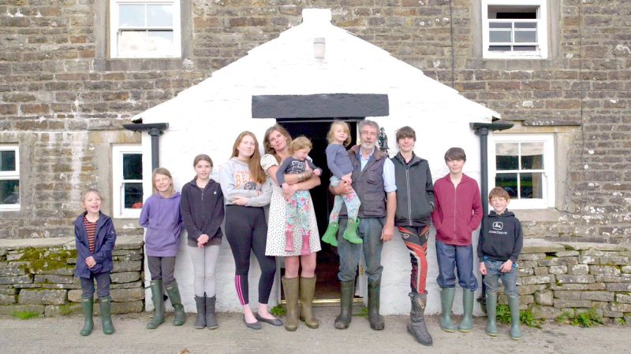

‘Irresponsible’ show
Unite raises safety concerns over Our Yorkshire Farm TV series
Hajera Blagg, Friday, December 14th, 2018
In an age when children’s lives are often dominated by smartphones, streaming TV and video games, there’s something doubtlessly alluring about the premise of the new hit show Our Yorkshire Farm, a docuseries on raising so-called ‘free-range’ kids.

The show tells the story of husband and wife Amanda and Clive Owen, hill shepherds in a remote farm in Yorkshire, and their nine children, aged 17 to 2, who work together to keep the farm ticking over.

This week’s most recent episode, aired on Tuesday (December 11), featured the family’s struggles over Britain’s hottest summer as they race to make the farm’s hay crop, while previous episodes look at the challenges of winter and spring.

It’s a heart-warming story to be sure, but beneath the glossy depiction of idyllic rural life are serious health and safety concerns Unite has raised.

‘Really disappointing’
Unite member and assistant farmer Matthew Belsey, who also serves on the Health and Safety Executive’s (HSE) Agriculture Industry Advisory Committee, said he was disheartened by the blatant risks and potential violation of health and safety laws on display on the show.

Among these Matthew highlights are children driving quad bikes without helmets, with multiple passengers on bikes designed for one person, which is illegal. Children, including toddlers, are shown riding on trailers without guardrails and riding in tractors when it is illegal to have a child under the age of 13 ride in or operate farm machinery. The children have also been shown climbing and playing on hay bales, each of which can weigh half a tonne.

“It’s really disappointing as a union to be working so hard to raise awareness about health and safety in the most dangerous industry in the economy – and then to see such risks and violations popularised on a TV show,” Matthew told UNITElive.

Indeed, agriculture tops the list of workplace fatalities each and every year – the fatal injury rate in agriculture is 18 times higher than the five-year average for all industries combined. Last year alone, 33 people were killed in farm-related accidents, including two children, the youngest of whom was 4.

Child deaths
“It’s a national scandal that each and every year so many people living, working or visiting farms have fatal accidents,” Matthew said. “And each and every year there is typically at least one child death but often more.”

While many may think that children living on farms understand the risks, the HSE has pointed out that the majority of children who die in farm incidents are in fact family members.

Fatal incidents recorded by the HSE over the years, for example, includes one in which an 8-year-old girl was playing in a farm bale stack. When she tried to climb down she fell 3.5 meters into a hay tedder below and died from severe head injuries. In another incident, a 12-year-old boy who was driving a quad bike on a farm swerved to avoid a ditch, toppled over and drowned in the ditch.

The number of non-fatal injuries among children on farms is high too – and these injuries can be serious and life-changing, such as having legs or arms amputated.

“It’s difficult to get across exactly how dangerous a farm environment can be,” Matthew noted as he criticised some fans of the show who’ve taken to Twitter to glorify the apparent disregard for health and safety on the programme:

