Jessica Lewis
Economics of Sustainability
BMSP6007
Anthony Burns
Assignment 2 – Report

Contents
- Introduction.......................................................................................................................3
1.1 Purpose of the report.............................................................................................3
1.2 What is the WEF?...................................................................................................3
2.0 Main Findings..............................................................................................................4 - 11
2.1 What is the risk outlook for the next 10 years?.....................................................4
2.2 The seventeen Sustainable Development Goals...............................................4 - 5
2.3 Impacts on global efforts on sustainable development....................................5 - 9
2.4 Theories..........................................................................................................9 - 11
3.0 Suggestions......................................................................................................................12
4.0 Conclusion........................................................................................................................13
5.0 References................................................................................................................14 - 16

1.0 Introduction
1.1 Purpose of the report
This report will explore the risk outlook for the next ten years from the World Economic Forum's (WEF) World Risk Report for 2023 and the seventeen Sustainable Development Objectives established by the United Nations (2015). It will assess the implications of this on the global consequences of sustainable development and make recommendations to put the world economy back on track to attaining the goals within the intended time frame.
1.2 What is the WEF?
The World Economic Forum (WEF) is a non-profit organisation founded by Klaus Schwab in 1971 (WEF, 2023). It has a positive impact on business and public sector decision-making by exposing new topics, organisations, and trends to members and the public. It also conducts research, promotes public-private sector cooperation, and facilitates member communication. The WEF cannot make authoritative decisions but has a significant influence over governmental and corporate policy, convening decision-makers from around the world to discuss important issues and determine the best course of action (Kagan, 2022). Every year, the WEF publishes the World Risk Report, which examines significant risks and emerging problems, enabling governments to plan ahead and develop innovative improvements and preventative measures.

2.0 Main Findings
2.1 What is the risk outlook for the next 10 years?
The World Economic Forum’s World Risk Report for the year 2023 has anticipated multiple concerning risks over the next ten years globally. These risks are either created by or brought about by us and result from a lack of cooperation and equality among nations. Climate changing and growing poverty are likely to occur due to people utilizing their power rather than band together to avert these catastrophes. The Covid-19 pandemic has caused economic and health crises, with carbon emissions increasing, the war in Ukraine turning food and energy into weapons, inflation rising, and social unrest. Risks to natural ecosystems, human health, security, digital rights, and economic stability are being neglected or receiving insufficient focus and funding.
The report investigates links between these hazards, focusing on a prospective "polycrisis" with a lack of natural resources such as food, water, metals, and minerals. It uses hypothetical futures to illustrate the socioeconomic and environmental effects that would follow (Zahidi, 2023). Natural ecosystems, human health, human security, digital rights and economic stability are amongst the risks mentioned in the report. Below, figure 1, is a list of the risks ranked by severity over the next decade:
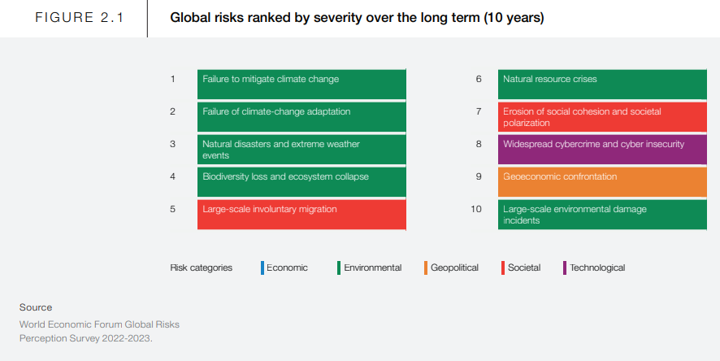
Figure 1: List of risks ranked by severity over the next decade (World Economic Forum, 2023).
2.2 The seventeen Sustainable Development Goals
The 17 Sustainable Development Goals (SDGs) of the United Nations are an immediate request for action by all nations in a global collaboration. They aim to reduce health, educational, and economic inequalities, combat climate change, and protect the oceans. The objectives focus on reducing health, educational, and economic inequalities, as well as combating climate change and protecting the oceans (Sinay, 2021). The 17 sustainable development goals can be seen below (Figure 2).
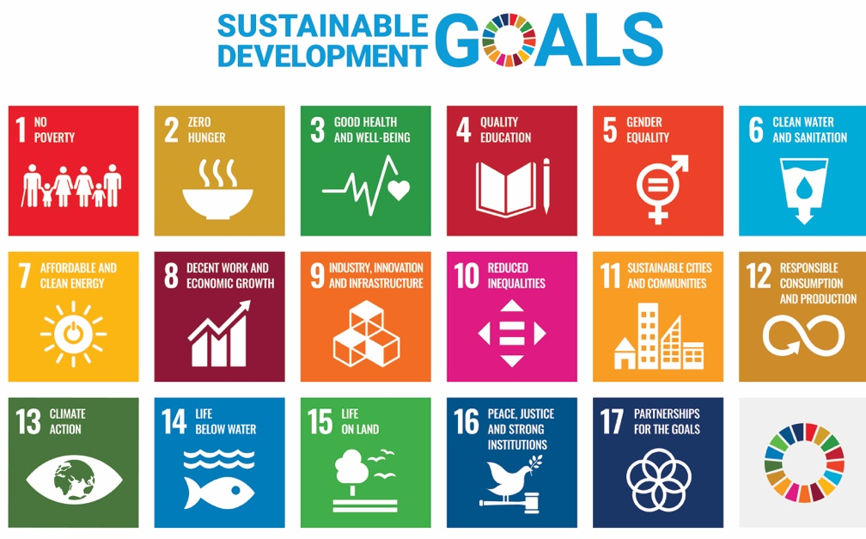
Figure 2: The Seventeen Sustainable Development Goals (United Nations, 2022).
2.3 Impacts on global efforts on sustainable development
The deadline for the United Nations 17 sustainable development goals to be met is 2030, when compared to the World Economic Forums annual risk report for 2023 and its outlook for the next 10 years shows that it is highly unlikely that these goals will be reached within the designated time frame. The two main risks chosen to be explored in this report are human health and economic stability.
Human health is one of the highest risks in the annual risk report for 2023 because of the Covid-19 pandemic combined with budget cuts, which runs the risk of focusing attention and resources elsewhere resulting in healthcare systems dealing with employee exhaustion and staff shortages. Over the next ten years, it is possible that more widespread and regular outbreaks of infectious diseases may overwhelm the world's already overburdened healthcare systems (WEF, 2023). The United Kingdom entered the pandemic with a health and care system that was already overburdened due to long-term underinvestment in staff and facilities, leading to a worn-out workforce, a huge and expanding backlog of care, and growing health inequities (Raleigh, 2021). COVID-19 poses a serious threat to the millions of people living in slums around the world due to lack of housing, limited food, running water, shared restrooms, waste management systems, crowded public transportation, and limited access to health care facilities. According to the United Nations Department of Economic and Social Affairs (2021), between 119 million and 124 million people were added to the poverty list in 2020, along with this the amount of people experiencing hunger rose by 83 million – 132 million. The consequences of the epidemic are being felt most severely by women and children, with disruptions in the delivery of healthcare and immunisation services as well as restricted access to diet and nutrition services leading to tens of thousands more maternal fatalities and hundreds of thousands more deaths among children under five. Additionally, the pandemic took resources away from other illnesses such as tuberculosis and cancer screening.
Climate change and nature loss are likely to increase the potential health stresses brought on by COVID-19, such as air pollution, increased exposure to wet heatwave days, disrupted access to safe water and sanitation, and increases in waterborne diseases. These health issues are already-existing difficulties and inequalities that climate change has made worse (Apo, 2022. These stresses affect the ‘climate action’ sustainable goal as well as the ‘good health and well-being' goal. In addition, as food insecurity rises, climate change is predicted to make malnutrition worse. An accelerated intake of heavy minerals, which have been connected to cancer, diabetes, heart disease, and stunted growth, can be brought on by higher atmospheric carbon dioxide levels. More years are being spent in poor health, and we may soon witness a more consistent decline in life expectancy beyond the pandemic's effects (WEF, 2023). Air pollution caused an additional 9 million deaths in 2019, accounting for one in six fatalities globally. Individuals do not die from pollution itself, but rather from diseases initially caused by the pollution (Murugesu, 2022).
The World Health Organisation projects a 10 million-staff shortage in the health sector by 2030 (WHO, 2022) due to inflation, economies expanding slowly, and governments reconsidering their spending to address social and security concerns. This is due to budget cuts, income loss, and increased costs of commodities and labour (WEF, 2023). These staff shortages and budgets cuts etc all affect the UNs sustainability goal; Good health and well-being as due to these issues patients are unable to get the required level of care when they need it.
Economic stability is also considered a high risk. The WEF (2023) report states that governments have taken advantage of low-cost financing to invest in future growth, assist in stabilising troubled financial institutions, and provide budgetary support during Covid-19. However, high debt levels may not be manageable in a more challenging economic environment. Throughout 2022/2023, the government has offered many help packages in response to the problem, such as £59.8 billion in household income support and an extension of the Energy Price Guarantee (EPG). However, household earnings are not keeping up with living expenses, and it won't be until 2027 that they are predicted to return to 2021 levels. The cost-of-living crisis is causing a growing number of children to fall into poverty.
In the UK, more than one in four children live in poverty, and millions more face the possibility of being hungry. Over the previous 12 months, more than half of parents have been compelled to reduce the amount of money they spend on food for their family. Over a quarter of parents reported that their child's mental health had gotten worse as a result of the circumstances, and one in five stated they had difficulty providing enough food due to the present cost-of-living problem. This crisis has not only affected people's livelihoods, but the health (physical, emotional and mental) and well-being of individuals, including young people and children. A decline in wellbeing, including elevated anxiety and deteriorating mental health, has been linked to the rising expense of living. This affects the UN's sustainable development goal of 'good health and well-being'.
The affordability dilemma is making it more difficult for small firms to hire and keep employees, as many people are struggling to make ends meet due to incomes not keeping up with the increase in living expenses. This is affecting the UN's sustainable development goal of 'decent work and economic growth'. Additionally, the cost-of-living crisis is affecting quality education, as top leaders are now reporting cuts to teaching assistants and spending reductions on IT equipment at a much higher rate than they were before 2022. This is affecting the UN's sustainable development goal of 'quality education’ (Montacute, 2023). Figure 3 below shows the areas in schools that have been cut for financial reasons and as you can see percentages have massively increased since 2022.

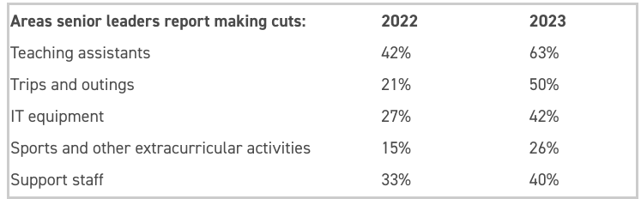
Figure 3: Areas cut for financial reasons in schools (Montacute, 2023).
Below is a map showing the goal for good health and well-being and the progress that has been made worldwide up to 2017. As can be seen on the map most of the world has reached the reached the 2030 target for this goal however there are still a few countries that only halfway therefore and couple, Sierra Leone, Chad and South Sudan, that are nowhere near the target.
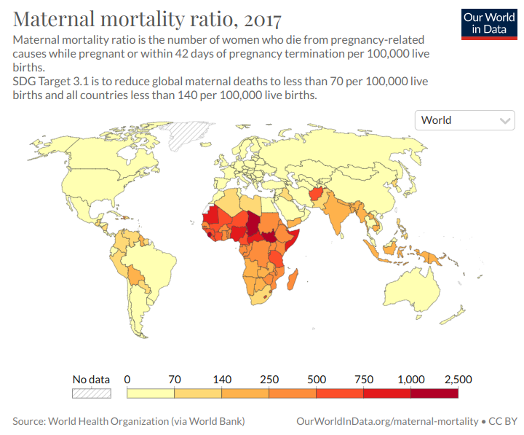
Figure 4: Maternal Mortality ratio, 2017 (SDG Tracker, 2017).
Figure 5 shows a map of the population living in poverty as of 2021. As can be seen on the map most of the countries account for between 0 and 3% of poverty. Only a few countries have up to 60% poverty and only 2 countries, Somalia and Malawi have between 70-80%. No countries pass the 80% mark in regard to poverty. This shows that most of the world in on track to reach the goal target of no poverty by 2030.
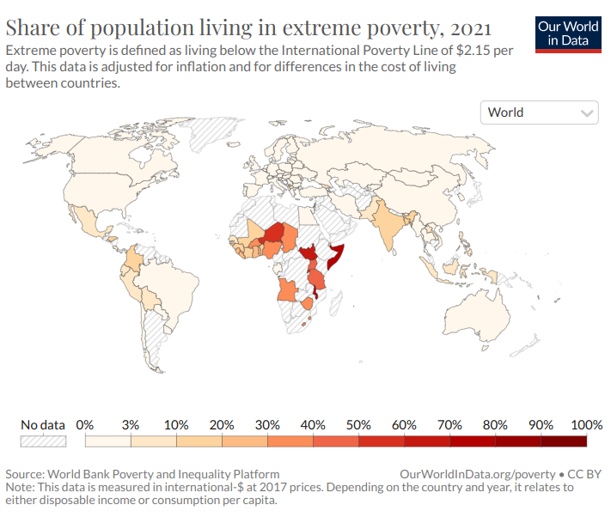
Figure 5: Share of population living in extreme poverty, 2021 (SDG Tracker, 2021).
2.4 Theories
Thomas Malthus, an English economist and demographer, published 'An Essay on the Principle of Population as It Affects the Future Improvement of Society' in 1798. He made three assumptions: (1) the total amount of land available for agriculture is always fixed, (2) population growth is limited by the amount of food available for subsistence, and (3) as the means of subsistence increase, the population will inevitably also increase (MacRae, 2023). Malthus warned that without regulation, the human population could theoretically grow exponentially and soon exceed its capacity to produce the resources for subsistence. He warned that people should practice conscious population control, such as the use of birth control and celibacy, to avoid disasters such as starvation and war. A Malthusian disaster refers to a naturally occurring limitation to population growth, such as famine, disease, or war. Many believe that pressures on future food production, joined with risks such as global warming, will make overpopulation an even more serious threat in the future (LibreTexts, n.d.).
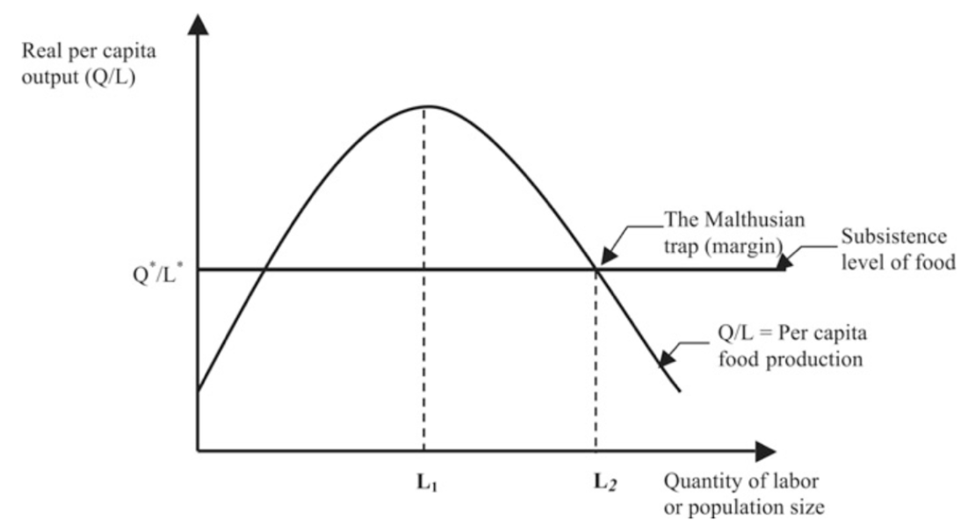
Figure 6: Malthus’ Theory of Population Growth (Hussen, 2019).
The core of this concept can be better understood with a simple graph, as shown in Figure 3. Assuming that labour (L) can be used as an alternate for population size and real production (Q/L) can be used as a measure of per capita income. Figure 3 shows the relationship between population size and per capita income. The output (Q) is intended to represent agricultural or food products in general. In Figure 3, (Q⋆/L⋆) (thick horizontal line) represents the output per unit of labour sufficient to survive. Therefore, when labour reaches a certain level (L2), we reach the Malthusian trap. This will be a stable equilibrium in the long run. According to Malthus, for populations below (L2), as long as food per capita exceeds the minimum food necessary for subsistence, the human population has a natural tendency to continue increasing (Q⋆/L⋆) According to Malthus, for populations below (L2), as long as food per capita exceeds the minimum food necessary for subsistence, the human population has a natural tendency to continue increasing (Q⋆/L⋆). On the other hand, population growth beyond L2 is prevented by the positive control. Consequently, disease, malnutrition, and starvation will halt L2 growth in the long term. The model above suggests the optimal population size to reach the highest food level per capita (L1) (Hussen, 2019).
Neoclassical economics reject the idea that natural resources are limited, but do not think that economic expansion is constrained. They believe that technology can reduce the shortage of natural resources, distinguish between "general" and "specific" scarcities of natural resources, and that relative scarcity does restrict growth. Neoclassicists believe that economic progress through increases in per capita income and advances in technology offers solutions to environmental and humanity issues. Knowledge is the primary resource for sustaining human material progress, and education and physical capital are the best legacies to leave to future generations. The rate of technical advancement will determine the material progress of people in the future (Hussen, 2019)
Furthermore, the Environmental Kuznets Curve (EKC) suggests that early industrialization is associated with high pollution levels when growth is prioritised and environmental controls are not present, while improved economic development is associated with increased concern for environmental quality and a growing degree of environmental control (Pettinger, 2019).
Pollution
Income per capita
Early stages of industrial development
More advanced stages of development
EKC
Figure 4: Environmental Kuznets Curve
The population of the world has increased rapidly since the middle of the 20th century, from 2.5 billion in 1950 to 7.8 billion in 2020. This is due to a process known as the "demographic transition," in which longer life spans and fewer children are produced by declining rates of mortality and fertility (United Nations Department of Economic and Social Affairs, 2021). Malthus' theory of population growth would positively impact these changes and increase the chances of reaching the sustainable cities and communities' SDG by 2030 by individuals remaining celibate or using contraceptive birth control methods this would slowly decrease the growth of population over time and improving the lives of others. An example of a country that implemented a similar strategy was China, where the one-child policy was implemented in the late 1970s and early 1980s with the aim of limiting many family units in the nation to having just one child. This policy was justified by the need to slow China's massive population increase (Pletcher, 2023).

3.0 Suggestions
3.1 Suggestion 1
As a solution to the human health risk, governments, localities, and international organisations must collaborate to address the human health risk, address infrastructure and systemic inadequacies, and support vulnerable nations. This will save money and lives in the future (WHO, 2020).
The government should also support health and social care with a fully funded salary increase to encourage recruitment and retention, together with more overall expenditure and improved career advancement possibilities, in order to address the concerns of staff shortages and employee exhaustion. This will aid in halting the departure of employees seeking better-paying and less demanding positions (NHS Confederation, 2022).
3.2 Suggestion 2
Reducing taxes on gas, electricity, and other forms of energy would reduce consumer prices and reduce transitory inflation. It could be a short-term tax break until oil prices decline, and benefit people who depend on cars for transportation.
The government could also reduce a general tax like the VAT or income tax. The amount of discretionary income that might be used to cover living expenses would rise as a result (Pettinger, 2022).

4.0 Conclusion
To conclude this report after looking at the progress that has already been made on some of the United Nations Sustainable Development Goals it is possible, they could be accomplished in the predicted timeframe as long as governments, countries and individuals all work together. People everywhere in the world all need to work together to succeed in achieving all 17 SDGs, as mentioned poverty in most countries has improved but quality of education has decreased. This means that some of the SDGs are moving further and faster toward their target than others. Regarding theories, Malthus’ theory of population, although similar was introduced in China, would not be feasible to decrease or stabilise population growth for the whole world however there are other solutions that can be implemented to instead improve the lives of those already living and the future of those to come.

5.0 References
Apo, S. (2022). ‘Explained: How climate change affects health’ https://wellcome.org/news/how-climate-change-affects-health-explained Date Retrieved: 11th May 2023
Barnardos. (2022). ‘At what cost? The impact of the cost-of-living on children and young people’ https://www.barnardos.org.uk/sites/default/files/2022-10/At%20what%20cost_impact%20of%20cost%20of%20living%20final%20report.pdf Date Retrieved: 11th May 2023
Dorais, S. (2022). ‘How is the current cost-of-living crisis affecting small businesses?’ https://www.chaserhq.com/blog/how-is-the-current-cost-of-living-crisis-affecting-small-businesses#:~:text=The%20cost%20of%20living%20crisis%20is%20also%20making%20it%20harder,search%20of%20better%2Dpaid%20work. Date Retrieved: 11th May 2023
Hourston, P. (2022). ‘Cost of living crisis' https://www.instituteforgovernment.org.uk/explainer/cost-living-crisis Date Retrieved: 11th May 2023
Hussen, A. M. (2019). ‘Principles of environmental economics and sustainability an integrated economic and ecological approach’ (4th ed.). London: Routledge https://ashraffeps.yolasite.com/resources/Environmental_Eco./Principles%20of%20Environmental%20Economics.pdf
Kagan, J. (2022). ‘World Economic Forum (WEF): Definitions and History of Meeting’ https://www.investopedia.com/terms/w/world-economic-forum.asp#toc-what-is-the-world-economic-forum-wef Date Retrieved: 2nd May 2023
LibreTexts. (n.d.). ‘17.2D: Malthus’ Theory of Population Growth’ https://socialsci.libretexts.org/Bookshelves/Sociology/Introduction_to_Sociology/Sociology_(Boundless)/17%3A_Population_and_Urbanization/17.02%3A_Population_Growth/17.2D%3A_Malthus_Theory_of_Population_Growth Date Retrieved: 11th May 2023
MacRae, D. G. (2023). ‘Thomas Malthus’ https://www.britannica.com/biography/Thomas-Malthus#ref222944 Date Retrieved: 11th May 2023
Montacute, R. (2023). ‘THE COST-OF-LIVING CRISIS HITS SCHOOL SPENDING’ https://www.suttontrust.com/news-opinion/all-news-opinion/cost-of-living-crisis-hits-school-spending/ Date Retrieved: 12th May 2023
Murugesu, J. A. (2022). ‘Pollution killed 9 million people worldwide in 2019 alone’ https://www.newscientist.com/article/2320777-pollution-killed-9-million-people-worldwide-in-2019-alone/#:~:text=Pollution%20killed%209%20million%20people%20globally%20in%202019%2C%20accounting%20for,it%20caused%209%20million%20fatalities. Date Retrieved: 11th May 2023
NHS Confederation. (2022). ‘System on a cliff edge: addressing challenges in social care capacity’ https://www.nhsconfed.org/publications/system-cliff-edge-addressing-challenges-social-care-capacity Date Retrieved: 12th May 2023
Pettinger, T. (2019). ‘Environmental Kuznets Curve’ https://www.economicshelp.org/blog/14337/environment/environmental-kuznets-curve/ Date Retrieved: 11^{h} May 2023
Pettinger, T. (2022). ‘Policies to reduce cost of living crisis’ https://www.economicshelp.org/blog/170554/economics/policies-to-reduce-cost-of-living-crisis/ Date Retrieved: 12th May 2023
Pletcher, K. (2023). ‘One-child policy’ https://www.britannica.com/topic/one-child-policy Date Retrieved: 12th May 2023
Raleigh, V. (2021). ‘Covid-19 and the UK’s health care performance: how does it compare on the international stage?’ https://www.kingsfund.org.uk/blog/2021/11/covid-19-uk-health-care-performance Date Retrieved: 11th May 2023
Scott, E. (2022). ‘Cost of living: Impact on public wellbeing’ https://lordslibrary.parliament.uk/cost-of-living-impact-on-public-wellbeing/#heading-2 Date Retrieved: 11th May 2023
SDG Tracker. (2017). ‘Ensure healthy lives and promote well-being for all at all ages’ https://sdg-tracker.org/good-health Date Retrieved: 12th May 2023
SDG Tracker. (2021). ‘End poverty in all its forms everywhere’ https://sdg-tracker.org/no-poverty Date Retrieved: 12th May 2023
Sinay. (2021). ‘What Are the 17 Sustainable Development Goals (SDGs)?’ https://sinay.ai/en/what-are-the-17-sustainable-development-goals-sdgs/#:~:text=The%20SDGs%20are%20the,regarding%20economic%2C%20environmental%2C%20and%20social Date Retrieved: 9th May 2023
United Nations. (2022). ‘The 17 Goals’ https://sdgs.un.org/goals Date Retrieved: 9th May 2023.
United Nations Department of Economic and Social Affairs. (2021). ‘Global Population Growth and Sustainable Development’ https://www.un.org/development/desa/pd/sites/www.un.org.development.desa.pd/files/undesa_pd_2022_global_population_growth.pdf Date Retrieved: 12th May 2023
United Nations Department of Economic and Social Affairs. (2021). ‘Sustainable development report shows devastating impact of COVID, ahead of ‘critical’ new phase’ https://www.un.org/africarenewal/news/sustainable-development-report-shows-devastating-impact-covid-ahead-%E2%80%98critical%E2%80%99-new-phase Date Retrieved: 11th May 2023
WEF. (2023). ‘The Global Risks Report 2023 18th Edition: INSIGHT REPORT’ https://www3.weforum.org/docs/WEF_Global_Risks_Report_2023.pdf Date Retrieved: 11th May 2023
WEF. (2023). ‘Klaus Schwab’ https://www.weforum.org/about/klaus-schwab Date Retrieved: 2nd May 2023
WHO. (2020). ‘Urgent health challenges for the next decade’ https://www.who.int/news-room/photo-story/photo-story-detail/urgent-health-challenges-for-the-next-decade Date Retrieved: 12th May 2023
WHO. (2022). ‘Global Strategy on Human Resources for Health: Workforce 2030: Reporting at Seventy-fifth World Health Assembly’ https://www.who.int/news/item/02-06-2022-global-strategy-on-human-resources-for-health--workforce-2030 Date Retrieved: 11th May 2023
World Economic Forum. (2023). ‘World Economic Forum, Global Risks Perception Survey 2022-2023’. https://www3.weforum.org/docs/WEF_Global_Risks_Report_2023.pdf Date Retrieved: 8th May 2023.
Zahidi, S. (2023). ‘The Global Risks Report 2023 18th Edition: INSIGHT REPORT’ https://www3.weforum.org/docs/WEF_Global_Risks_Report_2023.pdf Date Retrieved: 8th May 2023

