

University of Wales Trinity Saint David

School of Engineering

Motion simulation and FEA
Peter Payne
P150305
03/02/20
Advanced computational methods
M6X00408

Contents
Introduction 3
Aims 3
Background research and theory 3
Methodology 3
Results 14
Analysis 14
Conclusion (further work) 14
Bibliography 14

Introduction
this assignment will cover the selection part, the modelling of said part in SolidWorks alongside any of the parts that need to be modelled in order to create an assembly in which the part would be utilised in its intended function. A motion simulation will be run to simulate the intended function of the part within a given scenario. The results of the motion simulation will be analysed using Finite element analysis in order to optimise the part.

Aims
the aims of this assignment are two part to accurately modelled in CAD using SolidWorks.

Background research and theory

Methodology

the partner has been chosen to be analysed within this report is the drive side crank arm on the road bicycle. The scenario that the crank arm is subject to is a maximum effort up a very steep hill. This can be shown in the Motion simulation with the maximum force on each of the pedals being 1000 N and the cadence of the paddle stroke being 60 rpm.

https://uowtsd-my.sharepoint.com/:f:/g/personal/ppayne_150305_student_uwtsd_ac_uk/EhGAfUUCqSVGg_LdxgMS5BsBraC5UTTudaWc1OPmUpL6sQ?e=4ZGoxJ
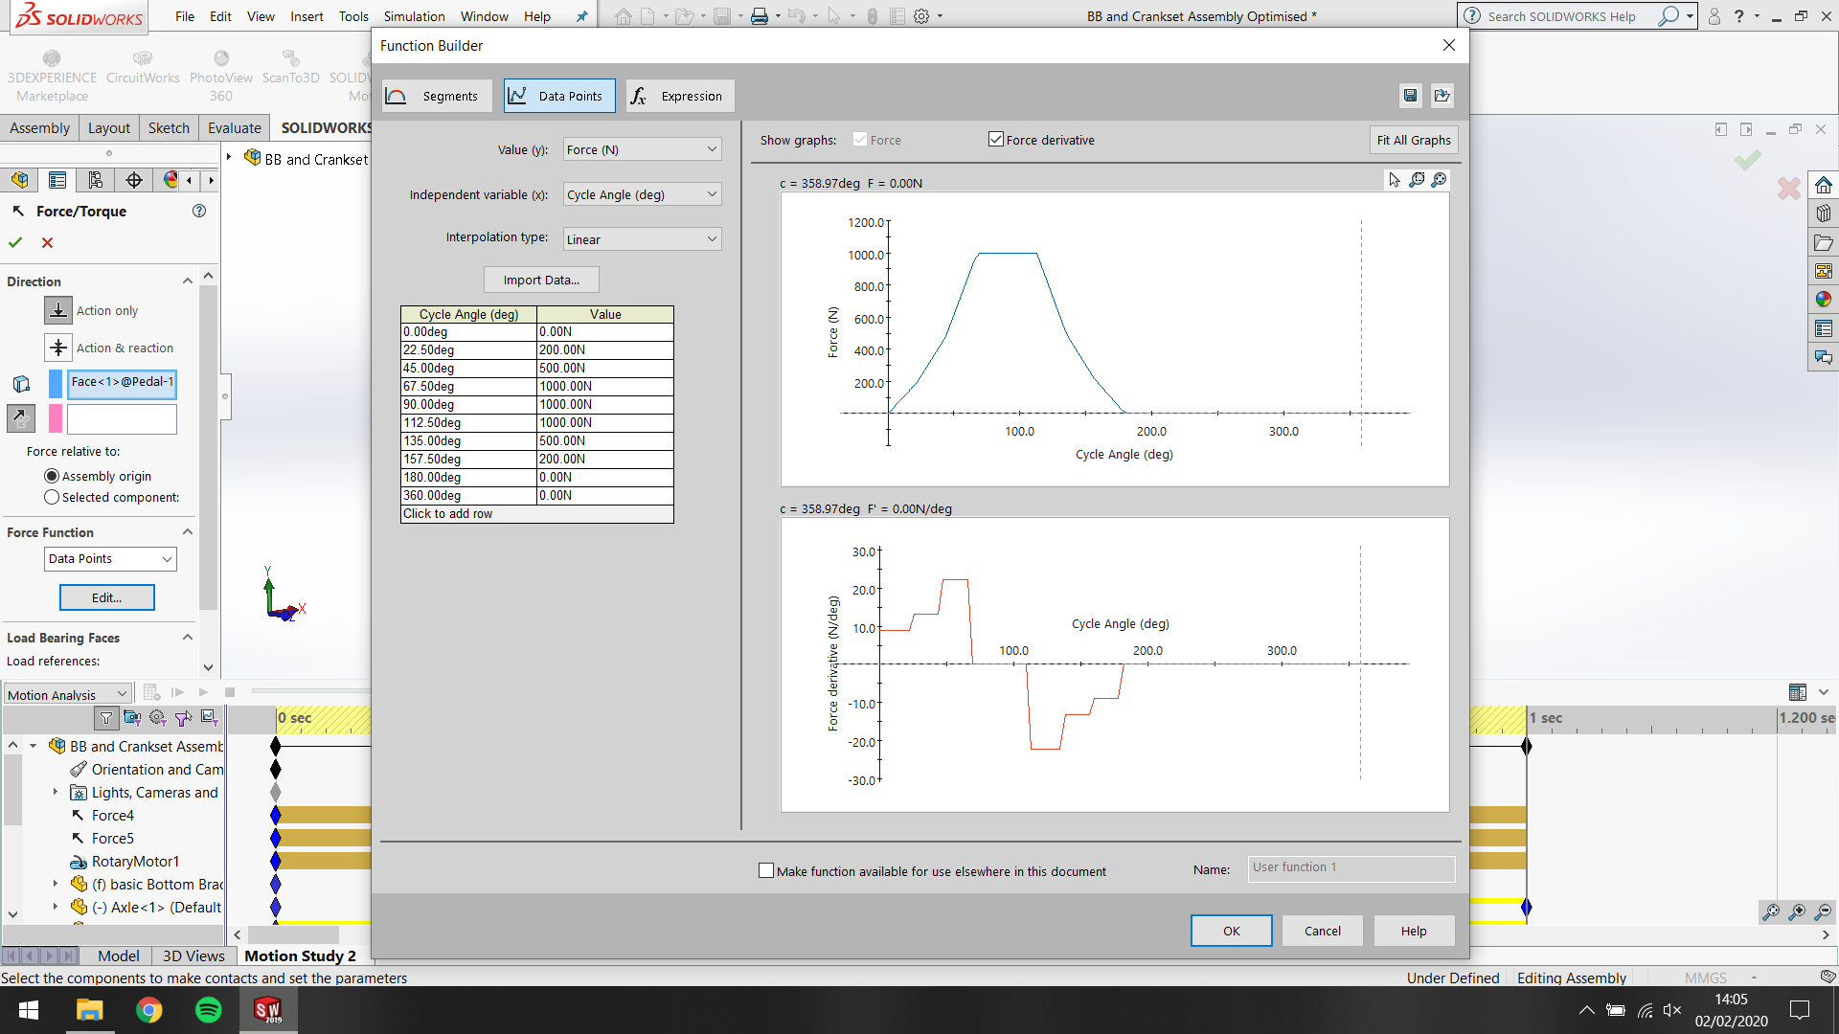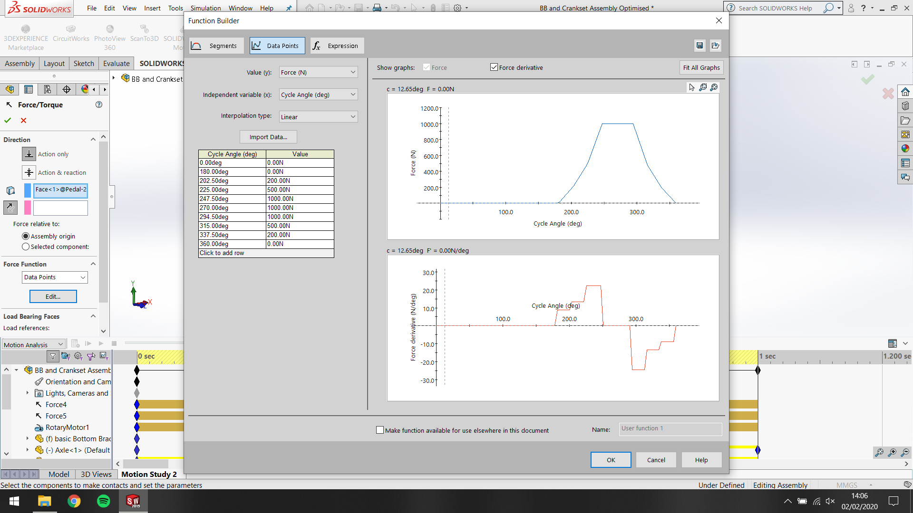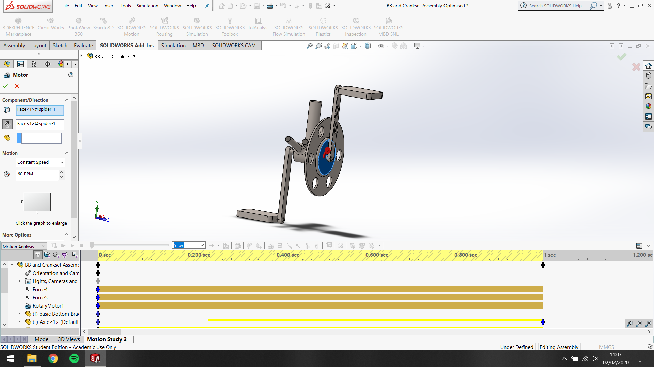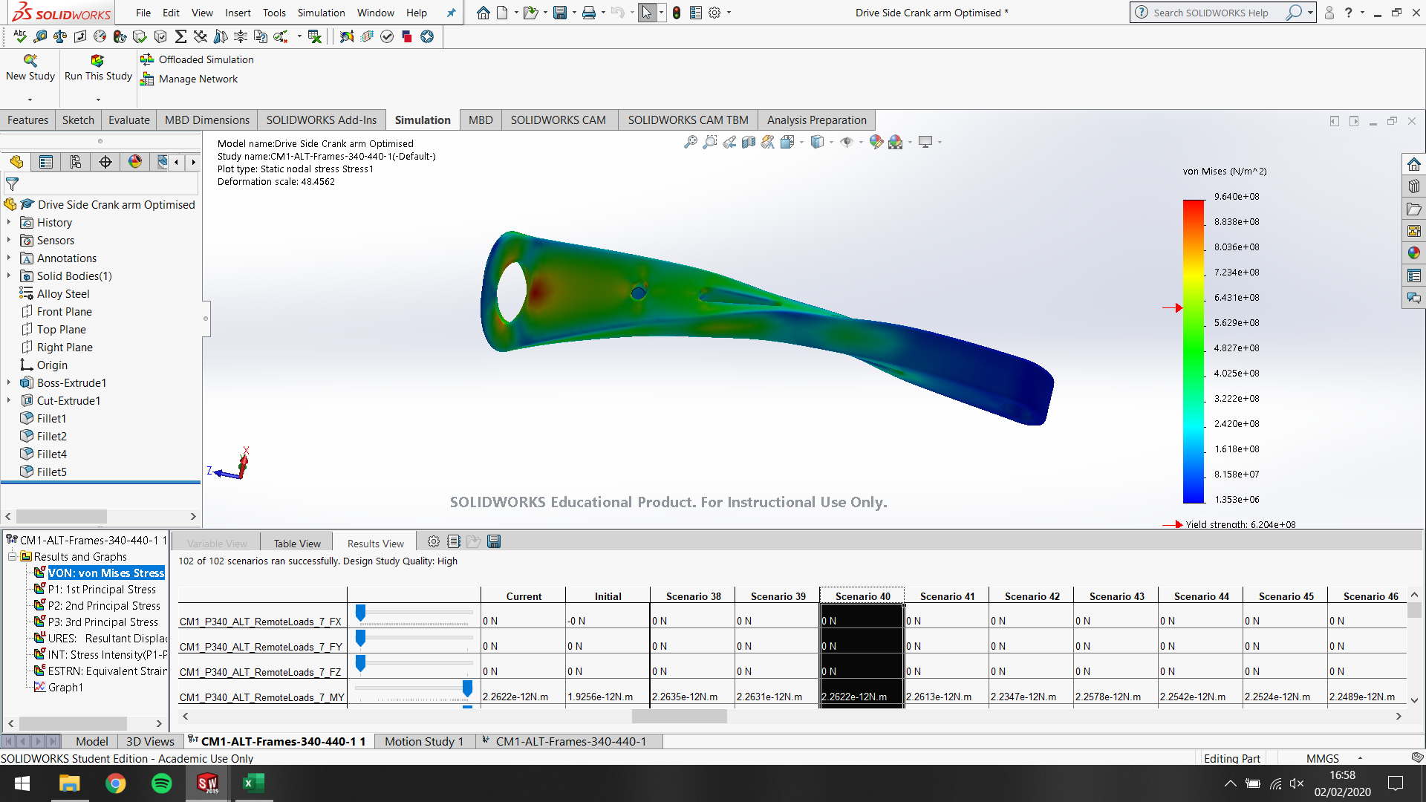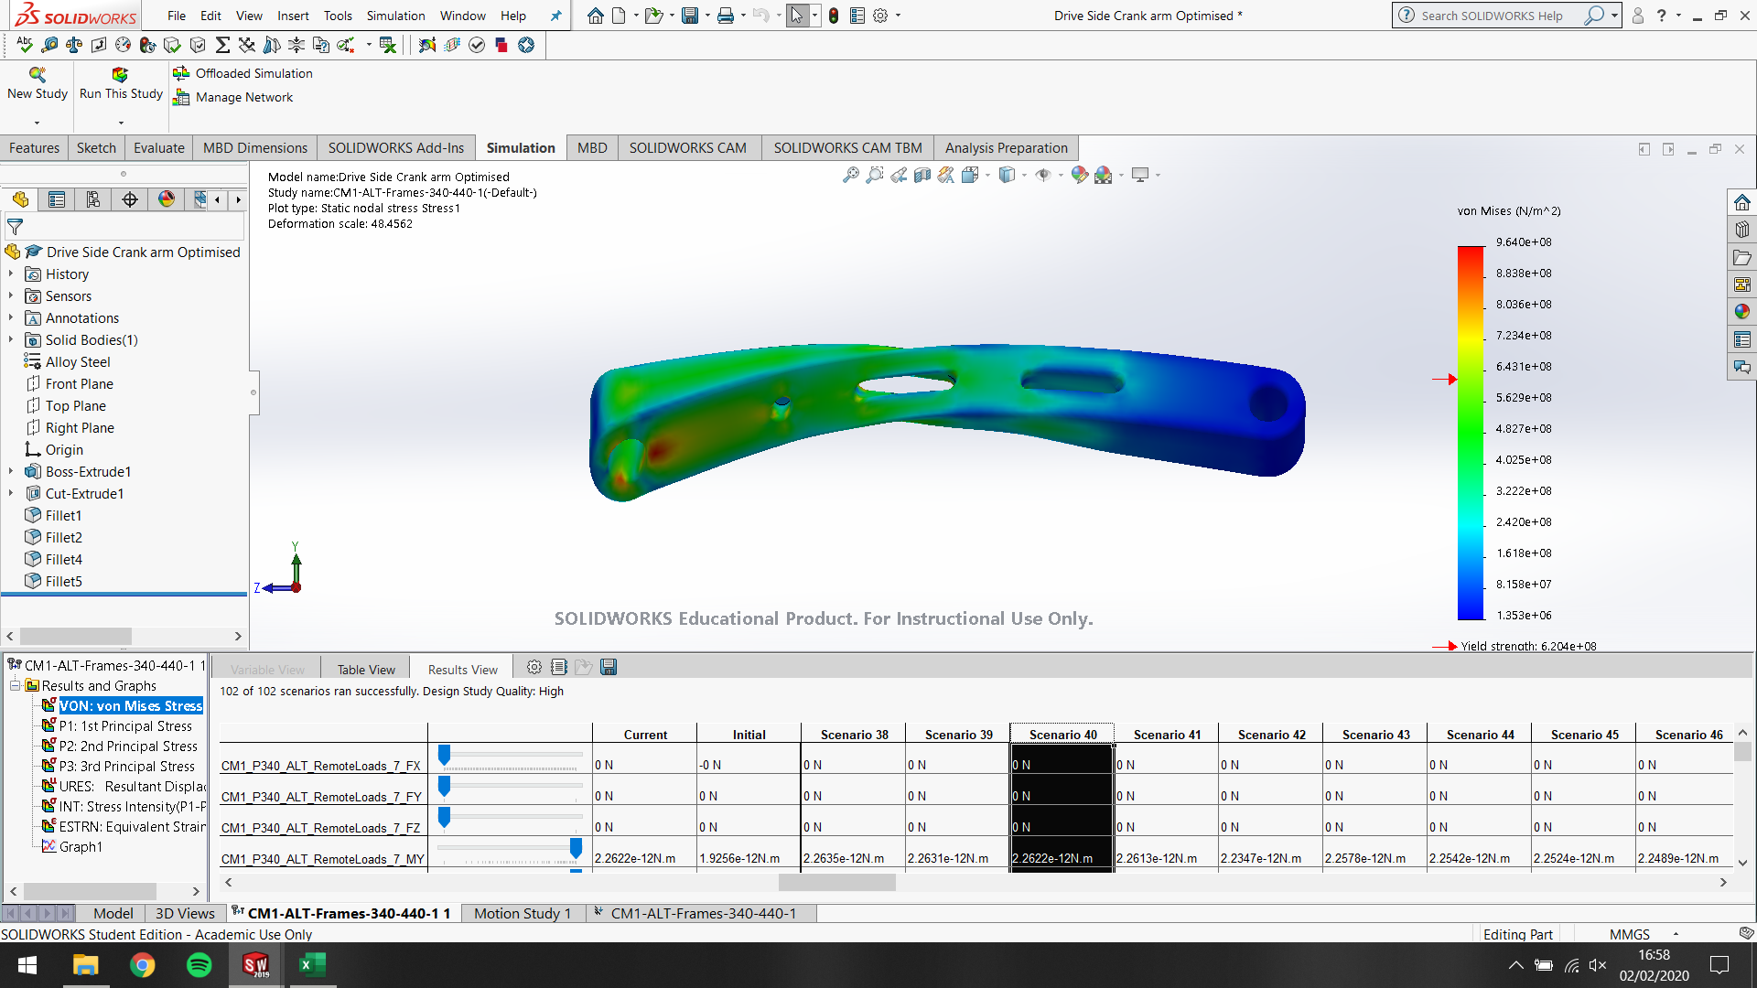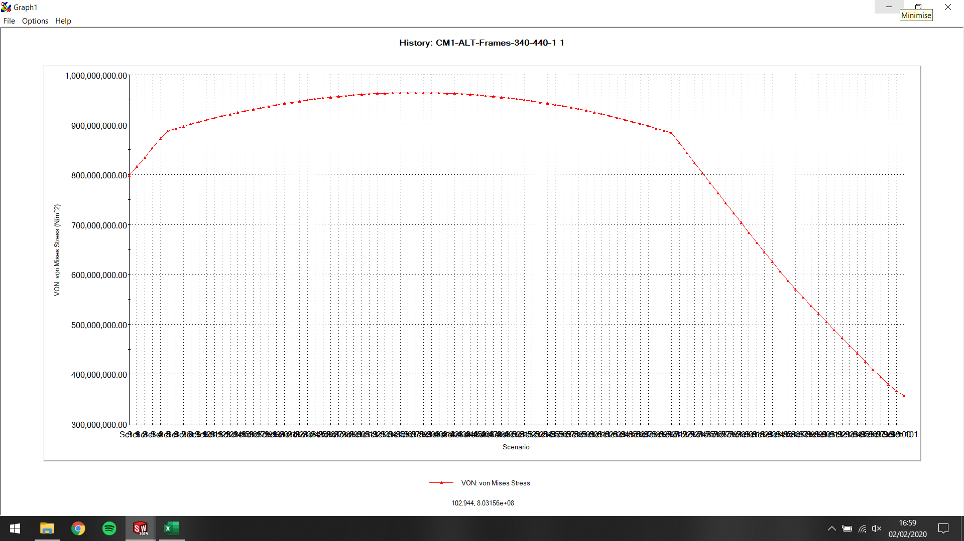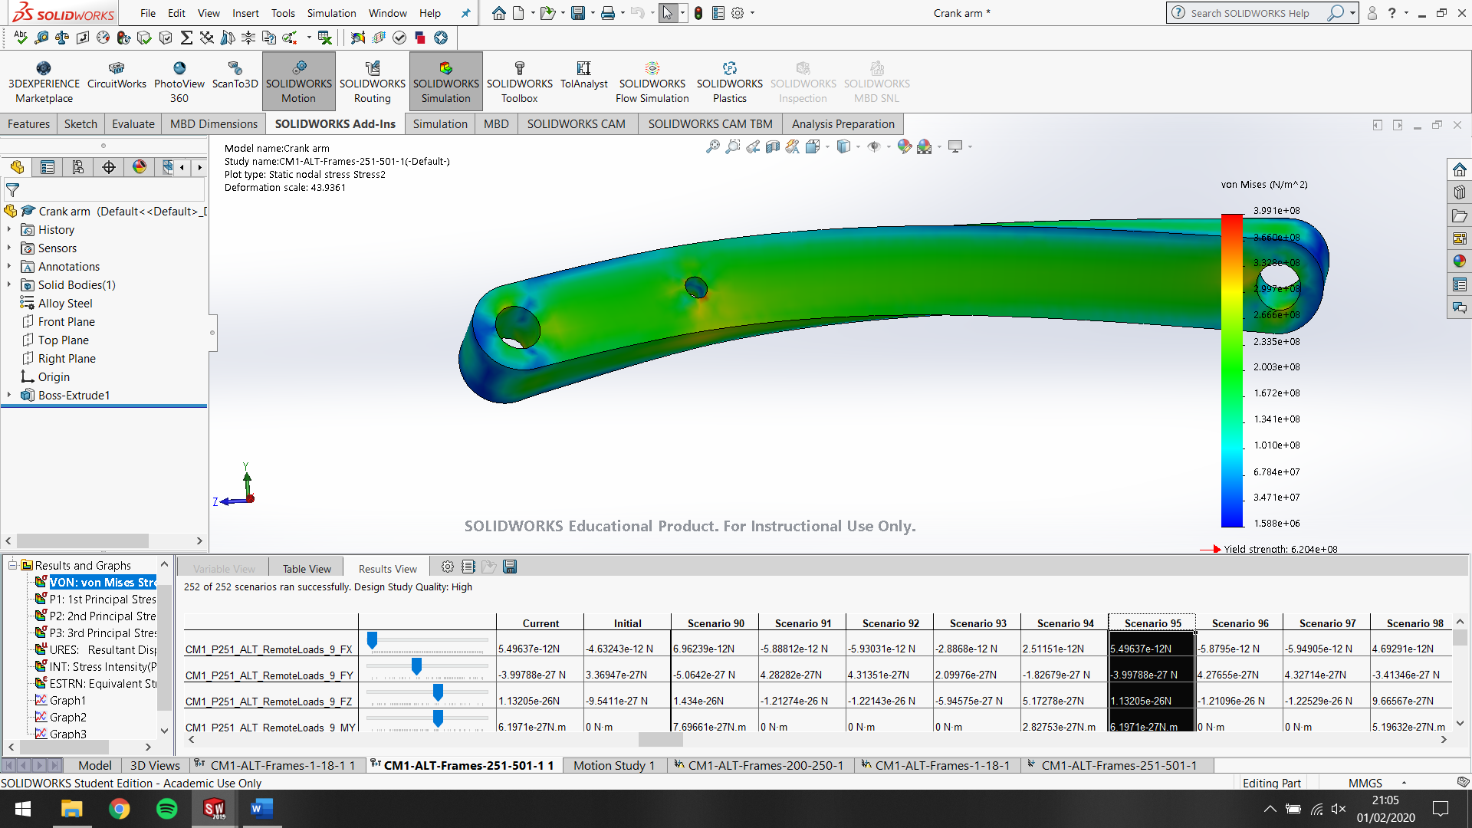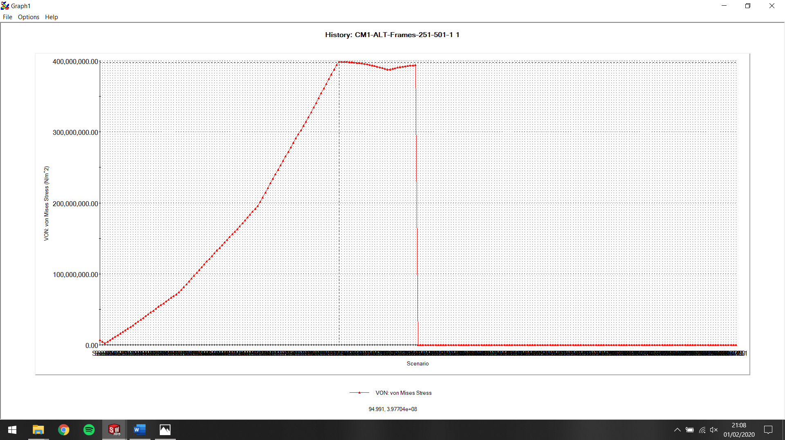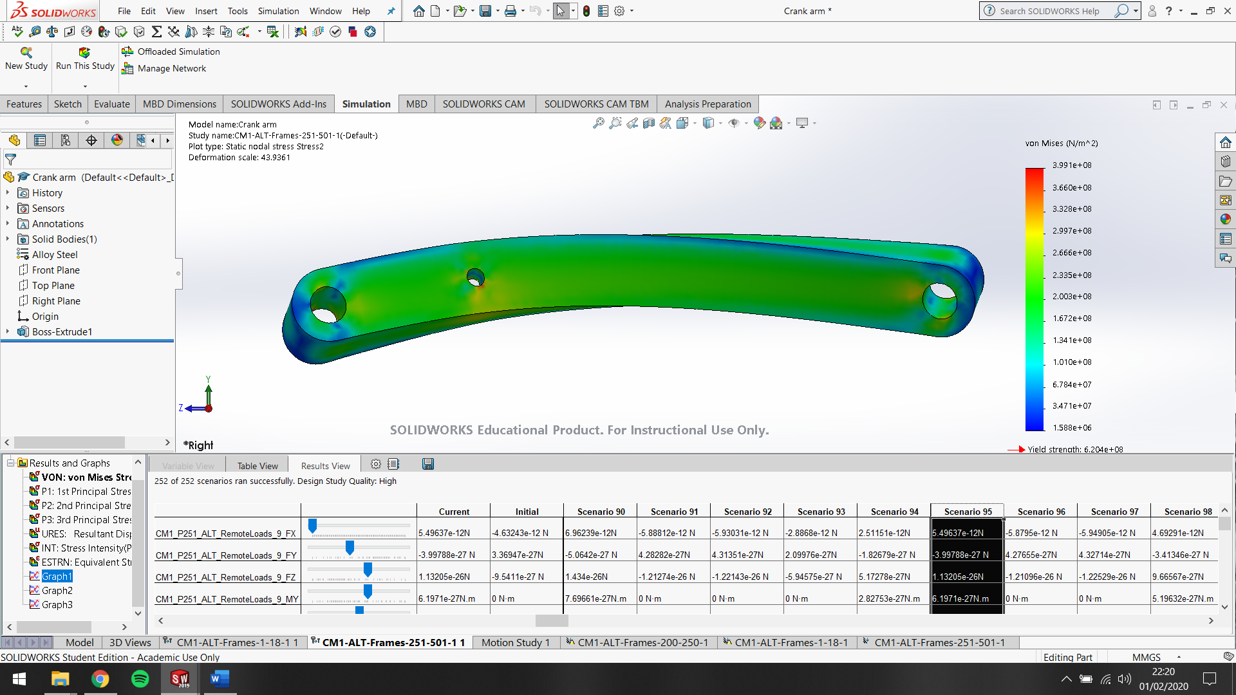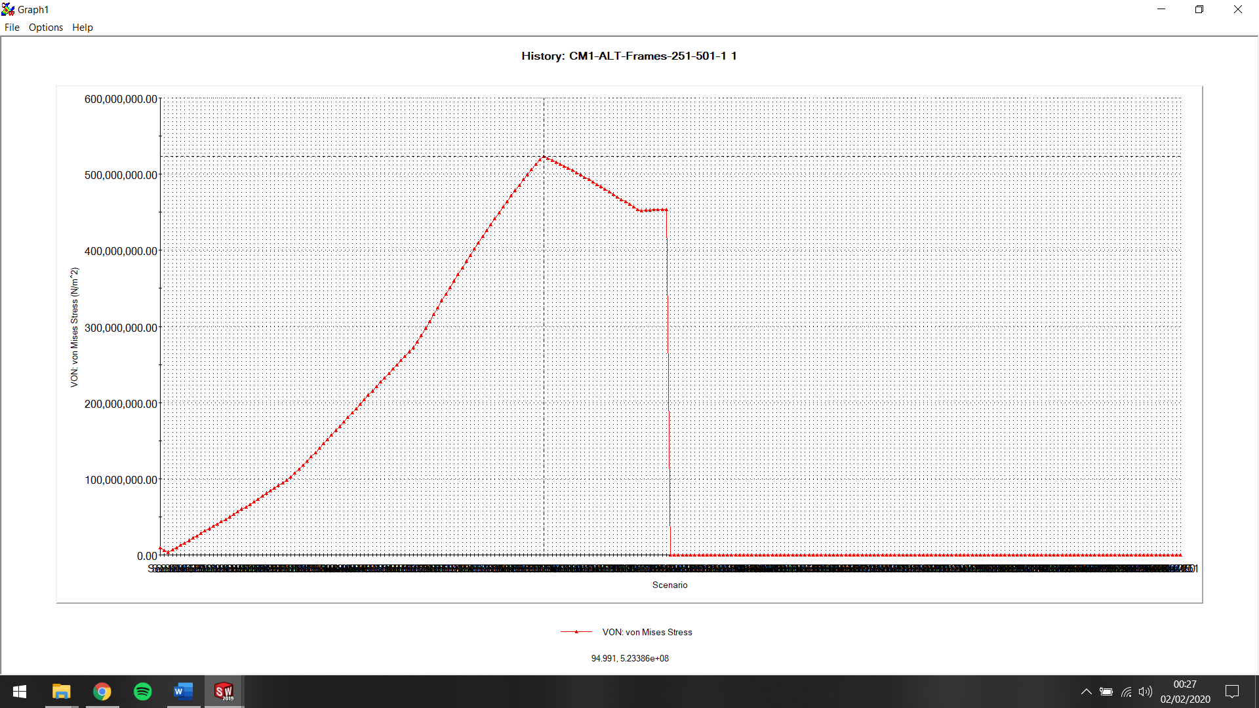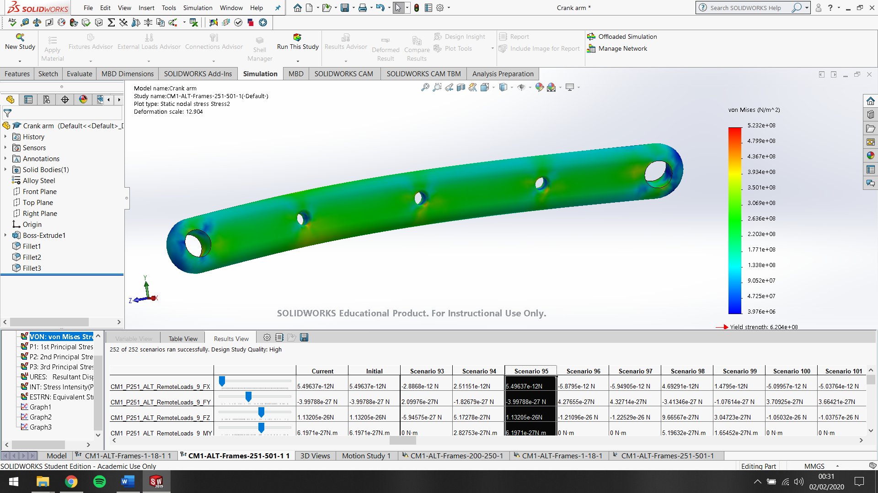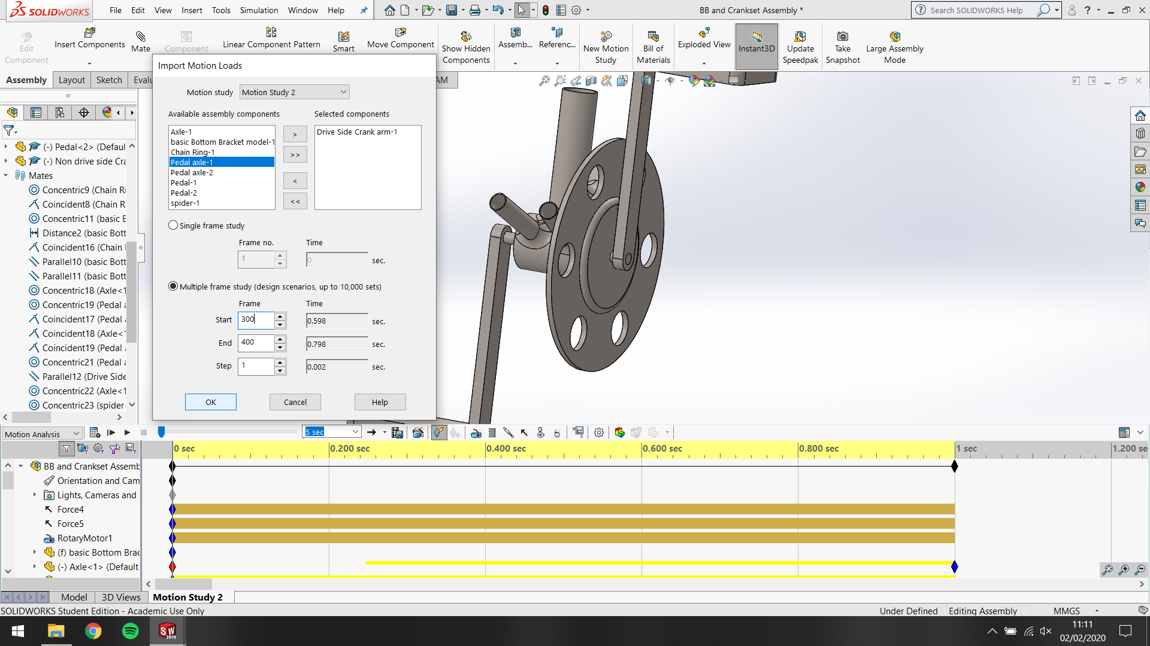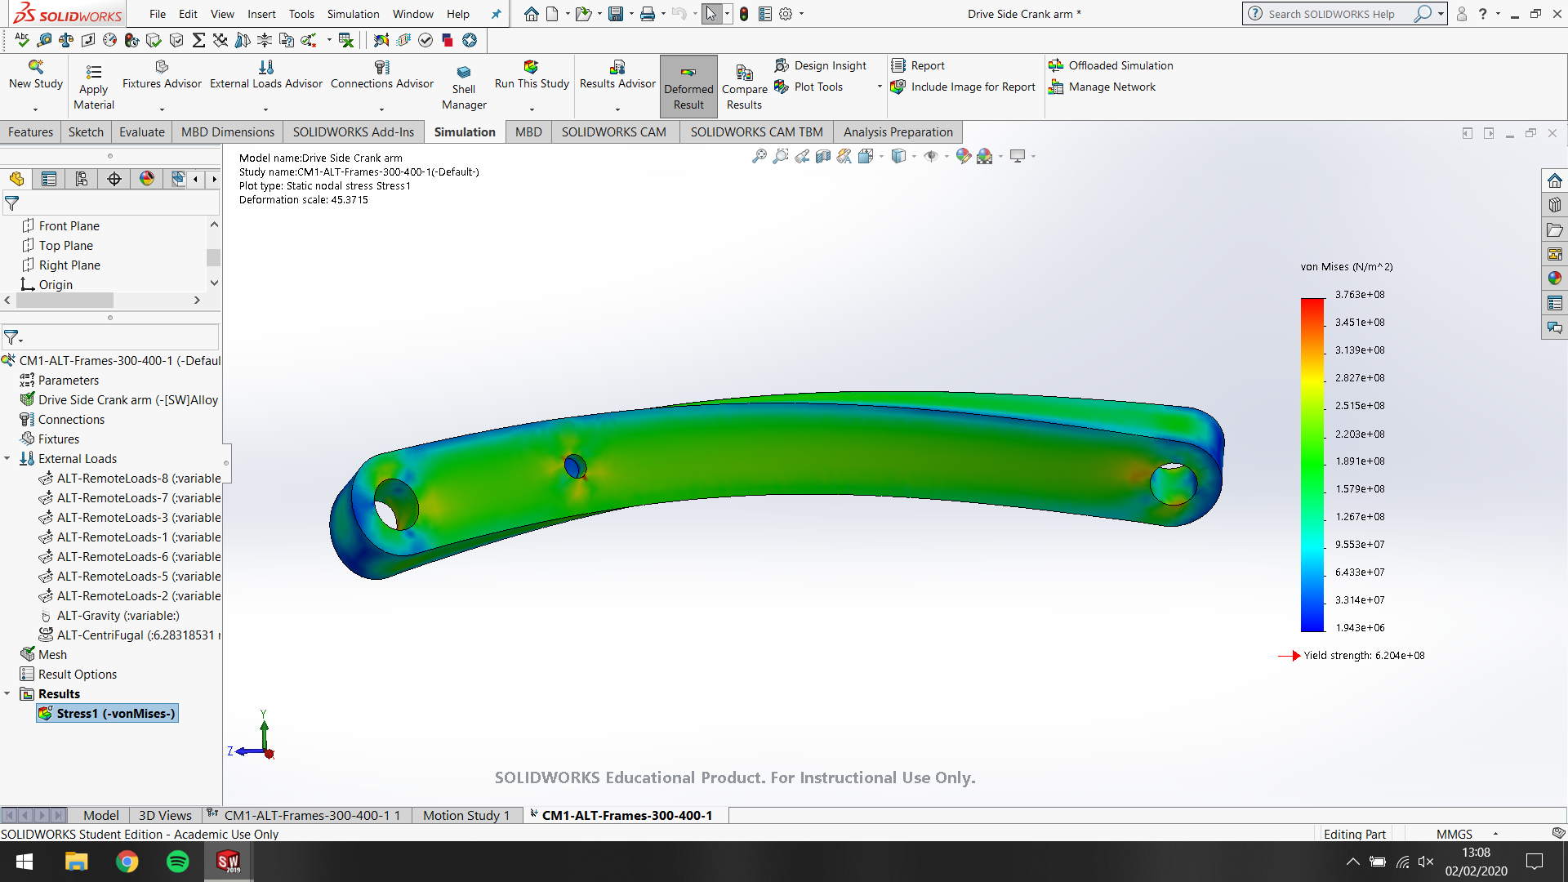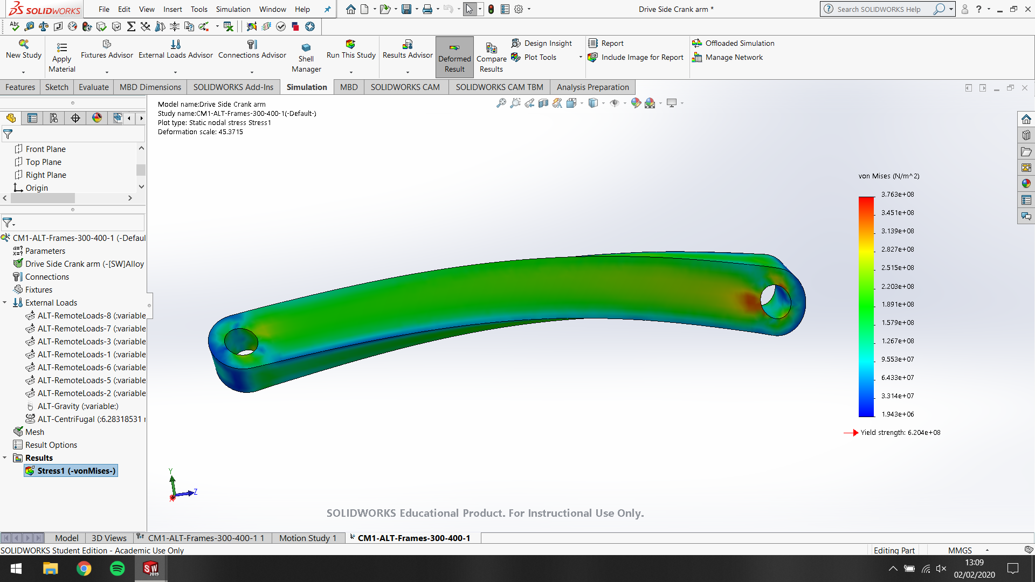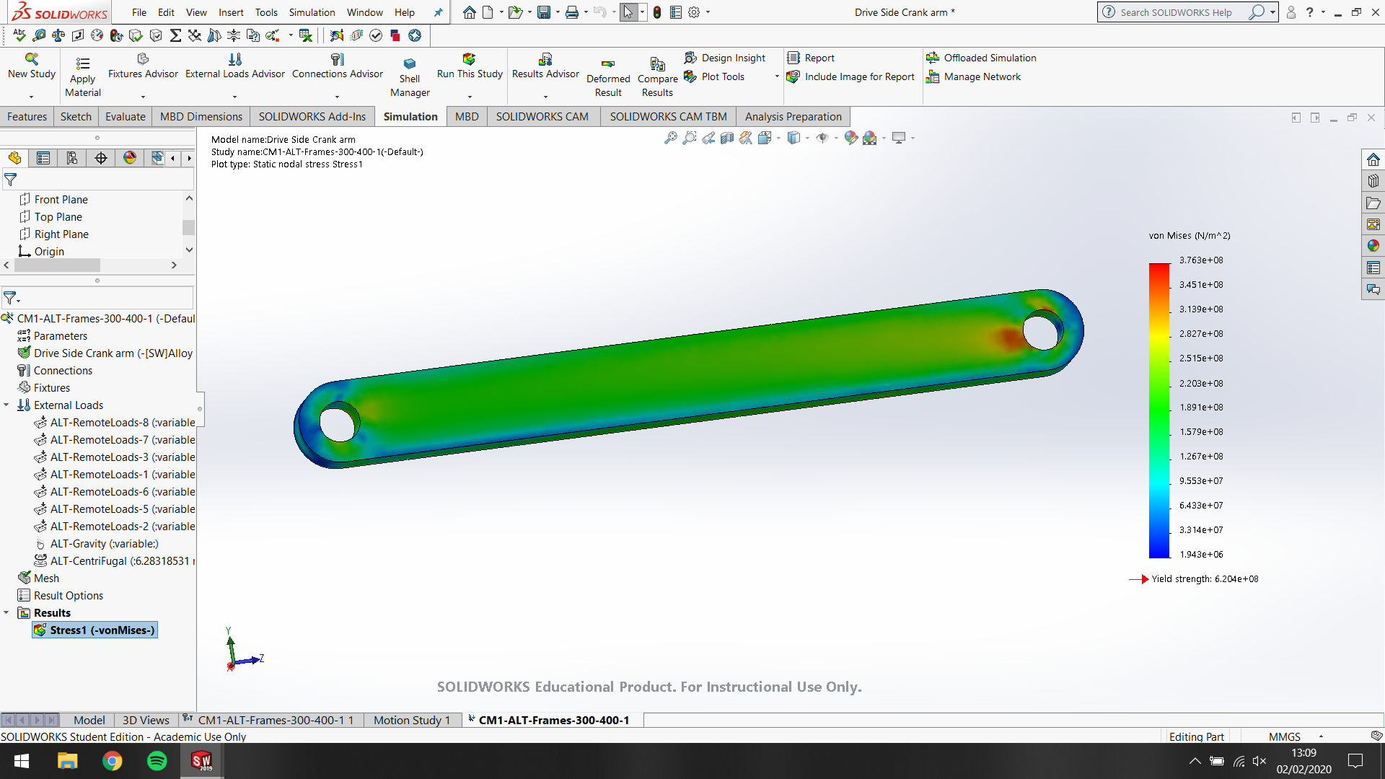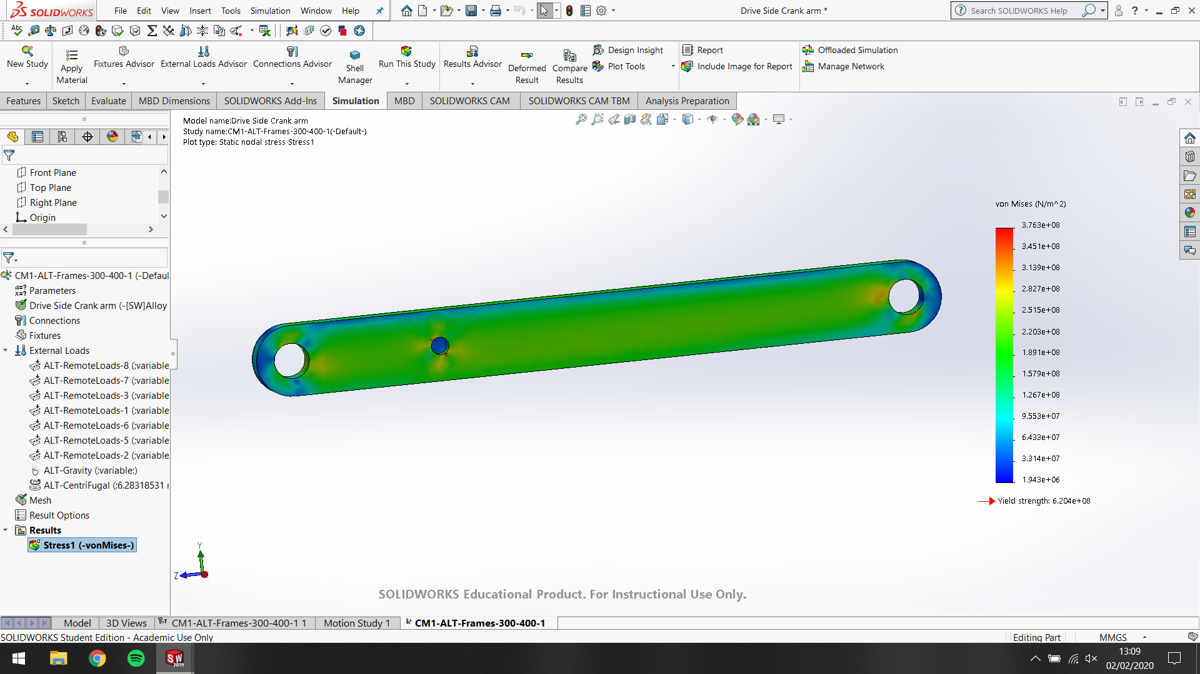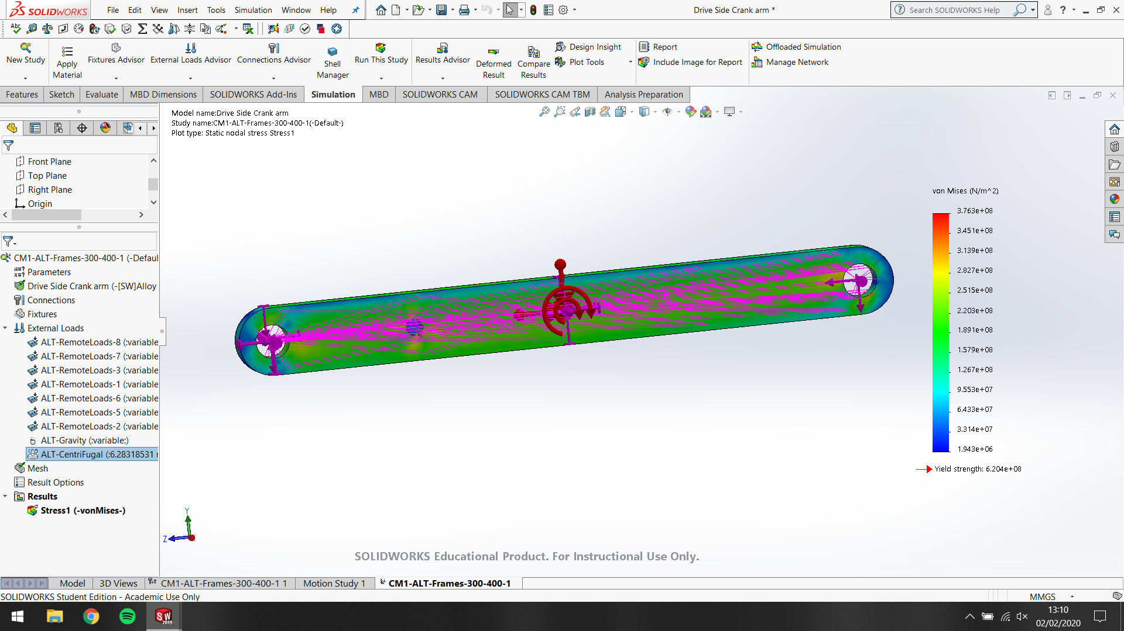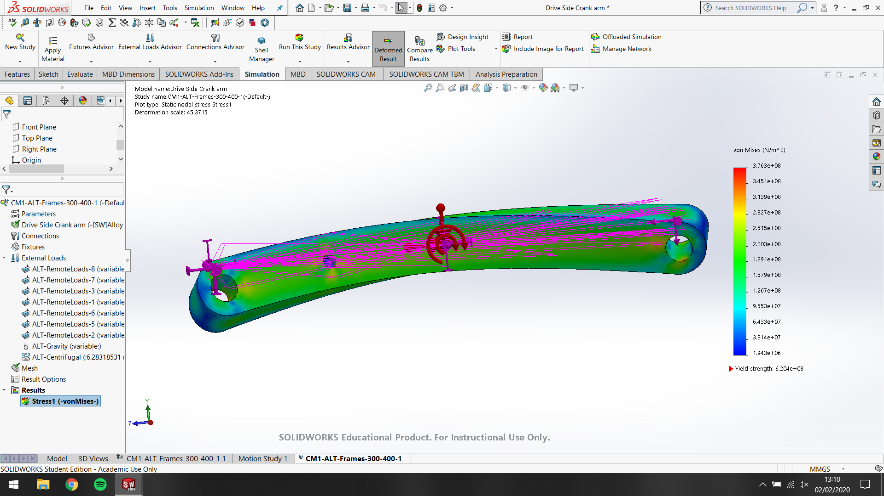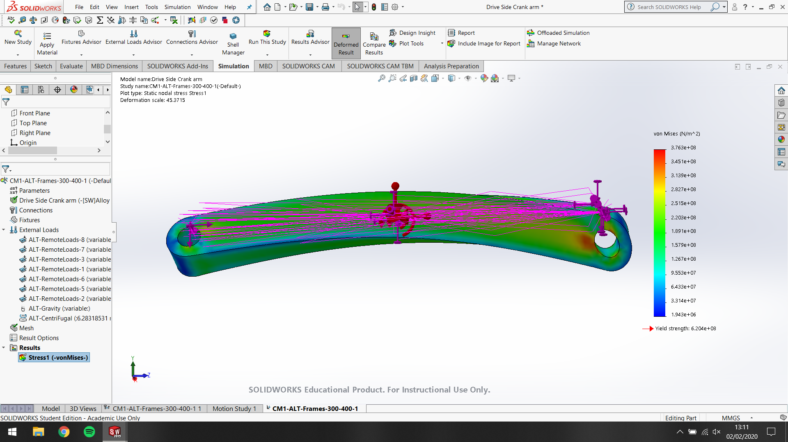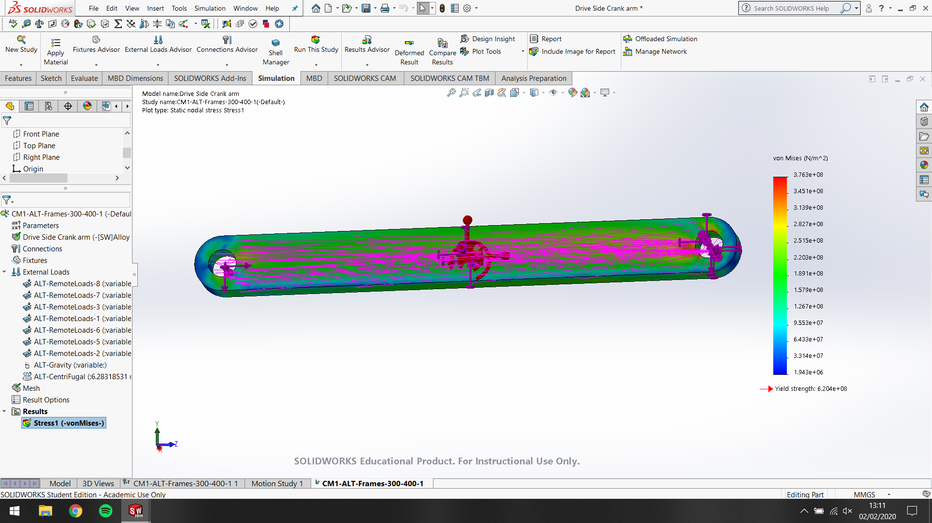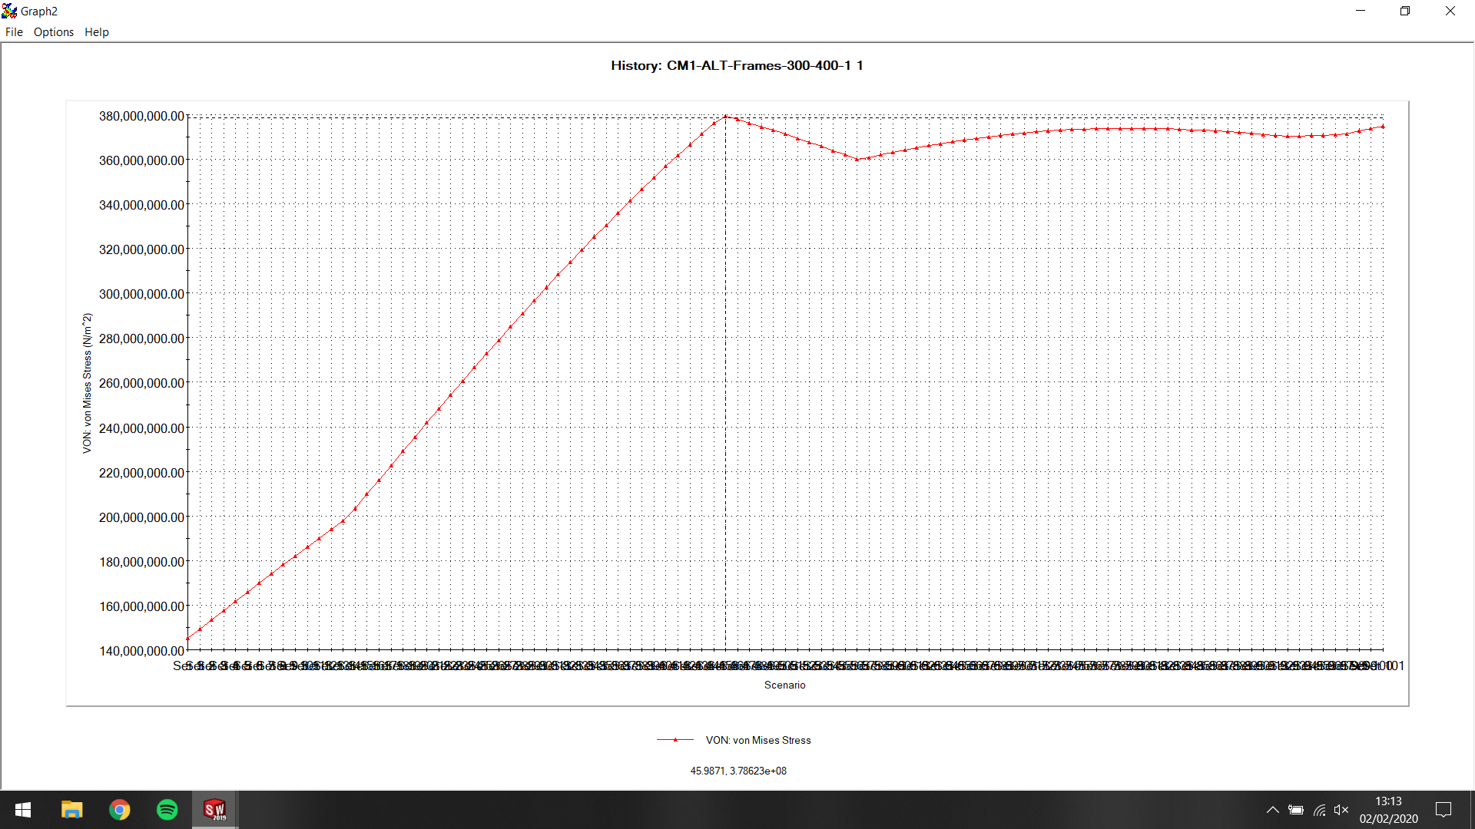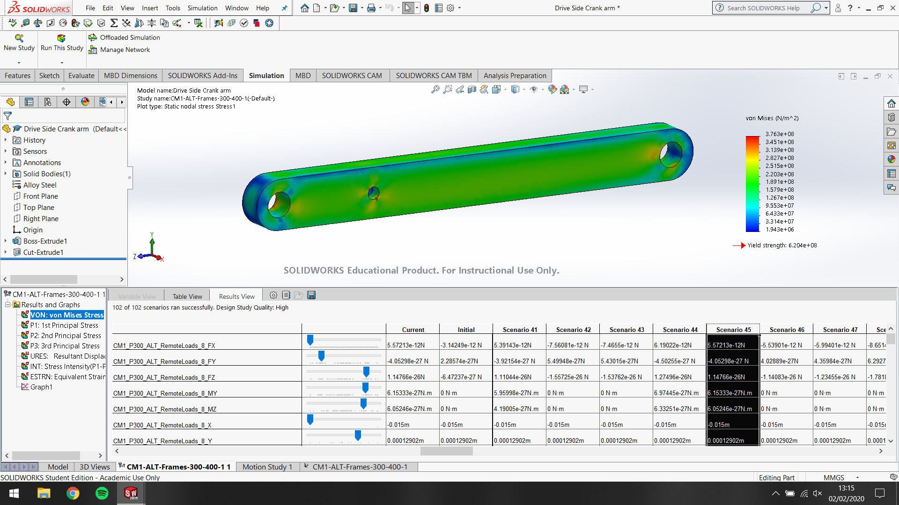

Results

Analysis

Conclusion (further work)

Bibliography
There are no sources in the current document.

