Student’s Name: Mohammed Miah
Student’s Number: 1914094 Module
Lecturer’s Name: Shao-Lan Yuen

Module Title: Effective Team Working & Communication
Assignment Title: Effective Team Work and Communication

Contents
Introduction 2
Discuss the strategies for effective team works 3
Discuss how to aware students range of develop communication skill on the workplace 6
Conclusion 8
Reference 8

Introduction
Team works means operating respective task within getting the group support. Effective team works means get positive result after maintain team performance. On this report team work and communication development process are including. How to develop the effective team working that information also discusses with specific point. Communication process how can impact on workplace that information also defines here. Most common communication skill is also including with example. Main purpose on this report is identifying the positive reason for improve the communication and team working performance.

Discuss the strategies for effective team works
Team works means group participation for complete relevant task. Team working performance is essential for complete complex task. On academic life team works has no alternative because team works performance impact on graduation. Effective team works bringing the positive outcomes and make sure for achieve success. Students can practice effective team work performance for complete their academic course. Different strategies and methods apply for make effective team working process. Effective teamwork strategy is mentioned below.
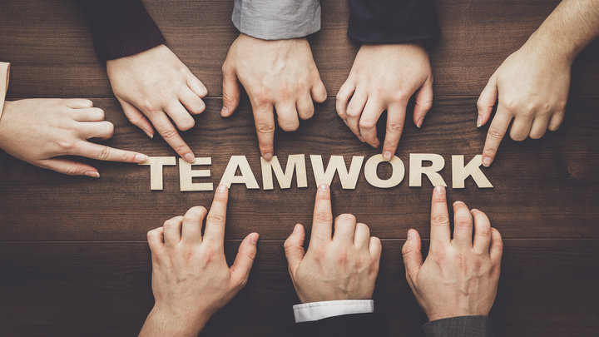

Strong communication
Communication is most important factors for effective team working process. Communication creates chain among the team members. Information share is the main purpose for team works and strong communication help for make effective team (Scott, 2016). On the team working it conflict and uncertain situation must be occur and communication make collaboration and create effective team works. Again strong communication makes friendship and friendship environment is responsible for effective team works.
Build up trust and respect
Team works depend on group participation and individual support must need for effective performance. Trust among the team members can make positive relation and inspired all members for published their individual opinion. Team members hope equal respect from their group members. If individual person could not get proper respect from other members he could not responsible on his duty. So build trust and provide respect strategy must improve the effective team working.
Encourage Socializing
Socializing can improve the group satisfaction and encourage team members for work in together (Blackstone, 2009). Mainly socialization indicates lives in and works together. If team members getting encourage for work together it must make positive impact on the team members. Beside encourage can remove the unnecessary movement and encourage team members for face critical situation. So Encourage strategy can make the effective team working performance.
Practice open communication
For make effective team works it must need to practice open communication process among the group members. When openly share their relevant information it make strong communication chain. Again it published essential opinion and expressed inner feeling. Again it also removes the unnecessary debts and removes the certain conflicts. Practice open communication strategy makes effective team works.
Clearly outline roles and responsibility
Team works success get proper values when team members get accurate direction. When individual member find the clear idea about his roles and responsibility; he can participate on his respective duty. Understanding the message, group task, and guideline easily complete the individual task and it help for operating effective team works. So clear outline and responsibility strategy make effective team works.
Organize team members
Team member organization according to the plan easily achieves the team goal. Without organize the team members it could not finish the respective works. Organize member doing their works within a sustain way (Finch, 2006). Well organize group follow the structural way and arrange the group for focus on goal. Organize team members also distribute members and recruit members who are adaptable and well trained for the specific task. So organizing strategy is helping for getting effective group working.
Define the Goal
Team works contain effective value when team members focus on goal. Define the goal inspire the team members for doing their works according to goal. Again focus on the goal finish the work just time. Time management also ensure when define the goal. Team members make awareness among themselves when they focus on goal. So first duty of a team manager is define the goal and this strategy is help for make effective team working environment.
Group decision making
Team working process is running with based on the group decision. If all group members could not participate on decision making, it impact on taking appropriate decision (Young, 2007). Participate all members enhance the power of group decision and help for taking accurate decision. Group decision takes the necessary step for conduct the team works effectively. When team takes decision it must need to ensure the all members participation. Group decision making process strategy makes the effective team working environment.
Use task management software
Current technological development innovate software that use for management group works. (Reynolds, 2013). According to the specific works mobile based software can manage the team members and indicates the proper direction. Management software make schedule that use the team members for finish their task accurate time. So software using strategy improves the effectiveness on team working.
Maintain the team works balance
Team working balance is helpful for effectiveness because it ensure the proper direction according to the individual members. All the team members need the same works and it can make team balance. According to the team works it should divide among the individual members. After divide the works it makes team balance and all members getting equal scope. Maintain balance strategy impact on the effectiveness on team working.
Create space
Create space on the team working can make chance to the individual members. When single person get space for team working he can innovate new idea and strategy for the team. Create space inspire group members for doing better effort on team working and it bring the positive advantage on group works. So make space on the team for the members can bring effectiveness on team working.
Friendship relation bonding
Friendship relation makes the group works effective and supportive. Friendship can remove the conflict between the team members (Reynolds, 2013). This condition supports each other for doing appropriate works. Strong communication chain also buildup from friendship relationship. Beside collaboration also make from the friendship relation.
Effective team works always bring positive result and reached on the goal. Those strategies easily make effective team and impact on getting positive result. So for build effective team above strategy must be maintained by the team workers.

Discuss how to aware students range of develop communication skill on the workplace
Communication means share information and on the workplace it is the most important issues.
Communication development easily reached on the define goal and achieved the success (Borgo, 2008). On the workplace employees communication must be developing for operates business successfully. Different strategy and plan use for develop communication skill. Effective communication is essential for every step on workplace. Most of the common strategy are mentioned here that impact on develop communication skill.
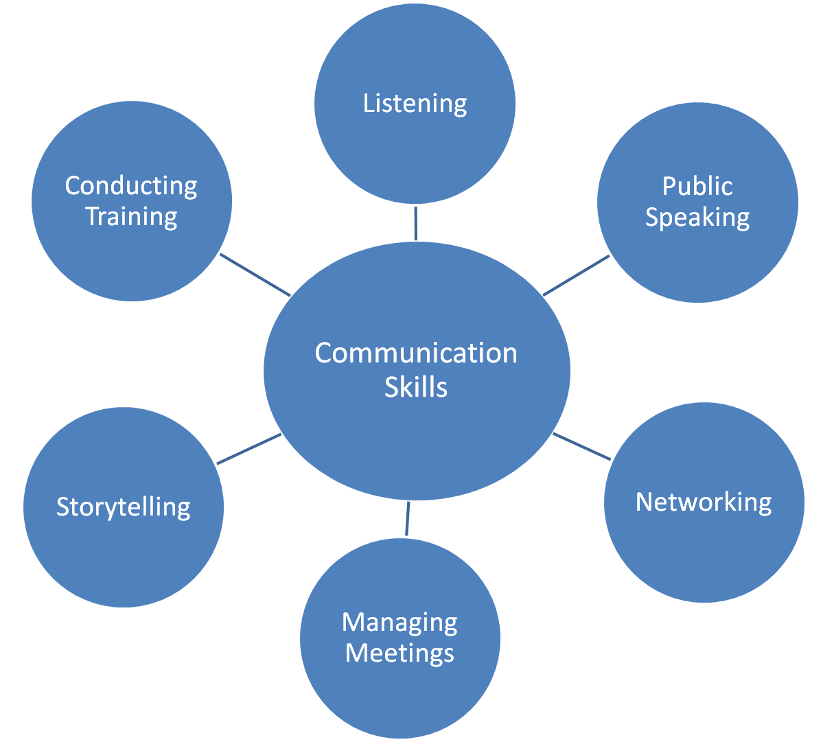
Use body movement
Communication skill not only abounds on speech but also related on body movement. Body
Movements attract the audience and share the accurate message (Reynolds, 2013). Again body movement expressed nonverbal message and support the speaker for expressed his speech. When speaker move body according to the voice it must provide accurate message. So body movement using improves the communication skill.
Take time to response
Feedback communication skill can be improved from the practice of taking time to response. When speaker provide speech it must be learn that means take time then analysis the information and provide response. This strategy improves the communication skill when you provide feedback to the audience or speaker.
Use correct spelling, verb and word
Communication purity can be ensuring by use the correct verb, spelling, and word. When communicator use wrong sequence it should provide the wrong message and interrupt the total communication process. Learner and audience are easily known the message when correct sequence is use on speaking. Using the correct word, spelling, and verb can improve the communication skill.
Avoid unnecessary word and information
Communication always maintains time facilities. If unnecessary words and information are using
on communication it may be impact on the speaker for understanding the proper message. Beside it make shortage on time and could finish communication in accurate time (Katz, 2011). Avoid the unnecessary information improve the appropriateness of the communication and acceptable for the audience. So avoid unnecessary information develop the individual communication and skill.
Formal dress code
Formalities are closely related on the communication because audience attract on formal dress code and focus on communicator. So maintain formal dress code improve the communication level. Again attract the audience is best way to improve the communication. For this reason formal dress code improve the communication skill.
Be humorous
Communication sometimes makes boringness among the listener and destroys the audience attention. If the interesting information, story, jokes can use on the communication it must reduce the boringness and help for attract the audience. Humorous quality should be absorbed because it improves the communication skill.
Being honesty and integrity
Communication share information and honesty make the communication acceptable to the audience. Acceptance is importance on effective communication process because audience beliefs those who express pure and honest speech. So honesty can improve he effective communication skill. Integrity is individual behavior that closely related on the communication behavior. When speaker show integrity on communication it should be impact on listener.
Ensure all participation
Group communication depend on participate all members. When all the members participate on
group communication, it improves the clarity of message (Benaven,2011). Accuracy also improve for participate all the members on communication. So arranging all members for participates on the communication process essential skill and communicator mainly responsible for this. So ensure all participants are such kind of skill that must improve the communication skill.
Workplace is sectors that include the professional carrier’s opportunities. After passing the
student level professional life that means workplace looks after the daily activities (Christian,2010). Students learn the communication process from the academic life and apply it on workplace. Who have strong communication skill getting respect form every one and will be selected on every profession. So communication skill should be improved for getting success and build strong carrier.

Conclusion
Effective team works means earn effective result from the team performance (Lesmo,
2008). Professional life and work place apply the team working perform ace for reached on their goal. Different types of skill improve team working performance. Strong communication chain strategy among the group members improves the teambuilding working. Communication is another important factor on workplace. Communication skill can be improve by apply effective strategy. Ensure all participant skill is responsible for easily conduct effective communication. Most of the popular communication skills are involve on effective team working process. Communication and effective team works are most important element for achieve success in workplace. Main purpose for improve effective team works and communication skill is getting the proper way for build future carrier on professional sectors.

Reference
Benaven, C. (2011). Swot analysis.
Blackstone, W. and Christian, E. (2010). Commentaries on the laws of England. [Charleston,
South Carolina]: Forgotten Books
Borgo, S. and Lesmo, L. (2008). Formal ontologies meet industry. Amsterdam: IOS Press.
Scott, M. (2016). The intellect industry. Chichester, West Sussex, England: J. Wiley & Sons.
Young, P. (2007). Business plan. Chandni Chowk, Delhi: Global Media
Ford, B., Bornstein, J., Pruitt, P. and Young, E. (2010). The Ernst & Young Business Plan Guide.
Chichester: John Wiley & Sons.
Step-by-step business plan. (2007). Perth: Small Business Development Corporation..

Reynolds, P. and Curtin, R. (2013). New Business Creation.
Generate your business idea. (2007). Manila: ILO.
Katz, J. and Green, R. (2011). Entrepreneurial small business.
Baton Rouge, LA: Claitor's Publishing Division.
Blackstone, W. (2009). Commentaries on the laws of England. [S.l.]: Forgotten Books.
Finch, B. (2006). How to write a business plan.

