Managing Enterprise in the 21st Century
Muntasir Reza Chowdhury
ID Number :1916797

Table of Contents
Managing Enterprise in the 21st Century 1
Executive Summary 3
Introduction 4
Business/ Company Overview 5
Product/ Services 6
Market Audit 8
Target Market 9
Marketing Plan 10
Management Team 13
Financial Plan 14
Conclusion 15
Reference 16

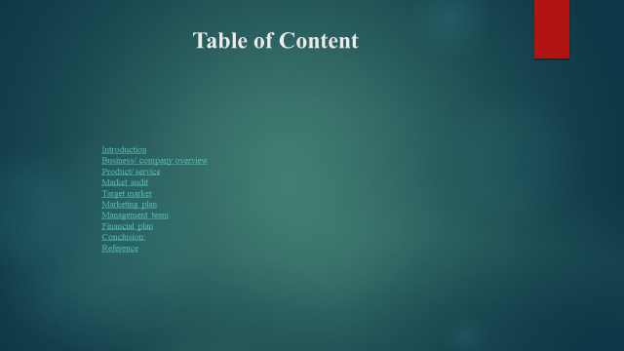

Executive Summary

This report is developed on the business plan of PepsiCo Company. At first, explain about company profile. Company's mission, vision, aim, establishment, and present condition. Then explained the product which PepsiCo produces and the product line of PepsiCo. After that the external and internal market audit system described. Under the marketing plan the product segmentation, positioning, marketing mix, SWOT, etc. tools are applied. The management team handles all the departments and the demand of the customers. The authority takes the decision of the company through financial planning. This report shows a complete business plan which helps the students in the future.

Introduction
This report is about a business plan which mainly facilitates a student by developing awareness about a business including self-employment and think about personal skills to set up a business in the future. From this report, a student will learn how a business planned to run. Through this students will set their mind for self-employment by starting their own business and these also help them to know about their personal skills about making a business plan. If there have absence of any personal skill this report helps them to find out and finally students should enrich their personal skills according to need. So, this report will discuss running and existing company's business plan, about the service or product of that company, financial plan, marketing plan, etc. All these things students will learn by doing this report work.
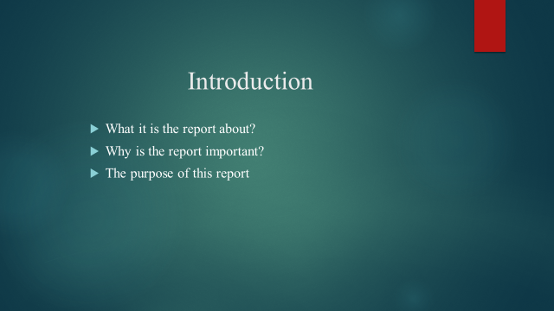

Business/ Company Overview
The chosen company for discussing a business plan is PepsiCo. PepsiCo is a renowned company in worldwide. PepsiCo is a food, snack, and Beverage Company and it was established in 1965 in the USA. Since then to now this company doing very well and maintaining its standard all the time. The mission of PepsiCo is “Create more smiles with every sip and every bite”. The company cares about its consumers and customers need, want, demand, for shareholders by delivering sustainable top tier TSR and also for its own progress (Simon, 2013). The vision of PepsiCo is "Be the global leader in convenient foods and beverages by winning with a purpose". Which shows the ambition to hold up the progress and sustainability in the worldwide market place by producing innovative and new taste product along with great popularity. PepsiCo has different types of product lines according to the need of the target customer and has a strong legacy, management, and market team. So, everything together helping the PepsiCo to get its deserving success.
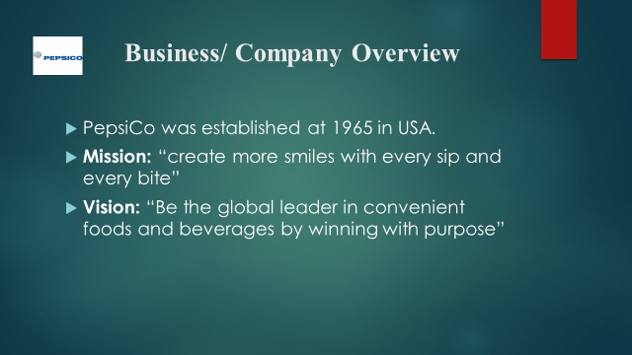

Product/ Services
The product of PepsiCo is known to all and in every corner of the world. PepsiCo has different types of thousands product and that’s why it has a different product line of its product which decreases the complexity of the same types of products. PepsiCo categorized its product according to drinks, foods, beverages, etc. (Thomke, 2017). From the drinks category, people can get juice, energy drinks, sports drinks, cold drinks, water, etc. and again from the foods category, people get breakfast cereal, snack foods, nuts, chips, etc.
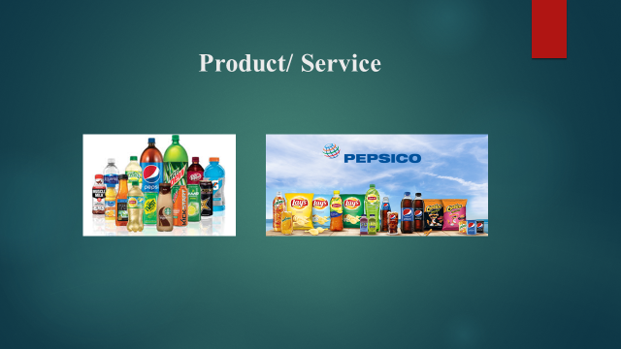
Also can add another information is that PepsiCo set its product line by different brands name which uses the name of PepsiCo. For example, Pepsi, Quaker, Mirinda, KFC, Pizza Hut, Sun chips, Aquafina, etc. So, PepsiCo innovates its new product by different tastes different brands. There has nothing to say about its service. PepsiCo provides the best service to the consumers and customers so that everybody is satisfied with the product and service quality. So, students can learn from that when they have to introduce customer with a new product with good taste and also about service quality. Also providing the best quality service which helps a business in the way of success. The success of business mostly depends on the service providing.
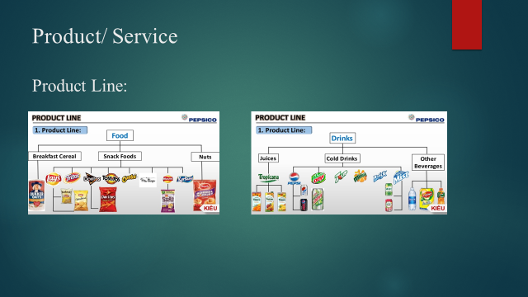

Market Audit
In a business or for a company market audit is a very important function. By doing market audits a company can find out its position in the market and also can know that people are satisfied with their service or not and how customers are responding to their product. If any new company or brand enters the market it's also can know by market audit or collecting information about the market (Simons and Zein, 2007). So, there have two types of the market which follow the PepsiCo Company.
- External marketing audit: PepsiCo Company make external marketing audit to know its condition in the world market and which other companies are doing well better than PepsiCo and which companies are PepsiCo's competitor. Customers are satisfied with the current product and price and to know details about customers' demand.
- Internal marketing audit: Internal marketing audit is not that much important than an external audit. Though to know the internal condition of the company this audit is prepared. By doing internal audit PepsiCo finds out its mistake and weakness and work for it. How the employee is working and responding this also notify by internal audit.
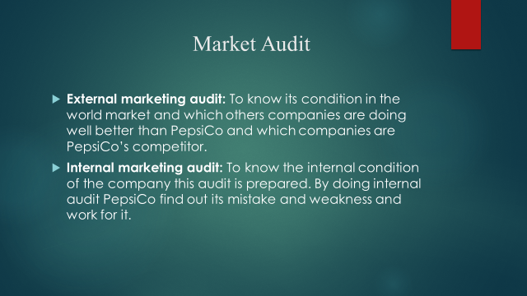

Target Market
The target market is basically about targeting customers on different needs and preferences. Every customer has different types of wanting to depend on their income, age, gender, religion, etc. PepsiCo segments its customer in some categories. They are explained below.
- Geographical: The demand for PepsiCo products depends on the region and area.
- Demographic: PepsiCo segment its target market on this point by the age, life cycle, gender of the customer (Grigsby, 2016).
- Psychographic: In this point, the demand for product depend on the income and lifestyle or life standard of customer.
So, students can learn how to target markets in the world market from this point. Every business should maintain this because the demand for products depends on the different criteria of the customer. Which company can fulfill these criteria of the customers can be successful easily.
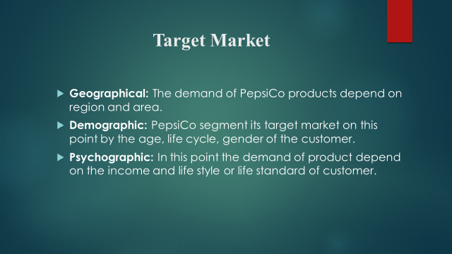

Marketing Plan
In every business have different types of the marketing plan. As PepsiCo is a famous company it has undifferentiated marketing strategies.
- Segmentation: PepsiCo segments its product according to behavior, geographic, demographic, etc. More briefly, according to the age, gender, region, rural/ urban area, lifestyle, class, family standard the demand varies.
- Positioning: Fulfilling the demand of products according to the place and PepsiCo positioning its product perfectly (Jacobson, 2003).
- Targeting: Target the market according to the need of customers. In which place which tastes product is more demanding, they collect the information and supply the product according to need.
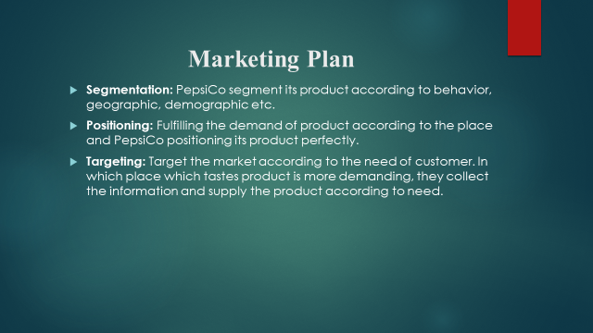

SWOT
- Strength: Second biggest food and beverage firm in the world which is PepsiCo’s biggest strength. Have more portfolio business worldwide. The quality of the product is up to the mark. So, the demand of the PepsiCo product in the market is very high.
- Weakness: Lack of product diversification and use more carbonate in the drink which is declined in the USA. The brand image in comparison with other top companies is not high.
- Opportunities: Increasing demand for healthy products and market expansion by more products and brands.
- Threats: Reducing the demand for a drink for health consciousness and heavy competition in the world market.
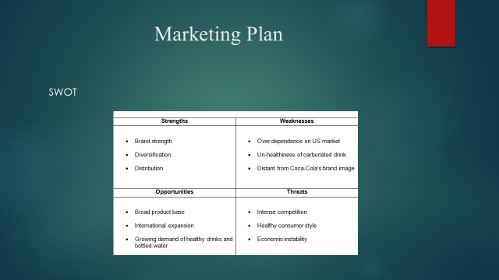

Marketing Mix
- Product: PepsiCo's products are available worldwide according to the need of the customer. The products are like soft drinks, energy drinks, snacks, water, breakfast bars, rich snacks, etc. As it has different types of products they demand products always high.
- Place: PepsiCo uses a global network for distributing its product. Everywhere in the world, the product of PepsiCo is available. The place is not a barrier for PepsiCo (Baines, 2011). For example, the sale of the drink is high in the Middle East country which is different in the USA/UK.
- Promotion: PepsiCo does the promotion of its products in different ways such as online, offline. Offline promotion is advertising, using a billboard, public relations, etc. and the offline promotion is giving advertise on Facebook, YouTube, etc.
- Price: The price of PepsiCo's product is always reasonable. They classified their product price according to the lifestyle of the customer and the demand of the customer. So that all categories of customers can get the product of that company at their expected price.

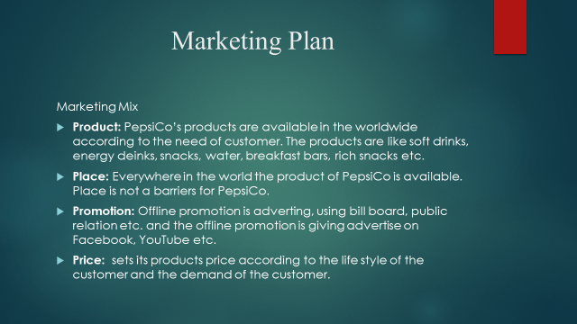

Management Team
The management department of a company is like the company's heart department. Because all the functions of the company are handled by the management team. From the decision making to handling employees' problems, collecting information about customers and consumers and their demand, making a financial plan and implement it, oversee all the functions of all departments in the company, and solve all problems related to the company, etc. PepsiCo Company's management team is a very active team and all the intelligent people work on that team which helping PepsiCo to hold its success (Griffin, 2017). They work together just like family and enjoy their work so that they don't feel dull for a moment. Students will learn about management skills for maintaining a business from that team and how to take decisions cleverly.
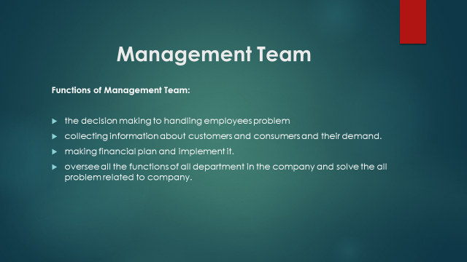

Financial Plan
The financial plan is from where a company or organization collects financing, how they use the finance for the business, and finally what the output is. So, PepsiCo is a big and established company. The share of PepsiCo Company is renowned worldwide. The source of financing of PepsiCo is its share. Most of its finance come from share and from their reserved money. Then the financial team plans how they use the money (Brigham and Houston, 2009). They plan for using money in different sectors and implement them. Then they keep the all financial information and make an output. Which is known as the financial statement. They prepare the financial statement very carefully because the selling of share or the investment of investors wholly depends on the financial statement analysis. Finally every year PepsiCo discloses its financial statement to the public and the interested people get to know about PepsiCo’s financial condition. Investors invest in PepsiCo by assuming the profit of their invested money by analyzing the financial statement of the company Students will learn from this how to make a financial plan and the process of a financial plan which is very important for running a business or company.
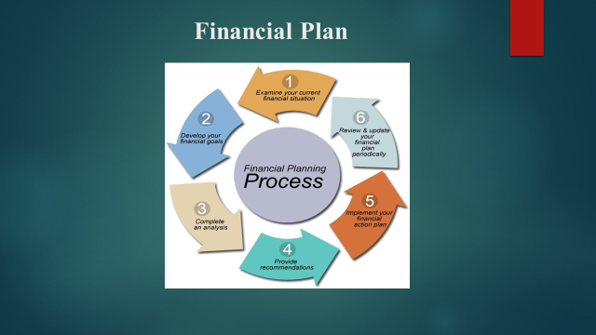

Conclusion
The success of a business definitely depends on the plan of that business. It is said that "A good planning is the halfway to success". So, good planning is very important for any business or company to gain success or to hold up success. In this report, we explained PepsiCo's business plan and how it operates all the functions. PepsiCo is a successful company without any argument and became possible for its good planning and implicate that properly. So, any students want to be successful in business they have to first make a good plan. And have to analyze all the possible weaknesses and strengths. By doing this report students can be encouraged for self-employment and will learn how to make a business plan and solve the problem in the business. So this report helps the student to learn gradually.
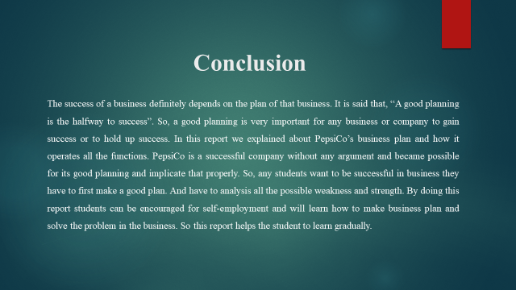

Reference

Baines, P. (2011). Political marketing. Vol. 2 : the political marketing mix: Strategy and implementation. London: Sage.
Brigham, E.F., and Houston, J.F. (2009). Fundamentals of financial management. Mason, Oh: South-Western Cengage Learning.
Griffin, R.W. (2017). Management. Boston, Ma: Cengage Learning.
Grigsby, M. (2016). Advanced customer analytics : Targeting, valuing, segmenting, and loyalty techniques. London: Kogan Page.
Jacobson, M.D. (2003). The Marketing Plan: How to Prepare and Implement It, 3rd ed.20034William M. Luther. The Marketing Plan: How to Prepare and Implement It, 3rd ed.. New York, NY : AMACOM 2001. 318 pp. (paperback) $19.95. Journal of Consumer Marketing, 20(1), pp.73–75.
Simon, M. (2013). Pepsico and Public Health: Is the Nation’s Largest Food Company a Model of Corporate Responsibility or Master of Public Relations? CUNY Law Review, 15(1), p.9.
Simons, D., and Zein, N. (2007). Audit market segmentation : the impact of mid-tier audit firms on the competition. Mannheim: Univ. Mannheim, Sonderforschungsbereich 504.
Thomke, S. (2017). Managing product and service development : text and cases. Boston, Mass. ; London: Mcgraw-Hill Irwin, [I.E.
‌


