





BUSINESS

PLAN
Prepared by: Cristian Stoleru

Student Number: 2215119

Module Name: Entrepreneurship

Lecturer's Name: Nishi Ramsurrun

ECOHIVE
SMARTLIVING
Smart Home Automation Devices

Executive Summary

EcoHive SmartLiving is an innovative smart living system that has been certainly built precisely to be used by residential occupants with a sustainable and convenient lifestyle. Our integrated system allows to provide a variety of solutions: smart thermostats and energy monitoring devices, automatic lighting and smart plugs, and security system, which are run by a single platform that helps to optimize energy consumption and simplify home management. Our target is the people who are more environmentally responsible and leads high technology by industry. Also, we target the people who look for the comfort and efficiency in their homes. The brilliance of our functionality and accessibility with advanced smart home devices creates a good difference from other similar products. Smart home sector, which is the largest among the rest, is forecast to be worth $154.4 billion worldwide by the end of 2024, and the growth rate will be 10% or more. EcoHive SmartLiving not only has an opportunity to recreate the future of home automation but also stress the importance of saving the energy and making the life at the home in the easier way. Trustfully, we do believe that the unique system of ours will be liked by a number of habitants and would provide highly valuable services to the customers.

Table of Content
1. Business description and market opportunity 4
1.1 About company 4
1.2 Market opportunity 4
2. Industry analysis 5
2.1 Overview 5
2.2 Competitive analysis 6
2.2.1 Porter's Five Forces 6
3. Operation and management team 8
3.1 Business process 8
3.2 Management team 10
4. Marketing plan and strategy 10
4.1 Marketing strategy 10
4.2 Competitor analysis: 5Ps framework 11
4.3 EcoHive SmartLiving's 4Ps strategy 12
5. Financial projections 13
5.2 Cost analysis 13
5.3 Profitability analysis 14
6. Risk management 15
6.1 Risks 15
6.2 Mitigation strategies 15
7. Exit strategy 15
8. Conclusion 16
References list 17

1. Business description and market opportunity

1.1 About company
EcoHive SmartLiving, a Limited Liability Company (LLC), is dedicated to empowering homeowners with innovative smart technology.

Mission:
By providing eco-friendly homeowners with user-friendly smart home automation technology that streamlines energy management.

Vision:
Environment-friendly and green homes are what EcoHive SmartLiving envisions in the future, i.e., where homes are smart and sustainable.
Product/Service
Smart thermostats | These adjustable thermostats are able to learn and program their energy use based on your daily habits.
Automated lighting | Smart lights can be operated manually as well as via timers and sensors, such as occupancy sensors and many other sensors.
Smart Plugs | These smart outlets are not only popular because you can control them remotely but also because homeowners
Home security system | Our system is equipped with state-of-the-art surveillance technology such as the smart locks, motion sensors….
Table 1: Products

1.2 Market opportunity
The smart home automation market worldwide is valued at almost $154.4 billion, and this value is expected to increase in 2024 (Statista, 2024). The existence of a sizable market share of the total market signifies a grounded basis of the EcoHive scene. According to a study by Market Research Future, the global automobile industry is estimated to have a value of $433.28 Billion by the year of 2032, with an estimated CAGR (Compound Annual Growth Rate) of 19.7%, which is a very high percentage. This surge spreads over a thriving market that could feature a newbie SmartLiving EcoHive as one of the players to capitalize on.

2. Industry analysis

2.1 Overview
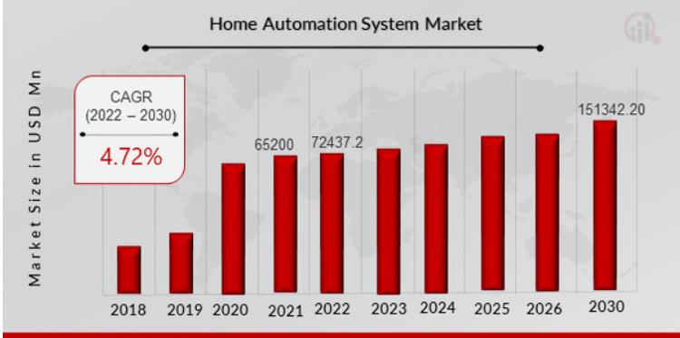
Figure 1: Home Automation Market (Marketresearchfuture.com)
The Start of the Home Automation System market observations was in 2021, the value of USD 65.2 billion was recorded. According to the research & forecast, the Home Automation System market is projected to increase from USD 72437.2 million in 2022 to around USD 151342.20 million by 2030. The annual growth rate in this process is expected to be 4.72% during the years 2022 to 2030 (Gupta, 2024).
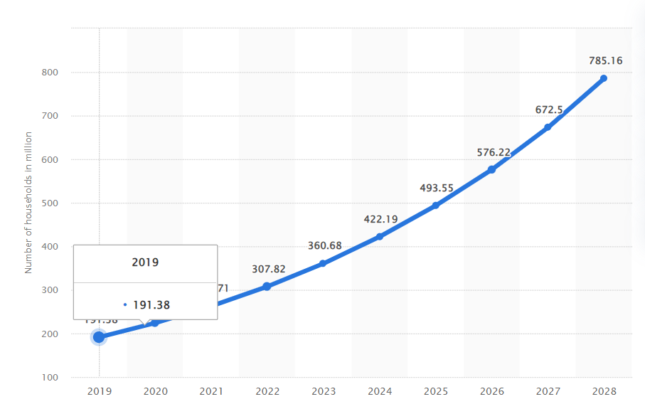
Figure 2: Smart Home Users (Statista, Global: Smart home number of users 2019-2028, 2023)
The number of users smart home worldwide is projected to rise by almost 4 times, reaching 1.2B in 2028 or 117.69% increase between 2023 and 2028.

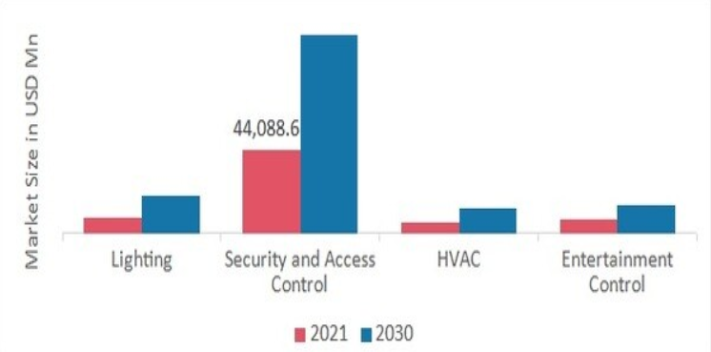
Figure 3: Product Insights (Market Research Future, nd)
As per research, home automation industry is experiencing exponential growth, as modern consumer requires smart home products. Security & access control prevails, the biproduct of which smart cameras and doorbell with a common purpose.
The home automation market boomed and is now projected to increase to $114.6 billion in 2025 (Market Research Future, nd).

2.2 Competitive analysis
The EcoHive SmartLiving s operating in a cutthroat competition with firm names that include Nest, Ecobee, Samsung SmartThings among others.
Here's an analysis of these key competitors using Porter's Five Forces framework:

2.2.1 Porter's Five Forces
Force | Description | Rating for EcoHive SmartLiving
Threat of new entrants | Difficulty for new companies to enter the market | Moderate
Bargaining power of suppliers | Suppliers' ability to control prices | Low
Buyer switching costs | Difficulty for customers to switch brands | Moderate
Competitive rivalry | Intensity of competition in the market | High
Bargaining power of buyers | Customers' ability to negotiate prices | Moderate
Table 2: Porter’s 5 analysis

Explanation

Threat of new entrants: In terms of level of exposure, Moderate is appropriate, I think. The market represents an opportunity.

Bargaining power of suppliers: There a need for media regulation, especially when the distributed platforms are concerned. EcoHive can take advantage of the increasing demand to cutting deals on reducing the costs with its suppliers who are now dealing with larger order quantities.

Buyer switching costs: Moderate every year. Consumers may incur some costs in switching such as devices that are compatible to various platforms which may cater for their various needs.

Competitive rivalry: High. If players are already active on the market, they have powerful brands and imposing portfolios that are hard to compete with (The impact of dominant players on market competition, nd).

Bargaining power of buyers: Moderate (there is measurable progress, but there is no revolution). Consumers on the market of the smart home systems they use are quite keen beneficiaries of this leverage as related with the prices.

2.2.2 VRIO analysis

EcoHive SmartLiving aims to achieve a competitive advantage through the VRIO framework:
VRIO Factor | Description | EcoHive SmartLiving
Valuable | Does the resource/capability provide a benefit to customers? | Yes
Rare | Is the resource/capability uncommon among competitors? | Yes (Patents Pending)
Inimitable | Can competitors easily replicate the resource/capability? | No (Unique Interface & Compatibility Focus)
Organized | Is the firm organized to capture the value of the resource/capability? | Yes (In-house Teams for Development, Marketing, and Customer Support)
Table 3: VRIO
User-friendly interface, energy saving, device-compatibility, intelligent feature for individual devices and easy to use features of our vehicle that helps us compete in the dynamic world of smart home automation.

3. Operation and management team

3.1 Business process
EcoHome SmartLiving’ express its excellence as a coordinated teamwork across its departments. Here's a breakdown of key operational activities:

Figure 4: Operations Process
- Product development: Overlooking full product lifecycle that, starts from course of action, taking concept and then to engineering phase, prototyping and quality assurance. This department is responsible for the innovative, user-friendly, and reliable smart home devices from ecohive, e.g. Smart motion sensors, smart light bulbs, etc.

- Manufacturing and supply chain: Streamlining procurement of goods, production operations, as well as inventory management to ensure a timely supply so the customer demand was promptly met.

- Marketing and sales: Creating and using a vivid marketing scope that connects the brand to its audience, creates product interest and increases sales. Through different forms of acquisition channels, under this department we are responsible for customer acquisition targeting.

- Customer support: Ensuring a high-quality client service by exercising different channels of communication (calls, emails, chat) to consider all kinds of queries, tackle problems, and make clients happy with our eco-friendly products.

- Inventory management: Using data analytics and forecasting models to achieve the level of inventory that will not allow stockouts but will also prevent the problem of overstocking.

- Distribution and fulfillment: Team up with reliable logistics service providers who will be able to guarantee timely and secure delivery of ecohive items directly to client or retailers.

3.2 Management team
Cristian Stoleru (CEO) - (Chief Executive Officer)
MBA and Bachelor of Arts in Business Management. I bring 18 years of B2C product experience in consumer electronics, having conducted operations in product development, marketing, and general management.

Benjamin Walker - CTO
My academic background comprises a Ph.D. in Computer Science and a Bachelor of Science in Electrical Engineering. Industry Experience: Having a plus 22-year experience in a software development and engineering field, I have a recommended expertise in embedded systems, IoT technologies, and cybersecurity.

Chloe Jackson - Branding Director
MBA, majoring in Marketing and Bachelor of Arts of Communications. 20 years + marketing, had every year experience in creating brand awareness and generating leads, increased customer acquisition strongly in tech sector. Achievements: 400% social media campaign success in engaging the brand. Adopted a performance-oriented marketing strategy which elicited a 30% rise in sales after only 1 year.

4. Marketing plan and strategy

4.1 Marketing strategy
EcoHive SmartLiving targets a specific customer profile: eco-accommodating homeowners and tech-mature individuals aged 25 to 55. In general, this group falls in the middle class and usually has the cash to spare, making them the target of various agencies' programs to help them better their living conditions (Pew Research Center, 2016). The smart home automation system that our user-friendly and comprehensive system provide is the much-adored solution for them.

4.2 Competitor analysis: 5Ps Framework

Google Nest
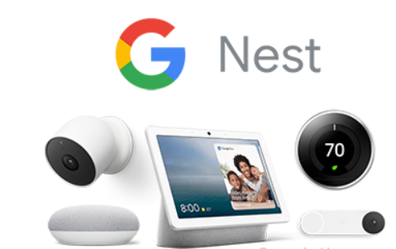
Figure 5: Google Nest (Computer Hope, 2024)
Nest provides the smart home products, like, thermostat, security camera, outdoor camera and detector. (Home.nest.com, nd). Nest products are positioned at a premium price point, targeting customers willing to pay for high-quality design and reliable performance (Amazon, nd) and Best Buy. they develop viral digital marketing campaigns with key figures cooperation in order to reach their goal audience.

Ecobee

Figure 6: Ecobee’s Logo (Ecobee.com)
Likewise, Ecobee specializes in smart thermostats that feature a learning function (Ecobe.com, n.d.). The prices for Ecobee products reach comparatives with Nest (Homedepot.com, n.d.). They engage in online advertising, apps, social media marketing.

Samsung SmartThings

Figure 7: Samsung SmartThings Logo (Samsung.com, nd)
Samsung SmartThings offers a vast ecosystem of compatible smart home devices from various brands (Smartthings 2024).

4.3 EcoHive SmartLiving's 4Ps strategy
Based on the competitor analysis, we can develop EcoHive SmartLiving's 4Ps strategy:

Product:
Our smart home system will be a complete one that primarily emphasizes energy efficiency with smart thermostats, power monitors, bulb control, smart plugs and a security system to appear later in our project plan.

Price:
A value-based approach to pricing will be employed, which will accomplish the balancing between the perception of value and affordability of a complete energy efficient no-fuss smart home system.

Place:
First of all, an e-commerce store will be our main sales channel, it will be developed, it will have detailed information about products, installation guides and purchasing options.

Promotion:
We aim to tap into the potential of social media channels like Facebook, Instagram, and Pinterest.

Financial projections
5.1 Revenue forecast:
Year | Target Market Penetration (UK) | Customers Acquired | Average Selling Price (ASP) | Projected Revenue
1 | 2% | 12,000 | £399 | £4.8 million
2 | 2% | 48,000 | £399 | £19.2 million
3 | 2% | 108,000 | £399 | £43.2 million
4 | 2% | 192,000 | £399 | £76.8 million
5 | 2% | 300,000 | £399 | £120 million
Table 6: Revenue Forecast (GBP)

The market for global smart home automation is predicted to reach $154.4 billion valuation by the year 2024 (Statista, 2024). Our major goal is to win market share of 2% per the UK smart home penetration rate as of 5 years period, or a minimum of 1.2 million clients expected.

5.2 Cost Analysis
Year | Product Development | Manufacturing (Variable) | Marketing & Sales | Customer Support | Operational Expenses | Total Expenses
1 | £200,000 | - | £150,000 | £50,000 | £50,000 | £450,000
2 | £100,000 | [Variable based on production volume] | Ongoing marketing efforts | £75,000 | £60,000 | [Variable based on volume & marketing strategy]
3 | £100,000 | [Variable based on production volume] | Ongoing marketing efforts | £100,000 | £70,000 | -
4 | £100,000 | [Variable based on production volume] | Ongoing marketing efforts | £125,000 | £80,000 | [Variable based on volume & marketing strategy]
5 | £100,000 | [Variable based on production volume] | Ongoing marketing efforts | £150,000 | £90,000 | [Variable based on volume & marketing strategy]
Table 7: Cost Analysis (GBP)

The first-year product development expenditures encompassing engineering, design, and prototyping is estimated to be about £200 000 while the annual expenditures will average £100 000. In the first year, we shall spend £150.000th for website development, SEO optimization, and the initial marketing campaigns, with the price slightly lowering as the production volume increases. We will remain focused on this portion of our operational budget because it can either decrease or remain the same as we start becoming more popular. Customer support cost will be around £50,000 in year 1 and then increase proportionally with the rate of growth of our audience. These costs could be £50,000 in the first year and increase moderately as we expand our audience.

5.3 Profitability analysis
Our profitability timeline will depend on achieving economies of scale in manufacturing and optimizing marketing spend. We anticipate achieving profitability within 3-4 years.

5.4 Funding requirements:

Category | Allocation
Product Development (Year 1) | £200,000
Marketing and Sales (Year 1) | £150,000
Inventory and Manufacturing Setup | £100,000
Operational Costs (Year 1) | £50,000
Total Funding Requested | £500,000
Table 8: Funding Requirements (GBP)

6. Risk management
EcoHive SmartLiving recognizes the dynamic nature of the smart home automation market and has identified several key risks that could potentially affect our success.

6.1 Risks
- The leading companies, such as Nest, Ecobee as well as Samsung SmartThings have already won their due place and brand prestige in the market.
- Smart home landscape is drastically changing constantly as there of new technology and features that keep emerging (Insights, 2023).
- The increased use of interconnected technologies brings with it the complications about data security loopholes as well.
.

6.2 Mitigation strategies
- We will underscore our attention to low power consumption, simple interphase for customers, and one system incorporating all sensors to be distinguishable from competitors.
- The budget also includes allocations for R&D to take advantage of cutting-edge technology utilization and mastered functionality.
- It will be our mission to give software issue updates and ensure the device’s compatibility with the new smart home devices on the market.
- We will carry on running security audits and adopt strict guidelines and standards to protect users’ data.
.

7. Exit strategy
EcoHive SmartLiving's envision several potential exit strategies that align with this vision:
Acquisition by a Larger Company: EcoHive Smartliving, having its high efficiency and usage-friendly system could be of huge market’s interest for players like technology or home automation companies.
Initial Public Offering (IPO): This IPO serves as a condition for our company to collect the required capital for the sake of continuing innovation strategies and advancement. Becoming a publicly traded company besides would be another step-in progression on our track to become a leading company in the area of smart home automation and will also allow us to boost our brand image.

8. Conclusion
EcoHive SmartLiving implements the ultimate and user-friendly smart home automation system featuring an array of eco-conscious functions to enhance energy efficiency and provide you with the opportunity to manage your household electronics in the most convenient way. What sets us apart is the fact that we predominantly emphasize efficiency as well as simplicity. We want our customers to have a smart home experience that covers a large number of smart devices. The worldwide market for smart home automation is believed to be experiencing the kind of fast growth that provides an exciting chance for the EcoHive SmartLiving. According to the results of the market research, we observe tangible demand for solutions of the above-mentioned type. Complete coincidence is represented with the formulation of the value proposition. EcoHive SmartLiving appears to be quite resilient because of a well-outlined market strategy, a real financial plan as well as comprehensive risk effective practices.

References List
(No date) Amazon.com: Nest Devices. Available at: https://www.amazon.com/Nest-Devices/s?k=Nest+Devices (Accessed: 19 April 2024).
Ecobee (no date) Smart Thermostats & Smart Home Devices. Available at: https://www.ecobee.com/en-us/ (Accessed: 12 April 2024).
Ecobee - programmable thermostats - thermostats (no date) The Home Depot. Available at: https://www.homedepot.com/b/Heating-Venting-Cooling-Thermostats-Programmable-Thermostats/ecobee/N-5yc1vZc4kcZeko (Accessed: 12 April 2024).
Features of the SmartThings services (2022) Samsung pk. Available at: https://www.samsung.com/pk/support/apps-services/features-of-the-smartthings-services/ (Accessed: 12 April 2024).
Global: Smart home number of users 2019-2028 (2023) Statista. Available at: https://www.statista.com/forecasts/887613/number-of-smart-homes-in-the-smart-home-market-in-the-world (Accessed: 10 April 2024).
Gupta, A. (2024) Home Automation Market Growth, trends, size and forecast to 2030, Home Automation Market Growth, Trends, Size and Forecast to 2030. Available at: https://www.marketresearchfuture.com/reports/home-automation-system-market-6082 (Accessed: 20 April 2024).
The impact of dominant players on market competition (no date) FasterCapital. Available at: https://fastercapital.com/topics/the-impact-of-dominant-players-on-market-competition.html (Accessed: 19 April 2024).
Lindner, J. (no date) Home Automation Industry Statistics • Gitnux, GITNUX. Available at: https://gitnux.org/home-automation-industry/#:~:text=Highlights%3A%20Home%20Automation%20Industry%20Statistics,at%20%2416.4%20billion%20in%202019. (Accessed: 10 April 2024).
Log into the nest app (no date) Log into the Nest app. Available at: https://home.nest.com/ (Accessed: 10 April 2024).
Pew Research Center (2016) 1. demographic trends and economic well-being, Pew Research Center’s Social & Demographic Trends Project. Available at: https://www.pewresearch.org/social-trends/2016/06/27/1-demographic-trends-and-economic-well-being/ (Accessed: 12 April 2024).
The rise of the Smart Home: How Technology is changing the way we live (2023) Insights. Available at: https://insightss.co/blogs/the-rise-of-the-smart-home-how-technology-is-changing-the-way-we-live/ (Accessed: 22 April 2024).
Smartthings (2024) Samsung US. Available at: https://www.samsung.com/us/support/owners/app/smartthings (Accessed: 19 April 2024).
What is google nest? (2022) Computer Hope. Available at: https://www.computerhope.com/jargon/g/google-nest.htm (Accessed: 10 April 2024).

