University of Wales Trinity Saint David
Research Proposal

The influence of Chinese dragon image on CHIMEAR

MA 3D Computer Animation
Student: Lun You
Lecturer: Phil Organ
Nabeel Masih

6_{th} Dec .2021
Announcement on the Originality of Dissertation

The article should be accompanied by a declaration, which states that: the article is original, has been written by the stated authors who are all aware of its content and approve its submission, has not been published previously, it is not under consideration for publication elsewhere, no conflict of interest exists, or if such conflict exists, the exact nature of the conflict must be declared and if accepted, the article will not be published elsewhere in the same form, in any language, without the written consent of the publisher.

Date:
Signature:

Abstract

The dragon appeared in the myth of all places, people can say that it is not strange. Dragons have different shapes and cultural backgrounds in different places. And with the development of science and technology, people have brought the image of dragons into movies, and the image of dragons has become more diversified. Today's computer technology is able to put the dragon element in front of the audience, and we can appreciate and analyze it.
In this paper, I will study the design of CHIMEAR and consider it in all aspects. Creating better, more detailed characters through research is the purpose and significance of current research.

Keywords: Dragon Chimera

Contents

1.Introduction 4
2.Research 6
2.1 What is a dragon? Where do dragons come from? 6
2.2 The difference between Eastern and Western dragons 8
2.2.1 Differences in appearance 9
2.2.2 Different cultural differences 11
2.3 The Chinese dragon in the movie 14
3.Methodology 16
4.Proposal plan 17
5.Conclusion 18
6.References 19
7.Bibliography 20

- Introduction

CHIMEAR came from outer space. It came to earth more than 3,000 years ago. It has a body like a snake, two talons like eagles, a head like a cow, horns like a deer, hair all over its body, and voice like a human. Because CHIMEAR's body is unique, it can glide freely through the atmosphere, much like a snake swims through water. At that time, human beings were in primitive society. When they saw CHIMEAR flying in the sky and speaking human language, they all regarded it as god and totem, and called it dragon.
So the humans and the creature, called the dragon, lived peacefully for years and years. The humans offered food to CHIMEAR, and CHIMEAR naively treated the humans as friends. But with the development of human civilization, people have more powerful weapons, also have greater ambition. I don't know when it started, People began to spread that dragon's horn could cure diseases, dragon's blood could heal wounds, dragon's claw could replace severed limbs, and people could even get endless life by eating gentian. Humans began to hunt and kill the gods they used to worship. Naive CHIMEAR thought humans were as good as before and stepped into the trap set by humans.
In less than a hundred years, CHIMERA had disappeared from the earth and people had gradually forgotten about the dragon who had always been around. Time comes to the 20th century, there are many mysteries, the Loch Ness Monster, the Yingkou Dragon incident in China, these things can not be explained by science as if to say, dragon, CHIMEAR it seems that it is back.
From ancient times to the present, there are many legends and myths about dragons in various countries. In different myths, dragons play different roles, either good or evil. In the movie CHIMEAR is combined with the legend of the dragon, giving a new interpretation of the appearance of the dragon.
This paper will analyze the description of dragon form in history, how the body is constructed, and what characteristics of dragon in different regions. Then, I analyzed the dragon's form, action and background in the film to determine the final effect of CHIMEAR.

- Research

2.1 What is a dragon? Where do dragons come from?

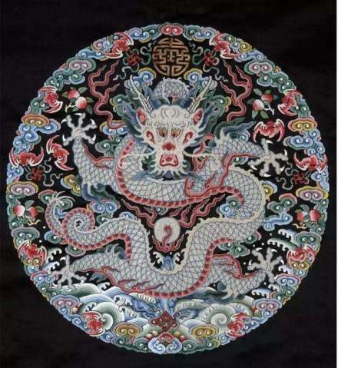
“The dragon was born in the youth of the East, a creature engendered between inward fear and outward peril, was nurtured among prehistoric wanderers, and has survived in the hinterlands of ignorance and superstition because it embodied the underlying principle of all morality-the eternal contrast and contest between Good and Evil, typified by the incessant struggle of man with the forces of nature and with his twofold self. In the East the dragon, like the primitive gods, was by turns deity and demon; carried westward, it fell almost wholly into the latter estate, or was transformed into a purely allegorical figure; and it has its counterpart, if not its descendants, in the religious faith and rites of every known land and all sorts of peoples.”[1] The image of dragon contains a variety of animal elements. Many people only discuss its origin based on a certain feature, so there are a variety of views about the prototype of dragon. One of the most influential is the dragon prototype for the snake said. Famous scholar Wen Yiduo was discussed the prototype of dragon in the 1940 s, according to the research, the dragon totem is the initial prototype of the snake totem, the elimination of the cow, deer totem clan, the ox horn or antlers in the snake's head, and then add the pig's head or the head of the horse, plus a tiger or a crocodile legs, eagle claw, fish scales, the tail of a flower, After a long period of development, the collection of many totems has formed the image of Chinese dragon totem. After Wen Yiduo, many scholars also believe that the prototype of dragon is snake.
Some people believe that the dragon is based on a crocodile. Wei Juxian, an expert on ancient Chinese history, first proposed that the dragon is based on a crocodile. In his 1934 book, he said that "the dragon is the crocodile", and some foreign scholars also believe that the dragon is the crocodile. In addition, some people believe that the basic forms of the dragon's backbone are snakes, lizards and horses, while others believe that dragons evolved from lightning or rainbows.

2.2 The difference between Eastern and Western dragons
“In early cultures, the dragons were often seen as mighty serpents and beasts that were either extremely benevolent or fearsome and difficult to kill. The beliefs of a region are often influenced by geographical location. Eastern cultures often saw dragons as a knowledgeable deity that had power over storms and water. Additionally, they also saw the dragon as a powerful and benevolent creature that could ward off evil.

Western cultures had a very different perspective. They often saw dragons as evil beasts that reveled in killing and chaos. Many dragons are depicted as living in dark and dangerous places that were often perilous for men in ancient times. Additionally, they were often thought to guard hoards of treasure.

In both cultures, dragons were largely thought to be wingless before the Medieval Ages. During this time, the Western cultures began to transform their dragon portrayals, while the Eastern cultures continued with their traditions.”[2] Different regional cultures lead to different status of dragons in eastern and western legends. Their differences can be seen in descriptions of their appearance and cultural differences.

2.2.1 Differences in appearance

The Western dragon is usually described as having the body of a mountain lion, two large bat wings or pinions, four legs, and a head somewhat like a horse, with horns and scales. The colors most often mentioned in stories are green, red or gold. Its tail is long and sinuous, with spines at the end and possibly barbs. At the end of each leg are huge claws, similar to those of carnivorous birds. Dragons have rows of fangs and often dorsal spines. In late to modern times the creature usually breathes fire or poison, or poisonous blood. Has great strength and magical abilities.
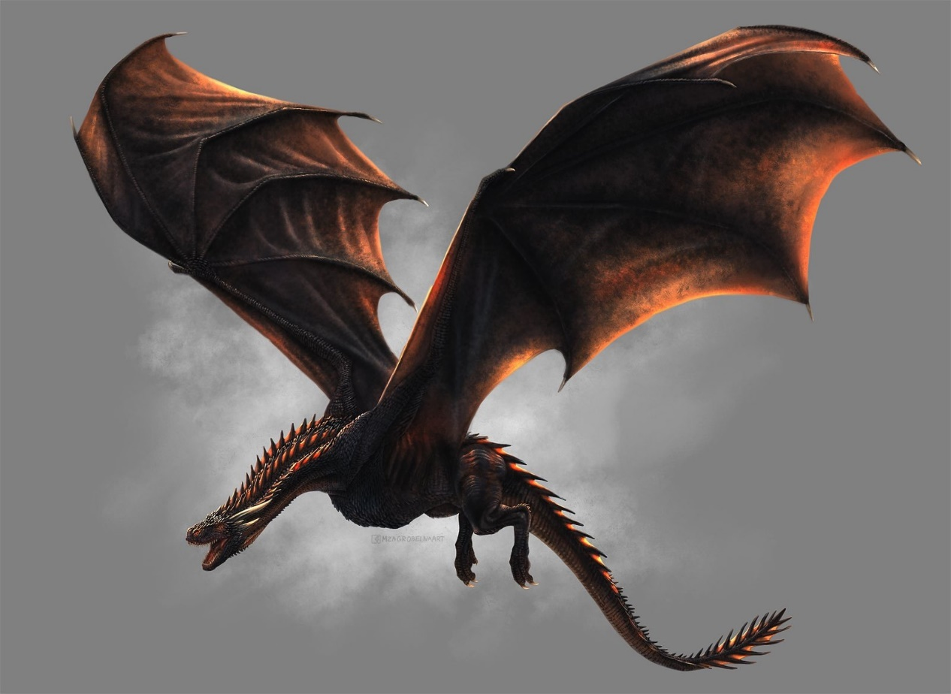
In the West, the word Dragon refers to a creature with four legs and a pair of independent wings, with a total of six limbs. Instead of having independent wings, they form wings with forelimbs like bats. The four-legged creature with independent hind legs is not a Dragon, but a bipedal Dragon wyvern.

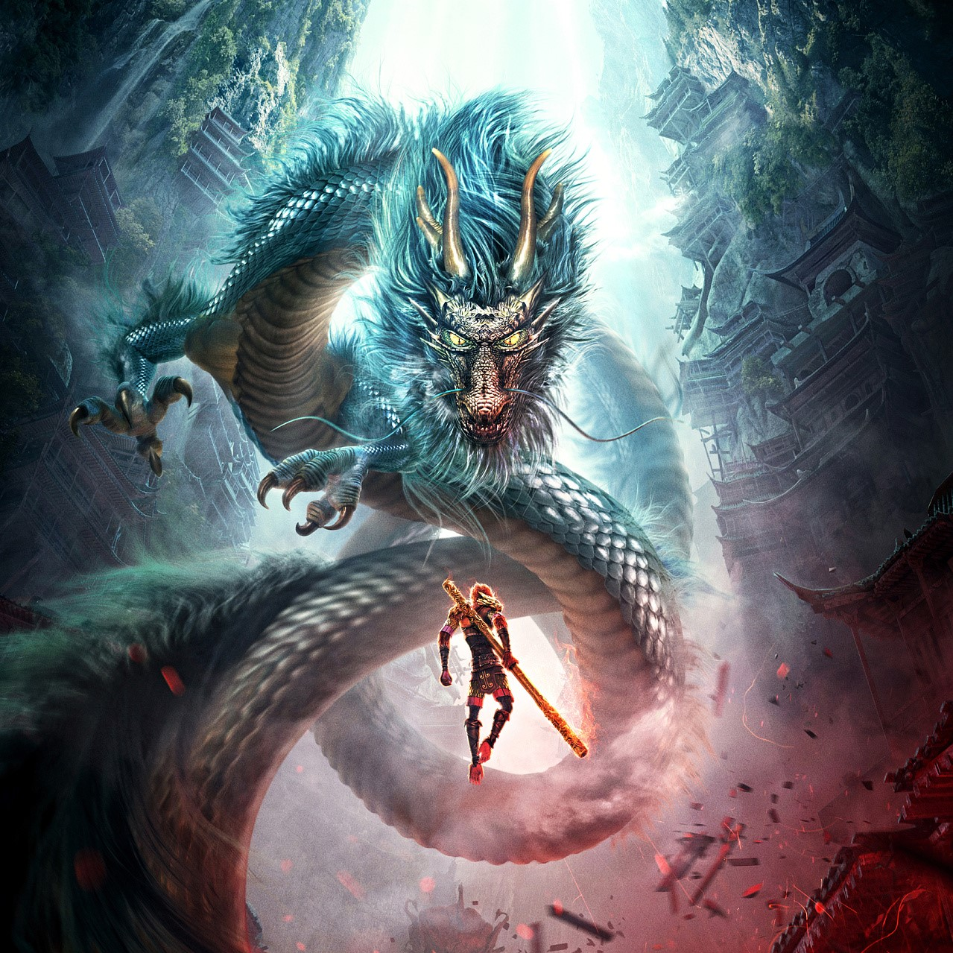
There are many theories about the origin of the image of the Chinese dragon. Some say it comes from the crocodile, some say it comes from the snake, some say it comes from the pig, and some even say that the earliest dragon is the lightning in the sky when it rains. Now most experts believe that the dragon is a totem synthesis with the snake as the main body. It has the body of a snake, the head of a pig, the horns of a deer, the ears of an ox, the whiskers of a sheep, the claws of an eagle and the scales of a fish.

2.2.2 Different cultural differences

“There are differences in traditional beliefs. In the West, people have endued dragons various images People think that the dragon is a huge monster with huge wings, a deer-like horns, a sturdy body, the eagle's claws and a large painting nostril. It can run out of flame to burn the house. At the same time, dragon is also very alert, guarding the treasures of gold and silver and the important intersections in the legends do not pass. It is cruel and inhuman, killing human beings. Its appearance will only cause endless harm to mankind The hero slays dragon is to promote justice, and warriors mark the supreme glory by killing the dragon. As mentioned Bible, sin is the essence of dragons Christians are proud to kill dragons. Therefore. Westerners think that the dragon is the embodiment of evil. In fact, despite the fact that the Christian faith has put Western dragons on a deep anti-stigmatization, for such creatures with terrible power, the ancient Europeans who are martial artists may fear the true attitude of Western dragons. In the Middle Ages or modern times, there were countless nobles with European dragon emblems. The early guns and artillery were also nominated by dragons or dragon-shaped monsters.”[3] Nowadays, the western folk view of dragon has long been separated from the absolute evil demon, and is more of a neutral creature with power. Although Christianity is still the mainstream of Western culture and the Western curriculum includes "religion", in the 21st century, not every Christian is a bigot like the crazy believers controlled by the church a few centuries ago. In this cultural atmosphere, "dragon" still has a large number of fans.

“In traditional Chinese culture, loong is the symbol of authority and nobility, and there are three opinions about the symbolization of loong. Firstly, people think that it is the symbol of the Chinese nation. This is the reason why Chinese people regard themselves as the offspring of loong. Secondly, loong is the symbol of emperor. It stands for the supreme power of the emperor. As we mentioned before, in Chinese history, the emperor of each dynasty called himself the real loong. Even all the emperor's daily stuffs are named with a character of loong, such as loong ti, the body of the emperor, loong guan, the splendid official cap, etc. At last, it is a symbol of wisdom. Zhu Geliang, who is a sage, is called as "wo loong" which means a sleeping loong. That is to say although he is cultivating his mind at that time, once he finds a proper chance, he can have a great achievement. A person who has great ambition, outstanding abilities and extraordinary achievements always be called as loong. So when someone says "wang zi cheng long", it does not means that he wants his child to be a creature with wings in back and horns on head. He really wish is that his child can be a person filled with wisdom” [4] Loong is the Chinese word for dragon, Compared with the evil image of the West, the Chinese dragon represents justice. Therefore, the role of the Chinese dragon must be much bigger than that of the Western dragon. It has many functions that the Western dragon does not have. The Chinese dragon represented hope and people in ancient society. In feudal society, the dragon was used as a symbol of imperial power and was dignified. Sacred and solemn, for the consolidation of the ruler's ruling position made a great contribution. In addition, among the traditional Chinese folk beliefs and totem worship, dragon worship, dragon totem and dragon belief, which have been advocated by China since ancient times, are more widely spread through Chinese people's thoughts.
Chinese and Western cultures have cultivated two "dragons" in different backgrounds, which form a sharp contrast due to the functions and values given to them by the society. The Chinese dragon is a kind of beast, but its status is high in folk belief. Western dragons are characterized by evil and fierce images. That's why the naive CHIMEAR is more like a Chinese dragon, they want to live in peace with humans.

2.3 The Chinese dragon in the movie

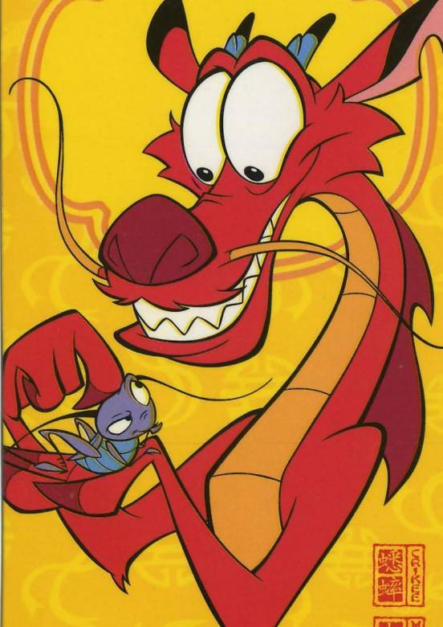
The Disney animated film Mulan, released in 1998, features a Chinese dragon Mushu，” In many scenes of Mulan, dragon elements are used, such as dragon tattoos on soldiers, screens and dragon-shaped patterns on flags , and dragon head images on cannonballs. The most obvious image of Mushu does not have the symbolic meaning of the Chinese dragon, but it is also clearly different from the image of the dragon in Western culture.” [5] The appearance of the dragon in the film refers to the Chinese dragon image in myth, but the meaning of expression is completely different. Dragons are no longer gods that people can't touch, much like CHIMEAR, they are more like people's friends, just like cats and dogs can keep people company.

Adding Chinese dragon images to movies is already the best way to express East Asian elements. In two animated films released in 2021, Wish Dragon and Raya and the Last Dragon, Chinese dragon images are used as references for the main characters. What's more, the two movies have one thing in common. They both treat dragons as friends of human beings, rather than gods on high, which makes them closer to the audience and makes them feel real.



3.Methodology

In mythology, the dragon is a supernatural animal. It looked strange, like a large herd of animals.

It is said that the Chinese dragon is made up of nine animals, but there is no agreement on which nine animals it is. People default dragon image, slender body, body surface like a snake, it has horns like deer, ears like cattle, there are two shrimp beard mouth, there are big convex round eyes, but also have long claws such as eagles, tigers like feet, with fins, mouth contains a bead.

But dragons also have different animal compositions at different times. The dragon in the Western Han Dynasty was slender and snake-like, with a tail and fin at the end. The head resembles a crocodile, the whole is slender and long. In the Eastern Han Dynasty, the dragon was stout, like a tiger, with a distinct tail and individual fins. The horns are like ox horns. Under the horn, there are raised ribs, the top of the front roll, there are similar antlers. And they all have wings. The legs are longer. The tiger is the main image, supplemented by other animal images. From the Southern and Northern Dynasties to the Sui Dynasty, the dragon was slender, tiger-shaped, with a distinct tail and flame rings on its neck and back. In the Song Dynasty, there was a circle of fins on the tail. Absorb the characteristics of the lion image, round and plump, head after iguana. In the Tang Dynasty, forked antlers appeared. The upper lip is long and pointed at the top, and the lower lip is short and no longer curling. Dragon wings are already ribbon shaped. In China, the dragon has gone through four stages of development: the stage of totem worship, the stage of god worship, the stage of combination of dragon god worship and emperor worship, and the stage of combination of Buddhist Nagarong worship and Chinese dragon worship.

4.Proposal plan

Human history is full of myths and legends about the creation of imaginary creatures. These myths and legends can bring a lot of inspiration and realize a lot of interesting imagination. When creating fantasy creatures, we still need to follow evolution and some scientific evidence, such as whether CHIMEAR's aerial gliding motion meets all the needs of having only two front PAWS.
In order to create an artistic and aesthetic fantasy creature, it actually needs to be created on the basis of a real biological structure. When splicing different species, it can replicate exactly the appearance of the original host and can be modified appropriately, such as increasing muscle density, body size, etc.
CHIMERAR is a kind creature. In order to make CHIMEAR more flexible and vivid, we can refer to the hair texture of various animals. The hair shape, material and tactile sensation of different areas on its body are different. The hair on the back is woolly and layered; The hair on the horn is like the hair of the antlers, thin. The antler-shaped dragon horn is also one of the traditional design elements of the Chinese dragon, which is a symbol of good luck. Western dragon horns are mostly goat horns and ox horns, which are more aggressive, but the antlers are fluffy, which seems to have an affinity. The whole design language is to let people love it, rather than fear it.

5.Conclusion

All in all, CHIMEAR's form and actions vary depending on what is required, and the character looks different. However, based on the background and story I want to express, the image of the role will also change according to the content. Through research, the image of the dragon in the myth is mostly similar to the style of God, while the dragon in the animated film is more close to the people without scales, which will make my creation direction more clear. By studying these dragons, I learned more about my own art style. The design of CHIMEAR should start from the element content, find the prototype you want to design, and then send out ideas, and integrate the unique style of the dragon into the design of CHIMEAR to create a more beautiful and unique character.

6.References

[1] Ingersoll, E. (1999). Dragons and dragon lore. Book Tree.

[2] Prof. Geller, (2018). Dragon. mythology.net.

[3] Yuan, L., & Sun, Y. (2021). A Comparative Study Between Chinese and Western Dragon Culture in Cross-Cultural Communication. In 6th Annual International Conference on Social Science and Contemporary Humanity Development (SSCHD 2020) (pp. 74-77). Atlantis Press.

[4] Yuan, L. I. U. (2015). Cultural differences of Chinese loong and Western dragon. Studies in Literature and Language, 10(3), 40-43.

[5] ZHEN, Z. (2021). Analysis of Sino-American Culture in Disney Animation Mulan. International Journal of Contents, 17(1), 11-17.

7.Bibliography

[1] Venuti, Lawrence. (1995)The Translator’s Invisibility–A History of Translation [M]. London and New York: Routledge.

[2] Webster’s Dictionary of American English [Z]. Random House. FLTRP, 1997.

[3] Werner J. Severin, James W.Tankard, Jr. (2000) The Clash of Civilizations and Remaking of World Order [J]. Allyn & Bacon, (07): 55-60.

[4] Beowulf, A. (2005). A verse translation. Penguin Classics.

[5] Chen, S. (1959). Romance of the three kingdoms, Zhu Geliang. Beijing: Zhong Hua Press.

[6] Jones, D. E. (2000). An instinct for dragons. New York: Routledge

[7] Pang, J. (2007). The culture of Chinese loong. Chongqing: Chongqing Publishing House.

[8] Shi, G. (2009). The difference between Chinese loong and western dragon. Journal of Chongqing Institute of Technology.
[9] The American Bible Society. (2006). Inside the mysteries of the Bible. Time Inc Home Intertainment.

[10] Tresidder, J. (2002). Symbols and their meanings. London: Cambridge University Press.

[11] Yang, C. M. (2000). The comparison and translation between loong and dragon. Journal of Guangxi Teachers Education University.

