The characteristics & reception of Isaac
Word count: 3232

The book of Genesis is rooted in the beginnings of relationships and in chapter 11, is where the Patriarchal history starts. Isaac was one of the key patriarchal figures of the Hebrew Bible, paired with his father Abraham, along with Isaac’s son, Jacob, forming the three patriarchs, through whom God’s chooses relationship with to give a covenantal promise. Therefore, Isaac plays a key role in the ancestral history of Israel.
Isaac’s story started in Genesis 21, with his birth, where the Lord visited Sarah, his mother and delivered the child He promised her, which took place in approximately 1851 BC. This took place in Beersheba, in the land of Canaan, which is nowadays, located in Southern Israel. Along with the birth passage, this essay will talk about the sacrifice of Isaac (Genesis 22), the wife-sister motif (Genesis 26) and the blessing narrative (Genesis 27) in order to understand Isaac’s character.
This essay examines the characteristics of Isaac as a son, as a husband, as a father and ultimately as a patriarch of Israel’s history. It will also examine the reception history of Isaac through the medium of artwork in children’s storybooks and how the reception differs between the Jewish faith and the Christian faith. Additionally, it will apply a psychological perspective to analyse Isaac’s character and will also investigate the blessing narrative through the lens of disability theology as reception history.
This essay concludes that Isaac has many negative characteristics as a patriarch and that Jewish and Christian interpretation of the text portray fundamental differences in the afterlife of Isaac.
Isaac as a son
The readers of the bible are introduced to Isaac in his birth narrative in Genesis 21, where he was named ‘Isaac’ or ‘Yitzhak’ in the Hebrew, meaning ‘laughter’; this is because God provided a miracle child despite Sarah’s infertility (Genesis 20:18) and both Abraham and Sarah’s old age of conceiving a child (Genesis 18:11). “Now Sarah said, ‘God has brought laughter for me; everyone who hears will laugh with me’” (Genesis 21:6). In Ancient Hebrew Culture, a person’s name coincides with their circumstances, fate and identity. They named Isaac as a commemoration of a moment for the long awaited heir, which was a time of joy and celebratory laughter, yet, some argue that this was actually a mocking laughter, revealing doubt and bitterness. This shows that the root of Isaac’s identity, within his name itself, has some discourse on the true meaning, which is important to his fate. Also, Isaac is unique as he was the only patriarch who did not later have a name change, plus, he was the grandfather of the twelve tribes of Israel (Genesis 32;35;49).
In Isaac’s case, God’s promise to Abraham was that he will essentially be the Father of a great nation, which occurred in Genesis 12, approximately twenty five years before God’s promise was delivered through the birth of Isaac. “He brought him outside and said, ‘Look towards heaven and count the stars, if you are able to count them.’ Then he said to him, ‘So shall your descendants be’” (Genesis 15:5). This word from God was a covenant promise to Abraham and his family line. However, before the birth of Isaac, Abraham and Sarah took this promise into their own hands and had a son called Ishmael by using Hagar, Sarah’s servant (Genesis 16). Ishmael was not treated as equal to Isaac by the family and was later expelled with his mother Hagar (Genesis 21), however, God still chose to bless Ishmael, who in Islam is highly valued and believed to be an ancestor of Muhammad and the Arabs. This highlights the complexities of election and sibling rivalry, which correlates with the story of Cain and Abel (Genesis 4) and later Jacob and Esau (Genesis 25).

One of the key stories of Isaac’s life is the ‘binding of Isaac’, also known as the ‘Aquedah’ in Genesis 22, in which Jews and Christians have quite different interpretations of the same text, as Christians read this story with New Testament eyes. In this controversial passage, which Bergen describes as “a crown jewel in the treasure box of Old testament narrative,” God puts Abraham to a test of faith and obedience by asking him to sacrifice Isaac.
“He said, ‘Take your son, your only son Isaac, whom you love, and go to the land of Moriah, and offer him there as a burnt-offering on one of the mountains that I shall show you’” (Genesis 22:2). In these verses, God even says “your only son”, which suggests that Ishmael is an illegitimate son, due to the nature in which he was conceived and therefore, Isaac was the only son, who remained as the potential heir.

“Abraham took the wood of the burnt-offering and laid it on his son Isaac, and he himself carried the fire and the knife. So the two of them walked on together. Isaac said to his father Abraham, ‘Father!’ And he said, ‘Here I am, my son.’ He said, ‘The fire and the wood are here, but where is the lamb for a burnt-offering?’ Abraham said, ‘God himself will provide the lamb for a burnt-offering, my son.’ So the two of them walked on together.’” (Genesis 22:6-8).“
In this text, it shows that Isaac walked with Abraham, suggesting a lack of force, however, it appears as though Isaac is being deceived into thinking there will be a lamb provided for the offering, or perhaps, it is Abraham who has faith that God will provide a lamb in replacement of his son. The significance of the burnt offering relates to the nature of it being a gift to God.
It is unclear from the scripture itself how old Isaac was during this ordeal, but it has some clues, such as Isaac carrying the wood and having some awareness of what is about to occur by asking questions. Flavius Josephus, a first century Roman Jewish historian, seemed to believe Isaac would have been twenty five years old, rather than a small child. Despite this, Isaac has a lack of a voice in this narrative, even though he is the central part to this story.
“He bound his son Isaac, and laid him on the altar, on top of the wood. Then Abraham reached out his hand and took the knife to kill his son. But the angel of the Lord called to him from heaven, and said..‘Do not lay your hand on the boy or do anything to him; for now I know that you fear God, since you have not withheld your son, your only son, from me..’ Abraham went and took the ram and offered it up as a burnt-offering instead of his son.” (Genesis 22:9-13)

In this passage, it suggests that Isaac’s agency has been taken away, therefore, his character is minimised. It also shows a traumatic experience for Isaac being almost sacrificed, which could have later affected his behaviour. Reiss describes Isaac as “the weak son of a powerful father and the weak father of two powerful sons.”
Jewish tradition views this passage as a model for Israel’s trials, for example, Jewish writers, Elie Wiesel and Aharon Zeitlin both interpret the correlation between the Akedah and the Holocaust, with a view of the Holocaust as a replica of the Aquedah and the Aquedah as a prophetic expression of the Holocaust. Furthermore, in another Jewish interpretation of the text, it is thought that Abraham did in fact sacrifice Isaac and he then was resurrected, showing the afterlife of Isaac. On the other hand, Christians interpret the sacrifice of Isaac as prophetic for Jesus’ sacrifice. This is because the earliest Christians could not understand why Jesus had been sacrificed and turned to the scriptures for hidden divine meanings, which were also found in the Passover Lamb (Exodus 12), among others, pointing to Christ’s sacrifice. In addition, the story is referenced in Hebrew 11:17-19 and James 2:21. However, Jews argue that Christians often appropriate the Hebrew Bible by using an eisegesis lens. This shows the afterlife of the texts and how different events in history can influence the interpretation of this particular biblical story. It also shows Isaac as a submissive participant lacking agency rather than a powerful patriarchal type of figure.
Artistic reception of the Akedah
Artists adopt choices about points of view, characters and scenes to enhance the biblical text, subtract from it or consolidate parts of the narrative to create a specific meaning.
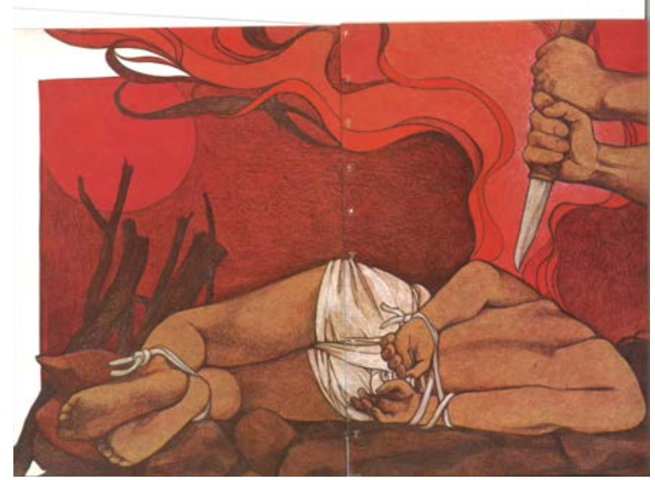

Figure 1: Cohen, B and Mikolaycak, C.. 1978. ‘With the altar lit, Abraham prepares to follow God’s command by plunging a knife into his son’s back.’ [Date accessed: November 2025]. Available From:
https://web.archive.org/web/20190126034755id_/http://muse.jhu.edu/article/661141/pdf
This specific illustration is from The Binding of Isaac, in a children’s book written from a Jewish perspective. It is an interesting portrayal of the akedah illustrating a darkness to the scene of the biblical story, by using red throughout. In this piece, Isaac’s face is not seen, and neither is Abraham’s face, which leads to the question of what would their emotions show if their faces were illustrated? Isaac is illustrated as being bound with rope may suggest a lack of consent and awareness to what was about to occur. His age in the scene could be interpreted as not a child, but potentially a young adult or teenager, unlike many other depictions of this scene. The painting lacks the angel of the Lord anywhere who stops the sacrifice from happening, but perhaps this is just before the angel’s arrival. Additionally, the author described the painting as “Abraham prepares to follow God’s command by plunging a knife into his son’s back”; ‘plunging’ is quite a strong verb to use and also, there is no mention in the passage the knife heading towards Isaac’s back, showing the afterlife of the biblical narrative.
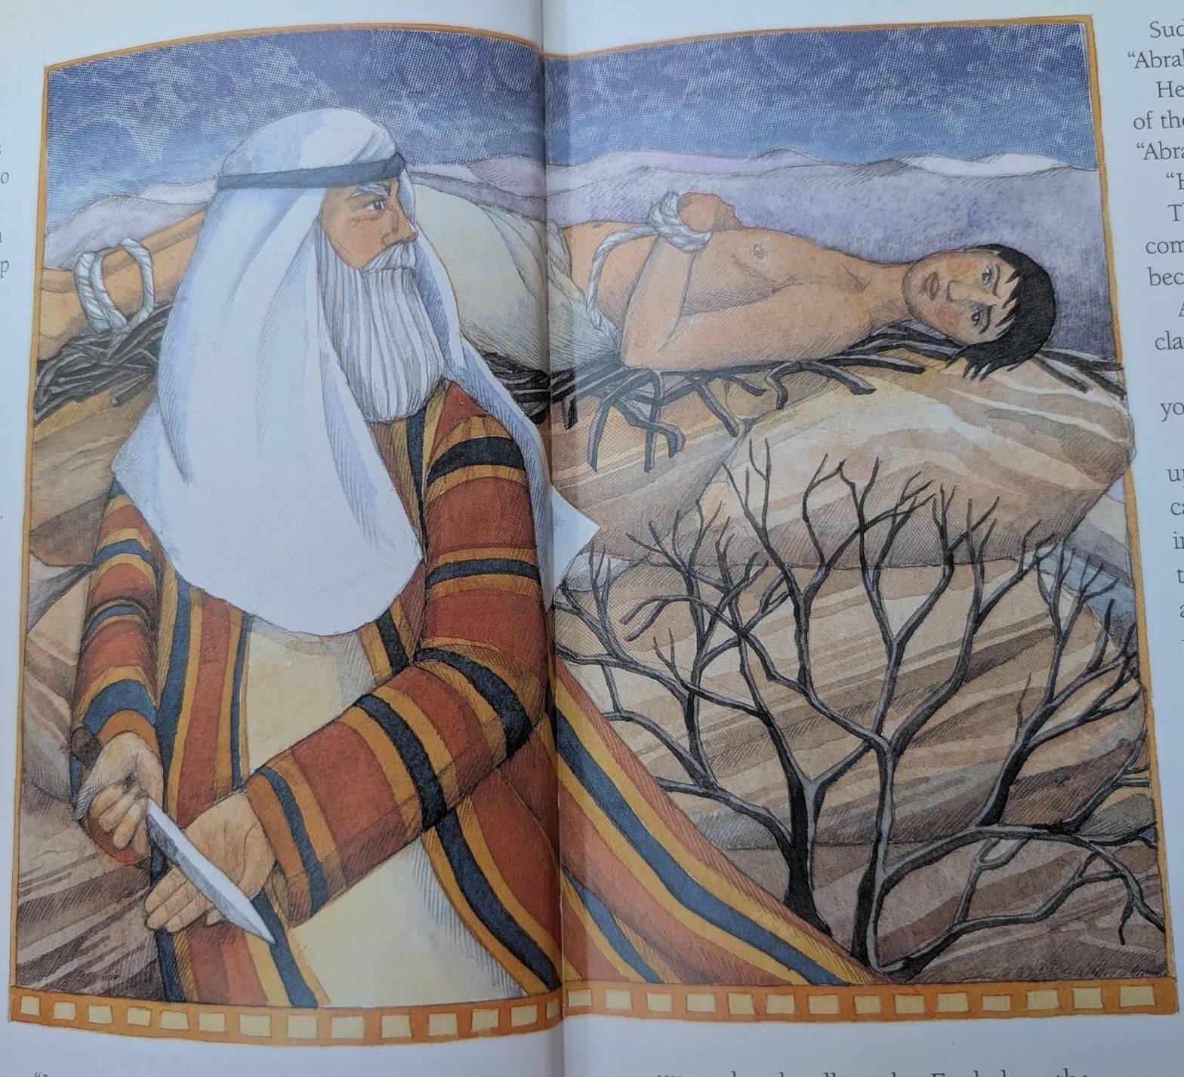

Figure 2: Watts, M and Cann, H. 2002. God tests Abraham. [Book: The Lion Bible for Children]. At: University of Derby Library

This specific illustration is from a Christian lens and shows Abraham hiding the knife from Isaac. This time, Isaac is laying on his back with his arms bound in front and both of their faces are visible in this image, unlike the previous. Isaac has a worried look, red cheeks and Abraham is turning behind to look at Isaac or perhaps to the distance to contemplate. It shows Abraham as old with grey hair and Isaac portrayed potentially as a young adult or teenager, similarly to the previous art piece. However, here they both have quite fair white skin, whereas the Jewish interpretation shows a much darker skin tone, suggesting a western retelling in this piece. Compared to the previous image, it does not seem as scary and the colours used are quite calming, but similarly the angel is also absent.
Isaac as a husband
Isaac plays an intriguing role as a husband to his wife Rebekah. In this passage, they settle in Gerar (located Southwest of Gaza) and he calls his wife in public his sister, in order to protect himself from harm, showing a lack of faith.
“So Isaac settled in Gerar. When the men of the place asked him about his wife, he said, ‘She is my sister’; for he was afraid to say, ‘My wife,’ thinking, ‘or else the men of the place might kill me for the sake of Rebekah, because she is attractive in appearance.’” (Genesis 26:6-7)
This passage mirrors the actions of his father from Genesis 20:1-2, “While residing in Gerar as an alien, Abraham said of his wife Sarah, ‘She is my sister.’’” The repetition of the wife/sister motif emphasises the ongoing cycle of expectation and disappointment, which, in the Christian perspective points towards the ‘New Adam’ who will fulfil God's promises, Jesus Christ; these passages portray a “like father, like son” narrative, showing a generational repetition of behaviour. This concept relates to the psychological term ‘modelling’, where children imitate behaviours of their parental figure and repeat them. This suggests that Isaac imitated the behaviours he witnessed in his father, as ‘the apple doesn’t fall far from the tree.’ It could be argued that Isaac not only inherited the blessing, but also the defence mechanisms of Abraham. Additionally, the role of the sacrifice could be linked to attachment style, which is the template of the parent-child relationship, which links to how the individual will socially and emotionally behave in their later life. Cycles of behaviour between generations tend to repeat unless healthy coping mechanisms replace them, which could explain Isaac’s behaviour to his wife and his future children. This story portrays Isaac in quite a negative light.

Isaac as a father
Another key story of Isaac’s life is his role as a father offering a blessing to his son near the end of his life, in order to pass on his inheritance and God’s covenantal promise. In Ancient Israel, it was normally the firstborn who received the inheritance, however, throughout the biblical narrative, God would often choose the youngest child, challenging this social norm, such as the story of Joseph (Genesis 41) and also David (1 Samuel 16).
“When Isaac was old and his eyes were dim so that he could not see, he called his elder son Esau and said to him, ‘My son’; and he answered, ‘Here I am.’ He said, ‘See, I am old; I do not know the day of my death. Now then, take your weapons, your quiver and your bow, and go out to the field, and hunt game for me. Then prepare for me savoury food, such as I like, and bring it to me to eat, so that I may bless you before I die” (Genesis 27: 1-4).
Here in this passage, Isaac chooses Esau, as his eldest son for the blessing. The text mentions “when Isaac was old and his eyes were dim”; כָּהָה can mean dim, a verb associated with blindness, but also faint or weak, but the same verb is used in Job 17:7 and Zechariah 11:17 to illustrate blindness. It has been suggested that Isaac’s blindness is the result of diabetes mellitus, from aging.

Disability theology studies the crossover between medical science and theology and focuses on the social model of disability; which starts from the idea that the impact of an impairment depends on the individual’s physical, social, cultural or educational context, rather than the diagnosis itself. Applying this perspective to Genesis 27, the passage validates the presence of disabled people within the history of Israel and shows how God’s covenant is not passed through a perfect model of faith.
“So he went in to his father, and said, ‘My father’; and he said, ‘Here I am; who are you, my son?’ Jacob said to his father, ‘I am Esau your firstborn. I have done as you told me; now sit up and eat of my game, so that you may bless me.’ But Isaac said to his son, ‘How is it that you have found it so quickly, my son?’ He answered, ‘Because the Lord your God granted me success.’Then Isaac said to Jacob, ‘Come near, that I may feel you, my son, to know whether you are really my son Esau or not.’ So Jacob went up to his father Isaac, who felt him and said, ‘The voice is Jacob’s voice, but the hands are the hands of Esau.’ He did not recognize him, because his hands were hairy like his brother Esau’s hands; so he blessed him. He said, ‘Are you really my son Esau?’ He answered, ‘I am.’Then he said, ‘Bring it to me, that I may eat of my son’s game and bless you.’ So he brought it to him, and he ate; and he brought him wine, and he drank.. So he came near and kissed him; and he smelled the smell of his garments, and blessed him” (Genesis 27:18-27).
In this passage, Isaac relies on his other senses, taste, smell, touch and hearing as his eyes to see. Furthermore, some scholars have argued that this form of disability could be a psychosomatic response to the Aquedah and that Isaac carries the scars of his trauma into his old age. This passage also presents the irony of Isaac suffering blindness, leading to Jacob becoming spiritually blind to manipulate Isaac’s faith in Yahweh to fulfill his own selfish desires.
Isaac’s actions could also be interpreted as a deliberate choice to bless Jacob, regardless of his previous favouritism towards Esau. It is suggested that there are two versions within this narrative, the first ending in verse 23 and the second starting in verse 24 and can be seen as different accounts of Isaac’s questioning towards Jacob. The first part characterises Isaac as skeptical, although the second presents a softer characterisation with Isaac only asking one question. In addition, in his relationship to Rebekah, she is shown as stronger and more proactive than Isaac and is portrayed as a weak character.

Artistic reception of the Blessing Narrative
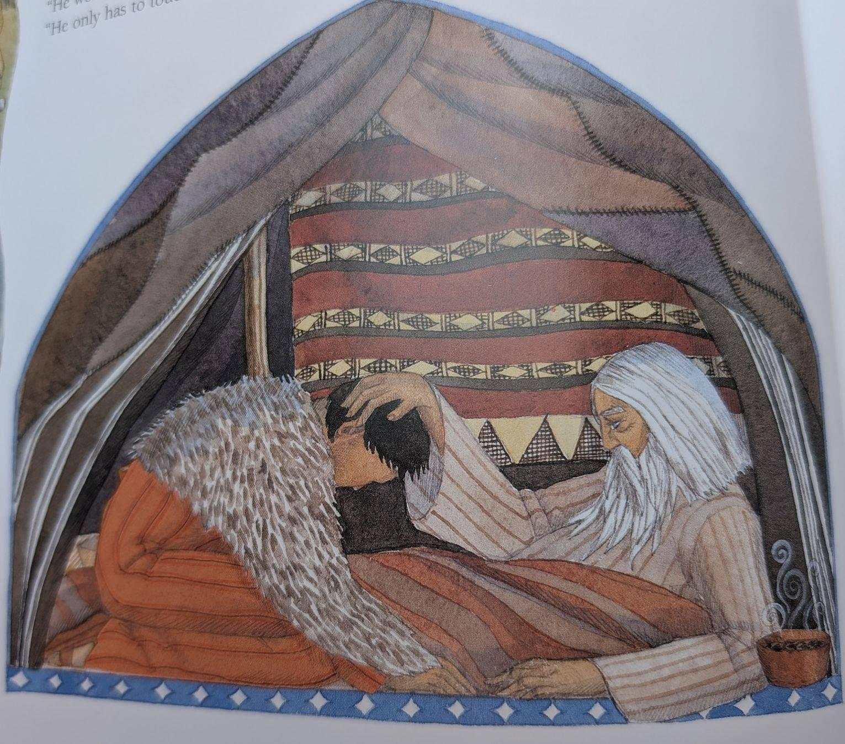
Figure 3: Watts, M and Cann, H. 2002. Isaac is tricked.. [Book: The Lion Bible for Children]. At: University of Derby Library
This interpretation of the blessing from the Christian lens shows submission mixed with deception. It shows the goat hair skin Jacob is wearing to deceive Isaac, along with Isaac’s blue eyes showing a tear. Perhaps the tear represents knowing he was lied to. This piece shows Isaac’s old age and the youthfulness of Jacob. It shows the stew to the side of Isaac still hot and the physically intimate laying of Isaac’s hand on Jacob’s head to bless him. This piece portrays Isaac in bed, representing his age and weakness. Many depictions of this scene portray Rebekah in this scene, however, this illustration does not. In the text itself, during this deception scene, Rebekah is not present, but only present in the lead up to this scene, orchestrating the deception. Yet again, in the Christian perspective, they are both depicted as having fair skin, suggesting western influence as reception to this story.
In conclusion, this essay examined Isaac’s role as a son, as a husband and as a father within the biblical texts, combining both Jewish and Christian interpretations to analyse his character. It also analysed artistic depictions of the Akedah from a Jewish and Christian lens through the medium of children’s storybooks to investigate the afterlife of Isaac.
Isaac, as one of the key patriarchs of Israel’s ancestry has been depicted as a victim in the Akedah, deceiver in the wife-sister motif and victim of deception in the blessing narrative. His character is often hidden behind the shadows of other characters in the story and is often quite passive in his role. He has been described as the weak son of a powerful father and the weak father of two powerful sons. It is important to note that God may often choose the people we least expect, as reflected throughout both the Old Testament and the New Testament.

References
Adams, Sean A., and Zanne Domoney-Lyttle (eds), Abraham in Jewish and Early Christian Literature, Library of Second Temple Studies, 93 (Bloomsbury Academic, 2019)
Altripp, Michael, and others, ‘Isaac (Patriarch)’, in Encyclopedia of the Bible and Its Reception (De Gruyter, 2016), xiii <https://www.degruyter.com/database/EBR/entry/MainLemma_7660/html> [accessed 19 December 2025]
Amirav, Hagit, ‘The Christian Appropriation of the Jewish Scriptures: Allegory, Pauline Exegesis, and the Negotiation of Religious Identities’, ASE, 2011, pp. 39–55
Anderson, Bradford A., ‘Isaac’s Death and Resurrection Remembered: Reception History, Cultural Memory, and the Aqedah in Jewish Tradition’, in Social Memory Theory and Conceptions of Afterlife in Jewish and Christian Antiquity (Brill Schöningh, 2022), pp. 120–39, doi:10.30965/9783657796212_006
Bandura, Albert, and Aletha C. Huston, ‘Identification as a Process of Incidental Learning’, The Journal of Abnormal and Social Psychology (US), 63.2 (1961), pp. 311–18, doi:10.1037/h0040351
Bergen, Robert D, ‘THE ROLE OF GENESIS 22:1-19 IN THE ABRAHAM CYCLE: A COMPUTER- ASSISTED TEXTUAL INTERPRETATION’, Criswell Theological Review, 4.2 (1990)
‘Bible Map: Beersheba’, Bible Hub, n.d. <https://bibleatlas.org/beersheba.htm> [accessed 19 December 2025]
‘Bible Map: Gerar’, Bible Hub, n.d. <https://bibleatlas.org/gerar.htm> [accessed 19 December 2025]
Boase, Elizabeth, ‘LIFE IN THE SHADOWS: THE ROLE AND FUNCTION OF ISAAC IN GENESIS—SYNCHRONIC AND DIACHRONIC READINGS’, Vetus Testamentum, 51.3 (2001), pp. 312–35, doi:10.1163/15685330152913594
Brown, Michael, ‘Biblical Myth and Contemporary Experience: The “Akedah” in Modern Jewish Literature’, Judaism (New York, United States), 31.1 (1982), pp. 99–111
Cober, Lucas, ‘“Without Blemish or Defect:” Disability and Interpretation of the Hebrew Bible’ (unpublished phd, Concordia University, 2025) <https://spectrum.library.concordia.ca/id/eprint/996120/> [accessed 14 November 2025]
Cohen, Barbara, and Charles Mikolaycak, The Binding of Isaac (Lothrop, 1978)
Davis, Anne K., ‘Israel’s Inheritance: Birthright of the Firstborn Son’, CTS Journal, 2008, pp. 79–84
Eames, Christopher, ‘When Was the Age of the Patriarchs?’, ArmstrongInstitute.Org, n.d. <https://armstronginstitute.org/845-when-was-the-age-of-the-patriarchs> [accessed 18 November 2025]
Goudarzi, Mohsen, ‘The Ascent of Ishmael: Genealogy, Covenant, and Identity in Early Islam’, Arabica, 66.5 (2019), pp. 415–84, doi:10.1163/15700585-12341543
Groh, Ashley M., and others, ‘Stability of Attachment Security from Infancy to Late Adolescence’, Monographs of the Society for Research in Child Development, 79.3 (2014), pp. 51–66
Herzberg, Bruce, ‘Isaac’s Blindness: A Case of Narrative Deficiency’, Narrative, 22.1 (2014), pp. 94–109
Hussain, Amir, ‘Abraham, Sarah, Hagar, Ishmael and Isaac: The Bonds of Family’, Theological Studies Faculty Works, 2011
Jacob, Rev Alex, ‘Isaac & Ishmael Exploring God’s Big Mission Plan’, Olive Press, no. 14 (2012) <https://www.cmj-usa.org/IsaacIshmaelExploringGodsBigMissionPlan> [accessed 12 December 2025]
Jensen, Robin, ‘Painting the Text: The Artist as Biblical Interpreter; Between the Text and the Canvas: The Bible and Art in Dialogue’, Biblical Interpretation, 18.2 (2010), pp. 172–77, doi:10.1163/156851508X379011
Josephus, Flavius, ‘Book 1: From The Creation To The Death of Isaac’, in The Antiquities of the Jews (Blackmask, 94 AD), p. 18
Levin, S., ‘Isaac’s Blindness: A Medical Diagnosis’, Judaism (New York, United States), 37.1 (1988), pp. 81–83
Lorberbaum, Yair, ‘Yitshak and God’s Separation Anxiety’, The Journal of Jewish Thought and Philosophy, 21.2 (2013), pp. 105–42, doi:10.1163/1477285X-12341244
MacDonald, Nathan, ‘Did God Choose the Patriarchs? Reading for Election in the Book of Genesis’, in Genesis and Christian Theology (Eerdmans, 2011), pp. 245–66
Matthews, Kenneth A., ‘Section 13: Abraham’s Test’, in New American Commentary: Genesis 11:27-50:26, New American Commentary (NAC) Volume (B&H Publishing Group, 2005), i, p. 960 <https://app.logos.com/> [accessed 19 December 2025]
McCarter, P Kyle, The Patriarchal Age: Abraham, Isaac and Jacob, n.d.
Ronning, John, ‘THE NAMING OF ISAAC: THE ROLE OF THE WIFE/SISTER EPISODES IN THE REDACTION OF GENESIS’, Westminister Theological Journal, 53 (1991), pp. 1–27
Sabel, Bernhard A., and others, ‘Mental Stress as Consequence and Cause of Vision Loss: The Dawn of Psychosomatic Ophthalmology for Preventive and Personalized Medicine’, The EPMA Journal, 9.2 (2018), pp. 133–60, doi:10.1007/s13167-018-0136-8
Sasser, M. Tyler, ‘The Binding of Isaac: Jewish and Christian Appropriations of the Akedah (Genesis 22) in Contemporary Picture Books’, Children’s Literature, 45.1 (2017), p. 11
Seymour, Timothy P., ‘Personal Names and Name Giving in the Ancient Near East’, UCLA Historical Journal, 4 (1983), pp. 108–20
Shkop, Esther M., ‘And Sarah Laughed...’, Tradition: A Journal of Orthodox Jewish Thought, 31.3 (1997), pp. 42–51
Skinner, Ellen A., and Melanie J. Zimmer-Gembeck, ‘The Development of Coping’, Annual Review of Psychology, 58.1 (2007), pp. 119–44, doi:10.1146/annurev.psych.58.110405.085705
Snyman, Gerrie F., ‘Readers’ Disgust in the Case of Rebekah, Jacob, Isaac, and Esau: Perverters of Justice?’, Old Testament Essays, 33.3 (n.d.), doi:https://doi.org/10.17159/2312-3621/2020/v33n3a6
Tang, Michael Zhaohan, ‘The Trial of Abraham and the Trembling of the Audience: Rereading the Aqedah’, Classic Mediterranean and Middle East Honours Projects, 31 (2024)
Van Dam, Cornelis, ‘The Burnt Offering In Its Biblical Context’, MJT, 7.2 (1991), pp. 195–206
Volpe, Medi Ann, ‘Disability Theology’, St Andrews Encyclopaedia of Theology, 2025 <https://www.saet.ac.uk/Christianity/DisabilityTheology#section2> [accessed 17 December 2025]
Walsh, Carey Ellen, ‘Christian Theological Interpretations of God’s Grace in the Binding of Isaac’, Perichoresis, 10.1 (2012), pp. 41–66, doi:10.2478/v10297-012-0003-7
Watts, Murray, and Helen Cann, The Lion Bible for Children (Lion Publishing, 2002)
Zucker, David J., ‘ISAAC: A LIFE OF BITTER LAUGHTER.’, Jewish Bible Quarterly Dor Le Dor, 40.2 (2012), pp. 105–10, 73894287

Rev Alex Jacob, ‘Isaac & Ishmael Exploring God’s Big Mission Plan’, Olive Press, no. 14 (2012) <https://www.cmj-usa.org/IsaacIshmaelExploringGodsBigMissionPlan> [accessed 12 December 2025].
Abraham in Jewish and Early Christian Literature, ed. by Sean A. Adams and Zanne Domoney-Lyttle, Library of Second Temple Studies, 93 (Bloomsbury Academic, 2019). (p1)
Elizabeth Boase, ‘LIFE IN THE SHADOWS: THE ROLE AND FUNCTION OF ISAAC IN GENESIS—SYNCHRONIC AND DIACHRONIC READINGS’, Vetus Testamentum, 51.3 (2001), pp. 312–35, doi:10.1163/15685330152913594.
Christopher Eames, ‘When Was the Age of the Patriarchs?’, ArmstrongInstitute.Org, n.d. <https://armstronginstitute.org/845-when-was-the-age-of-the-patriarchs> [accessed 18 November 2025].
‘Bible Map: Beersheba’, Bible Hub, n.d. <https://bibleatlas.org/beersheba.htm> [accessed 19 December 2025].
Michael Altripp and others, ‘Isaac (Patriarch)’, in Encyclopedia of the Bible and Its Reception (De Gruyter, 2016), xiii <https://www.degruyter.com/database/EBR/entry/MainLemma_7660/html> [accessed 19 December 2025].
David J. Zucker, ‘ISAAC: A LIFE OF BITTER LAUGHTER.’, Jewish Bible Quarterly Dor Le Dor, 40.2 (2012), pp. 105–10, 73894287.
Timothy P. Seymour, ‘Personal Names and Name Giving in the Ancient Near East’, UCLA Historical Journal, 4 (1983), pp. 108
Esther M. Shkop, ‘And Sarah Laughed...’, Tradition: A Journal of Orthodox Jewish Thought, 31.3 (1997), pp. 42–51.
Yair Lorberbaum, ‘Yitshak and God’s Separation Anxiety’, The Journal of Jewish Thought and Philosophy, 21.2 (2013), pp. 105–42, doi:10.1163/1477285X-12341244.
P Kyle McCarter, The Patriarchal Age: Abraham, Isaac and Jacob, n.d.
Zucker, ‘ISAAC’.
Mohsen Goudarzi, ‘The Ascent of Ishmael: Genealogy, Covenant, and Identity in Early Islam’, Arabica, 66.5 (2019), pp. 415–84, doi:10.1163/15700585-12341543.
Nathan MacDonald, ‘Did God Choose the Patriarchs? Reading for Election in the Book of Genesis’, in Genesis and Christian Theology (Eerdmans, 2011), pp. 245–66.
Amir Hussain, ‘Abraham, Sarah, Hagar, Ishmael and Isaac: The Bonds of Family’, Theological Studies Faculty Works, 2011.
Robert D Bergen, ‘THE ROLE OF GENESIS 22:1-19 IN THE ABRAHAM CYCLE: A COMPUTER- ASSISTED TEXTUAL INTERPRETATION’, Criswell Theological Review, 4.2 (1990).
Kenneth A. Matthews, ‘Section 13: Abraham’s Test’, in New American Commentary: Genesis 11:27-50:26, New American Commentary (NAC) Volume (B&H Publishing Group, 2005), i, p. Unknown as this is an ebook without page numbers <https://app.logos.com/> [accessed 19 December 2025].
Cornelis Van Dam, ‘The Burnt Offering In Its Biblical Context’, MJT, 7.2 (1991), pp. 195–206.
Michael Zhaohan Tang, ‘The Trial of Abraham and the Trembling of the Audience: Rereading the Aqedah’, Classic Mediterranean and Middle East Honours Projects, 31 (2024).
Flavius Josephus, ‘Book 1: From The Creation To The Death of Isaac’, in The Antiquities of the Jews (Blackmask, 94 AD), p. 18.
Tang, ‘The Trial of Abraham and the Trembling of the Audience: Rereading the Aqedah’.
Gerrie F. Snyman, ‘Readers’ Disgust in the Case of Rebekah, Jacob, Isaac, and Esau: Perverters of Justice?’, Old Testament Essays, 33.3 (n.d.), doi:https://doi.org/10.17159/2312-3621/2020/v33n3a6.
Matthews, ‘Section 13: Abraham’s Test’.
Michael Brown, ‘Biblical Myth and Contemporary Experience: The “Akedah” in Modern Jewish Literature’, Judaism (New York, United States), 31.1 (1982), pp. 99–111.
Bradford A. Anderson, ‘Isaac’s Death and Resurrection Remembered: Reception History, Cultural Memory, and the Aqedah in Jewish Tradition’, in Social Memory Theory and Conceptions of Afterlife in Jewish and Christian Antiquity (Brill Schöningh, 2022), pp. 120–39, doi:10.30965/9783657796212_006.
M. Tyler Sasser, ‘The Binding of Isaac: Jewish and Christian Appropriations of the Akedah (Genesis 22) in Contemporary Picture Books’, Children’s Literature, 45.1 (2017), p. 11.
Carey Ellen Walsh, ‘Christian Theological Interpretations of God’s Grace in the Binding of Isaac’, Perichoresis, 10.1 (2012), pp. 41–66, doi:10.2478/v10297-012-0003-7.
Hagit Amirav, ‘The Christian Appropriation of the Jewish Scriptures: Allegory, Pauline Exegesis, and the Negotiation of Religious Identities’, ASE, 2011, pp. 39–55.
Robin Jensen, ‘Painting the Text: The Artist as Biblical Interpreter; Between the Text and the Canvas: The Bible and Art in Dialogue’, Biblical Interpretation, 18.2 (2010), pp. 172–77, doi:10.1163/156851508X379011.
Barbara Cohen and Charles Mikolaycak, The Binding of Isaac (Lothrop, 1978).
Murray Watts and Helen Cann, The Lion Bible for Children (Lion Publishing, 2002). p39
‘Bible Map: Gerar’, Bible Hub, n.d. <https://bibleatlas.org/gerar.htm> [accessed 19 December 2025].
John Ronning, ‘THE NAMING OF ISAAC: THE ROLE OF THE WIFE/SISTER EPISODES IN THE REDACTION OF GENESIS’, Westminister Theological Journal, 53 (1991), pp. 1–27.
Albert Bandura and Aletha C. Huston, ‘Identification as a Process of Incidental Learning’, The Journal of Abnormal and Social Psychology (US), 63.2 (1961), pp. 311–18, doi:10.1037/h0040351.
Ashley M. Groh and others, ‘Stability of Attachment Security from Infancy to Late Adolescence’, Monographs of the Society for Research in Child Development, 79.3 (2014), pp. 51–66.
Ellen A. Skinner and Melanie J. Zimmer-Gembeck, ‘The Development of Coping’, Annual Review of Psychology, 58.1 (2007), pp. 119–44, doi:10.1146/annurev.psych.58.110405.085705.
Anne K. Davis, ‘Israel’s Inheritance: Birthright of the Firstborn Son’, CTS Journal, 2008, pp. 79–84.
Lucas Cober, ‘“Without Blemish or Defect:” Disability and Interpretation of the Hebrew Bible’ (unpublished phd, Concordia University, 2025) <https://spectrum.library.concordia.ca/id/eprint/996120/> [accessed 14 November 2025].
S. Levin, ‘Isaac’s Blindness: A Medical Diagnosis’, Judaism (New York, United States), 37.1 (1988), pp. 81–83.
Medi Ann Volpe, ‘Disability Theology’, St Andrews Encyclopaedia of Theology, 2025 <https://www.saet.ac.uk/Christianity/DisabilityTheology#section2> [accessed 17 December 2025].
Bernhard A. Sabel and others, ‘Mental Stress as Consequence and Cause of Vision Loss: The Dawn of Psychosomatic Ophthalmology for Preventive and Personalized Medicine’, The EPMA Journal, 9.2 (2018), pp. 133–60, doi:10.1007/s13167-018-0136-8.
Bruce Herzberg, ‘Isaac’s Blindness: A Case of Narrative Deficiency’, Narrative, 22.1 (2014), pp. 94–109.
Boase, ‘LIFE IN THE SHADOWS’.
Watts and Cann, The Lion Bible for Children. p45.

