Assessment 1 Written Assignment



Student ID:202116
Student Name: Claudia-Ancuta Dragan
Module name: INTRODUCTION TO RESEARCH
Module code: (BMHP5005_LON)
Lecturer name: Dr Rachel Cohen

Aim
Analysis of the effects of fibromyalgia on pain among women aged 20-60 in the UK.

Objective
- To identify the meaning and symptoms of fibromyalgia
- To analyse the effects of fibromyalgia on pain among women in the UK
- To interpret the various therapies which would help in treating fibromyalgia.

Background information
Fibromyalgia is regarded as a disorder which is spreading across musculoskeletal pain and is generally accompanied by sleep, mood issues, memory loss and fatigue (Maugars, et al., 2021). It could be stated by some of the researchers that the impact of fibromyalgia is intensified with the functioning of the brain and spinal cord. This will be processing the pain and non-pain signals. Some of the most common symptoms of the disorder involve tenderness and widespread muscle pain. (Siracusa, R. 2021.)
The tendency of women suffering from fibromyalgia is higher in women as compared to men who are due to their hormonal changes and higher stress due to menstruation, pregnancy and others. This proportion involves a 9:1 ratio between women and men, which shows gender differences. .(Siracusa, R.2011)

Rationale
The reason behind choosing this topic is the increasing effects and tenderness of fibromyalgia among women aged 20-60 in the UK. There are increasing cases of the syndrome among women as they are affected twice the case of men with this problem (Harvie, et al., 2021). They are diagnosed by people of all ages, especially during middle age and are more likely to get worse affected by the same as they get older. So it is essential for the researcher to research the current topic so that they can gain more knowledge and understanding of the case. The problem is mainly caused by surgery, infection, physical trauma and psychological stress or disorder. (Sarzi-Puttini 2020)

Tools methods
For the collection and analysis of data in the research, there are different types of methods and tools which are used Interviews, experiments, case study, focus groups, thus helping to form results and outcomes quickly. The tools and techniques selected for the gathering and analysis of the information has a direct and considerable impact on the results and outcomes of the study (Newman and Gough, 2020). In addition to this, interpretivism has also supported carrying out deep observation of the social world. The inductive approach is also selected because it has provided the researcher with an opportunity to make use of the top-bottom approach to identify and analyse the effect of fibromyalgia on pain among women aged 20-60 in the UK. ( Harvie, D.S)

Approach
The research approach is the mainly selected method that is primarily used in collecting and interpreting results in the correct manner. (Basias and Pollalis, 2018). The current research their uses of inductive approach, which would help the researcher to find the right solution to the problem. This is the approach that draws the conclusions for going towards the general from specified reasoning. This form, of course, is currently used within the research for finding specified findings due to, which is known as bottom-up reasoning (Basias and Pollalis, 2018). In the current research that is based on analysis of the effects of fibromyalgia on pain among women aged 20-60 of UK inductive approach is very helpful. This also offers a theoretical orientation to the practice so that it could be used for understanding the research in a corrective manner. However, the deductive has not been followed due to the fact that it is not logically approaching where the researcher is progressing from general ideas to specified conclusions.

Data collection
The process through which the researcher is able to identify, select and collect information through different sources so that results can be appropriately generated. In this particular research, there are the use secondary sources of data collection that help in finding correct answers to the questions. (Newman and Gough, 2020). The secondary form of data collecting is most widely used in gathering data from sources like articles, journals and books. This is a very flexible and semi-structured form of collecting facts and figures from these sources (Hakami, 2022). This is done through logical and general conclusions so that there are specified observations. Moreover, there is no use of a primary source of data collection as this is not helping in analyzing the effects of fibromyalgia on pain among women aged 20-60 in the UK. For which the researcher needs to collect data through interviews or conducting surveys, so secondary would be best suited.

Data analysis
Ethical practice
Various types of ethical practices have also been followed for researching the specified topic, which is very much important from the viewpoint of the researcher. Ethics are an essential part of any research, which deals with answering questions in the correct manner. The current study, there use only authentic and valid sources of information so that it calculates reliable results (Blumberg, Cooper and Schindler, 2014). Further, it could be added that there is the use of the correct method of referencing and citations so that reader could relate the writing back to desired results. Lastly, there is no use of unauthentic sites such as Wikipedia and slide share, which may hamper the way in which data is collected and interpreted.

Thematic Review

Overview of Fibromyalgia
As per the views of Bair and Krebs, (2020) a disorder named Fibromyalgia is a disease which gives rise to musculoskeletal pain in accordance with other symptoms such as fatigue, sleep, memory and mood issues. Painful sensations are amplified in the case of Fibromyalgia, which gives affects the brain as well as the spinal cord such that procession could be done of painful and non-painful signals. The symptom which generally gets occurred due to this illness is that the whole body of an individual receives dwells within the pain and also gets stiffed (Sarzi-Puttini, et al. 2020).
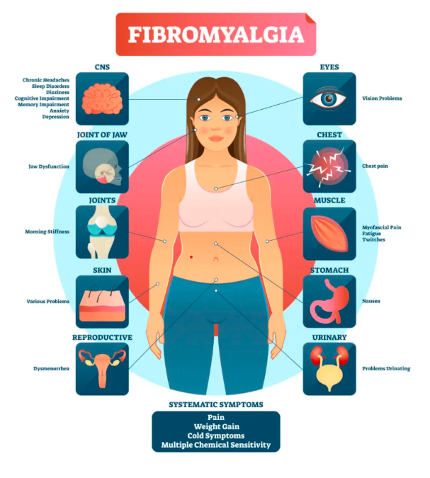
Figure 1: Causes of Fibromyalgia
(Source: Abraham, 2020)
However, Siracusa, et al. (2021) has argued the fact stating that musculoskeletal pain is not the only suffering the women have to go through in this particular state; instead, it has been said that they have to pass through the critical symptoms consisting of depression and anxiety, sleeping disorder, memory disorder and so on. When there are instances where women are not able to sleep in the proper manner, then at that point in time, it becomes highly problematic for them to concentrate over on the work which is being done to them. The mental process of all of the women becomes highly vulnerable in this case (Goebel, et al. 2021).
Wolfe, et al. (2018) stated that even digestive conditions also get an increase in the context of the Fibromyalgia in women. Constant stomach pain, which the person has to go through in accordance with the disease that they have been suffering from, makes them highly irritated while doing the daily chores. Stomach pain which individual has to go through in their daily life routine, is one of the most challenging situations they face (Galvez-Sánchez and Reyes del Paso, 2020). The worst part the women have to go through in their everyday routine life is that the symptoms that the body gets exposed to in terms of this particular illness could sometimes suddenly get improved, and sometimes it could get worse. The regular living pattern gets disturbed in accordance with such disease that resides within the body of an individual.

Therapies related to the illness
According to Sarzi-Puttini, et al. (2021) there are several treatments which would be adopted in accordance with this particular type of illness; if it is adopted by an individual, it has a chance that the condition could be further improved. In this, the daily living patterns of the individual are generally changed, wherein they are made more inclined towards exercising on a daily basis. Relaxation techniques are also applied in the same aspect where the muscles of individuals, which are strained up to a more significant amount, are then relaxed such that an individual may be able to live an everyday life or near-to-normal life.
However, Galvez-Sánchez, Duschek and Del Paso, (2019) stated critically that sometimes there is so much pain in the body of an individual that they may not be able to exercise on a daily basis. This could lead to inactivity within their body, and relaxation is also not provided to them. This therapy could sometimes result in failure when the individual is highly in the situation of pain and is not able to move the muscles as it is actually needed.
As per the views of Sagy, et al. (2019), cognitive behavioural therapy is one of those contexts within which it could be stated that the person is given a talking session such that management could be done of their problems in a way that their style of thinking is changed completely. The most common effect of this therapy is seen over on anxiety as well as depression of an individual which they have been going from. This could further be related to the Gate Control Theory of Pain. In this theory, it has been stated that perceived pain which is there within the body of an individual, is given the signal from the brain as well as the spinal cord of the individual. When the pain signals are passed over by them, then the body is able to feel taking place within itself (Häuser and Fitzcharles, 2022). So with the help of cognitive behavioural theory, if the thinking of a person is changed, then there would be chances that further establishment of better results could be done.
However, Grayston, et al. (2019) has argued that every time making, a change in the thinking style of a person could never make an improvement in the way that a person is going through pain. In this regard, it is also necessary that proper measures be taken about how the pain could be lowered. If the cognitive behaviour of the individual did not change at any given point in time, then at that moment, it would be hard to cure the pain that they have been going through in their daily life (Wolfe, et al. 2019).

Effects of Fibromyalgia on pain ongoing in the UK for women’s
Häuser, Sarzi-Puttini and Fitzcharles, (2019) stated that women go through a high level of issues due to the pain that is caused to them in accordance with the illness that becomes part of their body. Tingling in the hands as well as feet is one of the problems that get occurred highly among women of the UK in the rise of this particular illness. In this respect, it becomes problematic for them to carry out their daily chores in a proper manner, whether they are related to their professional life or personal life. This means that they are not able to do their household work, nor are they able to perform skilled work (Maffei, 2020).
Other than that, the women go through constant pain in their face as well as jaws which are also referred to as a temporomandibular joint syndrome. This causes the highest level of disorder, where they are also not able to intake their meals of the day properly. This then directly exerts an effect over on the complete body working of the women. (Maffei, 2020).
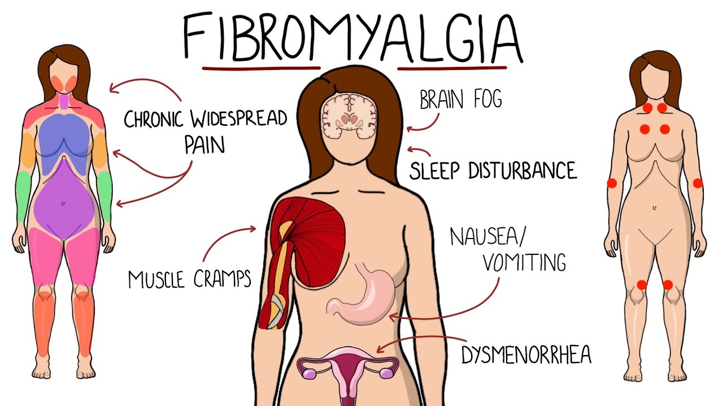
Figure 2: Fibromyalgia effects on women
(Source: YouTube, 2021)
From the figure that has been given above, it could be adequately understood what all effects the women will have to go through in respect of pain being caused by Fibromyalgia. According to Bidonde, et al. (2019), women are highly likely to get prone to this particular illness in relation to that men. The leading cause which has been studied around this specific illness is obesity, as well as accidents happening to individuals. Other than physical stress also, emotional stress is one of the aspects which make the person prone to this illness being suffered by them. When women tend to have problems with the way that they think and carry out their work, it could be stated that they might miss many important works that would have been related to their family members, too (Creed, 2020). The children of women suffering from this illness have to suffer a lot due to the low mental health of their own mothers. They are not able to concentrate over on the things that are being stated to them, making it hard for all of the individuals to work in the best possible manner. Migraines are some of the types of effect that is caused due to the illness that has been taken into discussion. Giorgi, et al. (2022) stated critically that women are given an ample number of ways through which they could make better the disorder they go through such that better living conditions could be prospered for them.

Discussion of the finding
Fibromyalgia is one of the disorders which are very commonly found in women compared to that men. (Bair and Krebs, 2020). This means that this illness gets more over in women as compared to that men and causes a high level of pain in their bodies. There have been found several studies in which the understanding has been developed that due to this illness, a person has to go through a higher degree of pain in their daily living, which causes inefficiency in their routine of work (Bair and Krebs, 2020).
People with the disease have been found to experience a variety of symptoms, many of which make life completely miserable for the sufferers. These symptoms include more than just muscle pain. According to reports, in addition to experiencing pain from this illness, women tend to have poor memories. This indicates that they are more likely to forget things that have been mentioned by others. One of the absurd consequences of the acquired illness is this, to use an example. In addition to physical stress, mental stress can also affect a person's susceptibility to this condition (Sarzi-Puttini, et al. 2020). It can be said that women who have trouble thinking and working may miss out on many important tasks that would have had an impact on their families as well. The children of these women suffer great agony because of the poor mental health of their own mothers. Everyone struggles to function as efficiently as possible because they are unable to concentrate on what is being said to them. Migraines are among the side effects. (Bair and Krebs, 2020).

The pain that women experience as a result of the illness that develops in their bodies causes them a significant level of problems. One of the issues that have become very prevalent in UK women since the onset of this sickness is numbness in the hands and feet. In this regard, it becomes difficult for individuals to complete their everyday tasks correctly if they are indeed related to their personal or professional lives (Siracusa, et al. 2021). This implies that they are unable to carry out their household duties as well as their professional duties. When they are not able to carry out their daily chores, which are inclusive of both household duties as well as professional duties, then it could be stated that they become dependent on other people to do work for them, which also lowers their self-confidence.
The lowering of self-confidence, which occurs within an individual, is the way through which they lend to depression as well as anxiety. (Goebel, et al. 2021). Depression, which is caused to them, is highly pragmatic and makes their will to live life in a usual way very limited. This could further be treated with the help of cognitive behavioural therapy, also known as CBT. One of those situations where it might be said that the individual receives talking sessions so that management of their issues can be done in a way that entirely alters their way of thinking is cognitive behavioural therapy (Goebel, et al. 2021). An individual's anxiety and/or depression that they have been experiencing are the most prevalent effects of this therapy.
The worst thing that happens to women in their everyday lives is that the manifestations of this specific disease that the body experiences might sometimes suddenly get better and other times, they can grow worse (Wolfe, et al. 2018). According to such illness that exists within an individual's body, the regular pattern of living becomes interrupted. There are numerous therapies that might be used for this specific form of illness, and if they are used by the patient, there is a chance that the situation will become better yet. (Wolfe, et al. 2018).
As is considered that this is a disease that causes pain all over the body, and through this, it also causes fatigue and sleeps issues in the human body. In addition to this, there are symptoms that involve numbness and tingling in feet and in hands; not only this, but the person also feels pain in the Jaw and face, and as a result of this, there is a major disorder of the jaw which is also known as TMJ, temporomandibular joint syndrome (Galvez-Sánchez and Reyes del Paso, 2020). A person feeling with fibromyalgia often faces challenges in working as they also feel issues regarding memory. It is commonly seen in female as there are issues regarding digestion, and the body often faces abdominal pain with bloating, which directly result in constipation, thus further it results in irritable bowel syndrome, commonly known as IBS. These are the specific signs and symptoms of the issue which is faced by the individual having fibromyalgia (Sarzi-Puttini, et al. 2021).
Apart from this, the body also faces pain and stiffness all over the body and this, as a result, causes tiredness; however, this results in anxiety which thus causes the sleeping disorder. In addition to this, there are also risk factors which are associated with it as it can directly impact the individual who all the muddle age; apart from this Rheumatoid Arthritis and Lupus are the factors which cause certain issues within the body, and thus it leads to having fibromyalgia.

Conclusions
It is summarized that fibromyalgia is a disease that gives rise to musculoskeletal pain within the human body there are also certain signs and symptoms which are associated. In the above-mentioned assessment, there are therapies which are related to fibromyalgia, (Hakami, (A. 2022.)
such as cognitive behavioural therapy; thus, it helps in the overall management of the issues which is faced by the body. Apart from this, the effects of Fibromyalgia on pain among women within the UK are classified, and also the main causes are interpreted, which is regarding obesity and illness, which is common among women. (Siracusa, et al., 2021).

Recommendations
Fibromyalgia is a common disease that give rise to musculoskeletal pain and the person feels sleep disorder and other very common risk which thus gave rise to further dwelling pain and this can lead to major issues within the body. Hence for the same here are some of the recommendations which help in eradicating the challenges that are faced by the women suffering with this disease.
- It is recommended that First-choice treatments can be taken for the person suffering from this condition. In addition to exercises it is suggested that a person can choose low to moderate intensity activities which undertake activities involve water aerobics, biking, etc. which can eradicate higher chances of growth of this disease (Galvez-Sánchez, Duschek and Del Paso, 2019).
- It is suggested that Fibromyalgia with the help of medications might help eradicating pain by 30% and individuals can also take non-medication therapies with Pastoral counseling. As the condition results in migraine, abdominal pain, constipation, etc., nonpharmacologic therapies would help in reducing pain and disorders within the person (Sagy, et al. 2019).

References
Abraham, M., 2020. Symptoms of Fibromyalgia. [Online] <Accessed Through: https://www.google.com/url?sa=i&url=https%3A%2F%2Fwww.calmclinic.com%2Fanxiety%2Fsymptoms%2Ffibromyalgia&psig=AOvVaw1unEQ765pRHx0aTvX9vmfQ&ust=1669292007898000&source=images&cd=vfe&ved=0CBAQjRxqFwoTCPDlprujxPsCFQAAAAAdAAAAABAE> [Accessed on: 23rd November 2022]

Bair, M.J. and Krebs, E.E., 2020. Fibromyalgia. Annals of internal medicine, 172(5), pp.ITC33-ITC48.

Basias, N., andPollalis, Y. 2018. Quantitative and qualitative research in business & technology: Justifying a suitable research methodology. Review of Integrative Business and Economics Research, 7, 91-105.

Bidonde, J., Busch, A.J., Schachter, C.L., Webber, S.C., Musselman, K.E., Overend, T.J., Góes, S.M., Dal Bello‐Haas, V. and Boden, C., 2019. Mixed exercise training for adults with fibromyalgia. Cochrane Database of Systematic Reviews, (5).

Blumberg, B., Cooper, D., and Schindler, P. 2014. Business Research Methods, 4th Edition, McGraw Hill

Creed, F., 2020. A review of the incidence and risk factors for fibromyalgia and chronic widespread pain in population-based studies. Pain, 161(6), pp.1169-1176.

Galvez-Sánchez, C.M. and Reyes del Paso, G.A., 2020. Diagnostic criteria for fibromyalgia: critical review and future perspectives. Journal of clinical medicine, 9(4), p.1219.

Galvez-Sánchez, C.M., Duschek, S. and Del Paso, G.A.R., 2019. Psychological impact of fibromyalgia: current perspectives. Psychology research and behavior management, 12, p.117.

Giorgi, V., Sirotti, S., Romano, M.E., Marotto, D., Ablin, J.N., Salaffi, F. and Sarzi-Puttini, P., 2022. Fibromyalgia: One year in review 2022. Clin Exp Rheumatol, 40(6), pp.1065-1072.

Goebel, A., Krock, E., Gentry, C., Israel, M.R., Jurczak, A., Urbina, C.M., Sandor, K., Vastani, N., Maurer, M., Cuhadar, U. and Sensi, S., 2021. Passive transfer of fibromyalgia symptoms from patients to mice. The Journal of clinical investigation, 131(13).

Grayston, R., Czanner, G., Elhadd, K., Goebel, A., Frank, B., Üçeyler, N., Malik, R.A. and Alam, U., 2019, April. A systematic review and meta-analysis of the prevalence of small fiber pathology in fibromyalgia: Implications for a new paradigm in fibromyalgia etiopathogenesis. In Seminars in arthritis and rheumatism (Vol. 48, No. 5, pp. 933-940). WB Saunders.

Hakami, A. A. A. 2022. Ethical considerations of qualitative non-therapeutic research on people with obsessive-compulsive disorder: an overview. F1000Research, 11(137), 137.

Harvie, D.S., Vasco, D., Sterling, M., Low-Choy, S. and Niederstrasser, N.G., 2021. Psycho-sensory relationships in chronic pain. British Journal of Pain, 15(2), pp.134-146.

Häuser, W. and Fitzcharles, M.A., 2022. Facts and myths pertaining to fibromyalgia. Dialogues in clinical neuroscience.

Häuser, W., Sarzi-Puttini, P. and Fitzcharles, M.A., 2019. Fibromyalgia syndrome: under-, over-and misdiagnosis. Clin Exp Rheumatol, 37(Suppl 116), pp.90-7.

Maffei, M.E., 2020. Fibromyalgia: recent advances in diagnosis, classification, pharmacotherapy and alternative remedies. International journal of molecular sciences, 21(21), p.7877.

Maugars, Y., Berthelot, J.M., Le Goff, B. and Darrieutort-Laffite, C., 2021. Fibromyalgia and associated disorders: from pain to chronic suffering, from subjective hypersensitivity to hypersensitivity syndrome. Frontiers in Medicine, 8.

Mohajan, H. K. 2018. Qualitative research methodology in social sciences and related subjects. Journal of Economic Development, Environment and People, 7(1), 23-48.

Newman, M., and Gough, D. 2020. Systematic reviews in educational research: Methodology, perspectives and application. Systematic reviews in educational research, 3-22.
Sagy, I., Bar-Lev Schleider, L., Abu-Shakra, M. and Novack, V., 2019. Safety and efficacy of medical cannabis in fibromyalgia. Journal of clinical medicine, 8(6), p.807.

Sarzi-Puttini, P., Giorgi, V., Atzeni, F., Gorla, R., Kosek, E., Choy, E.H., Bazzichi, L., Häuser, W., Ablin, J.N., Aloush, V. and Buskila, D., 2021. Fibromyalgia position paper. Clinical and Experimental Rheumatology, 39(3 Supp), pp.186-193.
Sarzi-Puttini, P., Giorgi, V., Marotto, D. and Atzeni, F., 2020. Fibromyalgia: an update on clinical characteristics, aetiopathogenesis and treatment. Nature Reviews Rheumatology, 16(11), pp.645-660.

Siracusa, R., Paola, R.D., Cuzzocrea, S. and Impellizzeri, D., 2021. Fibromyalgia: pathogenesis, mechanisms, diagnosis and treatment options update. International journal of molecular sciences, 22(8), p.3891.

Wolfe, F., Schmukler, J., Jamal, S., Castrejon, I., Gibson, K.A., Srinivasan, S., Häuser, W. and Pincus, T., 2019. Diagnosis of fibromyalgia: Disagreement between fibromyalgia criteria and clinician‐based fibromyalgia diagnosis in a university clinic. Arthritis care & research, 71(3), pp.343-351.

Wolfe, F., Walitt, B., Perrot, S., Rasker, J.J. and Häuser, W., 2018. Fibromyalgia diagnosis and biased assessment: Sex, prevalence and bias. PloS one, 13(9), p.e0203755.

YouTube, 2021. Symptoms of Fibromyalgia. [Online] <Accessed Through: https://www.google.com/url?sa=i&url=https%3A%2F%2Fwww.youtube.com%2Fwatch%3Fv%3DsT2NJyZKGDs&psig=AOvVaw3e2DPBdO8nCQC1xuoueBDp&ust=1669278473262000&source=images&cd=vfe&ved=0CBEQjhxqFwoTCIiM4YTxw_sCFQAAAAAdAAAAABAO> [Accessed on: 23rd November 2022]

Basias, N., and Pollalis, Y. 2018. Quantitative and qualitative research in business & technology: Justifying a suitable research methodology. Review of Integrative Business and Economics Research, 7, 91-105.

Hakami, A. A. A. 2022. Ethical considerations of qualitative non-therapeutic research on people with obsessive-compulsive disorder: an overview. F1000Research, 11(137), 137.

Harvie, D.S., Vasco, D., Sterling, M., Low-Choy, S. and Niederstrasser, N.G., 2021. Psycho-sensory relationships in chronic pain. British Journal of Pain, 15(2), pp.134-146.

Newman, M., and Gough, D. 2020. Systematic reviews in educational research: Methodology, perspectives and application. Systematic reviews in educational research, 3-22.

Juuso, P., Skär, L., Olsson, M. and Söderberg, S., 2011. Living with a double burden: Meanings of pain for women with fibromyalgia. International journal of qualitative studies on health and well-being, 6(3), p.7184.

