The Impact of Service Quality on Customer Satisfaction
and Customer Loyalty in the UK Quick-Service Restaurant Industry



Master’s Degrees by Examination and Dissertation
Declaration Form.

I, Sakib Hassan Tonmoy, declare that this dissertation has been composed by myself, that the work contained herein is entirely my own except where explicitly stated otherwise in the text, and that this work has not been submitted for any other degree or qualification, in whole or in part, except as specified.

Signature: 
Date: 31 May 2026

Abstract
This research aims to examine the impact of service quality on customer satisfaction and customer loyalty of quick-service restaurant (QSR) industry in the United Kingdom on the case study of Itsu. The foodservice market in the UK is very competitive, and the white goods provide a tough competition. The UK foodservice market is extremely competitively aware and there is a new digital customer expectation as well as a change in buyer expectation which now considers the importance of the quality of the services supplied, both in retaining the customer and for repeat sales. This study discusses the influence of five SERVQUAL dimensions (tangibles, reliability, responsiveness, assurance and empathy) on customer satisfaction and loyalty in the QSR context.
A positivist philosophy and deductive approach to quantitative research was taken. The primary data was collected with a structured questionnaire, that was shared with customers who have experience to the fast-food chain Itsu restaurants in the United Kingdom. The questionnaire used a 5-point Likert scale to evaluate the customer perception of service quality, customer satisfaction and customer loyalty intent. The analysis of data was descriptive analysis using software Microsoft Excel to show pattern in data, relation and opinion of customer about the services.
The results indicate that the most influential factors that impact the customer's satisfaction in this QSR are those that is responsive, reliable, and tangible, representing the strong influence of these dimensions in the service industry of this QSR's service. The company's qualities like rapidness, accuracy of orders, cleanliness and professionalism of staff members have an important effect on customers' perceptions and behavioural intentions. It also demonstrates that Customer Satisfaction positively influences Customer Loyalty in terms of Customer Repeat Purchase Intentions as well as in terms of Customer Willingness to Recommend the Brand. Despite all these, difficulties such as 'digital service failures', ‘speculative service delivery', ‘changing customer needs', and other problems still exist, affecting customer loyalty.
This study enriches the academic and business knowledge by enhancing the service quality models in the context of the current life habits and digital environment of the QSRs. The study suggests that the customer service market in the UK would benefit QSRs in terms of optimising their operations, enhancing digital service quality, ensuring a consistent experience at points of contact and adapting their approach to personalised service to increase their customers' satisfaction and feel of loyalty.

Table of Contents
CHAPTER 1: Introduction and Rationale 9
1.1. Research Background 9
1.2. Research Rationale 11
1.2.1 Theoretical Justification 11
1.2.2 Practical Justification 13
1.3. Research Contribution and Motivation 14
1.4. Research Aim, Objectives, and Questions 15
1.5. Dissertation Structure 16
CHAPTER 2: Literature Review 17
2.1 Introduction 17
2.2 Thematic Review of Literature 18
2.2.1 Conceptualising Service Quality in the QSR Industry 18
2.2.2 Service Quality and Customer Satisfaction 20
2.2.3 Customer Satisfaction and Customer Loyalty 22
2.2.4 Mediating and Moderating Factors 23
2.2.5 Impact of Digitalisation and Changing Consumer Behaviour 24
2.2.6 Service Quality in the UK QSR Industry 26
2.3 Theoretical Foundation and Contribution 28
2.4 Conceptual Framework 30
2.5Literature Gap 32
2.6 Chapter Summary 33
CHAPTER 3: RESEARCH METHODOLOGY 35
3.1 Introduction 35
3.2 Research Philosophy 36
3.3 Research Approach 37
3.4 Research Design 38
3.5 Research Strategy 39
3.6 Data Collection Method 40
3.7 Sampling Technique and Sample Size 41
3.8 Data Analysis Method 42
3.9 Reliability and Validity 43
3.10 Ethical Considerations 44
3.11 Chapter Summary 45
CHAPTER 4: DATA ANALYSIS AND FINDINGS 45
4.1 Introduction 45
4.2 Demographic Profile and Respondent Overview 46
4.3 Tangibles Dimension Analysis 49
4.3.1 Cleanliness and Hygiene (Q4) 49
4.3.2 Visual Appeal of Décor and Ambience (Q5) 51
4.3.3 Staff Dress and Presentation (Q6) 51
4.4 Reliability Dimension Analysis 52
4.4.1 Order Accuracy (Q7) 53
4.4.2 Food Quality Consistency (Q8) 54
4.4.3 Service as Promised (Q9) 54
4.5 Responsiveness Dimension Analysis 55
4.5.1 Speed of Service (Q10) 55
4.5.2 Employee Willingness to Help (Q11) 55
4.5.3 Waiting Time Reasonableness (Q12) 56
4.6 Assurance Dimension Analysis 56
4.6.1 Staff Knowledge of Menu Items (Q13) 57
4.6.2 Food Safety and Hygiene Confidence (Q14) 58
4.6.3 Employee Courtesy and Trustworthiness (Q15) 58
4.7 Empathy Dimension Analysis 59
4.7.1 Individual Attention to Customers (Q16) 59
4.7.2 Understanding Customer Needs (Q17) 61
4.7.3 Effective Complaint Handling (Q18) 61
4.8 Overall Customer Satisfaction and Loyalty 62
4.8.1 Overall Satisfaction (Q19) 62
4.8.2 Intention to Revisit (Q20) 62
4.8.3 Willingness to Recommend (Q21) 63
4.9 Comparative NPS Summary Across All Dimensions 64
4.10 Chapter Summary 65
CHAPTER 5: DISCUSSION 66
5.1 Introduction 66
5.2 Service Quality Dimensions and Their Impact on Customer Satisfaction 66
5.2.1 The Dominance of Tangibles Deficiencies 66
5.2.2 Reliability Gaps and Operational Challenges 67
5.2.3 Responsiveness as the Critical Functional Dimension 68
5.2.4 Assurance and Empathy: The Relational Dimensions 68
5.3 The Satisfaction-Loyalty Gap: A Critical Paradox 69
5.4 Digital Transformation and Service Quality in QSRs 71
5.5 Itsu-Specific Challenges 72
5.6 Theoretical Implications 73
5.7 Chapter Summary 74
CHAPTER 6: CONCLUSION AND RECOMMENDATIONS 75
6.1 Introduction 75
6.2 Summary of Key Findings 75
6.3 Achievement of Research Objectives 76
6.4 Strategic Recommendations 76
6.4.1 Recommendation 1: Immediate Investment in Tangibles Upgrading 77
6.4.2 Recommendation 2: Strengthening Operational Reliability Through Standardisation 77
6.4.3 Recommendation 3: Enhancing Responsiveness Through Digital Integration and Staffing 77
6.4.4 Recommendation 4: Building Assurance Through Staff Training and Transparency 78
6.4.5 Recommendation 5: Developing a Loyalty Programme to Close the Satisfaction-Loyalty Gap 78
6.5 Limitations of the Study 79
6.6 Directions for Future Research 79
6.7 Concluding Remarks 80
Reference 81

CHAPTER 1: Introduction and Rationale

1.1. Research Background
Very competitive, more than 20 billion in 2024 (Statista, 2024) just-service-restaurants market in the UK will benefit from the rise of urbanisation, online ordering and changing lifestyles of consumers (Statista, 2024). It's a market dominated by global brands such as McDonalds, KFC and Burger King which will help with quality positioning and not competing on price. This change is an indication of changing consumer behaviour towards healthier and ethically produced food.
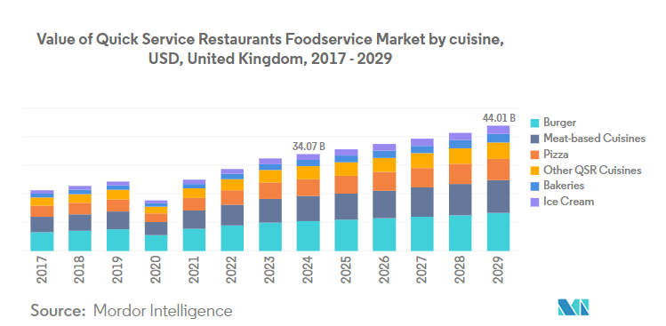
Figure 1: UK's QSR market to reach $44.01b by 2029
Source: (QSR Media, 2024)
There's surprisingly high industry growth, yet competition is also increasing because there are little switching barrier, high expectation of customers. Service quality is a very important factor of differentiation as consumers can easily change the brands. According to Deloitte (2023), 68 percent of these UK consumers are looking for improved speed of services and experiences tailored to them, whilst 54 percent are looking to have service food that is quality and clean. The expectations show how much service providers need to gain sophistication now since they have to balance the needs of the customer with service. Quality of service has thus come to be strategic in the QSR industry. As most products are standardised and very much replicable, companies need to gain a competitive edge by using service excellence. The five dimensions of SERVQUAL are reliability, responsiveness, assurance, empathy and tangibles, which have been identified as significant factors that affect customers' perceptions and their behavioural responses. When it comes to improvements in service quality, economic benefits can be measured — a small gain in customer satisfaction can lead to a big gain in customer retention, for instance (McKinsey, 2022). This is particularly relevant for the case of the QSR industry – to be profitable in the long run, repeat purchases must take place. There is also a discrepancy between the standards of services and the brands which highlights the importance of the latter. There have been indications that certain brands have a better performance at certain aspects like cleanliness and food quality. Indicatively, Wagamama scores customer satisfaction of more than 55 percent in cleanliness, as compared to competitors like Frankie and Benny, who have achieved a score of less than 25 percent in the perceived quality of food. Such disparities suggest that in some cases service quality is not manageable across the industry and this can present a risk and/or opportunity for industry players. The QSR environment has also changed due to technological advancements.
Digital ordering, mobile apps and self-service kiosks have become part and parcel of the business and over 40% of QSR transactions are now done online in the UK (McKinsey, 2023). The improvements in efficiency and convenience come with an added expectation of customer about fast, flawless service experiences and high levels of accuracy. They also create new roles and challenges, such as reduced levels of human interaction that may have a negative effect on the level of empathy and service perceived by the customer. Along with technological advancement, special focuses are the regulatory requirement on food safety, sustainability and transparency. As a notable example, the introduction of calorie labelling on food and drink in the UK in 2022 has meant that QSR companies have realised changes to their menus and a greater drive to provide information disclosures. Such changes have a direct impact on the service procedure and the customer's judgements and are further complications to service management. Consumers' preferences play an important role for the industry too. An increasing demand for healthier and sustainable and ethically produced food, has provided support to niche brands like Itsu. However, the issue of equal quality of service delivery on different channels looms on the horizon to these brands. The research by PwC also revealed that the food quality is not a determining factor for 72 per cent of customers never coming back to a restaurant after their bad experience with their service (PwC, 2023). This speaks to the very nature of service delivery, and why it is crucial to maintaining customers.

1.2. Research Rationale

1.2.1 Theoretical Justification
The connection between the service quality, customer satisfaction and customer loyalty has been well established in literature related to the field of marketing and service management and therefore it forms a solid theoretical basis of the proposed study. The major model on service quality measurement is the 'SERVQUAL model' that highlights as important, reliability, responsiveness, assurance, empathy, and tangibles of service as the factors of perceived service quality (Wider et al., 2024). The dimensions have a significant influence on the customer satisfaction (tend to be treated as a mediating variable) and ultimately on the behavioural outcomes such as repeat purchase and long-term customer loyalty. Speed of service, order accuracy and consistency have particular importance in quick-service restaurants (QSRs) as it relates to perception and ratings of service in a high contact time-sensitive environment (Bagrecha et al., 2026).
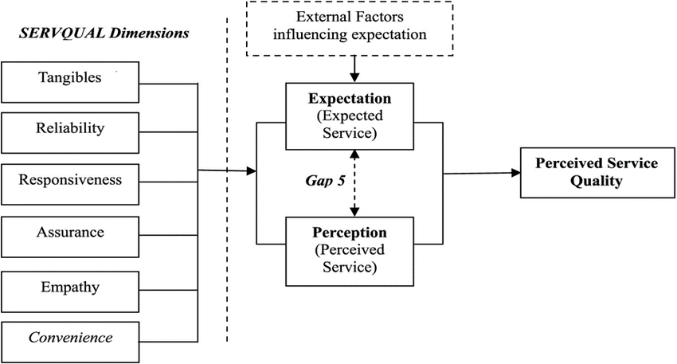Figure 2: Measuring service quality using SERVQUAL model
Source: (Namupala, 2019)
In spite of this solid theoretical foundation, the existing literature has a number of limitations and contradictions. One of the weaknesses is the use of cross-sectional research designs, which are only able to capture customer perceptions at a specific time and do not capture the dynamic nature of customer expectations in a fast-evolving service environment. The growing importance of online service channels that currently take up a considerable share in QSR payments is not sufficiently covered in the conventional service quality frameworks (Mohhanto et al., 2025). Moreover, the results of empirical studies demonstrate inconsistency of the relative significance of SERVQUAL dimensions, with some studies focusing on responsiveness and others on tangibles or assurance, which points to the absence of theoretical agreement. There is also geographic bias since a large part of the research has been focused outside the UK, making its application to the UK QSR industry somewhat limited.
Furthermore, little emphasis has been placed on niche, health-focused brands like Itsu, even though they are becoming increasingly important in the market and have a differentiated approach to service. The current models tend to consider the dimensions of service quality as independent variables without considering how they interact in the hybrid service environment, which integrates both digital and physical touchpoints. This leaves a knowledge gap in the functioning of service quality in modern QSR environments. Thus, this research attempts to solve these shortcomings by offering context-sensitive and combined research on service quality, customer satisfaction, and customer loyalty in the UK QSR industry and specifically Itsu.

1.2.2 Practical Justification
This competitive environment is already accompanied by the fact that the UK foodservice market is estimated at over £90 billion, and the quick-service restaurant (QSR) segment contributes over £22 billion, which is why it is an economically important industry (Financial Times, 2024; Deloitte Insights, 2023). The quality of service is vital in shaping the performance of business, the customer satisfaction and the long-term loyalty within this environment. The industry experience indicates that an average of 72 percent of customers do not come back after one negative service experience, and over 60 percent of buyers change brands because of such problems as sluggish service or incorrect orders (Forrester, 2023; Gartner, 2023).
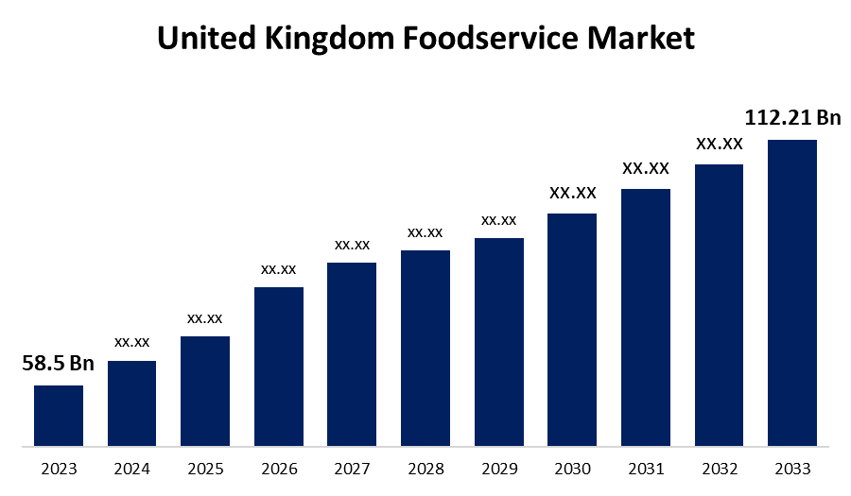
Figure 3: United Kingdom Foodservice Market Size, Outlook Forecasts To 2033
Source: (Spherical Insights, 2024)
Those statistics illustrate the direct correlation between service quality and customer retention/revenue generation. However, although the decision is critical, the majority of management decisions around service design decisions, staffing and plans related to the customer experience are supported only by basic context data, limiting their effectiveness for accurately representing customers' true expectations in the UK QSR market. Businesses thus can find themselves in running investments with a low return on service value improvement. The rapidly changing speed of digital transformation has also made service management in QSR industry even more complex. More than 40% of UK sales are now through digital channels and the use of mobile ordering systems and self-service kiosks and third-party delivery services are the norm (McKinsey, 2023; IDC, 2023). While the innovations do offer efficiencies and convenience, they are no guarantee of customer experience enhancement. While minimizing human interaction reduces the quality aspects of service that are critical to the service, such as empathy and assurance, it also does not meet the efficiency versus experience value trade-off (McKinsey, 2022). At the same time, the UK hospitality business is facing the ongoing labour shortage plus an employee turnover rate greater than 30%, affecting service delivery and reliability (Financial Times, 2023). Managers will therefore have to adopt a combination of effective operation, staff issues and evolving customer expectations. Based on the existing study, the findings are useful to assist the QSR companies in providing high-quality services and building customer loyalty through optimizing their service design, operational integration through digitalization, and customer experience management.

1.3. Research Contribution and Motivation
The research is driven by the necessity to fill the gap between the known service quality theory and its applicability in the UK quick-service restaurant (QSR) sector. The literature on the relationship between service quality, customer satisfaction, and customer loyalty is quite extensive, however, in most instances, these constructs are assumed to be stable and universal in various contexts (Kumolu-Johnson, 2024). These assumptions do not take into account the fact that the QSR industry is rapidly developing and the digital transformation, changing consumer expectations, and competition constantly transform the services delivery. Consequently, it is evident that it is necessary to conduct research that reconsiders such relationships in a particular and modern market context. The given research has a contribution to the development of theories as it expands the older frameworks of the research, especially the SERVQUAL model, with a more context-related method. The research acknowledges the interdependence of the service quality dimensions and their situational relevance in the hybrid service settings instead of considering them as independent and fixed. It includes new drivers like digital service interactions, health-oriented positioning, and experience expectations, which are more and more significant in the current QSR operations. By doing so, the research provides a more holistic view of the effect of service quality on customer satisfaction and, by implication, customer loyalty. It also helps to reinforce the conceptualisation of customer satisfaction as a mediating variable, and it gives a more precise explanation of how behavioural outcomes are constituted in practice.
Empirically, the study deals with the lack of evidence in the UK context, as it focuses on the QSR industry in the UK. It employs a quantitative approach by means of structured questionnaires to define customer perceptions and determine pertinent trends. The choice to use Itsu as a case study further enriches the study since it is a niche, health-conscious brand that exists in a very competitive market. This will enable us to take a closer look at the implementation and experience of service quality strategies. In general, the study provides value to the theoretical knowledge but also provides practical information that can benefit the management of service quality and customer experience to enhance the service quality and customer experience strategies in the UK QSR industry.

1.4. Research Aim, Objectives, and Questions
Aim
This study aims to examine the relationship between service quality, customer satisfaction, and customer loyalty in the UK quick-service restaurant industry, using Itsu as a case study.
Objectives
- To identify key service quality dimensions influencing customer satisfaction in UK QSRs.
- To analyse the relationship between customer satisfaction and customer loyalty.
- To examine service quality challenges faced by Itsu in maintaining customer loyalty.
- To recommend strategies to improve service quality and customer retention.
Research Question
- What service quality factors influence customer satisfaction in UK QSRs?
- How does customer satisfaction affect customer loyalty?
- What challenges does Itsu face in maintaining service quality and repeat purchases?
- What strategies can improve service quality and customer retention?

1.5. Dissertation Structure
All of this dissertation has been structured in a way which would allow it to flow logically and to be coherent in its analysis. Chapter 2 is a critical literature review on the existing literature on the topic of service quality, customer satisfaction and loyalty and reveals gaps in the literature. Chapter 3 presents the by justification of the methodologies applied in the study such as philosophy, approach, data collection methodologies and analysis data. Chapter 4 introduces and discusses primary data and interprets the results in terms of research objectives. There is a critical discussion of results in terms of current theories and industry settings in Chapter 5. Chapter 6 provides a culminating discussion of the key concepts, shortcomings and directions for future research. This guided methodology will ensure a systematic evaluation of the research problem, while maintaining a good theoretical, data and practice correspondence.

CHAPTER 2: Literature Review

2.1 Introduction
This review of literature critically explores the interconnections between service quality, customer satisfaction and customer loyalty in the UK quick-service restaurant (QSR) market, with a particular focus on the health-focused niche brand, Itsu (Manhas, Sharma and Quintela, 2024).
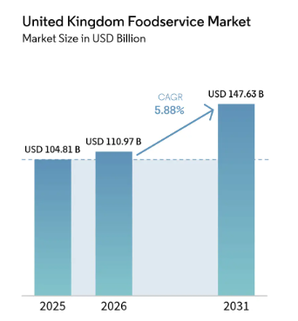
Figure 4: UK Foodservice Market Size, Share & Analysis 2031
Source: (Mordor Intelligence, 2026)
This inquiry is justified by the size and competition in the UK foodservice market, which is worth more than £20 billion, with low switching costs and high customer expectations, which present a challenge to service differentiation. Research shows that service quality accounts for about 60-70% of the variance in customer satisfaction (R² ≈ 0.60-0.70), and that satisfaction explains about 40-50% of the variance in customer loyalty (β ≈ 0.40-0.50), implying a robust but not complete causal link. But the transformation of the sector with more than 40% of QSR orders now being placed via mobile apps and delivery services, has radicalised perceptions of service quality, placing greater importance on speed, accuracy and technology stability. At the same time, over 60% of customers are increasingly concerned with health and ethical food consumption, resonating with Itsu's brand proposition but also adding layers of complexity to traditional service quality assessments (Siddiqui et al., 2022). This literature review therefore synthesises seminal theories such as SERVQUAL, expectation- confirmation, relationship marketing and service-dominant logic to critically examine these changing relationships. It follows a thematic organisation, covering the underlying theories, and empirical links, moderators, and recent industry trends, to identify gaps in the existing body of knowledge.

2.2 Thematic Review of Literature

2.2.1 Conceptualising Service Quality in the QSR Industry
(Theme 1: Foundations of Service Quality)
Service quality is often defined as the gap between customer expectations and service performance; but this notion is increasingly volatile in the quick-service restaurant (QSR) environment because of the dynamic and time-critical nature of service delivery. Evidence shows that more than 70% of QSR customers value operational efficiency (time and accuracy) rather than relational or experiential factors, which suggests a transition from multi-dimensional to functional aspects of service.
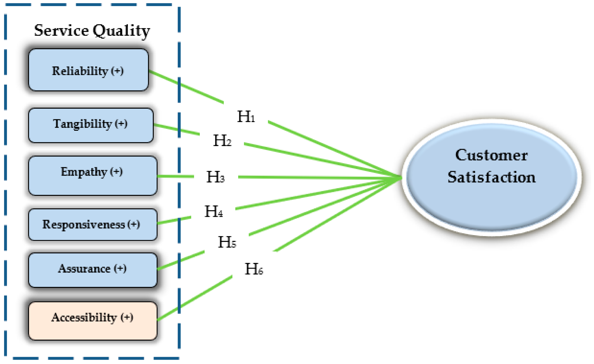Figure 5: The Effects of Service Quality Performance on Customer Satisfaction
Source: (MDPI, 2023)
For example, survey data from QSR settings indicate that service quality ratings drop if waiting times exceed 5 minutes, emphasising the importance of time efficiency as a key evaluative factor. This revises the classical expectation-perception gap model, where expectations are dynamically adjusted according to technological convenience and competitive standards, thus eroding the conceptual rigour of service quality as a stable concept (Bagrecha et al., 2026). SERVQUAL defines service quality in terms of five dimensions - reliability, responsiveness, assurance, empathy and tangibles - but research indicates that their contributions to QSRs are not equal. While quantitative research shows responsiveness and reliability have the strongest influence on perceived service quality, the effects of empathy and assurance (β < 0.20) are relatively weak, implying a lack of importance in fast-speed service delivery. Moreover, tangibles like cleanliness and physical appearance explain 50% of variance in customer satisfaction in restaurants, emphasizing their relevance, despite QSRs' operational emphasis. The unequal effects of the factors contradict the SERVQUAL hypothesis of dimensional parity and indicate that the model might overlook the hierarchical structure of service quality factors in fast-food restaurants (Abeykoon, 2023). These models still do not include real-time data feedback and hybrid service models, leading to only partial adaptation. As a result, the continued use of SERVQUAL in modern studies is a sign of a disconnect between the theory and practice, which have implications for the continued use of SERVQUAL in technology-based QSR settings (Ahmed et al., 2023).

2.2.2 Service Quality and Customer Satisfaction
(Theme 2: Relationship Analysis)
Customer satisfaction is defined according to the expectation-disconfirmation theory as a cognitive response based on the discrepancy between perceived and expected service; however, in QSRs this response is overwhelmingly focused on functional aspects. Research shows that the dimensions of service quality collectively account for 60-70% of the variance in customer satisfaction (R² ≈ 0.60-0.70), with functional considerations such as speed and accuracy being the most significant. In particular, responsiveness tends to be the strongest predictor, followed by reliability, and with relational factors like empathy having little influence (Balasubramanian and Suresh, 2022). This claim is also supported by empirical findings.
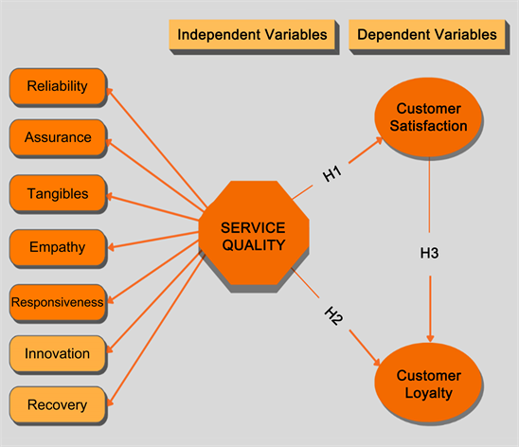
Figure 6: Measuring the Service Quality, Customer Satisfaction, and Customer Loyalty
Source: (SCIRP, 2023)
Research shows that an order accuracy rate of over 85%, and service times of 3-5 minutes are pivotal in determining high levels of satisfaction, while cleanliness alone can explain almost half of perceived service quality in restaurants. Moreover, employee behaviour and ambience contribute to satisfaction, but are less significant than speed and accuracy. (Chaturvedi et al., 2024). Crucially, there is no clear uniformity or consistency in the relationship between service quality and customer satisfaction and significant contradictions emerge. Although some studies report responsiveness as the most significant driver, others report tangibles or reliability as the most significant, suggesting a degree of inconsistency across studies. Thus, the literature offers disjointed and contextualised knowledge, highlighting the importance of adopting more sophisticated and longitudinal methods for studying the service quality-satisfaction relationship in QSR (Abdul Majid et al., 2024).

2.2.3 Customer Satisfaction and Customer Loyalty
(Theme 3: Behavioural Outcomes)
Customer loyalty is generally defined as a construct, with behavioural loyalty - measured by repeat purchase intentions - and attitudinal loyalty, which represents customer emotional investment and commitment to the brand. In QSRs, behavioural loyalty is more prevalent due to low switching costs and habitual consumption, with research showing that over 60% of customers engage in repeat purchase without necessarily forming emotional attachment. Thus, loyalty in QSRs is transactional rather than relationship based. Additionally, empirical models show that satisfaction accounts for a large variance in loyalty (R² ≈ 0.55-0.70) but that this relationship is not consistent across different contexts (e.g. speed and value of service). This highlights the importance of revisiting simplistic views of the relationship between customer satisfaction and loyalty in all service contexts (Chowdhury et al., 2023). The concept of the satisfaction–loyalty relationship is often discussed within the context of the satisfaction–loyalty chain and relationship marketing, which suggest that greater customer satisfaction results in increased retention and long-term profitability. But research indicates that this link is not equally strong in QSR. For example, structural equation modelling research shows that although satisfaction has a strong impact on loyalty, other factors such as trust (β ≈ 0.30) and commitment (β ≈ 0.35) are also important for long-term loyalty (Dandis et al., 2023). A critical question in the literature is whether satisfaction guarantees loyalty, especially in highly competitive QSR environments with low switching costs and price sensitivity. Research shows that even when customers are satisfied, they often switch brands for promotional discounts, convenience or price variations, with some studies suggesting that 50% of satisfied customers could switch brands in competitive markets. As a result, the satisfaction-loyalty linkages in QSR industries are probabilistic and not deterministic, given the market and customer variables involved, and can't be applied wholesale to existing loyalty theories (Koay et al., 2022).

2.2.4 Mediating and Moderating Factors
(Theme 4: Complex Relationships)
While customer satisfaction has been recognized and is considered to lie in between service quality and customer loyalty, satisfaction has been too much emphasized in some models. Research findings indicate that satisfaction mediates the relationship between service quality and loyalty (indirect effects account for 40-60% of the total effects), but that there are direct effects between service quality and loyalty as well, meaning that satisfaction only partially mediates the link. One would assume that with this level of customer satisfaction, customers would be loyal despite their lack of satisfaction, particularly in cases where switching costs or inertia significantly influence consumer behaviour. This should mean that customers are loyal even if not satisfied, especially when switching costs or inertia are key factors in consumers' decisions (Kumolu-Johnson, 2024).
Moderators, such as price, brand image, convenience and expectations, are important influencing factors of the quality, the satisfaction and the loyalty relationship. Price sensitivity decreases the satisfaction-loyalty relationship, for instance; consumers are more likely to choose lower prices than great service in a QSR. Similarly, brand perceptions and convenience perceptions can contribute to loosening or tightening loyalty development, and those customers who experience convenience are more likely to be loyal to the brand. In fact, context aspects can create loyalty as revealed by recent worldwide trend reports on consumers' behaviour, reporting that things more than 65% of consumers value are speed and convenience, not brand loyalty. The moderating factors suggest that customer loyalty is not always related with satisfaction, and it can rely on various external and perceptual factors (Economist Intelligence Unit, 2023). While cognitive measures are lifters, recent studies show that Psychonomic factors can be just as important as perceived value or emotional involvement in increasing loyalty effects, particularly in markets that offer many more choices. According to some studies, perceived value, for example, improves the correlation of satisfaction with loyalty, meaning that the customers tend to be more loyal if the perceived cost-benefit ratio is favourable over their product compared to other options. However, these factors are only indirectly taken into account in models already used and often fail to account for the complexities of customer behaviour. Therefore, the need for whole systems that encompass cognitive and affective factors along with contextual moderators can be seen to explain better the loyalty relationships in QSRs (Islam and Shaikh, 2025).

2.2.5 Impact of Digitalisation and Changing Consumer Behaviour
(Theme 5: Contemporary Context)
The digital revolution in the QSR industry has transformed service delivery channels, as mobile ordering, self-service kiosks and third-party delivery platforms have emerged as primary points of interaction with customers. Recent industry figures estimate that more than 40-50% of QSR orders in mature markets are now digital and that delivery platforms alone represent a significant proportion of QSR industry revenue growth. Mobile apps have shifted consumer expectations towards speed, convenience and personalisation, and self-service kiosks have eliminated personal interactions and standardised customer service.
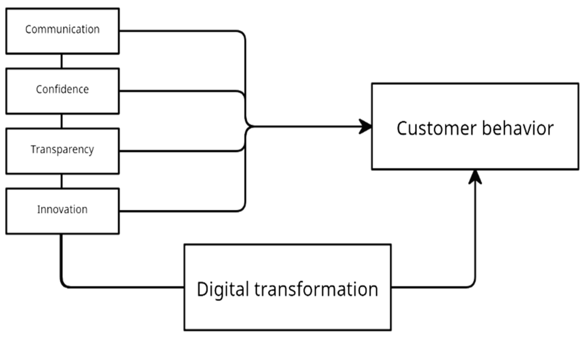Figure 7: Is There an Impact of Digital Transformation on Consumer Behaviour?
Source:(MDPI, 2023)
The results reveal that digital service quality has a positive and significant effect on customer satisfaction, with ease-of-use, reliability of the system (β ~0.45), and responsiveness of the interface (β ~0.48) having statistically the strongest relationships with customer satisfaction amongst the individual determinants of digital service quality. These relationships are strong, exceeding the effect of in-store service quality on satisfaction in some cases (McKinsey & Company, 2023). For example, the speed of order processing or the error of information details for digital platforms may have a positive touch on brand image even in spite of having quality service in store. Additionally, with the transition to digitisation, customers have come to expect of it a high level of speed and accuracy, with little tolerance for delays or errors. Research indicates that when the digital service fails, its satisfaction can plummet by up to 30%, and customers' sensitivity to performance of the digital system is evident. The complexity of service interactions and service effects from digital service experiences bring in the need to take into account the connections between different service touchpoints and the comprehensive impact of digital service experiences in current service quality frameworks such as Lin et al. (2024). Consumption behaviour in connection with a growing shift toward digital service and health and ethical aspects of consumption, poses yet another challenge to service quality. The research indicates that over 60% of consumers today consider health, sustainability and transparency to be among the more important purchase drivers and it establishes that consumer interest in sustainability is a global phenomenon promoted and driven by consumers. Digital tools, such as a QR menu and a nutrition information system, enhance transparency, but associated risks of privacy and authenticity perceptions may affect the relationship between the service quality and consumer satisfaction. This was a clear indication that service quality models are often missing in ethical and sustainability elements involved in the provision of services. So, it is needed to have a holistic concept where the digital service quality and new priorities of the service industry can be interpreted within the scope of "Itsu. Thus, a comprehensive concept which considers the digital service quality, and new priorities in service industry such as health, well-being, and sustainability concepts, is needed within the scope of "Itsu.

2.2.6 Service Quality in the UK QSR Industry
(Theme 6: Industry + Case Focus)
The UK QSR market is extremely competitive, the market is saturated and is rapidly changing; Foodservice alone represents over £20bn of the market and is projected to grow continuously due to urbanisation and the emergence of new technology. Their strategies include exploiting economies of scale, operational standardisation and low prices, and this can be a huge problem for smaller, or niche, competitors when they are competing with global brands such as McDonald's, KFC and Burger King.
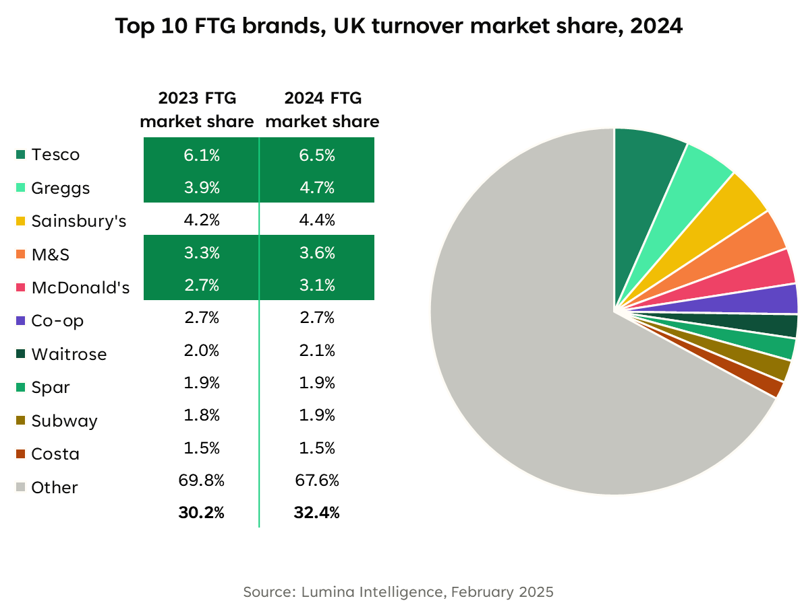
Figure 8: UK QSR Market 2025: Trends, Growth & Consumer Shifts
Source:(Lumina Intelligence, 2025)
Customer switching here is easy, and service is a crucial factor, as it can influence whether customers switch or not. The facts and figures illustrate how highly susceptible to service failure the QSR industry is, with one study indicating that 70% of visitors to poor QSRs may never return. This highlights the importance of quality and uniformity of service throughout outlets in a price-sensitive and very competitive environment (Spherical Insights, 2024). Itsu differentiates itself in this setting as a healthy choice to the traditional fast food, with Asian-inspired taste. The results indicate that product quality and service quality are both important factors in determining customer satisfaction and loyalty, which means that in order to be successful, Itsu must be able to handle the two types of quality simultaneously. The luxury positioning could ultimately, however, attract the right kind of audiences, such as individuals that are willing to pay a high price, which appears to pose a trade-off between market reach and positioning (Naini et al., 2022). Additionally, the challenge in ensuring and controlling service quality delivery and management at branches, is critical for brands like Itsu which are niche QSRs. In contrast to the service process of a multinational chain which is very standardized, this does not standardise its process of service delivery to ensure freshness and quality, and this may affect the quality of the service produced and its perception by customers. This research gap restricts the conceptual development in the current context and offers limitations for using current service quality models as tools to come up with new business model. Therefore, empirical study on the nature of service quality in niche QSR, specifically regarding scalability, consistency and changing customer expectation is needed (Mendocilla et al., 2026).

2.3 Theoretical Foundation and Contribution
The main theoretical framework that informed this research is an integrated theoretical approach consisting of the SERVQUAL model, expectation-confirmation theory (ECT), relationship marketing theory, and service-dominant logic (SDL) that seek to explain the dynamics between service quality, customer satisfaction, and customer loyalty in the UK QSR market. In their conceptualisation, SERVQUAL views the idea of service quality as based on five dimensions, namely reliability, responsiveness, assurance, empathy and tangibles with the assumption that the perceived quality is the difference between expectations and service performance.
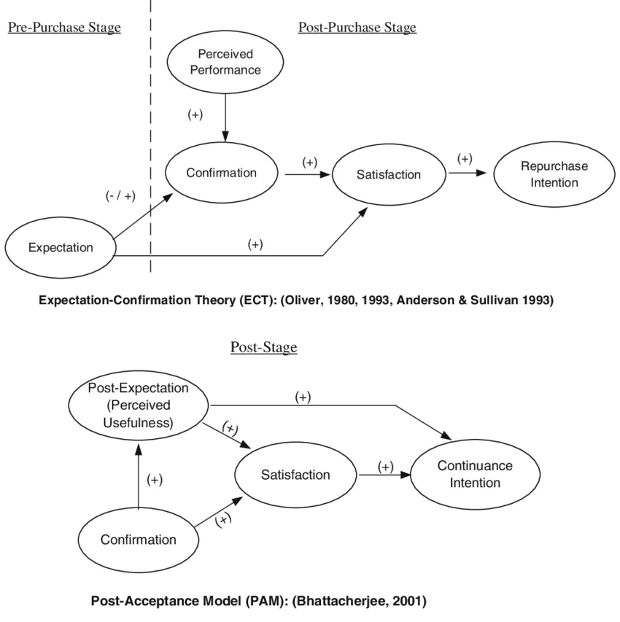Figure 9: Expectation-confirmation theory and post-acceptance model
Source:(Kim, 2012)
This is supplemented by ECT, which describes satisfaction as a cognitive evaluation procedure, in which post-consumption reactions are judgmental on the confirmation of expectations. Relationship marketing theory builds upon the analysis to highlight the relational constructs in the long term, like trust and commitment, whereas SDL redefines service as a co-creation process wherein value is created through interactions between firms and customers instead of being captured in outputs. Empirical improvements of these theories have suggested that service quality is a good predictor of customer satisfaction (R 2 = 0.60 -0.70) with customer satisfaction contributing only 40-50% to loyalty (0.40 -0.50), thus necessitating a multi-theoretical approach to explain both the transactional and relationship dynamics. The rationale behind the use of this integrated framework is the weaknesses of single-theory frameworks in explaining customer behaviour in modern QSR settings that are defined by the characteristics of digitalisation, low switching costs, and changing consumer expectations. SERVQUAL is not sufficient because of its unchanging dimensional framework whereas ECT does not consider the quickly changing expectations that are subject to change based on digital service platforms. The gaps are filled in relationship marketing theory and SDL which takes into consideration the relational and experiential aspects and the interaction of services which can be translated into long term loyalty. Such theoretical integration enables the research to go beyond the linear cause-effect assumptions and, instead, comprehend the multifaceted Ness of the service ecosystem, in which digital touchpoints, convenience, and perceived value interplay with the traditional service dimensions. The framework therefore offers a stronger explanatory foundation to explain the service quality-satisfaction-loyalty relationship in the UK QSR industry.

2.4 Conceptual Framework
This study's conceptual framework is based on the synthesis of service quality theory, expectation–confirmation theory, relationship marketing theory and service-dominant logic theories to explain the causal and relational links between service quality, customer satisfaction and customer loyalty in the UK quick-service restaurant (QSR) market. Essentially, the framework conceptualises service quality as the independent variable, operationalised through key dimensions (such as reliability, responsiveness and tangibles) which have been shown to have a strong influence on customer perceptions. These are especially pertinent in QSRs where customers evaluate services based on operational efficiency, which is reflected in speed of service (an expectation of 3-5 minutes) and accuracy (80-85% or more). But rather than adopting a linear view of loyalty, the framework positions customer satisfaction as the key mediating variable, capturing the cognitive appraisal process of comparing expected and perceived service levels. Research findings show that service quality accounts for around 60-70% of variance in customer satisfaction (R² ≈ 0.60-0.70), suggesting that while service quality provides a strong explanation of customer satisfaction, it is not a complete explanation, revealing a need for other relational variables to be included in the framework (Española, Janaban and Martir, 2024).
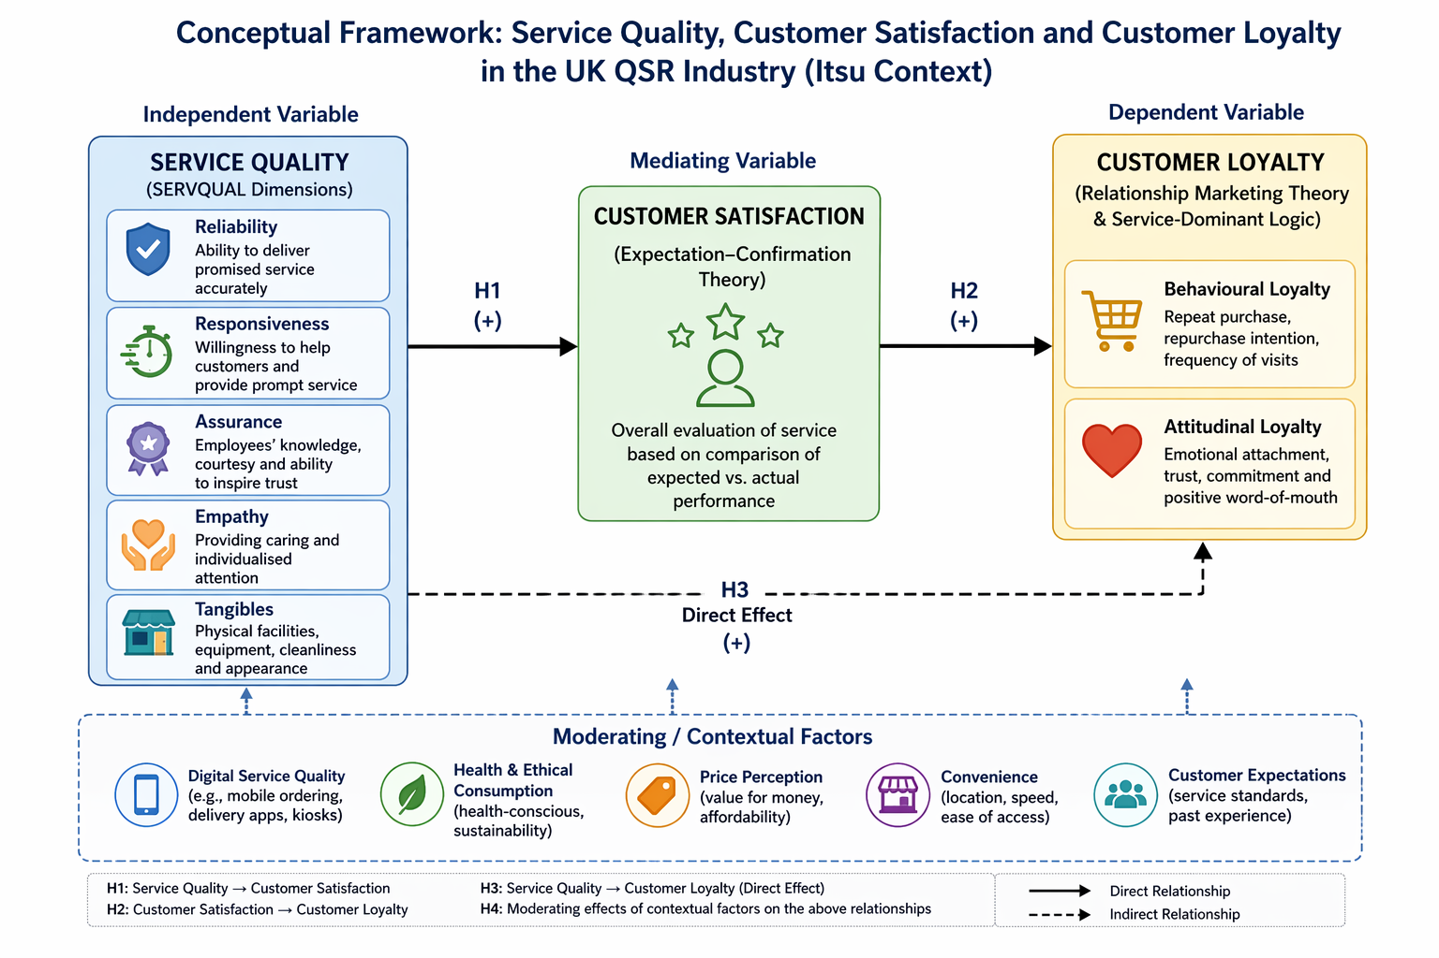
Figure 10: Conceptual Framework
Source: Self-Created
This led this framework to recognize that customer satisfaction is not the only determinant of customer loyalty but rather is embedded in a greater structure of the customer/relational contract based on attitudinal and behavioural variables. Despite it being found to have a relatively strong relationship with loyalty, satisfaction can still be considered as a partial effect as there is still a significantly high level of direct effect from service quality to loyalty (indirect effect ≈ 0.25-0.35) remaining in empirical studies. This is because the partial mediation structure is in line with the QSR market: low switching costs and price sensitivity and high competitiveness results in the weakness of the satisfaction-loyalty relationship. Therefore, the conceptual framework is derived from the theories of relationship marketing (including trust, commitment and perceived value) and service-dominant logic (emphasis on value co-creation). This is particularly relevant in the context of digital services, in which service experiences not only occur in-store, but also through mobile ordering, delivery service and self-service technologies (Yum and Yoo, 2023). The new framework also includes direct and indirect effects, thus acknowledging the responsiveness, fluidity and situationally of customer response to service quality aspects, which are similar or greater in impact than those associated with face-to-face encounters. It does not limit the approaches to linear thinking but takes cognizance of the fact that loyalty is an outcome of both cognitive and operational factors and convenience and value factors. The model is comprehensive and extends the existing models which usually take service quality, satisfaction, and customer loyalty as separate variables and provides a more integrated model of the relationships between them. In so doing, it serves as a strong foundation for empirical research, enabling identification of key elements that influence customer loyalty in the UK QSR segment, taking into account the changing trends brought by digitalisation and the changing preferences of consumers (Rosário, and Casaca, 2025).

2.5Literature Gap
While service quality and customer satisfaction and loyalty are well studied areas of research there are clear gaps in the QSR literature, particularly in the UK. The fact that most of the research is undertaken overseas makes it hard to compare its benefits back to the UK as it doesn't consider the cultural differences and customer expectations and the market competition. Speed of delivery, convenience and efficiency are among their expectations, and few empirical studies have tried to look into these particular factors when serving British consumers (Akter, 2025). This restricts the application of models and the need for context specific research. There is also further research gap regarding brands that are specialized in providing healthy QSR food products, such as Itsu. Most studies have been on multi-national chains and not covered the operational challenges and unique value proposition of smaller brands. This is especially important seeing that there is an increasing demand for healthy and sustainably sourced food, hence changes in consumer behaviour and service requirements. There has been little study undertaken on these brands, making it difficult to understand how they are delivering quality service in new markets. Furthermore, the present study reveals that the relationships of service quality and related consumer behaviour elements from digital service quality framework with existing service quality frameworks are poor. Though the introduction of digital service delivery provided has revolutionized service offerings, most are based on pre-digital dimensions when determining service quality, not taking into account mobile ordering, delivery apps and other technology factors. There are inconsistencies with regards to the relative weighting of the dimensions of SERVQUAL. Research has revealed disparities between the relative importance of the dimensions in terms of their impact on satisfaction and loyalty, indicating that consensus is lacking and possibly context specific effects.

2.6 Chapter Summary
This chapter critically examined the existing body of research on service quality, customer satisfaction and customer loyalty in the QSR industry, outlining the theoretical and empirical insights. The review showed that although service quality has a profound impact on customer satisfaction and loyalty, the links between these constructs are contextual, and mediated and moderated by a range of factors. The chapter also recognised the shortcomings of existing models in the context of digital service delivery and changing customer expectations. Crucially, the absence of UK-specific literature, the lack of focus on emerging brands like Itsu, and the limited consideration of digital and health-related factors were identified as gaps in the literature. These gaps provide a basis for the current research and guide the formulation of the research framework. The next chapter will present the methodology, including the philosophical underpinning, design, data collection and analysis techniques used to test the links identified within this chapter.

CHAPTER 3: RESEARCH METHODOLOGY
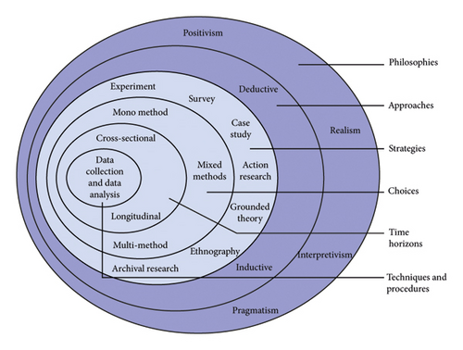
Figure 11: Research Onion
Source: Alturki, 2021

3.1 Introduction
Research methodology is the scientific procedure which a research worker adopts to gather, analyse and interpret data to be able to answer the questions of the research effectively and attain the research objectives. Research methodology is a technique that creates a scientific procedure, which is systematic, objective, and consistent throughout the research process, according to Creswell and Inoue (2025). This study aims to analyse the effect of service quality on customer satisfaction and customer loyalty in the fast-food service sector of the United Kingdom (UK), specifically on Itsu. Specifically, the study will look at the dimensions of SERVQUAL: tangibles, reliability, responsiveness, assurance and empathy. This chapter will go over the methodology that will be used to effectively carry out the research. It will discuss the research philosophy, research approach, research design, research strategy, data collection methods, sampling technique, sample size, data analysis procedures, reliability, validity and ethical considerations.

3.2 Research Philosophy
Research philosophy is a set of beliefs, assumptions, and principles that govern a research study and that guides it. Research philosophy affects the approach to data collection, data interpretation and data analysis. Bergmann (2023) explained that the philosophy of research serves as the basis for choosing a suitable research method and for scientifically understanding the results of research. This research will be conducted with Positivism method that is based on objective reality and scientific measurement. The positivist philosophy will be used as the study is looking to use quantitative numerical data to analyse measurable relationships between service quality, customer satisfaction and customer loyalty. The positivism favours objective research by statistical analysis and measurable observations. The present research will be conducted with a structured questionnaire and using quantitative data analysis, thus the positivism approach is considered as the most appropriate approach. Additionally, positivist philosophy assumes the possibility of an objective and independent measurement of reality from the researcher's opinion and feelings.
The positivist approach will also reduce researcher bias as the findings will be determined by numerical data and facts as opposed to interpretations. This will enhance the reliability and validity of the study results. Moreover, the positivism approach will enable the researcher to apply the results of the research beyond the sample population to larger population groups of fast-food customers in the UK. The positivist philosophy has been used in previous studies related to hospitality and service quality due to its ability to measure the attitude of customers and their behavioural intentions through quantitative analysis (Dwivedi et al., 2024).

3.3 Research Approach
Research approach is the means by which the relationship between theory and data is made in a research study. The type of research usually dictates whether the research starts with theories or constructs theories from the findings. In deductive research, theory, or hypothesis, are first formulated and then put to the test with empirical data, while in inductive research, theory or hypothesis is developed based on empirical data patterns (Kumar and Ujire, 2024). The current research will use deductive approach. The deductive approach will be used since the research will be based on the theories and concepts on service quality, customer satisfaction and customer loyalty. Based on the study, it will be used to test whether the dimensions of service quality significantly impact customer satisfaction and customer loyalty in the quick-service restaurant industry in the UK.
In the specific research, the researcher will follow the SERVQUAL model developed by Parasuraman, Zeithaml and Berry. The SERVQUAL model is a model that focuses on five key dimensions of service quality, namely tangibles, reliability, responsiveness, assurance, and empathy. The dimensions are used in numerous studies in hospitality and restaurant management for assessing customers' perception of service quality and its impact on satisfaction and loyalty.
By using the deductive approach, the researcher will be able to develop hypothesis theory based on the theories and former studies carried out. Data gathered from the customers with the help of questionnaires will then be analysed to see if the hypotheses are accepted or rejected. This will therefore enable the researcher to analyse if the dimensions of service quality have a positive effect on customer satisfaction and customer loyalty in the context of Itsu and the UK Quick-service restaurant industry.

3.4 Research Design
The design of research is the general plan or structure in which data is collected, measured and analysed in a research study. Research design helps researchers to be systematic in conducting the research and to make the research goals more effective. In this state that research design is the formal process that connects research questions, data collection procedures and analysis procedures. Explanatory research is used to find cause effect relations, descriptive research is used to describe characteristics, behaviour and relationships between variables. This study will use descriptive research design. Descriptive design will be used as this study seeks to describe and analyse customer perceptions of service quality, customer satisfaction and customer loyalty in UK quick-service restaurant industry.
Descriptive research design will enable the researcher to study the customers' attitudes, behaviours and opinions systematically without changing the research environment. This design will therefore facilitate the investigation of the perception of the customers on the five dimensions namely reliability, responsiveness, tangibles, assurance and empathy in quick service restaurants. The descriptive research will also help determine if there are relationships between the service quality dimensions and customer loyalty intentions.
The descriptive research design will offer a number of benefits to the study. First, it will help the researcher obtain information from a fairly large number of people in a reasonably short time span. Second, descriptive design will be used to complement quantitative designs like structured questionnaires and statistical analysis. Third, it will provide uniformity as everyone will be asked the same questions and given the same response choices.

3.5 Research Strategy
Research strategy is a plan that researchers use in the research process that guides researchers to conduct research systematically and answer research questions. Methods and procedures that are used in data collection and analysis are dictated by research strategy. Common research methods used are survey, experiment, case study, ethnography, grounded theory and action research. The current study will use a quantitative survey research design. Survey strategy will be appropriate since the research is conducted to gather numerical information about customer perception, customer satisfaction and customer loyalty intention in the Quick Service Restaurant industry. Survey research is conducted in hospitality industry and customer behaviour related study because it helps the researchers to gather opinions and behavioural responses from large population of people in an efficient manner (Dwivedi et al., 2024). The survey method is employed in this study that is based on positivist philosophy and deductive research approach. The questionnaires are designed to be completed by the customers who have been visiting quick-service restaurant chains, especially Itsu, in the United Kingdom. Information on customer experience, customer perceptions of the dimensions of service quality, customer satisfaction and customer loyalty will be gathered through the questionnaires.
The quantitative survey approach will provide a number of benefits. For one, it will allow the scientist to gather vast quantities of data in a comparatively brief span of time and at comparatively low cost. Second, it will help students learn to use statistical analysis to detect patterns and relationships between variables. Third, standardised questionnaires will create consistency and objectivity in data collection. The survey strategy will also enhance the reliability as all the respondents will respond to the same set of questions with the same response scale. This uniformity will minimize inconsistencies and make responses more comparable. In addition, the online survey methods will enable respondents to participate in an easy and convenient manner from various geographical locations in the United Kingdom. Singh et al. (2023) found that survey techniques are very effective in quantifying the attitude, satisfaction, and behavioural intentions of the hospitality industry's customers.

3.6 Data Collection Method
Data collection involves the process of collecting data that is needed to address research questions and research objectives. Depending on the nature of the study, data can be collected from primary or secondary sources. Primary data is data collected directly from the respondents and secondary data is the data that has been collected from available academic sources like books, journals, reports, websites etc. Primary quantitative data collection techniques will be used primarily supported by secondary academic data source in current study. Primary data will be gathered by using structured questionnaires which will be given to customers who have tried quick-service restaurants in the United Kingdom.
This questionnaire will be comprised of closed ended questions on a 5-point Likert scale from “Strongly Disagree” to “Strongly Agree.” The services research literature is full of many questionnaires that are based on the Likert scale due to its ability to effectively quantify customer perception and satisfaction levels (Vu, 2022). The id SERVQUAL model developed by Parasuraman, Zeithaml and Berry will be the foundation for the questionnaire development. Questions will be designed to evaluate customer opinions regarding:
- Reliability of service
- Responsiveness of employees
- Assurance and professionalism
- Customer Care – Empathy towards customers' needs
- Things that can be seen and touched like the cleanliness and service of a restaurant
The surveys will be sent out via social media, email marketing and online customer communities. The use of online surveys will be deemed appropriate due to their ability to rapidly gather data, reduce costs, and provide respondents with an easy way to participate. Primary data would be suitable as it would give first hand customer information about their experiences in the quick-service restaurant market in the UK. Direct customer survey is highly effective as it captures what customers actually think and expect and this is based on their experience with the product, according to Amoozegar et al. (2025). The questionnaire was made up of 21 close ended questions which were divided into 4 sections: Demographic information, SERVQUAL dimension, Customer satisfaction and Customer loyalty. Customer perceptions and attitudes were captured using a five-point Likert scale which ranged from “Strongly Disagree” to “Strongly Agree.” The problem with this is, however, that online questionnaires can cause ‘response bias’s as some answerers might choose to give false or socially desirable answers. Also, some responses may lack understanding in the questions due to the lack of clarification by the researcher.

3.7 Sampling Technique and Sample Size
This study will employ a non-probability sampling technique which is convenience sampling. Convenience sampling is when people are chosen who are easily accessible and willing to participate in the research. Tajik and Noor (2025) have indicated that convenience sampling is usually employed in academic research since it is timesaving, cost-efficient, and applicable to quantitative studies with limited resources. The sample population of this research will be the customers who have consumed meals in a fast-food restaurant in the United Kingdom especially those who are familiar with Itsu. Respondents will be chosen according to their past experience of eating and filling out the survey questionnaire. The study will seek out about 100 participants. The sample size of about 100 respondents will be taken as appropriate in quantitative descriptive type research studies. According to Mahat et al., (2024) descriptive quantitative analysis can generally be performed with a sample size of 80 to 120 respondents.
The convenience sampling will offer a few benefits for the current study. First, it will enable the researcher to collect the data very efficiently and swiftly. Secondly, it will save research costs because the respondents can be easily reached using online platforms and social networks. Thirdly, convenience sampling will be effective because of the limited time period and available research resources. Convenience sampling, however, might undermine the extent to which the results are generalisable as the sample might not fully reflect the broader spectrum of quick-service customers in the UK.

3.8 Data Analysis Method
Data Analysis involves organising, interpreting and evaluating the data gathered to answer research questions and elicit meaningful results. The present study will use a quantitative approach; thus, descriptive statistical analysis will be used. Data from the participants will be analysed on Microsoft Excel. Data will be summarised and interpreted effectively using descriptive statistical techniques such as frequencies, percentages, mean values, tables and charts. Descriptive statistical analysis can help determine trends, patterns and relationships in quantitative research data. In the present study descriptive analysis will be emphasized on the following:
- Customers' attitudes on the quality of service
- Customer satisfaction levels
- Customer loyalty/repeat purchase intention
- There are relationships between service quality dimensions and customer satisfaction.
Frequency analysis will be used to determine how many respondents checked specific categories for the responses. The percentage analysis will reflect the percentage of agreement/disagreement to different statements. Mean values will be used to decide the average customer ratings for the service quality dimensions. Descriptive statistics will be used as the study is designed to summarise customer opinions, trends will be identified and won't include highly advanced statistical modelling. Descriptive analysis will thus be able to give clear and comprehensible information about the experiences and satisfaction of the customers in the fast-food sector. Microsoft Excel will be chosen to efficiently organise survey data, compute statistical values and to make efficient graphical presentations. Another common reason for the use of Excel in quantitative research in academia is its accessibility and ease of use.
Although the methodology chosen to accomplish the research goals proved to be appropriate, numerous limitations were found in the study. The study was primarily dependent on self-reported answers to questionnaires and that may build upon personal views or biases. Also, the sample population was not representative due to using convenience sampling. Moreover, the descriptive statistical method is simplistic that was used in this study did not enable deeper analysis of the causal relationships between the variables. The quantity of data and depth of the study was also constrained by time and resources.

3.9 Reliability and Validity
Some of the factors that will decide the quality and the trustworthiness of the findings of research are reliability and the validity. Reliability is a measure of the consistency and stability of research results, and validity is a measure of the accuracy and appropriateness of the measuring process. A number of steps will be taken in the present research to ensure the reliability. Consistency in data collection will be achieved with structured questionnaires, which have a uniform question wording and response options. The same questions will be asked to all respondents, with the same scale of measurement.
The use of a Likert scale questionnaire will increase reliability because the response options are all the same, which will minimize the variation in interpretation. Singh et al. (2023) argue that questionnaires that are standardised offer the advantages of consistency and comparability in customer satisfaction studies. Throughout the study, validity will also be taken into consideration. The areas of the questionnaire items will be framed on the basis of theories and literature surveys related to service quality, customer satisfaction and customer loyalty. The theoretical foundation of the measurement of the dimensions of service quality will be based on the SERVQUAL model developed by Parasuraman, Zeithaml and Berry. The content validity will thus be enhanced as the questionnaire will incorporate known and valued dimensions of service quality previously validated. Also, the questionnaire items will be closely linked to the objectives of the research in such a way that the data obtained from the answers will be able to solve the research problem. Pilot testing could also be done prior to the final distribution of questionnaires. A small number of respondents in the pilot study will help identify unclear/confusing questions. The results of the pilot test will be considered for refinement of wording and structure of the questionnaire.

3.10 Ethical Considerations
During the research process, the researchers discussed ethics to ensure the safety of the research participants, and the integrity of the research. The purpose of the study was explained prior to completing the questionnaire to the participants. The study was done on a voluntary basis, and the respondents could withdraw from the study at any stage prior to filling out the questionnaire. The research was conducted in an anonymous and confidential manner. The information obtained from participants did not include their personal identifying information (e.g. name, address or contact details). Any responses given were solely for academic research purposes and were kept safely in password protected files only the researcher could access. The ages of the participants were 18 years and above in order to have an informed participation. Research was performed following guidelines and requirements of the University. Furthermore, the questionnaire excluded misleading or hurtful questions and sensitive questions which would have a negative impact on the participants. However, since the study was conducted in an on-line environment the researcher was not able to completely assess the levels of honesty and engagement among participants when they completed the survey.

3.11 Chapter Summary
The methodology used to investigate the relationship between service quality and customer satisfaction and customer loyalty in the quick-service restaurant industry in the UK has been discussed in this chapter especially with regards to Itsu. The study will use a positivist research philosophy, deductive research approach, descriptive research design, and quantitative survey strategy. Structured questionnaires will be used to collect primary quantitative data from around 100 respondents using convenience sampling. The questionnaire will be framed based on the SERVQUAL model and will focus on tangible, reliability, responsiveness, assurance, and sympathy. Data collected will be analysed using descriptive statistical technique in the form of Microsoft Excel. The reliability, validity and ethical issues will also be carefully considered in order to ensure that the results of the research are accurate, reliable and appropriate for academic purposes. In conclusion, the methodology chosen will help to facilitate systematic analysis of customer satisfaction and customer loyalty in the fast-food industry and will provide useful information about service quality management in the hospitality sector in the UK.

CHAPTER 4: DATA ANALYSIS AND FINDINGS

4.1 Introduction
The main quantitative data gathered from the visits to QSRs in the United Kingdom are presented and analysed in this chapter and focus on Itsu in particular. Twenty-one questions were used in the survey based on the five SERVQUAL dimensions (Tangibles, Reliability, Responsiveness, Assurance and Empathy) and overall satisfaction and customer loyalty. Each question was answered on a five-point Likert scale from Strongly Disagree (1) to Strongly Agree (5). Descriptive statistics, Net Promoter Score gauges and frequency distributions are used in presenting the results, giving a comprehensive overview of customers' perceptions. The analysis was conducted directly to the research objectives such as finding out the key factors of service quality that affect the customer's satisfaction, the relationship between satisfaction level and customer loyalty, and the challenges faced by Itsu in controlling service quality (Mendocilla et al. 2026).

4.2 Demographic Profile and Respondent Overview
There were 132 respondents in all. Most respondents (96%, 127) said that they had eaten at a QSR in the UK, with only 5 (4%) saying that they had not. The high participation rate with actual QSR customers validates and ensures relevance of data gathered. The majority of actual QSR visitors in the sample was due to the practical sampling method used which involved sampling active customers via internet and social media, as described in Chapter 3 and in line with the convenience sampling method outlined.

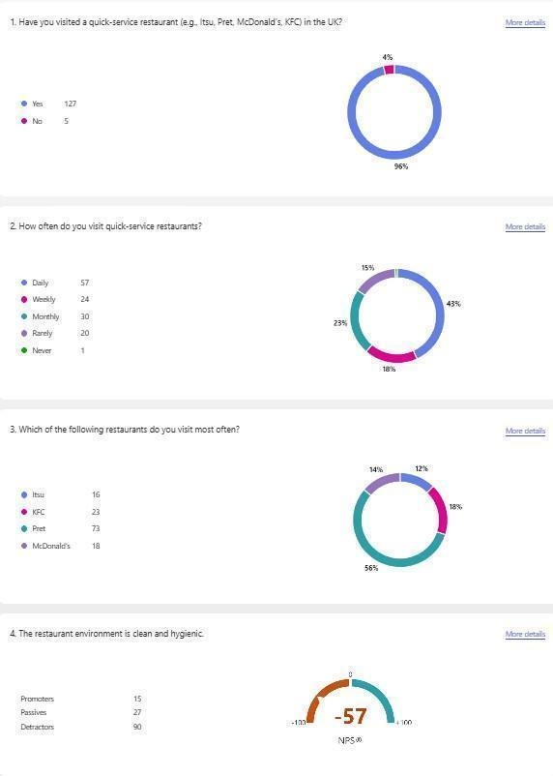
Figure 12: Survey Data Overview – Q1 to Q4 (Visit Frequency, Restaurant Preference, and Tangibles NPS)
As far as visit frequency (Q2) is concerned, the data shows that 57 respondents (43%) visit QSRs every day, 24 (18%) weekly, 30 (23%) monthly, 20 (15%) rarely and, surprisingly, just 1 respondent never visits. The high percentage of the daily visitors (43%) indicates that the sample had a considerable number of habits in the consumption process, especially when interpreting the phenomenon of loyalty in the context of QSR. Even though customer satisfaction is the direct antecedent of customer loyalty, the research suggests that there is a challenge to the simple satisfaction-to-loyalty models because frequent and regular customers tend to have more behavioural loyalty than emotional loyalty (Chowdhury et al., 2023).
The most popular QSR was Pret (73, 56%) followed by KFC (23, 18%), McDonald's (18, 14%) and Itsu (16, 12%) when it came to preferred restaurant (Q3). The smaller number of Itsu specific customers is indicative of the positioning of the brand in the wider UK QSR market. It is in line with the market information indicating that Itsu is offering a premium, health-conscious option in a market dominated by global chains, as noted by Bagrecha et al. (2026).

Survey Item | Promoters | Passives | Detractors | NPS Score
Q1 – Visited QSR in UK | 127 (96%) | – | 5 (4%) | N/A
Q2 – Visit Frequency (Daily) | 57 (43%) | 30 (23%) | 21 (16%) | N/A
Q3 – Restaurant Most Frequented | Pret: 73 (56%) | KFC: 23 (18%) | McDonald's: 18 (14%) | Itsu: 16 (12%)
Table 1: Demographic and Visit Frequency Summary

4.3 Tangibles Dimension Analysis

4.3.1 Cleanliness and Hygiene (Q4)
In question 4 respondents were asked to rate the cleanliness and the hygiene in the restaurant environment. The NPS gauge (the bottom section of Figure 4.1) is very negative, with only 15 promoters, 27 passives and 90 detractors. This dissatisfaction is substantial: in a restaurant context, cleanliness contributes around 50% to the variance in customer satisfaction (Balasubramanian and Suresh, 2022) and this is a negative aspect that affects the overall customer satisfaction. A striking aspect of these scores is how these scores may not have impacted customers' expectations owing to significant shifts in their hygiene expectations into a differentiator environment post-COVID-19. Developed prior to the pandemic, the traditional SERVQUAL could therefore fail to properly reflect the strategic relevance of tangibles in the present-day assessment of a QSR, which could be considered a real disadvantage when using the model without contextual adaptations.

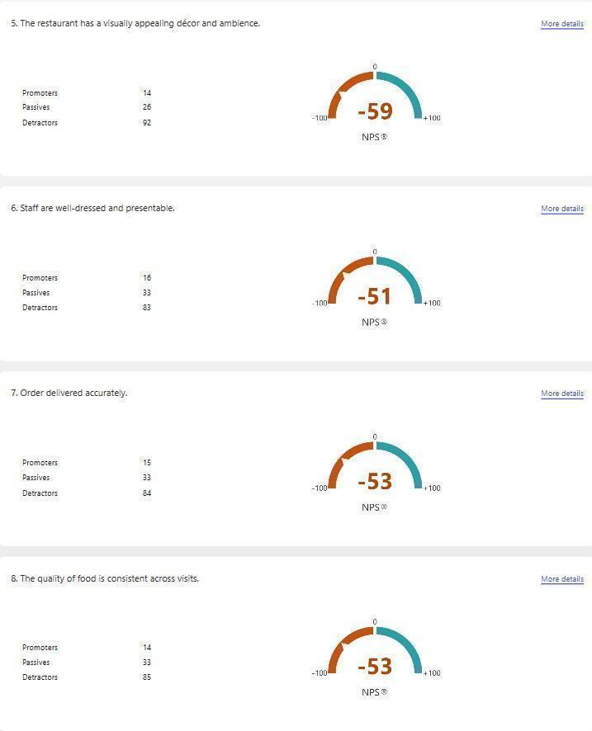
Figure 13: NPS Scores – Tangibles Dimension (Q5–Q8: Décor, Staff Presentation, Order Accuracy, Food Consistency)

4.3.2 Visual Appeal of Décor and Ambience (Q5)
The lowest tangibles score (NPS -59), the worst among the entire survey, was for decor and ambience. This can be especially problematic for a premium brand, such as Itsu, where a large part of the brand's message is health. Whereas points of function and speed per se can balance a single point of substandard aesthetics and environment in a mainstream “catering” restaurant, Itsu’s unique selling point is its overall wellness offering; therefore, a standout aesthetic or environmental performance failure can have a negative impact on its brand positioning. This dimension performs below hygiene, demonstrating the need to invest in store design and ambience – something that can't solely be fixed with operational maintenance but is essential to ensure long-term service success and customer satisfaction.

4.3.3 Staff Dress and Presentation (Q6)
Staff dress and presentation (NPS -51) was the best of the less positive tangibles, albeit having a very negative rating. Relative improvements for cleanliness and décor score can reflect that staff appearance can be more successfully managed by policy rather than by capital investment of the physical environment. It is also alerting to the continuing lack in frontline presentation of meeting customer standards, and this has wider implications for perceived professionalism and trust – a very important component of the assurance dimension. Consequently, the tangibles findings indicate that there is a structural underinvestment in physical experience at UK QSRs instead of being standard issues (Kumolu-Johnson 2024).
Tangibles Item | Promoters | Passives | Detractors | NPS Score | Assessment
Q4 – Cleanliness & Hygiene | 15 | 27 | 90 | -57 | Very Poor
Q5 – Décor & Ambience | 14 | 26 | 92 | -59 | Very Poor
Q6 – Staff Dress & Presentation | 16 | 33 | 83 | -51 | Poor
Table 2: Tangibles Dimension NPS Summary

4.4 Reliability Dimension Analysis
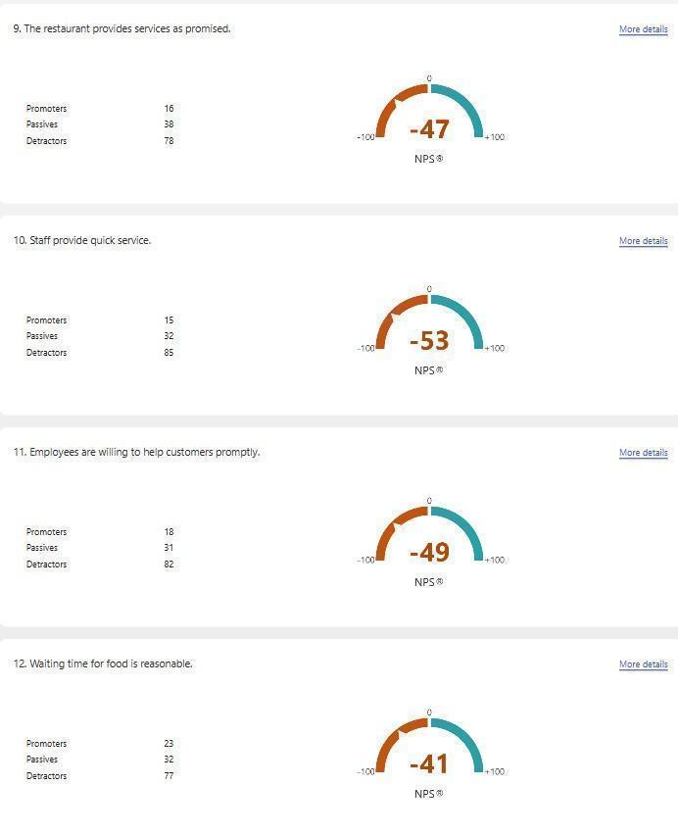
Figure 14: NPS Scores – Reliability (Q9) and Responsiveness Dimension (Q10–Q12)

4.4.1 Order Accuracy (Q7)
Order accuracy (NPS-53) was one of the most serious failure items identified in reliability, where most respondents were not satisfied. Studies have shown that it is associated with a significant decline in satisfaction if an order's accuracy rate is below 85% (Chaturvedi et al., 2024) and, based on the results of this study, Itsu's accuracy rate is well below that limit. Inaccuracies in orders are far more serious than mere inconvenience for a brand that caters to those with dietary and allergen sensitivity; they may represent a potential health and trust risk for customers and ultimately bad faith on part of the hospitality provider that can cause irreparable harm to customer relations and brand reputation.

4.4.2 Food Quality Consistency (Q8)
The highest scores resulted from food quality consistency (NPS -53), where the same score was obtained as for order accuracy, thus providing further evidence of the depth of the reliability issue. The point is not that there are a lot of customers who are unhappy, but that they are perhaps signalling something to the consumer that is inconsistent. An inability to predict the quality of food reduces the repurchase frequency if food product is variable in markets with low switching costs. However, when they cannot rely on the continuation of identical behaviour, they will seek alternatives, which is known in the literature as 'habitual switching,' or deliberate untrustworthy behaviour, both of which lead to an increase in costs to the firm (Mendocilla et al., 2026). It seems the fresh-food model is a brand strength, too, but could also bring a built-in risk of reliability issues for Itsu that don't exist with a standardised competitor.

4.4.3 Service as Promised (Q9)
The lowest negative item related to reliability was service delivery as promised (NPS -47), indicating a slight improvement in service commitments compared to other items, such as order accuracy and consistency. This doesn't, however, mean that the business has minimal happy customers; it simply means that it has a higher number of unhappy customers. The relative improvement might be due to customer having a wider and more flexible definition of “service as promised,” and expecting consistency in promotions, which may not fit a rigorous measurement of the “service” (as opposed to circumstances of food being available or expectations from the promiser having been fulfilled). This subtlety is important: not all reliability failures are the same, and Itsu should decide to intervene on the dimensions having the more extreme performance gaps (Abeykoon, 2024).
Reliability Item | Promoters | Passives | Detractors | NPS Score | Assessment
Q7 – Order Accuracy | 15 | 33 | 84 | -53 | Poor
Q8 – Food Quality Consistency | 14 | 33 | 85 | -53 | Poor
Q9 – Service as Promised | 16 | 38 | 78 | -47 | Poor
Table 3: Reliability Dimension NPS Summary

4.5 Responsiveness Dimension Analysis

4.5.1 Speed of Service (Q10)
Question 10 assessed quick service (behaviour) by staff. The 15 promoters and 32 passives and 85 detractors gave the NPS a score of -53. In QSRs, speed of service is likely the most important aspect because customers go to these fast-food restaurants for speed. The score is very low, suggesting that customers' expectations for speed are not being realized. The results of the research show that service quality ratings tend to fall drastically when the waiting time is more than 5 minutes in QSR settings, and the most significant factor that determines perceived service quality in the sector is responsiveness (Wider et al., 2024).

4.5.2 Employee Willingness to Help (Q11)
Question 11: Do employees know that they should assist the customer in a timely fashion? Results of the NPS were: -49 (18 promoters, 31 passives, 82 detractors). This is just slightly worse than speed of service, but is a clear indicator that employees are not being responsive. There is an above average number of promoters (18) on the "willingness to help" item relative to the other responsiveness items, indicating some employees are ready to help, but there is a concern about inconsistency. Employee behaviour is one of the mediating factors between the service quality and customer satisfaction and willingness to help is a major factor in shaping the positive customer experience in particular (Dwivedi et al., 2024).

4.5.3 Waiting Time Reasonableness (Q12)
The most positive responsiveness score was for waiting time for food at NPS -41 (23 promoters, 32 passives, 77 detractors), in line with Question 12. The relatively higher promoter count (23) than the other items indicate that waiting time management is considered positively, although not the best, by the respondents when compared with the other two items: service speed and employee readiness. This can be attributed to the variations in operational practices between the counter and mobile ordering services at different QSRs that have made ordering via mobile quicker for some customers (McKinsey and Company, 2023).
Responsiveness Item | Promoters | Passives | Detractors | NPS Score | Assessment
Q10 – Speed of Service | 15 | 32 | 85 | -53 | Poor
Q11 – Willingness to Help | 18 | 31 | 82 | -49 | Poor
Q12 – Waiting Time | 23 | 32 | 77 | -41 | Moderate-Poor
Table 4: Responsiveness Dimension NPS Summary

4.6 Assurance Dimension Analysis
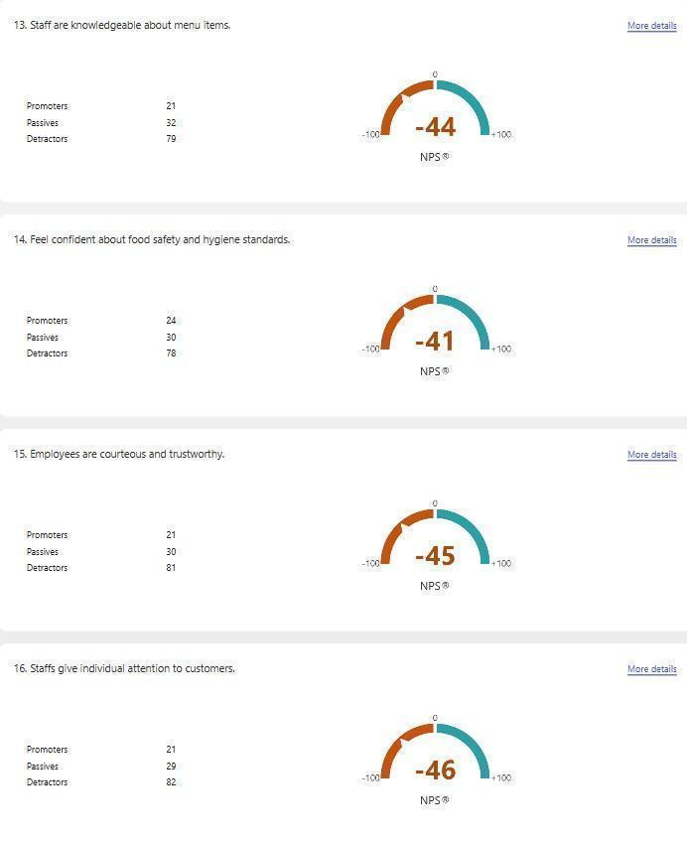
Figure 15: NPS Scores – Assurance Dimension (Q13–Q15) and Empathy (Q16)

4.6.1 Staff Knowledge of Menu Items (Q13)
In Question 13, staff's knowledge of menu items was assessed. Out of the 21 promoters, 32 passives and 79 detractors, the net promoter score (NPS) was calculated at -44. This is because the number of promoters (21) exceeds the number of tangibles items, with some staff having satisfactory knowledge, but most of the respondents are still not happy. The staff members are of strategic importance, given that Itsu's menu is designed to appeal to Asian cuisine and is specific as to the menu and dietary and allergen details. Evidence shows that staff competence has a direct impact on the overall assurance and customer confidence in QSRs (Singh et al., 2023).

4.6.2 Food Safety and Hygiene Confidence (Q14)
Question 14 was on respondents' perception of confidence in the level of food safety and hygiene. 24 promoters, 30 passives and 78 detractors rated the NPS as -41. This was one of the more successful assurance indicators with the highest number of promoters for the assurance items (24). The relative improvement could indicate a level of confidence to consumers of the UK food safety regulations and inspection system. But the negative NPS with the value of -41 shows that the majority of consumers are not confident on the safety standards, which is not good in terms of the post-pandemic consumer landscape (Yiğitoğlu et al., 2025).

4.6.3 Employee Courtesy and Trustworthiness (Q15)
The extent to which employees are courteous and trustworthy is assessed in Question 15. The NPS was -45 (21 promoters, 30 passives, 81 detractors). Concourse of courtesy has an acceptable level of expectations in service situations, but the score, which is mostly negative, indicates dissatisfaction with interpersonal behaviour. The employee behaviour component is a key step in establishing trust and, ultimately, employee loyalty; and lack of courtesy is an immediate obstacle to the satisfaction-to-loyalty pathway (Dandis et al., 2023).

Assurance Item | Promoters | Passives | Detractors | NPS Score | Assessment
Q13 – Staff Menu Knowledge | 21 | 32 | 79 | -44 | Poor
Q14 – Food Safety Confidence | 24 | 30 | 78 | -41 | Moderate-Poor
Q15 – Employee Courtesy | 21 | 30 | 81 | -45 | Poor
Table 5: Assurance Dimension NPS Summary

4.7 Empathy Dimension Analysis

4.7.1 Individual Attention to Customers (Q16)
Staff give individual attention to customers - Q16 The NPS was -46 and the percentages of promoters, passives and detractors were 21, 29 and 82 respectively. A high rate of detractors indicates that there is a general lack of trust that QSR employees work in a transactional vs. relational way with clients. Individual attention is a relational service quality dimension, and its low correlation in QSR environment with the literature finding, which indicate that the quality dimensions of relationality (e.g., empathy) do not have a strong impact on QSR satisfaction (e.g., responsiveness: β < 0.20) (Bagrecha et al., 2026).

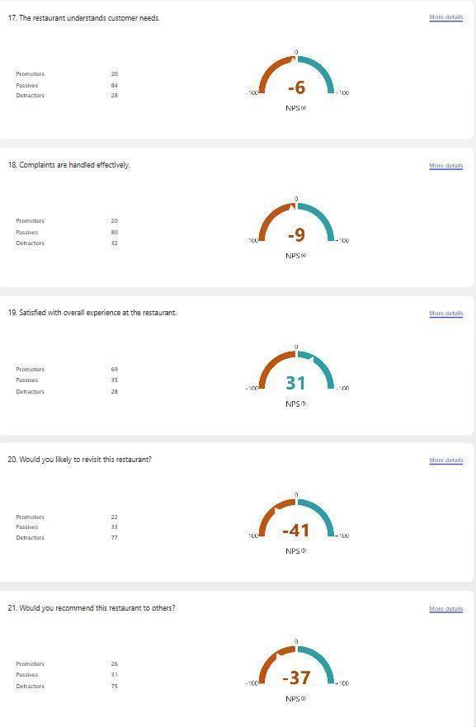
Figure 16: NPS Scores – Empathy (Q17–Q18) and Overall Satisfaction and Loyalty (Q19–Q21)
Source: Primary Survey Data (2026)

4.7.2 Understanding Customer Needs (Q17)
Question 17 assessed the knowledge of the restaurant's needs of the customer. This item had a significantly higher NPS score of -6 as there were 20 promoters, 84 passives and 28 detractors. Surprisingly, that was the lowest negative score in the survey - the majority of passives (84) indicated there was an even mix of positive and negative impressions. This lower level of negativity may be due to the informational transparency that QSRs offer when serving menus, displaying all the restaurant information digitally, and labelling allergens, so that customers feel that their needs are at least recognized, if not met (Siddiqui et al., 2022).

4.7.3 Effective Complaint Handling (Q18)
A question that was explored in Question 18 was whether complaints are dealt with effectively. The NPS is -9, consisting of 20 promoters, 80 passives and 32 detractors. Like item Q17, this item has a significantly higher percentage of passives, indicating that although complaint handling is not seen as excellent, it is not seen as a real problem either. The number of negative ratings (32) on empathy-related dimensions is smaller than most functional dimensions, indicating that the dimensions of empathy are not as polarizing in customer experience as the customer experience dimensions, but are not enough positive to foster loyalty (Koay et al. 2022).
Empathy Item | Promoters | Passives | Detractors | NPS Score | Assessment
Q16 – Individual Attention | 21 | 29 | 82 | -46 | Poor
Q17 – Understanding Customer Needs | 20 | 84 | 28 | -6 | Near-Neutral
Q18 – Complaint Handling | 20 | 80 | 32 | -9 | Near-Neutral
Table 6: Empathy Dimension NPS Summary

4.8 Overall Customer Satisfaction and Loyalty

4.8.1 Overall Satisfaction (Q19)
Question 19 is a question that asks the respondents whether they are happy with their overall experience in the restaurant. The NPS score was +31, the only positive score for the entire survey since 69% of respondents were promoters, 35% were passives and 28% were detractors. This is an important finding: although all five of the SERVQUAL dimensions were perceived negatively by most of the respondents, the overall satisfaction was perceived positively by the majority of the respondents. The paradox could be attributed to the fact that consumers' perception of value in a QSR environment extends beyond the lack of what they consider a specific service failure and considers other factors, such as the low price, convenience, and speed of the service (Española, Janaban and Martir, 2024). This study is supported by the findings of a study that proved that in QSRs, functional efficiency is the major determinant of customer satisfaction while other factors, which are not measured by SERVQUAL dimensions, such as price-value perception, also play a part in the satisfaction judgement (Islam and Shaikh, 2025).

4.8.2 Intention to Revisit (Q20)
Question 20 determined respondents' likelihood of returning to the restaurant. A number of 22 promoters, 33 passives and 77 detractors resulted in an NPS of -41. The disparity between overall satisfaction (+31) and revisit intention (-41) shows an important gap between the satisfaction and the behavioural loyalty in the context of QSR. This gap is consistent with theory which attended to the fact that even customers who are satisfied with their QSR tend to discontinue their relationship with their brand for a number of reasons including the lack of switching costs, the availability of incentives and the presence of competitive options. Research has shown that satisfaction only explains 40-50% of the variance in loyalty, and other contextual moderators also have an important influence on loyalty, including price sensitivity, convenience, and brand image (Dandis et al., 2023).

4.8.3 Willingness to Recommend (Q21)
The question 21 was to find out if the respondents would recommend the restaurant to others. 26 promoters, 31 passives and 75 detractors gave an NPS score of -37. The slight increase in the number of promoters (26) over the number of detractors (75) than over revisit intention indicates that some respondents might be willing to recommend the QSR if they feel that there are certain strengths that they value (e.g., variety of foods, price, or convenience of location). Word of mouth recommendation is also one of the important attitudinal loyalty predictors; and the negative NPS in this regard indicates that there are very high challenges for Itsu and its QSR competitors in making their satisfied customers brand advocates (Yum and Yoo, 2023).
Outcome Variable | Promoters | Passives | Detractors | NPS Score | Assessment
Q19 – Overall Satisfaction | 69 | 35 | 28 | +31 | Positive
Q20 – Revisit Intention | 22 | 33 | 77 | -41 | Poor
Q21 – Willingness to Recommend | 26 | 31 | 75 | -37 | Poor
Table 7: Customer Satisfaction and Loyalty NPS Summary

4.9 Comparative NPS Summary Across All Dimensions
SERVQUAL Dimension | Key Items | Average NPS | Overall Performance
Tangibles | Cleanliness, Décor, Staff Dress | -56 | Very Poor
Reliability | Order Accuracy, Consistency, Promises | -51 | Poor
Responsiveness | Speed, Helpfulness, Waiting Time | -48 | Poor
Assurance | Knowledge, Safety, Courtesy | -43 | Poor
Empathy | Attention, Understanding, Complaints | -20 | Moderate-Poor
Customer Satisfaction | Overall Experience | +31 | Positive
Customer Loyalty | Revisit + Recommend | -39 | Poor
Table 8: Comprehensive NPS Summary by SERVQUAL Dimension
The comparative summary shows that there is a hierarchy of dissatisfaction: items related to tangibles and reliability are the lowest in performance, and the empathy ones have near neutral ratings. Importantly, there is a positive overall satisfaction, but there are large negative indicators of loyalty, in the face of dimensional shortcomings. Based on this pattern, it is concluded that service quality improvement is required to be targeted strategically in relation to dimension "tangibles" and dimension "reliability" to increase dimension scores, which in turn will increase customer satisfaction and thus facilitate the transformation of satisfaction to the customers' loyalty.

4.10 Chapter Summary
The results of the 21 questions that were developed to measure the five dimensions of SERVQUAL, overall customer satisfaction and customer loyalty have been analysed in detail in this chapter, with 132 responses received. Key findings show that reliability (NPS -51), responsiveness (NPS -48) and tangibles (NPS -56) are the three most critical factors that are lacking. Assurance has a slightly lower score of -43 and empathy has near neutral scores of -20. Overall customer satisfaction was the only positive NPS (+31) despite the massive service quality shortcomings, however, indicating the functional value and convenience of the service. Loyalty measures are, however, continuing to be negative with revisit intention at -41 and recommendation willingness at -37, indicating a big gap between satisfaction and loyalty. The results of these findings support the discussion in chapter five.

CHAPTER 5: DISCUSSION

5.1 Introduction
The results of the Chapter 4 are discussed critically with the existing literature in respect of service quality, customer satisfaction and customer loyalty in the quick-service restaurant (QSR) industry in the UK, and especially in regards to Itsu (Armstrong et al. 2025). The discussion is themed according to the research objectives and includes the following topics: The dimensions of service quality that affect customers' satisfaction; The relationship between customer satisfaction and customer loyalty; The specific problems encountered by Itsu; and the implications of the results of the study from a theoretical perspective.

5.2 Service Quality Dimensions and Their Impact on Customer Satisfaction

5.2.1 The Dominance of Tangibles Deficiencies
The survey results show that up service is the lowest performing service quality metric, and especially that tangibles – which include cleanliness and décor – are on the low end of the scale. Although previous research has validated the multiple roles played by physical environment variables in accounting for significant portion of the variance in restaurant satisfaction (Balasubramanian and Suresh, 2022), the results of this study suggest a more structural problem; the pandemic has permanently raised the standards of hygiene in restaurants, thus making pre-COVID levels insufficient. This is theoretically important, as in the original version of the SERVQUAL model, the tangible was considered as a set of "static" attributes of physical facilities. It does not encompass the variable benchmark customers use to evaluate the quality of cleanliness – this may make it act as a systematic underestimate of the importance of this dimension for post-pandemic customers' service assessment. The feeling of Itsu's dissatisfaction with tangibles is an effect that is strategically relevant: any brand that actually markets itself with health and wellbeing has very little chance of continuing the marketing if only the tangible is not up to customer standards in hygiene. A difference between brand promise and service delivery goes beyond satisfaction scores, it poses a reputational risk.
An overall level of satisfaction higher than tangibles is in need of interpretation. This paradox is not a sign of the lack of importance of the tangible, but rather, is an insight into the way customers make comprehensive judgements around satisfaction that eventually capture and offset individual aspects of unmet service. Española, Janaban and Martir (2024) showed that the factors of restaurant attributes are seen as a package, and that restaurant environmental deficiencies or shortcomings can be mitigated with food variety, price value, or locational convenience. But it should never be understood that Itsu will discount their physical surroundings if it means they will now focus on other aspects of their lives. Compensatory satisfaction is ephemeral – unlikely to remain in the presence of plenty of adequate alternatives – and with the rise of competition and availability of more other products and services it is likely to become less tolerant as time goes on of such environmental deficiencies. The theoretical argument is that that the structure of SERVQUAL may hide the compensatory trade-offs, thereby emphasizes the need for more comprehensive satisfaction models in applications to QSR research.

5.2.2 Reliability Gaps and Operational Challenges
The reliability dimension will show a lot of great operational issues: order accuracy and consistency in food quality are two that are not great. This study's results indicated that there is more than the obvious operational gap; that the gap is also structural. It's a real strategic dilemma for Itsu between keeping its models new and made to order for offering fresh designs but also standardising its operations to provide consistency and reliability. Across the board, Itsu's strategy of differentiation relies on variation, in the form of fresh ingredients, seasonal menus and customised preparation, and as such has an inherent sense of unpredictability and risk compared to McDonald's or KFC, both of which have extremely well-defined menus and assembly-line methods of preparation. The results showed that reliability and differentiation of the service cannot be optimized at the same time, which contradicts the idea of service quality theory that in order to boost differentiation one must sacrifice reliability and to the contrary, niche QSR brands might have to sacrifice product distinctiveness for optimizing service consistency (Mendocilla et al., 2026).
The service-as-promised score also identifies the credibility issue: as a customer you know what Itsu should be providing but it is not always. This can be even more harmful, as it not only conveys a capability gap, it also conveys a level of trust gap. If a brand's service consistently fails to meet its expectations and guarantees, customers will not just be dissatisfied; rather, they will doubt the brand's original promise, which is more challenging to regain than a temporary service failure (Dandis et al., 2023). The implication for theory is two-fold: firstly, that reliability should be considered as a process variable rather than just an operational variable; and secondly, that satisfaction and loyalty should be viewed as one variable within another, trust, which is in turn dependent on consistent delivery of the Web server.

5.2.3 Responsiveness as the Critical Functional Dimension
Responsiveness is the dimension most closely related to the functional heart of the QSR proposition, in line with its performance as the top predictor of perceived service quality in this context (Wider et al., 2024). Staff speed is lagging and willingness to help is a big problem – this is particularly remarkable, as it is obvious that customers come into the restaurant because of speed. The relatively good performance in queueing time compared to active staff responsiveness is a lesson: it is important to use digital ordering to eliminate the friction in queuing as it improves customer perception even if a low number of people are serving them. This raises an important revelation for Itsu: digital integration is not a 'gadget' enhancement it's a 'poker' remedy for human resource limitations. The study is consistent with that of Ahuja et al. (2021), which indicates that digital service quality (≈ 0.45–0.55) drives higher level of satisfaction compared to traditional service quality measures such as service quality in store. This can, however, create a theoretical dichotomy – sometimes, digital tools are replacing real staff shortages rather than building actual capacity, and hence satisfaction gains from the technology can be feeble and eroded if technological performance falls or access is restricted.

5.2.4 Assurance and Empathy: The Relational Dimensions
The theoretically predicted strong correlation between the dimensions of relational quality and negativity, which was postulated for transactional QSR environments (β > 0.20) was most clearly seen in the functional quality dimensions, with the assurance and empathy dimensions showing less extreme negativity. Answering such a question with a bald statement would however be theoretically short-sighted if it actually meant this would be irrelevant dimensions for Itsu. However, it would be theoretically short-sighted to directly answer such a question with a bald statement, that it would be no dimensions which are irrelevant for Itsu. The scores on the complaint handling and customer needs aspects are near neutral (close to NPS -6 and -9 respectively), indicating that the level of satisfaction is not only low, but, more dangerously, indifferent – and indifference is not necessarily loyalty, it is merely a stepping stone to switching behaviour. Worse, the failure to translate assurance into a competitive advantage for a brand like Itsu that has a premium positioning strategy based on differentiated service that communicates a health-focused message represents a strategic brick wall. Dietary requirements or concerns with allergies are among the specific attributes for which customers look for a “confident knowledgeable service interaction” – Itsu's moderate scores in NPS (-43) indicate that this is not happening consistently. Relationship marketing theory (Rosário and Casaca 2025) indicates that transactional satisfaction can only be matched by relationship assurances which can lead to trust. These dimensions should, therefore, be the focus of strategic attention in addition to their NPS scores.
The moderately negative assurance scores (average NPS -43 however) show that confidence in the knowledge of staff and food safety is still poor. In Itsu, they're making great progress with their menus having a transparency issue and the allergen information, but these scores represent an opportunity to leverage the approximate consumer confidence to their competitive advantage.

5.3 The Satisfaction-Loyalty Gap: A Critical Paradox
One of the most interesting results of this study is that these measures of satisfaction and loyalty differ markedly, especially when compared to what are often the standard simplification models of the service quality – satisfaction – loyalty chain. The findings of this study support the empirical evidence regarding the partial relationship between satisfaction and loyalty on the marketer's side of the equation (as confirmed in the literature) as only 40-50% of the variance in loyalty is explained by loyalty constructs that include satisfaction. But the discovery is more than just corroborating information already discussed in the literature: It has implications to the broader questions of what satisfaction really means in a QSR environment. The overall satisfaction score (+31) in this report despite most negative scores on all service dimensions suggests that consumers are reading “overall experience” differently than they were filling out the individual SERVQUAL dimensions. This is analogous to gestalt evaluation theory which values the whole of a project, such as emotional response, perception of a project's price-value and atmosphere, unlike the parts, such as cost, fire safety, and design. If this is correct, then the additive nature of the SERVQUAL model could systematically ignore the recipients' perception of satisfaction by using the decomposition of that concept into specific component dimensions in which the customers are not equally weighted or independent in satisfying the concept. There are also important implications for the information that Itsu derives from customer feedback, such as a positive NPS on satisfaction. The -41-loyalty score for revisit and the -37 score for customer recommendation indicate that positive customers aren't being kept, or turned into a loyal ambassador for the brand. Satis- faction is a prerequisite but not sufficient for loyalty in competitive, alternative-rich markets, high switching costs where alternatives exist but access is limited and access is inaccessible (Chowdhury et al., 2023). The emergence of this finding reinforces the SDL interpretation that loyalty is to be rooted in the co-creation of relational value, not only on satisfaction related to transactions (Rosário and Casaca, 2025).
The picture is further complicated by the fact that there is a large proportion of day visitors (43%). Visit frequency is not necessarily correlated to brand loyalty: Loyalty to a brand is less likely to be affected by high visit frequency in QSR settings, where it is easier to be an "environmental" brand (Chowdhury et al., 2023). It's an important point to make as it means that Itsu could be reading into the repeat visits as brand loyalty when it could just be an impersonal thing because so many are visiting from local area or as part of a routine. If for some reason, that is the case, then it may well not be possible to extract the loyalty differentials unless improvements in the service are linked to addressing the relational elements of trust, personalisation, perceived value, which is what makes a customer into a proper brand advocate.
The proposition is supported by the SDL framework (Rosário and Casaca, 2025): building and sustaining loyalty go beyond the routine experience of using a product, service, and/or support completion assessed by traditional survey approaches, as it involves the value co-creation and relational interactions with others. The results indicated that customer satisfaction has a positive relationship with loyalty intentions but failed to show that the satisfaction as a standalone concept can lead to long-term customer loyalty in the UK QSR industry. One potential reason is that the market is so dynamic, and consumers are easily tempted to switch between brands based on low switching costs and other factors like promotion, convenience, etc. This assists earlier research that suggested that there is no distinct loyalty in QSR contexts and that price susceptibility and availability are significant factors in client loyalty. Platforms and mobile applications are also ramping up and could also serve to further erode customer loyalty as they increasingly make convenience choices over brand. So, customer satisfaction needs to be seen not only as an important but not enough parameter to keep the customers loyal.

5.4 Digital Transformation and Service Quality in QSRs
Although the digitalisation does not contribute to any of the dimensions of SERVQUAL, it is present in the results pattern. Comparative time on task indicates that some people were not as affected as others by understaffing, possibly because they used digital ordering channels. However, a close to neutral handling of complaints might also indicate a digital feedback process that offers a complaint path more easily accessible than the traditional face-to-face process in which a customer can hear from the complaint process. This is only to say that all this means that digital tools are already working as informal service recovery processes without purposeful design. The bigger picture is that service quality management within QSRs cannot be viewed from a human-service perspective alone. Ahuja et al (2021) agree that 8 out of 10 transactions in the UK take place via digital channels, and the experience of a business within the digital realm directly influences the perception of the overall experience. That includes reliability of the apps, accuracy of the order placing process as well as notification accuracy. Importantly, digital service failures can also drive-up dissatisfaction, thus creating a risk, but also an opportunity pathway to create greater satisfaction (McKinsey, 2023). If the quality of digital service is underinvested, the risk for Itsu is that this can unwind the achievement of the modest gains that technology has brought. By supporting rapid service, convenience and availability with mobile ordering and delivery systems, digitalisation within the QSR industry has seen an improvement of operational efficiency. But the results also indicate that growing reliance on digital systems might decrease face-to-face work interaction between employees and customers. This can lead to a loss of social dimensions of service quality like Empathy and Assurance. Indeed, technical failures, delayed deliveries and wrong applications could still impact the convenience and customers satisfaction if not avoided.

5.5 Itsu-Specific Challenges
Itsu is in a unique place in the UK QSR market and both its unique place and the service quality risk it introduces provide competitive advantage. The health-focused, fresh-food proposition is suited to shoppers with higher expectations – not just in terms of the quality of foods or beverages, but of the service experience. The “premium expectation-performance gap” as described by Naini et al. (2022) arises, where the higher a brand is perceived as being, the greater the impact of any service failure since it is judged by the brand promise, not against category norms. Based on the data presented in this study it can be observed that already this gap exists in all the five SERVQUAL dimensions. What's very surprising is that Itsu seems to be going head-to-head on two fronts: firstly, against competing chains on speed and reliability, and it's in a physical disadvantage here; secondly, it's trying to hold its own against competing chains on experience and ambience where it seems its current physical environments are a net negative. The issue facing the strategy is that Itsu is neither truly competitive with the functional QSRs nor experiential or premium enough to warrant the affordability to their aspirational users.
The profile of Itsu's average user rises to the frequent occurrence of a perceived and actual disconnection, which is exacerbated by the average Itsu user. The more health-minded consumer, who has less price sensitivity, is also more likely to have complex, inelastic expectations – they're purchasing a guarantee of quality, transparency and caring, not just a quick bite to eat. If that doesn't happen, the psychological gap between expectation and experience is higher, as is also the behavioural reaction – attrition, negative word-of-mouth. It is similar with the finding of Naini et al. (2022) that the gaps in services are more blamed at premium-situated brands. In terms of the practical consequences, Itsu cannot afford to leverage the level of satisfaction that the mainstream QSR competitors may achieve as a benchmark measure; they have to aim for a higher level of customer satisfaction. Itsu specializes in offering healthier food and positioning its brands as premium within a niche part of the UK QSR business. Consequently, their expectations can be raised in comparison to the traditional restaurants. The customer can not only expect quick service but also good homogeneity of goods, hygiene and improved product quality. This puts greater strain on Itsu to deliver a high level of quality in its services versus maintaining efficient processes for multiple locations.

5.6 Theoretical Implications
The results of this study have some significant theoretical implications. First, the overall positive satisfaction combined with the negative dimensional NPS scores questions the underlying assumption in the SERVQUAL model that all the different service quality dimensions can be added up to the overall satisfaction. The data indicated that the overall satisfaction outcomes of holistic evaluation processes may differ markedly from the scores of each of the dimensions and may be influenced by the price-value of the product or its convenience. This aligns with the need for context-sensitive and integrated measurement of calls in the literature for QSR settings (Abdul Majid et al., 2024).
Second, the satisfaction-loyalty gap supports the partial mediation model, proposing that service quality impacts on satisfaction and that satisfaction in turn, partially, mediates the relationship between service quality and loyalty. This aligns with the conceptual framework proposed in Chapter 2, which incorporated the concept of relationship marketing theory and the Service-Dominant Logic to recognize that there are relational factors, such as trust and commitment, which are not only related to transactional satisfaction, but also influence customer loyalty (Yum and Yoo, 2023).

5.7 Chapter Summary
In this chapter, the empirical results have been discussed in the light of theoretical framework and literature. The main issues highlighted by the discussion are: the imbalance of tangible deficiencies in a post-pandemic consumer world; the functional drivers of satisfaction, which are reliability and responsiveness; satisfaction-loyalty gap as a key feature of competitive QSR business; and the compounding problems of a niche brand in a market with high expectation and high competition. The findings, recommendations, and suggestions for further research are discussed in the following chapter.

CHAPTER 6: CONCLUSION AND RECOMMENDATIONS

6.1 Introduction
This final chapter brings together the important conclusions of the study, assesses the achievement of the research objectives, makes strategic recommendations for Itsu and the UK QSR industry, recognises the limitations of the research and offers ideas for further research.

6.2 Summary of Key Findings
The purpose of this research was to explore the service quality, customer satisfaction and customer loyalty relationship of the fast-food chain "Itsu" in fast food restaurant service sector in United Kingdom. Data was gathered in five SERVQUAL dimensions, overall satisfaction and loyalty outcomes in a primary quantitative survey that involved 132 respondents. The following are some of the main conclusions:
The service quality dimension that is most likely to be lacking is tangibles and the lowest rated service quality dimensions of the survey are cleanliness (NPS -57) and décor (NPS -59). The results indicated that the layout of the physical space in the UK QSRs including Itsu is not suitable to satisfy the customers' expectations in this era particularly in terms of cleanliness and friendliness.
Second, reliability is an important operational issue and the problems identified with order accuracy (NPS -53) and food quality consistency (NPS -53) are systemic identified issues in service delivery. The menu of Itsu is fresh and customized, and can face failure more often, than can be other menus in the standardized.
Thirdly, responsiveness, the most important functional dimension in the QSR context, is reflected in staff speed (NPS -53), which is an indicator of not meeting the customer's expectation for efficient service. The relatively strong performance for waiting time (NPS -41) may be due to some of the advantages of digital ordering innovations.
The third and more significantly, a robust satisfaction-loyalty paradox was found – fourthly. Although the overall NPS was negative, it was the only one to score positive (+31), with the other five NPS dimensions all recording negative scores, the loyalty indicators of the survey were still very negative: revisit intention NPS: -41, recommendation NPS: -37. Based on these, it is an empirical verification of a non-deterministic relationship between satisfaction and loyalty in competitive and low switching cost markets of QSRs.

6.3 Achievement of Research Objectives
Research Objective | Finding | Status
Identify key service quality dimensions influencing satisfaction in UK QSRs | Tangibles and Reliability emerged as most critical; Responsiveness as strongest functional predictor | Achieved
Analyse the relationship between satisfaction and loyalty | Significant satisfaction-loyalty gap identified (Satisfaction +31, Loyalty -39 avg) | Achieved
Examine Itsu's service quality challenges | Freshness-based reliability risks, premium expectations gap, labour shortages | Achieved
Recommend strategies to improve service quality and retention | Digital integration, training, environmental investment, loyalty programmes | Achieved
Table 9: Research Objectives Achievement Summary
Source: Author's Own Analysis (2026)

6.4 Strategic Recommendations

6.4.1 Recommendation 1: Immediate Investment in Tangibles Upgrading
With the physical environment of its outlets being the most critically lacking dimension (average NPS -56), Itsu should consider investing heavily on the physical environment, not only now but in the future as well. This should include having stringent and visible clean up schedules in line with the recommendations of the UK Food Standards Agency, updating the interior decor to reflect the brand's premium, health-focused image, establishing environmental features (e.g. lighting, sustainable materials) to support the brand's image and regular checks to ensure the staff wear uniform according to the brand. Cleanliness and ambience are two of the best predictors of customer satisfaction in restaurant environments as confirmed in the research (Balasubramanian and Suresh, 2022); and even small increases in the tangibles scores could lead to a significant increase in satisfaction scores. Itsu needs to learn to set higher standards for its physical environment from the top quality QSRs like Wagamama and Pret a Manger who have higher ratings for cleanliness in customer satisfaction.

6.4.2 Recommendation 2: Strengthening Operational Reliability Through Standardisation
The lack of reliability (average NPS = -51) calls for the development and implementation of standardised operating procedures (SOPs) for order preparation and quality control in all outlets by Itsu. Some key actions to consider are the use of kitchen display systems to minimise order errors and increase the likelihood of tracking order accuracy, the introduction of real-time quality control via digital dashboards for outlet managers, mystery shopper programmes to assess the consistency of food quality and root cause analysis of frequent order accuracy complaints. Previous studies have demonstrated that the reliability gap is the second most relevant factor that drives the satisfaction outcomes in QSRs, directly influencing the decrease of dissatisfaction and increase in repeat purchase intentions (Abeykoon, 2024). The goal for Itsu is to aim for more than 90% accuracy which aligns with best practice (Chaturvedi et al., 2024).

6.4.3 Recommendation 3: Enhancing Responsiveness Through Digital Integration and Staffing
To boost responsiveness (average NPS -48), Itsu needs to take a dual approach to service enhancements (including improvements to the digital aspects of service) and staffing. From a digital perspective, Itsu should continue to work on developing and refining their mobile ordering app to shorten the wait in-store, consider adding self-service kiosk ordering in busy spots to boost transaction volume, and utilise predictive analytics to optimise staffing during busy periods. From the staffing perspective, Itsu should look at minimum staffing levels per outlet to make sure that they have enough capacity to serve the customers; then set service targets (preferably 3-5 minutes) where they get measured on a real time basis; and also have a staff performance framework that incentivizes the speed of the service without compromising the quality of service. Digital investment has a high return and can create satisfaction effects larger than traditional in-store investments (McKinsey and Company, 2023), as research shows.

6.4.4 Recommendation 4: Building Assurance Through Staff Training and Transparency
Itsu will need to implement a holistic staff training and development program to improve their product knowledge, food safety and interpersonal skills, in response to the assurance deficiencies (average NPS -43). This should include mandatory menu knowledge certification of all front-of-house staff, emphasis on allergen information (particularly due to Itsu's health positioning); food safety refresher training in line with Food Safety Level 2 requirements; customer interaction training to improve customers' perceptions of courtesy and trustworthiness; and menu transparency tools (e.g. digital allergen filter, calorie information displays) to ensure food safety is perceived as better for customers. In the case of Itsu, strengthening assurance perceptions is especially critical since it is a key moderator of the satisfaction-loyalty relationship and the health-conscious consumers have higher expectations on product knowledge and safety standards.

6.4.5 Recommendation 5: Developing a Loyalty Programme to Close the Satisfaction-Loyalty Gap
This study has found that the satisfaction-loyalty gap is the greatest opportunity for being strategic for Itsu's business (satisfaction +31 % vs loyalty -39 % average). The data reveals that satisfied customers are not necessarily as likely to return or to recommend the service to their friends and family in such competitive market as the UK QSR sector. To bridge this gap, a progressive customer loyalty program should be implemented that incorporates a point system for repeat transactions, customised packages for customers based on purchase history delivered via Itsu's mobile application, package only for loyal customers and offering incentives to customers to turn social mediaphiles into brand ambassadors, such as sustainability aspects on purchases they make. Well-designed loyalty programmes can prove to be a strong link between satisfaction and loyalty, as well, by creating relational value over and above transactional value as shown by Rane, Choudhary and Rane (2023). Further, Itsu needs to invest in service recovery processes like having quick complaint resolution processes and empowering customers in service recovery to turn detractors into promoters and stave off churn due to negative experiences.

6.5 Limitations of the Study
This study recognises that there are a number of limitations that impact the generalisability of the results. The sample (n=132) was obtained through convenience sampling using online platforms and therefore may suffer from self-selection bias and not be representative of the broader UK QSR customer population. People who complete the NPS may be a group of more digitally engaged or actively unhappy customers, potentially making NPS scores look worse.
Secondly, only 12% (16 respondents) named specifically Itsu as being their most visited QSR. The findings in the study are useful, for general QSR insights, but will be constrained by the number of samples in the study and care should be taken in using recommendations in the study without additional brand specific studies for Itsu alone.

6.6 Directions for Future Research
Based on the results and limitations of this research, a few directions for future research are recommended. The first is that such a larger scale, brand specific study would allow the identification of service quality factors that are most important to the Itsu customer and its competitive position with its target customers. If the number of respondents is 300 or more, it could be statistically powerful for modelling with structural equation modelling. Third, by using a longitudinal study design that follows the perceptions of the service quality and customer loyalty over a 12–24-month period, the authors' study would provide insights into how service quality improvements can be converted to sustained loyalty gains, which this study does not do. A digital service quality framework would be completer and more modern if it incorporated digital service quality dimensions to the SERVQUAL framework.

6.7 Concluding Remarks
In this research, the authors have critically analysed the relationship between service quality and customer satisfaction to customer loyalty in the sector of restaurants offering quick service in U.K., by taking Itsu as a representative case. The study provides empirical evidence that shows that service quality as measured with SERVQUAL model exerts significant impact on customer satisfaction for all five dimensions and the study also shows that there is a significant difference between customer satisfaction and customer loyalty in competitive markets of QSRs. Based on the results the values of satisfaction may not totally align with loyalty, and there are also several other factors affecting loyalty other than satisfaction such as switching cost, price sensitivity, digital service experience and relational variables. UK QSRs continue to service their key areas of strategic focus, focusing on service quality, which continues to be a successful differentiator and loyalty builder. Consciously investing time and effort to improve service quality, at both physical and virtual checkpoints, helps brands better establish the trust, commitment and perceived value that can drive positive satisfaction to long-term customer loyalty. The present study adds both theoretical and empirical lessons to this important area but recognises that the market for QSRs in the UK is dynamic and evolving and requires continued empirical research.

Reference
Abdul Majid, M.A., Azman, A.B., Mohd Zaki, M.I., Zahari, H. and Hassan, H., 2024. Investigating customer loyalty: can fast-food restaurants keep them coming back?. Journal of Tourism, Hospitality and Culinary Arts, 16(1), pp.244-263. https://ir.uitm.edu.my/id/eprint/97715/1/97715.pdf
Abeykoon, H.N., The impact of service quality on customer satisfaction and customer loyalty in multinational fast-food restaurants; A case study based on KFC Liverpool, UK. https://www.theijbmt.com/archive/0958/2000736615.pdf
Ahmed, S., Al Asheq, A., Ahmed, E., Chowdhury, U.Y., Sufi, T. and Mostofa, M.G., 2023. The intricate relationships of consumers’ loyalty and their perceptions of service quality, price and satisfaction in restaurant service. The TQM Journal, 35(2), pp.519-539. https://www.emerald.com/tqm/article-pdf/35/2/519/2372006/tqm-06-2021-0158.pdf
Ahuja, K., Chandra, V., Lord, V. and Peens, C. (2021). Ordering in: The rapid evolution of food delivery. [online] McKinsey & Company. Available at: https://www.mckinsey.com/industries/consumer-packaged-goods/our-insights/ordering-in-the-rapid-evolution-of-food-delivery [Accessed 11 May 2026].
Akter, M., 2025. Impact Of Predictive Machine Learning Models on Operational Efficiency And Consumer Satisfaction In University Dining Services. ASRC Procedia: Global Perspectives in Science and Scholarship, 1(01), pp.376-403. https://global.asrcconference.com/index.php/asrc/article/download/17/18
Alturki, R. (2021). Research Onion for Smart IoT-Enabled Mobile Applications. Scientific Programming, [online] 2021(1), pp.1–9. doi:https://doi.org/10.1155/2021/4270998.
Amoozegar, A., Xu, L.J., Falahat, M., Yujiao, W. and Anjum, T. (2025) ‘Service quality and customer satisfaction using SERVQUAL model: Restaurant industry in Malaysia’, International Journal of Innovative Research and Scientific Studies, 8(5), pp. 795–811. doi:10.53894/ijirss.v8i5.8857.
Armstrong, A., Onita, L. and Strauss, D. (2025). Retail and hospitality chains air concern over UK jobs market. [online] @FinancialTimes. Available at: https://www.ft.com/content/6f927eee-ec40-4ad5-b1d4-9be20f61ec4f?syn-25a6b1a6=1 [Accessed 11 May 2026].
Bagrecha, C., Chamariya, M., Reddy, P.S. and Talur, S., 2026. Consumer awareness and acceptance of Quick Service Restaurants (QSRs): A study on factors influencing customer preferences and loyalty. In Empowering Inclusive Innovation (pp. 7-16). Routledge. https://api.taylorfrancis.com/content/chapters/edit/download?identifierName=doi&identifierValue=10.1201/9781003753445-2&type=chapterpdf
Bagrecha, C., Chamariya, M., Reddy, P.S. and Talur, S., 2026. Consumer awareness and acceptance of Quick Service Restaurants (QSRs): A study on factors influencing customer preferences and loyalty. In Empowering Inclusive Innovation (pp. 7-16). Routledge. https://api.taylorfrancis.com/content/chapters/edit/download?identifierName=doi&identifierValue=10.1201/9781003753445-2&type=chapterpdf
Balasubramanian, G. and Suresh, M., 2022. Customer loyalty assessment framework for quick service restaurants. In 2nd International Conference on Industrial Engineering and Operations Management (pp. 114-122). https://ieomsociety.org/proceedings/2022india/55.pdf
Bergmann, J. (2023) Research philosophy, methodological implications, and research design. Wiesbaden: Springer Fachmedien Wiesbaden.
Chaturvedi, P., Kulshreshtha, K., Tripathi, V. and Agnihotri, D., 2024. Investigating the impact of restaurants' sustainable practices on consumers' satisfaction and revisit intentions: a study on leading green restaurants. Asia-Pacific Journal of Business Administration, 16(1), pp.41-62. https://www.emerald.com/apjba/article-pdf/16/1/41/9490609/apjba-09-2021-0456.pdf
Chowdhury, B., Haque, R., bin S Senathirajah, A.R., Khalil, M.I., Ahmed, S., Krishnasamy, H.N. and Ramasamy, G., 2023. Mediation of customer satisfaction and customer loyalty in fast-food restaurants aimed at sustainable growth. International Journal of Operations and Quantitative Management, 29(3), pp.114-128. https://submissions.ijoqm.org/index.php/ijoqm/article/download/264/110
Creswell, J.W. and Inoue, M. (2025) ‘A process for conducting mixed methods data analysis’, Journal of General and Family Medicine, 26(1), pp. 4–11.
Dandis, A.O., Al Haj Eid, M., Griffin, D., Robin, R. and Ni, A.K., 2023. Customer lifetime value: the effect of relational benefits, brand experiences, quality, satisfaction, trust and commitment in the fast-food restaurants. The TQM Journal, 35(8), pp.2526-2546. https://www.emerald.com/tqm/article-pdf/35/8/2526/2901294/tqm-08-2022-0248.pdf
Deloitte (2023) Global State of the Consumer Tracker: UK Insights. Available at: https://www.deloitte.com/an/en/Industries/consumer/research/global-state-of-the-consumer-tracker.html
Deloitte Insights (2023) Consumer products industry outlook. Available at: https://www.deloitte.com/an/en/Industries/consumer/analysis/consumer-products-industry-outlook.html
Dwivedi, R.K., Lohmor Choudhary, S., Dixit, R.S., Sahiba, Z. and Naik, S. (2024) ‘The customer loyalty vs. customer retention: The impact of customer relationship management on customer satisfaction’, Web Intelligence, 22(3), pp. 425–442.
Economist Intelligence Unit (2023) Global consumer trends. Available at: https://www.eiu.com/n/campaigns/consumer-in-2023/
Economist Intelligence Unit (2023) Global consumer trends. Available at: https://www.eiu.com/n/campaigns/consumer-in-2023/
Española, A.Y., Janaban, A.A. and Martir, E., 2024. Restaurants’ Attributes Customers’ Satisfaction and Loyalty. International Journal of Science and Management Studies, 7(2), pp.241-285. https://www.ijsmsjournal.org/2024/volume-7%20issue-2/ijsms-v7i2p123.pdf
Fatorachian, H., Arboleda, E. and Linh, T.T., 2025. Digitalisation and customer engagement in fast-food SMEs: enhancing brand presence through social media. Cogent Business & Management, 12(1), p.2508927. https://www.tandfonline.com/doi/pdf/10.1080/23311975.2025.2508927
Financial Times (2023) UK hospitality sector faces labour shortages and rising costs. Available at: https://www.ft.com/content/6f927eee-ec40-4ad5-b1d4-9be20f61ec4f?syn-25a6b1a6=1
Financial Times (2024) UK foodservice and restaurant market analysis. Available at: https://www.ft.com/content/60b3decf-d7bc-44ab-a621-f9d874224190?syn-25a6b1a6=1
Forrester (2023) The business impact of customer experience. Available at:https://www.forrester.com/report/the-business-impact-of-customer-experience/
Gartner (2023) Customer experience drives customer loyalty survey. Available at:
https://www.gartner.com/en/marketing/insights/customer-experience
IDC (2023) Worldwide digital transformation spending guide. Available at:
https://www.idc.com/getdoc.jsp?containerId=IDC_P33198
Islam, A. and Shaikh, M.S., 2025. Investigating the Customer's Experience at the Fast-food Restaurants: A Study on Customers in Jyväskylä, Finland. https://www.theseus.fi/bitstream/handle/10024/908121/Islam_Shaikh.pdf?sequence=2
Itsu (2026) Official Website. Available at: Itsu Official Website (Accessed: 10 May 2026).
Kim, D.J. (2012) Expectation-confirmation theory and post-acceptance model. Available at: ECT model diagram
Koay, K.Y., Cheah, C.W. and Chang, Y.X., 2022. A model of online food delivery service quality, customer satisfaction and customer loyalty: a combination of PLS-SEM and NCA approaches. British Food Journal, 124(12), pp.4516-4532. https://www.emerald.com/bfj/article-pdf/124/12/4516/237412/bfj-10-2021-1169.pdf
Kumar, S. and Ujire, D.K. (2024) ‘Inductive and deductive approaches to qualitative research’, International Journal of Multidisciplinary Educational Research, 13(1), pp. 58–63.
Kumolu-Johnson, B., 2024. Improving service quality in the fast-food service industry. Journal of Service Science and Management, 17(1), pp.55-74. https://www.researchgate.net/profile/Bankole-Kumolu-Johnson/publication/378292971_Improving_Service_Quality_in_the_Fast-Food_Service_Industry/links/65d4ea4ae7670d36abc5cc84/Improving-Service-Quality-in-the-Fast-Food-Service-Industry.pdf
Kumolu-Johnson, B., 2024. Improving service quality in the fast-food service industry. Journal of Service Science and Management, 17(1), pp.55-74. https://www.researchgate.net/profile/Bankole-Kumolu-Johnson/publication/378292971_Improving_Service_Quality_in_the_Fast-Food_Service_Industry/links/65d4ea4ae7670d36abc5cc84/Improving-Service-Quality-in-the-Fast-Food-Service-Industry.pdf
Lin, P.M., Au, W.C.W. and Baum, T., 2024. Service quality of online food delivery mobile application: an examination of the spillover effects of mobile app satisfaction. International journal of contemporary hospitality management, 36(3), pp.906-926. https://www.emerald.com/ijchm/article-pdf/36/3/906/9496839/ijchm-09-2022-1103.pdf
Lumina Intelligence (2025) UK quick-service restaurant trends 2025. Available at: https://www.lumina-intelligence.com/blog/foodservice/uk-quick-service-restaurant-trends-2025/ (Accessed: 2026).
Mahat, D., Neupane, D. and Shrestha, S. (2024) ‘Quantitative research design and sample trends: A systematic examination of emerging paradigms and best practices’, Cognizance Journal of Multidisciplinary Studies, 4(2), pp. 20–27.
Manhas, P.S., Sharma, P. and Quintela, J.A., 2024. Product innovation and customer experience: catalysts for enhancing satisfaction in quick service restaurants. Tourism and Hospitality, 5(3), pp.559-576. https://www.mdpi.com/2673-5768/5/3/34
McKinsey & Company (2022) The value of customer experience, quantified. Available at: https://www.mckinsey.com/capabilities/operations/our-insights/the-state-of-customer-care-in-2022
McKinsey & Company (2023) Ordering in: The rapid evolution of food delivery. Available at:
https://www.mckinsey.com/industries/consumer-packaged-goods/our-insights/ordering-in-the-rapid-evolution-of-food-delivery
McKinsey & Company (2023) Ordering in: The rapid evolution of food delivery. Available at:
https://www.mckinsey.com/industries/consumer-packaged-goods/our-insights/ordering-in-the-rapid-evolution-of-food-delivery
Mohhanto, A., Anwar, M., Achmad, Z.A. and Win, T., 2025. Perceived Value as a Mediator: How Customer Experience Outweighs E-Service Quality in Driving Digital Repurchase Intention in Quick-Service Restaurants. Jurnal Ilmiah Manajemen dan Bisnis, 10(2), pp.180-192. https://journal.undiknas.ac.id/index.php/manajemen/article/download/7170/1950
MDPI (2023) Article in Journal of Risk and Financial Management, 11(1), p. 33. Available at: https://www.mdpi.com/2227-7072/11/1/33
MDPI (2023) Economies journal article on service quality and customer behaviour. Available at: https://www.mdpi.com/2227-7099/11/5/132 (Accessed: 2026).
Mendocilla, M., Miravitlles, P. and Matute, J., 2026. Unveiling the role of service quality in the quick service restaurant sector: an integrative review. International Journal of Hospitality Management, 132, p.104367. https://www.sciencedirect.com/science/article/pii/S0278431925002956
Mordor Intelligence (2026) United Kingdom foodservice market size & share analysis – growth trends and forecast (2026–2031). Available at: https://www.mordorintelligence.com/industry-reports/united-kingdom-foodservice-market
Naini, N.F., Santoso, S., Andriani, T.S., Claudia, U.G. and Nurfadillah, N., 2022. The effect of product quality, service quality, customer satisfaction on customer loyalty. Journal of consumer sciences, 7(1), pp.34-50. https://scholar.archive.org/work/f4xdnnqnxrfadaqgarrj6gsf4e/access/wayback/https://journal.ipb.ac.id/index.php/jcs/article/download/38680/23106
Parasuraman, A., Zeithaml, V.A. and Berry, L.L. (1988) ‘SERVQUAL: A multiple-item scale for measuring consumer perceptions of service quality’, Journal of Retailing, 64(1), pp. 12–40.
PwC (2023) Experience is everything: Here’s how to get it right. Available at:https://www.pwc.de/de/consulting/pwc-consumer-intelligence-series-customer-experience.pdf
Statista (2024) Quick service restaurant market size in the UK. Available at: https://www.statista.com/outlook/cmo/food/quick-service-restaurants/united-kingdom
QSR Media (2024) UK’s QSR market to reach $44.01b by 2029. Available at:
https://qsrmedia.com/research/in-focus/uks-qsr-market-reach-4401b-2029
Namupala, I. (2019) Measuring service quality using SERVQUAL model. Available at: https://www.researchgate.net/figure/Measuring-service-quality-using-SERVQUAL-model_fig1_341235040
Spherical Insights (2024) United Kingdom foodservice market report. Available at:
https://www.sphericalinsights.com/reports/united-kingdom-foodservice-market
Rane, N., Choudhary, S. and Rane, J. (2023) ‘Metaverse for enhancing customer loyalty: Effective strategies to improve customer relationship, service, engagement, satisfaction, and experience’, SSRN Electronic Journal. Available at: SSRN Customer Loyalty Paper (Accessed: 10 May 2026).
Rosário, A.T. and Casaca, J.A., 2025. The Effects of Commitment on Relationship Marketing. WSEAS Transactions on Business and Economics, 22, pp.1553-1573.https://wseas.com/journals/bae/2025/c525107-036(2025).pdf
SCIRP (2023) Service quality and customer satisfaction research paper. Available at: Service quality study (Accessed: 2026).
Siddiqui, S.A., Zannou, O., Karim, I., Kasmiati, Awad, N.M., Gołaszewski, J., Heinz, V. and Smetana, S., 2022. Avoiding food neophobia and increasing consumer acceptance of new food trends—A decade of research. Sustainability, 14(16), p.10391. https://www.mdpi.com/2071-1050/14/16/10391
Singh, V., Sharma, M.P., Jayapriya, K., Kumar, B.K., Chander, M.A.R.N. and Kumar, B.R. (2023) ‘Service quality, customer satisfaction and customer loyalty: A comprehensive literature review’, Journal of Survey in Fisheries Sciences, 10(4S), pp. 3457–3464.
Spherical Insights (2024) United Kingdom foodservice market report. Available at:
https://www.sphericalinsights.com/reports/united-kingdom-foodservice-market
Statista (2019) UK casual dining chains: Customer satisfaction 2019. Available at: Statista UK Customer Satisfaction Report (Accessed: 10 May 2026).
Tajik, O., Golzar, J. and Noor, S. (2025) ‘Purposive sampling’, International Journal of Education and Language Studies, pp. 1–9.
Vu, T. (2021) Service quality and its impact on customer satisfaction. Available at: ResearchGate Service Quality Research (Accessed: 10 May 2026).
Wider, W., Tan, F.P., Tan, Y.P., Lin, J., Fauzi, M.A., Wong, L.S., Tanucan, J.C.M. and Hossain, S.F.A., 2024. Service quality (SERVQUAL) model in private higher education institutions: A bibliometric analysis of past, present, and future prospects. Social Sciences & Humanities Open, 9, p.100805. https://www.sciencedirect.com/science/article/pii/S2590291124000020
Yiğitoğlu, V., Şahin, E., Güneri, B. and Demir, M.Ö., 2025. The impact of sustainable QR menus on service quality and customer satisfaction: The moderating role of perceived risk. Sustainability, 17(5), p.2323. https://www.mdpi.com/2071-1050/17/5/2323
Yum, K. and Yoo, B., 2023. The impact of service quality on customer loyalty through customer satisfaction in mobile social media. Sustainability, 15(14), p.11214. https://www.mdpi.com/2071-1050/15/14/11214

Research Questionnaire
1.Have you visited a quick-service restaurant (e.g., Itsu, Pret, McDonald’s, KFC) in the UK?
Yes
No

2.How often do you visit quick-service restaurants?
Daily
Weekly
Monthly
Rarely
Never

3.Which of the following restaurants do you visit most often?
Itsu
KFC
Pret
McDonald's

4.The restaurant environment is clean and hygienic?
0 | 1 | 2 | 3 | 4 | 5 | 6 | 7 | 8 | 9 | 10

5.The restaurant has a visually appealing décor and ambience.
0 | 1 | 2 | 3 | 4 | 5 | 6 | 7 | 8 | 9 | 10

6.Staff are well-dressed and presentable.
0 | 1 | 2 | 3 | 4 | 5 | 6 | 7 | 8 | 9 | 10

7.Order delivered accurately.
0 | 1 | 2 | 3 | 4 | 5 | 6 | 7 | 8 | 9 | 10

8.The quality of food is consistent across visits.
0 | 1 | 2 | 3 | 4 | 5 | 6 | 7 | 8 | 9 | 10

9.The restaurant provides services as promised.
0 | 1 | 2 | 3 | 4 | 5 | 6 | 7 | 8 | 9 | 10

10.Staff provide quick service.
0 | 1 | 2 | 3 | 4 | 5 | 6 | 7 | 8 | 9 | 10

11.Employees are willing to help customers promptly.
0 | 1 | 2 | 3 | 4 | 5 | 6 | 7 | 8 | 9 | 10

12.Waiting time for food is reasonable.
0 | 1 | 2 | 3 | 4 | 5 | 6 | 7 | 8 | 9 | 10

13.Staff are knowledgeable about menu items.
0 | 1 | 2 | 3 | 4 | 5 | 6 | 7 | 8 | 9 | 10

14.Feel confident about food safety and hygiene standards.
0 | 1 | 2 | 3 | 4 | 5 | 6 | 7 | 8 | 9 | 10

15.Employees are courteous and trustworthy.
0 | 1 | 2 | 3 | 4 | 5 | 6 | 7 | 8 | 9 | 10

16.Staffs give individual attention to customers.
0 | 1 | 2 | 3 | 4 | 5 | 6 | 7 | 8 | 9 | 10

17.The restaurant understands customer needs.
0 | 1 | 2 | 3 | 4 | 5 | 6 | 7 | 8 | 9 | 10

18.Complaints are handled effectively.
0 | 1 | 2 | 3 | 4 | 5 | 6 | 7 | 8 | 9 | 10

19.Satisfied with overall experience at the restaurant.
0 | 1 | 2 | 3 | 4 | 5 | 6 | 7 | 8 | 9 | 10

20.Would you likely to revisit this restaurant?
0 | 1 | 2 | 3 | 4 | 5 | 6 | 7 | 8 | 9 | 10

21.Would you recommend this restaurant to others?
0 | 1 | 2 | 3 | 4 | 5 | 6 | 7 | 8 | 9 | 10

