

Assignment Title: Business Report – Comparison of Two Hospitality Organisations
Module Code: BMIH5007
Student Name: Martin Yankov
Lecturer Name: Tristan Hawkins
Student ID Number: 2126972
Assignment 1: Business Report – Comparison of Corinthia Hotels and Ibis Hotels.

Executive Summary
The report has elucidated the operation of sustainability, including the involvement of profit optimisation, expense restrictions and profitability maximisation process of the business. The process of controlling sales, values and target budgeting can be interlinked with the overall problem-facing process based on the industry of hospitality. The profitability for the long-term can be underlined with a cash-flow controlling process, investment in the overall technology and infrastructure and stability hanging process with the happiness of the guests.

Table of Contents
Introduction 3
Evaluating annual revenue 4
Identifying revenue of Corinthia Hotels 4
Analysing revenue of Ibis hotel 5
Concluding final results 6
Elucidating Market Position Comparison of Two Hotels 8
Elucidating Growth Potential Comparison of the Both Hotels Ibis and Corinthia 11
Elucidating Comparison of Both Hotels’ CSR Initiatives 13
Conclusion with Recommendation 15
References 16

Introduction
Corinthia Hotel Group Is known as a very well-known hotel chain in Europe that offers luxury accommodation services. The respective business is very well known to its guests due to all the measures of Health and cleanliness. IBIS is a big multinational hotel chain that also provides the same kind of luxury food and staying services. The reports were constructed to showcase the overall revenue and profitability trends of both businesses. Moreover, the existing market position of both the business will be highlighted in the report as well. Huge opportunities for both businesses towards future expansion will be discussed in the report. Furthermore, the report will also discuss the corporate social responsibility commitment of both businesses.

Evaluating annual revenue

Identifying revenue of Corinthia Hotels
An annual turnover of £ 238,207 is earned by Corinthia Hotel and the net amount of profitability is almost £ 2342. Moreover, in the year 2020, annual revenue of £ 129,266 was made by the respective company. However, the pandemic has created a low revenue of £ 91,909. However, for the year 2019, an amount of £ 268,286 was almost total revenue. Moreover, the business has been able to secure very sustainable and stable growth throughout the last decade. Hence, it can be assumed that the business is making a sufficient amount of revenue and profitability as well. The business will be successful in maintaining future expansion projects. Huge brand value was the main reason for the huge sales of the respective hotels.
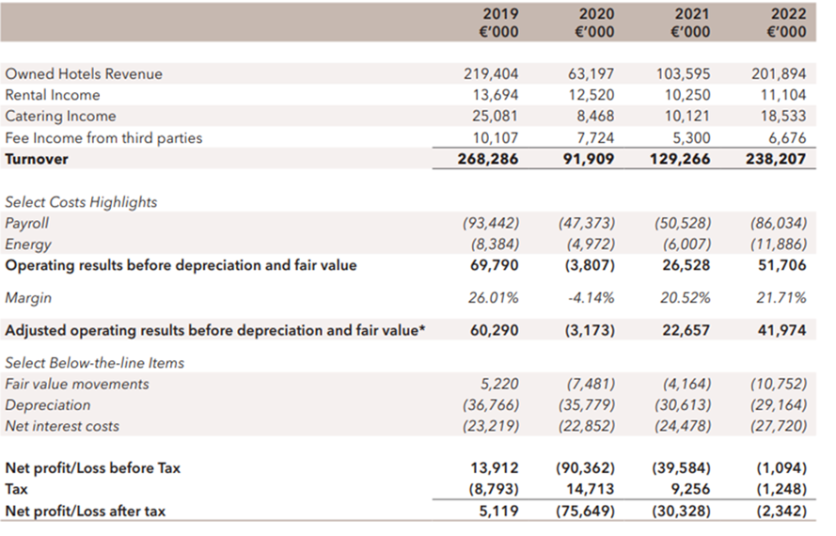
Figure: Total revenue of Corinthia Hotel
Source: (Corinthia Group, 2024)

Analysing revenue of Ibis hotel
IBIS Hotel is also a very well-reputed multinational business around the globe that has multiple subsidiary businesses. The official website of the respective company has announced that the respective company has made an early revenue of 308 million British pounds in the year 2022. Additionally in the year 2021, the overall business revenue was almost 151 million British pounds. The fact is very clear that the respective hotel chain has successfully gained huge jails over the last couple of years. Providing excellent quality luxury services at affordable prices is the main reason for the respective hotel for the huge business growth. It can be analyzed that the respective hotel chain has a huge potential for further growth and development. A huge level of upward growth will be forecasted in the upcoming years.
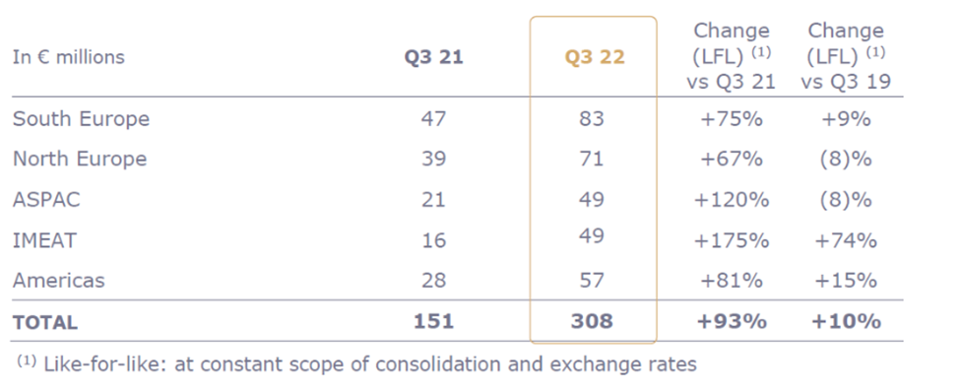
Figure: Total revenue of Ibis hotels
Source: (Ibis, 2024)

Concluding final results
The revenue trends profitability and net income of both businesses have forecasted very promising financial figures. however, as per the comparison Ibis Hotel has earned more annual revenue than the Corinthia Hotel. Both businesses have huge potential for future growth and development. Moreover, it can be examined that investing more money in the projects of ibis will provide more potential return on investment.

Elucidating Market Position Comparison of Two Hotels
Market Positioning of Corinthia Hotels
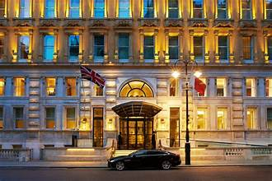
Figure: Corinthia Hotel
Source: (Corinthia, 2024)
Brand Perceptions: The positioning of Corinthia hotels can be underlined with a premium brand of luxury. The strategic properties of the iconic cities are located in Budapest, London and St. Petersburg. For example, Rome situated Corinthia Hotel has a premium position based on the appropriate significance of location that is prime and has overall comprehensive investments. IHI or investment in international hotels can create luxury services with added value (Bacari et al., 2021).
Market Share: Operates a luxury hotel portfolio with multiple locations including St. Petersburg, St. George and Budapest. A particular share of the market can be recognised with availability based on travellers’ high-end value with the presence of a niche market based on overall contribution.

Customer Demographics: Corinthia hotels can create specific executives of business, affluent travellers and tourist discerning processes based on the experiences of luxury. Their often-corporate events are hosted based on overall meetings of high-profile and conferences with appropriate meetings (Sannindra et al., 2022).
Brand Perceptions: Corinthia can establish an international brand for global luxury. Their overall quality commitment, customised services and amenities are opulent with perceptions that are reinforced. Associate guests with sophistication and elegance can create tradition and blend.
Market Positioning of Ibis Hotels
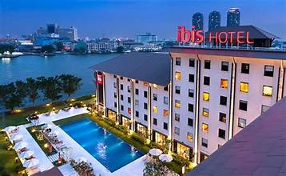
Figure: Ibis Hotel
Source: (Ibis, 2024)
Brand Perceptions
Ibis Hotel can create an overall framework of the hotel based on a budget that is mid-range. They can position with the overall traveller's preferences. Standardised services based on the comfortable emphasis on extravagant files’ process can create a service process. Ibis Hotel is part of Accor Group and this makes the hotel an international footprint.

Market Share
A crucial share of the market of this hotel can be underlined with a segment of budget hotels. Strategic properties of the location can create a hub based on transportation with the accessibility of the travellers of the business, families and travellers (Loschi, 2021).
Customer Demographics
Travellers are cost-conscious seek clean and rooms function and overall affordable prices. Their location had centred on city centres and airports based on business travellers’ appeals.
Brand Perception
Ibis brand value can be underlined with travellers’ preferences and choices can be appreciated based on the comfort of no-frills, service that is effective and amenities with straightforward offerings of Ibis (Debattista, 2022).
This can be underlined that the overall segment of luxury can be observed in the personalised experiences and segment of luxury. The travellers’ budget-consciousness can be underlined with standardised comfort, travellers’ budget-consciousness. Both market positions are different based on the different needs of the consumers.

Elucidating Growth Potential Comparison of the Both Hotels Ibis and Corinthia
Growth Potential of Corinthia Hotels
Expansion Strategies
Corinthia aims to underline the footprint of the world based on strategic selection with new properties’ locations. Their iconic cities’ focus is underlined with historical importance. The example can be included in St. Petersburg and London. The organisation of Corinthia Group has active progression based on the overall value network, with the acquisition of the land and operations of the hotel. Exploration of Corinthia has significant prospects based on the third-party worldwide location including the presence of the brand (Loschi, 2021).
Market Opportunities
The developing demand for the experiences of luxury travel can be interlinked with Corinthia’s opportunity. The customised commitment related to service can integrate alignment with trends and opportunities. Resumes of business travel and properties of Corinthia can attract the clients of the corporation including events, meetings and conferences (Avellino and Ebejer, 2022).
Potential Barriers
Developing requirements based on the luxury hotels can create a comprehensive investment for capital, and secure Corinthia’s acquisition for funding, renovations and construction. The competitive market of luxury hotels can be established with the overall player's establishments such as Ritz-Carlton, St. Regis and other players. This can be underlined by the process of the navigation system. Local regulation with compliance can be underlined with requirements of legal work, as it can be complicated based on the various countries' perceptions (Algareu, et al., 2021).

Growth Potential of Ibis Hotel
Expansion Strategies
Accor Group can create an international footprint based on the international presence of strong emphasis. This can enhance overall new features of the specific markets. The franchise framework can be interlinked with allowing process can be inclined with local investors’ partnering process with developers and local investors (Sannindra et al., 2022).
Market Opportunities
The segment of the hotel budget can be interlinked with a robust process based on the affordable seeking process with an overall reliable and affordable communication process. The tap of ibis can be underlined based on the overall procedure of market emergence based on Africa, Asia and South America. The travellers of the middle class can incline the overall progression process.
Potential Barriers
The hotel market is competitive and has the presence of multiple players such as Premier Inn, Holiday Inn Express and Travelodge. The edge of competition must be maintained by Ibis. Consistent assurance can be interlinked based on international networks with hotel franchise transformation. Downturns of the economy can create an impact on the travel budget. The adaption needs of the Ibis can transform the behaviour of the consumers. Meeting guest expectations evolving process can be interlinked with sustainability terms and the significance of adopted technology (Hendriyatmoko and Poernomo, 2023).
Leveraging Corinthia Hotels can position luxury including the overall progression of expenses related to strategy. The Ibis Hotel can capitalise on overall international reach based on the framework of budget-friendliness. The unique opportunities faced by the organisation can be underlined with transforming journeys and obstacles.

Elucidating Comparison of Both Hotels’ CSR Initiatives
CSR Initiative of Corinthia Hotels
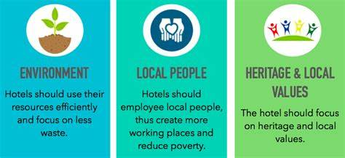
Figure: CSR initiatives of Hotel
Source: (Hendriyatmoko and Poernomo, 2023)

Practices of Sustainability
Corinthia can commit to the development of sustainability and it can be safeguarded based on the well-being, of communities and people with the appropriate operation. This can conclude the energy efficiency with reduction of waste, practices and conservation of waste. The elimination of Corinthia’s aims can be underlined with plastic’s single usage with the overall experience of the guests. This aligns with the commitment based on the decline of plastic pollution (Dumoulin and Giacomel, 2020).
Community Engagement
Corinthia can engage with the overall communities of the local area by giving them opportunities of employment, supporting businesses in local areas and contributing to the development of the community. Their celebration of heritage, local culture, traditions and heritage can be fostered with pride in the community (Lagarias et al., 2022).
Ethical Practices of Business
Adheres to global norms and applicable laws can be interlinked with an ethical framework based on the fairness, transparency and business operation integration process. The expectations need to be considered based on guests, employees, investors and stakeholders of the overall local communities.
CSR initiatives of Ibis Hotel
Sustainability Practices
Ibis Hotel can be underlined with Accor Group and pursues overall goals of the environment. The elimination of 2022 aims can be interlinked with the experiences of the guests and neutral carbon imprint based on 2050’s building process to decline emission of Carbon. The implemented properties of Ibis can save measures of energy, for example, efficient lighting and systems of HVAC.
Community Engagement
Collaboration of Ibis with the organisation of local places, supporting projects of community, healthcare and education. Their participation of the staff in the initiatives of community service (Lagarias et al., 2022).
Ethical Practices of Business
Maintaining transparency based on operations, policies and pricing and the well-being and safety of the guests also can be underlined in the business ethical practices (Debattista, 2022).
Ibis and Corinthia, both can recognise building sustainability, and business responsibility by reflecting commitment based on the impact of positive dedication based on society’s positive impact.

Conclusion with Recommendation
Recommendation
The hotel of Corinthia needs to implement panels for solar use, lighting for energy-efficient processes and technologies for water savings. Ibis need to use properties based on single-use plastics. Local NGO collaborations are needed for both hotels to boost the development of the economy. Safety protocols enhancement with overall procedures of response emergency is needed to engage the community. Improvement of safety protocols with response procedures related to emergencies of the guests needs to be more proficient for the guests.
Conclusion
This report can be processed with the overall activity of the operation with the comparison of the two well-recognised hotels. Treatment of guests can be underlined with the certain income amount and initiatives of CSR including the societies’ overall enhancement techniques. The market share diversity with the transforming nature of the consumers’ demographics can be interlinked with an overall chart and graphics of the organisations. The hospitality service potential prospects can be underlined based on the overall effective prospects of the business.

References
Algareu, A., Abdunnabi, M., Mabruk, M. and Elmaghrabi, A.M., (2021). Legionella Bacteria Activity investigation in Domestic Water Heating Systems: Tripoli-Libya as a case study. Solar Energy and Sustainable Development Journal, 10(2), pp.11-20.
Avellino, M. and Ebejer, J., (2022). Tourism in coastal resorts and historic areas: with a focus on Malta’s tourism.
Bacari, C., Séraphin, H. and Gowreesunkar, V.G., (2021). Sustainable development goals and the hotel sector: Case examples and implications. Worldwide Hospitality and Tourism Themes, 13(1), pp.9-21.
Corinthia, (2024). ELEGANT SURROUNDINGS. [Online] Available at: https://www.corinthia.com/en-gb/?_affclk=adn%3A3817%3A%3A7b99fee4b20a1c0eff289b33dd8f43ae%3A8002y1&utm_source=RTM+Media%2C+PPC+&+Media+Buying&utm_medium=affiliate&utm_campaign=Affilired&_affclk=adn%3A3817%3A%3A7b99fee4b20a1c0eff289b33dd8f43ae%3A8002y1%3As [Accessed 14 February 2024].
Debattista, D., (2022). MALTA, THE POSSIBILITIES OF SUSTAINABLE LUXURY TOURISM ON A MEDITERRANEAN ISLAND MEGALOPOLIS. The Online Open Access Repository of the Institute of Tourism Studies (Malta).
Debattista, D., (2022). MALTA, THE POSSIBILITIES OF SUSTAINABLE LUXURY TOURISM ON A MEDITERRANEAN ISLAND MEGALOPOLIS. The Online Open Access Repository of the Institute of Tourism Studies (Malta).
Dumoulin, R. and Giacomel, A., (2020). Disruption and the strategy of hotel groups. Shapes of Tourism Employment: HRM in the Worlds of Hotels and Air Transport, 4, pp.9-21.
Hendriyatmoko, D. and Poernomo, M.I., (2023). Communication Of The Crisis Of Hotel Ibis Budget Daan Mogot Jakarta In Facing The Covid-19 Pandemic. International Journal Of Humanities Education and Social Sciences, 3(2).
Ibis, (2024). Hotel Ibis Budget Abbeville. [Online] Available at: https://www.luxuryhotelsguides.com/?hotelid=666131&msclkid=ea53fcef26ba173e7042993849fe2808 [Accessed 16 February 2024].
Lagarias, A., Zacharakis, I. and Stratigea, A., (2022). Assessing the coastal vs hinterland divide by use of multitemporal data: Case study in Corinthia, Greece. European Journal of Geography, 13(2), pp.001-026.
Loschi, C., (2021). Youth as agenda-setters between donors and beneficiaries: The limited role of Libyan youth after 2011. Middle East Law and Governance, 13(1), pp.49-71.
Sannindra, A.E., Tarigan, E. and Nugraha, R.N., (2022). ANALYSIS OF SERVICE QUALITY TO CUSTOMER SATISFACTION AT IBIS SENEN HOTEL JAKARTA. Jurnal Manajemen Pelayanan Hotel, 6(2), pp.358-367.
Sannindra, A.E., Tarigan, E. and Nugraha, R.N., (2022). ANALYSIS OF SERVICE QUALITY TO CUSTOMER SATISFACTION AT IBIS SENEN HOTEL JAKARTA. Jurnal Manajemen Pelayanan Hotel, 6(2), pp.358-367.
Tan, Y. and Despotis, D., (2021). Investigation of efficiency in the UK hotel industry: a network data envelopment analysis approach. International Journal of Contemporary Hospitality Management, 33(3), pp.1080-1104.
Welly, G., Hardini, R., Digdowiseiso, K. and Zaki, N.A.M., (2024). The Effect of Service Quality, Price and Complaint Handling on Customer Satisfaction of ibis budget Daan Mogot hotel. Journal of Social Science, 5(2), pp.406-414.

