Abstract
HNC/HND/BSc Construction Management
Building Survey
Digital Surveying and Highway Design
Jayden Brewer 2403712

Contents
Contents………………………………………………………………………………………………………………………………………….1
Introduction……………………………………………………………………………………………………………………………………2
Survey objectives and scope……………………………………………………………………………………………………………2
Selection of digital tools and technologies……………………………………………………………………………………2,3
Survey plan…………………………………………………………………………………………………………………………………..4,5
Challenges and solutions…………………………………………………………………………………………………………………5
Conclusion and summary…………………………………………………………………………………………………………………6
References……………………………………………………………………………………………………………………………………….6

1. Introduction
a. Building surveys are important and must be carried out accurately. They can be used to identify potential Health and Safety risks such as defects. They are also carried out to ensure the building is compliant with building regulations.
b. Digital technologies now play a crucial part in building surveys as they are more accurate than a person would be. Large amounts of data can be gathered more efficiently using digital technologies such as the use of drones for exterior surveying. The use of laser scanning provides great 3D detail of a building’s contents very accurately. Overall digital technologies allow us to be more efficient and more accurate when surveying buildings.
c. To be able to identify why digital tools are beneficial when surveying and to be able to correctly plan out a building survey, ensuring all areas are to be assessed.

2. Survey objectives and Scope
a. Building surveys are typically carried out to determine the condition of a building. This could be ensuring that there are no defects on the building that could be a potential Health and Safety hazard, thermographic surveys to check material efficiency and 3D laser scanning to produce an accurate 3D image of the interior/exterior of a building. Regular surveys could help to prevent large maintenance work if an issue is discovered at an early stage.
b. The building we will be surveying will be the Y Fforwm building on the UWTSD Swansea Campus. Y Fforwm is a library building used by students and is a relatively small building located on Swansea docklands. When conducting this survey, we will identify key ground control points. These points will be easily identifiable and clear of anything that may interfere with satellite or drone view.

3. Selection of Digital tools and Technologies
a.
Drones are often used in building surveys as they are time and cost effective. These drones can cover a large area in a small amount of time while producing detailed and clear images of the building. Automated flying routes are created preflight and the drone will take images at every point you have set. Clear ground control points are crucial for an accurate survey as points need to match to create the most accurate picture of the surveyed area/building.
Laser scanning is a highly accurate and time efficient way of surveying a building. These scanners will draw an image onto a tablet with high precision. Ground control points will need to be set before you begin the scan. These points will be logged on the equipment and used for other surveying equipment such as drones.
Thermographic surveys are carried out on a thermal imagery camera. These cameras can be handheld and can also be attached to a drone to capture high level areas. A heat scale will inform you as to where heat is leaving the building and how warm areas are. Areas where high heat loss occurs can be assessed and any defects/nonconformance can be made good. When air tightness tests are being carried out, a thermal camera can be used to easily identify air leaks.
All of the information gathered with the equipment used can be merged together using a computer system that will allow you to view the whole building in detail.

b.
I Have decided that using a drone for the external survey will be beneficial as it is effective in keeping costs low due to the drone’s ability to capture images and information quickly. Although the one-off cost of purchasing the drone and camera will be expensive, the ability to capture information quickly will reduce costs. The use of a drone will require someone to pilot the drone and have the correct tickets/training.
Use of a drone
A drone will also be a good option as we have a clear and open landing/takeoff area in the wasteland located behind the building. As we are not near any restricted airspace, we will have no problems with restricted flying. The max range of the drone is 500m in view range and “no more than 120m high” (CAA, n,d), this will not be an issue as the building we will be surveying is small, therefor only a small flightpath will be flown. Using a drone will allow us to get close to high level areas that require surveying.
The use of a drone will be safer than using a MEWP to survey high level areas as no operative will be working at height and be at risk of falling. A MEWP will also need an operator which will further increase costs.
Use of laser scanner
Laser scanning will also be used in the survey as they are time effective due to them being handheld and lightweight. Laser scanners are very accurate when picking up objects and transferring an image onto a screen, high quality scanners can be as accurate as up to millimeters. These scanners require the user to move at a slower pace so maximum accuracy is achieved. These scanners can be used by anyone and are lightweight, therefor minimum effort is required to use this tool.
Use of thermal imaging camera
Thermal imaging cameras allow us to see heat loss in a building. Areas that experience high levels of heat loss will be highlighted. This allows us to see if the component of the building is compliant and effective. If an area is experiencing heat loss it will easily allow us to identify the defect and make changes. An efficient building can save a lot of money in comparison to a building with poor efficiency due to the use of heating costs. If a building can contain heat, then it will not be required to be heated as much or as often.
4. Survey Plan
The purpose of this survey is to assess the building condition to highlight any defects or nonconformance.
A date will be arranged for the survey where the weather will not be an issue for any of the technology we will be using to conduct the survey.
The survey will cover an external inspection of the building. External walls, windows, doors, roof and the surrounding area will be surveyed by a drone that will fly at …m high. To ensure the safety of others in the area, the drone will have a set landing and takeoff point which is located in the wasteland behind the building. This area is a good place for this as it is a large area that has no potential hazards for the drone to collide with and the public will not have access to this area. The drone will fly a pre-planned flight path by an “operator that has an operative ID and a flyer ID.” (Ruas.co.uk, n,d)
The drone will take images from set points that are pre planned in order to get the best view of the areas required to be surveyed. Once the drone has flown its flight path it will be landed, and all information will be collected and analyzed. Any defects that have been identified can be added to a defects/snag list which will be issued to the subcontractor responsible. All of the photos taken can be put together and an overall image of the whole building can be created.
When surveying the internal area of the building we will use a handheld laser scanner. The equipment will be controlled by someone that will walk the whole building. The laser scanner will project a 3d image onto a screen that is also carried on the survey. The scanner will pick up all internal aspects such as doors, windows, columns and other internal building components. The scanner is accurate up to a few millimeters, therefor drawing an accurate image ono the screen used.
Once all information is captured it will be uploaded to a software and assessed. Any defects that are found can be added to a defect list.
There is no Health and Safety risks associated with the use of this scanner as the equipment is small and lightweight. However, we will conduct the survey when the building is closed to the public, so the scanner does not pick up anything that is not usually in the building such as items left by the public.
Finally, we will use the thermal imaging camera so we can see where the building suffers heat loss. In order for the thermal camera to pick up heat loss, there needs to be a temperature difference of at least 10°C between the internal and external of the building.
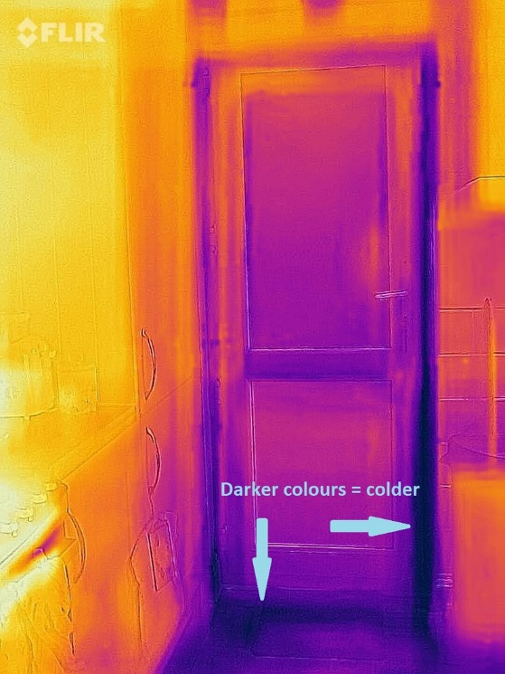

(Octopus Energy)
The above image shows how thermal imaging cameras show heat loss. In this example we can see cold areas and heat loss around the door frame.
Thermal cameras can be used to identify any leaks behind plasterboard as well as pick up heat loss. Using the camera around windows and doors will be beneficial as this often an area that experiences heat loss, this could be down to seals around the windows or frames.

5. Challenges and Solutions
When carrying out the survey we may face potential challenges that may affect our ability to complete the survey.
When using the drone, the weather could affect our ability to fly the drone. High winds and heavy rain will put a stop to the survey as the drone will not be able to withstand poor conditions. Battery life will not be an issue for the drone if it is fully charged as the building is small therefor the flight time is not long. Weather conditions will need to be checked during the planning stage and the days leading up to the flight to eliminate the chances of being exposed to poor weather conditions.
A potential challenge using the laser scanner may be the operator’s ability to hold the devise steady when moving, this will affect the accuracy of the scanner and lead to an inaccurate survey. The reflectiveness and shine on materials can affect the scanners’ ability to correctly record what is in front of it. When “scanning around windows the laser may pass through the window” (Pointscan.co.uk) and not register it as a closed off area. This problem can be eliminated by covering windows with a non-reflective material.
The thermal imaging camera may be affected by the difference in temperature between the internal and the exterior of the building. This issue could be avoided by conducting the survey at a time where the building has reached an even temperature throughout.

6. Conclusion and summary
In order to conduct a building survey there must be a clear plan set in place. This plan will give all the information you need in order to have a successful survey. Health and safety measures must be set in place so there are no accidents during the survey. After all information is gathered and put together we will be able to see any defects and issues wrong with the building, these defects can them be fixed by subcontractors in order for the building to perform as it should.

References
(n.d.). Retrieved from Octopus Energy: https://octopus.energy/blog/how-to-use-flir-thermal-camera/
(n.d.). Retrieved from Pointscan.co.uk: https://www.pointscan.co.uk/challenges-in-3d-laser-scanning/
CAA. (n,d, n,d n,d). Retrieved from https://register-drones.caa.co.uk/drone-code/the_drone_code.pdf
(n,d, n,d n,d). Retrieved from Ruas.co.uk: https://ruas.co.uk/drone-license-what-is-it-and-do-i-need-one/#:~:text=An%20Operator%20ID%20and%20a,to%20fly%20under%20certain%20conditions.

